Community Training API

# Description

This application is for people who want to train and track their performance together. In this application users can create training plans and invite other users to participate in them as well. Users can post and track their and each other's performance in the Results Table and they can see each other's performance as well to motivate each other.

# Domain

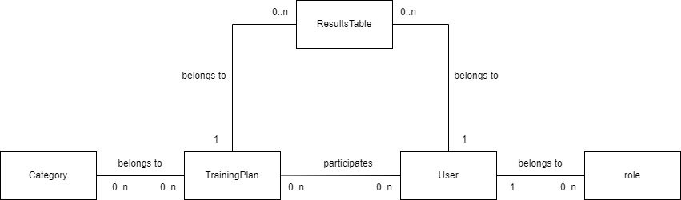

# Use cases

* [anonymous] log in
* [logged in] log out
* [admin] manage categories
* [admin] manage users
* [anyone] view and search for public training plans
* [logged in] view and search for training plans I participate in
* [logged in] view training plans I participate in
* [logged in] create new training plan
* [logged in] apply for training plan
* [logged in] quit from training plan I participate in
* [logged in] post my done activity to training plan

API

| API | GET api/auth/login |
| --- | --- |
| Description | Logs in a user |
| Request body | username/password |
| Response body | - |
| Status code | 200: OK  401: Login failed |
| API | GET api/auth/logout |
| Description | Logs in a user |
| Request body | username/password |
| Response body | - |
| Status code | 200: OK |
| API | GET api/categories/{id} |
| Description | Gets a category |
| Request body | - |
| Response body | One category |
| Status code | 200: OK  404: Category cannot be found |
| API | POST api/categories/ |
| Description | Creates a new category |
| Request body | One category |
| Response body | One category |
| Status code | 201: Created  400: Model validation errors |
| API | PUT api/categories/{id} |
| Description | Updates a category |
| Request body | One category |
| Response body | - |
| Status code | 204: Updated successfully, no content  400: Model validation errors  404: Category not found |
| API | DELETE api/categories/{id} |
| Description | Deletes a new category |
| Request body | - |
| Response body | - |
| Status code | 204: Deleted successfully, no content  404: Category not found |
| API | GET api/trainingplans?user={userid}&name={nameterm} |
| Description | Searches among training plans |
| Request body | - |
| Response body | List of training plans |
| Status code | 200: OK |
| API | GET api/trainingplans/{id} |
| Description | Gets a training plan |
| Request body | - |
| Response body | One training plan |
| Status code | 200: OK  404: training plan cannot be found |
| API | POST api/trainingplans/ |
| Description | Creates a new training plan |
| Request body | One training plan |
| Response body | One training plan |
| Status code | 201: Created  400: Model validation errors |
| API | PUT api/trainingplans/{id} |
| Description | Updates a training plan |
| Request body | One training plan |
| Response body | - |
| Status code | 204: Updated successfully, no content  400: Model validation errors  404: training plan not found |
| API | DELETE api/trainingplans/{id} |
| Description | Deletes a training plan |
| Request body | - |
| Response body | - |
| Status code | 204: Deleted successfully, no content  404: Category not found |
| API | PUT api/resulttables/{trainingplan_id} |
| Description | Updates a result table |
| Request body | One category |
| Response body | - |
| Status code | 204: Updated successfully, no content  400: Model validation errors  404: training plan not found assigned to the user |
| API | GET api/resulttables?trainingplan={trainingplan_id} |
| Description | Searches among result tables |
| Request body | - |
| Response body | List of result tables |
| Status code | 200: OK |
| API | GET api/resulttables/{trainingplan_id} |
| Description | Gets a result table |
| Request body | - |
| Response body | One result table |
| Status code | 200: OK  404: result table cannot be found |

Authentication, authorization

The API can authenticate users. Authentication is maintained by JWT tokens. Users can belong to roles.

The following roles are specified

* user
* admin

The API has actions that can be called by anonymous users but some actions are authorized and can only be accessed by authenticated users in a certain role.