Recipe book API

Description
In the Recipe book application users can manage their recipes, arrange them into recipe books, categorize them and share them with other users. Shared recipes are visible for everyone as opposed to private recipes. Besides the textual description of the recipe one can also upload images to them. Public recipes can be rated and commented by any logged in user.
Domain
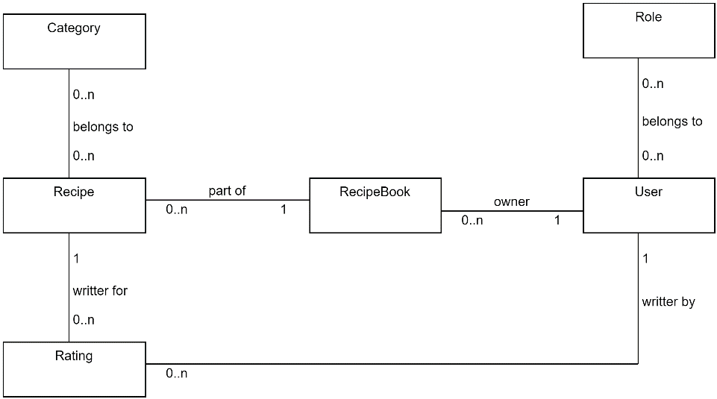
Use cases
- [anonymous] log in
- [logged in] log out
- [admin] manage categories
- [admin] manage users
- [anyone] view and search for public recipes
- [logged in] view my private recipes
- [logged in] manage my recipe books
- [logged in] manage the recipes in my recipe books
- [logged in] Rate and comment a public recipe

API
API | GET api/auth/login
Description | Logs in a user
Request body | username/password
Response body | -
Status code | 200: OK  401: Login failed
API | GET api/auth/logout
Description | Logs in a user
Request body | username/password
Response body | -
Status code | 200: OK
API | GET api/categories/{id}
Description | Gets a category
Request body | -
Response body | One category
Status code | 200: OK  404: Category cannot be found
API | POST api/categories/
Description | Creates a new category
Request body | One category
Response body | One category
Status code | 201: Created  400: Model validation errors
API | PUT api/categories/{id}
Description | Updates a category
Request body | One category
Response body | -
Status code | 204: Updated successfully, no content  400: Model validation errors  404: Category not found
API | DELETE api/categories/{id}
Description | Deletes a new category
Request body | -
Response body | -
Status code | 204: Deleted successfully, no content  404: Category not found
API | GET api/recipebooks?user={userid}&name={nameterm}
Description | Searches among recipe books
Request body | -
Response body | List of recipe books
Status code | 200: OK
API | GET api/recipebook/{id}
Description | Gets a recipe book
Request body | -
Response body | One recipe book
Status code | 200: OK  404: Recipe book cannot be found
API | POST api/recipebooks/
Description | Creates a new recipe book
Request body | One recipe book
Response body | One recipe book
Status code | 201: Created  400: Model validation errors
API | PUT api/recipebooks/{id}
Description | Updates a recipe book
Request body | One recipe book
Response body | -
Status code | 204: Updated successfully, no content  400: Model validation errors  404: Recipe book not found
API | DELETE api/recipebooks/{id}
Description | Deletes a recipe book
Request body | -
Response body | -
Status code | 204: Deleted successfully, no content  404: Category not found
Etc…

Authentication, authorization
The API can authenticate users. Authentication is maintained by JWT tokens. Users can belong to roles.
The following roles are specified
- user
- admin
The API has actions that can be called by anonymous users but some actions are authorized and can only be accessed by authenticated users in a certain role.

