*Appendices*

Process of Data Information Load

1. Data dictionary

|  |  |  |  |
| --- | --- | --- | --- |
| **Name** | **Type** | **Length** | **Description** |
| account_Number | varchar(50) | 50 | Unique user account number which also serves as the account primary key. |
| account_Username | varchar(50) | 16 | Contains user's Username which is used in the system for logging in. This is also used as a modifier to know who send what and who is logged on. |
| account_Password | varchar(50) | 16 | Contains user's Password which is used in the system for logging in, primarily needed to ensure safety |
| account_AccessLevel | varchar(50) | 50 | Indicates the user's account level which limits the areas a user may interact on |
| employee_Code | varchar(50) | 50 | Holds the information of the employee who uses the registered an account |
| official_Number | int | 50 | Indicates the number of record in which a certain item is scheduled to be returned to, serves as the unique identity of the record item |
| official_TurnOverDate | varchar(50) | 9 | Indicates the date where a specific item would be returned |
| item_Number | varchar(50) | 50 | The unique identifier of a registered item in the database |
| department_Code | varchar(10) | 50 | The unique identifier of a department registered in the database |

|  |  |  |  |
| --- | --- | --- | --- |
| category_Code | varchar(50) | 50 | The unique identifier of a category registered in the database |
| category_Description | varchar(50) | 50 | Indicates the description of each category registered in the database |
| classification_Code | varchar(50) | 50 | The unique identifier of a classification code registered in the database |
| classification_Description | varchar(50) | 50 | Indicates the description of each classification registered in the database |
| department_Name | varchar(50) | 50 | Indicates the name of the registered department in the database |
| department_Division | varchar(50) | 50 | Indicates the division in which the department belongs to |
| department_Head | varchar(50) | 50 | Indicates the officer in charge in the department that is registered in the database |
| department_RC | varchar(50) | 50 | Indicates the department identification for bills payments |
| dieselRefill_Number | int | 50 | The unique identifier of the diesel refill record in the database |
| dieselRefill_AmountRefilled | varchar(50) | 50 | Indicates the amount of diesel refilled on a specific vehicle |
| dieselRefill_RefillDate | varchar(50) | 9 | Indicates the date in which the diesel refill took place |
| dieselRefill_AmountBeforeRefilled | decimal(18,2) | 18 | Indicates the amount of diesel before a diesel refilling was completed |
| dieselStocks_Code | varchar(50) | 50 | The unique identifier of the diesel stock recorded in the database |
| dieselRefillAmountWorth | decimal(18,2) | 18 | Indicates the current price amount of the diesel |
| dieselRefill_AmountWorthBefore | decimal(18,2) | 18 | Indicates the previous amount of the diesel |
| dieselStocks_Division | varchar(50) | 50 | Indicates the division in which the stocks are allocated |
| dieselStocks_DieselAmount | decimal(18,2) | 18 | Indicates the amount of diesel stocks alloted in a specific division |
| dieselStocks_Amount | decimal(18,2) | 18 | Indicates the price amount of diesel stocks alloted in a specific division |
| disposedItem_Number | varchar(50) | 50 | The unique identifier of an item to be disposed of |
| disposedItem_Memorandum | varchar(50) | 50 | Indicates the memorandum for the item to be disposed of |
| disposedItem_DateReturned | varchar(50) | 9 | Indicates the date where the disposed item was recovered |
| disposedItem_Purpose | varchar(50) | 50 | Indicated the purpose of the item on what should be done on it |
| employee_LastName | varchar(50) | 20 | Indicates the surname of the user/employee |
| employee_FirstName | varchar(50) | 30 | Indicates the given name of the user/employee |
| employee_MiddleName | varchar(50) | 20 | Indicates the middle name of the user/employee |
| employee_Position | varchar(50) | 20 | Indicates the position of the user/employee |
| fuel_DRISNumber | varchar(50) | 50 | The unique identifier of a DRISNumber in the database |
| fuel_PlateNumber | varchar(50) | 10 | Indicates the plate number of the vehicle that requests a fuel refil permit |
| fuel_DriverLastName | varchar(50) | 20 | Indicates the surname of the driver that drives the vehicle that request to have a fuel refill |
| fuel_DriverFIrstName | varchar(50) | 30 | Indicates the given name of the driver that drives the vehicle that request to have a fuel refill |
| fuel_DriverMiddleName | varchar(50) | 20 | Indicates the middle name of the driver that drives the vehicle that request to have a fuel refill |
| passenger_Number | varchar(50) | 50 | The unique identifier of a passenger from a trip ticket |
| fuel_TripPurpose | varchar(1000) | 1000 | Indicates the purpose of the trip from a trip ticket |
| fuel_DepartureTime | varchar(100) | 10 | Indicates the departure time of a trip |
| fuel_ArrivalTime | varchar(100) | 10 | Indicates the arrival time of a trip |
| fuel_Destination | varchar(1000) | 1000 | Indicates the place where trip is headed |
| fuel_Quantity | decimal(10,2) | 10 | Indicates the amount requested from the trip ticket |
| fuel_Type | varchar(50) | 10 | Indicates the type of fuel requested |
| fuel_RequestDate | varchar(50) | 10 | Indicates the date when the fuel was requested |
| fuel_VehicleType | varchar(50) | 50 | Indicates the type of vehicle to be loaded by fuel |
| fuel_RequestStatus | varchar(50) | 10 | Indicates the status of the request where it is approved, pending, or rejected |
| fuel_IssuanceDate | varchar(50) | 10 | Indicates when the fuel request was issued |
| fuel_CardNumber | varchar(50) | 50 | The unique identifier of the fuel request registered in the database |
| gasolineRefill_Number | int | 50 | The unique identifier of the gasoline refill request in the database |
| gasolineRefill_AmountRefilled | decimal(18,2) | 18 | Indicates the amount of gasoline refilled |
| gasolineRefill_RefillDate | varchar(50) | 10 | Indicates the date when the gasoline to be loaded |
| gasolineRefill_AmountBeforeRefilled | decimal(18,2) | 18 | Indicates the amount of gasoline before Refilling takes place |
| gasolineStocks_Code | varchar(50) | 50 | The unique identifier of the gasoline stock recorded in the database |
| gasolineRefill_AmountWorth | varchar(50) | 50 | Indicates the current price amount of the gasoline |
| gasolineRefill_AmountWorthBefore | decimal(18,2) | 18 | Indicates the last price amount of the gasoline |
| gasolineStocks_Division | varchar(50) | 50 | Indicates the division where the stocks are allocated |
| gasolineStocks_DieselAmount | decimal(18,2) | 18 | Indicates the amount in of liters from the stocked gasoline |
| gasolineStocks_AmountWorth | decimal(18,2) | 18 | Indicates the amount in peso of the stocked gasoline |
| passenger_LastName | varchar(50) | 20 | Indicates the surname of the passenger |
| passenger_FIrstName | varchar(50) | 30 | Indicates the given name of the passenger |
| passenger_MIddleName | varchar(50) | 20 | Indicates the middle name of the passenger |
| property_Code | varchar(50) | 50 | The unique identifier ot he property stored in the database |
| property_PurchaseOrderNumber | varchar(50) | 50 | Indicates the PO number from a request |
| property_PurchaseRequestNumber | varchar(50) | 50 | Indicates the number of the purchase request |
| property_InvoiceNumber | varchar(50) | 50 | Indicates the invoice number of the property to be recorded |
| property_DeliveryReceiptNumber | varchar(50) | 50 | Indicates the delivery receipt number of the propoerty to be recorded |
| property_DateAcquired | varchar(50) | 10 | Indicates the date when the property was acquired |
| item_itemType | varchar(50) | 50 | Indicates the type of item to be recorded |
| item_Unit | varchar(50) | 50 | Indicates the unit of the item to be recorded |
| item_UnitQuantity | int | 50 | Indicates the quantity of the unit to be recorded |
| item_UnitValue | decimal(18,2) | 18 | Indicates the value of the unit to be recorded |
| item_Description | varchar(50) | 50 | describes the item to be recorded |
| item_WarrantyDate | varchar(50) | 10 | Indicates the date of warranty of the recorded item |
| item_DateEncoded | varchar(50) | 10 | Indicates the date when the item was encoded |
| item_Status | varchar(50) | 50 | Indicates the status of the recorded item |
| item_Remarks | varchar(50) | 50 | Indicates the remark of the recorded item |
| item_SerialNumber | varchar(50) | 50 | Indicates the serial number of the recorded item |
| supplier_Code | varchar(50) | 50 | The unique identifier of a supplier code registered in the database |
| supplier_Name | varchar(50) | 50 | Indicates the name of the supplier |
| supplier_Address | varchar(1000) | 1000 | Indicates the address of the supplier that supplies a specific material/item |
| tmpBillEntity_Number | int | 50 | The unique identifier of the temporary bill entry |
| tmpBillEntity_FPP | varchar(50) | 50 | Indicates the temporary FPP entry |
| tmpBillEntity_Amount | decimal(18,2) | 18 | Indicates the temporary Bill Entity amount |
| tmpDisposal_Number | varchar(50) | 50 | The unique identifier of the temporary disposal entry |
| tmpDisposal_Memorandum | varchar(50) | 50 | Indicates the temporary memorandum for disposal |
| tmpDisposal_DateReturned | varchar(50) | 10 | Indicates the temporary Date of recovery of the item to be disposed |
| tmpItem_Number | varchar(50) | 50 | The unique identifier of the temporary Item number |
| tmpItem_UnitQuantity | int | 50 | Indicates the Unit quantity of the temporary Item |
| tmpItem_Description | varchar(50) | 50 | Indicates the description of the temporary item |
| tmpItem_UnitValue | decimal(18,2) | 18 | Indicates the unit value of the temporary item |
| tmpItem_Remarks | varchar(50) | 50 | Indicates the remark of the temporary item |
| tmpItem_WarrantyDate | varchar(50) | 10 | Indicates the date of warranty of the temporary item |
| tmpItem_SerialNumber | varchar(50) | 50 | Indicates the serial number of the temporary item |
| tmpItem_ItemType | varchar(50) | 50 | Indicates the type of temporary item to be recorded |
| units_Type | varchar(50) | 50 | The unique identifies of a unit recorded in the database |

1. Data flows diagram



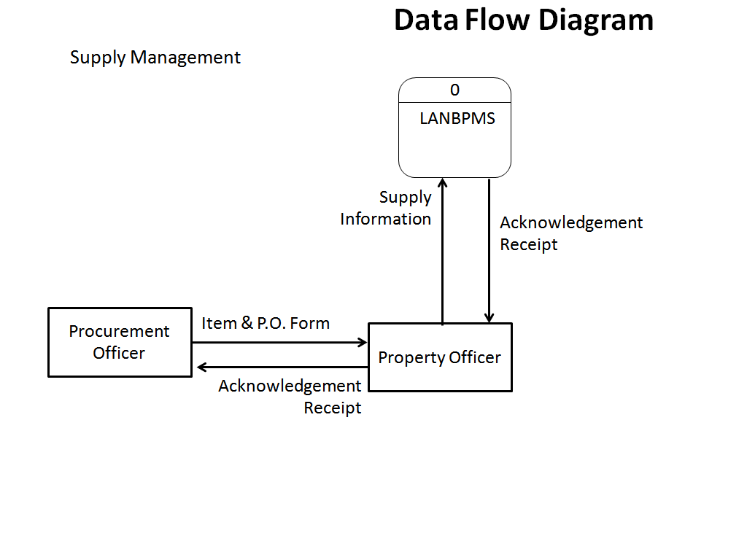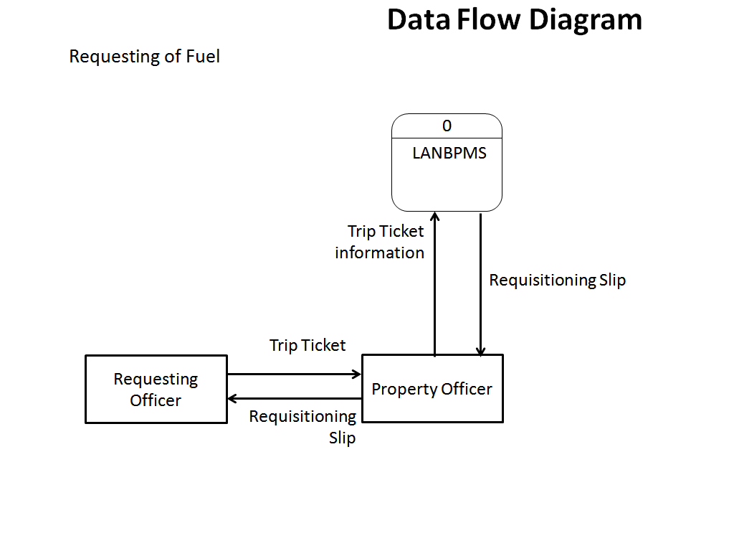

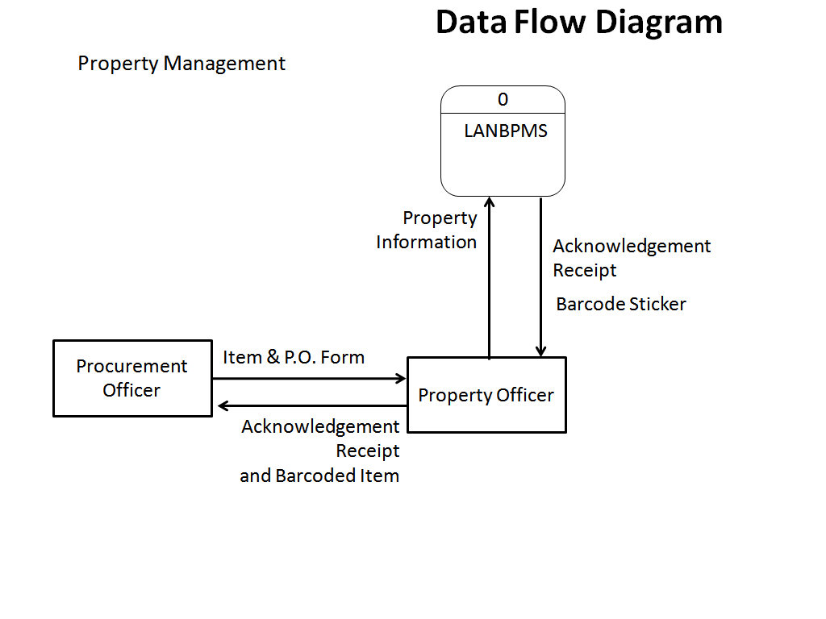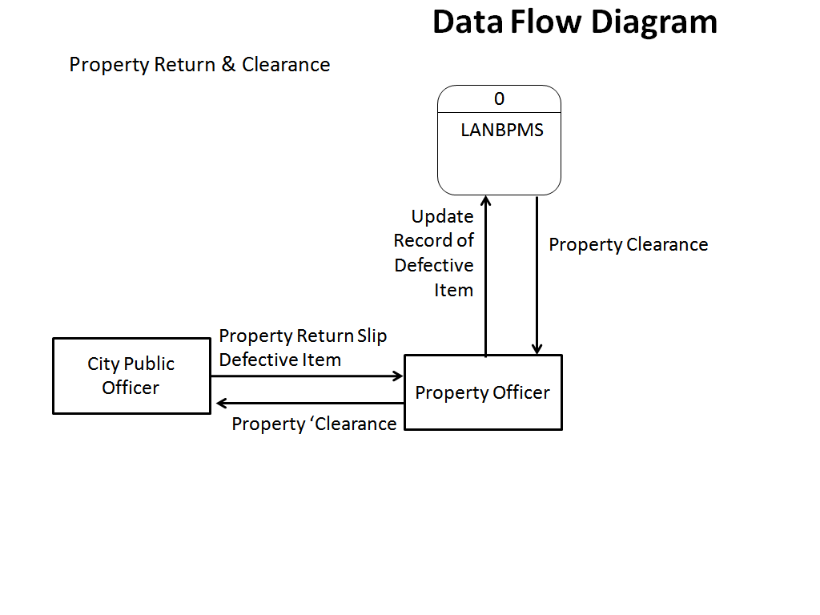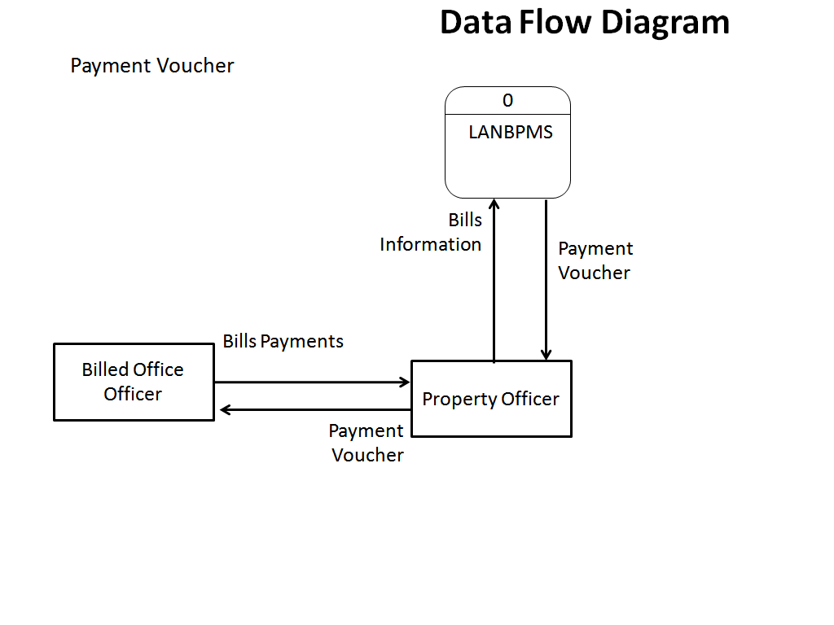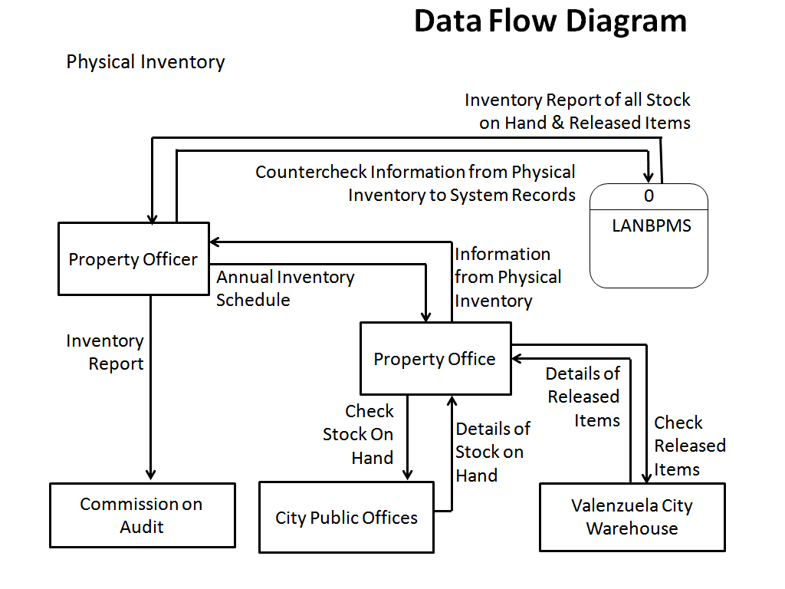

1. Jackson Structured Programming
2. Normalization

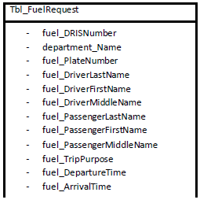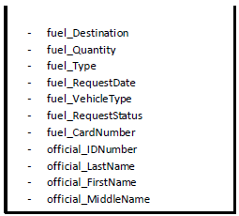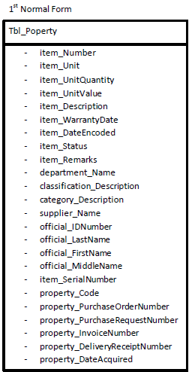

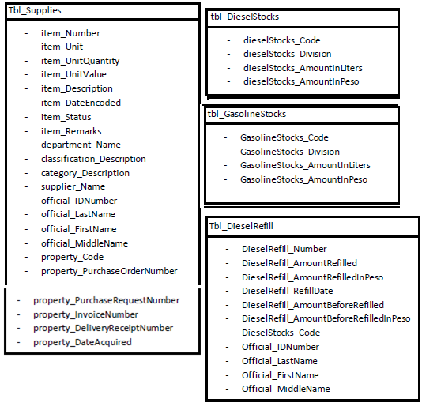

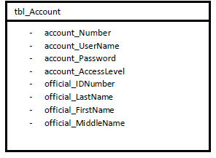

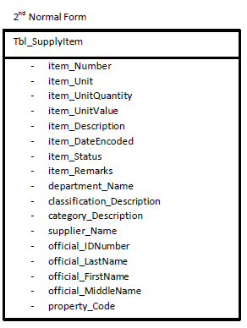

1. *Entity relationship diagram*

**

*Test Case Result*

Case Diagram

Use-cases

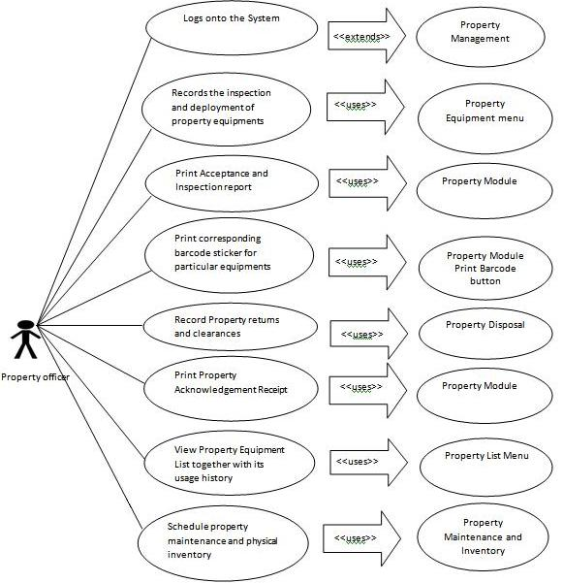The following use-cases are typical interactions between the external environment and the internal software system.

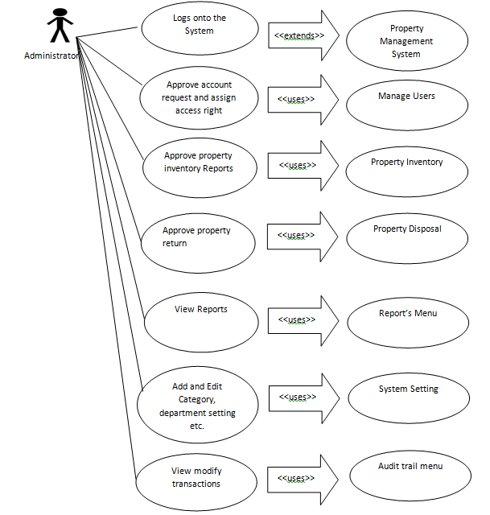

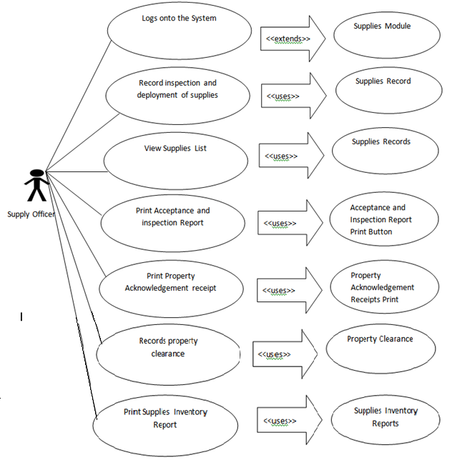

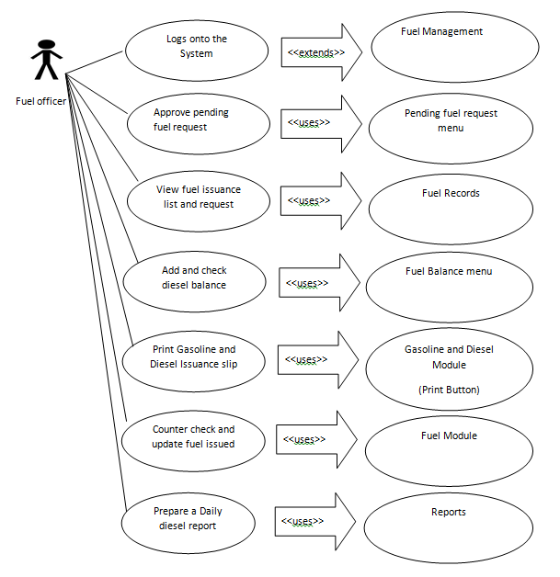

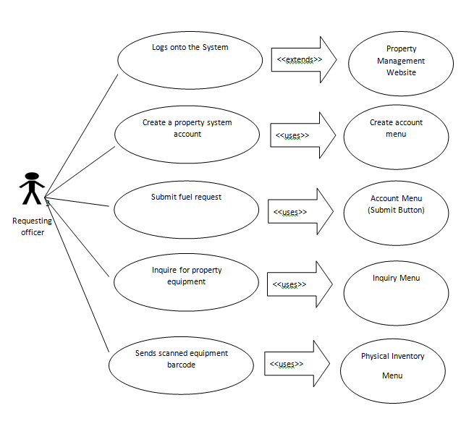

Evaluation of test document tool

1. Survey Questionnaire

Pamantasan ng Lungsod ng Valenzuela

Information Technology Department

**Name: Position:**

**Department: Age:**

**Direction:** Rate the proposed system “*Web-Based Warehouse Inventory Management System for the Property office of Valenzuela”* based from the following criteria given. **Schemes are given below:**

**(5) Excellent** – The feature is easily and efficiently done

**(4) Very good** – The said feature is done but needs some improvement

**(3) Good** – Doing the said feature is done but can still be improved

**(2) Fair** – There is difficulty in doing the said feature

**(1) Poor** – The system does not provide the said features.

|  |  |  |  |  |  |  |
| --- | --- | --- | --- | --- | --- | --- |
|  | **Questions** | **5** | **4** | **3** | **2** | **1** |
| 1 | All necessary transactions are catered by the system. |  |  |  |  |  |
| 2 | Information retrieval is accurate and reliable. |  |  |  |  |  |
| 3 | Extraction of specific information is easy and convenient. |  |  |  |  |  |
| 4 | Viewing of usage history of every equipment and tracing of former proprietor is possible. |  |  |  |  |  |
| 5 | Keeping records of the amount of gasoline and diesel left for future references regarding fuel allocation is efficient. |  |  |  |  |  |
| 6 | All necessary reports/documents can be produced and offers consistency. |  |  |  |  |  |
| 7 | Conducting of property inspection on their own office and use of proposed system to forward updates regarding equipment registered to them and its whereabouts is convenient. |  |  |  |  |  |
| 8 | The information needed for reports are complete and precise |  |  |  |  |  |
| 9 | Navigating into each modules environment is easy |  |  |  |  |  |
| 10 | Searching for information relating to properties and supplies is dynamic and efficient |  |  |  |  |  |

**Pamantasan ng Lungsod ng Valenzuela**

Information Technology Department

**Name: Position:**

**Department: Age:**

**Direction:** Rate the processes of the property office based on the given criteria. **Schemes are given below:**

**(5) Excellent** – The transaction or process is done quickly and efficiently

**(4) Very good** – The said transaction or process is provided but needs some improvement

**(3) Good** – The said transaction or process is provided but needs improvement

**(2) Fair** – There is much difficulty in doing the said transaction or process

**(1) Poor** – There is much difficulty or no provision of the said transaction or process.

|  |  |  |  |  |  |  |
| --- | --- | --- | --- | --- | --- | --- |
|  | **Questions** | **5** | **4** | **3** | **2** | **1** |
| 1 | Requesting different forms to be filled up regarding property and supply is easy |  |  |  |  |  |
| 2 | Request regarding fuel allocation, property maintenance, etc. are processed quickly and efficiently |  |  |  |  |  |
| 3 | Getting updates regarding requests are quick |  |  |  |  |  |
| 4 | The property office provides for inquiries for different processes done in their office |  |  |  |  |  |
| 5 | The property office processes covers the 3S Goals of Valenzuela   * Simple Process * Speed in Delivery * Service Excellence |  |  |  |  |  |
| 6 | Property clearances are done quickly and easily |  |  |  |  |  |
| 7 | Updates regarding repair of equipment are quick and efficient |  |  |  |  |  |
| 8 | Verification regarding the status of bill payments are provided |  |  |  |  |  |
| 9 | Processes in the Property office are done simply |  |  |  |  |  |
| 10 | Requested properties and supplies are ensured to be appropriate and in good condition as they are delivered to its requisitioning office |  |  |  |  |  |