EventAlpha AI — System Architecture & Deployment
Project: EventAlpha AI
Document status: Target architecture / implementation specification
Reference date: 26 August 2026
Primary goal: low-latency, cloud-first trading decision support based on market data, global events, filings, macro data and social signals.
Safety principle: the system may generate probabilistic trading signals, but it must never claim guaranteed profitability. Live execution is disabled by default; the mandatory path is research → backtest → shadow → paper trading → explicit human approval.

1. Architectural style
EventAlpha should be event-driven internally, modular in code, and simple to deploy initially. The recommended MVP deployment has four runtime roles:
- web — Next.js UI;
- api — FastAPI REST/WebSocket gateway;
- worker-fast — low-latency ingestion, AI routing, signal/risk tasks;
- worker-batch — historical ingestion, reprocessing, backtests, analytics.
All roles use shared PostgreSQL/TimescaleDB, Redis and object storage. This avoids premature microservice complexity while preserving clear boundaries.
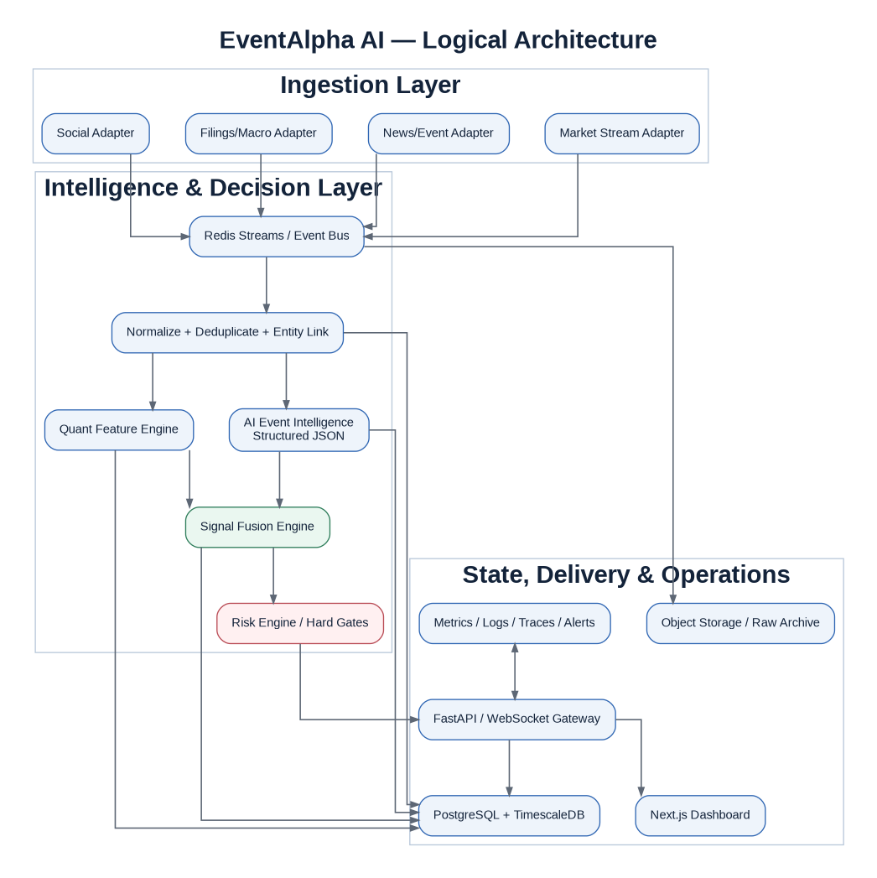
Logical architecture

2. Ingestion layer
Each provider implements a common adapter contract:
connect/start
health
subscribe / poll
normalize_provider_timestamp
emit RawEnvelope
reconnect with backoff
shutdown cleanly
Every incoming item receives: - provider and source; - provider-native identifier; - source publication/event timestamp if present; - EventAlpha received_at in UTC; - SHA-256/content fingerprint; - payload location or normalized raw fields; - trace/correlation ID.

Reliability rules
- bounded exponential backoff with jitter;
- heartbeat and last-seen timestamp;
- duplicate-safe ingestion;
- dead-letter stream after retry budget;
- provider quota/rate-limit metrics;
- clock drift monitoring;
- explicit DEGRADED provider health state.

3. Normalization and event clustering
Pipeline: 1. canonicalize encoding/URLs/source names; 2. language detection; 3. deterministic fingerprints; 4. near-duplicate similarity; 5. named-entity extraction/linking; 6. canonical event cluster assignment; 7. novelty score versus recent related clusters; 8. source independence assessment.
The same event reported by 50 outlets should not become “50x confidence.” Confidence should increase mainly when independent authoritative evidence arrives.

4. AI intelligence service
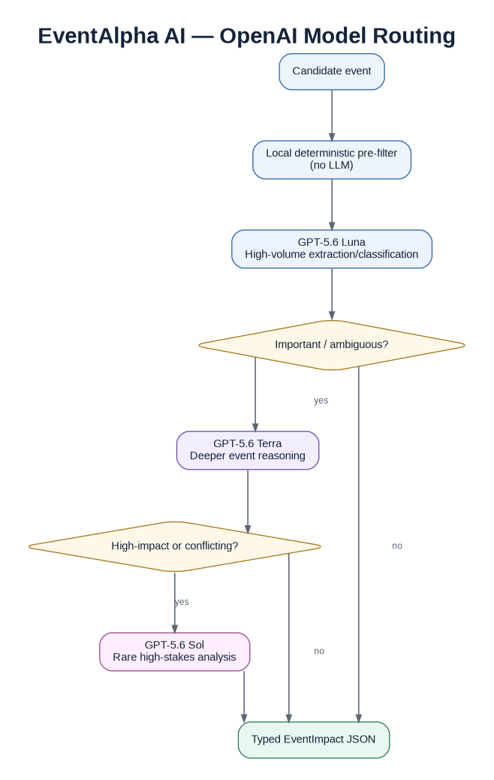
OpenAI router
The AI service receives a canonical event plus carefully selected evidence, never an unbounded raw firehose. It returns a strict AIEventAnalysis schema containing: - event taxonomy; - entities/assets/sectors/countries; - direction per impacted asset; - impact magnitude; - confidence/uncertainty; - novelty and causal channels; - horizon; - contradicting evidence; - invalidation scenarios; - concise explanation; - citations/source IDs used.
Model router: - Luna default fast lane; - Terra if event importance/ambiguity threshold exceeded; - Sol only when materiality is high and evidence conflict/complexity merits the cost.

5. Quant feature service
Features are computed as of a timestamp. Example groups:

Price/return
- 1m/5m/15m/1h returns;
- gap vs prior close;
- distance from VWAP/moving reference;
- momentum/reversal indicators.

Volatility/liquidity
- realized volatility;
- ATR-like range measures;
- bid/ask spread where available;
- volume and dollar-volume z-scores;
- abnormal trade intensity.

Cross-asset/context
- sector ETF move;
- index move;
- VIX/rates/USD/commodity context;
- rolling beta/correlation regime.
Feature calculations must be deterministic, versioned and backtestable from the same historical inputs.

6. Signal fusion engine
The signal engine does not simply average opinions. It consumes: - AI event impact; - credibility/novelty; - quant features; - macro/context features; - social features when available; - cross-source confirmation; - model calibration output.
A simple auditable baseline can begin with a versioned weighted score, then be replaced/augmented by a trained tabular model when enough labeled history exists.
Conceptual baseline:
raw_edge =
w_event * event_impact * credibility * novelty
+ w_quant * quant_score
+ w_context * market_context
+ w_social * social_score
+ w_confirm * market_confirmation
score = tanh(raw_edge)
probability = calibrated_model(score, regime, horizon, ...)
Weights are configuration/model artifacts, never magic constants hidden in code.

7. Risk engine
The risk engine is deterministic and authoritative. It can: - approve; - downgrade BUY/SELL to HOLD/AVOID; - reduce suggested paper size; - block trading entirely.
Hard gates include stale data, provider outage, spread/liquidity, extreme volatility, daily loss budget, exposure concentration, max concurrent positions, corrupted/missing evidence and global kill switch.

8. Real-time delivery
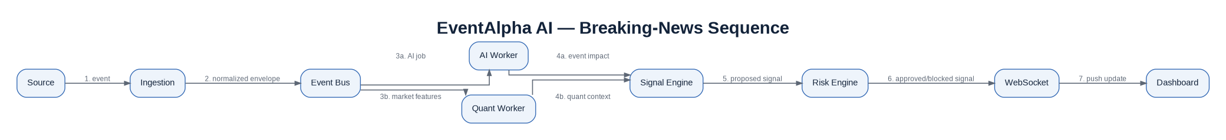
Breaking news sequence
The backend publishes typed WebSocket events such as: - event.created; - event.updated; - signal.created; - signal.updated; - risk.blocked; - paper_order.updated; - provider.health.
WebSocket clients receive summaries; the UI fetches full details over REST when needed.

9. Persistence and audit
Use append-oriented audit tables. A signal must be reproducible from: - source raw item IDs; - event version; - AI prompt/schema/model version; - feature-set version and exact values; - strategy config hash; - risk config hash; - code version/commit SHA where possible.
Never overwrite historical model output in place. Create a new analysis/version.

10. Production deployment
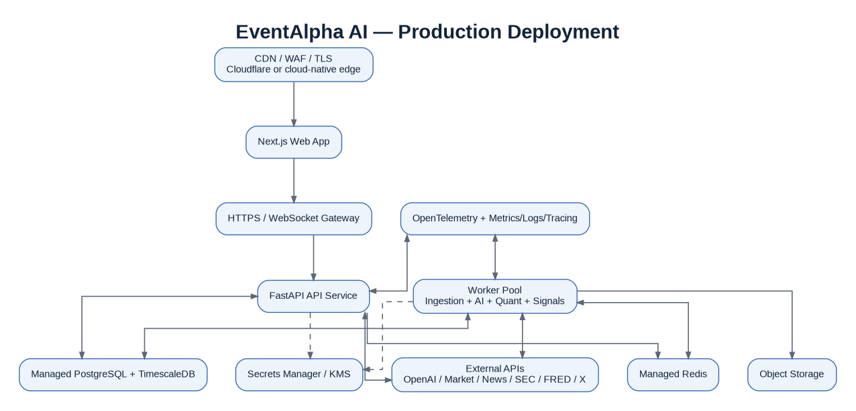
Production deployment

Security zones
- public edge: HTTPS only;
- web/API private application network where possible;
- databases not publicly exposed;
- egress restricted/observable;
- secrets from manager at runtime;
- least-privilege IAM/service accounts.

High availability path
MVP can run single instances with managed DB/Redis backups. Production target: - multiple API replicas; - worker replicas with consumer groups; - managed PostgreSQL HA; - Redis failover; - object storage versioning/lifecycle; - health checks and automatic restart; - documented recovery runbook.

11. Scaling plan

Stage A — MVP
Redis Streams + PostgreSQL/Timescale, 1-4 workers.

Stage B — validated product
Separate fast/batch queues, read replicas, autoscaling workers, stronger provider redundancy.

Stage C — high-volume multi-asset
Consider Redpanda/Kafka, ClickHouse for massive tick analytics, dedicated feature service and isolated execution service. Only adopt after profiling proves need.

12. Failure-mode design
Failure | Expected behavior
OpenAI timeout | retry bounded; fallback model/rule or mark analysis unavailable; no guessed action
Market feed stale | block actionable signal
News provider down | continue with remaining providers and lower source coverage
Redis restart | restore consumers; persist critical state in DB
DB unavailable | stop new actionable decisions; buffer only within safe bounded limits
Broker paper API down | stop order attempts; retain signal/evidence; reconcile later
Conflicting sources | escalate model or output HOLD/AVOID with conflict reason
Cost budget exceeded | disable nonessential/batch AI; preserve fast critical lane

Verified source references
The architecture deliberately uses provider adapters so vendors can be replaced. Capabilities and prices below were verified on 26 August 2026 and must be rechecked before production procurement.
- OpenAI, Responses API / Structured Outputs / streaming: https://developers.openai.com/api/reference/cli/resources/responses/methods/create
- OpenAI, GPT-5.6 Luna: https://developers.openai.com/api/docs/models/gpt-5.6-luna
- OpenAI, GPT-5.6 Terra: https://developers.openai.com/api/docs/models/gpt-5.6-terra
- OpenAI, GPT-5.6 Sol: https://developers.openai.com/api/docs/models/gpt-5.6-sol
- Alpaca, real-time market data WebSockets: https://docs.alpaca.markets/us/docs/real-time-stock-pricing-data
- Alpaca, paper trading: https://docs.alpaca.markets/us/v1.4.2/docs/paper-trading
- Databento, live market data API: https://databento.com/docs/api-reference-live
- SEC, EDGAR APIs: https://www.sec.gov/search-filings/edgar-application-programming-interfaces
- Federal Reserve Bank of St. Louis, FRED/ALFRED API: https://fred.stlouisfed.org/docs/api/fred/fred/fred.html
- X, Filtered Stream: https://docs.x.com/x-api/posts/filtered-stream/introduction
- GDELT, global event/news data: https://www.gdeltproject.org/data.html
- NewsAPI, Everything endpoint: https://newsapi.org/docs/endpoints/everything

