EventAlpha AI — Architecture Diagrams & Processing Flows
Project: EventAlpha AI
Document status: Target architecture / implementation specification
Reference date: 26 August 2026
Primary goal: low-latency, cloud-first trading decision support based on market data, global events, filings, macro data and social signals.
Safety principle: the system may generate probabilistic trading signals, but it must never claim guaranteed profitability. Live execution is disabled by default; the mandatory path is research → backtest → shadow → paper trading → explicit human approval.
This document is the visual companion to the architecture. Editable SVG and PNG versions are delivered in the diagrams/ folder.

1. System context
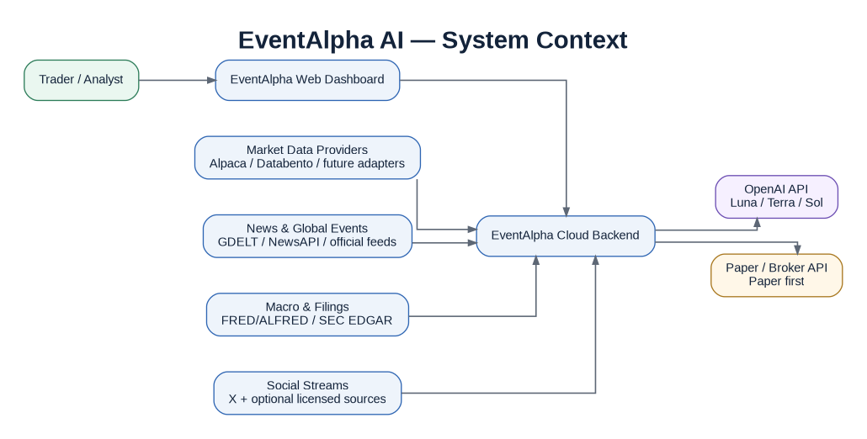
System context
Purpose: shows that EventAlpha is a cloud application that consumes external market/event sources and OpenAI; the trader interacts with EventAlpha, not directly with secret-bearing vendor APIs.

2. Logical architecture
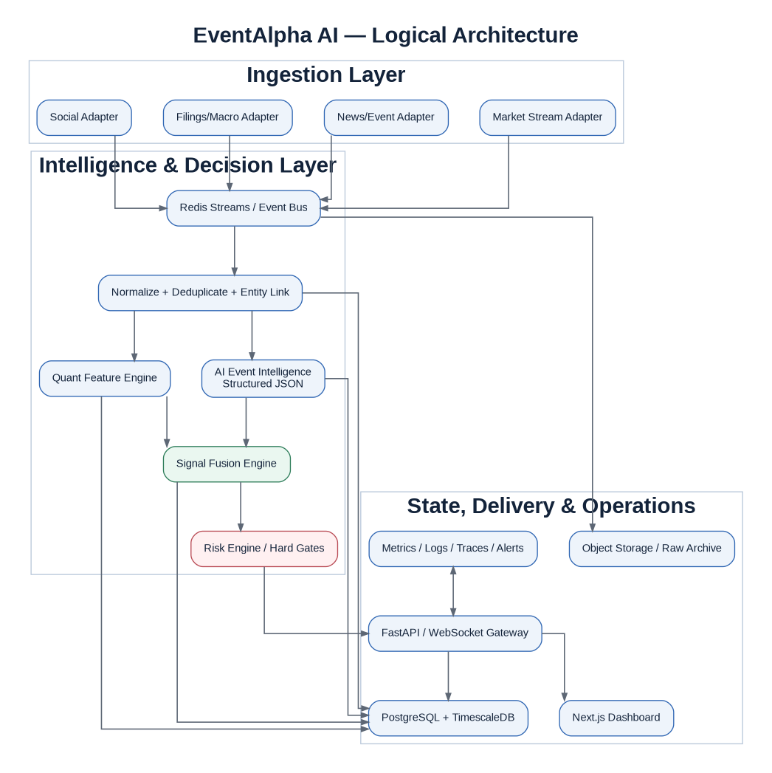
Logical architecture
Key rule: event ingestion, AI intelligence, quant features, fusion and risk are separate logical modules even if deployed together during MVP.

3. Event-to-signal pipeline
Event to signal
Key rule: the AI analysis is one input. The final published signal happens only after quantitative confirmation and deterministic risk checks.

4. OpenAI model router
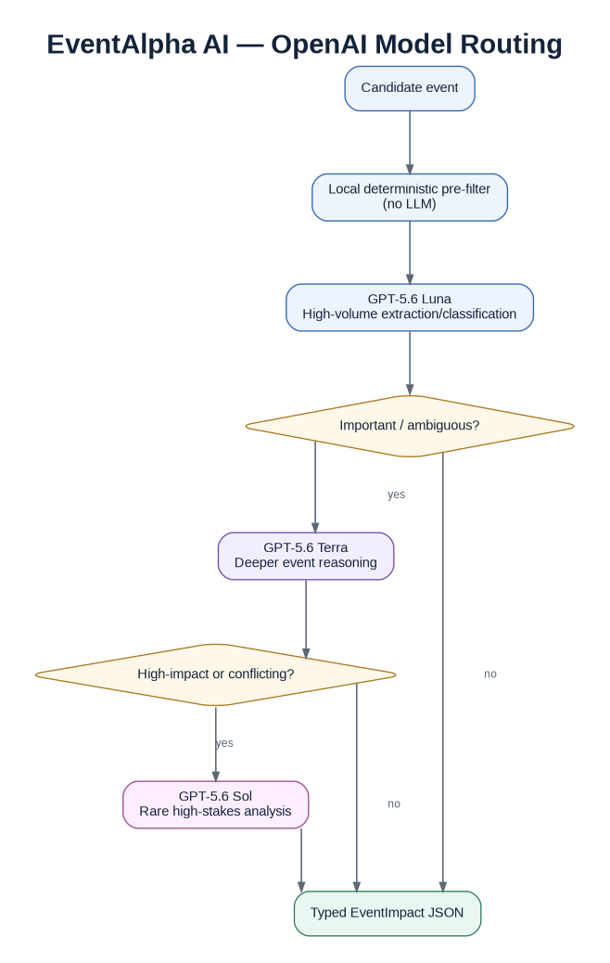
OpenAI model router
Key rule: Luna handles volume, Terra handles complexity, Sol handles rare escalations. This optimizes latency and cost.

5. Breaking-news sequence
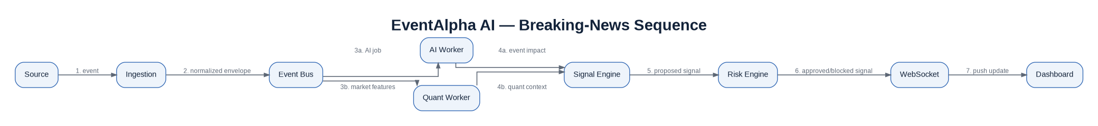
Realtime sequence
Key rule: AI and quant work can run concurrently after normalization. The UI receives only the approved/blocked decision after risk evaluation.

6. Production deployment
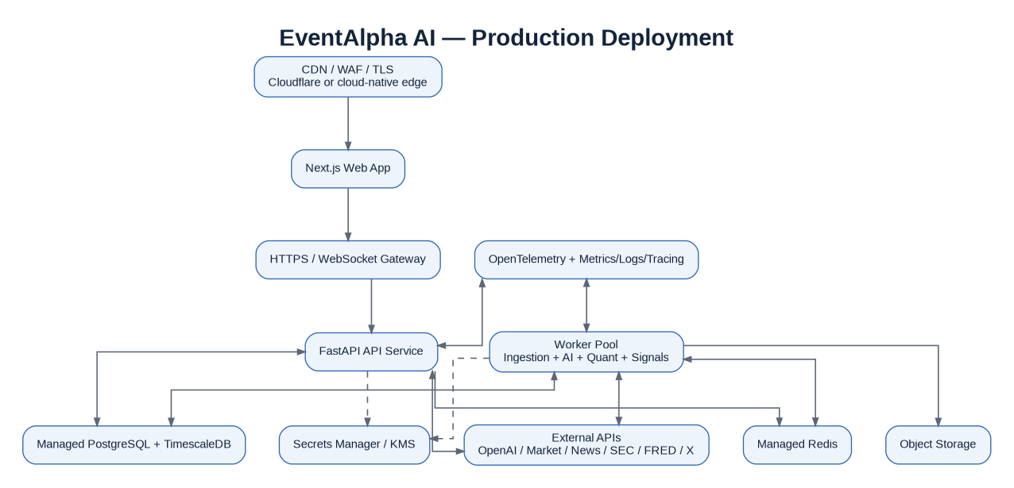
Production deployment
Key rule: secrets and databases are server-side. The public browser never contains OpenAI/broker credentials.

7. Core data model
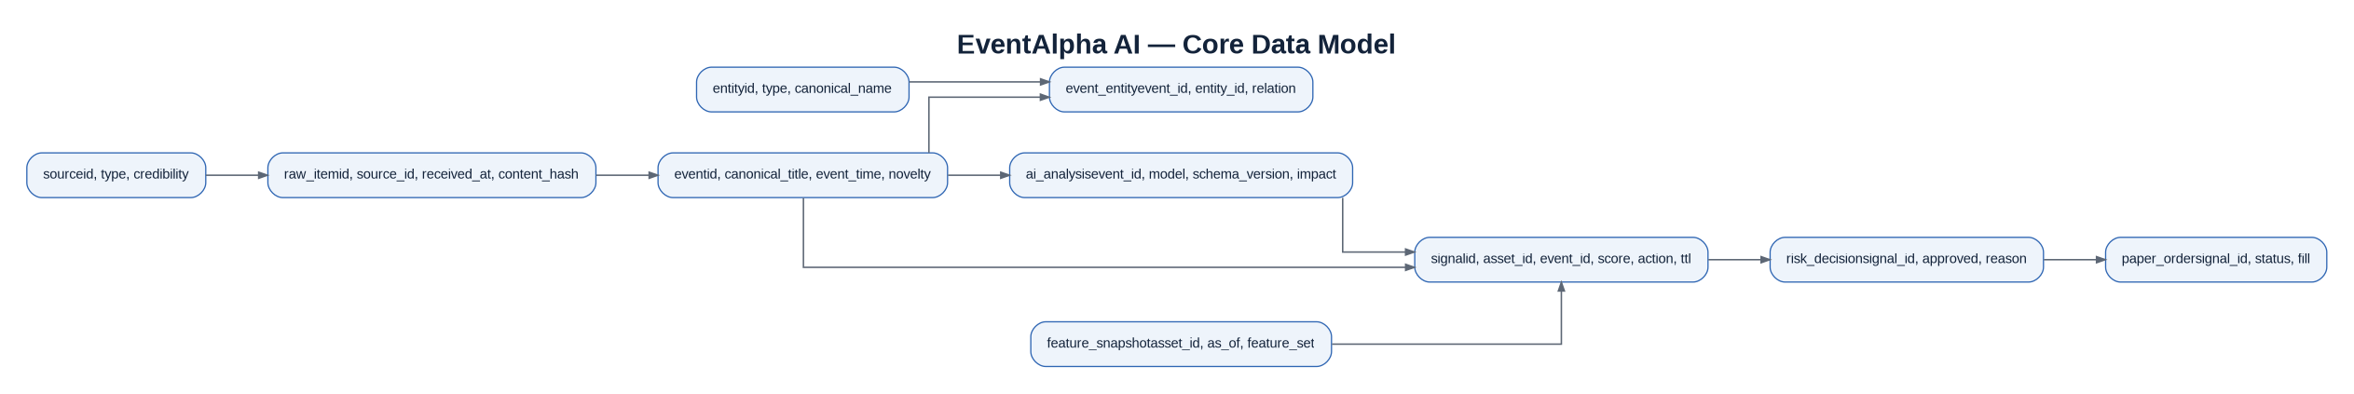
Core data model
Key rule: keep raw source → canonical event → analysis/features → signal → risk → paper execution traceable.

8. Strategy promotion gates
Promotion gates
Key rule: a strategy does not jump from a backtest to live money. It passes out-of-sample, shadow and paper stages first, followed by explicit review.

9. Diagram ownership
Keep diagrams version-controlled next to architecture docs. Any major change to a service boundary, data flow, security zone or strategy promotion process must update the corresponding diagram in the same pull request.

