PLANIT

Personal Finance Mobile App
Technical Architecture & Complete Diagram Blueprint
Companion to Product Specification v0.2 | Technical Blueprint v1.0
Purpose Define the implementation structure clearly enough to build the mobile app, backend, database, offline synchronization, financial workflows, analytics, security and deployment without inventing architecture during coding.

Source of truth Business behavior comes from Product Specification v0.2. This document refines implementation details where a concrete technical decision is required; it does not change the approved product intent.

Document map
Section | Contents
1 | Architecture principles and final technology stack
2 | System, container, mobile, backend and deployment diagrams
3 | Domain and database model
4 | Financial state models and critical workflows
5 | Offline synchronization, authentication and media
6 | Analytics and user-interface architecture
7 | API contract map, trust boundaries and idempotency
8 | Development environment, CI/CD and implementation order
9 | Database rules, endpoint responsibilities and test blueprint
10 | Build checklist and definition of done

How to use this document Build in dependency order. For each feature, use the matching workflow diagram, database tables, API responsibility and acceptance tests together. A screen mockup alone is never enough to define a financial operation.

1. Architecture principles and final technology stack
Principle | Implementation rule
Ledger first | Account balances are derived from opening balance plus posted ledger movements. Never “just update a balance” without a traceable movement.
Decimal-safe money | Backend uses Python Decimal and PostgreSQL NUMERIC(19,4). API money values are serialized as decimal strings. Mobile never uses binary double for financial arithmetic.
Atomic money writes | Transfer pairs, debt origination + cash movement, repayment + debt update, reconciliation + adjustment, and reallocation transfers succeed or fail together.
Idempotent mobile writes | Every high-risk write carries a client operation UUID and Idempotency-Key so network retries cannot duplicate money.
Offline-capable, server-authoritative | The mobile app is immediately usable from local SQLite, while PostgreSQL remains the authoritative synchronized financial history.
Modular monolith first | One FastAPI deployment with strong internal modules. Do not split into microservices until scale or team boundaries actually require it.
Private by default | Every data query is scoped to the authenticated user; media is private and served through short-lived signed URLs.
Derived analytics | Dashboards are computed from ledger/debt/item facts. Cached aggregates are disposable projections, never primary truth.

1.1 Recommended technology stack
Layer | Choice | Why | When
Mobile language/framework | Dart + Flutter | Single Android/iOS codebase and precise UI control. | MVP
State management | Riverpod | Explicit dependencies, testable state, good async handling. | MVP
Navigation | go_router | Declarative navigation and deep-link-ready route structure. | MVP
HTTP client | Dio | Interceptors for JWT, retry policy, idempotency headers and structured errors. | MVP
Local database | Drift on SQLite | Typed queries, migrations, streams and offline cache/outbox. | MVP
Model generation | Freezed + json_serializable | Immutable DTO/domain models and predictable JSON mapping. | MVP
Secure secrets | flutter_secure_storage | Backed by Android Keystore / iOS Keychain. | MVP
Charts | fl_chart | Native Flutter dashboard charts. | MVP
Images | image_picker + image compression package | Capture/select product, shop and receipt images. | MVP/Phase 2
Backend | Python + FastAPI | Typed modular API with automatic OpenAPI documentation. | MVP
Server validation | Pydantic | Request/response validation and explicit schemas. | MVP
ORM / SQL | SQLAlchemy | Transactions, relational mapping and custom reporting queries. | MVP
Migrations | Alembic | Versioned, reproducible PostgreSQL schema changes. | MVP
Database driver | asyncpg | Async PostgreSQL driver for FastAPI/SQLAlchemy. | MVP
Database | PostgreSQL | Strong constraints, NUMERIC money, transactional integrity, analytics SQL. | MVP
Media storage | S3-compatible storage; MinIO locally | Private scalable images without DB blobs. | MVP
Recurring jobs | Separate Python worker + APScheduler/platform scheduler | Processes due recurring rules with DB-backed duplicate protection. | Phase 2
Local infrastructure | Docker Compose | Reproducible PostgreSQL + MinIO + backend development services. | MVP
Testing | flutter_test + mocktail; pytest + API integration tests | Domain, UI, API and database regression coverage. | MVP
CI/CD | GitHub Actions or equivalent | Lint, tests, migrations, builds and staged deployment. | MVP
Observability | Structured logging; Sentry/OpenTelemetry optional | Crashes, traces and production diagnosis. | Harden

Money representation Server: NUMERIC(19,4) + Python Decimal. JSON: amount values as strings such as "100.00" with a separate ISO currency code. Mobile: Decimal/scaled-integer value object; SQLite may store a fixed 4-decimal scaled integer for arithmetic plus currency. Never calculate money using Dart double or Python float.

1.2 Project repository structure
Path | Responsibility
mobile/lib/core/ | money, errors, networking, routing, theme, auth, sync primitives
mobile/lib/features/accounts/ | accounts, balances, reallocation, reconciliation
mobile/lib/features/transactions/ | expense, income, transfer, refunds, activity
mobile/lib/features/debts/ | people, debts, repayments, shared expenses
mobile/lib/features/catalog/ | merchants, branches, products, categories, tags
mobile/lib/features/analytics/ | dashboard queries, filters and chart view models
mobile/lib/features/recurring/ + goals/ | subscriptions/rules and savings goals
backend/app/api/ | FastAPI routers and dependencies
backend/app/domain/ | entities, enums, money rules, pure business invariants
backend/app/services/ | application use cases / transaction boundaries
backend/app/repositories/ | persistence interfaces and SQLAlchemy implementations
backend/app/models/ | SQLAlchemy database models
backend/app/schemas/ | Pydantic API schemas
backend/app/analytics/ | read queries and KPI classification
backend/app/security/ | JWT, refresh sessions, password hashing, authorization
backend/app/media/ | object-storage adapter and signed URLs
backend/alembic/ | database migration history
backend/tests/ | unit, API and database integration tests
infra/ | Docker Compose, deployment definitions, environment templates
docs/ | product spec, this architecture blueprint, ADRs

2. System and application architecture diagrams
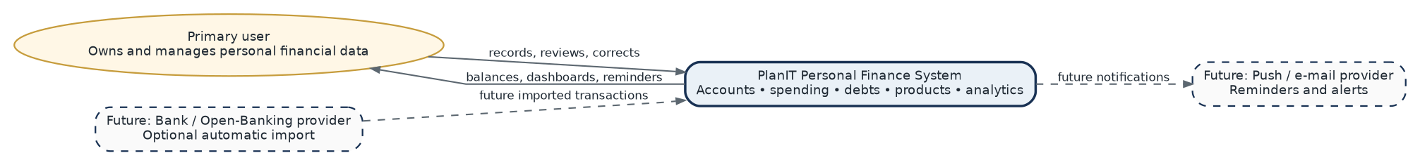
Diagram 1 - System context. Defines the user, PlanIT boundary and explicitly marks future external integrations as non-MVP.
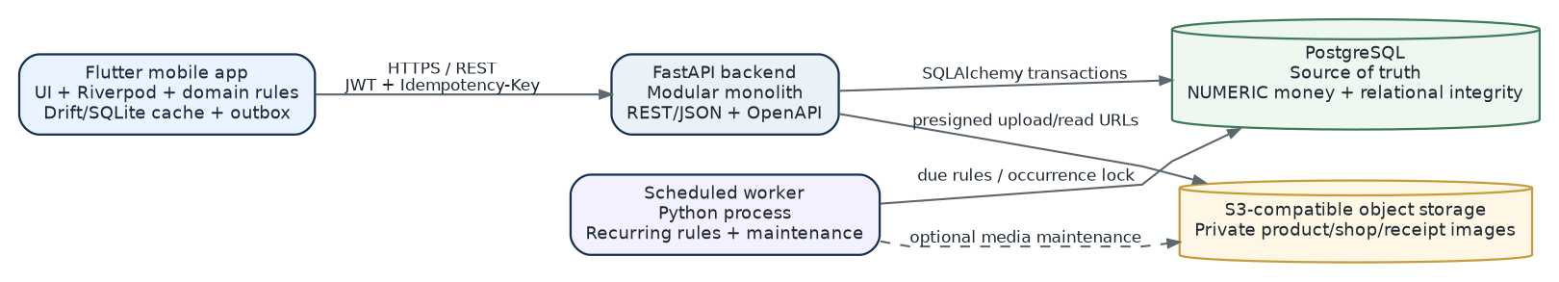
Diagram 2 - Container architecture. Shows runtime containers and authoritative data stores. The worker is a separate process but shares backend code/modules.

2.1 Mobile application architecture
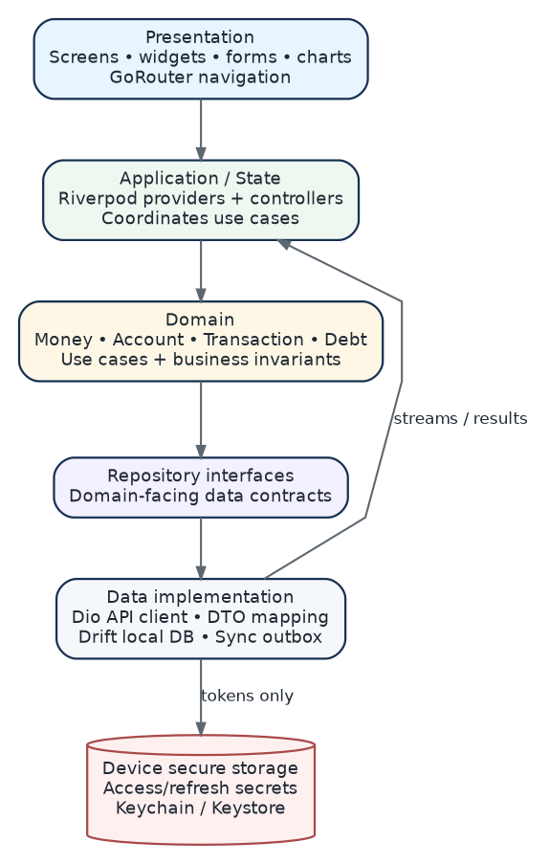
Diagram 3 - Flutter clean architecture. Dependencies point inward toward domain rules. UI never talks directly to SQL or HTTP.
Mobile rule A feature may read from local Drift immediately, but high-risk financial commits are represented as explicit operations and synchronized idempotently. Pending state must be visible to the user until server acknowledgment.

2.2 Backend modular-monolith architecture
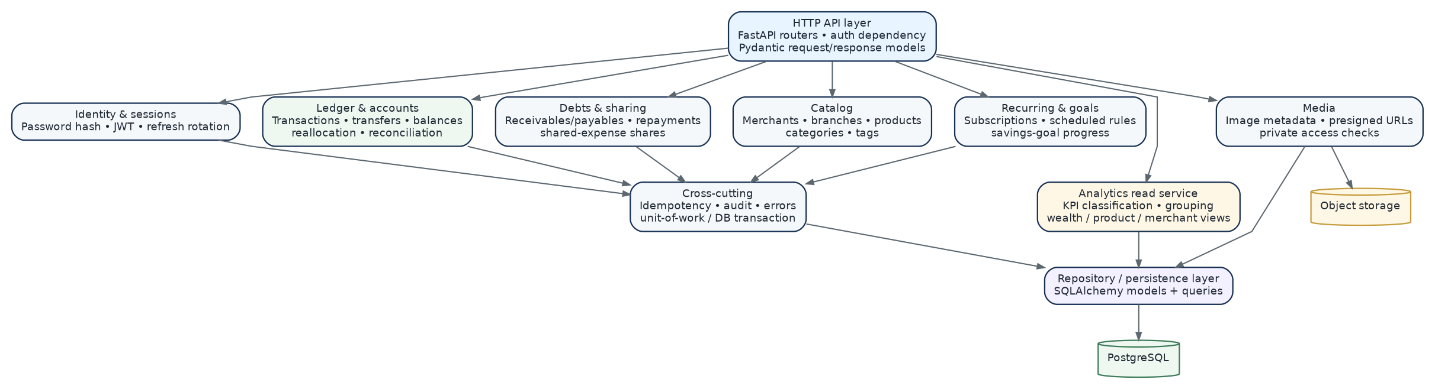
Diagram 4 - Backend modules. Logical modules live in one FastAPI application. Cross-module money writes use one unit-of-work/database transaction.

2.3 Production deployment
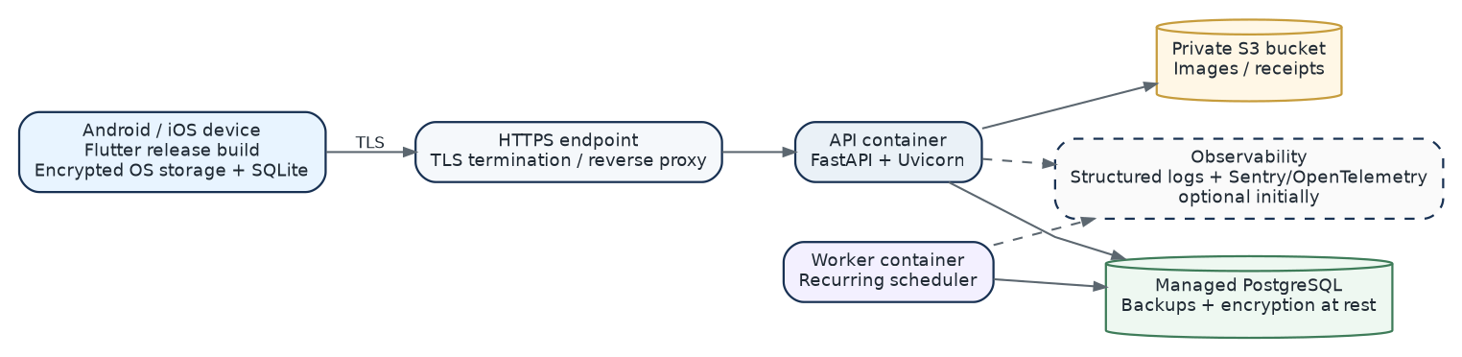
Diagram 5 - Deployment topology. Minimal production topology with mobile, API, worker, PostgreSQL and private object storage.
Scaling path Scale API containers horizontally first. Keep PostgreSQL authoritative. Add a read cache or queue only when measured load justifies it. Do not introduce Redis merely because architecture diagrams look more expensive with more cylinders.

3. Domain and database model
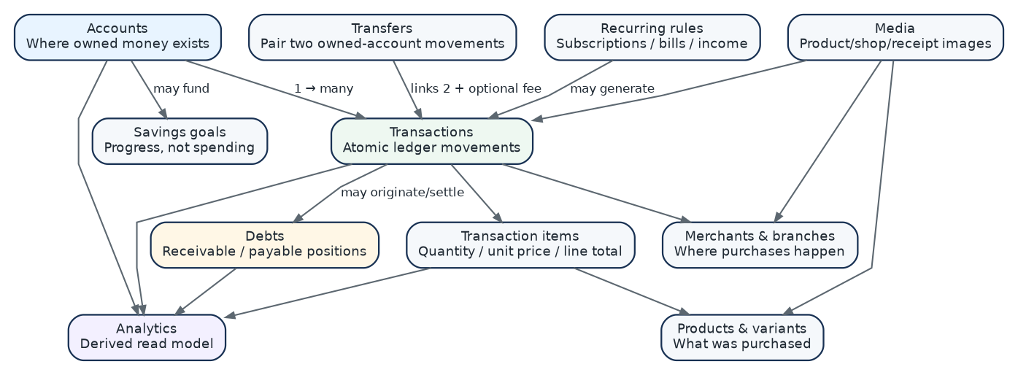
Diagram 6 - Domain relationship map. Shows the business domains before database implementation details.

3.1 Core ledger ERD
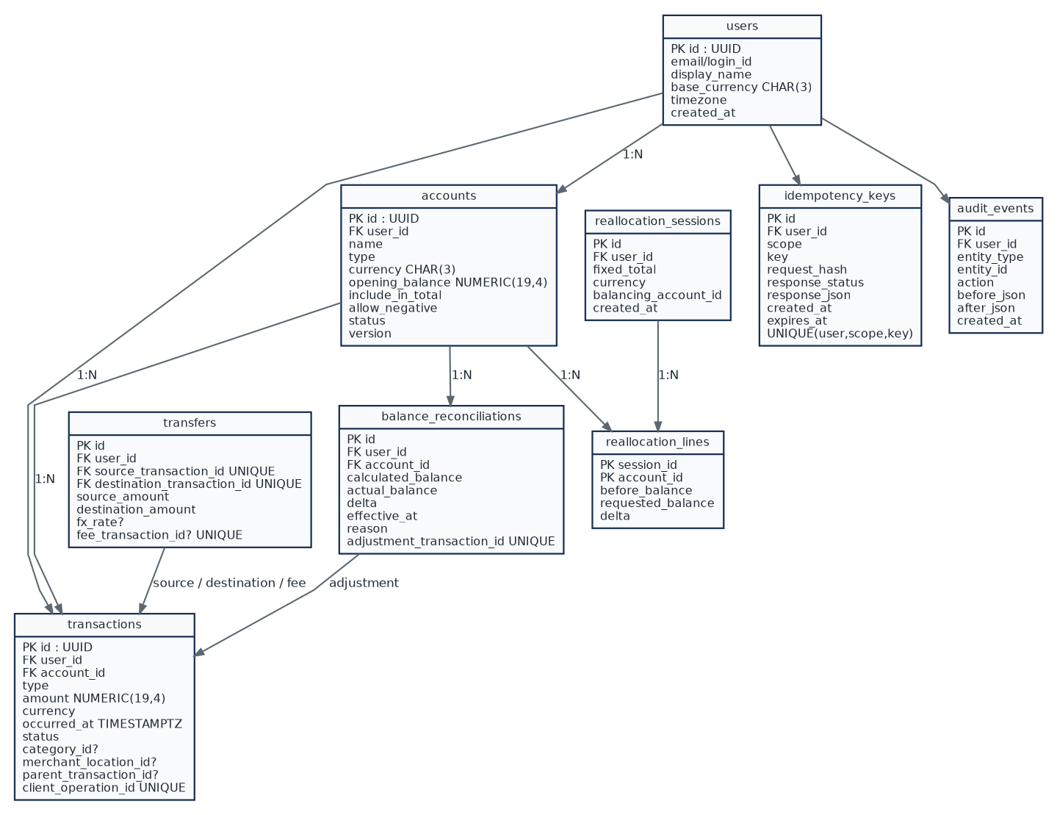
Diagram 7 - Core ledger ERD. The balance-critical tables: users, accounts, transactions, transfers, reconciliation, reallocation, idempotency and audit.

3.2 Merchant, product and media ERD
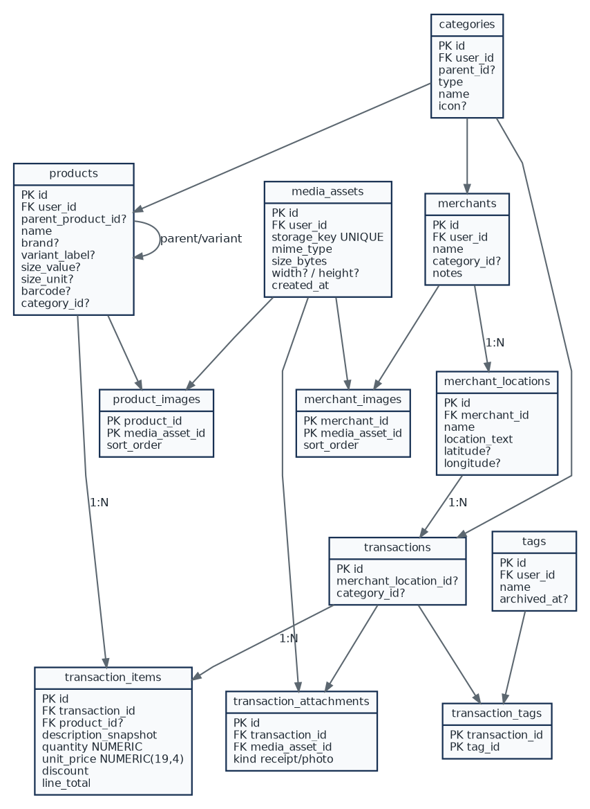
Diagram 8 - Catalog and purchase-detail ERD. Separates merchant brand from branch/location and product identity from transaction-line snapshots.

3.3 Debts and shared-expense ERD
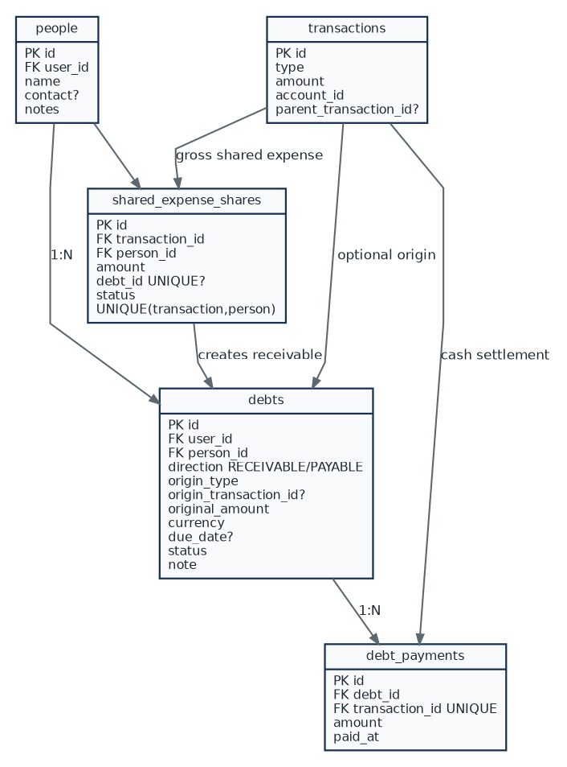
Diagram 9 - Debt ERD. Represents existing debts, lend/borrow cash movements, repayments and recoverable shared-expense portions.

3.4 Supporting tables ERD
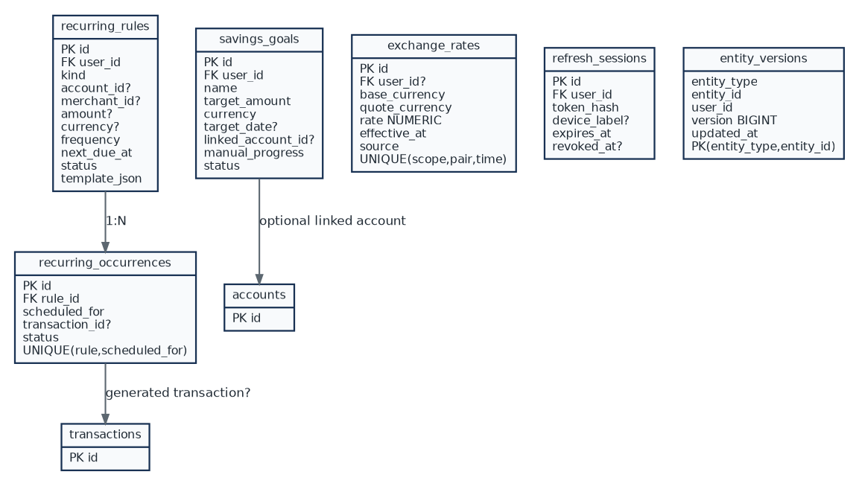
Diagram 10 - Supporting tables. Recurring-rule deduplication, goals, exchange rates, refresh sessions and entity versioning.

3.5 Database table responsibilities
Table/group | Responsibility
transactions | Single source of posted account movements. One row belongs to exactly one owned account.
transfers | Links source and destination ledger rows and an optional fee row; principal is analytics-neutral.
transaction_items | Product-level purchase lines; product analytics must aggregate from here, not from free-text notes.
debts + debt_payments | Position and settlement history. Remaining amount is derived from original amount minus valid payments.
shared_expense_shares | Defines recoverable portions of an expense and links them to receivable debts.
balance_reconciliations | Explains real-world balance corrections; exactly one generated adjustment transaction per reconciliation.
reallocation_sessions/lines | Audit of fixed-total edits; committed deltas become real internal transfer ledger rows.
recurring_occurrences | Unique execution key for each rule/date; prevents a scheduler restart from generating duplicates.
idempotency_keys | Stores request identity and canonical result for retry-safe write APIs.
audit_events | Traceability of important changes, especially reversals, reconciliations, account lifecycle and security-sensitive updates.
media_assets + link tables | Object metadata and relationships; binary files remain in object storage.
exchange_rates | Explicit rate history used when converting analytics or creating FX transfers.

3.6 Required database constraints and indexes
Rule | Constraint / enforcement
FK scope | All owned records reference the authenticated user directly or through an owner-scoped parent. Service queries never accept client-provided user_id as authority.
Money | NUMERIC(19,4); amount >= 0 where sign is represented by transaction type; rate > 0; quantity > 0.
Transfer | source_account != destination_account; source/destination ledger transaction IDs are unique; transfer pair created atomically.
Debt payment | payment > 0 and cannot exceed remaining balance unless an explicit overpayment feature is added.
Refund | sum(valid refunds) <= original refundable amount; parent transaction belongs to same user.
Shared expense | share > 0; total shares <= eligible original expense amount; unique person per transaction unless explicit multi-share rows are required.
Reconciliation | adjustment_transaction_id UNIQUE NOT NULL after commit; delta = actual_balance - calculated_balance.
Closed account | Backend rejects new POSTED transactions for CLOSED accounts.
Recurring occurrence | UNIQUE(rule_id, scheduled_for).
Idempotency | UNIQUE(user_id, scope, key); same key with different request hash returns conflict.
Transaction item | line_total = quantity * unit_price - discount according to one documented rounding policy.
Deletion | Posted financial rows are reversed, not hard-deleted. Hard deletion is limited to safe drafts or account-wide privacy deletion workflows.

Table | Indexes
transactions | (user_id, occurred_at DESC); (account_id, occurred_at DESC); (merchant_location_id, occurred_at DESC); (category_id, occurred_at DESC)
transaction_items | (product_id, transaction_id); (transaction_id)
debts | (user_id, status, due_date); (person_id, status)
recurring_rules | (user_id, status, next_due_at)
audit_events | (user_id, entity_type, entity_id, created_at DESC)
merchant_locations | (merchant_id); optional normalized-name index for search
products | (user_id, normalized name/brand); barcode where not null
idempotency_keys | UNIQUE(user_id, scope, key); expiry index for cleanup

4. Financial state models and critical workflows
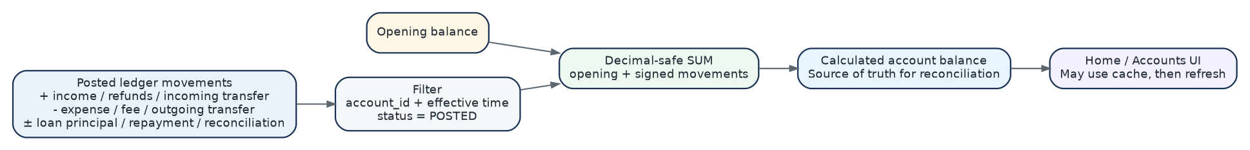
Diagram 11 - Account balance calculation. Defines the source-of-truth balance path used by Accounts, Home and reconciliation.

4.1 Transaction classification matrix
Transaction type | Account effect | Spending KPI | Income KPI | Meaning
EXPENSE | - | Yes | No | Normal purchase/service spending.
INCOME | + | No | Yes | Normal earned/received income.
TRANSFER_OUT | - | No | No | Owned-account principal movement.
TRANSFER_IN | + | No | No | Owned-account principal movement.
TRANSFER_FEE | - | Yes | No | Fee is real spending.
REFUND | + | Reduces spending | No | Linked to original expense.
LOAN_PRINCIPAL_OUT | - | No | No | Cash lent; creates receivable.
LOAN_PRINCIPAL_IN | + | No | No | Cash borrowed; creates payable.
DEBT_REPAYMENT_IN | + | No | No | Receivable settlement.
DEBT_REPAYMENT_OUT | - | No | No | Payable settlement.
RECONCILIATION_ADJUSTMENT | +/- | No | No | Correction shown separately.
REVERSAL | inverse | Inverse original classification | Inverse as appropriate | Linked correction entry; original is retained.

4.2 State machines
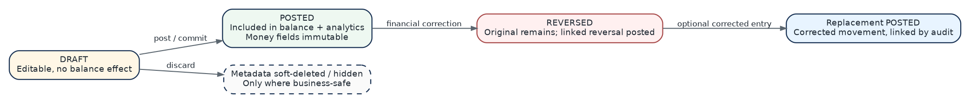
Diagram 12 - Transaction state machine. Posted financial history is corrected through explicit reversal/replacement instead of silent mutation.
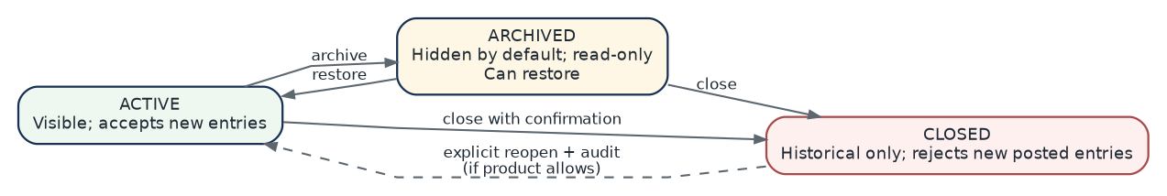
Diagram 13 - Account lifecycle. Archived is reversible hiding/read-only behavior; closed accounts reject new financial postings.

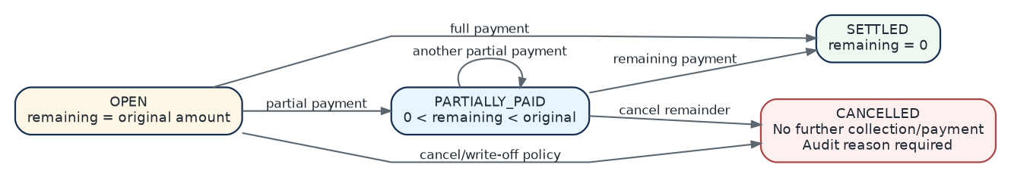
Diagram 14 - Debt lifecycle. Debt status is a deterministic consequence of payment history plus an explicit cancellation/write-off action.

4.3 Expense with merchant, products and receipt
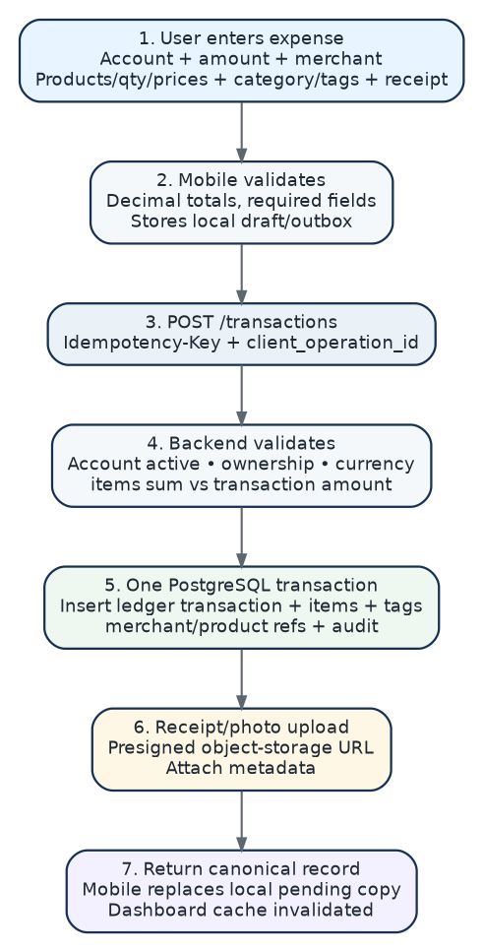
Diagram 15 - Expense workflow. The complete path from mobile entry to ledger/items/media and refreshed analytics.

4.4 Transfer, fee and currency conversion
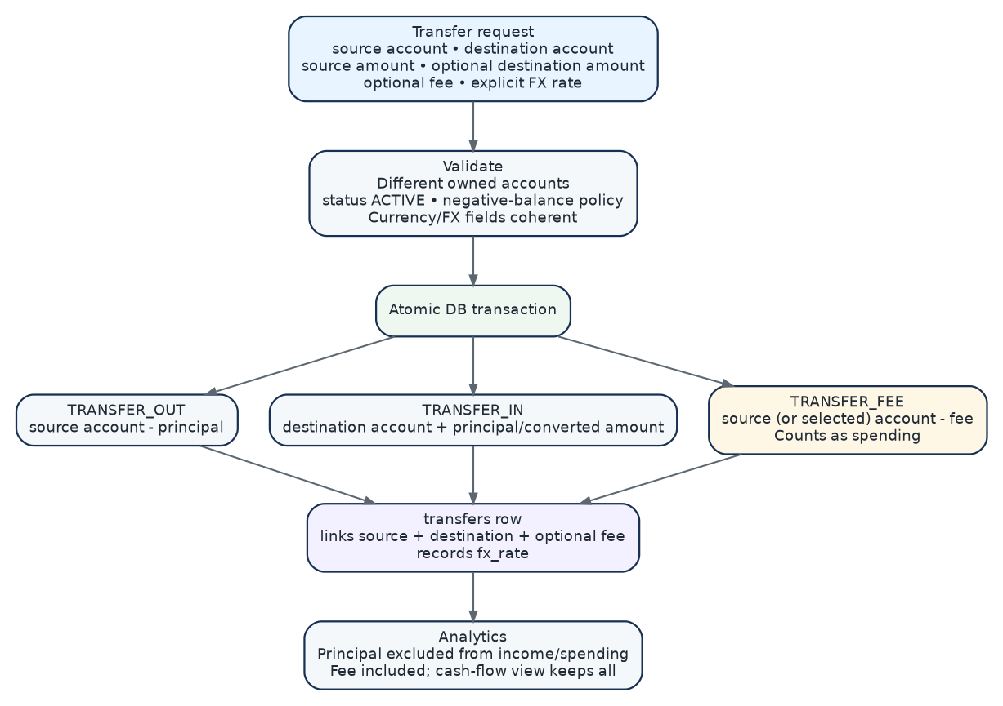
Diagram 16 - Transfer workflow. Principal movements are linked and neutral to spending; fees are separate expense movements. Cross-currency transfers record explicit source/destination amounts and rate.
FX rule Never infer a hidden currency conversion merely because two accounts use different currencies. The user or imported bank data must provide the destination amount/rate. Store the rate used by the transaction so historical reporting remains reproducible.

4.5 Keep Total Fixed reallocation
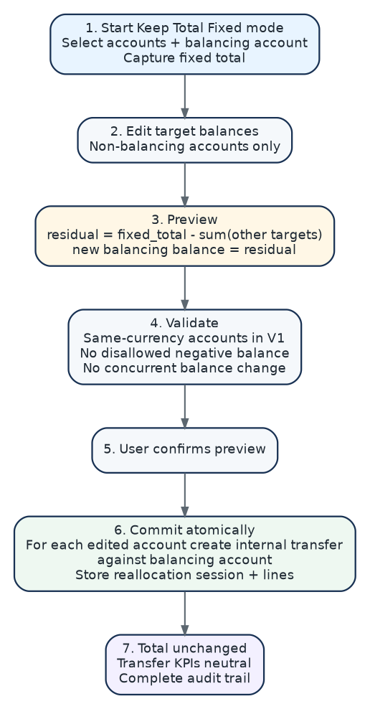
Diagram 17 - Reallocation workflow. Turns target balances into traceable internal transfers while preserving the captured total.
V1 safety decision Keep Total Fixed should initially operate only across accounts in the same currency. Multi-currency reallocation must be a separate explicit FX operation because otherwise the app would silently invent exchange trades.

4.6 Balance reconciliation
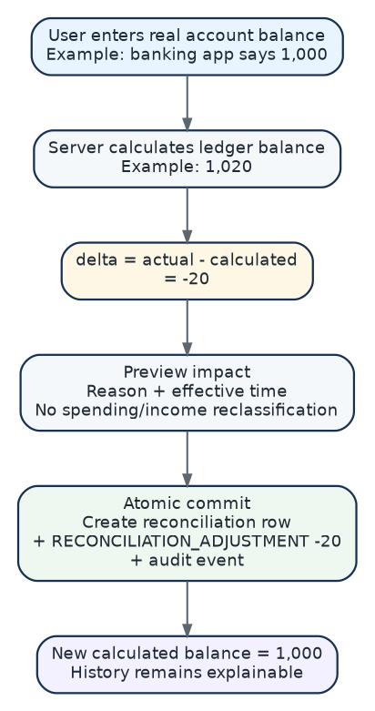
Diagram 18 - Reconciliation workflow. Corrects the ledger to a known real balance without pretending the difference was normal spending or income.

4.7 Debt creation modes
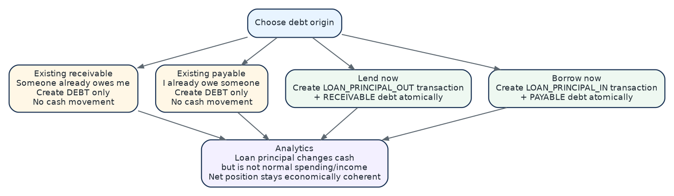
Diagram 19 - Debt origination. Separates historical debt recording from lending or borrowing money now.

4.8 Debt repayment
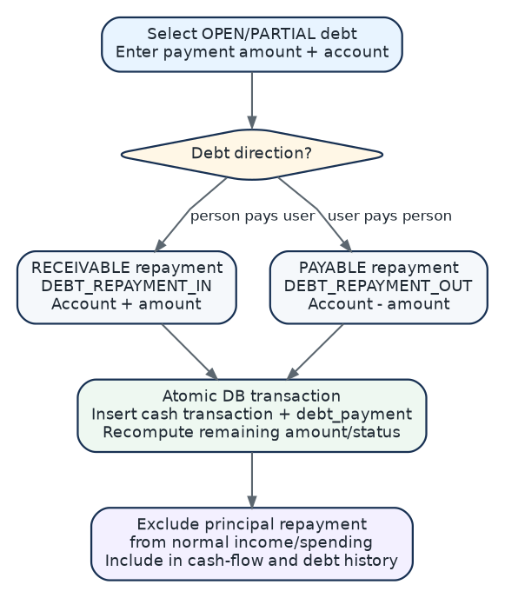
Diagram 20 - Debt repayment. Updates cash and debt position atomically while excluding principal settlement from normal income/spending KPIs.

4.9 Shared expense and reimbursement
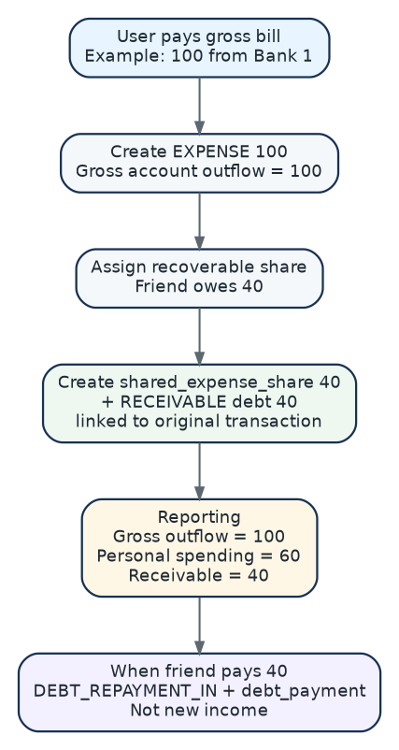
Diagram 21 - Shared-expense workflow. Preserves the gross account outflow while showing the user’s personal portion and receivable separately.

4.10 Refund / return
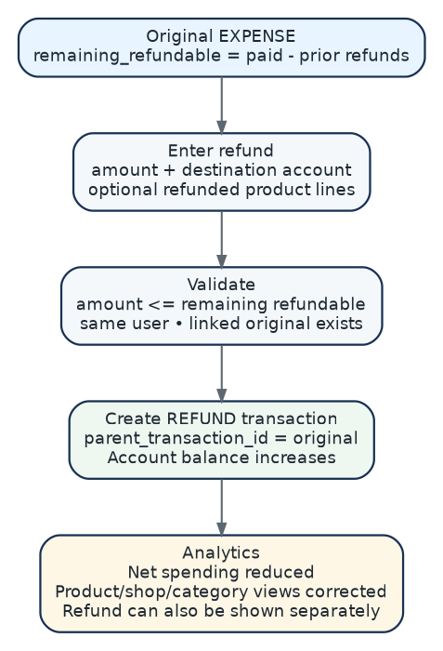
Diagram 22 - Refund workflow. Links refunds to the original purchase so balances and merchant/product/category analytics all reconcile.

4.11 Recurring commitments
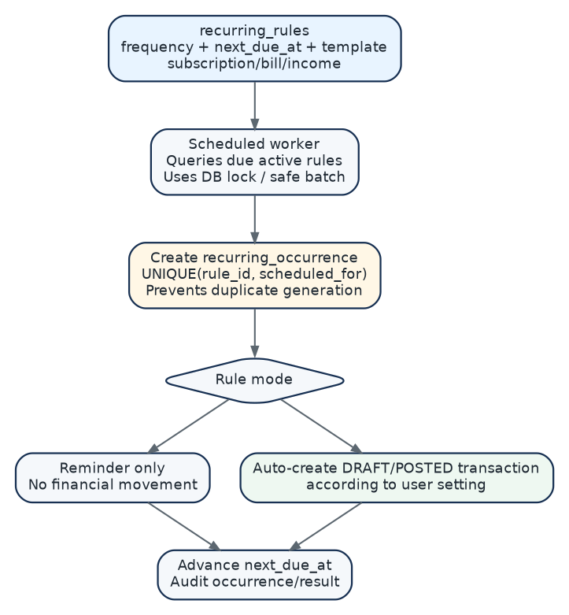
Diagram 23 - Recurring-rule execution. Uses a unique occurrence key so background retries cannot duplicate a monthly subscription or bill.

5. Offline synchronization, media and authentication
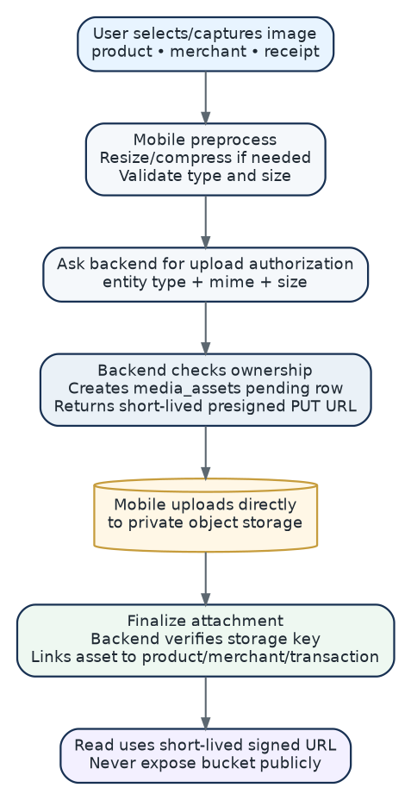
Diagram 24 - Private media upload. Uploads files directly to object storage while the backend controls authorization and database links.

5.1 Offline outbox synchronization
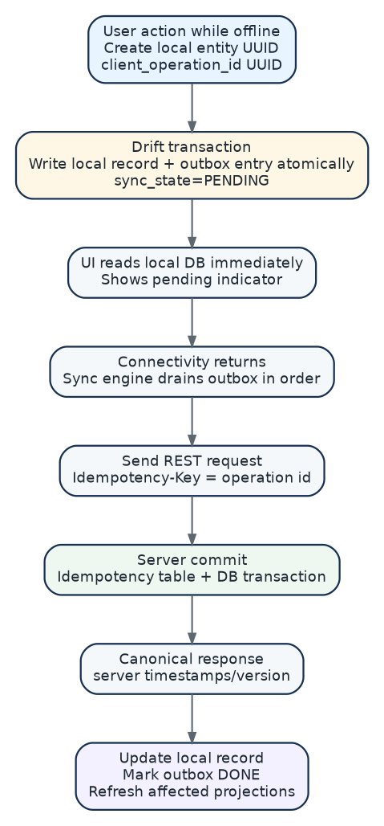
Diagram 25 - Offline write synchronization. Local SQLite gives immediate UX; the outbox and idempotency key give exactly-once business effect under retries.

5.2 Conflict policy
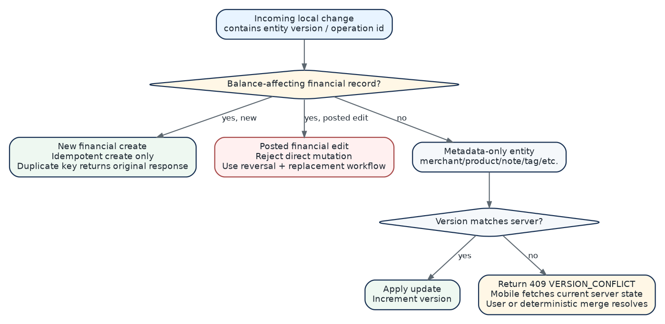
Diagram 26 - Conflict resolution. Financial history gets stricter conflict handling than metadata such as names, tags or pictures.
Conflict | Policy | Result
Create high-risk financial operation | Retry with same Idempotency-Key | Server returns original canonical response; no duplicate.
Edit POSTED amount/account/type | Do not overwrite | Use reversal + replacement with audit link.
Edit metadata with matching version | Apply | Increment version and updated_at.
Edit metadata with stale version | 409 conflict | Fetch server state; user/deterministic merge then retry.
Delete local record already posted server-side | Do not hard-delete | Request reversal/archive/cancel according to entity type.
Image upload interrupted | Retry media operation | Unattached pending media may be cleaned up later.

5.3 Authentication and session flow
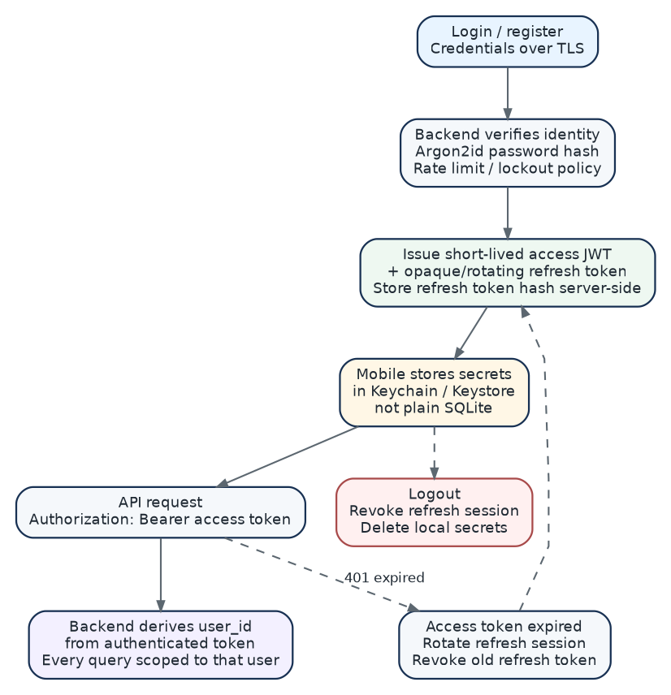
Diagram 27 - Authentication flow. Uses short access tokens, rotating refresh sessions and server-derived user ownership.
Area | Rule
Passwords | Argon2id hash; never store plaintext. Add rate limiting and generic login errors.
JWT | Short lifetime access token. Minimal claims: subject/user ID, session ID, issued/expiry timestamps.
Refresh token | Opaque random token; server stores only hash; rotate on refresh; revoke on logout/compromise.
Device storage | Only secure OS storage for tokens. SQLite stores application data, not reusable plaintext secrets.
Authorization | Every service/repository call receives authenticated user context; ignore any client user_id ownership claim.
Transport | HTTPS/TLS only outside local development.
Media | Private bucket. Short-lived signed upload/read URLs after ownership check.
Logs | Never log passwords, refresh tokens, full authorization headers or sensitive receipt content by default.

6. Analytics and user-interface architecture
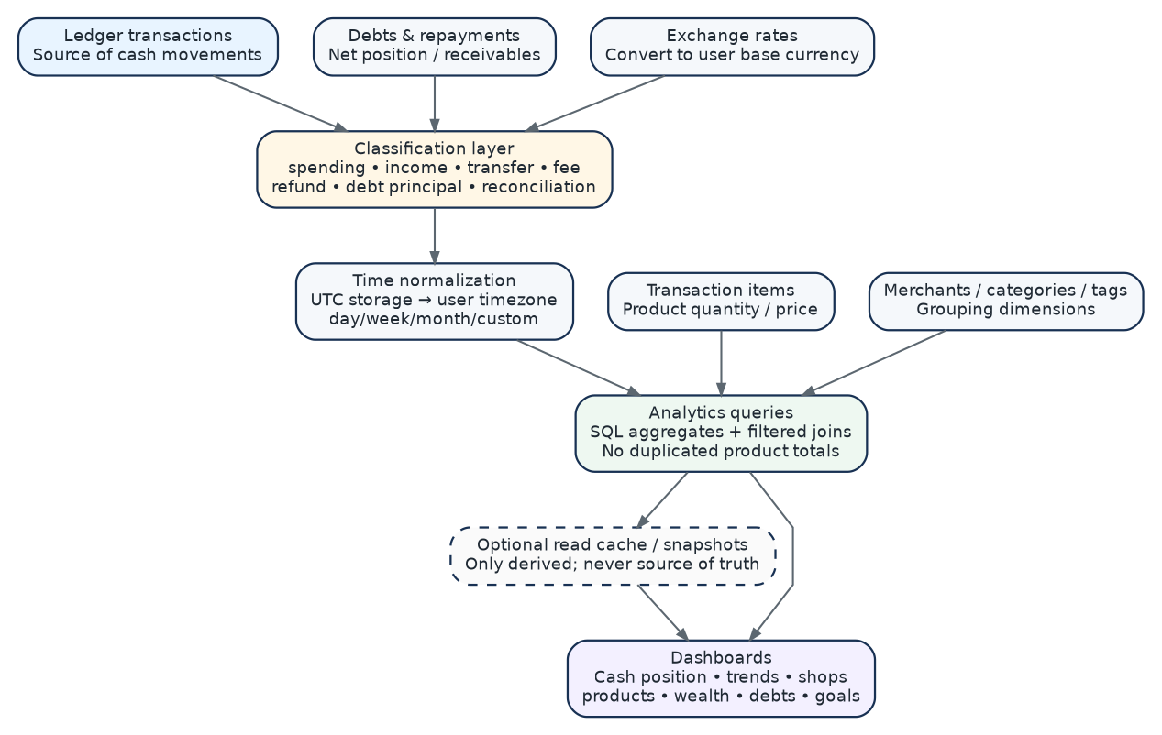
Diagram 28 - Analytics data pipeline. Shows how raw ledger facts become trustworthy period, merchant, product and wealth dashboards.

6.1 Dashboard dependencies
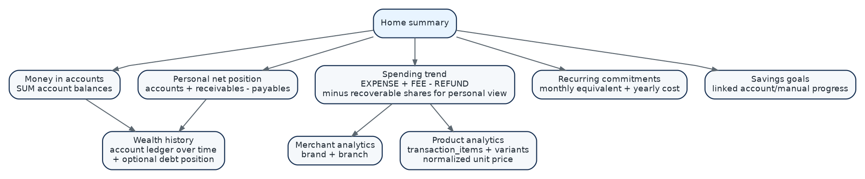
Diagram 29 - Dashboard dependency map. Prevents each screen from inventing a different total formula.

6.2 Required dashboard calculations
Metric | Authoritative formula / source
Money in accounts | Sum calculated balances for active/selected include_in_total accounts, converted to base currency using explicit rate policy.
Personal net position | Money in accounts + open receivables - open payables.
Gross spending | Eligible EXPENSE + TRANSFER_FEE movements, before recoverable shared-expense subtraction, minus linked refunds as configured.
Personal spending | Gross spending - recoverable shared-expense shares - linked refunds.
Income | Eligible INCOME only; borrowing and debt repayments are excluded.
Cash flow | All signed account movements, including transfers and debt principal, grouped separately by classification.
Merchant spending | Transactions joined through merchant_location → merchant; allow brand or branch grouping.
Product spending | transaction_items grouped by product/variant; line totals drive product totals.
Normalized unit price | line effective price divided by normalized quantity only when units are compatible.
Wealth history | Reconstruct account balances at period boundaries from ledger; optionally add debt position for net-position history.
Recurring monthly equivalent | Normalize weekly/monthly/annual commitments to a comparable monthly and yearly cost.
Savings goal progress | Linked-account balance or manual progress; goal allocation does not become spending unless backed by a true expense.

6.3 Screen navigation
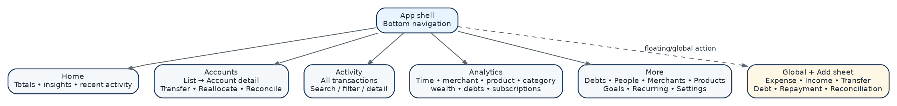
Diagram 30 - Screen navigation. Recommended information architecture for the first clean mobile implementation.

6.4 Global Add flow
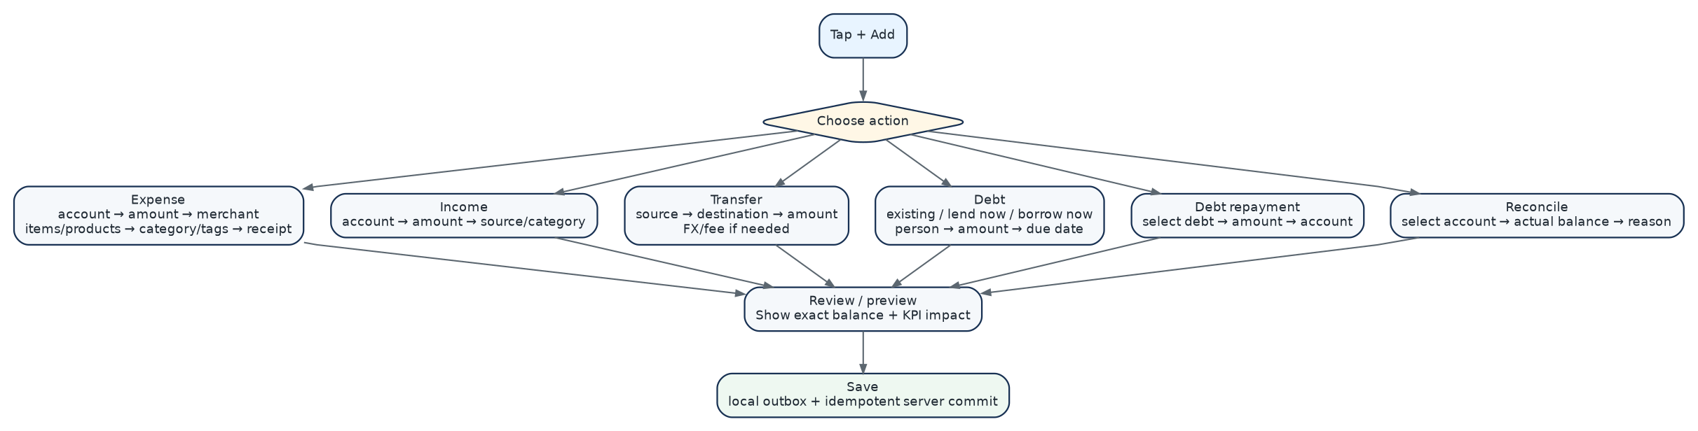
Diagram 31 - Add-action decision flow. Keeps financial operations distinct while reusing one entry shell and a common review/preview step.

7. API contract map, trust boundaries and idempotency
Diagram 32 - API surface map. Groups endpoints by domain. Routers delegate to services; they do not contain money calculations themselves.

7.1 Endpoint responsibilities
Endpoint/group | Responsibility
POST /auth/register | Create identity; hash password; create initial session.
POST /auth/login, /refresh, /logout | Issue/rotate/revoke sessions.
GET/POST/PATCH /accounts | Account metadata/lifecycle; balance is returned from ledger calculation/projection.
POST /transactions | Expense/income/cash movements that are not specialized flows; supports items/tags references.
POST /transactions/{id}/refund | Validate refundable remainder and create linked REFUND.
POST /transactions/{id}/reverse | Create reversal; never delete posted movement.
POST /transfers/preview + /commit | Validate owned accounts, fees/FX and atomically create linked ledger rows.
POST /reallocations/preview + /commit | Calculate fixed-total residual, verify stale balances and create internal transfers + audit session.
POST /reconciliations/preview + /commit | Calculate ledger balance/delta, then create adjustment + reconciliation atomically.
POST /debts | Record existing debt or originate lend-now/borrow-now based on explicit origin_type.
POST /debts/{id}/payments | Create settlement cash movement + debt payment atomically.
CRUD /merchants /products /categories /tags /people | User-scoped catalog and metadata.
GET /analytics/... | Read-only, filtered aggregate endpoints using centralized classification rules.
POST /media/uploads + /finalize | Authorize signed upload and attach verified object to an entity.
CRUD /recurring + /goals | Manage recurring templates and savings targets.

7.2 Trust boundaries
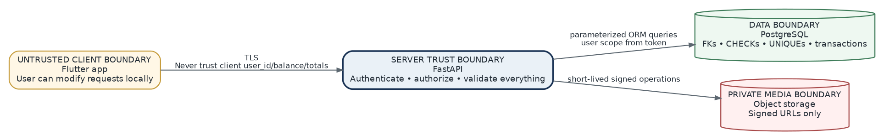
Diagram 33 - Trust boundaries. The server validates every financial fact; client-calculated balances and user IDs are display/input hints, never authority.

7.3 Retry safety and audit
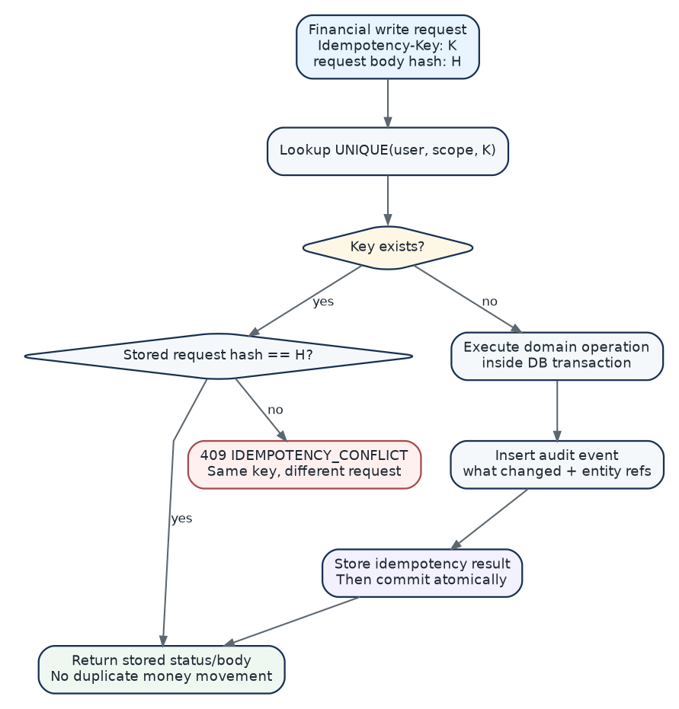
Diagram 34 - Idempotency and audit flow. Guarantees that retrying the same operation returns the same business result instead of performing it twice.

7.4 API error contract
Code | Meaning | Client behavior
ACCOUNT_CLOSED | Attempt to post a new financial movement to a closed account. | User chooses another account or explicitly reopens according to policy.
NEGATIVE_BALANCE_NOT_ALLOWED | Operation would take an account below allowed balance. | Change amount/source account or enable negative balance if allowed.
CURRENCY_MISMATCH | Operation requires explicit FX data or unsupported mixed currency. | Provide destination amount/rate or use same-currency workflow.
REFUND_EXCEEDS_REMAINING | Requested refund is greater than unrefunded original amount. | Show refundable maximum.
DEBT_OVERPAYMENT | Payment exceeds remaining debt. | Clamp/show remaining amount; no silent overpayment.
VERSION_CONFLICT | Metadata entity changed since local version. | Refresh/merge and retry.
IDEMPOTENCY_CONFLICT | Same idempotency key reused with a different payload. | Generate a new operation ID only for a genuinely new operation.
STALE_BALANCE | Reallocation/reconciliation preview used balances that changed before commit. | Refresh preview and reconfirm.
INVALID_LINE_TOTAL | Product lines and declared transaction total violate tolerance/rounding rule. | Correct quantities, prices, discounts or total.
UNAUTHORIZED_ENTITY | Referenced object does not belong to authenticated user. | Do not reveal whether another user’s object exists.

8. Development environment, CI/CD and implementation order
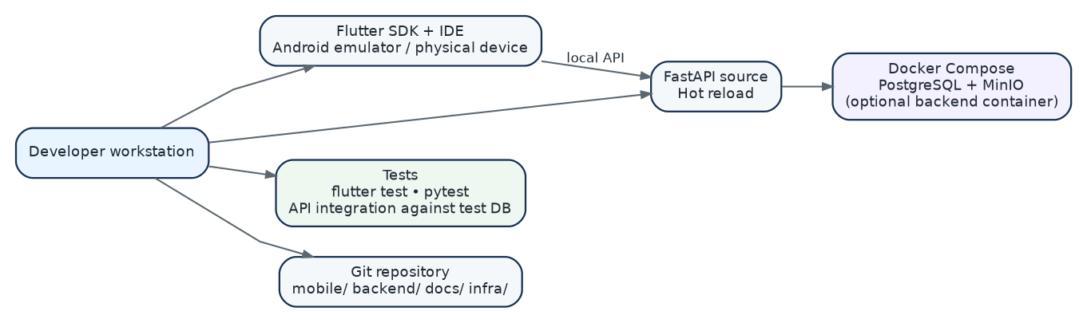
Diagram 35 - Local development topology. Keeps mobile, backend, PostgreSQL and object storage reproducible on one workstation.

8.1 Environment configuration
Environment | Rules
Local | Flutter emulator/device → local FastAPI; PostgreSQL + MinIO in Docker Compose; test credentials only.
Test/CI | Ephemeral PostgreSQL; fake/private media adapter where possible; migrations applied from zero before integration tests.
Staging | Production-like managed database/storage with synthetic data; mobile staging API URL; migration and smoke-test gate.
Production | Separate secrets, database, bucket and API hostname; protected deployment; automated backups and restore procedure.

8.2 CI/CD pipeline
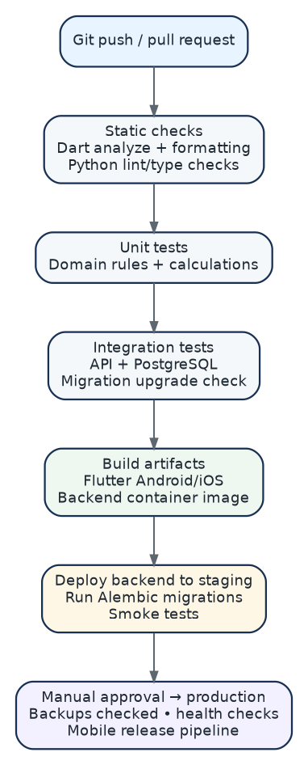
Diagram 36 - CI/CD pipeline. A database migration check is part of CI; deployment is not simply “works on my laptop, ship it.”

8.3 Recommended implementation dependency order
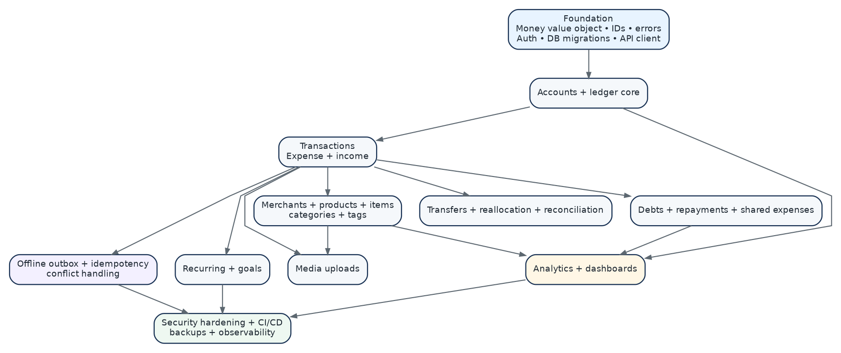
Diagram 37 - Implementation dependency map. Builds the ledger foundation before analytics and automation so every later feature rests on stable semantics.

9. Test blueprint
Testing philosophy Financial correctness is mostly domain and database correctness, not screenshot correctness. Every money rule should have unit tests plus at least one API/database integration test. Mobile UI tests verify that the right operation is formed and the right result/error is shown.

Area | Test level | Minimum verification
Money arithmetic | Unit | Decimal addition/subtraction, scale, rounding, currency mismatch rejection.
Account balance | Unit + DB | Opening balance + every transaction type; status/time filters.
Transfer atomicity | DB integration | No half-transfer if destination/fee insert fails.
Transfer KPI neutrality | Analytics integration | Principal excluded from spending/income; fee included.
Reallocation | Unit + DB | Residual math; balancing account; stale balance rejection; total unchanged.
Reconciliation | Unit + DB | delta = actual - calculated; exactly one adjustment; KPI exclusion.
Debt origination | DB integration | Existing debt no cash; lend/borrow create linked cash movement atomically.
Debt repayment | DB integration | Partial/full status; overpayment rejection; KPI exclusion.
Shared expense | Analytics integration | Gross outflow vs personal spending vs receivable.
Refund | DB + analytics | Remaining refundable cap and corrected merchant/product/category totals.
Products | Unit + DB | Variant identity, item totals, normalized price only for compatible units.
Recurring worker | Integration | Unique occurrence prevents duplicate generation after retry/restart.
Idempotency | API integration | Same key/body repeats same response; same key/different body -> conflict.
Offline outbox | Mobile unit/integration | Pending → retry → acknowledged; no duplicate operation IDs.
Authorization | API integration | Cross-user entity references rejected without information leakage.
Account lifecycle | API integration | Closed account posting rejected; history remains readable.
Media security | API integration | Unsigned/private objects inaccessible; signed URLs limited and ownership checked.
Migrations | CI integration | Fresh upgrade to head and upgrade from previous release schema.
Analytics timezone | Unit/integration | Day/week/month grouping honors user timezone around UTC boundary.
Multi-currency | Unit/integration | Stored FX rate reproduces historical conversion; no implicit mixed-currency reallocation.

9.1 Definition of done for a financial feature
- Business rule is represented by a domain use case, not embedded only in a UI widget.
- Database write is atomic and has explicit constraints/unique keys for the critical invariants.
- High-risk write supports Idempotency-Key and a client operation UUID.
- Authorization scope comes from the authenticated user context.
- Posted history is reversible/auditable rather than silently destructively edited.
- Offline state and server acknowledgment behavior are defined.
- Analytics classification is explicitly defined: spending, income, transfer, debt principal, refund, fee or reconciliation.
- Unit tests cover math and invariants; API/database test covers transaction behavior.
- Mobile displays validation errors and pending/success states without inventing a balance.
- Migrations, API schema and local Drift schema are updated together.
- No financial computation uses float/double.
- Documentation diagram/table is updated if the behavior or data relationship changed.

10. Build checklist and immutable decisions
Decision | Locked technical direction
Architecture | Flutter mobile + FastAPI modular monolith + PostgreSQL + S3-compatible media storage.
Offline | Drift/SQLite cache with an outbox. PostgreSQL remains authoritative.
Money | NUMERIC(19,4)/Decimal; decimal strings over JSON; no floating point.
IDs | UUID entity IDs and client_operation_id UUIDs; client-generated IDs allow offline creation.
Time | Store TIMESTAMPTZ/UTC; group and display using user timezone.
Ledger | Balances derive from posted transactions; corrections create explicit movements.
Transfers | Two linked account movements + optional separate fee; principal excluded from spending/income.
Reallocation | Committed as internal transfers; same-currency only for V1.
Reconciliation | Creates adjustment transaction and audit record; excluded from normal spending/income.
Debts | Existing debt can have no cash movement; lend/borrow now must create cash movement + debt atomically.
Shared expenses | Gross cash outflow retained; recoverable share creates receivable; personal spending subtracts recoverable share.
Refunds | Linked to original transaction and capped by remaining refundable amount.
Catalog | Merchant brand and branch are separate. Product variants/sizes remain distinct.
Media | Private object storage, database metadata, signed URLs.
Auth | Short JWT access + rotating hashed refresh sessions; user scope derived server-side.
Retry safety | Idempotency-Key on financial writes and recurring occurrence uniqueness.
Analytics | Central classification rules; dashboards are derived read models.
Deployment | Dockerized backend; managed PostgreSQL/object storage in production; backups and migration gate.
Testing | Domain + DB integration coverage is mandatory before financial workflow is considered complete.

Recommended next artifact After this blueprint is approved, the clean next step is a database data dictionary + API request/response contract document, followed by mobile wireframes. Coding should start only after those three artifacts agree on names and flows.

