GONDAR UNIVERSITY STEM CENTER
Local Science Fair · Digital Technology & Software Development
OMNISERVICE CENTER
Every Service. One Smart Center.

An AI-Powered Service Marketplace for Ethiopia
Competition Proposal
Project details
Category | Digital Technology & Software Development
Team members | Abrham Kefyalew  Solomon [surname]
School / grade | [school name and grade]
Supervisor / teacher | [supervisor name]
Location | Gondar, Ethiopia
Date | September 2026

Abstract
Finding a trustworthy plumber, tutor, electrician or photographer in an Ethiopian city still depends largely on word of mouth. Seekers cannot easily check a stranger’s reliability, small providers have no way to show their past work, and jobs are managed informally by phone. OMNISERVICE CENTER is a working web marketplace that addresses these problems.
A seeker describes a need in ordinary language. The OMNI engine, written from scratch as transparent rule-based code, identifies the service among 26 across 12 sectors, detects the city and urgency, and ranks verified providers on trust score, distance, availability and price. The interface shows exactly why each provider was ranked as it was, and says so honestly when it cannot match a request. A provider’s trust score is computed from real records (reviews, completion rate, response time, job volume and cancellations) and changes the moment a review is saved. The platform supports the full workflow from request through quotation, booking, payment and review, for three user roles: seekers, providers and administrators. Payments cover Telebirr, CBE Birr, Ethiopian bank transfer, PayPal and cards, in a clearly labelled sandbox.
The prototype runs on Node.js and Express with a plain-JavaScript front end, needs no build step, works almost entirely offline, and is verified by a 37-checkpoint end-to-end test and a browser check of every screen. All providers and reviews are generated demonstration data and are labelled as such. The proposal describes the design, the results, the limits of the current version and a roadmap to a real-user pilot in Gondar.
Keywords: service marketplace, trust score, natural-language matching, Ethiopia, mobile money, reputation system, web application.

Acknowledgements
The team thanks the Gondar University STEM Center for organising the Local Science Fair and giving young developers a place to show their work. We are grateful to [teachers, supervisors and mentors] for their guidance, and to our families and friends for their patience and for testing early versions. We also acknowledge the open-source communities behind Node.js, Express, Leaflet and OpenStreetMap, whose free tools made this project possible.

Table of Contents
1 Introduction 1
1.1 Background 1
1.2 Problem Statement 1
1.3 Aim and Objectives 2
1.4 Design Questions 2
1.5 Scope and Limitations 2
1.6 Significance 3
2 Review of Related Work 4
2.1 The Digital and Payments Landscape in Ethiopia 4
2.2 Service Marketplaces and the Trust Problem 4
2.3 Reputation Systems 4
2.4 Natural-Language Matching Without Machine Learning 4
2.5 Multi-Criteria Ranking and Location-Aware Search 5
2.6 Gap Addressed by OMNISERVICE CENTER 5
3 Methodology and System Design 6
3.1 Development Approach 6
3.2 Requirements 6
3.3 System Architecture 6
3.4 Technology Stack 7
3.5 Data Model 8
3.6 The OMNI Matching Engine 8
3.7 The Trust Score 9
3.8 Service Lifecycle 10
3.9 Payment Architecture 10
3.10 Security and Access Control 11
3.11 User Interface 11
3.12 Data Ethics and Honesty Rules 12
4 Implementation and Results 13
4.1 Service Catalogue 13
4.2 Features by User Role 13
4.3 Demonstration Dataset 13
4.4 Testing and Verification 14
4.5 Discussion 14
5 Impact, Sustainability and Business Model 15
5.1 Beneficiaries and Social Impact 15
5.2 Alignment with National Strategy and Global Goals 15
5.3 Sustainability and Business Model 15
5.4 Risks and Mitigation 16
5.5 Ethical Considerations 16
6 Limitations and Future Work 17
6.1 Current Limitations 17
6.2 Roadmap 17
6.3 Proposed Pilot Evaluation 18
7 Conclusion 19
References 20

1 Introduction

1.1 Background
Ethiopia is going through a rapid digital shift. According to DataReportal’s Digital 2026 report, about 93.2 million cellular mobile connections were active in the country at the end of 2025, roughly 68 percent of the population, and 29.5 million people were using the internet [1]. Other sources count internet and data users differently and report higher figures, including 42.5 million cited by the Ministry of Innovation and Technology [5] and about 47 million reported by Ethio telecom [6], but all of them show that connectivity has grown sharply in the last five years. Mobile money has grown with it: Ethio telecom’s Telebirr platform closed the 2022/23 fiscal year with 34.3 million subscribers [2] and processed 1.81 trillion birr in transactions in 2023/24 [3].
National policy points the same way. The Digital Ethiopia 2025 strategy, approved by the Council of Ministers in 2020, was built around the economy’s main drivers (agriculture, manufacturing and services) and around national goals of job creation and inclusive prosperity [4], and a successor, Digital Ethiopia 2030, was announced at the end of 2025 [7]. The infrastructure that a digital service marketplace needs is therefore arriving: phones, mobile data and mobile payments.
What has not kept pace is the layer that connects everyday people to the local professionals they need. Finding a plumber, an electrician, a tutor, a photographer or a lawyer is still mostly done through word of mouth, phone calls to friends, and informal networks. This works when you already know someone. It works badly when you are new to a city, when the job is urgent, or when you are a small provider with no way to show the quality of your past work to strangers.

1.2 Problem Statement
Based on everyday experience of how services are found in Ethiopian cities, the project addresses four connected problems:
- Discovery is slow and depends on who you know. There is no single place to describe a need and see who can meet it. A seeker may need to ask several people, and providers who are good but unconnected stay invisible.
- Trust cannot be checked. A stranger’s claim to be reliable cannot be verified before a job starts, and past customers’ experiences are not recorded anywhere a new customer can read them.
- Price and availability are opaque. Seekers do not know whether a quote is fair, and providers have no easy way to show that they are free now.
- The job itself is unmanaged. Requests, quotes, scheduling and payment are scattered across calls and messages, so nothing is recorded, and disputes come down to one person’s word against another’s.
Global marketplaces address parts of this problem, but they are built around other countries’ payment systems, addresses and service types. The team’s own observation is that a complete tool built around Ethiopian cities, Ethiopian mobile money and the way Ethiopians describe a problem does not yet exist. A formal survey of seekers and providers is part of the planned pilot (Section 6.3); this proposal does not present survey data it does not have.

1.3 Aim and Objectives
Aim. To design, build and test a working AI-assisted service marketplace, OMNISERVICE CENTER, that lets a person describe a job in ordinary language and receive a ranked, explained list of verified local providers, and that supports the whole job from request to payment and review.
The specific objectives are:
- To build a matching engine (OMNI) that reads free text and identifies the service required, the city and the urgency, and ranks verified providers using several measurable criteria.
- To make its reasoning visible so that any ranking can be checked rather than taken on trust.
- To compute a provider trust score from real records (reviews, completions, cancellations and response time) so that it changes with behaviour and cannot be typed in by hand.
- To support the full service lifecycle: request, quotation, booking, scheduling, completion, payment and review, with messaging and notifications.
- To offer payment through methods Ethiopians actually use (Telebirr, CBE Birr, local bank transfer) alongside PayPal and cards, in a clearly labelled sandbox.
- To give administrators tools to verify providers and to report on activity.
- To run on an ordinary laptop with no build step and almost no internet dependency, so that the system can be demonstrated anywhere.

1.4 Design Questions
The project was guided by three questions:
- Can a transparent, rule-based parser turn everyday language, including local phrasing and spelling variants such as “Gondar/Gonder”, into a correct service, location and urgency?
- Can a trust score be calculated entirely from stored records, so that one new review or completed job changes where a provider ranks in every later search?
- Can one small, dependency-light codebase carry the complete workflow, including three user roles and multi-method payments, and be verified by automated tests?

1.5 Scope and Limitations
The delivered system is a fully working prototype covering 12 service sectors and 26 services. Providers, reviews and job history in the demonstration are generated data and are labelled “Demo data” throughout. Payments run in a sandbox and no real money moves. Amharic translation, live payment gateways, uploaded verification documents and a production database are outside the scope of this version and are described honestly as future work in Section 6. The proposal makes no claim of real users, real partnerships or real transaction volumes.

1.6 Significance
For seekers, the project reduces the effort of finding help and replaces reputation-by-rumour with a score that is calculated and explained. For providers, especially small and newly established ones, it offers visibility and a way to build a public track record from completed work. For administrators and the wider community, it produces structured records of local service activity.

2 Review of Related Work

2.1 The Digital and Payments Landscape in Ethiopia
Section 1.1 summarised connectivity and mobile-money figures. Two points matter for design. First, the population is overwhelmingly mobile-first, so the interface must work well on a phone-sized screen and cannot assume a desktop or a fast connection. Second, mobile money has moved from novelty to mainstream: with tens of millions of subscribers [2], a marketplace that accepts only card payments would exclude most of its potential users. This is why OMNISERVICE CENTER treats Telebirr and CBE Birr as first-class payment methods rather than afterthoughts.
Sources also disagree on how many people are online, which is itself a useful caution. DataReportal counts 29.5 million internet users at the end of 2025 [1], while government and operator figures are considerably higher [5][6]. These are different measurement bases, so this proposal quotes the lowest figure as its conservative baseline.

2.2 Service Marketplaces and the Trust Problem
Online marketplaces for local services, such as TaskRabbit for household tasks or Upwork for freelance work, showed that a platform can create value by lowering search costs and by making quality visible. Their central design problem is trust between strangers: a buyer must decide whether to pay someone they have never met. Platforms have answered with identity checks, ratings, escrow-style payment and dispute handling. OMNISERVICE CENTER adopts the same principles and adapts them: admin verification before a provider is visible, ratings that can only come from a completed booking, and a payment flow with a receipt and duplicate-payment protection.

2.3 Reputation Systems
Resnick and colleagues [8] describe reputation systems as mechanisms that collect, distribute and aggregate feedback about past behaviour so that strangers can decide whom to trust. They identify three requirements: entities must be long-lived enough for reputation to matter, feedback about current interactions must be captured, and past feedback must guide present decisions. The trust score in this project follows this logic directly. Providers keep a persistent identity, every completed job can generate a review, and the aggregated score feeds straight back into ranking (Section 3.7).
A known weakness of simple averages is that a new provider with one perfect review can outrank an experienced one. The trust score here reduces this problem by combining several signals (Section 3.7) and by capping the job-volume bonus, so newcomers can compete without being able to game the score with a single review.

2.4 Natural-Language Matching Without Machine Learning
Modern assistants use large statistical models, but many practical retrieval problems are solved well by weighted term matching. Salton and Buckley [9] showed that term weighting, where more specific terms count for more than generic ones, is a strong foundation for text retrieval. OMNI applies the same principle in a small, controlled form: every service has a synonym list, and multi-word phrases such as “water heater” score higher than single words such as “water”. The advantage of this approach for the present project is transparency. Every decision can be traced to the words that caused it, and the interface can display them. When nothing matches, the system says so instead of inventing an answer.

2.5 Multi-Criteria Ranking and Location-Aware Search
Choosing a provider is a multi-criteria decision: trust, proximity, availability and price all matter, and no single one is enough. A weighted-sum score is the simplest transparent way to combine them. For proximity, OMNI computes great-circle distance with the haversine formula [10], which is accurate enough at city scale and needs no external mapping service. Providers are drawn on a Leaflet map [14] over OpenStreetMap imagery [15], and the list still works without the map tiles.

2.6 Gap Addressed by OMNISERVICE CENTER
Taken together, the literature shows that the individual components (reputation, weighted retrieval, distance ranking, mobile payment) are well understood. What is missing for the Ethiopian context is their integration into one working product that understands local language and place names, ranks by an explained trust score, and pays through local methods. That integration, and the discipline of keeping every step inspectable, is the contribution of this project.

3 Methodology and System Design

3.1 Development Approach
The system was built iteratively: each capability was designed, implemented, and then verified by an automated end-to-end script before the next was added. The two verification tools that came out of this process, test-flow.js and ui-check.js, are described in Section 4.4. The guiding rules were (1) nothing is faked, so every number shown on screen is computed from stored records; (2) everything is explainable, so the reasoning behind a result can be displayed; and (3) everything demo is labelled, so no generated record is presented as real.

3.2 Requirements
Table 1. Functional requirements
ID | Requirement | Delivered by
FR1 | A seeker describes a need in plain language and receives ranked providers with the reasoning shown | OMNI engine, AI Agent screen, landing-page widget
FR2 | Three separate user roles (seeker, provider, admin) with enforced permissions | JWT authentication, role guards, client router
FR3 | A seeker can post a request and a provider can answer it with a priced quotation | requests and quotations routes
FR4 | Accepted quotations become bookings that move through scheduled, in progress and completed | Booking status transitions
FR5 | Trust score recalculated from reviews, completions, cancellations and response time | trustScore.js
FR6 | In-app messaging and notifications for both parties | inbox routes
FR7 | Payment by Telebirr, CBE Birr, Ethiopian bank transfer, PayPal or card, with validation and receipts | payments.js, shared payment modal
FR8 | Admin verification of providers, platform statistics and exportable reports | admin routes and Command Center
FR9 | Provider profiles with pictures, and a gallery of offered products or services | providers routes
FR10 | Map of matched providers with distance | Leaflet map, /omni/map

Non-functional requirements were: runs with npm install and npm start on Node.js 18 or newer with no database server and no build step; works offline apart from map background tiles; role-restricted access to every non-public route; no hidden or hard-coded results; and a modular design in which the database layer can be replaced without rewriting the API.

3.3 System Architecture
OMNISERVICE CENTER is a three-layer web application (Figure 1). The browser runs a plain-JavaScript single-page interface with three role-specific views. All communication with the server goes through one file, api.js, so the interface has a single point of contact with the backend. The Express server exposes a REST-style API [13] grouped by resource, and three self-contained modules hold the core logic: the OMNI engine, the trust score, and the payment processor. Every route reads and writes data only through the small collection API in db.js.
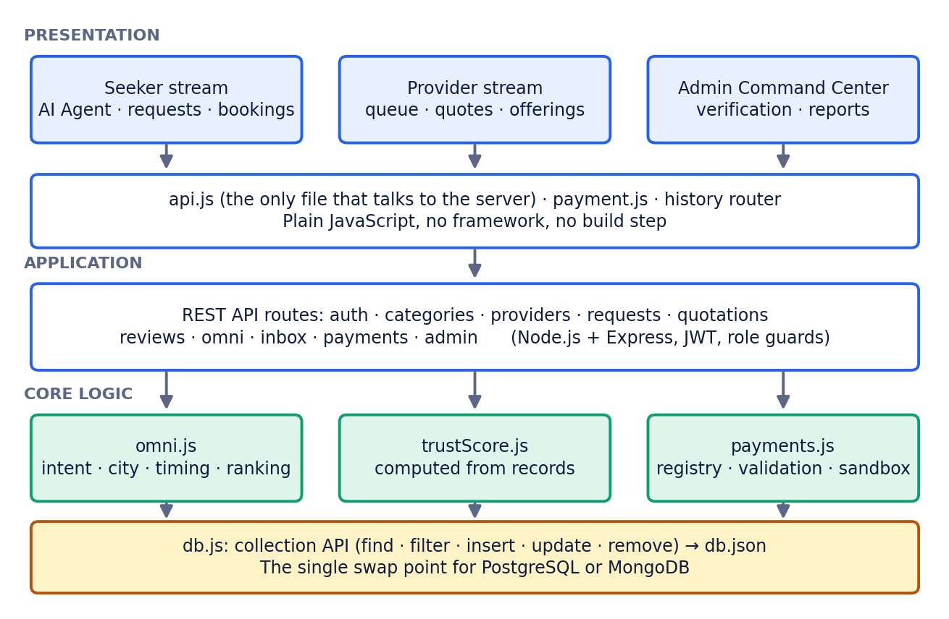
Figure 1. Three-layer architecture of OMNISERVICE CENTER.

3.4 Technology Stack
Table 2. Technology choices and reasons
Component | Choice | Reason
Server | Node.js 18+ with Express | Small, widely documented, runs on any laptop
Authentication | JSON Web Tokens [11]; bcrypt password hashing [12] | Stateless sessions; passwords never stored in plain text
Storage | JSON file behind a collection API (db.js) | No installation; replaceable by PostgreSQL or MongoDB by rewriting one module
Front end | Plain JavaScript, HTML, CSS; no framework | No build step; easy to inspect and explain
Maps | Leaflet [14] bundled locally; OpenStreetMap tiles [15] | Free and open; list still works with no tiles
Fonts | Inter and Sora, bundled | Consistent look with no internet needed
Testing | Node script (test-flow.js), Puppeteer browser check (ui-check.js) | Repeatable checks of API and every screen

3.5 Data Model
The datastore holds thirteen collections. Each record has a generated identifier, and generated demonstration records carry an isDemoData flag that the interface turns into a visible label.
Table 3. Collections in the datastore
Collection | Purpose
users | Accounts for all three roles, with hashed passwords
providerProfiles | Business details, services offered, city and coordinates, availability, price level, verification status, trust score
categories | 12 sectors containing 26 services
requests | Seeker job requests with a validated status
quotations | Provider price offers for a request
bookings | Accepted jobs and their progress; payment status
reviews | Ratings and comments, one per completed booking
messages, notifications | Communication and alerts between parties
payments | Sandbox transactions, receipts and references
promotions, ads | Provider promotion purchases and listings
disputes | Reported problems; the admin API can list and update them

3.6 The OMNI Matching Engine
OMNI is implemented in src/omni.js. Every request is parsed fresh; nothing is cached or scripted. Processing has four stages.
- Intent. Each of the 26 services has a list of words and phrases that people actually use (for plumbing: pipe, leak, faucet, drain, water heater, and so on). The engine scores every service against the text. A single word adds 2 points and a multi-word phrase adds 3, because phrases are stronger evidence. The highest-scoring service wins, and the words that matched are recorded.
- Location. Seven cities are recognised with common alternative spellings, for example Gondar/Gonder, Bahir Dar/Bahirdar, Hawassa/Awasa and Adama/Nazret.
- Timing. Patterns such as “today”, “tomorrow”, “urgent”, “this week” and “next week” are converted into an urgency level from 0 to 4.
- Ranking. Every verified provider offering the detected service is scored on the criteria in Figure 2 and the top eight are returned with the reasons that raised each score.
If no service receives any score, the engine returns an explicit “could not match” result with guidance on how to rephrase, rather than a guess. The match score of a provider is:
score = 0.5·trust + city(+25/−10) + max(0, 20−km) + urgent(+15) + 2·(5−price) + reviews(+5)
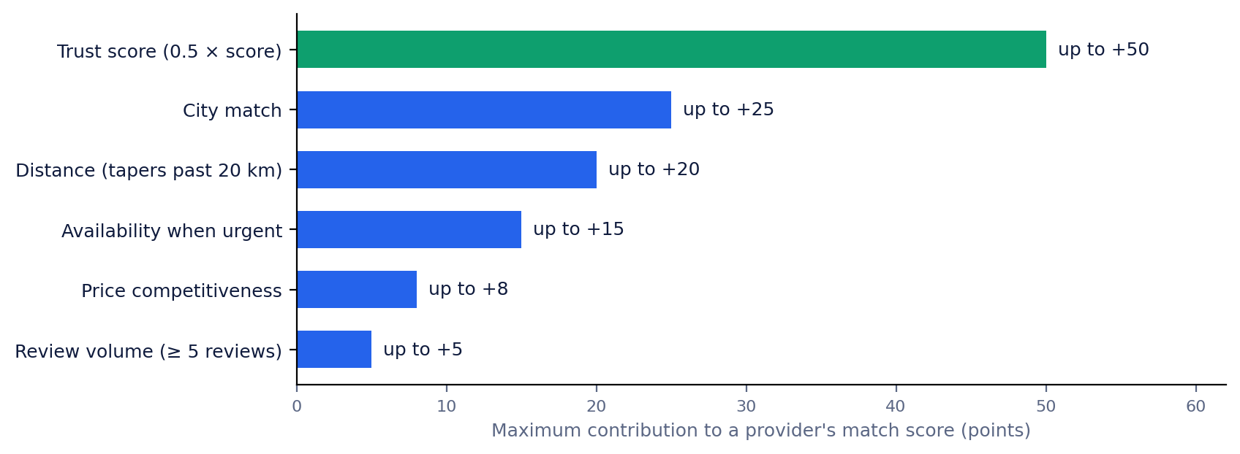
Figure 2. Maximum contribution of each criterion to a provider’s OMNI match score.
Trust carries the most weight, up to 50 points, because a nearby provider who cannot be relied on is a poor recommendation. A stated city adds 25 points for a match and subtracts 10 for a mismatch. Distance, computed with the haversine formula [10], adds up to 20 points and tapers to zero at 20 km. If the request is urgent (level 3 or higher), providers who are available now receive 15 points. Price index (1 = low, 5 = premium) adds up to 8 points, and a provider with five or more reviews receives 5 points. Only providers whose status is verified are ever considered.
Worked example (hypothetical providers, for illustration)
Query: “My pipe is leaking in Gondar, I need someone today.” OMNI detects Plumbing (matched on: pipe, leaking), city Gondar, timing today (urgency 3).
Provider A: trust 88, in Gondar, 2 km away, available now, price index 2, 6 reviews: 44 + 25 + 18 + 15 + 6 + 5 = 113.
Provider B: trust 92, in Gondar, 9 km away, by appointment, price index 3, 3 reviews: 46 + 25 + 11 + 0 + 4 + 0 = 86.
Provider C: trust 94, in Bahir Dar, too far to score on distance, by appointment, price index 1, 12 reviews: 47 − 10 + 0 + 0 + 8 + 5 = 50.
Provider C has the highest trust score but ranks last, because for an urgent job in Gondar location and availability matter. The interface shows these reasons beside each result.

3.7 The Trust Score
The trust score, implemented in src/trustScore.js, is a pure function of stored records. It is recalculated whenever a review is submitted or a job completes, and it is never typed in. Five signals are combined:
Table 4. Trust score components
Signal | How it is calculated | Effect on score
Average review rating | Mean of ratings (1–5) scaled to 0–100 | Weight 40%
Completion rate | Completed jobs ÷ (completed + cancelled) | Weight 25%
Response time | Average minutes to respond; 0 minutes scores 100 and 240 minutes or more scores 0 | Weight 20%
Job volume | 1.5 points per completed job, capped at 15 | Bonus up to +15
Cancellations | Cancellation rate × 100 × 0.15 | Penalty up to −15

trust = 0.40·rating + 0.25·completion + 0.20·response + volume − 0.15·cancel%
The result is rounded and limited to the range 0–100. Where a signal has no data yet, a neutral default is used (60 for rating, 70 for completion, 65 for response) so that a newcomer is neither punished nor promoted. A provider with no bookings and no reviews starts at zero. Because the volume bonus is capped, an experienced provider cannot buy an unlimited advantage, and because it is additive, a newcomer with excellent ratings can still compete.
Integrity rules. A review can only be written by the seeker who owns a booking, only after the booking is marked completed, only once per booking, and only with a whole-number rating from 1 to 5. A rating therefore cannot come from a stranger or be posted for a job that never happened. Paid promotion is recorded separately and is not read by the OMNI ranking function, so a provider cannot buy a higher trust-based ranking.

3.8 Service Lifecycle
A job follows the path in Figure 3. The server enforces the order with a state machine: a request in one state can only move to the states permitted from it, and any other change is rejected with an explanatory message. The main path is draft, submitted, matching, responses, provider selected, accepted, scheduled, in progress, completed, confirmed and reviewed. Side paths handle cancellation, expiry, rejection, failure and dispute.
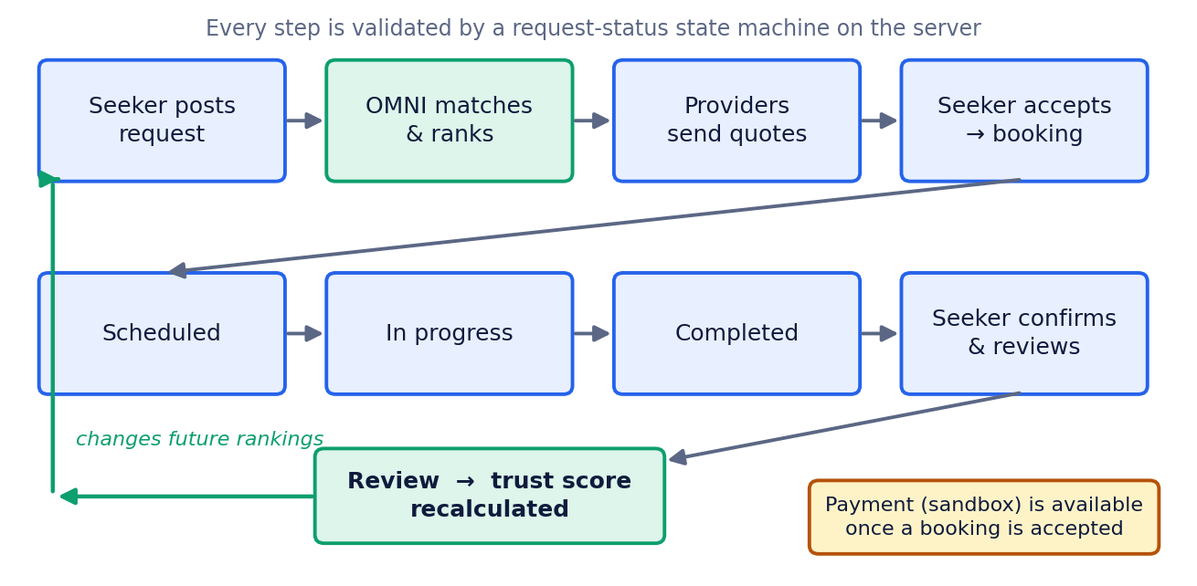
Figure 3. The service lifecycle and the trust-score feedback loop.
The feedback loop at the bottom of Figure 3 is the central idea of the system. Each review changes a provider’s trust score, and that changes their position in every future search. Notifications are sent to the other party at each step.

3.9 Payment Architecture
The payment module (src/payments.js) contains a registry of methods, a validator for each, and a two-step flow of initiate then confirm, mirroring how real mobile-money, bank and card gateways work: a prompt or redirect is issued, and the result is confirmed on the return leg.
Table 5. Payment methods and validation
Method | Data collected | Validation
Telebirr | Phone number | Ethiopian mobile number format
CBE Birr | Phone number | Ethiopian mobile number format
Ethiopian bank transfer | Bank (CBE, Bank of Abyssinia, Dashen, Awash, Hibret, Wegagen, Nib) and last four digits of account | Bank list and digit check
PayPal | Email address | Email format
Debit / credit card | Card number, expiry, CVV, name | Luhn checksum [16], expiry date, CVV length

The system runs in PAYMENT_MODE = 'sandbox'. No gateway keys are configured anywhere in the project, no real money moves, and every transaction is labelled as sandbox in the interface. Switching one method to a live gateway means implementing that method’s process() function against the provider’s real API; the routes, the receipt model and the interface would not change. A booking that has been paid rejects a second payment attempt. Providers can also buy promotion through the same modal, in two illustrative tiers (Boosted listing, 450 ETB; Featured provider, 1,200 ETB), and only verified providers may do so.

3.10 Security and Access Control
- Passwords are hashed with bcrypt [12] and never stored or returned in plain text.
- Sessions use signed JSON Web Tokens [11] that expire after seven days.
- Role guards restrict each route to the roles allowed to use it. Seekers cannot reach admin routes, only providers can send quotations, and only seekers can post requests, accept quotations or write reviews. The client router also keeps a signed-in user inside their own stream.
- Ownership checks ensure that a user can act only on their own requests, bookings and reviews.
- Verification gate. New providers are created as *pending* and are invisible in search until an administrator verifies them. New accounts cannot appear as trusted providers by registering.
- Input validation is applied at the API (for example rating range, payment fields and required request text), and the profile-picture upload size is limited by compressing images in the browser before upload.
These measures follow the general principles in the OWASP Top 10 [17], but the prototype is not a hardened production system. Section 6.1 lists what would be needed before public deployment.

3.11 User Interface
The interface has three streams, one per role. The Seeker stream contains the AI Agent, a request form, a list of requests and bookings with a progress bar, a payment button, messaging and reviews. The Provider stream contains an incoming-request queue, a quotation form, job management, an offerings gallery, profile editing and promotion purchase. The Admin Command Center contains platform statistics, provider verification, user and request views, an open-dispute count, payment reports and CSV export. A landing page lets any visitor try OMNI before signing in, and shows the “How OMNI got there” panel with the matched words, detected city and timing, and the number of providers scored. All fonts and the mapping library are bundled locally, so the whole interface loads with no internet connection; only the map’s background imagery needs one, and when it is missing the map says so plainly and still shows every provider.

3.12 Data Ethics and Honesty Rules
Three rules were applied throughout. First, generated providers, reviews and job history carry an isDemoData flag and are visibly labelled. Second, no real business, partnership, statistic or support channel is presented as real. Third, sandbox payments are labelled as such wherever they appear. These rules matter because a marketplace is built on trust, and a demonstration that misrepresented its own data would undermine the very idea it is showing.

4 Implementation and Results

4.1 Service Catalogue
The catalogue has 12 sectors and 26 services, chosen to cover the kinds of help people in Ethiopian towns and cities routinely need.
Table 6. Sectors and services
Sector | Services
IT & Tech | IT Support & Repair; Web & App Development
Transportation & Mobility | Rides, Delivery & Courier; Moving & Relocation
Telecom & Connectivity | Internet & Mobile Setup
Government & Public Services | Documentation & Civil Services
Education & Training | Tutoring & Exam Prep; Courses & Workshops
Health & Wellness | Medical & Clinical; Fitness & Wellness
Home, Construction & Property | Plumbing; Electrical; Construction & Renovation; Painting; Carpentry; General Repair & Maintenance
Business & Professional Services | Legal Services; Accounting & Tax
Shopping, Retail & Local Services | Tailoring; Beauty & Barber
Agriculture & Environment | Farming & Agri-Services; Landscaping & Gardens
Creative, Media & Entertainment | Photography & Video; Event Planning
Personal, Lifestyle & Community | Home & Office Cleaning; Childcare

4.2 Features by User Role
Table 7. What each role can do
Role | Main capabilities
Service Seeker | Ask OMNI in plain language; view ranked, explained matches and a map; post a request; compare quotations with the provider’s trust score; accept one; track progress; pay by six method types; message the provider; leave a review; keep a profile picture and bio
Service Provider | Register (starts as pending); receive incoming requests; send priced quotations; confirm schedule, start and complete jobs; manage a gallery of offerings with photos and prices; edit profile; buy promotion; see notifications and messages
Administrator | See platform totals computed from real records; verify or reject provider applications; browse users and requests; see the count of open disputes; view every sandbox payment; export company, user and payment reports as CSV

4.3 Demonstration Dataset
So that every search returns a real comparison, a seed script generates a demonstration dataset: providers around seven Ethiopian cities (Gondar, Bahir Dar, Addis Ababa, Mekelle, Hawassa, Dire Dawa and Adama), with every one of the 26 services guaranteed at least two verified providers in Gondar, the home city. Beyond those, a further group of providers is spread across the cities with a mix of verified, pending and rejected status, and three named demonstration seekers. The generator also creates job histories and reviews, and trust scores are then computed from that history, not typed in. The database seeds itself on first start, and npm run seed resets it to a clean state at any time.

4.4 Testing and Verification
Two automated tools verify the system.
`test-flow.js` drives the running API through the full lifecycle in 37 checkpoints. It logs in as each role and then covers: service catalogue loading; OMNI parsing of several different queries and correct refusal of a query it cannot match; posting a request and auto-matching; the provider queue; sending and accepting a quotation; moving a booking through scheduled, in progress and completed; a review and the resulting trust-score change; notifications and two-way messaging; admin statistics, verification queue and approval; report generation; role-based access control (a seeker is blocked from admin routes); new providers start pending and are invisible in search; payment by Telebirr with receipt and booking status update; rejection of a duplicate payment; rejection of an invalid card number by the Luhn check; a provider promotion purchase via CBE Birr; and provider offerings and profile pictures.
`ui-check.js` uses a headless browser (Puppeteer) to visit every screen of all three streams and fails if any JavaScript error appears. Together the two tools check both the back end and what the user actually sees.
What the tests do and do not show
They show that the implemented workflow behaves as designed and that the security rules hold for the cases tested. They do not measure how well OMNI understands real users’ wording at scale, or how real providers and seekers would behave. Those questions need the user pilot described in Section 6.3.

4.5 Discussion
What works well. The three design questions can be answered from the implementation. Everyday phrasing, place-name variants and urgency words are turned into a service, city and timing by an inspectable rule set (Question 1). The trust score is a function of stored records and moves the moment a review is saved, and this is visible in the interface (Question 2). The complete workflow, including three roles and five payment method types, runs from a small codebase with four runtime dependencies (Express, cors, bcryptjs and jsonwebtoken) and is covered by automated checks (Question 3).
Trade-offs. A rule-based engine is only as good as its synonym lists. It handles the vocabulary it has been given, and phrasing outside it will fail to match; the system then says so honestly instead of guessing. This is a deliberate choice for a prototype where explainability matters more than coverage, and it is easy to extend by adding words. A JSON-file datastore is simple and portable but does not scale to heavy concurrent use; the db.js boundary exists so it can be replaced.

5 Impact, Sustainability and Business Model

5.1 Beneficiaries and Social Impact
- Seekers save time and reduce risk: they describe the problem once and receive an explained shortlist.
- Small providers and skilled individuals gain a public track record. A tailor, tutor or electrician with no shop front can build a visible, verifiable history from completed jobs.
- Newcomers to a city, such as students and workers who have moved, can find reliable help without a local network.
- Local economies benefit when demand and supply meet more efficiently and when payments move into recorded digital channels.

5.2 Alignment with National Strategy and Global Goals
The project is consistent with the aims of Digital Ethiopia 2025, which set out to use digital technology to support jobs, inclusive prosperity and services across the economy [4][6], and with its successor strategy [7]. It also supports two of the United Nations Sustainable Development Goals: Goal 8 (decent work and economic growth), through new ways for small providers to find paid work, and Goal 9 (industry, innovation and infrastructure), through a locally designed software product.

5.3 Sustainability and Business Model
The prototype already contains the first revenue mechanism: providers can buy promotion in tiers (Boosted listing, Featured provider). A design choice protects trust: promotion is displayed but does not change trust-based ranking. Two further models are proposed for a live version and are not yet implemented:
- A small commission on jobs paid through the platform, taken only when a booking is successfully completed and paid.
- An optional subscription for business providers who want analytics and a verified-business badge.
Seekers would use the platform free of charge. Prices above are illustrative placeholders for the prototype and would be set after the pilot and after consulting providers about what they are willing to pay.

5.4 Risks and Mitigation
Table 8. Principal risks
Risk | Mitigation in design or plan
Fake or low-quality providers | Admin verification before visibility; trust score built from completed jobs; admin API for reviewing disputes
Fake or manipulated reviews | Reviews only from the booking’s own seeker, once, after completion; promotion cannot affect ranking
Payment fraud or error | Validation per method; duplicate-payment block; receipts; sandbox until a licensed gateway is integrated
OMNI misunderstands a request | Transparent reasoning panel; explicit “could not match” result; synonym lists extendable from real queries
Data loss or scaling limits of the JSON store | Single storage boundary (db.js); planned migration to PostgreSQL
Low connectivity | Local fonts and libraries; map degrades gracefully; phone-sized layout
Privacy of personal data | Hashed passwords; role-based access; data minimisation; formal privacy policy before launch

5.5 Ethical Considerations
The team took the view that a trust platform must itself be trustworthy. Demonstration data is labelled, sandbox payments are labelled, ranking reasons are shown, and the limits of the system are stated in this document. Any real launch would need consent-based collection of personal data, a privacy policy that follows Ethiopian law, clear complaint handling, and a fair policy for providers who are rejected or removed.

6 Limitations and Future Work

6.1 Current Limitations
The team wants to be direct about what this version is and is not.
- Demonstration data. All providers, reviews and job histories are generated. The system has not yet been used by real seekers and providers.
- Sandbox payments. No live Telebirr, CBE Birr, bank, PayPal or card gateway is connected.
- Language. The interface is in English. Amharic support is planned but not translated.
- Verification documents. Document upload is stubbed at the data-model level; administrators approve on submitted details only.
- Datastore. A JSON file is used in place of a production database.
- Deals and adverts are stored in the browser rather than on the server.
- Hardening. Before public use the system needs a configured production secret for token signing, stricter cross-origin rules, a stronger password-hashing cost, rate limiting, an administrator-only restriction on the trust-recompute route, a privacy policy and independent security testing.
- Matching coverage. OMNI uses keyword and phrase rules, so wording outside its vocabulary is not understood.

6.2 Roadmap
Table 9. Proposed phases
Phase | Goals | Outcome
1. Prototype (this proposal) | Working marketplace, OMNI, trust score, sandbox payments, three roles, automated tests | Complete and demonstrable
2. Pilot in Gondar | Recruit real seekers and providers in a few services; survey them; log queries OMNI fails to match and extend the synonym lists | Evidence of real use and of matching quality
3. Localisation and data | Amharic interface and Amharic keywords; migrate to PostgreSQL; document upload for verification | Usable by more people, on a durable database
4. Live payments and reach | Integrate licensed payment gateways; SMS or USSD access for users without smartphones; mobile-optimised or installable app | Real transactions; wider access
5. Smarter matching | Learn from accepted matches to tune weights; optional language-model assistance layered on top of the transparent rules, keeping explanations | Better accuracy without losing explainability

6.3 Proposed Pilot Evaluation
A pilot would test the design questions against reality. Proposed measures, all to be collected with users’ consent, are:
- Match quality: the proportion of OMNI searches where the user selects a provider from the top three, and the proportion returning “could not match”.
- Speed: time from posting a request to the first quotation received.
- Completion: the share of accepted bookings that reach completed and reviewed.
- Trust: whether users report that the trust score and the reasoning panel helped them decide, measured by a short survey.
- Provider benefit: whether small providers report new customers or bookings.

7 Conclusion
OMNISERVICE CENTER shows that a useful, intelligent-feeling service marketplace can be built from transparent, inspectable parts. A person describes a job in their own words; OMNI works out the service, city and urgency, ranks verified providers on trust, place, availability and price, and shows exactly why. A computed trust score turns every completed job and review into a lasting, checkable reputation. The workflow continues through quotation, booking, payment and review, and it is bounded by role-based security and an administrator verification gate.
The project also holds itself to a standard of honesty that suits a trust platform: demonstration data, sandbox payments and the limits of a rule-based engine are all stated openly. Against the background of fast-growing connectivity and mobile money in Ethiopia, and national digital strategies that call for exactly this kind of locally built service, the team believes OMNISERVICE CENTER is a credible first step. The next steps are a real-user pilot in Gondar, Amharic support and a live payment gateway, so that the prototype can become a service that people rely on.

References
Web sources were accessed in September 2026.
[1] DataReportal (2026). Digital 2026: Ethiopia. https://datareportal.com/reports/digital-2026-ethiopia
[2] The Reporter Ethiopia. “Ethio telecom eyes 10m new Telebirr customers.” https://www.thereporterethiopia.com/35659/
[3] The Reporter Ethiopia. “Ethio telecom celebrates another profitable year.” https://www.thereporterethiopia.com/41056/
[4] Capital Ethiopia (2020). “Digital Ethiopia.” https://capitalethiopia.com/2020/06/21/digital-ethiopia/
[5] Fana Broadcasting Corporate (2024). “Digital Ethiopia 2025 Strategy increases internet users by over 42 million – MInT.” 14 December 2024. https://fanabc.com/english/digital-ethiopia-2025-strategy-increases-internet-users-by-over-42-million-mint
[6] Shega (2025). “Digital Ethiopia 2025: Progress, Challenges, and the Road Ahead.” 27 October 2025. https://shega.co/news/digital-ethiopia-2025-progress-challenges-and-the-road-ahead
[7] allAfrica (2025). “Ethiopia Anchors Digital Sovereignty in New Digital Ethiopia 2030 Strategy – Ministry Says.” 29 December 2025. Listed at https://allafrica.com/list/aans/post/af/cat/ict/pubkey/publisher:editorial:00011031.html
[8] Resnick, P., Kuwabara, K., Zeckhauser, R., & Friedman, E. (2000). Reputation systems. Communications of the ACM, 43(12), 45–48.
[9] Salton, G., & Buckley, C. (1988). Term-weighting approaches in automatic text retrieval. Information Processing & Management, 24(5), 513–523.
[10] Sinnott, R. W. (1984). Virtues of the haversine. Sky and Telescope, 68(2), 159.
[11] Jones, M., Bradley, J., & Sakimura, N. (2015). JSON Web Token (JWT). RFC 7519, Internet Engineering Task Force.
[12] Provos, N., & Mazières, D. (1999). A future-adaptable password scheme. In Proceedings of the USENIX Annual Technical Conference, FREENIX Track, 81–91.
[13] Fielding, R. T. (2000). Architectural Styles and the Design of Network-based Software Architectures (Doctoral dissertation). University of California, Irvine.
[14] Agafonkin, V. Leaflet: an open-source JavaScript library for interactive maps. https://leafletjs.com
[15] OpenStreetMap contributors. OpenStreetMap. https://www.openstreetmap.org/copyright
[16] Luhn, H. P. (1960). Computer for verifying numbers. U.S. Patent 2,950,048.
[17] OWASP Foundation. OWASP Top 10: Web Application Security Risks. https://owasp.org/www-project-top-ten/

