University Of Gondar Steam Center

Project proposal

Personal information
□ Name = Abrham kefyalew& Solomon Mekonen
□ Grade = 12 NATURAL
□ School = UOG.community.school
□ E-mail = abrhamk16@gmail.com
□ Contact = +251 13173366
Project information
□ Category = Software development
□ Project title = OMNISERVICE CENTER

2019.EC
University Of Gondar Steam Center
Project proposal

PROJECT PROPOSAL
OMNISERVICE CENTER WEB PLATFORM
INTRODUCTION
The OMNISERVICE CENTER web platform is an AI-assisted service marketplace that connects people who need a service with verified local providers in Ethiopia. A user describes a need in ordinary language, and the built-in OMNI engine finds the service, the city and the urgency, then ranks providers by trust, distance, availability and price. The platform supports the whole job, from request and quotation to booking, payment and review, so that finding and hiring help becomes fast, transparent and safe.
BACKGROUND OF THE PROJECT
Services such as plumbing, electrical work, tutoring, tailoring, legal help and photography are needed by every household and business. Ethiopia is becoming more connected: about 93 million mobile connections were active at the end of 2025 (DataReportal, Digital 2026: Ethiopia), and mobile money such as Telebirr is used by tens of millions of people. However, finding a reliable provider still depends mostly on word of mouth. Customers cannot check a stranger’s reliability, small providers cannot show their past work, and jobs and payments are managed informally.
The OMNISERVICE CENTER platform addresses this gap by providing one online system where a customer can describe a need, see ranked and verified providers with the reasons for the ranking, and complete the job with recorded quotations, payments and reviews.
PURPOSE & GOAL OF THE WEB
Purpose
The primary purpose of the OMNISERVICE CENTER website is to digitally transform how services are found and hired in Ethiopia by providing an intelligent, trustworthy and organized platform. It serves as a bridge between service seekers and service providers.
Goals
- To help people find the right service provider quickly from a plain-language request
- To build trust through verified providers and a trust score calculated from real records
- To give small local providers visibility and a public track record
- To support payment through methods Ethiopians use, such as Telebirr and CBE Birr
- To support economic growth and job creation through digital services
Objectives
General Objective
To develop a fully functional web-based service marketplace with an intelligent matching engine for Ethiopia.
Specific Objectives
- To design a responsive website with three user streams: seeker, provider and admin
- To organize services into 12 sectors and 26 services
- To build the OMNI engine that reads a request and ranks providers with visible reasoning
- To compute a trust score from reviews, completed jobs, response time and cancellations
- To support the full job lifecycle: request, quotation, booking, payment and review
- To provide admin tools for provider verification and reports
- To prepare the system for future features such as live payment gateways and Amharic language
SYSTEM FEATURES
The OMNISERVICE CENTER platform includes the following features:
- Modern and responsive landing page with the OMNI widget, usable before login
- AI Agent that turns everyday language into a service, a city and an urgency level
- “How OMNI got there” panel that shows the reasoning behind every result
- Ranked provider matches with distance and an interactive map
- Categorized services: 12 sectors and 26 services
- Request, quotation, booking, completion and review workflow with progress tracking
- Trust score computed from real records, never typed in by hand
- Sandbox payments: Telebirr, CBE Birr, Ethiopian bank transfer, PayPal and card, with receipts
- Messaging and notifications between seeker and provider
- Provider profile, profile picture and offerings gallery
- Admin Command Center with provider verification, statistics and CSV reports
- Secure login with hashed passwords, signed tokens and role-based access
- Works with almost no internet: fonts and map library are bundled
ECONOMIC FEATURES OF THE SYSTEM
The OMNISERVICE CENTER platform also provides important economic advantages:
- Gives small providers such as tailors, tutors and electricians free visibility and a verifiable track record
- Saves seekers time and cost when searching for reliable help
- Moves payments into recorded digital channels such as Telebirr and CBE Birr
- Provides a revenue path through provider promotion (Boosted listing 450 ETB and Featured provider 1,200 ETB in the prototype) and, in future, a small commission on completed jobs
- Provides a digital advertising channel for local businesses
- Supports self-employment and job creation across many sectors
DESIGN AND ARCHITECTURE
The system follows a three-layer web architecture: a browser interface, a REST API server, and core logic modules on top of a replaceable data store.
Architecture
- Frontend: HTML, CSS, JavaScript (no framework, no build step)
- Backend: Node.js with Express REST API
- Database: JSON data store behind one module (db.js); future PostgreSQL or MongoDB
- Security: bcrypt password hashing, JWT sessions, role guards
- Maps: Leaflet with OpenStreetMap
- Core modules: omni.js (matching), trustScore.js (trust), payments.js (payments)
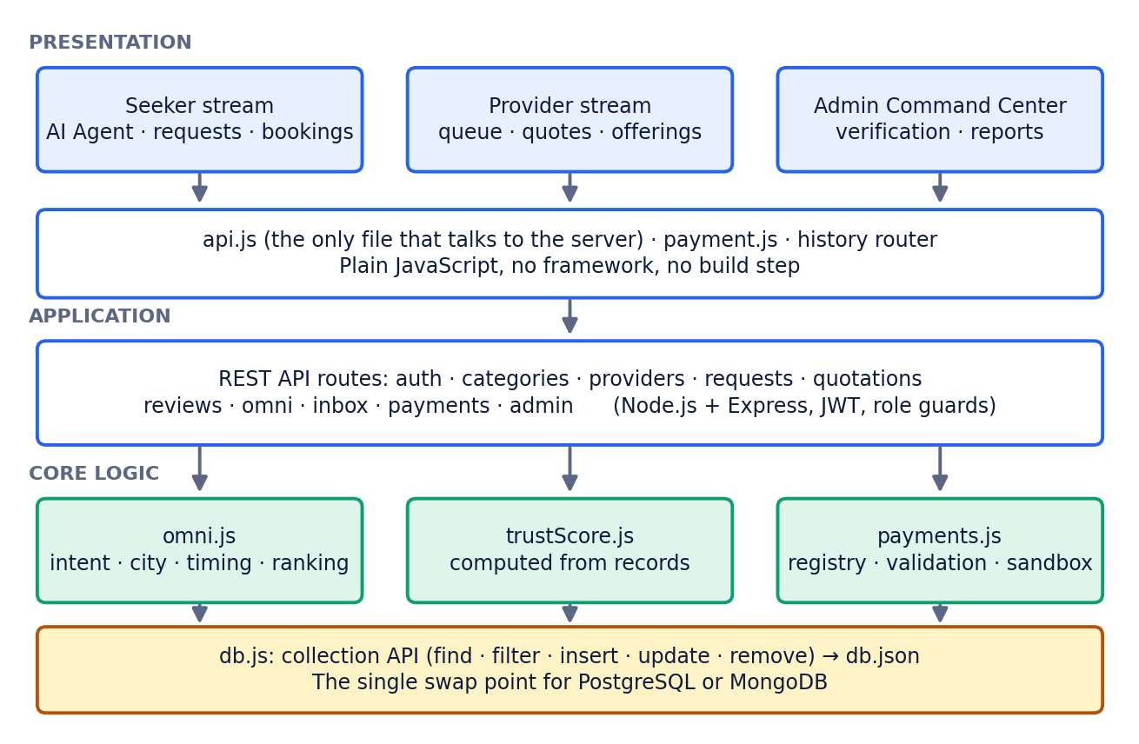
Design
- Simplicity and clarity
- Transparency: every ranking shows its reasons
- Separate, easy-to-follow streams for seeker, provider and admin
- Mobile-friendly layout
DATABASE DESIGN
The system includes the following database entities:
- Users (seeker, provider and admin accounts with hashed passwords)
- Provider profiles (business details, city and coordinates, availability, price level, verification status, trust score)
- Categories (12 sectors containing 26 services)
- Requests, quotations and bookings (the job lifecycle and its status)
- Reviews (rating and comment, one per completed booking)
- Messages and notifications
- Payments (sandbox transactions and receipts)
- Promotions, advertisements and disputes
CONCLUSION
The OMNISERVICE CENTER web platform is a modern digital solution that improves how services are found and hired in Ethiopia. It gives customers a ranked, explained and trustworthy way to choose a provider, gives small providers a public and verifiable track record, and supports the whole job through quotation, payment and review. The prototype uses generated demonstration data and sandbox payments, both clearly labelled, and it is ready for a real-user pilot, live payment gateways and Amharic language support. This project also demonstrates the practical use of web development technologies to solve real-world problems.

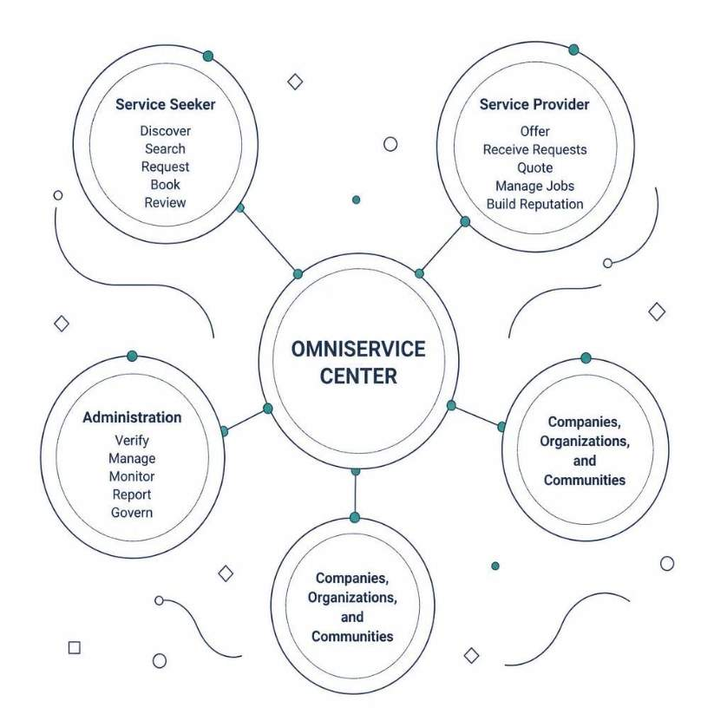
Overview of the web page

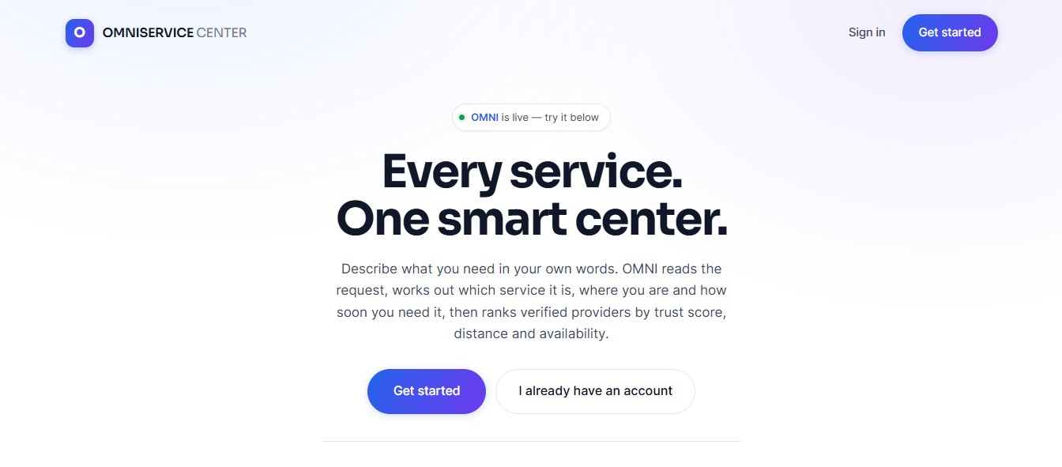

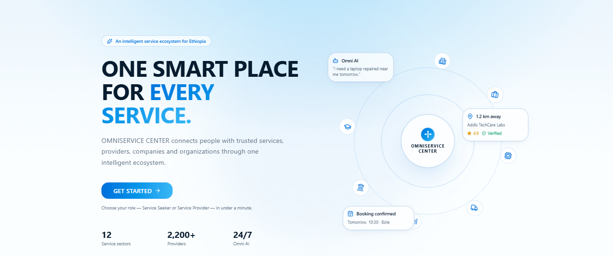

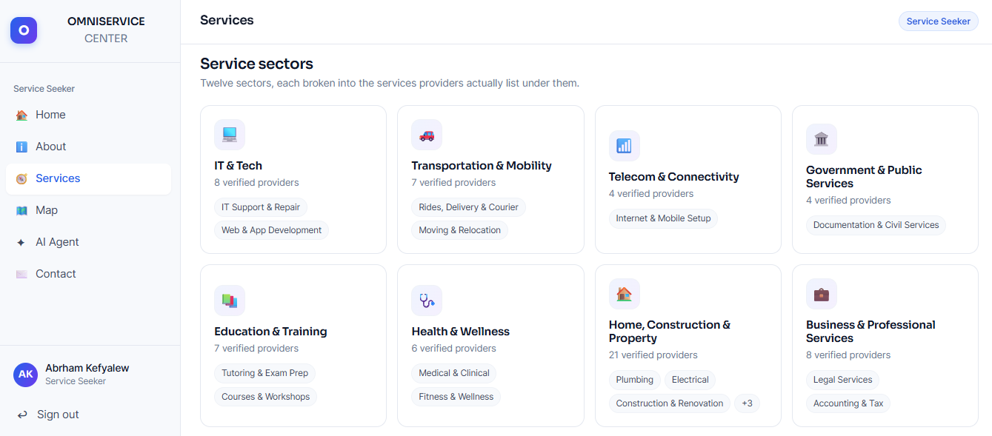
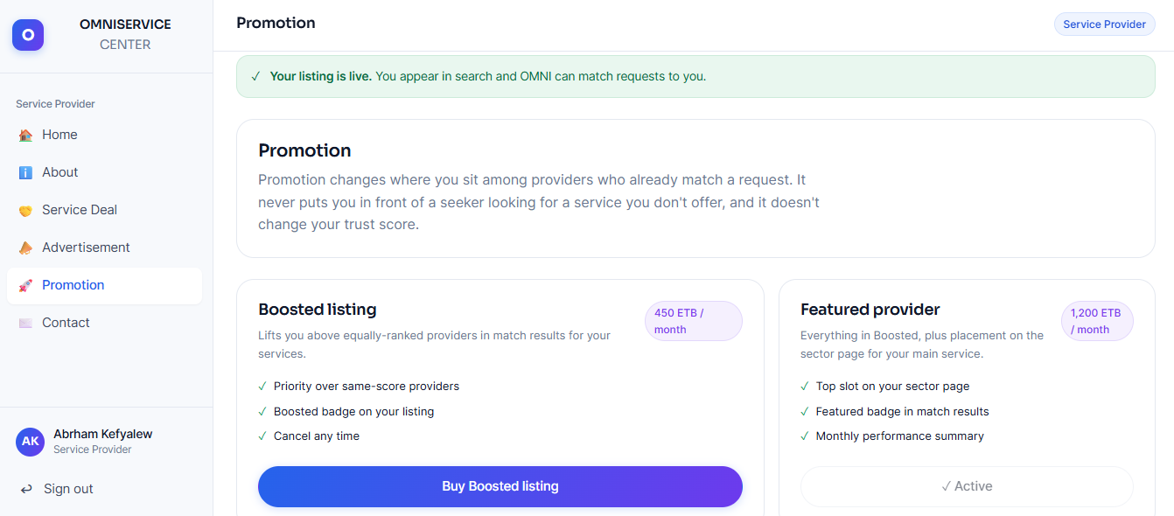
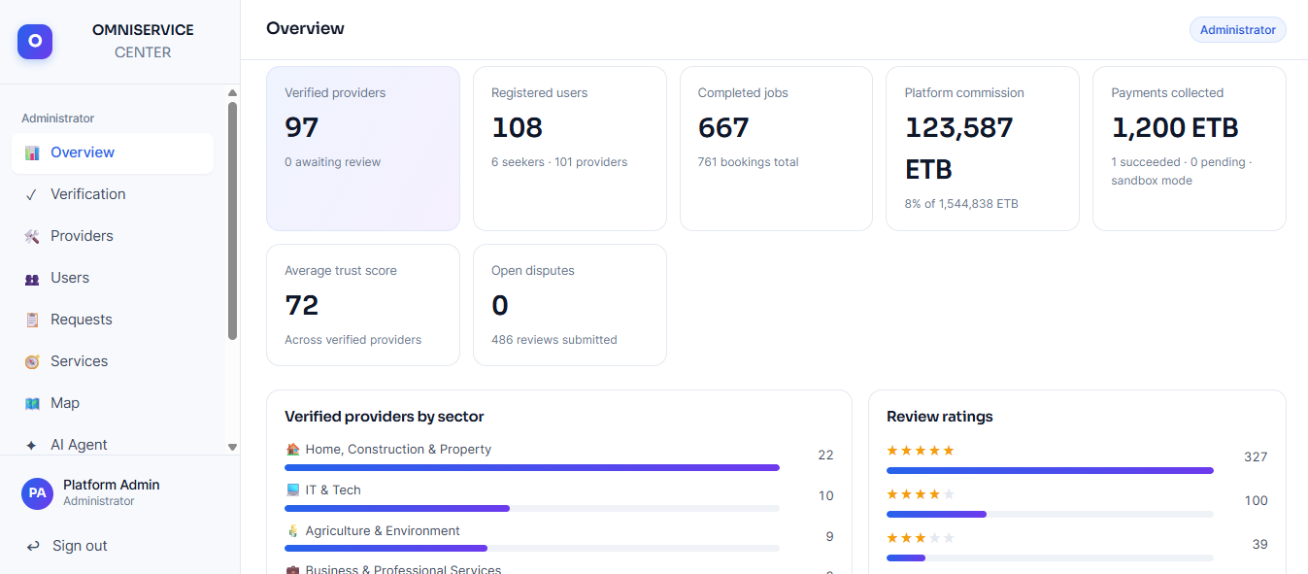

OVER VIEW OF THE CODE
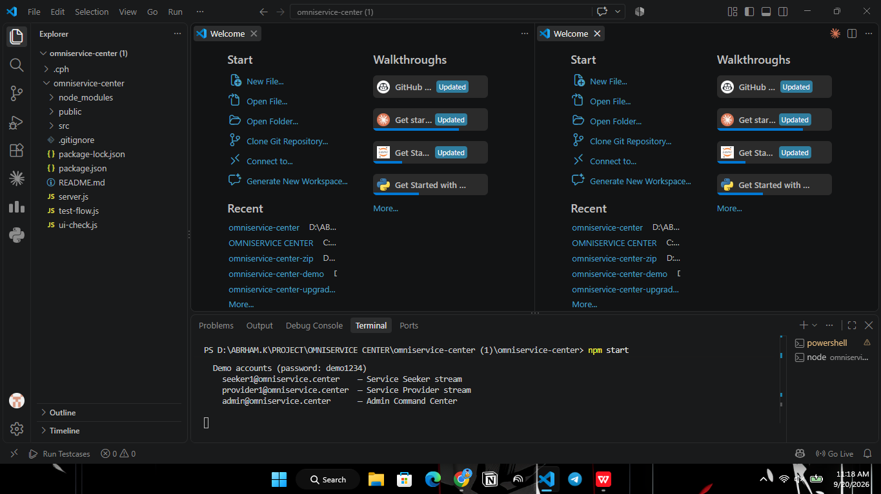

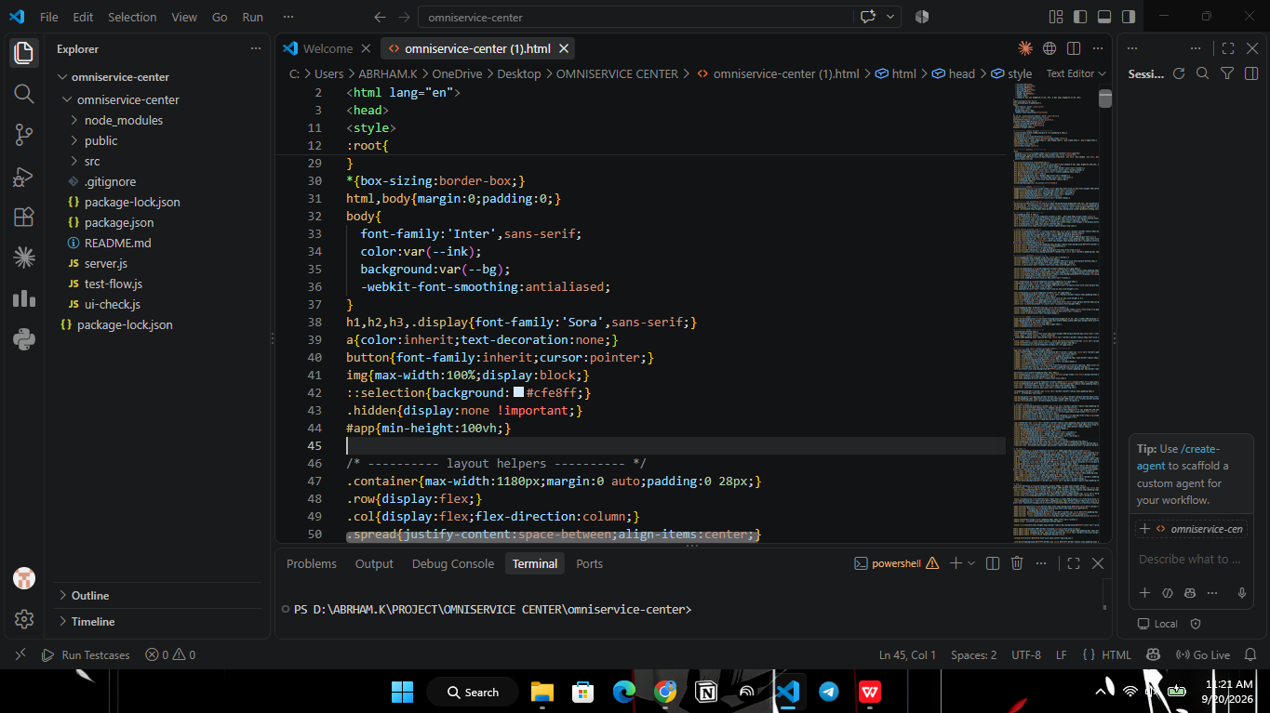
Thank
you!



