



MetaDefender Managed File Transfer
Proof of Value Document
1 June 2026

Provided for:
Provided by: Abrielle Land

Table of Contents
Table of Contents 1
Overview 2
Success Criteria 3
Test Cases 4
Requirements 5
Deploy MetaDefender Core 6
Deploy MetaDefender MFT 8
Integrate & Configure MFT 10
Test Environment 11
Appendix 13

Overview
Purpose, Scope, & Objectives
The purpose and scope of this Proof of Value (PoV) is to demonstrate the capabilities of OPSWAT’s MetaDefender Managed File Transfer (MFT) solution within your specific environment. The primary objectives are to verify the solution's effectiveness in securely transferring files while scanning for malware.

OPSWAT Solution Being Evaluated
MetaDefender Core - MD Core Documentation
MetaDefender MFT - MD MFT Documentation

Limitations
Performance benchmarking. This is due to a number of variables that affect performance (file set, networking configurations, hardware characteristics). OPSWAT will review the performance metrics from the test and advise if any improvements need to be made and where.

Agreed Upon PoV Timeline (2 Weeks)
  - POV Start Date:
  - POV End Date:

Success Criteria
Goals and Objectives
- Verify the solution's effectiveness in malware and Zero Day detection.
- Assess the capabilities of Deep Content Disarm and Reconstruction (CDR).
- Ensure the solution meets the predefined success criteria.
Specific Criteria
- Integration and Compatibility
  - Ease of integration with existing infrastructure.
  - Compatibility with various operating systems and environments.
  - API availability and ease of use for custom integrations.
- Scanning and Detection Capabilities
  - Speed and accuracy of malware detection.
  - Support for a wide range of file types and archives.
  - Effectiveness in detecting advanced threats and zero-day vulnerabilities.
- Security and Compliance
  - Adherence to industry standards and regulations.
  - Ability to support data privacy and protection requirements.
  - Integration with compliance monitoring tools.

Expected Outcomes & Deliverables
- Comprehensive report on performance against success criteria.

Test Cases
Test Case 1:
Scenario: Create a Guest User account in MFT, upload a clean file and a malicious file.
Reference: Uploading File - MetaDefender MFT
Expectation: MFT will block the malicious file and allow the clean file.
Test Case 3 (Customer Defined):
Scenario:
Expectation:
Test Case 4 (Customer Defined):
Scenario:
Expectation:
Test Case 5 (Customer Defined):
Scenario:
Expectation:

Requirements
Approach:
- Preparation: Using a controlled test environment, deploy MetaDefender Core and MetaDefender MFT
- Execution: Execute predefined test cases to evaluate the performance and effectiveness of the solutions
- Evaluation: Analyze results and assess if the success criteria are met by the solution.

Tools, Equipment, & Resources Required:
- Physical or virtual Windows environment meeting the minimum system requirements for MetaDefender Core and MFT
- License key (provided by OPSWAT)
- SQL Server or SQL Express (required for MFT deployment)

Timeline & Milestones:
- Week 1 + Working Session 1:
  - Install MetaDefender Core
  - Install MetaDefender MFT
  - Integrate MetaDefender Core & MFT
  - Start testing Use Case 1

Deploy MetaDefender Core
Step 1 – Verify System Requirements for MetaDefender Core 8
Ensure the target system meets the recommended system requirements for MetaDefender Core.
Refer to the official documentation for:
- Supported operating systems (Windows Server 2016, 2019, 2022)
- Minimum hardware specifications (CPU cores, RAM, disk space)
- Recommended configurations for optimal performance with Deep CDR
- Required software components (e.g., .NET Framework, Visual C++ Redistributable)
🔗 Recommended System Configuration – MetaDefender Core

Step 2 – Download the Installer
- Go to https://my.opswat.com
- Sign in or create a free OPSWAT account
- Navigate to Product Downloads
- Select MetaDefender Core, choose your OS, and download the installer file
🔗 Installing MetaDefender Core – Official Guide

Step 3 – Run the Installation Wizard
- Launch the downloaded .msi file
- Follow the installation wizard prompts:
  - Accept license terms
  - Choose installation location
  - Complete the setup process
🔗 Initial Setup Using the Configuration Wizard

Step 4 – Complete Web-Based Configuration
After installation:
- Open a browser and go to:
http://<your-server>:8008 (default port: 8008)
- Log in to the web interface
- Follow the Initial Setup Configuration Wizard, which walks you through:
  - Setting the admin password
  - Uploading your license key
  - Configuring file storage, logging, and system preferences
  - Testing engine connectivity
  - Finalizing system readiness
🔗 Post-Installation Configuration Wizard

Deploy MetaDefender MFT
Step 1 – Verify System Requirements
Ensure the target system meets the minimum requirements for MetaDefender MFT installation.
Refer to the official documentation for:
- Supported operating systems
- Required CPU, RAM, and disk space
- Software prerequisites (e.g., .NET, Visual C++ redistributable)
🔗 System Requirements - MetaDefender MFT

Step 2 – Download the Installer
- Go to https://my.opswat.com
- Sign in to your My OPSWAT account
- Navigate to Product Downloads
- Locate MetaDefender MFT
- Select your operating system and download the installer file
🔗 Installation Instructions - MetaDefender MFT

Step 3 – Run the Installation Wizard
- Launch the downloaded installer (.msi file)
- Follow the on-screen installation wizard prompts
- Accept license terms, choose install location, connect to SQL Database, and complete setup
- Once installed, access the web interface to begin configuration
🔗 Wizard Installation - MetaDefender MFT

Step 4 – Complete Web-Based Configuration
After installation:
- Open a browser and go to:
http://<your-server>:<configured-port> (default is 8010)
- Log in to the web interface
- Follow the Post-Installation Configuration Wizard, which will walk you through:
  - Setting up the admin account
  - Configuring encryption settings
  - Specifying storage locations
  - Setting up email notifications
  - Reviewing default policies and templates
- Finish the wizard to apply initial settings and complete setup
🔗 Post-Installation Configuration – MetaDefender MFT

Integrate & Configure MFT
Step 1 – Set Up Integration with MetaDefender Core
- Ensure MetaDefender MFT is integrated with MetaDefender Core for advanced malware scanning.
- Follow the integration steps in the official documentation.
🔗 MetaDefender Core Integration - MetaDefender MFT

Step 2 – Configure Guest Creation Settings
- Define guest user creation policies and permissions.
- Customize guest access and authentication according to your needs.
🔗 Guest Creation Settings - MetaDefender MFT

Step 3 – Configure SMTP Settings
- Set up SMTP to enable email notifications for alerts, user actions, and system events.
- Provide SMTP server details and test the connection.
🔗 SMTP Configuration - MetaDefender MFT

Test Environment
[Important: It is not recommended to conduct a POV in a production environment]
Prerequistes:
OPSWAT will provide you with the necessary license key and guidance to perform the initial deployment and installation for Metadefender Core and MetaDefender MFT.
This is currently scheduled to include :
- OPSWAT MetaDefender Core (On Prem)
  - Metascan (8 engine Windows)
  - Deep CDR Module
- OPSWAT MetaDefender Managed File Transfer

Since the MetaDefender Core and MetaDefender Managed File Transfer are all on-prem offerings, there is a requirement to install the OPSWAT software on your systems.
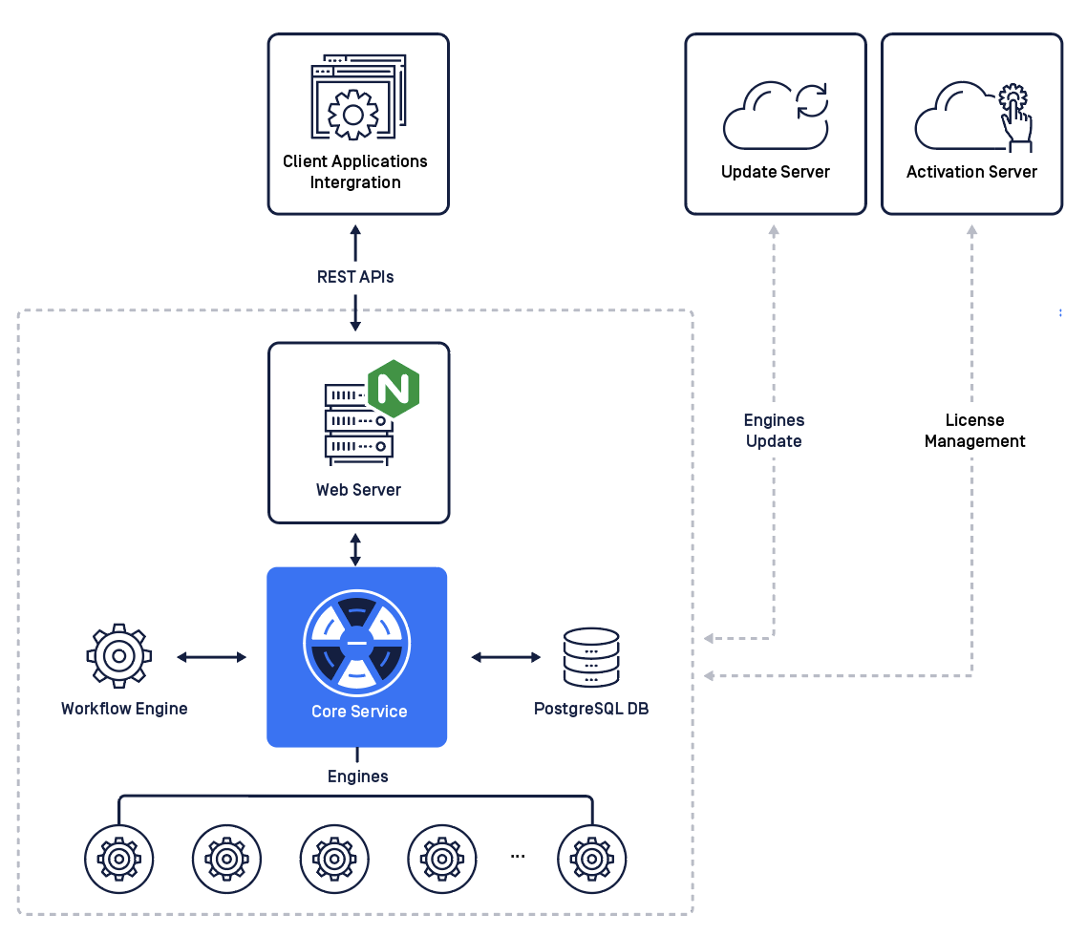
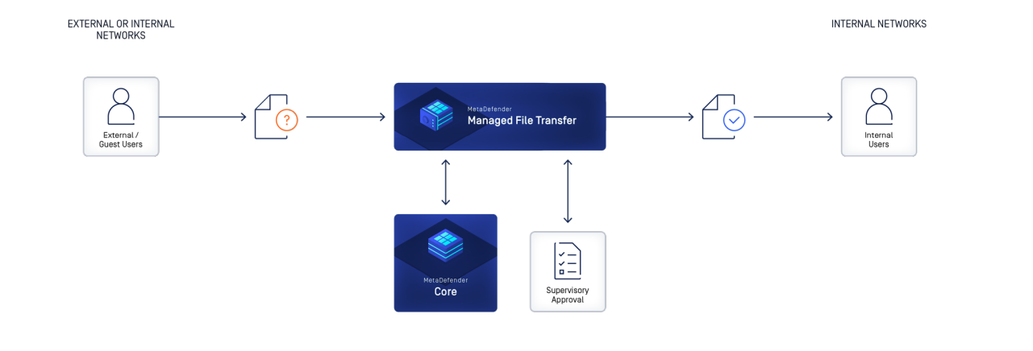

Appendix
MetaDefender Core Data Sheet
MetaDefender Endpoint Data Sheet
MetaDefender Manage File Transfer Solution Brief

