[v_SecurityCallReportV1]
[v_SecurityDataDumpV1]
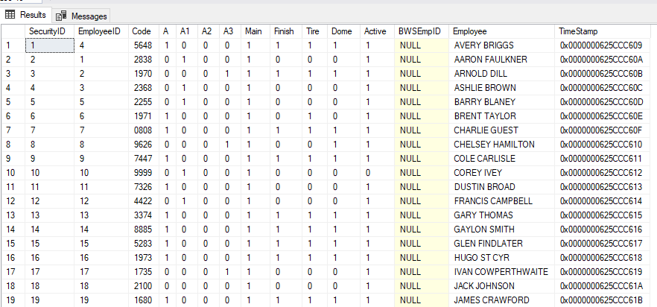
[v_SecurityV1BuildingAccessibility]
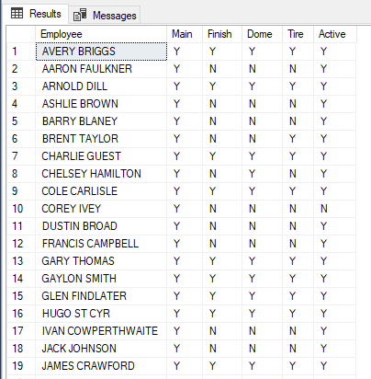
[v_SecurityV1KeyDistribution]
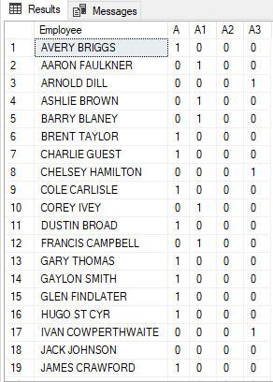
[SecurityCallersV1]
[v_SecurityCallRespondentsReportV1]
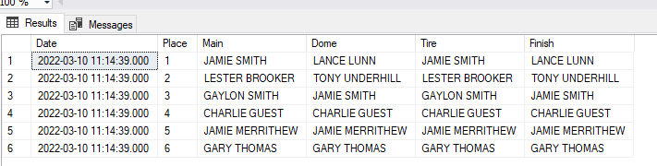
[SecurityV1]
