CS3413 Lab 5

Nov. 27 2018

Avery Briggs

3471065

Question 1:

I ran vmstat 5 in the terminal, and opened several new programs, including chrome, Firefox, LibreOffice, and emacs. Then I opened several new browser tabs and files on libreOffice. The first thing I noticed about the output was that the procs queue was filling up and dequeueing as fast as it could allocate memory. When the queue was at it's largest, the number of interrupts and context switches per second, were at their respective maximums, indicating that there were many requests being serviced and swapped in and out, while the CPU gradually services each request Also for I/O, there seems to be thousands of more blocks being received from a block device, than blocks being sent to block devices. You can see as each application is opened, that the amount of free memory gradually decreases, and the cache size gradually grows.

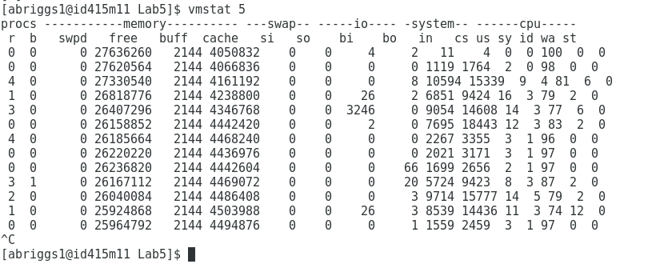

Question 2:

Process < ps -eo uid | less > produced the most page faults. The difference between a minor page fault and a major page fault is that, for a minor fault the page is already loaded into memory, but the page table has not been updated yet. This type of fault costs significantly less than the major page fault, which would require the page to be loaded into memory after the fault.

Question 3:

In order to cause heavy paging inside the OS, without running out of memory, I performed a similar test to question 1, but on a virtual machine. Opening several programs inside a VM can cause the physical memory to run low, while the virtual memory still thinks there is lots left over. This is because the VM is allocated a certain number of frames, but running programs inside causes the frames to constantly swap. This can lead to heavy paging inside the virtual machine.

Question 4:

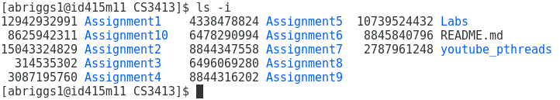

When comparing the i-node values for my files to someone else's, we saw that the results were very different. But this is expected, the odds of us both having the same files, with the same attributes, loaded into the same locations in memory are pretty much astronomical.

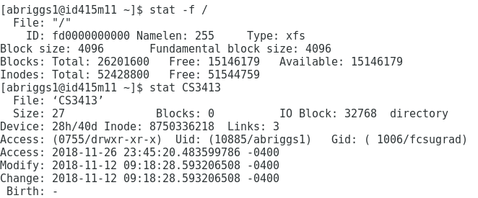

Question 5:

I copied my file 'Assignment9' from my CS3413 directory, to Desktop. The i-node values are:

CS3413/Assignment9 - 8844316202

Desktop/Assignment9 - 15039071004

I didn’t expect these files to have the same i-nodes, because each copy of the file is located on a different branch in the file systems tree.

