1. (1 point) What is the difference between network architecture and application architecture?

The main difference between network architecture and application architecture, is network architecture is fixed. Meaning it provides some specific set of services to the applications. In contrast, application architecture may vary as it is decided by the developer. The dev may choose how the application is structured over various end systems.

1. (1 point) For a communication session between a pair of processes, which process is the client and which is the server?

The process which initiates the communication is the client. The process that waits to be contacted is the server.

1. (1 point) In BitTorrent, suppose Alice provides chunks to Bob throughout a 30-second interval. Will Bob necessarily return the favor and provide chunks to Alice in this same interval? Why or why not?

No, Alice maybe chocked and not among one of Bob’s top four peers. If this is the case Bob will share primarily with only his peers.

1. (2 points) True or false?

a. A user requests a Web page that consists of some text and three images. For this page, the client will send one request message and receive four response messages.

False, if the user requests three images, this would correspond to 3 connections, not one. Therefore, there will be six responses not four.

b. With non-persistent connections between browser and origin server, it is possible for a single TCP segment to carry two distinct HTTP request messages.

False, in a non-persistent connection, after each exchange the connection will terminate, not allowing more than one request to be carried out during the connection.

c. The Date: header in the HTTP response message indicates when the object in the response was last modified.

False, the last-modified tag shows the last time the file was modified on the server end. The date tag simply reports the time that the request was created.

d. HTTP response messages never have an empty message body.

False, some HTTP status and error codes do not have any content within their message body.

1. (2 points) Consider the following string of ASCII characters that were captured by Wireshark when the browser sent an HTTP GET message (i.e., this is the actual content of an HTTP GET message). The characters are carriage return and line-feed characters (that is, the italic character string in the text below represents the single carriage-return character that was contained at that point in the HTTP header). Answer the following questions, indicating where in the HTTP GET message below you find the answer.

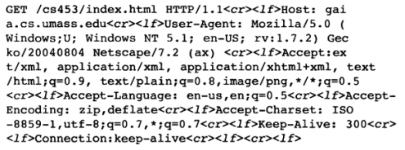

* 1. What is the URL of the document requested by the browser?

http://www.gaia.cs.umass.edu/cs453/index.html

* 1. What version of HTTP is the browser running?

HTTP 1.1

* 1. Does the browser request a non-persistent or a persistent connection?

This is a persistent connection because the keep-alive tag is set to 300 ms.

* 1. What is the IP address of the host on which the browser is running?

The IP address is >> gaia.cs.umass.edu.

* 1. What type of browser initiates this message? Why is the browser type needed in an HTTP request message?

Mozilla/5.0, it is required because different browsers handle content differently based on their design.