Addis Ababa University Institute of Technology
School of Information Technology and Engineering
AI – Project – Emotion Prediction Agent
Abreham Ararsa & Belete Tekle

Data Collection
The Face data we used for training is taken from kaggle in Representation Learning: Facial Expression Recognition Challenge from 2013. The data consists of 48x48 pixel of grayscale images of faces arranged in a row and seven categories/labels (0=Angry, 1=Disgust, 2=Fear, 3=Happy, 4=Sad, 5=Surprise, 6=Neutral) of emotions.

Feature filtering
We used a three layer Convolutional neural network for extracting features and we applied max-pooling to reduce the dimensions of the data. Finally we flatten the image matrix and pass it through a fully connected layer to classify the images.
Since we only have one input(image pixels) and one output(the predicted emotion, 0 to 6 ),We used sequential class from keras for creating the CNN model. We add each layer instance with conv2d method, which creates convolution kernel(4,4) that is convolved with the layer input to produce a tensor of outputs. The activation function used is relu, which activate each neuron(not all at once) to produce output for the next layer. The drop out rate used is 0.2.MaxPolling2D is used with window size and stride of 3 in each dimension.
Compile and train the model
in the model configuration, with use Adam optimizer and 'accuracy' as a metric to evaluate the model during the training and testing. And a loss/objective function used is cross-entropy.
in the training of the model, number of samples per gradient update is set to be 64, we have tried range of iteration to increase accuracy. verbosity mode used is progress bar during training and shuffle is on , to shuffle the training data before each epoch.

Facial Emotion Prediction
Capturing live frames:
we used pc camera as source of video and we used openCV library. we used VideoCapture class with '0' as an argument for capturing videos from the default source of video(camera), We have also tested the model on prerecorded videos and the results are promising. We created an infinite loop to capture frames from the video iteratively using the read method of VideoCapture class and convert the captured face data(if any) frame into gray-scale.
Detecting facial region:
We again make use of openCV's face detection API CascadeClassifier, to detect frontal face arias of the captured frame. The training data set we use for CascadeClassifier is haaarcascade_frontalface_default.xml. detectMultiScale returns the detected faces as list of rectangles and their locations.
prediction:
We loop through the detected face rectangles and draw the rectangles on the screen. we select area of interest from the image based on the returned rectangle and the location of the image. convert the selected area into array of metrics containing pixels after resizing the image based on our training data. reduce the rgb representation by dividing it by 255 and give the image to our model for prediction.

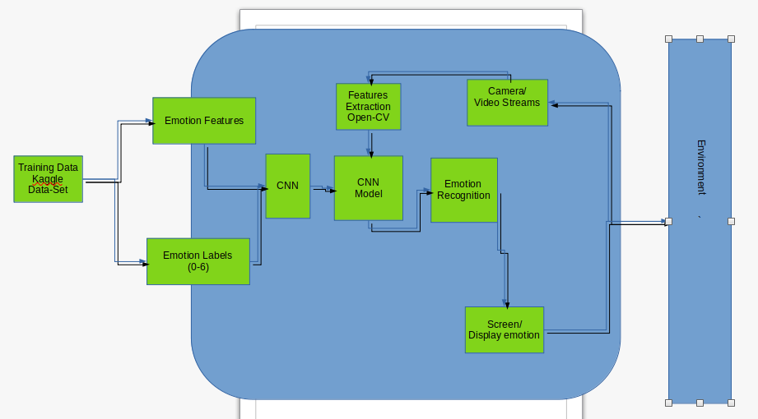
Fig : 1.1 : Emotion Prediction System

