Periodic leg movement index (mean ± standard deviation) in various age ranges.

|  |  |  |  |  |  |
| --- | --- | --- | --- | --- | --- |
|  | **CFS (*n* = 735)** | **WSC (*n* = 2400)** | **MrOS (*n* = 2911)** | **SSC (*n* = 766)** | **All (*n* = 6812)** |
| **Age [0 - 10]** | 2.23 ± 3.93  (*n* = 18) | - | - | - | 2.23 ± 3.93  (*n* = 18) |
| **Age [10 - 20]** | 2.55 ± 6.22  (*n* = 125) | - | - | 5.15 ± 13.17  (*n* = 13) | 2.80 ± 7.13  (*n* = 138) |
| **Age [20 - 30]** | 4.16 ± 10.47  (*n* = 103) | - | - | 2.30 ± 6.34  (*n* = 91) | 3.29 ± 8.81  (*n* = 194) |
| **Age [30 - 40]** | 4.83 ± 8.35  (*n* = 69) | 4.61 ± 7.19  (*n* = 8) | - | 3.40 ± 9.31  (*n* = 175) | 3.83 ± 8.99  (*n* = 252) |
| **Age [40 - 50]** | 7.09 ± 11.60  (*n* = 159) | 3.57 ± 7.73  (*n* = 315) | - | 6.16 ± 15.28  (*n* = 217) | 5.19 ± 11.55  (*n* = 691) |
| **Age [50 - 60]** | 10.83 ± 21.40  (*n* = 134) | 6.85 ± 14.85  (*n* = 860) | - | 10.11 ± 21.17  (*n* = 153) | 7.75 ± 16.75  (*n* = 1147) |
| **Age [60 - 70]** | 15.32 ± 26.20  (*n* = 65) | 10.50 ± 19.65  (*n* = 933) | 30.81 ± 33.80  (*n* = 460) | 15.92 ± 30.26  (*n* = 70) | 17.07 ± 27.07  (*n* = 1528) |
| **Age [70 - 80]** | 20.65 ± 34.38  (*n* = 49) | 19.88 ± 29.24  (*n* = 269) | 33.61 ± 36.59  (*n* = 1766) | 9.38 ± 24.67  (*n* = 38) | 31.14 ± 35.94  (*n* = 2122) |
| **Age [80 - 90]** | 18.58 ± 35.49  (*n* = 10) | 33.17 ± 31.84  (*n* = 9) | 44.47 ± 40.80  (*n* = 685) | 38.45 ± 56.80  (*n* = 4) | 43.93 ± 40.78  (*n* = 708) |

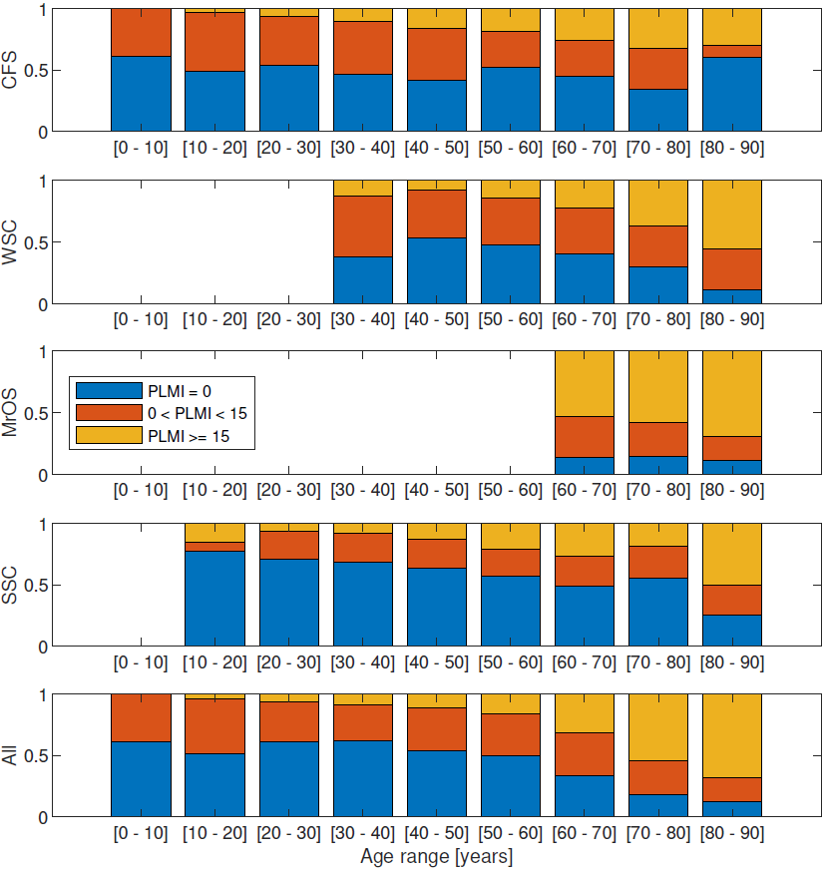

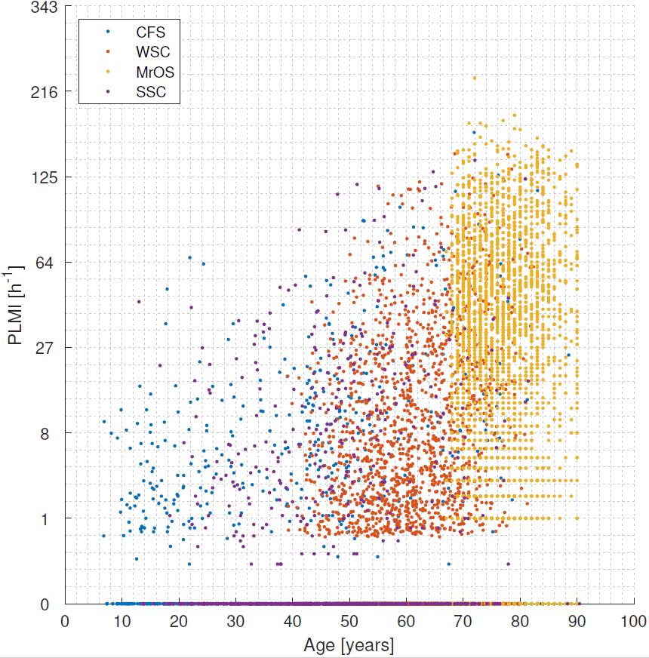

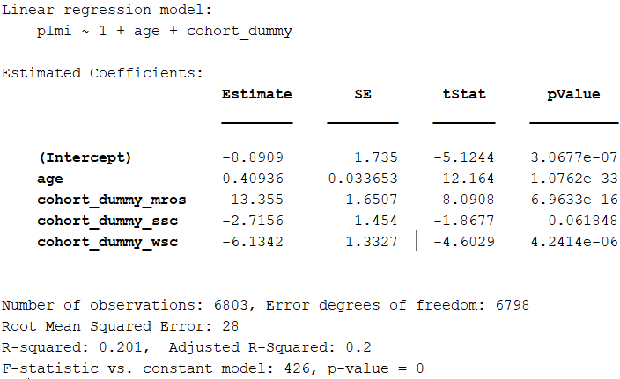

There is no variable for CFS, so the cohort effects are in relation to that cohort.