Name : Abrish Nasir

Sap id : 64530

Subject: Programming Fundamental

**LAB 8**

Task 1:

Write a program where the user has to guess a secret number. The program gives feedback if the guess is too high or too low and continues until the correct number is guessed.

Program:

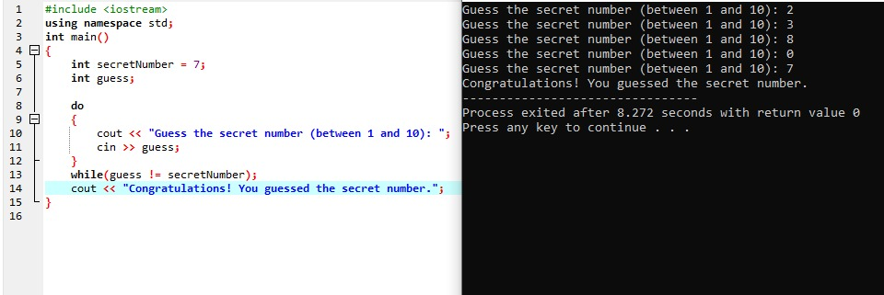

Task 2:

Write a program that calculates the factorial of a given number.

Program: 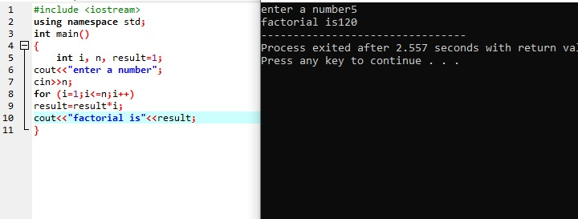

Task 3:

Write a program that starts a countdown from 10 and stops when it reaches 0 using a while loop.

Program:

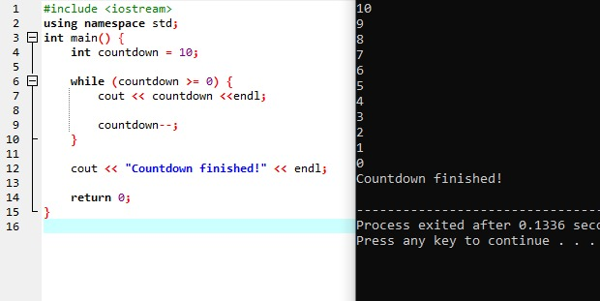

Task 4:

Write a program to print all even numbers between 1 and 20 using a while loop.

Program:

