Final Exam

Anshul Abrol  
[abroa01@pfw.edu](mailto:abroa01@pfw.edu)

1. PART #1

Unit 2: Prototype 2

Completion of Tutorial -

Unity Package and zip is Uploaded in oneDrive and below is the public link –  
<https://ind657-my.sharepoint.com/:f:/g/personal/abroa01_pfw_edu/ElOrw4FJVahCjHYR3czSfHcBG-kXo2MFGM4Iyv_4XSSbig?e=qbFFAI>

1. PART #2

Unit 4: Prototype 4

Completion of Tutorial -

Unity Package and zip is Uploaded in oneDrive and below is the public link –  
<https://ind657-my.sharepoint.com/:f:/g/personal/abroa01_pfw_edu/ElJxHzabCV5AnU6VsEGXRy0B-oYuHS0_y56bW3-MbVoobg?e=CpbJqJ>

**Challenge 4 –**

Unity Package and zip is Uploaded in oneDrive and below is the public link –

<https://ind657-my.sharepoint.com/:f:/g/personal/abroa01_pfw_edu/EqCxhI3Hf7BMhJNGUrqcdd4BH-8JzPBlvTdgr42kplYXJA?e=ROUDZh>

Source code files –

EnemyX.cs -  
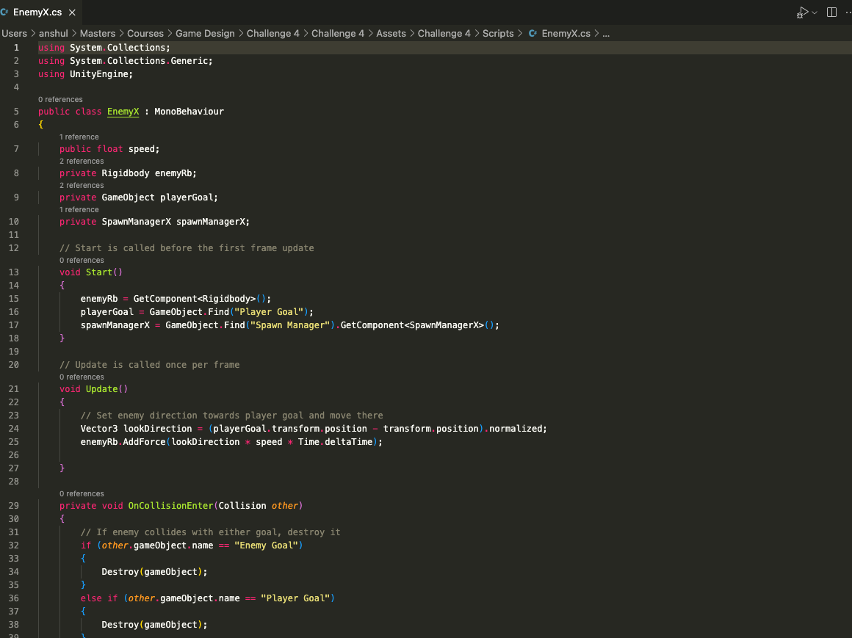

PlayerControllerX.cs -  
PLayerControllerX.cs


RotateCameraX.cs-

SpawnManagerX.cs -  
