Music Player Web Project Report

1. Introduction
This project is a Web-Based Music Player Application developed using HTML, CSS, and JavaScript.
The main objective of this project is to demonstrate how core web technologies work together to build
an interactive and dynamic web application. The project also emphasizes DOM manipulation, event handling,
and client-side scripting concepts used in modern web development.

2. Objectives of the Project
- - To design a user-friendly web-based music player
- - To implement interactive controls using JavaScript
- - To apply DOM manipulation and event listeners
- - To integrate data structures within a web project
- - To understand real-time audio handling in browsers

3. Technologies Used
- HTML – For creating the structure of the web page
- CSS – For styling, layout, and visual appearance
- JavaScript – For logic, interactivity, and audio control
- DOM – For dynamic content updates
- Event Listeners – For handling user actions
- HTML5 Audio API – For audio playback

4. Project Structure
- The project consists of the following files:
- - index.html: Defines the structure and layout
- - styles.css: Handles styling and UI design
- - music.js: Implements logic, audio handling, and data structures

5. HTML Implementation
HTML is used to create containers, buttons, sliders, and text areas.
Elements like div, input type range, and script tags are used to build the music player interface.

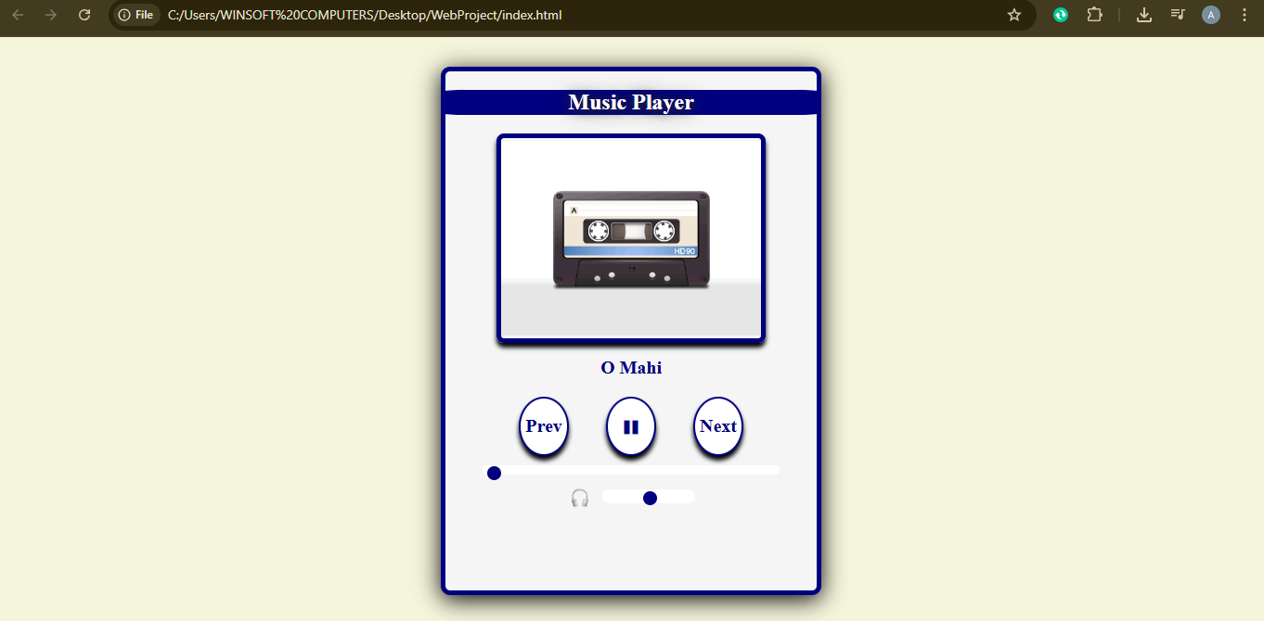

6. CSS Styling and Layout
CSS is used to enhance the appearance of the music player. Flexbox is used for alignment.
Borders, shadows, colors, and hover effects improve user experience.

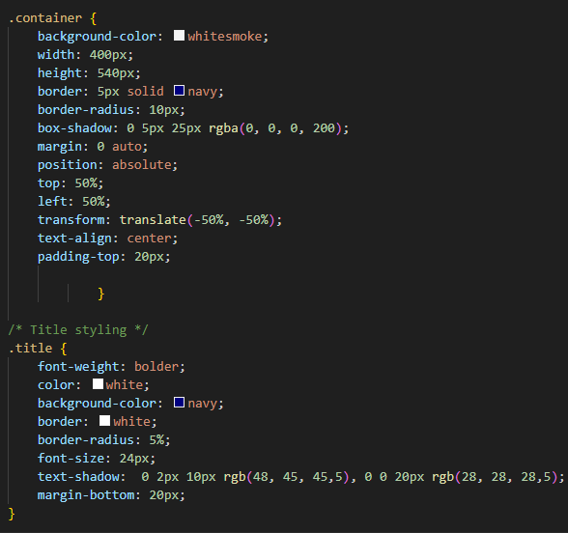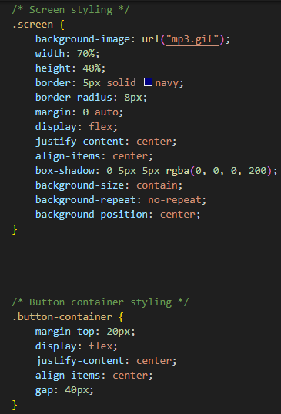
7. JavaScript Functionality
JavaScript controls the core functionality of the music player such as:
- - Playing and pausing audio
- - Switching songs
- - Updating progress bar
- - Controlling volume
- - Displaying current song name

8. DOM Manipulation
DOM methods like querySelector() and getElementById() are used to select and update HTML elements dynamically.

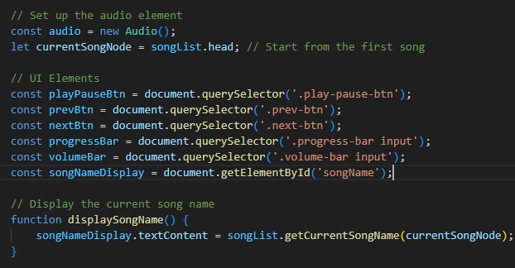
9. Event Handling
Event listeners handle user interactions such as button clicks and slider inputs.

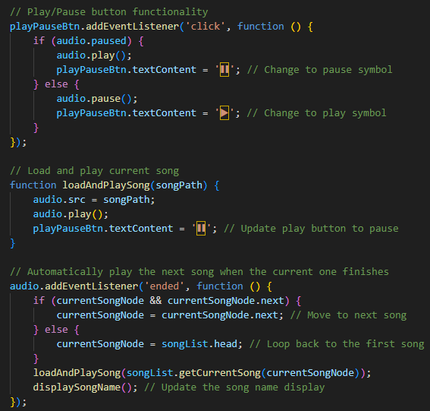

10. Data Structure Integration
A Circular Doubly Linked List is implemented to manage songs efficiently.
This allows seamless navigation between songs.

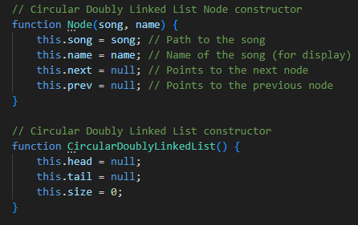
11. Audio API Usage
HTML5 Audio API is used to load, play, pause, and track songs in real time.

12. Testing and Results
The project was tested by playing multiple songs, switching tracks, adjusting volume,
and using the progress bar. All features worked correctly.]

13. Limitations
- - Uses local audio files
- - No online streaming
- - Limited playlist features

14. Future Enhancements
- - Online song support
- - Playlist creation
- - Shuffle and repeat options
- - Mobile responsiveness

15. Conclusion
This project successfully demonstrates a complete web application using HTML, CSS, JavaScript,
DOM manipulation, and event handling. It provides hands-on experience in front-end web development.

