


A LALR(1) Parser and Lexical Analyzer Generator for JavaScript written in JavaScript

Version 0.28
User's Manual

November 18, 2008

Copyright © 2007, 2008 by Jan Max Meyer, J.M.K S.F. Software Technologies
http://www.jmksf.com jscc<at>jmksf<dot>com

Table of Contents
1.Introducing JS/CC 3
Welcome to JS/CC! 3
The intention behind JS/CC 4
Future plans 4
Some words by the author 4
2.A quick start example 6
Building JS/CC for your platform 6
Installation and Start-Up 6
An example parser 8
Compiling the example 10
3.The Grammar Definition Language 11
General 11
The Terminal Declaration Part 11
Regular Expressions 12
Ambiguous Regular Expressions 13
Associativity and Precedence 13
Whitespace 13
The Grammar Definition Part 14
Accessing right-hand side items in semantic action 15
Value types 15
Resolving conflicts 15
4.Implementing a scripting language 18
The idea 18
Defining the grammar 19
Executing the script 21
The complete program 21
5.Debugging parsers 29
General 29
driver.js_ 29
driver_rhino.js_ 30
driver_web.js_ 30
6.Internal documentation 31
General 31
Folder overview 31
Root folder 31
Source folder 32
Document folder 34
Samples folder 34
Enhancing JS/CC itself 35
Building JS/CC 35
Code style 35
Developer's documentation 36
License Agreements 36
Credits 38

Introducing JS/CC

Welcome to JS/CC!
JS/CC is the first available parser development system for JavaScript and ECMAScript-derivatives.
It has been developed, both, with the intention of building a productive compiler development system and with the intention of creating an easy-to-use academic environment for people interested in how parse table generation is done general in bottom-up parsing.
JS/CC is a platform-independent software that unions both: A regular expression-based lexical analyzer generator matching individual tokens from the input character stream and a LALR(1) parser generator, computing the parse tables for a given context-free grammar specification to build a stand-alone, working parser. The context-free grammar fed to JS/CC is defined in a Backus-Naur-Form-based meta language, and allows the insertion of individual semantic code to be evaluated on a rule's reduction. JS/CC itself has been entirely written in JavaScript so it can be executed in many different ways:
- as platform-independent, browser-based JavaScript embedded on a Website, which comes with a graphical parse tree generator
- as a Windows Script Host Application or a compiled JScript.NET executable
- as a Mozilla/Rhino or Mozilla/Spidermonkey interpreted application
- or as a V8 shell script
All versions can be build and run under Linux, Windows, Mac OSX and any other, *nix-based operating system. For productive execution, it is recommended to use the command-line versions, which are capable of assembling a complete compiler from a JS/CC parser specification, which is then stored to a .js JavaScript source file.
To use JS/CC and for understanding its internals and behavior, some knowledge of context-free grammars, bottom-up parsing techniques and compiler construction theory, in general, is assumed. To get a fundamental introduction to compiler design and the different techniques and appendages on this topic, I warmly suggest to the book Compiler Design in C, written by Allen I. Holub.
Maybe in future, the JS/CC user's manual itself (or I'll write a system-independent one) will provide a detailed introduction on the very huge topic of compiler construction, but for now, I limit this manual only on the usage of JS/CC itself, and its internals.
If you plan to add new features or write enhancements to JS/CC or its documentation, please read the information below in the particular section about JS/CC's internals.

Now, enjoy JS/CC!

The intention behind JS/CC
JS/CC is an open source project released under the terms and conditions of the Artistic License.
When I started coding JS/CC, it was just planned as a quick-and-dirty fun project of implementing a LALR(1) parser generator in JavaScript for educational purposes, but it rapidly grew up because I added tons of more, useful features trough the time, making it a really productive and useable system for compiler writers and people who are just interested in how a parser generator works. The best of all within this software is, that JS/CC is capable to compile a complete, working parser for any language from a grammar specification with embedded, semantic code segments only in a normal web-browser like Mozilla Firefox.
Since the first public release v0.24 of JS/CC, many things have changed in this project. It received recommendations and accolades, people started to use it for real productive and academic issues, and some solved bugs and ported it to other platforms. I would like to specially thank Louis P. Santillan (lpsantil), for his work at this point. He ported JS/CC to the platforms Rhino and V8, and helped on restructring the whole package.
First focused on Windows and JScript as default platform for the console version of JS/CC, the project's maintainance changed over to Linux. Windows will still be supported, but core development is done on Linux now and in future.

Future plans
Development on JS/CC still moves on, and the more people using it, the more fun there is of developing it further. Both the academic and productive idea behind JS/CC will be followed. For future releases, a more yacc-styled behavior is planned, plus some features taken from several other, popular parser generator projects. This includes virtual production handling, embedded semantics, better analysis of the parse table generation process and much more.
An alternative JS/CC front-end with a lex/yacc-like syntax would complete the whole system.
It would be even possible to make JS/CC a parser generator for other target platforms than ECMAScript – but these are just ideas for now!

Some words by the author
The kernel of JS/CC is entirely written and maintained by me, Jan Max Meyer. I'm a software developer and hobbyist programmer from Germany and was born in 1985. The art of compiler design is a study on my own, because it very much interests me and makes a lot of fun. This project is one result of this study. I never studied on computer sciences yet, but plan this somewhere in the future.
In my professional life, I work as application software developer at a local business software company. As one of my hobbies, I also run my own, tiny software company – this is
J.M.K S.F. Software Technologies - from home, where I'm in writing programs and solutions around the area of software development tools, application software and some web-solutions. JS/CC is a non-profit based product of this business.
There is also another project in the area of computer-aided recognizer generation where I'm currently on, but more about this will be found out when its finished – and if I really release it.
But for now, I wish you much fun and success on using JS/CC. I hope that this software will be useful in your business or just helps you on understanding how bottom-up parsing works a little more clearly.
One thing I would deeply appreciate is, if you have the fun and engagement on developing JS/CC further, adding new features or just make it more popular.

PS: If you really like JS/CC and if you want to give me a smart pleasure for my efforts in developing this software, I would be very happy if you spend some money to the WDCS – Whale and Dolphin Conservation Society – who fights against the senseless killing and capturing of marine animals, like whales and dolphins, which is unfortunately the case in some countries of the world today.
We must keep this world for us and our children, and stop this senseless killing of endangered animals. And in my opinion, every second counts!
To support the life of whales and dolphins in our oceans, please visit http://www.wdcs.org.
Thank you very much.

A quick start example

Building JS/CC for your platform
JS/CC is a platform independent software. Because of that, you have to set it up for one platform. By default, JS/CC is targeted to Mozilla/Rhino when downloading the Tarball and to Jscript, both Windows Script Host and .NET, when downloading the Windows setup.
Under Linux or your *nix-based system, it is recommended to use GNU Make for all build-operations, under Windows, Microsoft nmake is assumed.
Currently, JS/CC can be build for the following platforms:
- Mozilla/Rhino
- Mozilla/Spidermonkey
- JScript (Windows Script Host)
- JScript.NET
- V8
- Web environment (HTML/JavaScript, entirely platform-independent)
The Makefile for each supported platform can be found in the src-directory, and follows the naming-convention Makefile.<platform>. To get additional help and howtos on the various platforms and how to build JS/CC there, look into the Makefile header comments.
The only Makefile optimized for Windows/nmake is Makefile.jscript, all the rest uses GNU make under a *nix environment.

Installation and Start-Up
To install JS/CC, download the Tarball or Windows setup program. By unpacking/installing it, you get a pre-configured JS/CC environment which uses Mozilla/Rhino (Tarball), or Microsoft JScript (setup). The web-environment can be used from both editions and any operating system.
To build JS/CC for other platforms, read the build-howtos in the according Makefiles.
After you successfully built JS/CC, run it with your desired platform. Under windows, you can simply run jscc.exe or cscript //Nologo jscc.js.
To run JS/CC with Rhino, do rhino jscc.js, and msjs jscc.js for the Spidermonkey version (or simply ./jscc.js, when execute permission is set). v8sh jscc.js will run the V8 engine as platform.
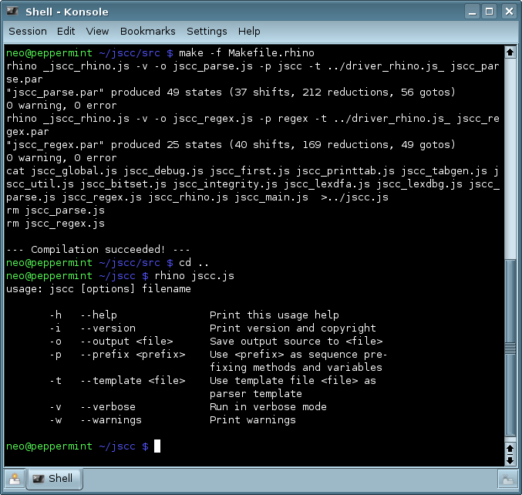Screenshot 1: Building and invoking JS/CC from a shell

To complete the list of invoking commands, run webenv/jscc.html with your favorite, JavaScript-enabled browser for the web environment ;).
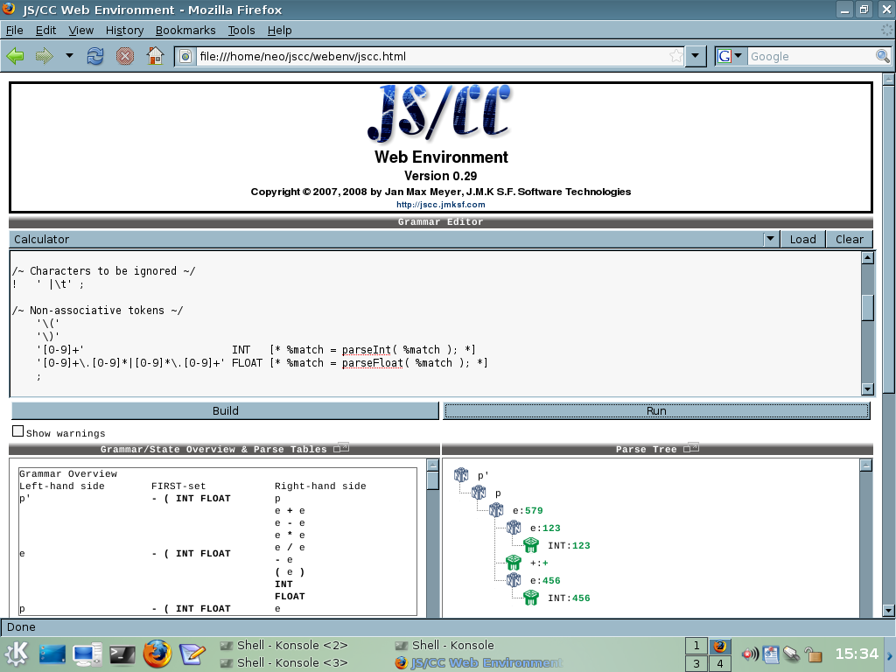Screenshot 2: The browser-based JS/CC web-environment

An example parser
In parser generators like yacc, a simple parser for mathematical expressions is the most widely used example to become familiar with the syntax and usage, so we do this even here. The parser definition language itself is described below in a more detailed way.
Store the following grammar definition into a text file of your choice; For parser source files, the .PAR file extension could be used, so the file is named "calc.par" in such case.
/~ Expression calculator written in JS/CC ~/

/~ Tokens to be ignored (e.g. whitespace, comments) ~/
! ' |\t'
;

/~ Grammar tokens ~/
'\+'
'\-'
'\*'
'/'
'\('
'\)'
'[0-9]+' INT [* %match = parseInt( %match ); *]
'[0-9]+\.[0-9]*|[0-9]*\.[0-9]+' FLOAT [* %match = parseFloat( %match ); *]
;
##
/~ The non-terminal "p" is the entry symbol, because it is the first one! ~/
program: expr [* print( %1 ); *]
;
/~ Don't confuse with the tokens: Here, we use the unescaped values because these
are not interpretered as regular expressions at this position! ~/
expr: expr '+' term [* %% = %1 + %3; *]
| expr '-' term [* %% = %1 - %3; *]
| term /~ Default semantic action fits here! ~/
;
term: term '*' factor [* %% = %1 * %3; *]
| term '/' factor [* %% = %1 / %3; *]
| factor /~ Default semantic action fits here! ~/
;
factor: '(' expr ')' [* %% = %2; *]
| INT /~ Default semantic action fits here! ~/
| FLOAT /~ Default semantic action fits here! ~/
;
/~ This is the parser entry point; Because this entry point could be very individual,
the compiler programmer has to decide which way he wants to read the source, parse
it and report the errors, if there are any. ~/
[*
var error_offsets = new Array();
var error_lookaheads = new Array();
var error_count = 0;

var str = new String( arguments[0] );
/*
The "##PREFIX##" is a wild card, where an optional, unique name will be inserted by
JS/CC when the parser is constructed. This enables the possibility to use multiple
different parsers in one project or script.
*/
if( ( error_count = __##PREFIX##parse( str,
error_offsets, error_lookaheads ) ) > 0 )
{
for( i = 0; i < error_count; i++ )
print( "Parse error near \""
+ str.substr( error_offsets[i] ) +
"\", expecting \"" +
error_lookaheads[i].join() +
"\"" );
}
*]

Compiling the example
To compile a working parser from the example described above, run JS/CC like as follows
rhino jscc.js -o calc.js calc.par
That's all! The result, calc.js, can now simply be executed using your desired platform.
As all *nix-like programs, JS/CC does output nothing when its invoked and successfully build the parser. The verbose-option prints out some statistics, e. g. how many states and actions had been created in the resulting parse table.

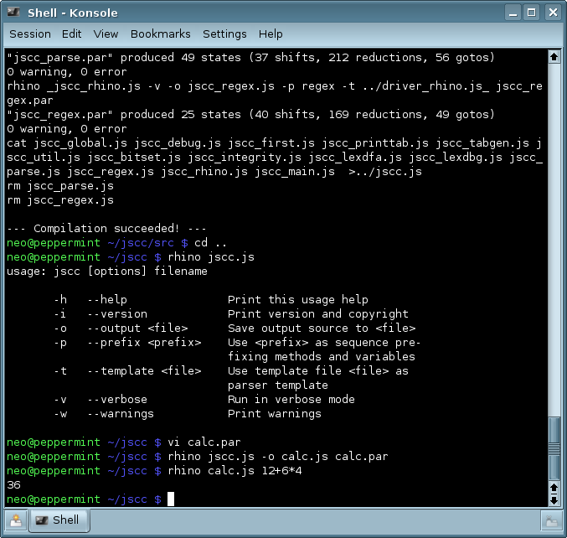Screenshot 3 - Compiling and executing the example

The Grammar Definition Language

General
As you can get from the expression calculator example above, the grammar definition language of JS/CC consists of two parts: The token definition part, and the grammar part, which defines the language's grammar using a Backus-Naur-Form-styled meta language. The two parts are separated by a ## symbol, which could be seen as a "separating line" between both parts.
[Some things in the current version of the JS/CC grammar definition language are currently a little bit nasty and need to be reworked in the future – like this ## separator...]

The Terminal Declaration Part
Tokens, or terminal symbols, are defined in the first part of each grammar definition file. These terminals are defined using a regular expression meta language, but it's also possible to give each terminal symbol an individual name and a individual code segment to be executed when this token is recognized by the generated lexical analyzer (e. g. to cut the leading and trailing quotation marks if a string is recognized from the token's attribute).
The general syntax to define tokens is
regular-expression label code
.
.
.
;
where label and code is optional.
The regular expression is specified in the ways described below, using a single- or double-quoted string.
A token's label is defined as a single word identifier, e. g. "FLOAT" or "INTEGER_NUMBER". Not allowed are separated words. If no label is specified, JS/CC uses the regular-expression definition itself as label, but without taking escape-characters, so the regular expression '\+' will result in the label '+', as in the above example. If '+' itself is specified as regular expression, a parse error will occur because the plus-character is the symbol for a positive closure in regular expressions.
A semantic code action is defined by enclosing the desired JavaScript code segment with a [* and *] symbol. If more than one code segment is specified in a row, all segments are summarized to one segment to be attached to the terminal symbol. To simply access things like the matched pattern, the offset where the pattern starts or the source string in this individual code segments, the wild cards %match, %offset and %source should be used. These wild cards are later substituted by the particular variable names in the resulting lexical analyzer.
Because JS/CC does also allow to pass precedence and associativity information to tokens or token groups, each block of token definitions is closed by a semicolon (;). Because of that, the semicolon is set behind the last token definition also in the above example, even if we don't use any precedence information here.

Regular Expressions
Because it was impossible to build a properly working lexical analyzer using JavaScript's build-in RegExp-object, JS/CC features its own implementation of regular expression processing. This is also the reason that not all the features of the JavaScript RegExp-object are provided, like back-references and predefined character classes.
The symbols and operators to be used within JS/CC's own regular expression language are summarized in the following table.
They form a minimal implementation of a regular expression engine.
Language Element | Description
Character | One character specifies exactly that character; If a regular-expression operator like + or * should be used, it must be escaped via \.
\ascii-code | One character, defined via ASCII-code, e.g. "\220" matches the Ü-umlaut of the extended ASCII-table.
\character | Escaped character. Must be used when a character of the meta-language itself should be matched, e.g. "\|".
. | Any character (character class matching all available characters).
[...] | Character-class; If a beginning circumflex (^) is given, the character-class is negated. Character ranges can be specified using a dash. For example "[A-Za-z]" specifies all capital and lower-case alphabet letters.
(...) | Sub-expression.
| | Or-operator; Allows to specify different expressions at one level.
* | Kleene-closure operator (none or many), to be specified behind a character, character-class or sub-expression.
+ | Positive-closure operator (one or many), to be specified behind a character, character-class or sub-expression.
? | Optional-closure operator (one or none), to be specified behind a character, character-class or sub-expression.
Table 1: JS/CC own regular expression meta language
Even to allow case-insensitive keywords within grammar definitions, a terminal symbol definition can be specified using single-quoted ('...') and double-quoted ("...") strings. A single-quoted string means that a terminal symbol is matched case-sensitive, a double-quoted one matches a terminal in any case order. For example, the terminal symbol definition "PRINT" will match for Print, print, PrINT and PRINT, while the definition 'PRINT' will only match for PRINT itself.
From these regular expression definitions, JS/CC constructs a deterministic finite automation which acts as lexer in the resulting parser.

Ambiguous Regular Expressions
If there are ambiguous regular expressions (where several expressions match the same string) within the terminal definition part, the expressions defined upper in the terminal definition part will take higher match precedence than the lower defined terminals.. It is recommended to define tokens with a higher specialization level as the first, and tokens with a lower level as the last in your token definition part.

Associativity and Precedence
Tokens can be grouped by precedence levels and associativity. This features allows to write faster and even smaller grammars, by resolving grammar conflicts by weighting terminal symbols.
A group without a group specifier will set no associativity and a precedence level of zero to all terminal symbols in this group (as in the first example).
Else, if a group begins with the symbol < for left-associativity, > for right-associativity and ^ for non-associativity, all terminal symbols within this group are set to the according associativity and precedence level. The precedence level is incremented each time a new group of these three types is opened, so groups that are defined at the bottom of the token definition part take the highest precedence.
The precedence information as associativity is used to resolve conflicts in ambiguous grammars by modifying the parse table's natural content; How this works in practice and what ways and possibilities there are is described below in the section dialing with grammar conflicts and their handling.

Whitespace
A special type of terminal symbol is introduced by the exclamation-mark (!) symbol: The whitespace symbols!
In this definition, there is only a regular expression possible; A label or code part is prohibited. As whitespace-tokens, terminals that should always be ignored can be specified, e. g. blanks, tabs or comments.

The Grammar Definition Part
The second – and most important - part of a JS/CC parser definition is the grammar definition part. In this part, below the ## symbol, the definition of the context-free grammar to be parsed by the generated parser is described. This is done by using a Backus-Naur-Form variant meta language, by defining non-terminals and their productions.
The general syntax for a non-terminal and its productions is
non-terminal : production¹ semantic-code
| production² semantic-code
.
.
.
| production^{n} semantic-code
;
The non-terminal defines a single-word identifier and acts as the left-hand side for the related productions attached to this symbol.
The production defines a sequence of zero or multiple terminals and non-terminals, defining the different syntax rules. To specify terminal symbols, it is possible to call them via their (unescaped) regular expression (as described above!) via a string-value or by their label, which must not (but can) be specified as a string value. In the example of the quick start part, both methods are used: FLOAT is called by its label, the token '+', for better readability, is called by it's generated name which came from the regular expression.
The semantic-code part behind the productions is optional, and defines an individual semantic code which is executed right before the according production is reduced to its left hand side. Same as in the token definition part, semantic code is enclosed by [* and *] and will be concatenated to one code segment which is associated with the according productions when multiple semantic code segments are specified in a row. Read more about this in the section below.
Note that in the above syntax scheme the number of productions is completely variable. At least, one right-hand side must be given to an according left-hand side, although this can be an epsilon production.
Each production is separated by a vertical "pipe" bar (|) from the others, and a non-terminal definition must always be closed by a semicolon. Else, JS/CC can not distinguish if the next symbol belongs to the right-hand side it currently parses or if it reads a new non-terminal definition.
Non-terminal symbols can be called on a right-hand side before they are defined, so the way the rules are defined is arbitrary. Integrative checks on the grammar are done by JS/CC before the parse tables will be constructed.

Accessing right-hand side items in semantic action
Within each semantic action attached to a production, as described above, the values of the right-hand side symbols can be accessed via wild cards, which are replaced by the particular variables and offsets later in the resulting parser.
The %n wild cards are used to address every individual token starting from the left of the right-hand side.
The %% wild card relates to the value of the left-hand side which is pushed to the parser's value stack right after the right-hand side symbols are popped.
So by passing a value to the %% wild card causes the inheritance of values from the current right-hand side to another call of the according non-terminal on a right-hand side within the parse tree. The values on the current right-hand side will be discarded when the reduction process occurs, and the value attached to %% is pushed instead, so it can be used elsewhere.
As example, in the given production
expr: expr '+' term [* %% = %1 + %3; *]
of the above expression calculator, the return values of the expr and the term on the right-hand side, which are addressed via %1 and %3 (%2 addresses the value of the '+'-terminal!) are added together, and the result is stored to the left hand-side (the expr on the far left in this case). Thus, you have full control over all individual tokens within each production.
If no individual semantic action is given to a right-hand side, the default action
%% = %1;
is used.
Semantic action between the symbols of a right-hand side is not allowed, only behind them.

Value types
Because JS/CC was designed for the use with JavaScipt, or any other typeless scripting language, it is not necessary to define – as in yacc – a special union structure to hold the values on the value stack. Both build-in primary types like String or Number objects as well as user-defined objects [each function in JavaScript is internally represented by an object] can be pushed to and popped off the value stack.
So don't confuse with the values; You have to know what value stands on which position.

Resolving conflicts
To automatically resolve shift-reduce or reduce-reduce conflicts at parse table generation, JS/CC features, by default, two mechanisms.
When a shift-reduce conflict occurs, JS/CC constructs the parse tables in favor of the shift, so the parse tree will grow right derivative.
When a reduce-reduce conflict occurs, JS/CC resolves the problem by reducing the production which was defined first, so productions which where defined above in the grammar will be reduced in favor when this conflict comes up.
As shortly described in the chapter about terminal symbol definition, JS/CC features the possiblity of manipulating the natural parse table generated by the LALR(1) table construction algorithm by weighting terminal symbols with a precedence level and an associativity. This information is used within shift-reduce conflicts to better decide if a shift or a reduce operation should be inserted.
If a shift-reduce conflict comes up, the precedence level and associativity information is compared with the according production's precedence level, because every production will, by default, get the same precedence level as its rightmost terminal symbol.
To explain this behavior, let's look at the following example. It defines a calculator same as the first example, but with lesser effort in writing the grammar; Here, we have only two non-terminal symbols instead of four, but we implement the same operator precedence behavior as in the original one.
/~ Tokens to be ignored (e. g. whitespace, comments) ~/
! ' |\t';
/~ Left-associative tokens, lowest precedence ~/
< '\+'
'\-';
/~ Left-associative tokens, highest precedence ~/
< '\*'
'/';

/~ Tokens with no associativity ~/
'\('
'\)'
'[0-9]+' INT [* %match = parseInt( %match ); *]
'[0-9]+\.[0-9]*|[0-9]*\.[0-9]+' FLOAT [* %match = parseFloat( %match ); *]
;
##
program: expr [* print( %1 ); *]
;
expr: expr '+' expr [* %% = %1 + %3; *]
| expr '-' expr [* %% = %1 - %3; *]
| expr '*' expr [* %% = %1 * %3; *]
| expr '/' expr [* %% = %1 / %3; *]
| '(' expr ')' [* %% = %2; *]
| INT
| FLOAT
;
Sometimes, it will also be necessary to give a production another precedence level than the one of the rightmost terminal. For example, if we want to add an unary minus operator to the grammar above, the production adopts the precedence level of the minus-symbol by default. But this minus-operator was configured for its use in a binary subtraction, not in an unary subtraction. By simply adding a new rule for unary minus to the grammar, most simple expressions will return the right result (e. g. "-2+3"), but in expressions like "4/-4*5", the result will simply be wrong, because, trough our precedence rules for multiplication, the generated parser parses "4/(-(4*5))" instead of "(4/(-4))*5".
To resolve this problem, we need to attach a higher precedence level to the production for unary minus. For this special case, JS/CC features the &-directive. The &-directive must be specified behind the rule's definition and in front of the semantic code action (if there is any). Behind the &-directive, a terminal symbol (both as string or its label) is specified, which precedence level is taken by the production instead of its default value.
So by changing the grammar to
expr: expr '+' expr [* %% = %1 + %3; *]
| expr '-' expr [* %% = %1 - %3; *]
| expr '*' expr [* %% = %1 * %3; *]
| expr '/' expr [* %% = %1 / %3; *]
| '(' expr ')' [* %% = %2; *]
| '-' expr &'*' [* %% = %2 * -1; *]
| INT
| FLOAT
;
we get the right parse tree and result, because our rule with the unary minus has a higher precedence now and reduces instead of shifting in the desired cases.

Implementing a scripting language

The idea
As a real, practical example, we will now write a simple, interpreted programming language, called XPL (eXample Programming Language) using JS/CC. XPL is a C-styled script language interpreter, providing simple user input/output operations, loops and conditional execution as well as variables. As variable type, only numbers are supported (integer and floating point, all use the same, internal JavaScript type "Number"). The Definition of user-defined functions is not possible in this scripting language, but it would be a thing of simplicity to add this feature.
For text output, XPL provides a special say-command which allows to output constant texts.
To get familiar with XPL's syntax, look at the following example scripts.
hello.xpl:
//This is a simple Hello World script, written in XPL.
say 'Hello World';
99-bottles-of-beer.xpl:
//The wonderful "99 bottles of beer"-program
bottles = 99;
do
{
//The output will not be the prettiest, but that is limited
//by the implementation (you can change it if you want ;))
write bottles;
if bottles == 1 say 'bottle of beer on the wall,';
else say 'bottles of beer on the wall,';

write bottles;
if bottles == 1
say 'bottle of beer';
else
say 'bottles of beer';

say 'Take one down, pass it around,';
bottles = bottles - 1;

write bottles;
if bottles == 0 say 'no more bottles of beer on the wall';
else if bottles == 1 say 'bottle of beer on the wall';
else say 'bottles of beer on the wall';

say ''; //Empty line
}
while bottles > 0;

say 'That''s it!';
countdown.xpl:
//A rocketry launch countdown ;)
say '--- The final countdown progam ---';

do
{
say 'Enter your starting number (it must be greater or equal 10!):';
read count;

if count < 10 say 'The number is lower 10!';
}
while count < 10;

say 'Starting sequence...';
while count >= 0 do
{
write count;

//Ignition at 3 loops before lift-off...
if count == 3 say 'Ignition...';
else if count == 0 say '...and lift-off!';
count = count - 1;
}

Defining the grammar
The unaugmented grammar definition for the XPL-grammar is the following, and consists of less than 80 lines of grammar and terminal definition code.
! ' |\r|\n|\t|//[^\n]*\n'

"IF"
"ELSE"
"WHILE"
"DO"
"SAY"
"WRITE"
"READ"
'{'
'}'
';'
'\('
'\)'
'='
'[A-Za-z_][A-Za-z0-9_]*' Identifier
'\'([^\']|\'\')*\'' String
'[0-9]+' Integer
'[0-9]+\.[0-9]*|[0-9]*\.[0-9]+' Float
;

> '=='
'!='
'<='
'>='
'>'
'<'
;

< '\+'
'\-'
;

< '/'
'\*'
;

##

Program: Program Stmt
|
;

Stmt_List: Stmt_List Stmt
|
;

Stmt: IF Expression Stmt
| IF Expression Stmt ELSE Stmt
| WHILE Expression DO Stmt
| DO Stmt WHILE Expression ';'
| SAY String ';'
| WRITE Expression ';'
| READ Identifier ';'
| Identifier '=' Expression ';'
| '{' Stmt_List '}'
| ';'
;

Expression: Expression '==' Expression
| Expression '<' Expression
| Expression '>' Expression
| Expression '<=' Expression
| Expression '>=' Expression
| Expression '!=' Expression
| Expression '-' Expression
| Expression '+' Expression
| Expression '*' Expression
| Expression '/' Expression
| '-' Expression &'*'
| '(' Expression ')'
| Integer
| Float
| Identifier
;

Executing the script
It is impossible to interpret an XPL script directly like in the first expression calculator example. It probably works also here, but only in expressions. Statements like while...do or if...else are not directly interpretable, because they have a body and a conditional part. Because of that, we need to compile the program internally into a structure for a virtual machine. This virtual machine uses an assembly like command language, working with opcodes and operands.
The parser has the purpose to build-up a cascading structure of nodes, which form the program that can be executed. This method avoids the use of dealing with jumps to addresses, but cannot be used to be written to a file.
Note that this compiler will not compile into an assembly code file. The assembly program is constructed directly into the memory as an internal structure. The virtual machine executing this structure will at least exist of one function, which calls itself recursively based on the operation it should execute.

The complete program
This is the complete, augmented program code for the XPL compiler and interpreter, based on the grammar definition from above. A script is executed from a file, which must be attached to the WSH script at startup.
/~
XPL - eXample Programming Language v0.3
Written 2007 by J.M.K S.F. Software Technologies, Jan Max Meyer

The complete source of this program is in the Public Domain.

This example demonstrates the implementation of XPL, a complete,
interpretered scripting language, written in JS/CC.

XPL provides simple input/output operations and can only handle
numeric values.

Watch out for the *.xpl-files within the example directory, which
contain example scripts to be executed using XPL.
~/

[*

//Structs
function NODE()
{
var type;
var value;
var children;
}

//Defines
var NODE_OP = 0;
var NODE_VAR = 1;
var NODE_CONST = 2;

var OP_NONE = -1;
var OP_ASSIGN = 0;
var OP_IF = 1;
var OP_IF_ELSE = 2;
var OP_WHILE_DO = 3;
var OP_DO_WHILE = 4;
var OP_WRITE = 5;
var OP_READ = 6;
var OP_SAY = 7;

var OP_EQU = 10;
var OP_NEQ = 11;
var OP_GRT = 12;
var OP_LOT = 13;
var OP_GRE = 14;
var OP_LOE = 15;
var OP_ADD = 16;
var OP_SUB = 17;
var OP_DIV = 18;
var OP_MUL = 19;
var OP_NEG = 20;

//Management functions
function createNode( type, value, childs )
{
var n = new NODE();
n.type = type;
n.value = value;
n.children = new Array();

for( var i = 2; i < arguments.length; i++ )
n.children.push( arguments[i] );

return n;
}
//Array to store variable names and values to
var v_names = new Array();
var v_values = new Array();
//Function to store a variable's content to a variables name. If the name does
//not exist already, the variable is automatically created.
function letvar( vname, value )
{
var i;
for( i = 0; i < v_names.length; i++ )
if( v_names[i].toString() == vname.toString() )
break;

if( i == v_names.length )
{
v_names.push( vname );
v_values.push( 0 );
}

v_values[i] = value;
}
//Function to get a variable's content over its name
function getvar( vname )
{
var i;
for( i = 0; i < v_names.length; i++ )
if( v_names[i].toString() == vname.toString() )
return v_values[i];

return 0;
}
//This is the interpreting function, working on base of the compiled program structure.
function execute( node )
{
var ret = 0;

if( !node )
return 0;

switch( node.type )
{
case NODE_OP:
switch( node.value )
{
case OP_NONE:
/* OP_NONE can have childs (a block!) */
if( node.children[0] )
execute( node.children[0] );
if( node.children[1] )
ret = execute(
node.children[1] );
break;
case OP_ASSIGN:
letvar( node.children[0], execute(
node.children[1] ) );
break;
case OP_IF:
if( execute( node.children[0] ) )
execute( node.children[1] );
break;
case OP_IF_ELSE:
if( execute( node.children[0] ) )
execute( node.children[1] );
else
execute( node.children[2] );
break;
case OP_WHILE_DO:
while( execute( node.children[0] ) )
execute( node.children[1] );
break;
case OP_DO_WHILE:
do
execute( node.children[0] )
while( execute( node.children[1] ) );
break;
case OP_WRITE:
WScript.Echo( execute( node.children[0] )
);
break;
case OP_READ:
letvar( node.children[0].toString(),
WScript.StdIn.ReadLine() );
break;
case OP_SAY:
WScript.Echo( node.children[0] );
break;
case OP_EQU:
ret = execute( node.children[0] ) ==
execute( node.children[1] );
break;
case OP_NEQ:
ret = execute( node.children[0] ) !=
execute( node.children[1] );
break;
case OP_GRT:
ret = execute( node.children[0] ) >
execute( node.children[1] );
break;
case OP_LOT:
ret = execute( node.children[0] ) <
execute( node.children[1] );
break;
case OP_GRE:
ret = execute( node.children[0] ) >=
execute( node.children[1] );
break;
case OP_LOE:
ret = execute( node.children[0] ) <=
execute( node.children[1] );
break;
case OP_ADD:
ret = execute( node.children[0] ) +
execute( node.children[1] );
break;
case OP_SUB:
ret = execute( node.children[0] ) -
execute( node.children[1] );
break;
case OP_DIV:
ret = execute( node.children[0] ) /
execute( node.children[1] );
break;
case OP_MUL:
ret = execute( node.children[0] ) *
execute( node.children[1] );
break;
case OP_NEG:
ret = execute( node.children[0] ) * -1;
break;
}
break;

case NODE_VAR:
ret = Number( getvar( node.value ) );
break;

case NODE_CONST:
ret = Number( node.value );
break;
}
return ret;
}

*]
/~ Defining whitespaces and comments ~/
! ' |\r|\n|\t|//[^\n]*\n'
/~ Keywords (case-insensitive!) and program structure operators ~/
"IF"
"ELSE"
"WHILE"
"DO"
"SAY"
"WRITE"
"READ"
'{'
'}'
';'
'\('
'\)'
'='
'[A-Za-z_][A-Za-z0-9_]*' Identifier
'\'([^\']|\'\')*\'' String [* %match = %match.substr( 1,
%match.length - 2 );
%match = %match.replace( /''/g,
"\'" );
*]
'[0-9]+' Integer
'[0-9]+\.[0-9]*|[0-9]*\.[0-9]+' Float
;
/~ Operators to be used in expressions ~/
> '=='
'!='
'<='
'>='
'>'
'<'
;

< '\+'
'\-'
;

< '/'
'\*'
;

##

Program: Program Stmt [* execute( %2 ); *]
|
;

Stmt_List: Stmt_List Stmt [* %% = createNode( NODE_OP,
OP_NONE, %1, %2 ); *]
|
;

Stmt: IF Expression Stmt [* %% = createNode( NODE_OP,
OP_IF, %2, %3 ); *]
| IF Expression Stmt ELSE Stmt [* %% = createNode( NODE_OP,
OP_IF_ELSE, %2, %3, %5 ); *]
| WHILE Expression DO Stmt [* %% = createNode( NODE_OP,
OP_WHILE_DO, %2, %4 ); *]
| DO Stmt WHILE Expression ';' [* %% = createNode( NODE_OP, OP_DO_WHILE,
%2, %4 ); *]
| SAY String ';' [* %% = createNode( NODE_OP, OP_SAY,
%2 ); *]
| WRITE Expression ';' [* %% = createNode( NODE_OP, OP_WRITE,
%2 ); *]
| READ Identifier ';' [* %% = createNode( NODE_OP, OP_READ,
%2 ); *]
| Identifier '=' Expression ';' [* %% = createNode( NODE_OP, OP_ASSIGN,
%1, %3 ); *]
| '{' Stmt_List '}' [* %% = %2; *]
| ';' [* %% = createNode( NODE_OP, OP_NONE );
*]
;

Expression: Expression '==' Expression [* %% = createNode( NODE_OP, OP_EQU,
%1, %3 ); *]
| Expression '<' Expression [* %% = createNode( NODE_OP, OP_LOT,
%1, %3 ); *]
| Expression '>' Expression [* %% = createNode( NODE_OP, OP_GRT,
%1, %3 ); *]
| Expression '<=' Expression [* %% = createNode( NODE_OP, OP_LOE,
%1, %3 ); *]
| Expression '>=' Expression [* %% = createNode( NODE_OP, OP_GRE,
%1, %3 ); *]
| Expression '!=' Expression [* %% = createNode( NODE_OP, OP_NEQ,
%1, %3 ); *]
| Expression '-' Expression [* %% = createNode( NODE_OP, OP_SUB,
%1, %3 ); *]
| Expression '+' Expression [* %% = createNode( NODE_OP, OP_ADD,
%1, %3 ); *]
| Expression '*' Expression [* %% = createNode( NODE_OP, OP_MUL,
%1, %3 ); *]
| Expression '/' Expression [* %% = createNode( NODE_OP, OP_DIV,
%1, %3 ); *]
| '-' Expression &'*' [* %% = createNode( NODE_OP, OP_NEG,
%2 ); *]
| '(' Expression ')' [* %% = %2; *]
| Integer [* %% = createNode( NODE_CONST, %1 ); *]
| Float [* %% = createNode( NODE_CONST, %1 ); *]
| Identifier [* %% = createNode( NODE_VAR, %1 ); *]
;
[*
//Utility function: Open and read a file
function open_file( file )
{
var fs = new ActiveXObject( 'Scripting.FileSystemObject' );
var src = new String();

if( fs && fs.fileExists( file ) )
{
var f = fs.OpenTextFile( file, 1 );
if( f )
{
src = f.ReadAll();
f.Close();
}
}

return src;
}
//Main
if( WScript.Arguments.length > 0 )
{
var str = open_file( WScript.Arguments(0) );
var error_cnt = 0;
var error_off = new Array();
var error_la = new Array();

if( ( error_cnt = __##PREFIX##parse( str, error_off, error_la ) ) > 0 )
{
for( i = 0; i < error_cnt; i++ )
WScript.Echo( "Parse error near \""
+ str.substr( error_off[i], 10 ) +
( ( str.length > error_off[i] + 10 ) ? "..." : "" ) +
"\", expecting \"" + error_la[i].join() + "\"" );
}
}
else
WScript.Echo( 'usage: xpl.js <filename>' );
*]

Debugging parsers

General
When JS/CC compiles a grammar, the parse tables are inserted into a so called driver template which then executes the parser based on the content of the parse tables.
This parser drivers offers several methods to debug grammars.
JS/CC comes with two parser driver templates. They are defined in the files driver.js_ and driver_web.js_, where the first one is for console-based parsers compiled for JScript.NET and JScript for Windows Script Host, and the latter one is a platform independent, web-based parser to be executed in a web browser.
The grammar debugging features of the respective parse table driver are enabled by setting some global variables to true.

driver.js_
The driver.js_ parser driver for JScript (both JScript.NET and JScript on Windows Script Host) provides the most debugging features. It is capable to trace the parse process – even step by step – and to print a pseudo-graphical parse tree as an ASCII-based image to the console.
The provided debugging features are:
- Trace (##PREFIX##_dbg_withtrace)
The parse trace provides information about each parser state which is entered with which input tokens, parse stack and value stack. This feature is very useful to understand the parse process and to detect possible value access errors.
- Step-by-step (##PREFIX##_dbg_withstepbystep)
This can only be used in conjunction with the parse trace, and waits that the user presses enter to continue to the next state. Has no effect when trace is switched off.
- Parse tree generation (##PREFIX##_dbg_withparsetree)
Generates a parse tree at the end of the parse. This parse tree, which is printed in a pseudo-graphical tree view, represents the structure of the complete parsed input splitted into all the used productions and tokens at the leafes of the tree.
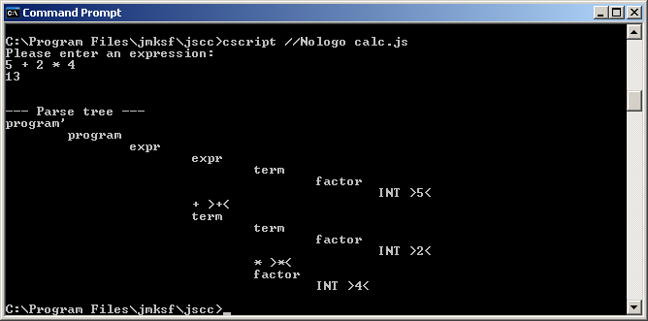Screenshot 4: The parse tree visualization feature of the driver.js_ parser

To switch the debugging features on, set the variables in the brackets to true before invoking parser function. The ##PREFIX## will be replaced by the optionally defined prefix you set when calling JS/CC.

driver_rhino.js_
This driver features the same possibilities like driver.js_, but can be used for parsers running on the the Mozilla Rhino platform.

driver_web.js_
This is the web-based version of the JS/CC default driver, based on driver.js. It should be used for browser-based JavaScript applications, generated to a HTML-file. It provides even the parse trace and step-by-step debugging features, but parse tree generation is not provided here.

Internal documentation

General
After all, the JS/CC parser development system consists of two parts: The parser generator, which analyzes a grammar, computes the parse table, and builds the code, and the parser driver, which works on the generated parse tables and runs the parser.
The parser driver is used by the parser generator as a template, where the parse tables and some arbitrary values are inserted to special, pre-defined insertion points (the so called "wildcards").
The result of this process is the individual parser, which can be executed.
Note that both parts of the JS/CC system have different copyright restrictions: The parser generator is a copyrighted open source program, for more information, see the Artistic License provided with the program package. The parser driver (template) instead is in the public domain – there is no copyright on it, which enables the use of JS/CC generated parsers both for commercial (even closed-source) and non-commercial applications. This also includes that changes of any kind are allowed on the parser driver, but note, that changing the parser driver without any knowledge on it can make newly generated parsers work wrong.
This internal documentation should be a short introducion for people who are interested in both coding or to simply get more familar with the parser generator and the parser driver.
Note that with the name JS/CC, the parser generator itself is meaned in the most cases.

Folder overview
This chapter gives a short overview about the directories of the JS/CC software package.

Root folder
The root-folder contains the binaries and executables of JS/CC.
File | Usage/Description
jscc.exe | JS/CC parser generator as JScript.NET executable; Recommended for productive usage.
jscc.html | JS/CC parser generator web interface for interactive parser generation and debugging.
jsccr.js | JS/CC parser generator implementation to be executed on the Mozilla/Rhino ECMAScript interpreter.
driver.js_ | JS/CC parser driver template to be used with WSH and JScript.NET programs. It provides powerful debugging possibilities and is used for productive parser generation.
driver_web.js_ | JS/CC web parser driver to be used for web-based applications. It features lesser debug possibilites than driver.js_ and cannot be executing with WSH or Jscript.NET.
driver_rhino.js_ | JS/CC parser driver for parsers to be executed on Mozilla/Rhino.
ARTISTIC | The license agreement of JS/CC (Artistic License).
CHANGES | Log about the changes and bugfixes in the latest version.
README.RHINO | Some additional information for the JS/CC Rhino port and how it is used.
jscc_logo_small.png | JS/CC Logo used by jscc.html.
jscc_logo.png | A huger version of the JS/CC Logo.
Table 2: root directory overview

Source folder
The source folder (/src) contains the whole source code of the JS/CC parser generator, and some additional files which are necessary to build and develop JS/CC.
File | Usage/Description | Used by
jscc.js | JS/CC parser generator entry source; This is the general entry point for all JScript versions of JS/CC. | JScript.NET  WSH JScript
jscc_RHINO.js | The JS/CC program entry for the Mozilla/Rhino port version. | Rhino
jscc_global.js | Global declarations and variables. This file contains only declarations, switches and other defineable values used within the whole process of parse table generation. | JScript.NET  WSH JScript  Web  Rhino
jscc_util.js | Utility functions used by several modules. | JScript.NET  WSH JScript  Web  Rhino
jscc_debug.js | Debug and dump functions for JS/CC debugging. | JScript.NET  WSH JScript  Web  Rhino
jscc_parse.par  jscc_parse.js  jscc_PARSE_WEB.js  jscc_parse_RHINO.js  jscc_parse_RHINO_BOOTSTRAP.js | JS/CC is a program which is build by using itself as development tool.  JS/CC's own grammar parser has been entirely rewritten in JS/CC, and generates jscc_parse.js during the make process. Changes should only be done to jscc_parse.par.  In the early time of JS/CC, a hand-written recursive descent parser was used to parse JS/CC grammars.  Be careful when changing this file!  (The grayed files are files which are generated by JS/CC itself during the make-process!) | JScript.NET  WSH JScript  Web  Rhino
jscc_integrity.js | Grammar integrity check functions. | JScript.NET  WSH JScript  Web  Rhino
jscc_first.js | FIRST-set computation for parse JS/CC grammars. | JScript.NET  WSH JScript  Web  Rhino
jscc_tabgen.js | Implementation of the LALR(1) parse table generation algorithm. | JScript.NET  WSH JScript  Web  Rhino
jscc_printtab.js | Generation of JavaScript code for the parse and lexing tables. | JScript.NET  WSH JScript  Web  Rhino
jscc_regex.par  jscc_regex.js  jscc_REGEX_WEB.js  jscc_regex_RHINO.js  jscc_regex_RHINO_BOOTSTRAP.js | Same to JS/CC's internal regular expression parser; This has also been rewritten entirely in JS/CC itself. This parser builds a nondeterministic finite automata from a regular expression, which can be converted to a deterministic fintie automata later.  Changes should only be made to jscc_regex.par.  Be careful when changing this file!  (The grayed files are files which are generated by JS/CC itself during the make-process!) | JScript.NET  WSH JScript  Web  Rhino
jscc_bitset.js | Bitset functionalities for smarter memory usage at NFA construction. | JScript.NET  WSH JScript  Web  Rhino
jscc_lexdfa.js | Subset-construction and minimization algorithm, builds the lexer tables for the lexical analyzer. | JScript.NET  WSH JScript  Web  Rhino
jscc_lexdbg.js | Debug-functions for the lexical analyzer generation. | JScript.NET  WSH JScript  Web  Rhino
Makefile | Makefile to manage the build process of the console-versions of JS/CC. As Make utility, Microsoft's nmake has been used, delivered with Visual Studio or Platform SDK.
Makefile.rhino | Makefile for the Mozilla/Rhino port of JS/CC. Please run this on a Unix system, not on Windows.
Table 3: src directory overview

Document folder
The document folder (/doc) contains this user's manual as PDF file.

Samples folder
The samples folder (/samples) contains some example files which are compileable using JS/CC. There you can find the examples used within this manual. Please run the Makefile to build the examples.

Enhancing JS/CC itself

Building JS/CC
To setup a JS/CC development environment, the path to the JScript.NET Compiler must be in the system's PATH envionment variable. It is also necessary to have a make-tool available, such as Microsoft nmake or Borland make, which also must be in the PATH.
Build JS/CC using the Makefile in the source directory.

Code style
When I developed JS/CC, I used a compact, C-like code style. JS/CC has also been build up on a structured and procedural way – no object-oriented aspect is used here.
When new code is added or changed within JS/CC, my wish is that this coding style is kept. It is also very important to hold a clean and continous style how the code is written.
Please write
if( a == b )
{
x = 10; /* Comment! */
y = new String();
z = parseInt( x, 10 );
}
else
x = 0;
instead of such ugly Kernighan&Ritchie-styled formatting like
if (a==b) {
x=10;y=new String();z=parseInt(x,10);
} else {
x=0;
}
It is really heavily to read and does not look that nice. Please do also watch for the parenthese and whitespace usage. A function/keyword call should be formatted as
function( param1, param2, param3 );
and not as
function(param1,param2,param3);
or the opposite
function ( param1 , param2 , param3 ) ;

It is also necessary to write comments wherever they are required. The function headers should be taken for new, huger functions. Smaller functions must not be furnished with a header, but a note about the author who wrote it and a short description will be useful.
If there where any changes made on JS/CC, please send them to me by mail, so I can put them into the public distribution package. Version maintainance is also done by me.

Developer's documentation
I tried to comment the most functions as good as I can, so the code itself acts also as developer documentation. Please correct or enhance the comments wherevery you think it is necessary.
Thanks a lot!

License Agreements
JS/CC is released under the Artistic License.
Preamble:
The intent of this document is to state the conditions under which a Package may be copied, such that the Copyright Holder maintains some semblance of artistic control over the development of the package, while giving the users of the package the right to use and distribute the Package in a more-or-less customary fashion, plus the right to make reasonable modifications.
Definitions:
- "Package" refers to the collection of files distributed by the Copyright Holder, and derivatives of that collection of files created through textual modification.
- "Standard Version" refers to such a Package if it has not been modified, or has been modified in accordance with the wishes of the Copyright Holder.
- "Copyright Holder" is whoever is named in the copyright or copyrights for the package.
- "You" is you, if you're thinking about copying or distributing this Package.
- "Reasonable copying fee" is whatever you can justify on the basis of media cost, duplication charges, time of people involved, and so on. (You will not be required to justify it to the Copyright Holder, but only to the computing community at large as a market that must bear the fee.)
- "Freely Available" means that no fee is charged for the item itself, though there may be fees involved in handling the item. It also means that recipients of the item may redistribute it under the same conditions they received it.
1. You may make and give away verbatim copies of the source form of the Standard Version of this Package without restriction, provided that you duplicate all of the original copyright notices and associated disclaimers.
2. You may apply bug fixes, portability fixes and other modifications derived from the Public Domain or from the Copyright Holder. A Package modified in such a way shall still be considered the Standard Version.
3. You may otherwise modify your copy of this Package in any way, provided that you insert a prominent notice in each changed file stating how and when you changed that file, and provided that you do at least ONE of the following:
a) place your modifications in the Public Domain or otherwise make them Freely Available, such as by posting said modifications to Usenet or an equivalent medium, or placing the modifications on a major archive site such as ftp.uu.net, or by allowing the Copyright Holder to include your modifications in the Standard Version of the Package.
b) use the modified Package only within your corporation or organization.
c) rename any non-standard executables so the names do not conflict with standard executables, which must also be provided, and provide a separate manual page for each non-standard executable that clearly documents how it differs from the Standard Version.
d) make other distribution arrangements with the Copyright Holder.
4. You may distribute the programs of this Package in object code or executable form, provided that you do at least ONE of the following:
a) distribute a Standard Version of the executables and library files, together with instructions (in the manual page or equivalent) on where to get the Standard Version.
b) accompany the distribution with the machine-readable source of the Package with your modifications.
c) accompany any non-standard executables with their corresponding Standard Version executables, giving the non-standard executables non-standard names, and clearly documenting the differences in manual pages (or equivalent), together with instructions on where to get the Standard Version.
d) make other distribution arrangements with the Copyright Holder.
5. You may charge a reasonable copying fee for any distribution of this Package. You may charge any fee you choose for support of this Package. You may not charge a fee for this Package itself. However, you may distribute this Package in aggregate with other (possibly commercial) programs as part of a larger (possibly commercial) software distribution provided that you do not advertise this Package as a product of your own.
6. The scripts and library files supplied as input to or produced as output from the programs of this Package do not automatically fall under the copyright of this Package, but belong to whomever generated them, and may be sold commercially, and may be aggregated with this Package.
7. Subroutines supplied by you and linked into this Package shall not be considered part of this Package.
8. The name of the Copyright Holder may not be used to endorse or promote products derived from this software without specific prior written permission.
9. THIS PACKAGE IS PROVIDED "AS IS" AND WITHOUT ANY EXPRESS OR IMPLIED WARRANTIES, INCLUDING, WITHOUT LIMITATION, THE IMPLIED WARRANTIES OF MERCHANTIBILITY AND FITNESS FOR A PARTICULAR PURPOSE.

Credits
Thanks a lot to Louis P. Santillan for his efforts in porting JS/CC to the Mozilla/Rhino ECMAScript platform.
A salute to all that real coders in the world
from Jan Max and Fynn!

Allen I. Holub, Compiler Design in C [Prentice-Hall Software Series], ISBN 978-0131550452

