Go-Fighter

**GAME DESIGN DOCUMET**

**Team Name: Monster Mesh**

**Team Number: 5**

**Team Members:**

**Tan Truong**

**Carlos Gamino**

**Austin Brooks**

**Aleksey Skvolygin**

Contents



Game Overview & Concept

Unique Selling Points

Platform Minimum Requirements

Competing Titles

Game Objectives

Game Rules

Gameplay

Game Controls

Game Camera

HUD

Player

Player Characteristics

NPC Enemies

Enemy Characteristics

Level Design

Audio

MVP (Minimum Viable Product)

Wishlist

Game Overview & Concept

Title: Go Fighter

Platform: PC Standalone

Genre: 3D survival shooter

Rating: (10+) ESRB

Target: Casual gamer

Go-Fighter is a 3D top down survival shooter, it has no story, it is more of a simple unadulterated action game to just play and enjoy. Levels are closed square sandboxes, and the game will auto aim and auto fire for the player when enemies get close. To finish a level the player must find the key to open the gate and end the level. The game presents both air and ground enemy units.

Unique Selling Points

• engaging environment

• engaging gameplay

• air and ground enemy units

• item pick ups

Platform Minimum Requirements

PC STANDALONE

OS: Windows 10

CPU: two core Intel i3, AMD equivalent, or greater.

Graphics card: generally anything made after 2004 should work

Competing Titles

Enter the Gungeon, Hotline Miami, Halo: Spartan Assault, etc.

Game Objectives

The objective of the game is to survive long enough to find the key to end the level

Game Rules

The game level is a closed game environment, where the player has to run around, fighting his way through enemy units and find the key to be able to get the key and end the level.

Gameplay

Game Controls (PC)

Move with up, down, left, right arrow keys.

Game will auto shoot for you

Game Camera

When the game starts, the camera will focus on the Player. The camera will follow the player from a top down view with the player at the center of the screen.

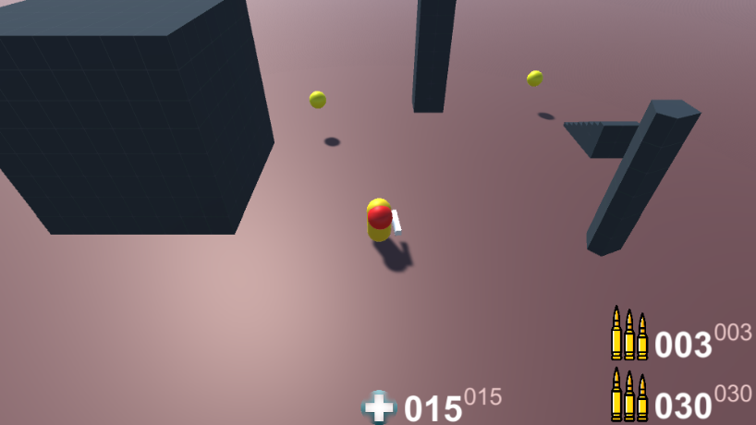HUD

The smaller number of represents the maximum

The bigger number represents the current amount

PLAYER Health

Displays the current and maximum health

Player Ammo

Displays the current amount of ammo for each type of gun ammunition

Ammo recharges over time

Player

Player Characteristics

The boy and girl live a wonderful life at their age of 4 . They have a great room where they sleep at night . Problem is, their parents have given them too many plush animals without noticing that at night they all become zombified!

NPC Enemies

Enemy Characteristics

There are several type of enemies, ground based enemies that walk around just like the player, and there will be enemies that fly around with flock behavior, there are even enemies that will drive around in flock behavior and attack you..

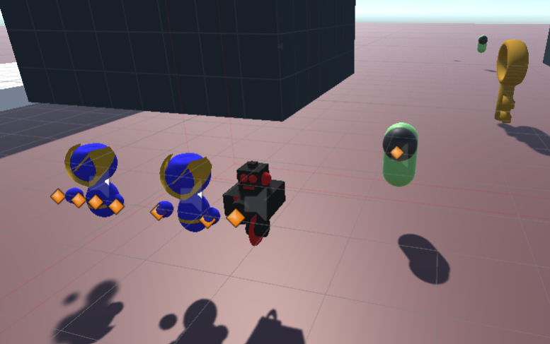

Level Design

Game environment is a type of fort where the terrain was created with the help of our terrain generator program. Level is a square sandbox environment with a fort surrounded by enemies, and the key to finish the level is at the center of the fort and guarded by all kinds of enemies.

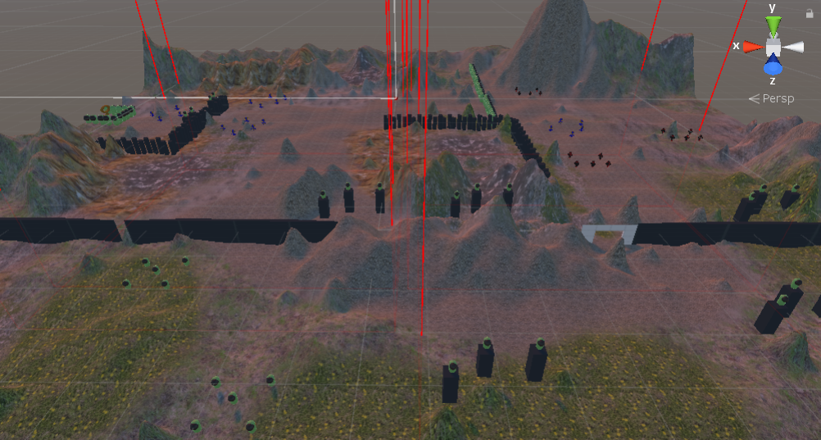

Audio

List of audio files used:

Gun shots were taken from a movie called Machine Gun Preacher

MVP (Minimum Viable Product)

• fully working game environment

• fully working multiplayer level

• Built for the PC platform

Wishlist

Randomly generated environments with randomly generated forts with key and enemy locations.