Go-Fighter

**TECHNICAL DESIGN DOCUMENT**

**Team Name: Monster Mesh**

**Team Number: 5**

**Team Members:**

**Tan Truong**

**Carlos Gamino**

**Austin Brooks**

**Aleksey Skvolygin**

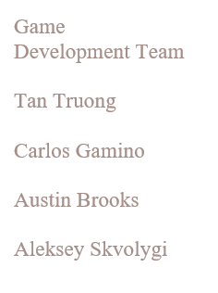Contents

Executive Summary

Game Overview

Technical Summary

Equipment

Hardware

Software

Evaluation

Game Engine

Target Platform

Development Plan

Work Environment

Remote Collaboration

Game Environment

Assets

Executive Summary

Game Overview

Go-Fighter is a 3D top down survival shooter, it has no story, it is more of a simple unadulterated action game to just play and enjoy. Levels are closed square sandboxes, and the game will auto aim and auto fire for the player when enemies get close. To finish a level the player must find the key to end the level. The game presents both air and ground enemy units.

Technical Summary

Go-Fighter will be fully developed in 5 months by 2 people using Unity game engine. For 3D asset creation, blender will be used in conjunction with gimp and Inkscape for texture, painting and sculpting. The total production cost of the game will be about $25,000 USD. Revenue from the game will go directly to repay the initial investment and any excess income will be used to help develop further wish lists updates and future DLC.

The game will be deployed for PC only.

PC STANDALONE

OS: Windows 10

CPU: two core Intel i3, AMD equivalent, or greater.

Graphics card: generally anything made after 2004 should work

Equipment

Hardware

4 Windows laptops of different makes and models

Software

Unity, unity asset store, blender.

Evaluation

Game Engine

The game engine utilized for the development of Go-Fighteris Unity because we can create a 3D game with ease, we can make it highly optimized and beautiful, and we can deploy it with a click to multiple platforms. In addition, we can use Unity’s integrated services to speed up our development process, optimize our game, connect with an audience, and achieve success.

Target Platform

Go-Fighter will be deployed as a PC standalone. We believe that the PC platform is the perfect target for this game as it is designed to educate new game developers on how to create a Unity game. Unity also gives us the posibility to deploy across multiple different platforms with ease, if we choose to develop the game for multiple platforms in the future

Development Plan

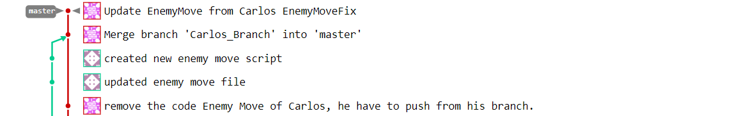

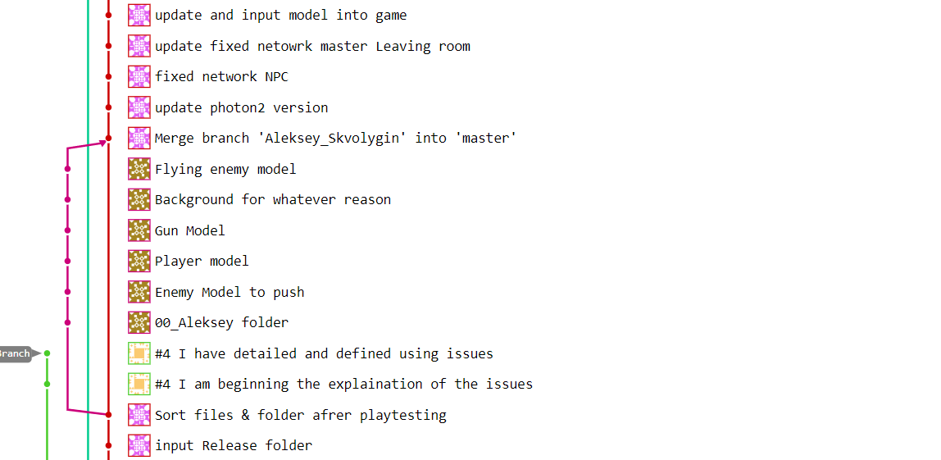

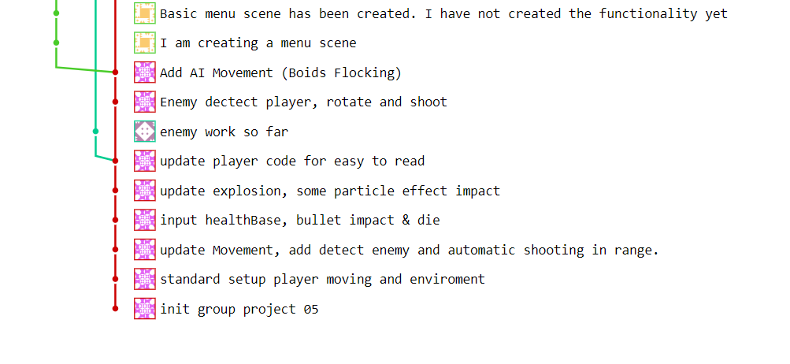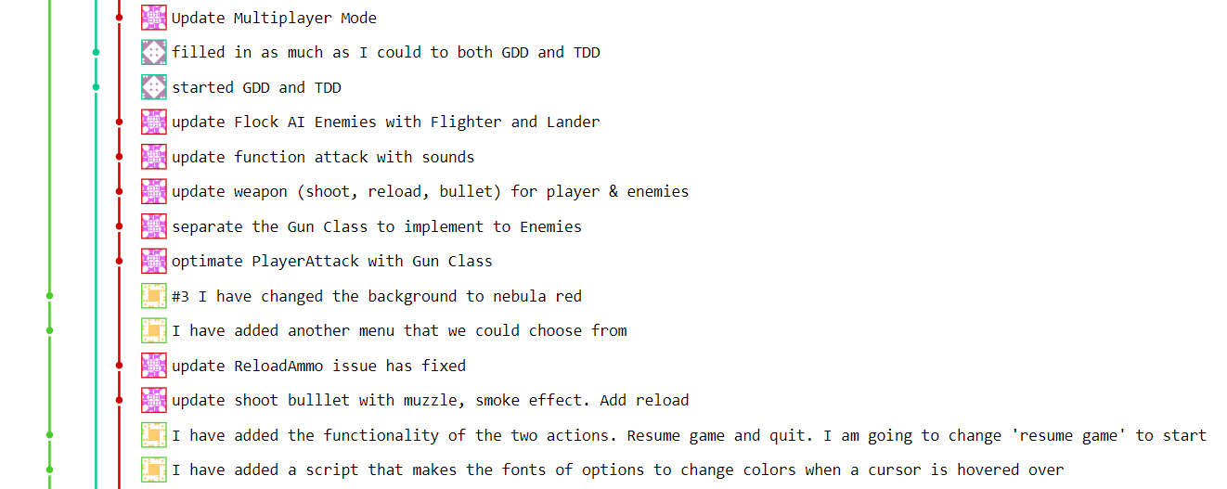

Work Environment

Remote Collaboration

collaborating on this is done through rijeka and we keep in contact through discord messaging app

Game Environment

The game level is a closed game environment, where the player has to run around, fighting his way through enemy units and find the key to be able to get the key and end the level.

Assets

Simple list of assets used in game:

Most of the assets used where created by the team:

Either by tan or Aleksey

Enemy soldiers, green, purple, black, tanks and fighter jets

Some assets where taken from the unity store and modified

Unity store assets:

Standard assets

Terrain textures

Bullets

Explosions

Health and ammo images

Fighter interceptor