PROJECT - DPSS

Alice Brunazzi

2025-05-02

# ANALISI

library(skimr)

## Warning: package 'skimr' was built under R version 4.3.3

library(readxl)  
data <- read_excel("C:/Users/Utente/Downloads/pone.0200893.s001.xls",   
 col_types = c("skip", "numeric", "text",   
 "text", "numeric", "numeric", "numeric",   
 "numeric", "numeric", "numeric",   
 "numeric", "numeric", "numeric",   
 "numeric", "numeric", "numeric",   
 "numeric", "numeric", "text", "numeric",   
 "numeric", "numeric", "numeric",   
 "numeric", "numeric", "numeric",   
 "numeric", "numeric", "numeric",   
 "numeric", "numeric", "numeric"))  
#View(pone_0200893_s001)  
skimr::skim_without_charts(data)

Data summary

|  |  |
| --- | --- |
| Name | data |
| Number of rows | 999 |
| Number of columns | 31 |
| _______________________ |  |
| Column type frequency: |  |
| character | 3 |
| numeric | 28 |
| ________________________ |  |
| Group variables | None |

**Variable type: character**

| skim_variable | n_missing | complete_rate | min | max | empty | n_unique | whitespace |
| --- | --- | --- | --- | --- | --- | --- | --- |
| Gender | 0 | 1 | 1 | 1 | 0 | 2 | 0 |
| ASA | 0 | 1 | 1 | 1 | 0 | 5 | 0 |
| AJCC | 0 | 1 | 2 | 2 | 0 | 2 | 0 |

**Variable type: numeric**

| skim_variable | n_missing | complete_rate | mean | sd | p0 | p25 | p50 | p75 | p100 |
| --- | --- | --- | --- | --- | --- | --- | --- | --- | --- |
| Age | 0 | 1.00 | 65.18 | 13.71 | 18.00 | 55.00 | 65.00 | 77.00 | 98.00 |
| ASA3 | 0 | 1.00 | 0.39 | 0.49 | 0.00 | 0.00 | 0.00 | 1.00 | 1.00 |
| DM | 0 | 1.00 | 0.20 | 0.40 | 0.00 | 0.00 | 0.00 | 0.00 | 1.00 |
| CAD | 0 | 1.00 | 0.07 | 0.26 | 0.00 | 0.00 | 0.00 | 0.00 | 1.00 |
| HF | 0 | 1.00 | 0.04 | 0.21 | 0.00 | 0.00 | 0.00 | 0.00 | 1.00 |
| CVA | 0 | 1.00 | 0.06 | 0.23 | 0.00 | 0.00 | 0.00 | 0.00 | 1.00 |
| CKD | 0 | 1.00 | 0.14 | 0.35 | 0.00 | 0.00 | 0.00 | 0.00 | 1.00 |
| CEA | 19 | 0.98 | 258.98 | 991.10 | 0.44 | 4.00 | 18.90 | 91.32 | 15126.00 |
| LogCEA | 19 | 0.98 | 1.39 | 0.90 | -0.36 | 0.60 | 1.28 | 1.96 | 4.18 |
| Laparoscopic | 0 | 1.00 | 0.04 | 0.19 | 0.00 | 0.00 | 0.00 | 0.00 | 1.00 |
| TumorLOC | 0 | 1.00 | 0.31 | 0.46 | 0.00 | 0.00 | 0.00 | 1.00 | 1.00 |
| EA | 0 | 1.00 | 0.17 | 0.37 | 0.00 | 0.00 | 0.00 | 0.00 | 1.00 |
| AnesTime | 0 | 1.00 | 338.40 | 121.01 | 45.00 | 255.00 | 315.00 | 390.00 | 960.00 |
| Log2AT | 0 | 1.00 | 8.31 | 0.52 | 5.49 | 7.99 | 8.30 | 8.61 | 9.91 |
| RBC | 0 | 1.00 | 0.54 | 0.70 | 0.00 | 0.00 | 0.00 | 1.00 | 2.00 |
| Liver_Only | 0 | 1.00 | 0.37 | 0.48 | 0.00 | 0.00 | 0.00 | 1.00 | 1.00 |
| Cell_diff | 55 | 0.94 | 1.12 | 0.35 | 0.00 | 1.00 | 1.00 | 1.00 | 2.00 |
| Mucin_TYPE | 57 | 0.94 | 0.08 | 0.27 | 0.00 | 0.00 | 0.00 | 0.00 | 1.00 |
| SignetRING | 57 | 0.94 | 0.04 | 0.21 | 0.00 | 0.00 | 0.00 | 0.00 | 1.00 |
| Lymphovascularinvasion | 54 | 0.95 | 0.51 | 0.50 | 0.00 | 0.00 | 1.00 | 1.00 | 1.00 |
| perineural | 57 | 0.94 | 0.22 | 0.42 | 0.00 | 0.00 | 0.00 | 0.00 | 1.00 |
| CT | 0 | 1.00 | 0.89 | 0.31 | 0.00 | 1.00 | 1.00 | 1.00 | 1.00 |
| RT | 0 | 1.00 | 0.11 | 0.31 | 0.00 | 0.00 | 0.00 | 0.00 | 1.00 |
| NACTRT | 0 | 1.00 | 0.16 | 0.36 | 0.00 | 0.00 | 0.00 | 0.00 | 1.00 |
| Death | 0 | 1.00 | 0.43 | 0.49 | 0.00 | 0.00 | 0.00 | 1.00 | 1.00 |
| Interval | 0 | 1.00 | 24.23 | 24.40 | 0.03 | 7.34 | 17.48 | 31.74 | 135.79 |
| Progress | 0 | 1.00 | 0.78 | 0.42 | 0.00 | 1.00 | 1.00 | 1.00 | 1.00 |
| IntervalR | 0 | 1.00 | 11.27 | 17.24 | 0.03 | 2.96 | 5.75 | 12.60 | 134.21 |

colnames(data)

## [1] "Age" "Gender" "ASA"   
## [4] "ASA3" "DM" "CAD"   
## [7] "HF" "CVA" "CKD"   
## [10] "CEA" "LogCEA" "Laparoscopic"   
## [13] "TumorLOC" "EA" "AnesTime"   
## [16] "Log2AT" "RBC" "AJCC"   
## [19] "Liver_Only" "Cell_diff" "Mucin_TYPE"   
## [22] "SignetRING" "Lymphovascularinvasion" "perineural"   
## [25] "CT" "RT" "NACTRT"   
## [28] "Death" "Interval" "Progress"   
## [31] "IntervalR"

VARIABILI DEMOGRAFICHE E CLINICHE: etá, genere, ASA, comorbiditá tipo: diabete, malattie cardio vascolari, insufficenza renale VARIABILI TUMORALI: CEA, localizzazione, grading, tipo istologico (mucinoso, a cellule ad anello con castone) , invasione linfovascolare e perineurale.  
VARIAVILI TRATTAMENTO: tipo di intervento (laparoscopico, anestesia epidurale), tempo di anestesia, trasfusioni RBC, chemioterapia CT, radioterapia RT e terapia neoadiuvante NACTRT TARGE: morte, progressione, tempi di followup (interval e intervalR)

| **Variabile** | **Descrizione** |
| --- | --- |
|  |  |
| Age | Età del paziente (in anni) |
| Gender | Sesso del paziente (Male, Female) |
| ASA | Classificazione ASA fisica pre-operatoria (da 1 a 5) |
| ASA3 | Indicatore binario: ASA ≥ 3 (1 = grave compromissione, 0 = no) |
| DM | Diabete mellito (1 = presente, 0 = assente) |
| CAD | Cardiopatia ischemica (Coronary Artery Disease) |
| HF | Insufficienza cardiaca (Heart Failure) |
| CVA | Ictus (Cerebrovascular Accident) |
| CKD | Malattia renale cronica (Chronic Kidney Disease) |
| CEA | Valore dell’antigene carcinoembrionario (marker tumorale) |
| LogCEA | Logaritmo naturale del CEA (per normalizzazione) |
| Laparoscopic | Intervento laparoscopico (1 = sì, 0 = no) |
| TumorLOC | Localizzazione del tumore (0 = colon, 1 = retto) |
| EA | Uso di anestesia epidurale (1 = sì, 0 = no) |
| AnesTime | Durata dell’anestesia (in minuti) |
| Log2AT | Logaritmo in base 2 della durata dell’anestesia |
| RBC | Numero di unità di sangue trasfuse durante l’intervento |
| AJCC | Stadio AJCC del tumore (tipicamente IV) |
| Liver_Only | Metastasi limitate al fegato (1 = sì, 0 = no) |
| Cell_diff | Grado di differenziazione cellulare (1 = ben differenziato, 2 = moderato, ecc.) |
| Mucin_TYPE | Tipo mucinoso del tumore (1 = presente, 0 = no) |
| SignetRING | Istotipo a cellule ad anello con castone (1 = sì, 0 = no) |
| Lymphovascularinvasion | Invasione linfovascolare (1 = presente) |
| perineural | Invasione perineurale (1 = presente) |
| CT | Chemioterapia post-operatoria (1 = sì, 0 = no) |
| RT | Radioterapia post-operatoria (1 = sì, 0 = no) |
| NACTRT | Terapia neoadiuvante (radio o chemio prima dell’intervento) |
| Death | Evento morte durante il follow-up (1 = morto, 0 = vivo) |
| Interval | Tempo in mesi fino alla morte o censura |
| Progress | Progressione del tumore (1 = sì, 0 = no) |
| IntervalR | Tempo in mesi fino alla progressione o censura |

# PREPROCESSING:

## 0. INTERVALS

cor(data$Interval, data$IntervalR, use="complete.obs")

## [1] 0.6614045

data$IntervalOD<- data$Interval  
data$Interval <- NULL  
  
data$IntervalOR <- data$IntervalR  
data$IntervalR <- NULL  
  
colnames(data)

## [1] "Age" "Gender" "ASA"   
## [4] "ASA3" "DM" "CAD"   
## [7] "HF" "CVA" "CKD"   
## [10] "CEA" "LogCEA" "Laparoscopic"   
## [13] "TumorLOC" "EA" "AnesTime"   
## [16] "Log2AT" "RBC" "AJCC"   
## [19] "Liver_Only" "Cell_diff" "Mucin_TYPE"   
## [22] "SignetRING" "Lymphovascularinvasion" "perineural"   
## [25] "CT" "RT" "NACTRT"   
## [28] "Death" "Progress" "IntervalOD"   
## [31] "IntervalOR"

## 1. ASA

indica, rispettivamente, i pazienti sani= 0, lievemente malati =1, gravi ma non a rischio di morte = 3, con rischio costante di morte = 4 e morente =5. ASA3, invece, binarizza la variabile, mostrando come 0 i pazienti a rischio accettbaile e 1 i pazienti a rischio grave.

SI TEME MULTICOLLINEARITÁ IN SECONDO MOMENTO.

Si plottano gli istogrammi al fine di vedere quale variabile possa essere piu informativa.

Prima della verifica, serve controllare che la variabile ASA3 non contenga errori.

# CONVERSIONE ASA  
  
str(data$ASA)

## chr [1:999] "3" "2" "2" "2" "2" "2" "2" "3" "2" "2" "3" "2" "2" "3" "2" ...

data$ASA_num <- as.numeric(as.character(data$ASA))  
  
# Step 2: Creazione manuale della variabile ASA3 (gold standard)  
data$ASA3_check <- ifelse(data$ASA_num >= 3, 1, 0)  
  
# Step 3: Confronto tra ASA3 originale e ASA3 calcolato  
table(Originale = data$ASA3, Calcolato = data$ASA3_check)

## Calcolato  
## Originale 0 1  
## 0 612 0  
## 1 0 387

Il valore 387 corrisponde con quello della documentazione fornita. Si testa per multicollinearitá controllando la correlazione tra variabili. Letteratura suggerisce non piú di 0.7

cor(data$ASA_num, data$ASA3)

## [1] 0.9018298

model <- lm(data$Death ~ ASA_num + ASA3, data = data)  
car::vif(model)

## ASA_num ASA3   
## 5.356097 5.356097

La correlazione mostra conferma per multicollinearitá, molto alta. DECISIONE: non tenerle entrambe

Il variance index inflator non aiuta nella decisione su quale rimuovere. Si onfronta AIC dei modelli fittati sulle variabili per verificare quale tenere.

# Modelli a confronto  
model1 <- glm(Death ~ ASA_num, data = data, family = "binomial")  
model2 <- glm(Death ~ ASA3, data = data, family = "binomial")  
  
AIC(model1, model2) # Confronta la bontà del fit

## df AIC  
## model1 2 1366.750  
## model2 2 1363.609

AIC più basso per ASA3 -> miglior fit, anche se la differenza è modesta (ΔAIC > 2 è comunque considerata significativa, in questo caso é -3.14).

# Rimozione della variabile ASA_num e ASA non modificata  
data$ASA_num <- NULL  
data$ASA3_check <- NULL  
data$ASA <- NULL

cat("Numero di record nel dataset:", nrow(data), "\n")

## Numero di record nel dataset: 999

##2- Cell_Diff

VARIABILE GRADO DI DIFFERENZIAZIONE CELLULARE

Le convenzioni standard di classificazione istologica danno alla variabile valori 1= ben differenziato, 2= non differenziato

hist(data$Cell_diff)

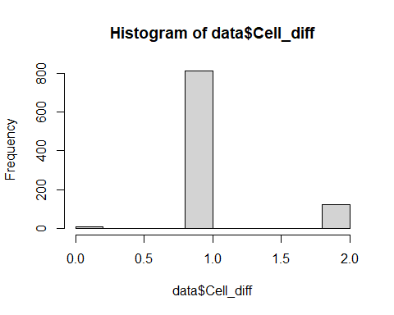

La variabile presenta dei valori non previsti nella scala 1-2, si provvede a verificarli manualmente e poi graficamente

sum(data$Cell_diff == 0, na.rm = TRUE)

## [1] 10

record_zero_diff <- data[!is.na(data$Cell_diff) & data$Cell_diff == 0, ]  
  
record_zero_diff

## # A tibble: 10 × 30  
## Age Gender ASA3 DM CAD HF CVA CKD CEA LogCEA Laparoscopic  
## <dbl> <chr> <dbl> <dbl> <dbl> <dbl> <dbl> <dbl> <dbl> <dbl> <dbl>  
## 1 64 1 0 0 0 0 0 0 11.6 1.06 0  
## 2 51 2 0 0 0 0 0 0 24.2 1.38 0  
## 3 83 1 1 1 0 0 1 1 581 2.76 0  
## 4 61 2 0 1 0 0 0 0 2.29 0.360 0  
## 5 56 2 0 0 0 0 0 0 1.47 0.167 0  
## 6 58 1 0 0 0 0 0 0 94.8 1.98 0  
## 7 57 1 1 0 0 0 0 0 32.2 1.51 0  
## 8 41 1 0 0 0 0 0 0 2.69 0.430 0  
## 9 57 1 0 0 0 0 0 1 1108 3.04 1  
## 10 60 2 0 0 0 0 0 0 1.78 0.250 0  
## # ℹ 19 more variables: TumorLOC <dbl>, EA <dbl>, AnesTime <dbl>, Log2AT <dbl>,  
## # RBC <dbl>, AJCC <chr>, Liver_Only <dbl>, Cell_diff <dbl>, Mucin_TYPE <dbl>,  
## # SignetRING <dbl>, Lymphovascularinvasion <dbl>, perineural <dbl>, CT <dbl>,  
## # RT <dbl>, NACTRT <dbl>, Death <dbl>, Progress <dbl>, IntervalOD <dbl>,  
## # IntervalOR <dbl>

I record problematici snon solo 10, sono sicuramente mal codificati e/ o danneggiati. Si reputa che la la loro eliminazione non comprometta l éfficacia statistica. si poteva imputare i 10 record nulli alla variabile 1 ma dato il numero quali nullo di records, l’eliminazione non impatta sulla variabile. La media e la sd corrispondono a quella fornita dalla documentazione

data <- data[!(data$Cell_diff == 0 | is.na(data$Cell_diff)), ]  
hist(data$Cell_diff)

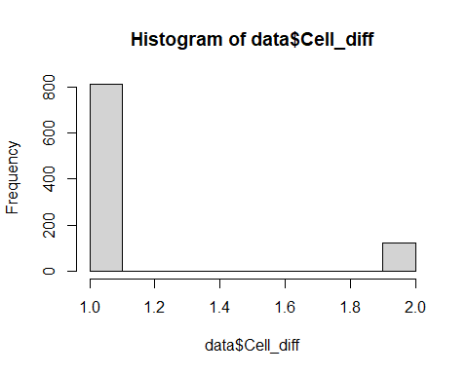

sum(data$Cell_diff > 1.5)

## [1] 121

sum(data$Cell_diff < 1.5)

## [1] 813

cat("Numero di record nel dataset:", nrow(data), "\n")

## Numero di record nel dataset: 934

Che corrispondono con i 121 (non differenziati) record e gli 823 (differeniati) nella documentazione riportata

## 3 - Binary

Si verificano tutte le variabili binarie (codificate 0 No 1 si) per verificare se presentano valori fuori dal range.

binary_vars <- c("DM", "CAD", "HF", "CVA", "CKD", "Laparoscopic", "EA",  
 "Liver_Only", "Lymphovascularinvasion", "perineural",  
 "CT", "RT", "NACTRT", "Death", "Progress")  
  
# VALORI UNICI, DEVONO ESSERE 0 E 1  
for (var in binary_vars) {  
 cat("\nVariabile:", var, "\n")  
 print(unique(data[[var]]))  
}

##   
## Variabile: DM   
## [1] 0 1  
##   
## Variabile: CAD   
## [1] 0 1  
##   
## Variabile: HF   
## [1] 0 1  
##   
## Variabile: CVA   
## [1] 0 1  
##   
## Variabile: CKD   
## [1] 0 1  
##   
## Variabile: Laparoscopic   
## [1] 0 1  
##   
## Variabile: EA   
## [1] 0 1  
##   
## Variabile: Liver_Only   
## [1] 0 1  
##   
## Variabile: Lymphovascularinvasion   
## [1] 1 0  
##   
## Variabile: perineural   
## [1] 0 1 NA  
##   
## Variabile: CT   
## [1] 1 0  
##   
## Variabile: RT   
## [1] 0 1  
##   
## Variabile: NACTRT   
## [1] 0 1  
##   
## Variabile: Death   
## [1] 1 0  
##   
## Variabile: Progress   
## [1] 1 0

Si nota che Perineural contine NA, si procede alla verifica

# Mostra tutti i record dove perineural è NA  
subset(data, is.na(perineural))

## # A tibble: 3 × 30  
## Age Gender ASA3 DM CAD HF CVA CKD CEA LogCEA Laparoscopic  
## <dbl> <chr> <dbl> <dbl> <dbl> <dbl> <dbl> <dbl> <dbl> <dbl> <dbl>  
## 1 53 1 0 0 0 0 0 0 2.61 0.417 0  
## 2 71 2 0 0 1 0 0 0 23.4 1.37 0  
## 3 52 1 0 0 0 0 0 0 21.1 1.32 0  
## # ℹ 19 more variables: TumorLOC <dbl>, EA <dbl>, AnesTime <dbl>, Log2AT <dbl>,  
## # RBC <dbl>, AJCC <chr>, Liver_Only <dbl>, Cell_diff <dbl>, Mucin_TYPE <dbl>,  
## # SignetRING <dbl>, Lymphovascularinvasion <dbl>, perineural <dbl>, CT <dbl>,  
## # RT <dbl>, NACTRT <dbl>, Death <dbl>, Progress <dbl>, IntervalOD <dbl>,  
## # IntervalOR <dbl>

data <- data[!is.na(data$perineural), ]  
unique(data$perineural)

## [1] 0 1

cat("Numero di record nel dataset:", nrow(data), "\n")

## Numero di record nel dataset: 931

## 4- Gender

data$Gender <- as.numeric(as.character(data$Gender))

cat("Numero di record nel dataset:", nrow(data), "\n")

## Numero di record nel dataset: 931

## 5- CEA

La variabile CEA contiene missing values 15, e di conseguenza LogCEA

summary(data$CEA)

## Min. 1st Qu. Median Mean 3rd Qu. Max. NA's   
## 0.440 4.008 18.170 265.620 87.405 15126.000 15

plot(data$CEA)

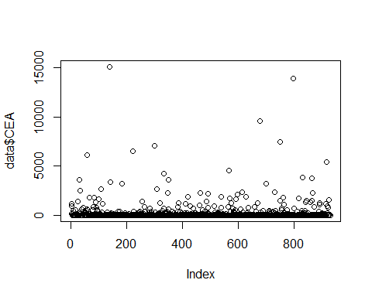

Essendo una variabile di profondo senso cliico (valore del’carcigene ~ marker tumorale), si procede in ordine: 1- scelta della variabile da tenere tra CEA e Log CEA, 2- VALUTARE SE imputare O eliminare dei valori mancanti

Si inizia controllando che LogCEA corrisponda al Logaritmo di CEA, senza errori

# 1. logaritmo naturale di (CEA + 1) — standard  
mean(log(data$CEA + 1), na.rm = TRUE)

## [1] 3.328466

# 2. logaritmo naturale   
mean(log(data$CEA), na.rm = TRUE)

## [1] 3.200846

# 3. logaritmo in base 10  
mean(log10(data$CEA), na.rm = TRUE)

## [1] 1.39011

# 4. logaritmo in base 10 di (CEA + 1)  
mean(log10(data$CEA + 1), na.rm = TRUE)

## [1] 1.445534

Si trova dunque che la variabile é il logaritmo in base 10, si procede con l’analisi

Si testa per multicollinearitá controllando la correlazione tra variabili. Letteratura suggerisce non piú di 0.7

# Ricreiamo LogCEA come log10(CEA)  
data$LogCEA_check <- log10(data$CEA)  
  
# Differenza assoluta tra le due  
diff <- abs(data$LogCEA - data$LogCEA_check)  
  
# Controlliamo quante differenze sono significative (> 0.001)  
sum(diff > 0, na.rm = TRUE)

## [1] 0

Si verifica ora la multicollinearitá tra le variabili

cor(data$CEA, data$LogCEA, use= "complete.obs")

## [1] 0.5459278

# Regressione + VIF  
  
model <- lm(Death ~ CEA + LogCEA, data = data)  
library(car)

## Warning: package 'car' was built under R version 4.3.3

## Loading required package: carData

## Warning: package 'carData' was built under R version 4.3.3

vif(model)

## CEA LogCEA   
## 1.424577 1.424577

# Modelli alternativi  
model1 <- glm(Death ~ CEA, data = data, family = "binomial")  
model2 <- glm(Death ~ LogCEA, data = data, family = "binomial")  
  
# Confronto AIC  
AIC(model1, model2)

## df AIC  
## model1 2 1245.873  
## model2 2 1230.633

La correlazione non é sufficentemente alta per giustificare l’ipotesi di multicollinearitá problematica. Il VIF ci sostiene nella scelta di mantenere entrambe le variabili.

Sapendo che entrambe verranno tenute, si manterrá a mente che LogCEA offre piú potere predittivo. Si valuterá in un secondo momento se scartare CEA.

#### Imputazione dei NA

Prima si verifica che i records corrispondano tra le due variabili problematiche

# Verifica se gli NA sono nelle stesse righe  
na_cea <- is.na(data$CEA)  
na_logcea <- is.na(data$LogCEA)  
  
# Rimuove i record con LogCEA ≤ 0 o NA  
data <- data[!is.na(data$CEA), ]  
  
#data$CEA_imputed <- NULL  
data$LogCEA_check <- NULL

Si verifica la distribuzione ella variabile OG per scegliere che tipo di imputazione utilizzare

hist(data$LogCEA)

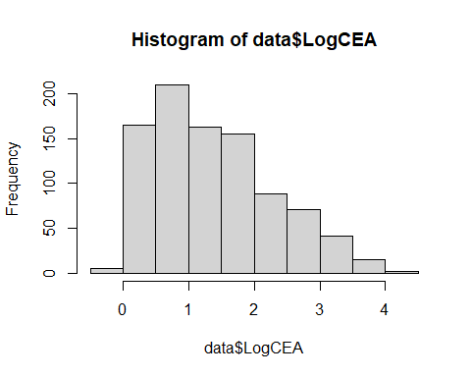

plot(data$LogCEA)

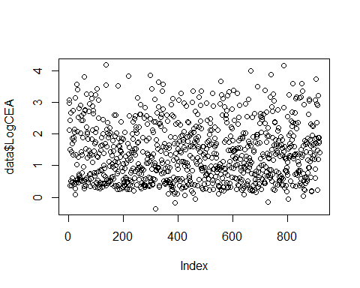

Variaile ESTREMAMENTE SKEWED, mediana scelta piú prodente

data$LogCEA[is.na(data$LogCEA)] <- 1.26435  
  
summary(data$CEA)

## Min. 1st Qu. Median Mean 3rd Qu. Max.   
## 0.440 4.008 18.170 265.620 87.405 15126.000

summary(data$LogCEA)

## Min. 1st Qu. Median Mean 3rd Qu. Max.   
## -0.3565 0.6029 1.2594 1.3901 1.9415 4.1797

cat("Numero di record nel dataset:", nrow(data), "\n")

## Numero di record nel dataset: 916

data$LogCEA <- log10(data$CEA)

————– AGGIUNTA POST: conviene eliminare la variabile CEA, molto multicollineare in fare di analisi successiva:

data$CEA <- NULL

## 6 - AnesTime

Presenti outliers, il range INTERQUANTILE deve essere tra 255 e 390 minuti, presenti valori maggiori

summary(data$AnesTime)

## Min. 1st Qu. Median Mean 3rd Qu. Max.   
## 50.0 270.0 315.0 342.8 390.0 960.0

cat("Numero di record nel dataset:", nrow(data), "\n")

## Numero di record nel dataset: 916

cor(data$AnesTime, data$Log2AT, use= "complete.obs")

## [1] 0.966106

# Regressione + VIF  
  
model <- lm(Death ~ AnesTime + Log2AT, data = data)  
library(car)  
vif(model)

## AnesTime Log2AT   
## 15.00617 15.00617

# Modelli alternativi  
model1 <- glm(Death ~ AnesTime, data = data, family = "binomial")  
model2 <- glm(Death ~ Log2AT, data = data, family = "binomial")  
  
# Confronto AIC  
AIC(model1, model2)

## df AIC  
## model1 2 1251.090  
## model2 2 1250.935

data$AnesTime <- NULL

## 7- Outliers

si controlla ora il dataset completo, per analizzare possibili outliers e valori mancanti

skimr::skim_without_charts(data)

Data summary

|  |  |
| --- | --- |
| Name | data |
| Number of rows | 916 |
| Number of columns | 28 |
| _______________________ |  |
| Column type frequency: |  |
| character | 1 |
| numeric | 27 |
| ________________________ |  |
| Group variables | None |

**Variable type: character**

| skim_variable | n_missing | complete_rate | min | max | empty | n_unique | whitespace |
| --- | --- | --- | --- | --- | --- | --- | --- |
| AJCC | 0 | 1 | 2 | 2 | 0 | 2 | 0 |

**Variable type: numeric**

| skim_variable | n_missing | complete_rate | mean | sd | p0 | p25 | p50 | p75 | p100 |
| --- | --- | --- | --- | --- | --- | --- | --- | --- | --- |
| Age | 0 | 1 | 65.23 | 13.62 | 18.00 | 55.00 | 65.00 | 77.00 | 95.00 |
| Gender | 0 | 1 | 1.38 | 0.49 | 1.00 | 1.00 | 1.00 | 2.00 | 2.00 |
| ASA3 | 0 | 1 | 0.38 | 0.48 | 0.00 | 0.00 | 0.00 | 1.00 | 1.00 |
| DM | 0 | 1 | 0.21 | 0.41 | 0.00 | 0.00 | 0.00 | 0.00 | 1.00 |
| CAD | 0 | 1 | 0.07 | 0.26 | 0.00 | 0.00 | 0.00 | 0.00 | 1.00 |
| HF | 0 | 1 | 0.04 | 0.20 | 0.00 | 0.00 | 0.00 | 0.00 | 1.00 |
| CVA | 0 | 1 | 0.06 | 0.23 | 0.00 | 0.00 | 0.00 | 0.00 | 1.00 |
| CKD | 0 | 1 | 0.13 | 0.34 | 0.00 | 0.00 | 0.00 | 0.00 | 1.00 |
| LogCEA | 0 | 1 | 1.39 | 0.90 | -0.36 | 0.60 | 1.26 | 1.94 | 4.18 |
| Laparoscopic | 0 | 1 | 0.04 | 0.20 | 0.00 | 0.00 | 0.00 | 0.00 | 1.00 |
| TumorLOC | 0 | 1 | 0.31 | 0.46 | 0.00 | 0.00 | 0.00 | 1.00 | 1.00 |
| EA | 0 | 1 | 0.16 | 0.37 | 0.00 | 0.00 | 0.00 | 0.00 | 1.00 |
| Log2AT | 0 | 1 | 8.34 | 0.48 | 5.64 | 8.08 | 8.30 | 8.61 | 9.91 |
| RBC | 0 | 1 | 0.53 | 0.68 | 0.00 | 0.00 | 0.00 | 1.00 | 2.00 |
| Liver_Only | 0 | 1 | 0.39 | 0.49 | 0.00 | 0.00 | 0.00 | 1.00 | 1.00 |
| Cell_diff | 0 | 1 | 1.13 | 0.33 | 1.00 | 1.00 | 1.00 | 1.00 | 2.00 |
| Mucin_TYPE | 0 | 1 | 0.08 | 0.26 | 0.00 | 0.00 | 0.00 | 0.00 | 1.00 |
| SignetRING | 0 | 1 | 0.04 | 0.21 | 0.00 | 0.00 | 0.00 | 0.00 | 1.00 |
| Lymphovascularinvasion | 0 | 1 | 0.52 | 0.50 | 0.00 | 0.00 | 1.00 | 1.00 | 1.00 |
| perineural | 0 | 1 | 0.22 | 0.42 | 0.00 | 0.00 | 0.00 | 0.00 | 1.00 |
| CT | 0 | 1 | 0.90 | 0.30 | 0.00 | 1.00 | 1.00 | 1.00 | 1.00 |
| RT | 0 | 1 | 0.11 | 0.31 | 0.00 | 0.00 | 0.00 | 0.00 | 1.00 |
| NACTRT | 0 | 1 | 0.16 | 0.36 | 0.00 | 0.00 | 0.00 | 0.00 | 1.00 |
| Death | 0 | 1 | 0.42 | 0.49 | 0.00 | 0.00 | 0.00 | 1.00 | 1.00 |
| Progress | 0 | 1 | 0.79 | 0.41 | 0.00 | 1.00 | 1.00 | 1.00 | 1.00 |
| IntervalOD | 0 | 1 | 24.61 | 24.25 | 0.03 | 8.11 | 18.05 | 31.95 | 135.79 |
| IntervalOR | 0 | 1 | 11.32 | 17.10 | 0.03 | 3.05 | 5.98 | 12.62 | 134.21 |

La variabile AJCC non contine nulli, si binarizza

data$AJCC_bin <- ifelse(data$AJCC == '4a', 0,1 )  
  
data$AJCC <- NULL

## 8- analisi e controllo info perse

print(paste('Diabete Mellito (DM):', sum(data$DM == 1), 'su 203, TOT', length(data$DM)))

## [1] "Diabete Mellito (DM): 191 su 203, TOT 916"

print(paste('Cardiopatia ischemica (CAD):', sum(data$CAD == 1), 'su 72, TOT', length(data$CAD)))

## [1] "Cardiopatia ischemica (CAD): 68 su 72, TOT 916"

print(paste('Scompenso cardiaco (HF):', sum(data$HF == 1), 'su 44, TOT', length(data$HF)))

## [1] "Scompenso cardiaco (HF): 40 su 44, TOT 916"

print(paste('Ictus / Stroke (CVA):', sum(data$CVA == 1), 'su 57 TOT', length(data$CVA)))

## [1] "Ictus / Stroke (CVA): 53 su 57 TOT 916"

print(paste('Malattia renale cronica (CKD):', sum(data$CKD == 1), 'su 138, TOT', length(data$CKD)))

## [1] "Malattia renale cronica (CKD): 123 su 138, TOT 916"

print(paste('Sesso: Maschi (TOT 612)', sum(data$Gender == 1), '- Femmine (TOT 387)', sum(data$Gender == 2), ', IN TOTALE ', length(data$Gender)))

## [1] "Sesso: Maschi (TOT 612) 568 - Femmine (TOT 387) 348 , IN TOTALE 916"

print(paste('Localizzazione Tumore - Colon:', sum(data$TumorLOC == 0), 'su 712 , TOTALE', length(data$TumorLOC)))

## [1] "Localizzazione Tumore - Colon: 635 su 712 , TOTALE 916"

print(paste('Localizzazione Tumore - Retto:', sum(data$TumorLOC == 1), 'su 313, TOTALE ', length(data$TumorLOC)))

## [1] "Localizzazione Tumore - Retto: 281 su 313, TOTALE 916"

print(paste('Grado cellulare G1:', sum(data$Cell_diff == 1), 'su 823'))

## [1] "Grado cellulare G1: 799 su 823"

print(paste('Grado cellulare G2:', sum(data$Cell_diff == 2), 'su 121' ))

## [1] "Grado cellulare G2: 117 su 121"

print(paste('Tipo Mucinoso:', sum(data$Mucin_TYPE == 1), 'su 73' ))

## [1] "Tipo Mucinoso: 69 su 73"

print(paste('Tipo Non-Mucinoso:', sum(data$Mucin_TYPE == 0), 'su 999-73 = 926' ))

## [1] "Tipo Non-Mucinoso: 847 su 999-73 = 926"

print(paste('Cellule ad anello con castone:', sum(data$SignetRING == 1), 'su 42' ))

## [1] "Cellule ad anello con castone: 41 su 42"

print(paste('Chirurgia laparoscopica:', sum(data$Laparoscopic == 1)))

## [1] "Chirurgia laparoscopica: 37"

print(paste('Anestesia epidurale (EA):', sum(data$EA == 1), 'su 165' ))

## [1] "Anestesia epidurale (EA): 151 su 165"

print(paste('Metastasi solo liver (Liver_Only):', sum(data$Liver_Only == 1), 'su 370' ))

## [1] "Metastasi solo liver (Liver_Only): 357 su 370"

print(paste('Invasione linfovascolare:', sum(data$Lymphovascularinvasion == 1), 'su 485'))

## [1] "Invasione linfovascolare: 472 su 485"

print(paste('Invasione perineurale:', sum(data$perineural == 1), 'su 208'))

## [1] "Invasione perineurale: 206 su 208"

print(paste('Trasfusioni - Nessuna:', sum(data$RBC == 0),'/577',   
 '- Meno di 4 unita:', sum(data$RBC == 1),'/305',   
 '- Più di 4 unita:', sum(data$RBC == 2), '/117'))

## [1] "Trasfusioni - Nessuna: 530 /577 - Meno di 4 unita: 286 /305 - Più di 4 unita: 100 /117"

print(paste('Chemioterapia post:', sum(data$CT == 1), 'su 999' ))

## [1] "Chemioterapia post: 822 su 999"

print(paste('Radioterapia post:', sum(data$RT == 1), 'su 110' ))

## [1] "Radioterapia post: 98 su 110"

print(paste('Terapia pre operatoria (NACTRT):', sum(data$NACTRT == 1), 'su 155'))

## [1] "Terapia pre operatoria (NACTRT): 143 su 155"

print(paste('4a:', sum(data$AJCC_bin == 0),'su 558'  
 ,'4:', sum(data$AJCC_bin ==1), 'su 441'))

## [1] "4a: 531 su 558 4: 385 su 441"

TARGET

print(paste('Decessi (Death):', sum(data$Death == 1)))

## [1] "Decessi (Death): 386"

print(paste("non decessi", sum(data$Death ==0)))

## [1] "non decessi 530"

print(paste('Progressioni tumorali (Progress):', sum(data$Progress == 1)))

## [1] "Progressioni tumorali (Progress): 725"

Si conclude che le INFRMAZIONI perse nel pre processing non impattano cosi tanto, ma si controllano le viualizzazioni delle distribuzioni delle variabili per controllare eventuali squilibri

# DATA VIZUALIZATION

### Distribuzioni

Si controllano inizialmente le distribuzioni generali di tutte le variabili.

# Seleziona solo le colonne numeriche  
numeric_vars <- data[, sapply(data, is.numeric)]  
  
  
library(ggplot2)

## Warning: package 'ggplot2' was built under R version 4.3.3

library(tidyr)

## Warning: package 'tidyr' was built under R version 4.3.3

# Converti in formato lungo  
numeric_long <- pivot_longer(as.data.frame(numeric_vars), cols = everything(), names_to = "Variable", values_to = "Value")  
  
ggplot(numeric_long, aes(x = Value)) +  
 geom_histogram(fill = "orange", color = "black", bins = 30) +  
 facet_wrap(~ Variable, scales = "free") +  
 theme_minimal()

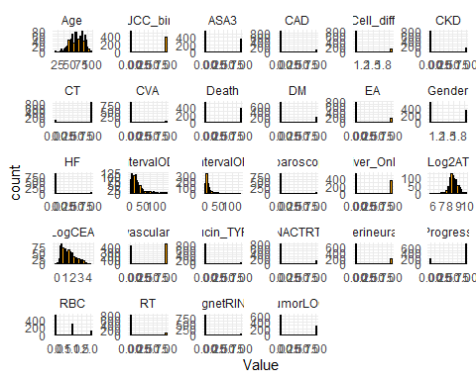

Non si notano comportamenti preoccupanti

### Outliers

Per verificare gli outliers:

library(ggplot2)  
library(dplyr)

## Warning: package 'dplyr' was built under R version 4.3.3

##   
## Attaching package: 'dplyr'

## The following object is masked from 'package:car':  
##   
## recode

## The following objects are masked from 'package:stats':  
##   
## filter, lag

## The following objects are masked from 'package:base':  
##   
## intersect, setdiff, setequal, union

for (var in colnames(data)) {  
 p <- ggplot(data, aes_string(x = "''", y = var)) +   
 geom_boxplot(fill = "orange3") +   
 labs(title = paste("Box Plot di", var), y = var, x = "") +  
 theme_minimal() +   
 theme(axis.text.x = element_blank(),  
 axis.ticks.x = element_blank())  
   
 print(p)  
}

## Warning: `aes_string()` was deprecated in ggplot2 3.0.0.  
## ℹ Please use tidy evaluation idioms with `aes()`.  
## ℹ See also `vignette("ggplot2-in-packages")` for more information.  
## This warning is displayed once every 8 hours.  
## Call `lifecycle::last_lifecycle_warnings()` to see where this warning was  
## generated.

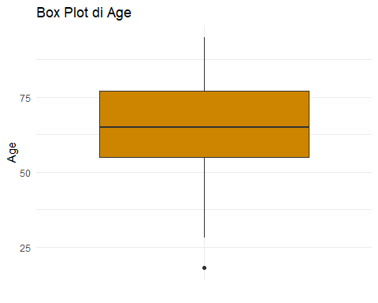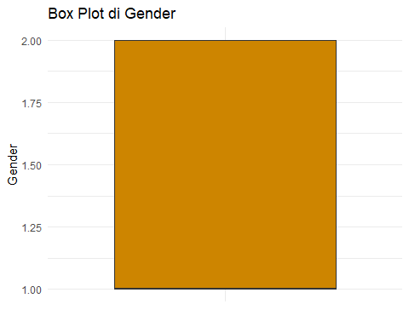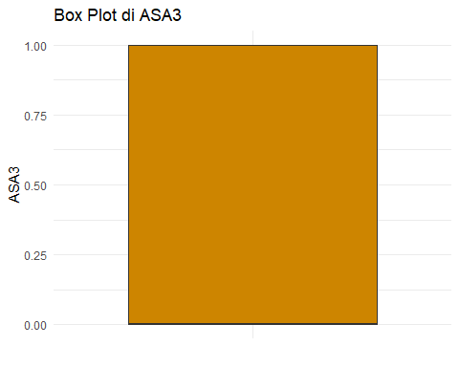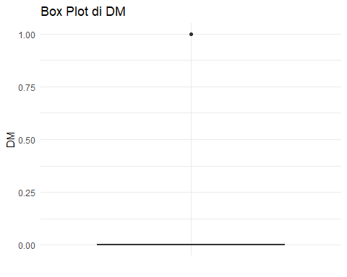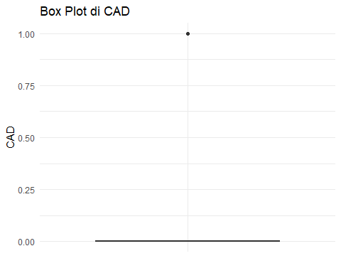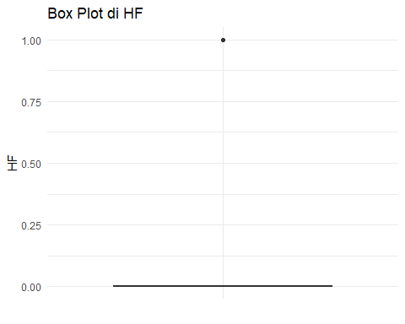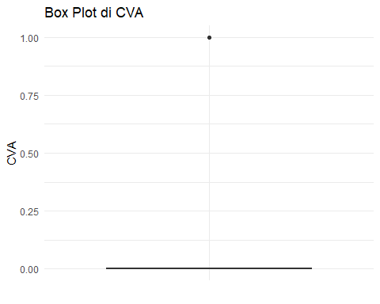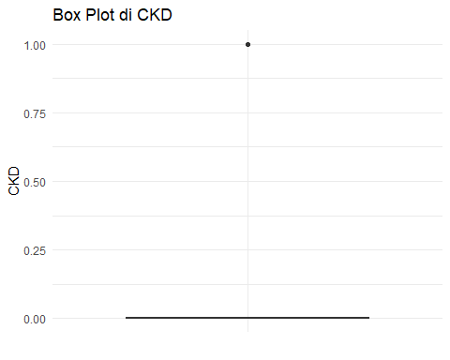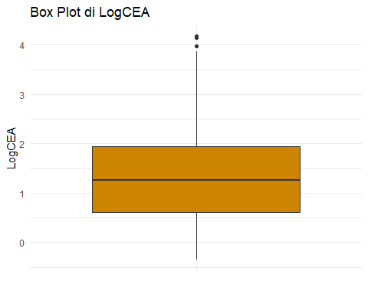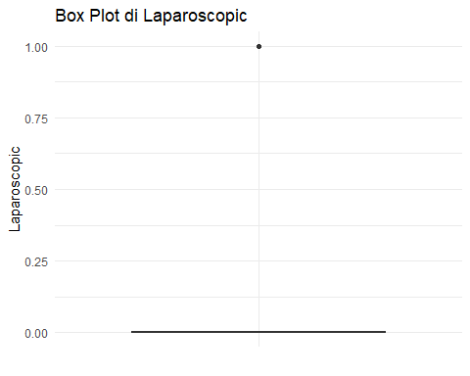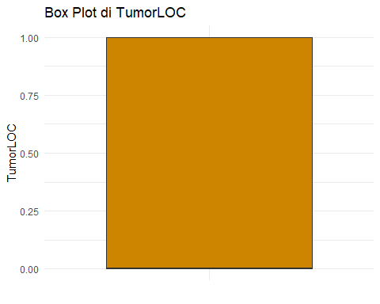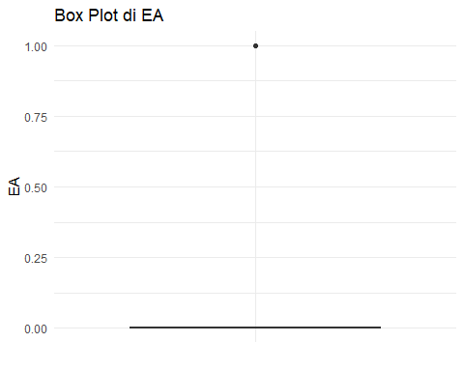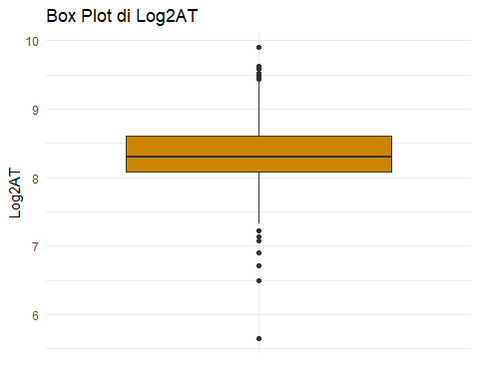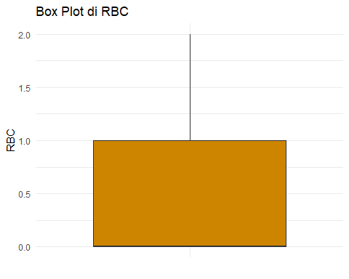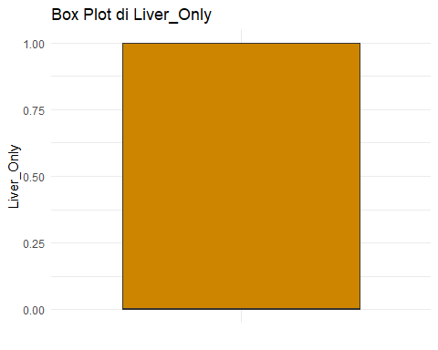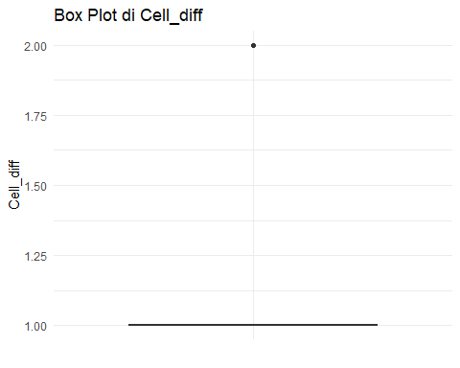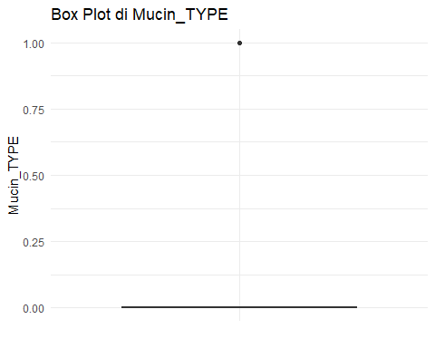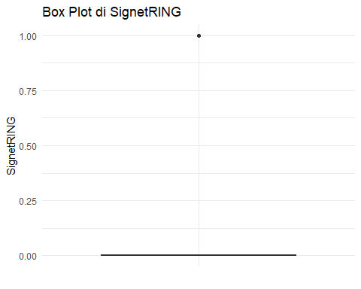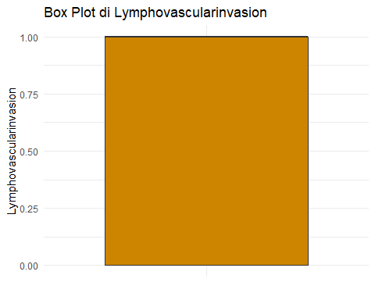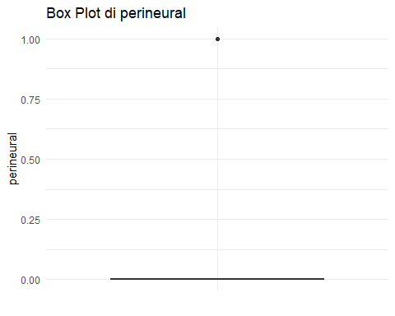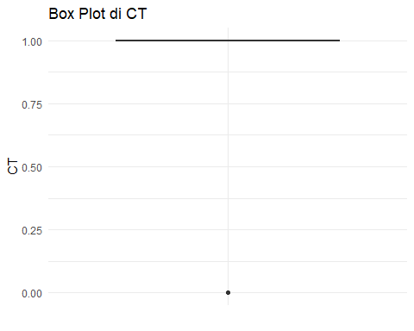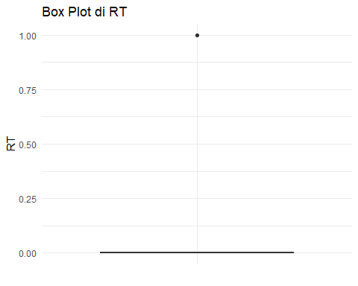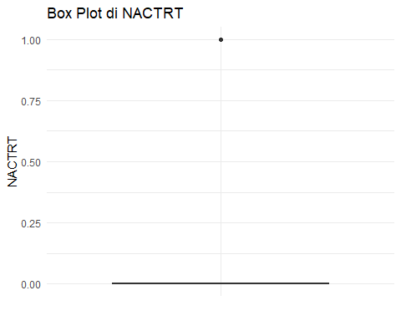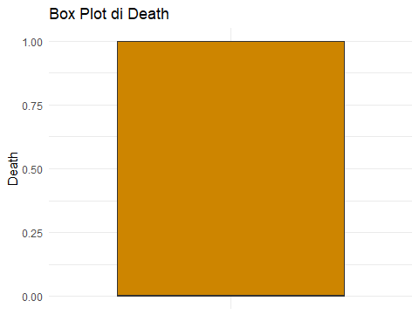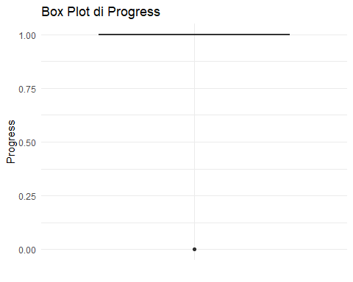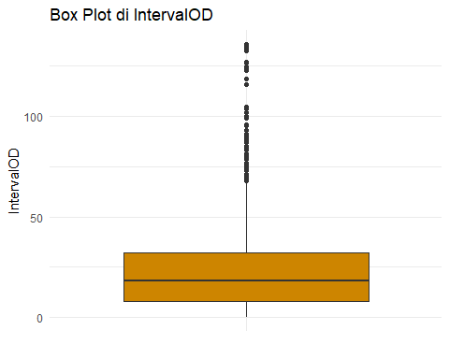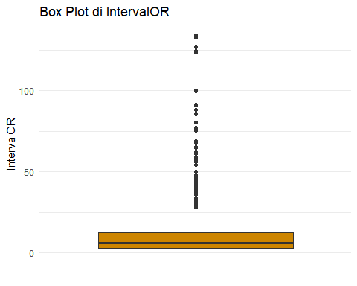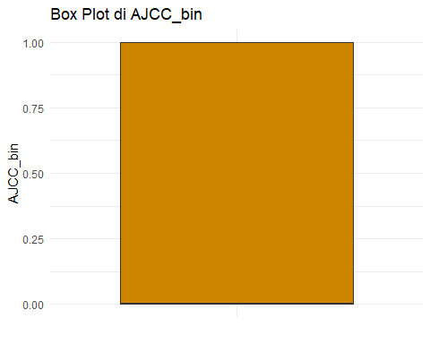

### Variables

Si prova ad analizzare se i comportamenti delle variabili sono influenzati dal sesso o dall’eta

ggplot(data, aes(x = factor(Gender))) +   
 geom_bar(fill = "orange") +   
 labs(title = "Distribuzione per sesso", x = "Sesso", y = "Conteggio")

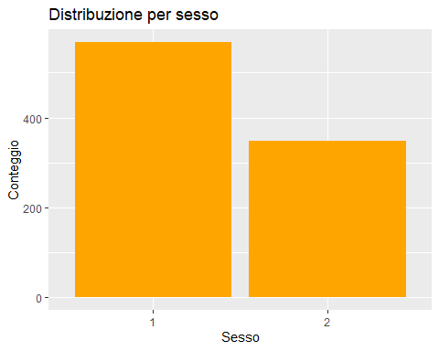

ggplot(data, aes(x = factor(Death))) +   
 geom_bar(fill = "orange") +   
 labs(title = "Distribuzione per morte", x = "morte", y = "Conteggio")

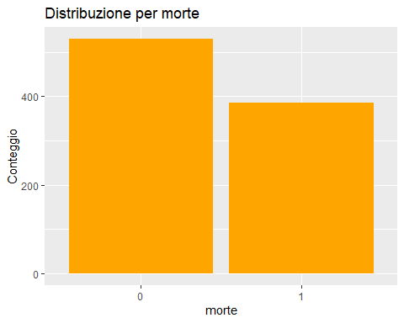

skim_without_charts(data$Age)

Data summary

|  |  |
| --- | --- |
| Name | data$Age |
| Number of rows | 916 |
| Number of columns | 1 |
| _______________________ |  |
| Column type frequency: |  |
| numeric | 1 |
| ________________________ |  |
| Group variables | None |

**Variable type: numeric**

| skim_variable | n_missing | complete_rate | mean | sd | p0 | p25 | p50 | p75 | p100 |
| --- | --- | --- | --- | --- | --- | --- | --- | --- | --- |
| data | 0 | 1 | 65.23 | 13.62 | 18 | 55 | 65 | 77 | 95 |

ggplot(data, aes(x = factor(Age))) +   
 geom_bar(fill = "orange") +   
 labs(title = "Distribuzione per Etá", x = "Age", y = "Conteggio")

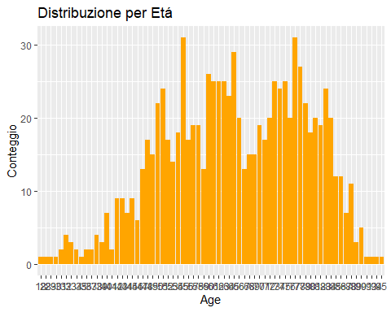

COMORBIDITÁ

ggplot(data, aes(x = factor(Gender), fill = factor(DM))) +  
 geom_bar(position = "fill") +  
 labs(title = "Prevalenza diabete per sesso", y = "Proporzione")

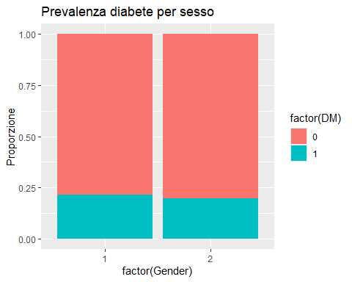

ggplot(data, aes(x = factor(DM), fill = factor(Age))) +  
 geom_bar(position = "fill") +  
 labs(title = "Prevalenza etá per diabete ", y = "Proporzione")

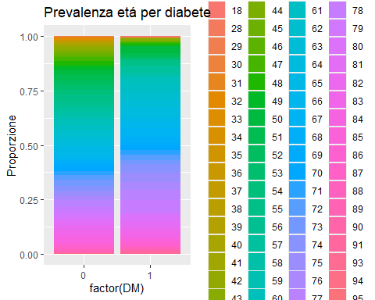

ggplot(data, aes(x = factor(Gender), fill = factor(HF))) +  
 geom_bar(position = "fill") +  
 labs(title = "Prevalenza infarto per sesso", y = "Proporzione")

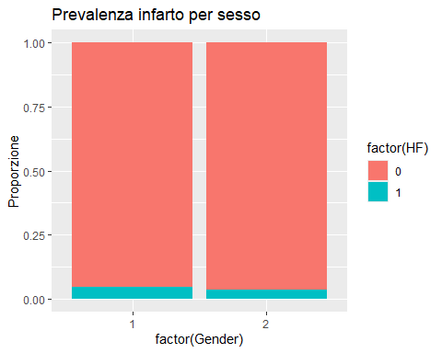

ggplot(data, aes(x = factor(Age), fill = factor(HF))) +  
 geom_bar(position = "fill") +  
 labs(title = "Prevalenza infarto per etá", y = "Proporzione")

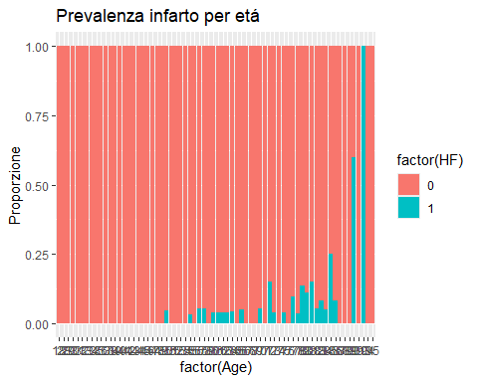

ggplot(data, aes(x = factor(Gender), fill = factor(TumorLOC))) +  
 geom_bar(position = "fill") +  
 labs(title = "Prevalenza posizione per sesso, colon 0", y = "Proporzione")

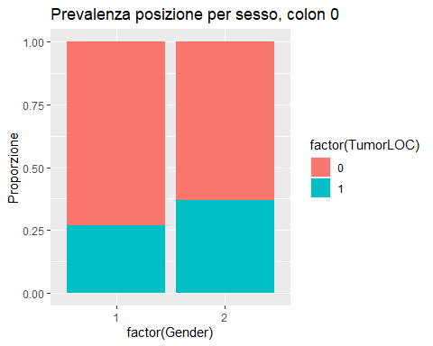

ggplot(data, aes(x = factor(Age), fill = factor(TumorLOC))) +  
 geom_bar(position = "fill") +  
 labs(title = "Prevalenza posizione per eta, colon 0 retto 1, ", y = "Proporzione")

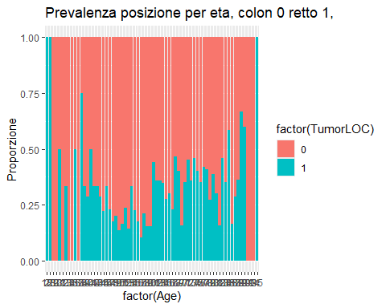

ggplot(data, aes(x = factor(TumorLOC), fill = factor(Age))) +  
 geom_bar(position = "fill") +  
 labs(title = "Prevalenza eta per posizione, colon 0 retto 1, ", y = "Proporzione")

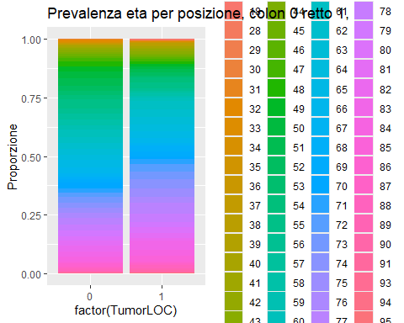

ggplot(data, aes(x = factor(Death), y = Age)) +  
 geom_boxplot(fill = "orange") +  
 labs(title = "Distribuzione etàmorte", x = "Decesso", y = "Età")

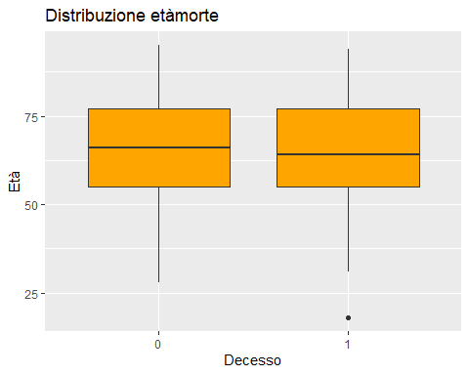

ggplot(data, aes(x = factor(RBC), fill = factor(Progress))) +  
 geom_bar(position = "fill") +  
 labs(title = "Progressione tumorale per livello di trasfusioni", y = "Proporzione")

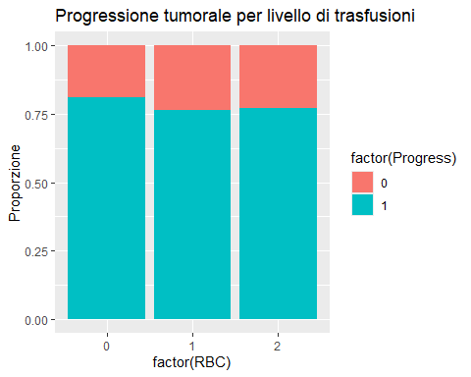

ggplot(data, aes(x = factor(RBC), fill = factor(Age))) +  
 geom_bar(position = "fill") +  
 labs(title = "etá per livello di trasfusioni", y = "Proporzione")

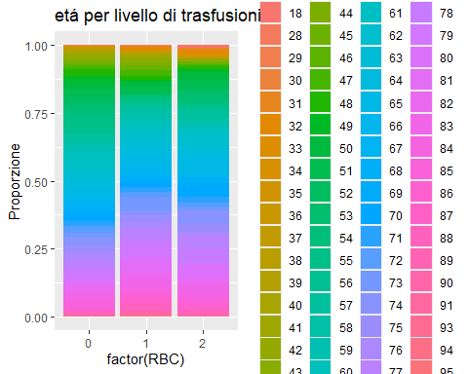

ggplot(data, aes(x = factor(RBC), fill = factor(Gender))) +  
 geom_bar(position = "fill") +  
 labs(title = "Genere per livello di trasfusioni", y = "Proporzione")

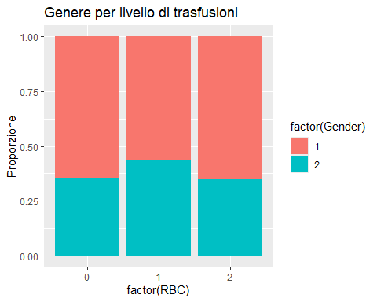

ggplot(data, aes(x = factor(Gender), fill = factor(Progress))) +  
 geom_bar(position = "fill") +  
 labs(title = "Progressione tumorale per Genere", y = "Proporzione")

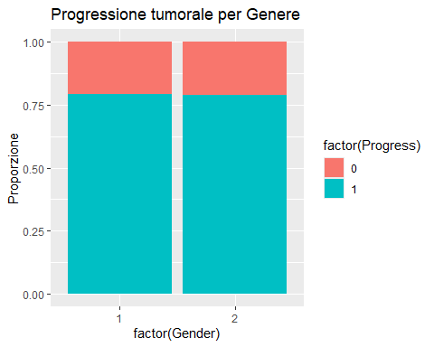

ggplot(data, aes(x = factor(Age), fill = factor(Progress))) +  
 geom_bar(position = "fill") +  
 labs(title = "Progressione tumorale per etá", y = "Proporzione")

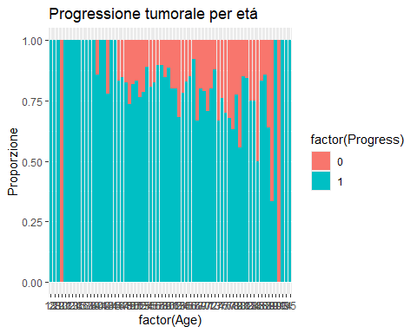

# CORRELATION

COMORBIDITA CORRELAZIONE

library(corrplot)

## Warning: package 'corrplot' was built under R version 4.3.3

## corrplot 0.92 loaded

corrplot(cor(data[, c("DM", "CAD", "HF", "CKD", "CVA")]), method = "color")

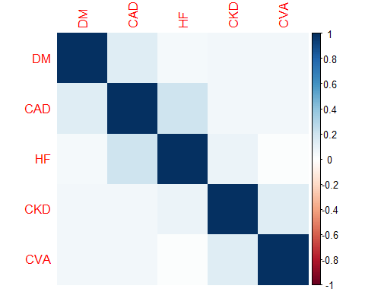

library(corrplot)  
corrplot(cor(data), method = "color")

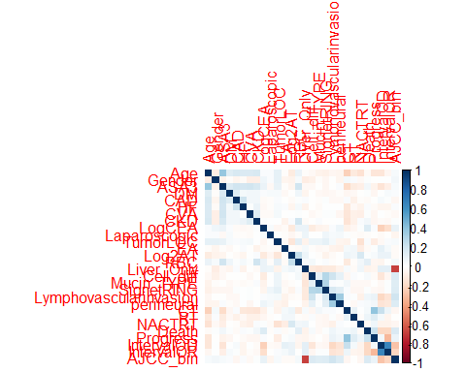

cor_matrix <- cor(data, use = "complete.obs")  
  
# Filtra le correlazioni con valore assoluto maggiore di 0.5 (escludendo la diagonale)  
high_corr <- cor_matrix  
high_corr[abs(high_corr) <= 0.35 | diag(ncol(high_corr)) == 1] <- NA  
  
# Mostra solo le correlazioni forti  
print(high_corr)

## Age Gender ASA3 DM CAD HF CVA CKD LogCEA  
## Age NA NA 0.3877214 NA NA NA NA NA NA  
## Gender NA NA NA NA NA NA NA NA NA  
## ASA3 0.3877214 NA NA NA NA NA NA NA NA  
## DM NA NA NA NA NA NA NA NA NA  
## CAD NA NA NA NA NA NA NA NA NA  
## HF NA NA NA NA NA NA NA NA NA  
## CVA NA NA NA NA NA NA NA NA NA  
## CKD NA NA NA NA NA NA NA NA NA  
## LogCEA NA NA NA NA NA NA NA NA NA  
## Laparoscopic NA NA NA NA NA NA NA NA NA  
## TumorLOC NA NA NA NA NA NA NA NA NA  
## EA NA NA NA NA NA NA NA NA NA  
## Log2AT NA NA NA NA NA NA NA NA NA  
## RBC NA NA NA NA NA NA NA NA NA  
## Liver_Only NA NA NA NA NA NA NA NA NA  
## Cell_diff NA NA NA NA NA NA NA NA NA  
## Mucin_TYPE NA NA NA NA NA NA NA NA NA  
## SignetRING NA NA NA NA NA NA NA NA NA  
## Lymphovascularinvasion NA NA NA NA NA NA NA NA NA  
## perineural NA NA NA NA NA NA NA NA NA  
## CT NA NA NA NA NA NA NA NA NA  
## RT NA NA NA NA NA NA NA NA NA  
## NACTRT NA NA NA NA NA NA NA NA NA  
## Death NA NA NA NA NA NA NA NA NA  
## Progress NA NA NA NA NA NA NA NA NA  
## IntervalOD NA NA NA NA NA NA NA NA NA  
## IntervalOR NA NA NA NA NA NA NA NA NA  
## AJCC_bin NA NA NA NA NA NA NA NA NA  
## Laparoscopic TumorLOC EA Log2AT RBC Liver_Only Cell_diff  
## Age NA NA NA NA NA NA NA  
## Gender NA NA NA NA NA NA NA  
## ASA3 NA NA NA NA NA NA NA  
## DM NA NA NA NA NA NA NA  
## CAD NA NA NA NA NA NA NA  
## HF NA NA NA NA NA NA NA  
## CVA NA NA NA NA NA NA NA  
## CKD NA NA NA NA NA NA NA  
## LogCEA NA NA NA NA NA NA NA  
## Laparoscopic NA NA NA NA NA NA NA  
## TumorLOC NA NA NA NA NA NA NA  
## EA NA NA NA NA NA NA NA  
## Log2AT NA NA NA NA NA NA NA  
## RBC NA NA NA NA NA NA NA  
## Liver_Only NA NA NA NA NA NA NA  
## Cell_diff NA NA NA NA NA NA NA  
## Mucin_TYPE NA NA NA NA NA NA NA  
## SignetRING NA NA NA NA NA NA NA  
## Lymphovascularinvasion NA NA NA NA NA NA NA  
## perineural NA NA NA NA NA NA NA  
## CT NA NA NA NA NA NA NA  
## RT NA NA NA NA NA NA NA  
## NACTRT NA NA NA NA NA NA NA  
## Death NA NA NA NA NA NA NA  
## Progress NA NA NA NA NA NA NA  
## IntervalOD NA NA NA NA NA NA NA  
## IntervalOR NA NA NA NA NA NA NA  
## AJCC_bin NA NA NA NA NA -0.6804736 NA  
## Mucin_TYPE SignetRING Lymphovascularinvasion perineural  
## Age NA NA NA NA  
## Gender NA NA NA NA  
## ASA3 NA NA NA NA  
## DM NA NA NA NA  
## CAD NA NA NA NA  
## HF NA NA NA NA  
## CVA NA NA NA NA  
## CKD NA NA NA NA  
## LogCEA NA NA NA NA  
## Laparoscopic NA NA NA NA  
## TumorLOC NA NA NA NA  
## EA NA NA NA NA  
## Log2AT NA NA NA NA  
## RBC NA NA NA NA  
## Liver_Only NA NA NA NA  
## Cell_diff NA NA NA NA  
## Mucin_TYPE NA NA NA NA  
## SignetRING NA NA NA NA  
## Lymphovascularinvasion NA NA NA 0.3550012  
## perineural NA NA 0.3550012 NA  
## CT NA NA NA NA  
## RT NA NA NA NA  
## NACTRT NA NA NA NA  
## Death NA NA NA NA  
## Progress NA NA NA NA  
## IntervalOD NA NA NA NA  
## IntervalOR NA NA NA NA  
## AJCC_bin NA NA NA NA  
## CT RT NACTRT Death Progress IntervalOD  
## Age NA NA NA NA NA NA  
## Gender NA NA NA NA NA NA  
## ASA3 NA NA NA NA NA NA  
## DM NA NA NA NA NA NA  
## CAD NA NA NA NA NA NA  
## HF NA NA NA NA NA NA  
## CVA NA NA NA NA NA NA  
## CKD NA NA NA NA NA NA  
## LogCEA NA NA NA NA NA NA  
## Laparoscopic NA NA NA NA NA NA  
## TumorLOC NA NA NA NA NA NA  
## EA NA NA NA NA NA NA  
## Log2AT NA NA NA NA NA NA  
## RBC NA NA NA NA NA NA  
## Liver_Only NA NA NA NA NA NA  
## Cell_diff NA NA NA NA NA NA  
## Mucin_TYPE NA NA NA NA NA NA  
## SignetRING NA NA NA NA NA NA  
## Lymphovascularinvasion NA NA NA NA NA NA  
## perineural NA NA NA NA NA NA  
## CT NA NA NA NA 0.3931775 NA  
## RT NA NA NA NA NA NA  
## NACTRT NA NA NA NA NA NA  
## Death NA NA NA NA NA NA  
## Progress 0.3931775 NA NA NA NA NA  
## IntervalOD NA NA NA NA NA NA  
## IntervalOR NA NA NA NA NA 0.6507935  
## AJCC_bin NA NA NA NA NA NA  
## IntervalOR AJCC_bin  
## Age NA NA  
## Gender NA NA  
## ASA3 NA NA  
## DM NA NA  
## CAD NA NA  
## HF NA NA  
## CVA NA NA  
## CKD NA NA  
## LogCEA NA NA  
## Laparoscopic NA NA  
## TumorLOC NA NA  
## EA NA NA  
## Log2AT NA NA  
## RBC NA NA  
## Liver_Only NA -0.6804736  
## Cell_diff NA NA  
## Mucin_TYPE NA NA  
## SignetRING NA NA  
## Lymphovascularinvasion NA NA  
## perineural NA NA  
## CT NA NA  
## RT NA NA  
## NACTRT NA NA  
## Death NA NA  
## Progress NA NA  
## IntervalOD 0.6507935 NA  
## IntervalOR NA NA  
## AJCC_bin NA NA

Correlazioni emerse Age – ASA3: 0.4647 ➤ Interpretazione: C’è una correlazione positiva moderata tra età e lo score ASA3 (American Society of Anesthesiologists physical status classification). Ha senso clinicamente: all’aumentare dell’età, è più probabile che il paziente abbia una condizione clinica peggiore.

Liver_Only – AJCC_bin: -0.5995 ➤ Interpretazione: C’è una correlazione negativa moderata/forte tra la presenza di metastasi epatiche isolate e la variabile binaria AJCC_bin (probabilmente uno stadio AJCC categorizzato). Potrebbe indicare che i pazienti con solo metastasi epatiche tendono ad avere stadi AJCC più bassi rispetto a quelli con metastasi più estese.

Interval – IntervalR: 0.7079 ➤ Interpretazione: Correlazione fortemente positiva tra Interval e Interval

# Pearson  
cor_pearson <- cor(data, use = "complete.obs", method = "pearson")  
  
# Spearman  
cor_spearman <- cor(data, use = "complete.obs", method = "spearman")  
  
# Kendall  
cor_kendall <- cor(data, use = "complete.obs", method = "kendall")

library(Hmisc)

## Warning: package 'Hmisc' was built under R version 4.3.3

##   
## Attaching package: 'Hmisc'

## The following objects are masked from 'package:dplyr':  
##   
## src, summarize

## The following objects are masked from 'package:base':  
##   
## format.pval, units

# Pearson con p-value  
res_pearson <- rcorr(as.matrix(data), type = "pearson")  
res_spearman <- rcorr(as.matrix(data), type = "spearman")

library(corrplot)  
  
# Pearson  
corrplot(cor_pearson, method = "color", type = "upper")

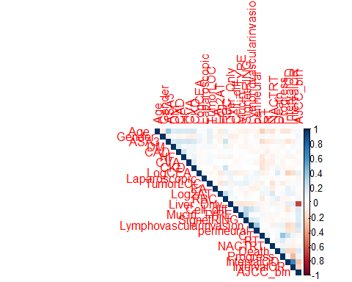

# Spearman  
corrplot(cor_spearman, method = "circle", type = "lower")

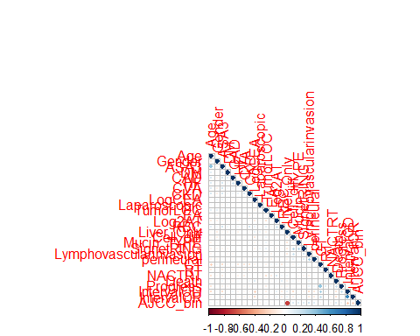

methods <- c("pearson", "spearman", "kendall")  
  
for (m in methods) {  
 cat("\n===== Metodo:", m, "=====\n")  
 cor_matrix <- cor(data, use = "complete.obs", method = m)  
 print(round(cor_matrix, 3))  
}

##   
## ===== Metodo: pearson =====  
## Age Gender ASA3 DM CAD HF CVA CKD  
## Age 1.000 -0.099 0.388 0.130 0.165 0.159 0.154 0.168  
## Gender -0.099 1.000 -0.070 -0.020 -0.050 -0.024 -0.088 -0.084  
## ASA3 0.388 -0.070 1.000 0.156 0.192 0.187 0.193 0.170  
## DM 0.130 -0.020 0.156 1.000 0.131 0.048 0.057 0.050  
## CAD 0.165 -0.050 0.192 0.131 1.000 0.204 0.055 0.059  
## HF 0.159 -0.024 0.187 0.048 0.204 1.000 0.016 0.088  
## CVA 0.154 -0.088 0.193 0.057 0.055 0.016 1.000 0.136  
## CKD 0.168 -0.084 0.170 0.050 0.059 0.088 0.136 1.000  
## LogCEA 0.021 0.069 0.082 0.028 -0.027 -0.038 -0.024 0.017  
## Laparoscopic 0.028 0.022 -0.034 0.031 -0.016 -0.017 -0.027 0.001  
## TumorLOC 0.106 0.108 0.099 0.032 0.028 0.032 0.048 0.002  
## EA -0.016 -0.051 -0.017 -0.032 -0.002 0.020 -0.009 -0.063  
## Log2AT -0.107 -0.069 -0.050 -0.005 -0.024 -0.051 0.009 0.021  
## RBC 0.088 0.031 0.194 0.065 0.018 0.045 0.020 0.191  
## Liver_Only -0.016 -0.100 -0.034 -0.058 0.030 -0.061 -0.006 -0.026  
## Cell_diff -0.032 -0.070 -0.034 -0.003 -0.009 -0.002 -0.039 -0.007  
## Mucin_TYPE -0.070 -0.019 -0.008 -0.034 -0.018 -0.021 -0.018 0.021  
## SignetRING -0.071 -0.050 -0.048 -0.046 0.019 0.005 0.014 -0.008  
## Lymphovascularinvasion -0.042 -0.001 -0.003 -0.040 -0.034 0.004 0.016 -0.009  
## perineural -0.059 -0.055 0.024 -0.019 -0.033 0.000 -0.044 0.003  
## CT -0.231 0.050 -0.183 -0.048 0.027 -0.121 -0.132 -0.141  
## RT -0.117 0.027 -0.109 -0.039 -0.071 -0.039 -0.071 -0.074  
## NACTRT -0.154 -0.033 -0.086 -0.006 -0.019 -0.062 -0.081 0.025  
## Death -0.027 0.011 0.058 0.019 -0.022 0.023 0.016 0.053  
## Progress -0.134 -0.008 -0.061 -0.047 -0.008 -0.022 -0.045 -0.042  
## IntervalOD -0.138 0.004 -0.146 0.003 0.031 -0.055 0.009 -0.024  
## IntervalOR -0.040 0.002 -0.084 0.031 0.014 -0.052 -0.012 -0.032  
## AJCC_bin 0.031 0.053 0.032 0.026 -0.047 0.024 -0.031 0.015  
## LogCEA Laparoscopic TumorLOC EA Log2AT RBC  
## Age 0.021 0.028 0.106 -0.016 -0.107 0.088  
## Gender 0.069 0.022 0.108 -0.051 -0.069 0.031  
## ASA3 0.082 -0.034 0.099 -0.017 -0.050 0.194  
## DM 0.028 0.031 0.032 -0.032 -0.005 0.065  
## CAD -0.027 -0.016 0.028 -0.002 -0.024 0.018  
## HF -0.038 -0.017 0.032 0.020 -0.051 0.045  
## CVA -0.024 -0.027 0.048 -0.009 0.009 0.020  
## CKD 0.017 0.001 0.002 -0.063 0.021 0.191  
## LogCEA 1.000 0.030 -0.049 -0.026 -0.118 0.080  
## Laparoscopic 0.030 1.000 0.008 -0.016 -0.046 -0.013  
## TumorLOC -0.049 0.008 1.000 -0.021 -0.131 0.114  
## EA -0.026 -0.016 -0.021 1.000 -0.018 -0.026  
## Log2AT -0.118 -0.046 -0.131 -0.018 1.000 0.235  
## RBC 0.080 -0.013 0.114 -0.026 0.235 1.000  
## Liver_Only 0.080 0.075 -0.061 0.043 0.071 0.031  
## Cell_diff -0.106 0.005 0.079 -0.011 0.010 0.043  
## Mucin_TYPE -0.069 0.004 0.070 -0.038 -0.018 0.002  
## SignetRING -0.054 0.063 0.108 -0.025 -0.069 0.025  
## Lymphovascularinvasion 0.021 0.033 0.048 -0.064 -0.029 -0.017  
## perineural 0.079 0.049 -0.052 -0.077 -0.007 -0.009  
## CT -0.073 0.015 -0.064 0.044 0.078 -0.116  
## RT -0.040 -0.017 0.007 0.056 0.050 -0.010  
## NACTRT 0.013 -0.027 -0.156 -0.094 0.163 0.058  
## Death 0.150 -0.018 0.022 -0.028 0.014 0.117  
## Progress 0.027 -0.004 -0.096 0.011 0.034 -0.050  
## IntervalOD -0.237 -0.028 -0.040 0.104 0.081 -0.060  
## IntervalOR -0.174 -0.006 0.025 0.049 0.081 -0.003  
## AJCC_bin 0.096 -0.051 0.038 -0.021 -0.023 0.048  
## Liver_Only Cell_diff Mucin_TYPE SignetRING  
## Age -0.016 -0.032 -0.070 -0.071  
## Gender -0.100 -0.070 -0.019 -0.050  
## ASA3 -0.034 -0.034 -0.008 -0.048  
## DM -0.058 -0.003 -0.034 -0.046  
## CAD 0.030 -0.009 -0.018 0.019  
## HF -0.061 -0.002 -0.021 0.005  
## CVA -0.006 -0.039 -0.018 0.014  
## CKD -0.026 -0.007 0.021 -0.008  
## LogCEA 0.080 -0.106 -0.069 -0.054  
## Laparoscopic 0.075 0.005 0.004 0.063  
## TumorLOC -0.061 0.079 0.070 0.108  
## EA 0.043 -0.011 -0.038 -0.025  
## Log2AT 0.071 0.010 -0.018 -0.069  
## RBC 0.031 0.043 0.002 0.025  
## Liver_Only 1.000 -0.118 -0.135 -0.119  
## Cell_diff -0.118 1.000 0.101 0.281  
## Mucin_TYPE -0.135 0.101 1.000 0.298  
## SignetRING -0.119 0.281 0.298 1.000  
## Lymphovascularinvasion -0.116 0.208 0.020 0.168  
## perineural -0.061 0.107 0.015 0.124  
## CT 0.034 -0.043 0.056 0.021  
## RT -0.023 0.026 -0.032 -0.041  
## NACTRT 0.069 0.007 -0.032 -0.049  
## Death -0.065 0.038 -0.034 0.018  
## Progress -0.058 -0.021 -0.006 -0.032  
## IntervalOD 0.118 -0.136 -0.031 -0.048  
## IntervalOR 0.113 -0.042 0.016 0.014  
## AJCC_bin -0.680 0.151 0.134 0.147  
## Lymphovascularinvasion perineural CT RT NACTRT  
## Age -0.042 -0.059 -0.231 -0.117 -0.154  
## Gender -0.001 -0.055 0.050 0.027 -0.033  
## ASA3 -0.003 0.024 -0.183 -0.109 -0.086  
## DM -0.040 -0.019 -0.048 -0.039 -0.006  
## CAD -0.034 -0.033 0.027 -0.071 -0.019  
## HF 0.004 0.000 -0.121 -0.039 -0.062  
## CVA 0.016 -0.044 -0.132 -0.071 -0.081  
## CKD -0.009 0.003 -0.141 -0.074 0.025  
## LogCEA 0.021 0.079 -0.073 -0.040 0.013  
## Laparoscopic 0.033 0.049 0.015 -0.017 -0.027  
## TumorLOC 0.048 -0.052 -0.064 0.007 -0.156  
## EA -0.064 -0.077 0.044 0.056 -0.094  
## Log2AT -0.029 -0.007 0.078 0.050 0.163  
## RBC -0.017 -0.009 -0.116 -0.010 0.058  
## Liver_Only -0.116 -0.061 0.034 -0.023 0.069  
## Cell_diff 0.208 0.107 -0.043 0.026 0.007  
## Mucin_TYPE 0.020 0.015 0.056 -0.032 -0.032  
## SignetRING 0.168 0.124 0.021 -0.041 -0.049  
## Lymphovascularinvasion 1.000 0.355 0.025 0.018 -0.070  
## perineural 0.355 1.000 0.001 -0.034 0.020  
## CT 0.025 0.001 1.000 0.094 0.007  
## RT 0.018 -0.034 0.094 1.000 -0.013  
## NACTRT -0.070 0.020 0.007 -0.013 1.000  
## Death 0.062 0.038 0.041 0.077 -0.026  
## Progress 0.088 0.058 0.393 0.134 0.065  
## IntervalOD -0.203 -0.143 0.224 0.047 -0.061  
## IntervalOR -0.140 -0.127 0.075 -0.052 -0.070  
## AJCC_bin 0.197 0.145 -0.040 -0.009 -0.049  
## Death Progress IntervalOD IntervalOR AJCC_bin  
## Age -0.027 -0.134 -0.138 -0.040 0.031  
## Gender 0.011 -0.008 0.004 0.002 0.053  
## ASA3 0.058 -0.061 -0.146 -0.084 0.032  
## DM 0.019 -0.047 0.003 0.031 0.026  
## CAD -0.022 -0.008 0.031 0.014 -0.047  
## HF 0.023 -0.022 -0.055 -0.052 0.024  
## CVA 0.016 -0.045 0.009 -0.012 -0.031  
## CKD 0.053 -0.042 -0.024 -0.032 0.015  
## LogCEA 0.150 0.027 -0.237 -0.174 0.096  
## Laparoscopic -0.018 -0.004 -0.028 -0.006 -0.051  
## TumorLOC 0.022 -0.096 -0.040 0.025 0.038  
## EA -0.028 0.011 0.104 0.049 -0.021  
## Log2AT 0.014 0.034 0.081 0.081 -0.023  
## RBC 0.117 -0.050 -0.060 -0.003 0.048  
## Liver_Only -0.065 -0.058 0.118 0.113 -0.680  
## Cell_diff 0.038 -0.021 -0.136 -0.042 0.151  
## Mucin_TYPE -0.034 -0.006 -0.031 0.016 0.134  
## SignetRING 0.018 -0.032 -0.048 0.014 0.147  
## Lymphovascularinvasion 0.062 0.088 -0.203 -0.140 0.197  
## perineural 0.038 0.058 -0.143 -0.127 0.145  
## CT 0.041 0.393 0.224 0.075 -0.040  
## RT 0.077 0.134 0.047 -0.052 -0.009  
## NACTRT -0.026 0.065 -0.061 -0.070 -0.049  
## Death 1.000 0.215 -0.202 -0.208 0.156  
## Progress 0.215 1.000 0.054 -0.323 0.083  
## IntervalOD -0.202 0.054 1.000 0.651 -0.285  
## IntervalOR -0.208 -0.323 0.651 1.000 -0.213  
## AJCC_bin 0.156 0.083 -0.285 -0.213 1.000  
##   
## ===== Metodo: spearman =====  
## Age Gender ASA3 DM CAD HF CVA CKD  
## Age 1.000 -0.105 0.400 0.129 0.168 0.160 0.157 0.171  
## Gender -0.105 1.000 -0.070 -0.020 -0.050 -0.024 -0.088 -0.084  
## ASA3 0.400 -0.070 1.000 0.156 0.192 0.187 0.193 0.170  
## DM 0.129 -0.020 0.156 1.000 0.131 0.048 0.057 0.050  
## CAD 0.168 -0.050 0.192 0.131 1.000 0.204 0.055 0.059  
## HF 0.160 -0.024 0.187 0.048 0.204 1.000 0.016 0.088  
## CVA 0.157 -0.088 0.193 0.057 0.055 0.016 1.000 0.136  
## CKD 0.171 -0.084 0.170 0.050 0.059 0.088 0.136 1.000  
## LogCEA 0.017 0.071 0.076 0.039 -0.029 -0.032 -0.024 0.012  
## Laparoscopic 0.023 0.022 -0.034 0.031 -0.016 -0.017 -0.027 0.001  
## TumorLOC 0.116 0.108 0.099 0.032 0.028 0.032 0.048 0.002  
## EA -0.015 -0.051 -0.017 -0.032 -0.002 0.020 -0.009 -0.063  
## Log2AT -0.109 -0.062 -0.042 -0.025 -0.019 -0.046 0.007 0.027  
## RBC 0.115 0.043 0.193 0.061 0.023 0.051 0.031 0.189  
## Liver_Only -0.024 -0.100 -0.034 -0.058 0.030 -0.061 -0.006 -0.026  
## Cell_diff -0.036 -0.070 -0.034 -0.003 -0.009 -0.002 -0.039 -0.007  
## Mucin_TYPE -0.067 -0.019 -0.008 -0.034 -0.018 -0.021 -0.018 0.021  
## SignetRING -0.062 -0.050 -0.048 -0.046 0.019 0.005 0.014 -0.008  
## Lymphovascularinvasion -0.048 -0.001 -0.003 -0.040 -0.034 0.004 0.016 -0.009  
## perineural -0.067 -0.055 0.024 -0.019 -0.033 0.000 -0.044 0.003  
## CT -0.232 0.050 -0.183 -0.048 0.027 -0.121 -0.132 -0.141  
## RT -0.119 0.027 -0.109 -0.039 -0.071 -0.039 -0.071 -0.074  
## NACTRT -0.147 -0.033 -0.086 -0.006 -0.019 -0.062 -0.081 0.025  
## Death -0.025 0.011 0.058 0.019 -0.022 0.023 0.016 0.053  
## Progress -0.132 -0.008 -0.061 -0.047 -0.008 -0.022 -0.045 -0.042  
## IntervalOD -0.187 0.020 -0.173 0.018 0.051 -0.041 -0.032 -0.035  
## IntervalOR -0.043 -0.012 -0.093 0.036 0.023 -0.033 -0.054 -0.044  
## AJCC_bin 0.034 0.053 0.032 0.026 -0.047 0.024 -0.031 0.015  
## LogCEA Laparoscopic TumorLOC EA Log2AT RBC  
## Age 0.017 0.023 0.116 -0.015 -0.109 0.115  
## Gender 0.071 0.022 0.108 -0.051 -0.062 0.043  
## ASA3 0.076 -0.034 0.099 -0.017 -0.042 0.193  
## DM 0.039 0.031 0.032 -0.032 -0.025 0.061  
## CAD -0.029 -0.016 0.028 -0.002 -0.019 0.023  
## HF -0.032 -0.017 0.032 0.020 -0.046 0.051  
## CVA -0.024 -0.027 0.048 -0.009 0.007 0.031  
## CKD 0.012 0.001 0.002 -0.063 0.027 0.189  
## LogCEA 1.000 0.016 -0.055 -0.022 -0.098 0.085  
## Laparoscopic 0.016 1.000 0.008 -0.016 -0.016 -0.016  
## TumorLOC -0.055 0.008 1.000 -0.021 -0.142 0.127  
## EA -0.022 -0.016 -0.021 1.000 -0.031 -0.030  
## Log2AT -0.098 -0.016 -0.142 -0.031 1.000 0.209  
## RBC 0.085 -0.016 0.127 -0.030 0.209 1.000  
## Liver_Only 0.080 0.075 -0.061 0.043 0.053 0.031  
## Cell_diff -0.126 0.005 0.079 -0.011 0.005 0.029  
## Mucin_TYPE -0.059 0.004 0.070 -0.038 -0.016 0.009  
## SignetRING -0.063 0.063 0.108 -0.025 -0.056 0.023  
## Lymphovascularinvasion 0.010 0.033 0.048 -0.064 0.000 -0.016  
## perineural 0.065 0.049 -0.052 -0.077 0.000 0.000  
## CT -0.065 0.015 -0.064 0.044 0.065 -0.117  
## RT -0.041 -0.017 0.007 0.056 0.043 -0.017  
## NACTRT 0.012 -0.027 -0.156 -0.094 0.164 0.051  
## Death 0.138 -0.018 0.022 -0.028 0.030 0.112  
## Progress 0.030 -0.004 -0.096 0.011 0.044 -0.054  
## IntervalOD -0.229 -0.020 -0.083 0.023 0.096 -0.104  
## IntervalOR -0.189 0.006 -0.050 0.009 0.079 -0.085  
## AJCC_bin 0.094 -0.051 0.038 -0.021 -0.003 0.045  
## Liver_Only Cell_diff Mucin_TYPE SignetRING  
## Age -0.024 -0.036 -0.067 -0.062  
## Gender -0.100 -0.070 -0.019 -0.050  
## ASA3 -0.034 -0.034 -0.008 -0.048  
## DM -0.058 -0.003 -0.034 -0.046  
## CAD 0.030 -0.009 -0.018 0.019  
## HF -0.061 -0.002 -0.021 0.005  
## CVA -0.006 -0.039 -0.018 0.014  
## CKD -0.026 -0.007 0.021 -0.008  
## LogCEA 0.080 -0.126 -0.059 -0.063  
## Laparoscopic 0.075 0.005 0.004 0.063  
## TumorLOC -0.061 0.079 0.070 0.108  
## EA 0.043 -0.011 -0.038 -0.025  
## Log2AT 0.053 0.005 -0.016 -0.056  
## RBC 0.031 0.029 0.009 0.023  
## Liver_Only 1.000 -0.118 -0.135 -0.119  
## Cell_diff -0.118 1.000 0.101 0.281  
## Mucin_TYPE -0.135 0.101 1.000 0.298  
## SignetRING -0.119 0.281 0.298 1.000  
## Lymphovascularinvasion -0.116 0.208 0.020 0.168  
## perineural -0.061 0.107 0.015 0.124  
## CT 0.034 -0.043 0.056 0.021  
## RT -0.023 0.026 -0.032 -0.041  
## NACTRT 0.069 0.007 -0.032 -0.049  
## Death -0.065 0.038 -0.034 0.018  
## Progress -0.058 -0.021 -0.006 -0.032  
## IntervalOD 0.104 -0.182 -0.016 -0.055  
## IntervalOR 0.093 -0.090 0.033 -0.016  
## AJCC_bin -0.680 0.151 0.134 0.147  
## Lymphovascularinvasion perineural CT RT NACTRT  
## Age -0.048 -0.067 -0.232 -0.119 -0.147  
## Gender -0.001 -0.055 0.050 0.027 -0.033  
## ASA3 -0.003 0.024 -0.183 -0.109 -0.086  
## DM -0.040 -0.019 -0.048 -0.039 -0.006  
## CAD -0.034 -0.033 0.027 -0.071 -0.019  
## HF 0.004 0.000 -0.121 -0.039 -0.062  
## CVA 0.016 -0.044 -0.132 -0.071 -0.081  
## CKD -0.009 0.003 -0.141 -0.074 0.025  
## LogCEA 0.010 0.065 -0.065 -0.041 0.012  
## Laparoscopic 0.033 0.049 0.015 -0.017 -0.027  
## TumorLOC 0.048 -0.052 -0.064 0.007 -0.156  
## EA -0.064 -0.077 0.044 0.056 -0.094  
## Log2AT 0.000 0.000 0.065 0.043 0.164  
## RBC -0.016 0.000 -0.117 -0.017 0.051  
## Liver_Only -0.116 -0.061 0.034 -0.023 0.069  
## Cell_diff 0.208 0.107 -0.043 0.026 0.007  
## Mucin_TYPE 0.020 0.015 0.056 -0.032 -0.032  
## SignetRING 0.168 0.124 0.021 -0.041 -0.049  
## Lymphovascularinvasion 1.000 0.355 0.025 0.018 -0.070  
## perineural 0.355 1.000 0.001 -0.034 0.020  
## CT 0.025 0.001 1.000 0.094 0.007  
## RT 0.018 -0.034 0.094 1.000 -0.013  
## NACTRT -0.070 0.020 0.007 -0.013 1.000  
## Death 0.062 0.038 0.041 0.077 -0.026  
## Progress 0.088 0.058 0.393 0.134 0.065  
## IntervalOD -0.188 -0.129 0.348 0.092 -0.010  
## IntervalOR -0.118 -0.120 0.232 0.016 -0.041  
## AJCC_bin 0.197 0.145 -0.040 -0.009 -0.049  
## Death Progress IntervalOD IntervalOR AJCC_bin  
## Age -0.025 -0.132 -0.187 -0.043 0.034  
## Gender 0.011 -0.008 0.020 -0.012 0.053  
## ASA3 0.058 -0.061 -0.173 -0.093 0.032  
## DM 0.019 -0.047 0.018 0.036 0.026  
## CAD -0.022 -0.008 0.051 0.023 -0.047  
## HF 0.023 -0.022 -0.041 -0.033 0.024  
## CVA 0.016 -0.045 -0.032 -0.054 -0.031  
## CKD 0.053 -0.042 -0.035 -0.044 0.015  
## LogCEA 0.138 0.030 -0.229 -0.189 0.094  
## Laparoscopic -0.018 -0.004 -0.020 0.006 -0.051  
## TumorLOC 0.022 -0.096 -0.083 -0.050 0.038  
## EA -0.028 0.011 0.023 0.009 -0.021  
## Log2AT 0.030 0.044 0.096 0.079 -0.003  
## RBC 0.112 -0.054 -0.104 -0.085 0.045  
## Liver_Only -0.065 -0.058 0.104 0.093 -0.680  
## Cell_diff 0.038 -0.021 -0.182 -0.090 0.151  
## Mucin_TYPE -0.034 -0.006 -0.016 0.033 0.134  
## SignetRING 0.018 -0.032 -0.055 -0.016 0.147  
## Lymphovascularinvasion 0.062 0.088 -0.188 -0.118 0.197  
## perineural 0.038 0.058 -0.129 -0.120 0.145  
## CT 0.041 0.393 0.348 0.232 -0.040  
## RT 0.077 0.134 0.092 0.016 -0.009  
## NACTRT -0.026 0.065 -0.010 -0.041 -0.049  
## Death 1.000 0.215 -0.137 -0.165 0.156  
## Progress 0.215 1.000 0.235 -0.019 0.083  
## IntervalOD -0.137 0.235 1.000 0.640 -0.275  
## IntervalOR -0.165 -0.019 0.640 1.000 -0.228  
## AJCC_bin 0.156 0.083 -0.275 -0.228 1.000  
##   
## ===== Metodo: kendall =====  
## Age Gender ASA3 DM CAD HF CVA CKD  
## Age 1.000 -0.087 0.330 0.106 0.138 0.132 0.130 0.141  
## Gender -0.087 1.000 -0.070 -0.020 -0.050 -0.024 -0.088 -0.084  
## ASA3 0.330 -0.070 1.000 0.156 0.192 0.187 0.193 0.170  
## DM 0.106 -0.020 0.156 1.000 0.131 0.048 0.057 0.050  
## CAD 0.138 -0.050 0.192 0.131 1.000 0.204 0.055 0.059  
## HF 0.132 -0.024 0.187 0.048 0.204 1.000 0.016 0.088  
## CVA 0.130 -0.088 0.193 0.057 0.055 0.016 1.000 0.136  
## CKD 0.141 -0.084 0.170 0.050 0.059 0.088 0.136 1.000  
## LogCEA 0.012 0.058 0.062 0.032 -0.024 -0.026 -0.020 0.010  
## Laparoscopic 0.019 0.022 -0.034 0.031 -0.016 -0.017 -0.027 0.001  
## TumorLOC 0.095 0.108 0.099 0.032 0.028 0.032 0.048 0.002  
## EA -0.012 -0.051 -0.017 -0.032 -0.002 0.020 -0.009 -0.063  
## Log2AT -0.075 -0.051 -0.035 -0.020 -0.016 -0.038 0.006 0.023  
## RBC 0.091 0.042 0.186 0.059 0.022 0.049 0.030 0.182  
## Liver_Only -0.020 -0.100 -0.034 -0.058 0.030 -0.061 -0.006 -0.026  
## Cell_diff -0.030 -0.070 -0.034 -0.003 -0.009 -0.002 -0.039 -0.007  
## Mucin_TYPE -0.055 -0.019 -0.008 -0.034 -0.018 -0.021 -0.018 0.021  
## SignetRING -0.051 -0.050 -0.048 -0.046 0.019 0.005 0.014 -0.008  
## Lymphovascularinvasion -0.040 -0.001 -0.003 -0.040 -0.034 0.004 0.016 -0.009  
## perineural -0.055 -0.055 0.024 -0.019 -0.033 0.000 -0.044 0.003  
## CT -0.192 0.050 -0.183 -0.048 0.027 -0.121 -0.132 -0.141  
## RT -0.099 0.027 -0.109 -0.039 -0.071 -0.039 -0.071 -0.074  
## NACTRT -0.122 -0.033 -0.086 -0.006 -0.019 -0.062 -0.081 0.025  
## Death -0.021 0.011 0.058 0.019 -0.022 0.023 0.016 0.053  
## Progress -0.109 -0.008 -0.061 -0.047 -0.008 -0.022 -0.045 -0.042  
## IntervalOD -0.125 0.017 -0.141 0.015 0.041 -0.033 -0.027 -0.028  
## IntervalOR -0.029 -0.010 -0.076 0.029 0.019 -0.027 -0.044 -0.036  
## AJCC_bin 0.028 0.053 0.032 0.026 -0.047 0.024 -0.031 0.015  
## LogCEA Laparoscopic TumorLOC EA Log2AT RBC  
## Age 0.012 0.019 0.095 -0.012 -0.075 0.091  
## Gender 0.058 0.022 0.108 -0.051 -0.051 0.042  
## ASA3 0.062 -0.034 0.099 -0.017 -0.035 0.186  
## DM 0.032 0.031 0.032 -0.032 -0.020 0.059  
## CAD -0.024 -0.016 0.028 -0.002 -0.016 0.022  
## HF -0.026 -0.017 0.032 0.020 -0.038 0.049  
## CVA -0.020 -0.027 0.048 -0.009 0.006 0.030  
## CKD 0.010 0.001 0.002 -0.063 0.023 0.182  
## LogCEA 1.000 0.013 -0.045 -0.018 -0.065 0.068  
## Laparoscopic 0.013 1.000 0.008 -0.016 -0.013 -0.015  
## TumorLOC -0.045 0.008 1.000 -0.021 -0.118 0.123  
## EA -0.018 -0.016 -0.021 1.000 -0.025 -0.029  
## Log2AT -0.065 -0.013 -0.118 -0.025 1.000 0.168  
## RBC 0.068 -0.015 0.123 -0.029 0.168 1.000  
## Liver_Only 0.066 0.075 -0.061 0.043 0.044 0.030  
## Cell_diff -0.103 0.005 0.079 -0.011 0.004 0.028  
## Mucin_TYPE -0.048 0.004 0.070 -0.038 -0.013 0.008  
## SignetRING -0.051 0.063 0.108 -0.025 -0.047 0.022  
## Lymphovascularinvasion 0.008 0.033 0.048 -0.064 0.000 -0.015  
## perineural 0.053 0.049 -0.052 -0.077 0.000 0.000  
## CT -0.053 0.015 -0.064 0.044 0.054 -0.113  
## RT -0.033 -0.017 0.007 0.056 0.036 -0.016  
## NACTRT 0.010 -0.027 -0.156 -0.094 0.136 0.050  
## Death 0.113 -0.018 0.022 -0.028 0.025 0.108  
## Progress 0.024 -0.004 -0.096 0.011 0.037 -0.052  
## IntervalOD -0.155 -0.017 -0.068 0.018 0.066 -0.082  
## IntervalOR -0.128 0.005 -0.041 0.007 0.054 -0.067  
## AJCC_bin 0.077 -0.051 0.038 -0.021 -0.003 0.043  
## Liver_Only Cell_diff Mucin_TYPE SignetRING  
## Age -0.020 -0.030 -0.055 -0.051  
## Gender -0.100 -0.070 -0.019 -0.050  
## ASA3 -0.034 -0.034 -0.008 -0.048  
## DM -0.058 -0.003 -0.034 -0.046  
## CAD 0.030 -0.009 -0.018 0.019  
## HF -0.061 -0.002 -0.021 0.005  
## CVA -0.006 -0.039 -0.018 0.014  
## CKD -0.026 -0.007 0.021 -0.008  
## LogCEA 0.066 -0.103 -0.048 -0.051  
## Laparoscopic 0.075 0.005 0.004 0.063  
## TumorLOC -0.061 0.079 0.070 0.108  
## EA 0.043 -0.011 -0.038 -0.025  
## Log2AT 0.044 0.004 -0.013 -0.047  
## RBC 0.030 0.028 0.008 0.022  
## Liver_Only 1.000 -0.118 -0.135 -0.119  
## Cell_diff -0.118 1.000 0.101 0.281  
## Mucin_TYPE -0.135 0.101 1.000 0.298  
## SignetRING -0.119 0.281 0.298 1.000  
## Lymphovascularinvasion -0.116 0.208 0.020 0.168  
## perineural -0.061 0.107 0.015 0.124  
## CT 0.034 -0.043 0.056 0.021  
## RT -0.023 0.026 -0.032 -0.041  
## NACTRT 0.069 0.007 -0.032 -0.049  
## Death -0.065 0.038 -0.034 0.018  
## Progress -0.058 -0.021 -0.006 -0.032  
## IntervalOD 0.085 -0.148 -0.013 -0.045  
## IntervalOR 0.076 -0.073 0.027 -0.013  
## AJCC_bin -0.680 0.151 0.134 0.147  
## Lymphovascularinvasion perineural CT RT NACTRT  
## Age -0.040 -0.055 -0.192 -0.099 -0.122  
## Gender -0.001 -0.055 0.050 0.027 -0.033  
## ASA3 -0.003 0.024 -0.183 -0.109 -0.086  
## DM -0.040 -0.019 -0.048 -0.039 -0.006  
## CAD -0.034 -0.033 0.027 -0.071 -0.019  
## HF 0.004 0.000 -0.121 -0.039 -0.062  
## CVA 0.016 -0.044 -0.132 -0.071 -0.081  
## CKD -0.009 0.003 -0.141 -0.074 0.025  
## LogCEA 0.008 0.053 -0.053 -0.033 0.010  
## Laparoscopic 0.033 0.049 0.015 -0.017 -0.027  
## TumorLOC 0.048 -0.052 -0.064 0.007 -0.156  
## EA -0.064 -0.077 0.044 0.056 -0.094  
## Log2AT 0.000 0.000 0.054 0.036 0.136  
## RBC -0.015 0.000 -0.113 -0.016 0.050  
## Liver_Only -0.116 -0.061 0.034 -0.023 0.069  
## Cell_diff 0.208 0.107 -0.043 0.026 0.007  
## Mucin_TYPE 0.020 0.015 0.056 -0.032 -0.032  
## SignetRING 0.168 0.124 0.021 -0.041 -0.049  
## Lymphovascularinvasion 1.000 0.355 0.025 0.018 -0.070  
## perineural 0.355 1.000 0.001 -0.034 0.020  
## CT 0.025 0.001 1.000 0.094 0.007  
## RT 0.018 -0.034 0.094 1.000 -0.013  
## NACTRT -0.070 0.020 0.007 -0.013 1.000  
## Death 0.062 0.038 0.041 0.077 -0.026  
## Progress 0.088 0.058 0.393 0.134 0.065  
## IntervalOD -0.153 -0.105 0.284 0.075 -0.008  
## IntervalOR -0.096 -0.098 0.189 0.013 -0.033  
## AJCC_bin 0.197 0.145 -0.040 -0.009 -0.049  
## Death Progress IntervalOD IntervalOR AJCC_bin  
## Age -0.021 -0.109 -0.125 -0.029 0.028  
## Gender 0.011 -0.008 0.017 -0.010 0.053  
## ASA3 0.058 -0.061 -0.141 -0.076 0.032  
## DM 0.019 -0.047 0.015 0.029 0.026  
## CAD -0.022 -0.008 0.041 0.019 -0.047  
## HF 0.023 -0.022 -0.033 -0.027 0.024  
## CVA 0.016 -0.045 -0.027 -0.044 -0.031  
## CKD 0.053 -0.042 -0.028 -0.036 0.015  
## LogCEA 0.113 0.024 -0.155 -0.128 0.077  
## Laparoscopic -0.018 -0.004 -0.017 0.005 -0.051  
## TumorLOC 0.022 -0.096 -0.068 -0.041 0.038  
## EA -0.028 0.011 0.018 0.007 -0.021  
## Log2AT 0.025 0.037 0.066 0.054 -0.003  
## RBC 0.108 -0.052 -0.082 -0.067 0.043  
## Liver_Only -0.065 -0.058 0.085 0.076 -0.680  
## Cell_diff 0.038 -0.021 -0.148 -0.073 0.151  
## Mucin_TYPE -0.034 -0.006 -0.013 0.027 0.134  
## SignetRING 0.018 -0.032 -0.045 -0.013 0.147  
## Lymphovascularinvasion 0.062 0.088 -0.153 -0.096 0.197  
## perineural 0.038 0.058 -0.105 -0.098 0.145  
## CT 0.041 0.393 0.284 0.189 -0.040  
## RT 0.077 0.134 0.075 0.013 -0.009  
## NACTRT -0.026 0.065 -0.008 -0.033 -0.049  
## Death 1.000 0.215 -0.112 -0.135 0.156  
## Progress 0.215 1.000 0.192 -0.015 0.083  
## IntervalOD -0.112 0.192 1.000 0.487 -0.225  
## IntervalOR -0.135 -0.015 0.487 1.000 -0.186  
## AJCC_bin 0.156 0.083 -0.225 -0.186 1.000

A livello interpretativo, PEARSON - RELAZIONE LINEARE CONTINUA:

1- ETÁ: eta correlata positivamente con HF (piú anzianitá = piú infartuati) e ASA3. Negativamente con chemioterapia 2- ASA3: correlato positivametne ma moderatamente con tutte le comorbiditá: é un buon proxy dello stato comorbito dei pazienti?

PEARSON: MONOTONA

Age – ASA3: ρ = 0.480 → Età maggiore si associa a status ASA3 (logico: pazienti più anziani tendono ad avere comorbidità).

Age – Interval: ρ = -0.345 → Età maggiore correlata a un tempo inferiore tra diagnosi e trattamento? Potrebbe indicare priorità clinica.

Interval – ASA3: ρ = -0.270 → Anche qui, pazienti più gravi (ASA3) ricevono cure più tempestive.

CKD – CVA: ρ = 0.264 → Insufficienza renale cronica associata a pregressi eventi cerebrovascolari (coerenza clinica).

ASA3 – CAD/HF/CVA/CKD: tutte >0.2 → conferma che ASA3 sintetizza diverse comorbidità.

MOLTO INTERESSANTE: PROGRESS E TUMORLOC ρ = -0.221: sedi tumorali hanno minore tendenza alla progressione!!!!

Age vs ASA3: ρ = 0.397 → correlazione moderata e positiva. Conferma che l’età avanzata tende ad associarsi a uno stato fisico compromesso (ASA3 alto).

Age vs HF (scompenso cardiaco): ρ = 0.176 → relazione debole ma coerente con la letteratura.

Age vs Interval: ρ = -0.236 → età maggiore è debolmente associata a un intervallo più breve (probabile tra intervento e progressione).

CHEMIOTERAPIA invece é neg corr con ASA3 e etá, cioe i pazienti giovani e meno fragili ricevono piu spesso chemioterapia.

ASA3 É UN OTTIMO SURROGATO SINTETICO DELLE COMORBIDITÁ: STATO CLINICO

SE SPEARMAN ÉMAGGIORE DI PEARSON: POTREBBE ESSERCI UNA RELAZIONE MONOTONA NON LINEARE!!!! - AGE e INTERVAL - CKD e RBC

* HFe ASA3
* PROGRESS - TUMOR LOR

# METODI PROIEZIONE - riduzione dimensionale spazi latenti

UMAP e t-SNE: sono solo metodi di proiezione (riduzione dimensionale). Non creano cluster di per sé, ma aiutano a visualizzare i dati.

I DATI VENGONO STANDARDIZZATI: per rendere comparabile ogni variabile, media 0 e sd 1 Lo richiedevano i metodi scelti - UMAP t-SNE e, dopo, PCA.

Viene effettuata la riduzione dimensionale per visualizzare dati ad alta dimensionalità in 2D.

t-SNE e UMAP sono tecniche non lineari (adatte a pattern complessi).

PCA è lineare, utile per interpretabilità e visualizzazione.

Non servono per clustering, ma per capire la distribuzione dei dati.

# install.packages(c("Rtsne", "umap"))  
  
# Caricamento pacchetti  
library(Rtsne)

## Warning: package 'Rtsne' was built under R version 4.3.3

library(umap)

## Warning: package 'umap' was built under R version 4.3.3

library(ggplot2)  
  
# Standardizza i dati  
data_scaled <- scale(data)  
  
# t-SNE  
set.seed(42)  
tsne_out <- Rtsne(data_scaled, dims = 2, perplexity = 30, verbose = TRUE, max_iter = 500)

## Performing PCA  
## Read the 916 x 28 data matrix successfully!  
## OpenMP is working. 1 threads.  
## Using no_dims = 2, perplexity = 30.000000, and theta = 0.500000  
## Computing input similarities...  
## Building tree...  
## Done in 0.42 seconds (sparsity = 0.149802)!  
## Learning embedding...  
## Iteration 50: error is 68.038564 (50 iterations in 0.37 seconds)  
## Iteration 100: error is 68.038521 (50 iterations in 1.00 seconds)  
## Iteration 150: error is 68.038593 (50 iterations in 1.26 seconds)  
## Iteration 200: error is 68.038593 (50 iterations in 1.33 seconds)  
## Iteration 250: error is 68.038536 (50 iterations in 1.73 seconds)  
## Iteration 300: error is 3.183366 (50 iterations in 1.18 seconds)  
## Iteration 350: error is 1.441138 (50 iterations in 0.51 seconds)  
## Iteration 400: error is 1.374193 (50 iterations in 0.49 seconds)  
## Iteration 450: error is 1.341848 (50 iterations in 0.36 seconds)  
## Iteration 500: error is 1.326467 (50 iterations in 0.41 seconds)  
## Fitting performed in 8.63 seconds.

tsne_df <- data.frame(  
 Dim1 = tsne_out$Y[,1],  
 Dim2 = tsne_out$Y[,2]  
)  
  
# UMAP  
umap_out <- umap(data_scaled)  
umap_df <- data.frame(  
 Dim1 = umap_out$layout[,1],  
 Dim2 = umap_out$layout[,2]  
)  
  
# Grafico t-SNE  
ggplot(tsne_df, aes(x = Dim1, y = Dim2)) +  
 geom_point(alpha = 0.7) +  
 labs(title = "t-SNE dei dati") +  
 theme_minimal()

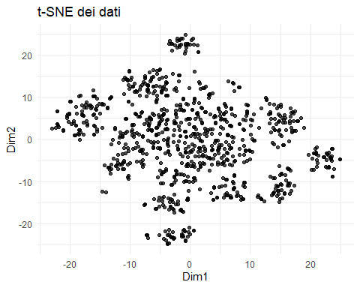

# Grafico UMAP  
ggplot(umap_df, aes(x = Dim1, y = Dim2)) +  
 geom_point(alpha = 0.7) +  
 labs(title = "UMAP dei dati") +  
 theme_minimal()

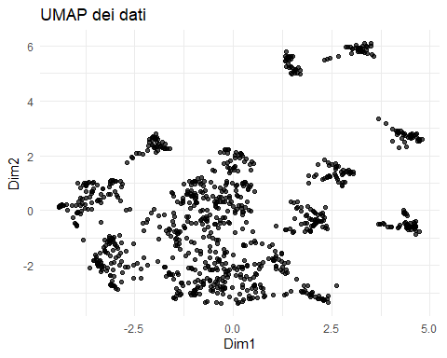

### INTERPRETAZIONE

Serve per vedere se la variabile target separa i dati nella proiezione.

Se i punti colorati per “Death” o chi per lei si raggruppano, significa che quella variabile ha un effetto latente.

# Aggiungiamo la variabile target (assumendo sia "Death")  
tsne_df$Death <- data$Death  
umap_df$Death <- data$Death  
  
# t-SNE con colorazione  
ggplot(tsne_df, aes(x = Dim1, y = Dim2, color = as.factor(Death))) +  
 geom_point(alpha = 0.7) +  
 labs(title = "t-SNE dei dati (colorato per Death)", color = "Death") +  
 theme_minimal()

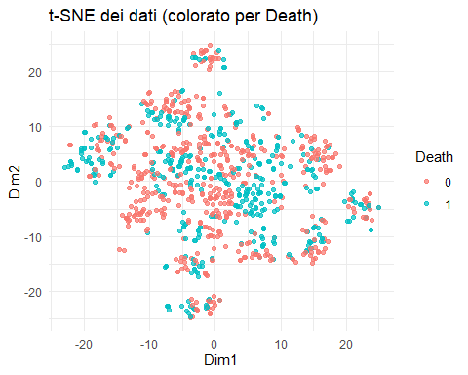

# UMAP con colorazione  
ggplot(umap_df, aes(x = Dim1, y = Dim2, color = as.factor(Death))) +  
 geom_point(alpha = 0.7) +  
 labs(title = "UMAP dei dati (colorato per Death)", color = "Death") +  
 theme_minimal()

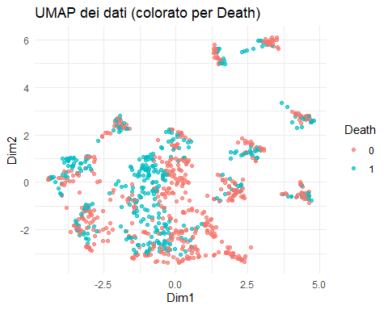

tsne_df$Gender <- data$Gender  
umap_df$Gender <- data$Gender  
  
# t-SNE con colorazione  
ggplot(tsne_df, aes(x = Dim1, y = Dim2, color = as.factor(Gender))) +  
 geom_point(alpha = 0.7) +  
 labs(title = "t-SNE dei dati (colorato per Death)", color = "Gender") +  
 theme_minimal()

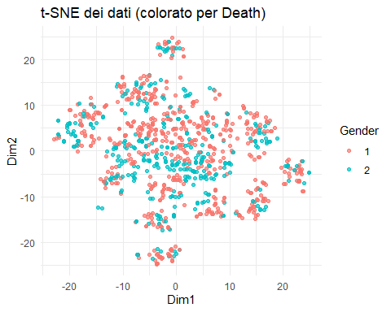

# UMAP con colorazione  
ggplot(umap_df, aes(x = Dim1, y = Dim2, color = as.factor(Gender))) +  
 geom_point(alpha = 0.7) +  
 labs(title = "UMAP dei dati (colorato per GEDER)", color = "Gender") +  
 theme_minimal()

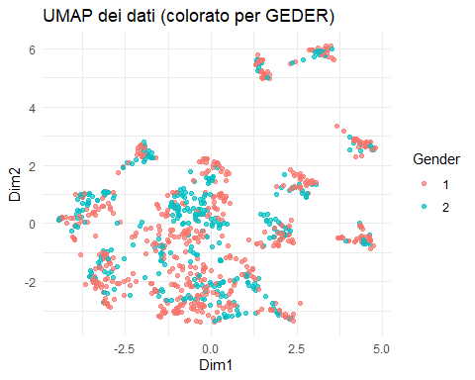

# Aggiungiamo la variabile target (assumendo sia "Death")  
tsne_df$ASA3 <- data$ASA3  
umap_df$ASA3 <- data$ASA3  
  
# t-SNE con colorazione  
ggplot(tsne_df, aes(x = Dim1, y = Dim2, color = as.factor(ASA3))) +  
 geom_point(alpha = 0.7) +  
 labs(title = "t-SNE dei dati (colorato per Death)", color = "ASA3") +  
 theme_minimal()

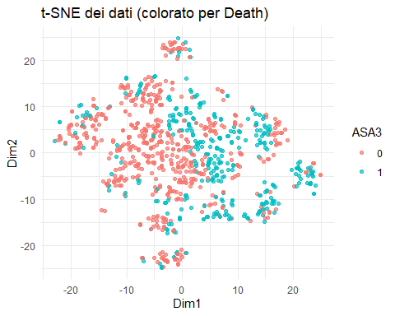

# UMAP con colorazione  
ggplot(umap_df, aes(x = Dim1, y = Dim2, color = as.factor(ASA3))) +  
 geom_point(alpha = 0.7) +  
 labs(title = "UMAP dei dati (colorato per ASA3)", color = "ASA3") +  
 theme_minimal()

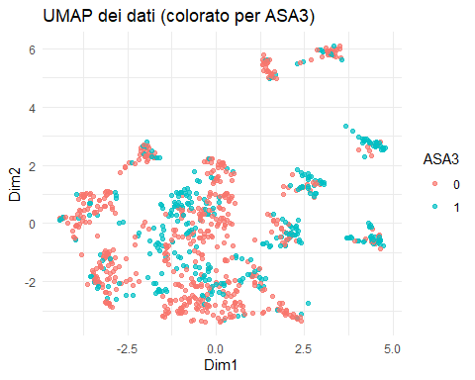

tsne_df$CT <- data$CT  
umap_df$CT <- data$CT  
  
# t-SNE con colorazione  
ggplot(tsne_df, aes(x = Dim1, y = Dim2, color = as.factor(CT))) +  
 geom_point(alpha = 0.7) +  
 labs(title = "t-SNE dei dati (colorato per CT)", color = "CT") +  
 theme_minimal()

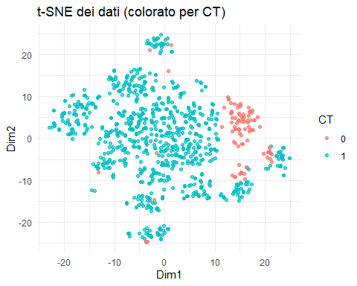

# UMAP con colorazione  
ggplot(umap_df, aes(x = Dim1, y = Dim2, color = as.factor(CT))) +  
 geom_point(alpha = 0.7) +  
 labs(title = "UMAP dei dati (colorato per CT)", color = "CT") +  
 theme_minimal()

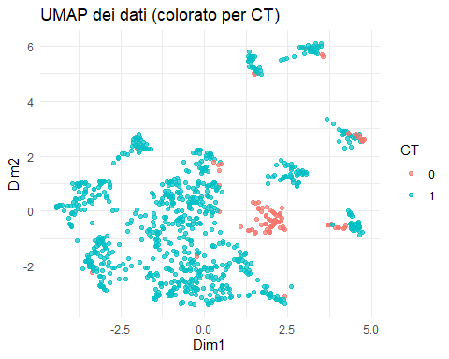

tsne_df$AJCC_bin <- data$AJCC_bin  
umap_df$AJCC_bin <- data$AJCC_bin  
  
# t-SNE con colorazione  
ggplot(tsne_df, aes(x = Dim1, y = Dim2, color = as.factor(AJCC_bin))) +  
 geom_point(alpha = 0.7) +  
 labs(title = "t-SNE dei dati (colorato per AJCC_bin)", color = "AJCC_bin") +  
 theme_minimal()

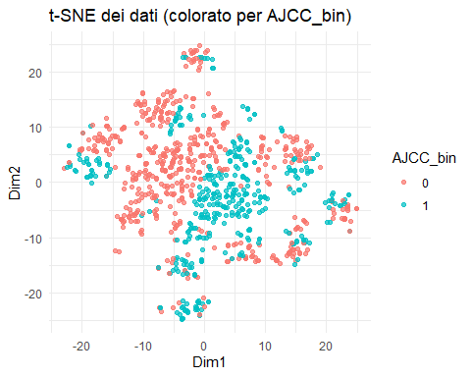

# UMAP con colorazione  
ggplot(umap_df, aes(x = Dim1, y = Dim2, color = as.factor(AJCC_bin))) +  
 geom_point(alpha = 0.7) +  
 labs(title = "UMAP dei dati (colorato per AJCC_bin)", color = "AJCC_bin") +  
 theme_minimal()

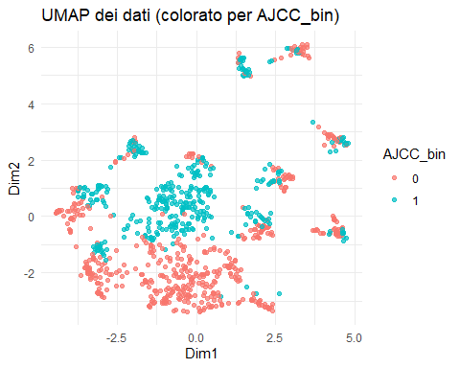

tsne_df$HF <- data$HF  
umap_df$HF <- data$HF  
  
# t-SNE con colorazione  
ggplot(tsne_df, aes(x = Dim1, y = Dim2, color = as.factor(HF))) +  
 geom_point(alpha = 0.7) +  
 labs(title = "t-SNE dei dati (colorato per HF)", color = "HF") +  
 theme_minimal()

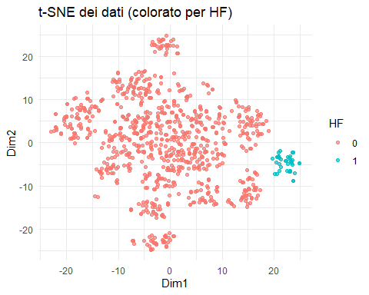

# UMAP con colorazione  
ggplot(umap_df, aes(x = Dim1, y = Dim2, color = as.factor(HF))) +  
 geom_point(alpha = 0.7) +  
 labs(title = "UMAP dei dati (colorato per HF)", color = "HF") +  
 theme_minimal()

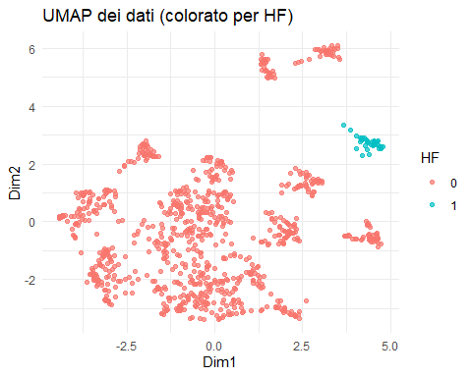

tsne_df$Liver_Only <- data$Liver_Only  
umap_df$Liver_Only <- data$Liver_Only  
  
# t-SNE con colorazione  
ggplot(tsne_df, aes(x = Dim1, y = Dim2, color = as.factor(Liver_Only))) +  
 geom_point(alpha = 0.7) +  
 labs(title = "t-SNE dei dati (colorato per Liver_Only)", color = "Liver_Only") +  
 theme_minimal()

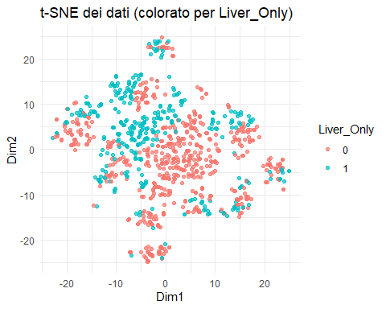

# UMAP con colorazione  
ggplot(umap_df, aes(x = Dim1, y = Dim2, color = as.factor(Liver_Only))) +  
 geom_point(alpha = 0.7) +  
 labs(title = "UMAP dei dati (colorato per Liver_Only)", color = "Liver_Only") +  
 theme_minimal()

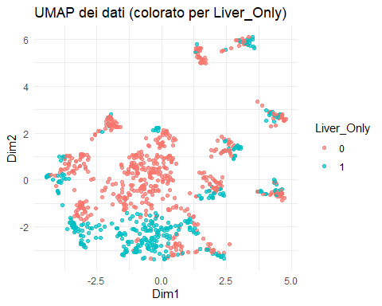

tsne_df$Laparoscopic <- data$Laparoscopic  
umap_df$Laparoscopic <- data$Laparoscopic  
  
# t-SNE con colorazione  
ggplot(tsne_df, aes(x = Dim1, y = Dim2, color = as.factor(Laparoscopic))) +  
 geom_point(alpha = 0.7) +  
 labs(title = "t-SNE dei dati (colorato per Laparoscopic)", color = "Laparoscopic") +  
 theme_minimal()

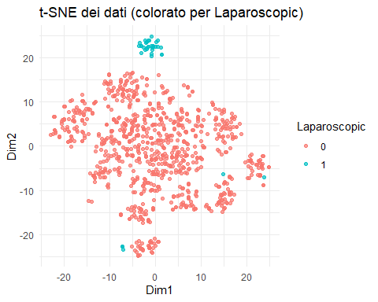

# UMAP con colorazione  
ggplot(umap_df, aes(x = Dim1, y = Dim2, color = as.factor(Laparoscopic))) +  
 geom_point(alpha = 0.7) +  
 labs(title = "UMAP dei dati (colorato per Laparoscopic)", color = "Laparoscopic") +  
 theme_minimal()

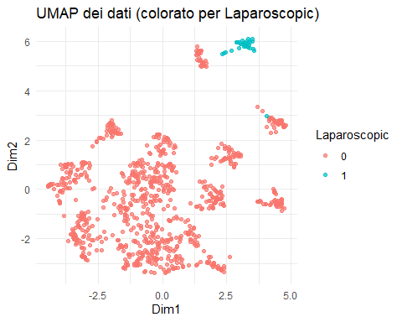

## t-test SU UMAP

t.test(umap_df$Dim1 ~ data$Laparoscopic)

##   
## Welch Two Sample t-test  
##   
## data: umap_df$Dim1 by data$Laparoscopic  
## t = -34.694, df = 285.68, p-value < 2.2e-16  
## alternative hypothesis: true difference in means between group 0 and group 1 is not equal to 0  
## 95 percent confidence interval:  
## -3.492608 -3.117587  
## sample estimates:  
## mean in group 0 mean in group 1   
## -0.1335028 3.1715947

t.test(umap_df$Dim1 ~ data$HF)

##   
## Welch Two Sample t-test  
##   
## data: umap_df$Dim1 by data$HF  
## t = -53.982, df = 492.31, p-value < 2.2e-16  
## alternative hypothesis: true difference in means between group 0 and group 1 is not equal to 0  
## 95 percent confidence interval:  
## -4.767586 -4.432722  
## sample estimates:  
## mean in group 0 mean in group 1   
## -0.2008801 4.3992735

LAPAROSCOPIA

Gruppo 0 (non laparoscopici): ≈ -0.14

Gruppo 1 (laparoscopici): ≈ 3.3 → forte separazionE = variabile determinante nei pattern latenti della popolazione

INFARTO GRUPPO 0 , NO HF, = -0.21 GRUPPO 1 , YES HF = 4.8

Si verficano tutte le variabili, per vedere che cosa comunica la U

### T TEST SU DIMENSIONE 1 DI UMAP

# Lista delle variabili da testare  
variabili <- c("Age", "Gender", "ASA3", "DM", "CAD", "HF", "CVA",   
 "CKD", "CEA", "LogCEA", "Laparoscopic", "TumorLOC", "EA", "AnesTime",   
 "Log2AT", "RBC", "Liver_Only", "Cell_diff", "Mucin_TYPE", "SignetRING",   
 "Lymphovascularinvasion", "perineural", "CT", "RT", "NACTRT",   
 "Interval", "Progress", "IntervalR", "AJCC_bin")  
  
# Dataframe per salvare i risultati  
risultati <- data.frame(  
 Variabile = character(),  
 p_value = numeric(),  
 t_stat = numeric(),  
 mean_group0 = numeric(),  
 mean_group1 = numeric(),  
 stringsAsFactors = FALSE  
)  
  
# Loop sulle variabili  
for (v in variabili) {  
 if (v %in% names(data)) {  
 # Isola la variabile target e la pulizia dei NA  
 tmp <- data.frame(  
 x = umap_df$Dim1,  
 group = data[[v]]  
 )  
 tmp <- tmp[complete.cases(tmp), ]  
   
 # Converti character/factor in numerico binario se possibile  
 if (is.character(tmp$group) || is.factor(tmp$group)) {  
 levels <- unique(tmp$group)  
 if (length(levels) == 2) {  
 tmp$group <- as.numeric(tmp$group == levels[2])  
 } else {  
 next # Salta variabili con più di 2 classi  
 }  
 }  
   
 # Esegui t-test solo se gruppo binario  
 if (length(unique(tmp$group)) == 2) {  
 t <- t.test(x ~ group, data = tmp)  
 risultati <- rbind(risultati, data.frame(  
 Variabile = v,  
 p_value = t$p.value,  
 t_stat = t$statistic,  
 mean_group0 = mean(tmp$x[tmp$group == 0]),  
 mean_group1 = mean(tmp$x[tmp$group == 1])  
 ))  
 }  
 }  
}  
  
# Ordina per significatività  
risultati <- risultati[order(risultati$p_value), ]  
  
# Visualizza  
print(risultati)

## Variabile p_value t_stat mean_group0 mean_group1  
## t4 HF 6.398122e-209 -53.9822595 -0.20088007 4.39927349  
## t7 Laparoscopic 1.936245e-104 -34.6936676 -0.13350285 3.17159469  
## t5 CVA 1.393998e-68 -36.1143917 -0.25625941 4.17267680  
## t3 CAD 2.699733e-58 -25.1980433 -0.24057574 3.00012099  
## t16 CT 5.111489e-33 15.3779506 2.31053838 -0.26422215  
## t17 RT 6.314969e-29 14.7199282 0.34978814 -2.91966015  
## t19 Progress 8.426028e-25 11.0794002 1.40176979 -0.36929383  
## t13 SignetRING 2.060273e-22 -13.1634029 -0.08301878 1.77174218  
## t18 NACTRT 7.261617e-22 10.8598525 0.34233706 -1.85053532  
## t1 ASA3 1.756279e-12 -7.1941937 -0.43971215 0.72775546  
## t6 CKD 9.743247e-06 -4.5720872 -0.14596002 0.94102676  
## t8 TumorLOC 2.669602e-04 -3.6694274 -0.18777152 0.42432354  
## t2 DM 1.029026e-02 -2.5830349 -0.10644638 0.40405038  
## t12 Mucin_TYPE 1.446632e-01 1.4725149 0.02937571 -0.36059753  
## t Gender 1.541788e-01 1.4263213 NaN 0.08556258  
## t10 Liver_Only 2.128323e-01 1.2469389 0.07927630 -0.12413292  
## t11 Cell_diff 2.273680e-01 -1.2118135 NaN -0.03363744  
## t14 Lymphovascularinvasion 2.521048e-01 -1.1459861 -0.09229925 0.08682387  
## t15 perineural 4.620611e-01 0.7362460 0.02945362 -0.10151492  
## t20 AJCC_bin 6.075282e-01 0.5137879 0.03334808 -0.04599436  
## t9 EA 7.222358e-01 -0.3559367 -0.01220246 0.06182042

### T TEST DI DIM2 DI UMAP

# Lista delle variabili binarie o categoriali 2 livelli  
vars <- c("Age", "Gender", "ASA3", "DM", "CAD", "HF", "CVA",   
 "CKD", "CEA", "LogCEA", "Laparoscopic", "TumorLOC", "EA",   
 "AnesTime", "Log2AT", "RBC", "Liver_Only", "Cell_diff",   
 "Mucin_TYPE", "SignetRING", "Lymphovascularinvasion", "perineural",   
 "CT", "RT", "NACTRT", "Interval", "Progress", "IntervalR", "AJCC_bin")  
  
# Data frame vuoto per salvare i risultati  
results <- data.frame(Variabile=character(),  
 p_value=double(),  
 t_stat=double(),  
 mean_group0=double(),  
 mean_group1=double(),  
 stringsAsFactors=FALSE)  
  
# Loop per ogni variabile  
for (var in vars) {  
 # Estrai la variabile target  
 group <- data[[var]]  
   
 # Verifica che ci siano solo due gruppi (t-test richiede questo)  
 if (length(unique(na.omit(group))) == 2) {  
 test <- try(t.test(umap_df$Dim2 ~ group), silent=TRUE)  
 if (!inherits(test, "try-error")) {  
 means <- tapply(umap_df$Dim2, group, mean, na.rm=TRUE)  
 results <- rbind(results, data.frame(  
 Variabile = var,  
 p_value = test$p.value,  
 t_stat = test$statistic,  
 mean_group0 = means[1],  
 mean_group1 = means[2]  
 ))  
 }  
 } else {  
 # Se la variabile non è binaria, saltiamo  
 warning(paste("Variabile non binaria:", var))  
 }  
}

## Warning: Variabile non binaria: Age

## Warning: Variabile non binaria: CEA

## Warning: Variabile non binaria: LogCEA

## Warning: Variabile non binaria: AnesTime

## Warning: Variabile non binaria: Log2AT

## Warning: Variabile non binaria: RBC

## Warning: Variabile non binaria: Interval

## Warning: Variabile non binaria: IntervalR

# Ordina per p-value crescente  
results <- results[order(results$p_value), ]  
  
# Visualizza i primi risultati  
print(results)

## Variabile p_value t_stat mean_group0 mean_group1  
## t4 HF 4.240648e-157 -34.5270195 -0.124409554 2.72456923  
## t7 Laparoscopic 1.631970e-78 -56.8650397 -0.242756619 5.76710995  
## t20 AJCC_bin 3.150395e-38 -13.5509611 -0.774713667 1.06850119  
## t13 SignetRING 1.519383e-23 -19.1795691 -0.230563551 4.92056359  
## t10 Liver_Only 1.193670e-22 10.1495307 0.597933643 -0.93626024  
## t12 Mucin_TYPE 7.882359e-20 -12.1426103 -0.240759776 2.95541349  
## t3 CAD 6.786351e-18 -10.3533042 -0.130674420 1.62958689  
## t11 Cell_diff 4.539633e-16 -9.1202721 -0.257428308 1.75799331  
## t14 Lymphovascularinvasion 3.102630e-11 -6.7255243 -0.510698681 0.48040300  
## t17 RT 3.605453e-08 -5.7495865 -0.095378280 0.79611667  
## t18 NACTRT 5.648979e-06 4.6482514 0.130434509 -0.70507605  
## t15 perineural 6.041506e-06 -4.6099173 -0.206312319 0.71107644  
## t8 TumorLOC 7.443072e-04 -3.3937558 -0.175536017 0.39667392  
## t1 ASA3 7.379853e-03 -2.6857344 -0.149821673 0.24796573  
## t16 CT 1.997188e-02 2.3549279 0.418365638 -0.04784230  
## t9 EA 2.964267e-02 2.1892779 0.072290091 -0.36623788  
## t2 DM 1.391424e-01 -1.4827086 -0.054992193 0.20874000  
## t6 CKD 1.423395e-01 -1.4739216 -0.041014314 0.26442562  
## t Gender 4.151029e-01 -0.8153791 -0.047349085 0.07728241  
## t19 Progress 4.472368e-01 -0.7610865 -0.116766381 0.03076190  
## t5 CVA 6.882853e-01 0.4029654 0.005581875 -0.09088978

## ASSI LATENTI DELLA UMPA: INTERPRETAZIONE CLINICA

ha imparato a comprimere l’informazione clinica in due dimensioni che riflettono cluster cliniCCI. pattern che emerge:

*dimensione1* è guidata soprattutto da: COMORBIDITÁ

Comorbidità cliniche e fragilità: CAD, CVA, HF, ASA3, CKD.

Tipo di chirurgia (Laparoscopic), radioterapia (RT), chemioterapia (CT).

Riflette quindi lo stato clinico generale e decisioni terapeutiche.

*dimensione2* è guidata soprattutto da: CARATTERISTICHE TUMORALI, STAGING E TRATTAMENTO

Parametri istopatologici e prognostici: Signet Ring, Mucin Type, AJCC_bin, Cell_diff, Lymphovascular invasion.

Trattamenti avanzati: NACTRT, chirurgia laparoscopica.

Presenza di metastasi (Liver_Only).

Riflette l’aggressività tumorale e il tipo istologico.

CRITERI DI SEPARAZIONE DIM 2 ha un singificato clinico focalizzato sull’approccio chirurgico e allo stadio del tumore DIM 1 si focalizza principalmente sulle comorbiditá e alle caratteristiche del tumore.

# CLUSTER

Il clustering è eseguito sia sui dati originali (“raw”) che su quelli ridotti tramite tecniche come PCA e UMAP per verificare la presenza di strutture di gruppo intrinseche. Sui dati raw, il clustering cerca pattern naturali nello spazio delle variabili originali. Tuttavia, le alte dimensioni possono rendere difficile identificare cluster chiari. La riduzione dimensionale (PCA lineare o UMAP non lineare) permette di comprimere l’informazione in poche dimensioni interpretabili, evidenziando pattern latenti e migliorando la separabilità visiva. Clustering su dati ridotti può rivelare strutture che non emergono nei dati originali. Confrontare i risultati nei due spazi aiuta a determinare se i cluster sono reali o artefatti della proiezione. È un approccio integrato per validare la solidità dei raggruppamenti e l’informazione utile presente nei dati. ## CLUSTER UMAP

Per visualizzare la separazione tra gruppi trovati.

head(umap_df)

## Dim1 Dim2 Death Gender ASA3 CT AJCC_bin HF Liver_Only  
## 1 -1.06827569 0.52201078 1 1 1 1 1 0 0  
## 2 2.58056259 1.33869973 1 2 0 1 0 0 1  
## 3 -1.14504555 -2.64269915 1 2 0 1 0 0 1  
## 4 -0.96934509 0.42800496 1 2 0 1 1 0 0  
## 5 -1.38344301 -1.08368099 1 1 0 1 0 0 0  
## 6 0.08707221 0.06347988 0 2 0 1 1 0 0  
## Laparoscopic  
## 1 0  
## 2 0  
## 3 0  
## 4 0  
## 5 0  
## 6 0

set.seed(42)  
kmeans_result <- kmeans(umap_df, centers = 3)  
umap_df$cluster <- as.factor(kmeans_result$cluster)  
  
  
library(cluster)

## Warning: package 'cluster' was built under R version 4.3.3

library(factoextra)

## Warning: package 'factoextra' was built under R version 4.3.3

## Welcome! Want to learn more? See two factoextra-related books at https://goo.gl/ve3WBa

fviz_nbclust(umap_df, kmeans, method = "silhouette")

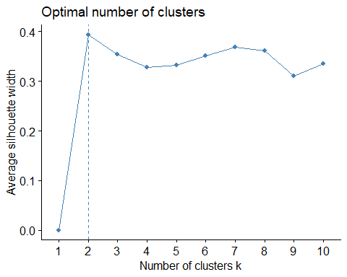

Si prova sia con 3 che con 2

set.seed(123) # Per riproducibilità  
kmeans_res <- kmeans(umap_df, centers = 3)  
  
# Aggiungi i cluster al data frame  
umap_df$cluster <- as.factor(kmeans_res$cluster)  
  
  
library(ggplot2)  
  
ggplot(umap_df, aes(x = Dim1, y = Dim2, color = cluster)) +  
 geom_point(size = 2) +  
 theme_minimal() +  
 labs(title = "K-means clustering (k = 2) su UMAP")

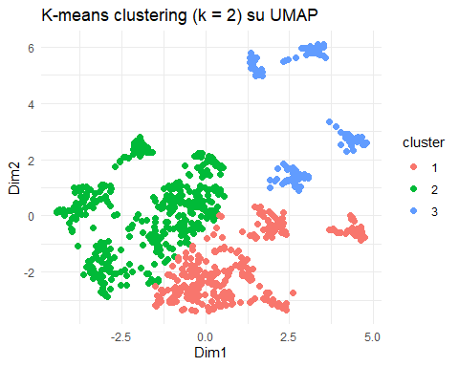

data$cluster <- umap_df$cluster

# Variabili continue  
aggregate(. ~ cluster, data = data, FUN = mean, na.rm = TRUE)

## cluster Age Gender ASA3 DM CAD HF CVA  
## 1 1 67.09816 1.343558 0.3680982 0.1625767 0.02760736 0.0000000 0.14417178  
## 2 2 62.39269 1.422374 0.3356164 0.2100457 0.00000000 0.0000000 0.00000000  
## 3 3 69.37500 1.335526 0.5131579 0.3026316 0.38815789 0.2631579 0.03947368  
## CKD LogCEA Laparoscopic TumorLOC EA Log2AT RBC  
## 1 0.1717791 1.351321 0.0000000 0.3404908 0.1809816 8.293515 0.5306748  
## 2 0.0913242 1.435982 0.0000000 0.2488584 0.1575342 8.407882 0.5091324  
## 3 0.1776316 1.341117 0.2434211 0.4013158 0.1513158 8.248017 0.5921053  
## Liver_Only Cell_diff Mucin_TYPE SignetRING Lymphovascularinvasion perineural  
## 1 0.5950920 1.058282 0.01533742 0.006134969 0.4171779 0.1226994  
## 2 0.2557078 1.148402 0.09360731 0.000000000 0.5570776 0.2762557  
## 3 0.3355263 1.217105 0.15131579 0.256578947 0.6052632 0.2960526  
## CT RT NACTRT Death Progress IntervalOD IntervalOR  
## 1 0.7852761 0.009202454 0.04601227 0.3006135 0.6441718 30.90140 16.497046  
## 2 0.9840183 0.200913242 0.26027397 0.5091324 0.9109589 20.93001 7.710688  
## 3 0.8881579 0.046052632 0.09210526 0.4276316 0.7631579 21.69999 10.611694  
## AJCC_bin  
## 1 0.1349693  
## 2 0.6073059  
## 3 0.4934211

results <- lapply(names(data)[names(data) != "cluster"], function(var) {  
 formula <- as.formula(paste(var, "~ cluster"))  
 model <- aov(formula, data = data)  
 pval <- summary(model)[[1]][["Pr(>F)"]][1]  
   
 means <- tapply(data[[var]], data$cluster, mean, na.rm = TRUE)  
   
 data.frame(  
 Variable = var,  
 p_value = round(pval, 5),  
 mean_cluster1 = round(means[1], 2),  
 mean_cluster2 = round(means[2], 2),  
 mean_cluster3 = round(means[3], 2)  
 )  
})  
  
results_df <- do.call(rbind, results)  
results_df <- results_df[order(results_df$p_value), ]  
print(results_df)

## Variable p_value mean_cluster1 mean_cluster2 mean_cluster3  
## 1 Age 0.00000 67.10 62.39 69.38  
## 14 CAD 0.00000 0.03 0.00 0.39  
## 15 HF 0.00000 0.00 0.00 0.26  
## 16 CVA 0.00000 0.14 0.00 0.04  
## 19 Laparoscopic 0.00000 0.00 0.00 0.24  
## 114 Liver_Only 0.00000 0.60 0.26 0.34  
## 115 Cell_diff 0.00000 1.06 1.15 1.22  
## 116 Mucin_TYPE 0.00000 0.02 0.09 0.15  
## 117 SignetRING 0.00000 0.01 0.00 0.26  
## 119 perineural 0.00000 0.12 0.28 0.30  
## 120 CT 0.00000 0.79 0.98 0.89  
## 121 RT 0.00000 0.01 0.20 0.05  
## 122 NACTRT 0.00000 0.05 0.26 0.09  
## 123 Death 0.00000 0.30 0.51 0.43  
## 124 Progress 0.00000 0.64 0.91 0.76  
## 125 IntervalOD 0.00000 30.90 20.93 21.70  
## 126 IntervalOR 0.00000 16.50 7.71 10.61  
## 127 AJCC_bin 0.00000 0.13 0.61 0.49  
## 118 Lymphovascularinvasion 0.00003 0.42 0.56 0.61  
## 112 Log2AT 0.00017 8.29 8.41 8.25  
## 12 ASA3 0.00046 0.37 0.34 0.51  
## 110 TumorLOC 0.00052 0.34 0.25 0.40  
## 17 CKD 0.00123 0.17 0.09 0.18  
## 13 DM 0.00205 0.16 0.21 0.30  
## 11 Gender 0.03968 1.34 1.42 1.34  
## 18 LogCEA 0.33378 1.35 1.44 1.34  
## 113 RBC 0.43646 0.53 0.51 0.59  
## 111 EA 0.61079 0.18 0.16 0.15

library(cluster)  
library(factoextra)  
  
# 1. Prepara i dati da clustering (solo le coordinate UMAP, non il factor cluster)  
coords <- umap_df[, c("Dim1", "Dim2")]  
  
# 2. Calcola la matrice di distanza (euclidea di default)  
diss <- dist(coords)  
  
# 3. Calcola i silhouette  
sil <- silhouette(as.integer(umap_df$cluster), diss)  
  
# 4. Statistica complessiva media  
avg_sil_width <- mean(sil[, "sil_width"])  
cat("Average silhouette width:", round(avg_sil_width, 3), "\n")

## Average silhouette width: 0.389

# 5. Visualizza il plot delle silhouette  
fviz_silhouette(sil)

## cluster size ave.sil.width  
## 1 1 326 0.36  
## 2 2 438 0.37  
## 3 3 152 0.51

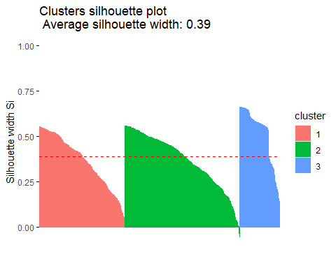

## CLUSTER UMAP con k=2

Per visualizzare la separazione tra gruppi trovati.

head(umap_df)

## Dim1 Dim2 Death Gender ASA3 CT AJCC_bin HF Liver_Only  
## 1 -1.06827569 0.52201078 1 1 1 1 1 0 0  
## 2 2.58056259 1.33869973 1 2 0 1 0 0 1  
## 3 -1.14504555 -2.64269915 1 2 0 1 0 0 1  
## 4 -0.96934509 0.42800496 1 2 0 1 1 0 0  
## 5 -1.38344301 -1.08368099 1 1 0 1 0 0 0  
## 6 0.08707221 0.06347988 0 2 0 1 1 0 0  
## Laparoscopic cluster  
## 1 0 2  
## 2 0 3  
## 3 0 1  
## 4 0 2  
## 5 0 2  
## 6 0 2

set.seed(42)  
kmeans_result <- kmeans(umap_df, centers = 2)  
umap_df$cluster <- as.factor(kmeans_result$cluster)  
  
  
library(cluster)  
library(factoextra)  
  
fviz_nbclust(umap_df, kmeans, method = "silhouette")

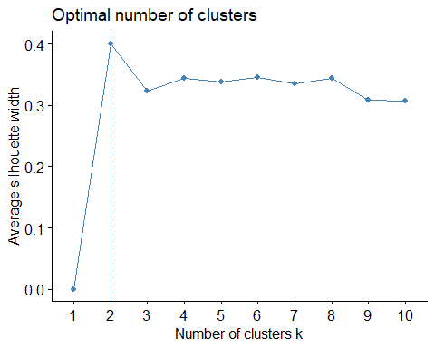

set.seed(123) # Per riproducibilità  
kmeans_res <- kmeans(umap_df, centers = 2)  
  
# Aggiungi i cluster al data frame  
umap_df$cluster <- as.factor(kmeans_res$cluster)  
  
  
library(ggplot2)  
  
ggplot(umap_df, aes(x = Dim1, y = Dim2, color = cluster)) +  
 geom_point(size = 2) +  
 theme_minimal() +  
 labs(title = "K-means clustering (k = 2) su UMAP")

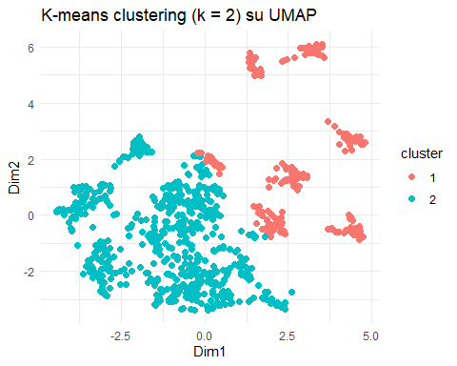

data$cluster <- umap_df$cluster

# Variabili continue  
aggregate(. ~ cluster, data = data, FUN = mean, na.rm = TRUE)

## cluster Age Gender ASA3 DM CAD HF CVA  
## 1 1 70.19245 1.313208 0.5358491 0.2792453 0.2566038 0.1509434 0.192452830  
## 2 2 63.20430 1.407066 0.3118280 0.1797235 0.0000000 0.0000000 0.003072197  
## CKD LogCEA Laparoscopic TumorLOC EA Log2AT RBC  
## 1 0.2000000 1.369588 0.1396226 0.3773585 0.1433962 8.263979 0.5471698  
## 2 0.1075269 1.398464 0.0000000 0.2780338 0.1735791 8.371862 0.5238095  
## Liver_Only Cell_diff Mucin_TYPE SignetRING Lymphovascularinvasion perineural  
## 1 0.3471698 1.226415 0.09811321 0.150943396 0.5924528 0.2830189  
## 2 0.4070661 1.087558 0.06605223 0.001536098 0.4838710 0.2012289  
## CT RT NACTRT Death Progress IntervalOD IntervalOR  
## 1 0.6943396 0.03396226 0.08679245 0.3962264 0.6528302 18.48973 8.90783  
## 2 0.9800307 0.13671275 0.18433180 0.4316436 0.8479263 27.09650 12.30065  
## AJCC_bin  
## 1 0.4528302  
## 2 0.4070661

results <- lapply(names(data)[names(data) != "cluster"], function(var) {  
 formula <- as.formula(paste(var, "~ cluster"))  
 model <- aov(formula, data = data)  
 pval <- summary(model)[[1]][["Pr(>F)"]][1]  
   
 means <- tapply(data[[var]], data$cluster, mean, na.rm = TRUE)  
   
 data.frame(  
 Variable = var,  
 p_value = round(pval, 5),  
 mean_cluster1 = round(means[1], 2),  
 mean_cluster2 = round(means[2], 2))  
})  
  
results_df <- do.call(rbind, results)  
results_df <- results_df[order(results_df$p_value), ]  
print(results_df)

## Variable p_value mean_cluster1 mean_cluster2  
## 1 Age 0.00000 70.19 63.20  
## 12 ASA3 0.00000 0.54 0.31  
## 14 CAD 0.00000 0.26 0.00  
## 15 HF 0.00000 0.15 0.00  
## 16 CVA 0.00000 0.19 0.00  
## 19 Laparoscopic 0.00000 0.14 0.00  
## 115 Cell_diff 0.00000 1.23 1.09  
## 117 SignetRING 0.00000 0.15 0.00  
## 120 CT 0.00000 0.69 0.98  
## 121 RT 0.00000 0.03 0.14  
## 124 Progress 0.00000 0.65 0.85  
## 125 IntervalOD 0.00000 18.49 27.10  
## 17 CKD 0.00019 0.20 0.11  
## 122 NACTRT 0.00022 0.09 0.18  
## 13 DM 0.00076 0.28 0.18  
## 112 Log2AT 0.00213 8.26 8.37  
## 118 Lymphovascularinvasion 0.00284 0.59 0.48  
## 110 TumorLOC 0.00309 0.38 0.28  
## 126 IntervalOR 0.00640 8.91 12.30  
## 119 perineural 0.00714 0.28 0.20  
## 11 Gender 0.00792 1.31 1.41  
## 114 Liver_Only 0.09209 0.35 0.41  
## 116 Mucin_TYPE 0.09569 0.10 0.07  
## 127 AJCC_bin 0.20366 0.45 0.41  
## 111 EA 0.26476 0.14 0.17  
## 123 Death 0.32548 0.40 0.43  
## 113 RBC 0.63957 0.55 0.52  
## 18 LogCEA 0.65975 1.37 1.40

*CLUSTER 1: ANZIANI CON COMORBIDITÁ* Significativamente piú anziano, cono ASA piu alto, con molto piu presenti variabili come CAD, HF e CVA. In questo cluster sono anche presenti valori per SignetRing. Meno aderenze estese.Meno femmine, piu chirurgie laparoscopiche, tumori piu retto. mAGGIORE DIFFERENZIAZIONE CELLULARE. INTERVALLO MINORE TRA OPERAZIONE CHIRURGICA E MORTE / RECIDIVA. I TUMORI PROGREDISCONO DI MENO, IL GRADO 4A4B É UGUALE

*CLUSTER 2: GIOVANI CON TRATTAMENTI AGGRESSIVI, PEGGIOR OUTCOME*

Valori molto piu alti di CT, RT e NACTRT. Tasso di progressione del tumore molto maggiore, quasi doppio. Tasso di morte maggiore. Marker tunmoreali piú elevati, interventi piu lunghi e piu complessi (meno laparoscopia, tumori piu colon che retto). Tempi piu lunghi prima delle recidive o della mote

library(cluster)  
library(factoextra)  
  
# 1. Prepara i dati da clustering (solo le coordinate UMAP, non il factor cluster)  
coords <- umap_df[, c("Dim1", "Dim2")]  
  
# 2. Calcola la matrice di distanza (euclidea di default)  
diss <- dist(coords)  
  
# 3. Calcola i silhouette  
sil <- silhouette(as.integer(umap_df$cluster), diss)  
  
# 4. Statistica complessiva media  
avg_sil_width <- mean(sil[, "sil_width"])  
cat("Average silhouette width:", round(avg_sil_width, 3), "\n")

## Average silhouette width: 0.448

# 5. Visualizza il plot delle silhouette  
fviz_silhouette(sil)

## cluster size ave.sil.width  
## 1 1 265 0.38  
## 2 2 651 0.48

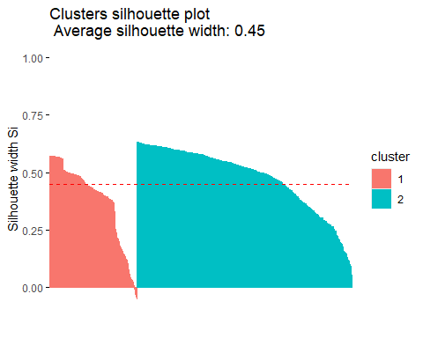

## CLUSTER RAW con viz UMAP

# 2. Clustering  
set.seed(42)  
kmeans_res <- kmeans(data_scaled, centers = 2, nstart = 25)  
  
# 3. UMAP per visualizzare  
umap_out <- umap(data_scaled)  
umap_df <- data.frame(Dim1 = umap_out$layout[,1], Dim2 = umap_out$layout[,2],   
 cluster = as.factor(kmeans_res$cluster))  
  
# 4. Visualizzazione  
ggplot(umap_df, aes(x = Dim1, y = Dim2, color = cluster)) +  
 geom_point(size = 2) +  
 labs(title = "Cluster (da dati originali) visualizzati su UMAP")

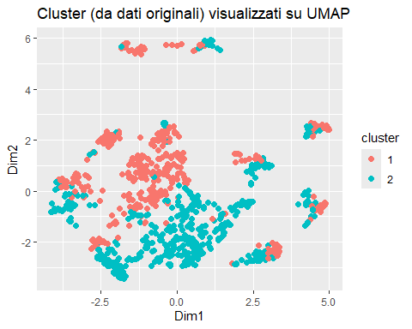

# 1. Calcola la matrice delle distanze (euclidea)  
dist_matrix <- dist(data_scaled)  
  
# 2. Calcola l'indice di silhouette  
library(cluster)  
sil <- silhouette(kmeans_res$cluster, dist_matrix)  
  
# 3. Calcola la silhouette media  
silhouette_score <- mean(sil[, 3])  
print(paste("Indice di Silhouette medio:", round(silhouette_score, 3)))

## [1] "Indice di Silhouette medio: 0.069"

## CLUSTER PCA

# PCA  
pca <- prcomp(data_scaled)  
# Scegli le prime N componenti che spiegano >80% varianza  
summary(pca)

## Importance of components:  
## PC1 PC2 PC3 PC4 PC5 PC6 PC7  
## Standard deviation 1.62086 1.5143 1.33523 1.20570 1.19565 1.15820 1.10167  
## Proportion of Variance 0.09383 0.0819 0.06367 0.05192 0.05106 0.04791 0.04335  
## Cumulative Proportion 0.09383 0.1757 0.23940 0.29132 0.34237 0.39028 0.43363  
## PC8 PC9 PC10 PC11 PC12 PC13 PC14  
## Standard deviation 1.06569 1.05116 1.03781 0.9997 0.99144 0.97252 0.9391  
## Proportion of Variance 0.04056 0.03946 0.03847 0.0357 0.03511 0.03378 0.0315  
## Cumulative Proportion 0.47419 0.51365 0.55212 0.5878 0.62292 0.65670 0.6882  
## PC15 PC16 PC17 PC18 PC19 PC20 PC21  
## Standard deviation 0.92065 0.91061 0.90472 0.87670 0.85766 0.84411 0.82224  
## Proportion of Variance 0.03027 0.02961 0.02923 0.02745 0.02627 0.02545 0.02415  
## Cumulative Proportion 0.71846 0.74808 0.77731 0.80476 0.83103 0.85648 0.88063  
## PC22 PC23 PC24 PC25 PC26 PC27 PC28  
## Standard deviation 0.78506 0.77350 0.75823 0.73717 0.7159 0.52551 0.47004  
## Proportion of Variance 0.02201 0.02137 0.02053 0.01941 0.0183 0.00986 0.00789  
## Cumulative Proportion 0.90264 0.92400 0.94454 0.96394 0.9822 0.99211 1.00000

# Prendiamo per esempio le prime 10  
pca_data <- as.data.frame(pca$x[, 1:10])  
  
# K-means su PCA  
kmeans_res <- kmeans(pca_data, centers = 2)

# Riduci i dati a 18 componenti principali  
pca_data <- as.data.frame(pca$x[, 1:17])  
  
# K-means clustering sui dati ridotti  
set.seed(42)  
kmeans_res <- kmeans(pca_data, centers = 2, nstart = 25)  
  
# Visualizza i cluster su UMAP  
umap_out <- umap(pca_data)  
umap_df <- data.frame(Dim1 = umap_out$layout[,1], Dim2 = umap_out$layout[,2],   
 cluster = as.factor(kmeans_res$cluster))  
  
# Visualizzazione  
library(ggplot2)  
ggplot(umap_df, aes(x = Dim1, y = Dim2, color = cluster)) +  
 geom_point(size = 2) +  
 labs(title = "Cluster sui primi 18 componenti principali")

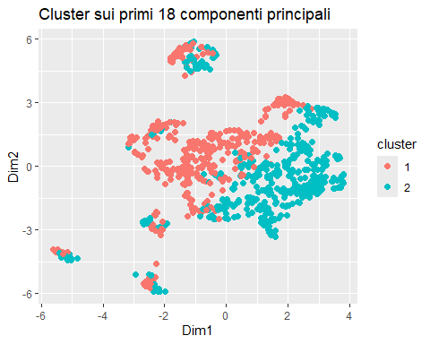

library(cluster)  
sil <- silhouette(kmeans_res$cluster, dist(pca_data))  
mean(sil[, 3]) # silhouette score medio

## [1] 0.08753149

skim_without_charts(data)

Data summary

|  |  |
| --- | --- |
| Name | data |
| Number of rows | 916 |
| Number of columns | 29 |
| _______________________ |  |
| Column type frequency: |  |
| factor | 1 |
| numeric | 28 |
| ________________________ |  |
| Group variables | None |

**Variable type: factor**

| skim_variable | n_missing | complete_rate | ordered | n_unique | top_counts |
| --- | --- | --- | --- | --- | --- |
| cluster | 0 | 1 | FALSE | 2 | 2: 651, 1: 265 |

**Variable type: numeric**

| skim_variable | n_missing | complete_rate | mean | sd | p0 | p25 | p50 | p75 | p100 |
| --- | --- | --- | --- | --- | --- | --- | --- | --- | --- |
| Age | 0 | 1 | 65.23 | 13.62 | 18.00 | 55.00 | 65.00 | 77.00 | 95.00 |
| Gender | 0 | 1 | 1.38 | 0.49 | 1.00 | 1.00 | 1.00 | 2.00 | 2.00 |
| ASA3 | 0 | 1 | 0.38 | 0.48 | 0.00 | 0.00 | 0.00 | 1.00 | 1.00 |
| DM | 0 | 1 | 0.21 | 0.41 | 0.00 | 0.00 | 0.00 | 0.00 | 1.00 |
| CAD | 0 | 1 | 0.07 | 0.26 | 0.00 | 0.00 | 0.00 | 0.00 | 1.00 |
| HF | 0 | 1 | 0.04 | 0.20 | 0.00 | 0.00 | 0.00 | 0.00 | 1.00 |
| CVA | 0 | 1 | 0.06 | 0.23 | 0.00 | 0.00 | 0.00 | 0.00 | 1.00 |
| CKD | 0 | 1 | 0.13 | 0.34 | 0.00 | 0.00 | 0.00 | 0.00 | 1.00 |
| LogCEA | 0 | 1 | 1.39 | 0.90 | -0.36 | 0.60 | 1.26 | 1.94 | 4.18 |
| Laparoscopic | 0 | 1 | 0.04 | 0.20 | 0.00 | 0.00 | 0.00 | 0.00 | 1.00 |
| TumorLOC | 0 | 1 | 0.31 | 0.46 | 0.00 | 0.00 | 0.00 | 1.00 | 1.00 |
| EA | 0 | 1 | 0.16 | 0.37 | 0.00 | 0.00 | 0.00 | 0.00 | 1.00 |
| Log2AT | 0 | 1 | 8.34 | 0.48 | 5.64 | 8.08 | 8.30 | 8.61 | 9.91 |
| RBC | 0 | 1 | 0.53 | 0.68 | 0.00 | 0.00 | 0.00 | 1.00 | 2.00 |
| Liver_Only | 0 | 1 | 0.39 | 0.49 | 0.00 | 0.00 | 0.00 | 1.00 | 1.00 |
| Cell_diff | 0 | 1 | 1.13 | 0.33 | 1.00 | 1.00 | 1.00 | 1.00 | 2.00 |
| Mucin_TYPE | 0 | 1 | 0.08 | 0.26 | 0.00 | 0.00 | 0.00 | 0.00 | 1.00 |
| SignetRING | 0 | 1 | 0.04 | 0.21 | 0.00 | 0.00 | 0.00 | 0.00 | 1.00 |
| Lymphovascularinvasion | 0 | 1 | 0.52 | 0.50 | 0.00 | 0.00 | 1.00 | 1.00 | 1.00 |
| perineural | 0 | 1 | 0.22 | 0.42 | 0.00 | 0.00 | 0.00 | 0.00 | 1.00 |
| CT | 0 | 1 | 0.90 | 0.30 | 0.00 | 1.00 | 1.00 | 1.00 | 1.00 |
| RT | 0 | 1 | 0.11 | 0.31 | 0.00 | 0.00 | 0.00 | 0.00 | 1.00 |
| NACTRT | 0 | 1 | 0.16 | 0.36 | 0.00 | 0.00 | 0.00 | 0.00 | 1.00 |
| Death | 0 | 1 | 0.42 | 0.49 | 0.00 | 0.00 | 0.00 | 1.00 | 1.00 |
| Progress | 0 | 1 | 0.79 | 0.41 | 0.00 | 1.00 | 1.00 | 1.00 | 1.00 |
| IntervalOD | 0 | 1 | 24.61 | 24.25 | 0.03 | 8.11 | 18.05 | 31.95 | 135.79 |
| IntervalOR | 0 | 1 | 11.32 | 17.10 | 0.03 | 3.05 | 5.98 | 12.62 | 134.21 |
| AJCC_bin | 0 | 1 | 0.42 | 0.49 | 0.00 | 0.00 | 0.00 | 1.00 | 1.00 |

## K MEANS raw

data$cluster <- NULL  
data_scaled <- scale(data)  
  
# Elbow plot per scegliere k  
fviz_nbclust(data_scaled, kmeans, method = "wss")

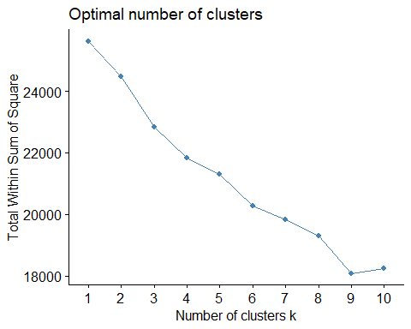

set.seed(123)  
kmeans_res <- kmeans(data_scaled, centers = 2, nstart = 25)  
  
# Visualizzazione  
fviz_cluster(kmeans_res, data = data_scaled,  
 ellipse.type = "convex",  
 palette = "jco",  
 ggtheme = theme_minimal())

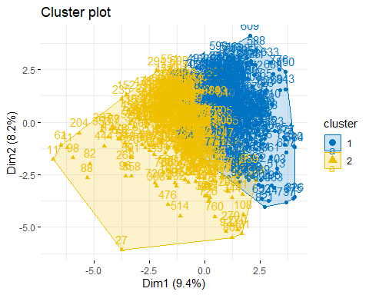

kmeans_res$centers

## Age Gender ASA3 DM CAD HF  
## 1 0.05192375 0.08058595 0.06292251 0.05520002 -0.04701169 0.05425701  
## 2 -0.04396769 -0.06823810 -0.05328116 -0.04674196 0.03980828 -0.04594344  
## CVA CKD LogCEA Laparoscopic TumorLOC EA  
## 1 -0.02345529 0.06004137 0.09128604 0.0004222486 0.06273396 -0.04640629  
## 2 0.01986133 -0.05084148 -0.07729866 -0.0003575492 -0.05312150 0.03929565  
## Log2AT RBC Liver_Only Cell_diff Mucin_TYPE SignetRING  
## 1 -0.01228065 0.07713773 -0.7889546 0.2163986 0.2016332 0.209462  
## 2 0.01039893 -0.06531824 0.6680664 -0.1832408 -0.1707378 -0.177367  
## Lymphovascularinvasion perineural CT RT NACTRT  
## 1 0.2694111 0.1911987 -0.05410417 -0.007194450 -0.05617134  
## 2 -0.2281304 -0.1619022 0.04581402 0.006092075 0.04756444  
## Death Progress IntervalOD IntervalOR AJCC_bin  
## 1 0.2217476 0.1205294 -0.3623106 -0.2694170 0.9857446  
## 2 -0.1877701 -0.1020612 0.3067953 0.2281353 -0.8347031

data$cluster <- as.factor(kmeans_res$cluster)  
  
# Riassunto per cluster  
aggregate(. ~ cluster, data = data, mean)

## cluster Age Gender ASA3 DM CAD HF  
## 1 1 65.93333 1.419048 0.4071429 0.2309524 0.06190476 0.05476190  
## 2 2 64.62702 1.346774 0.3508065 0.1895161 0.08467742 0.03427419  
## CVA CKD LogCEA Laparoscopic TumorLOC EA Log2AT  
## 1 0.05238095 0.1547619 1.472213 0.04047619 0.3357143 0.1476190 8.334722  
## 2 0.06250000 0.1169355 1.320587 0.04032258 0.2822581 0.1794355 8.345672  
## RBC Liver_Only Cell_diff Mucin_TYPE SignetRING Lymphovascularinvasion  
## 1 0.5833333 0.004761905 1.200000 0.12857143 0.088095238 0.6500000  
## 2 0.4858871 0.715725806 1.066532 0.03024194 0.008064516 0.4012097  
## perineural CT RT NACTRT Death Progress IntervalOD  
## 1 0.3047619 0.8809524 0.1047619 0.1357143 0.5309524 0.8404762 15.82094  
## 2 0.1572581 0.9112903 0.1088710 0.1733871 0.3286290 0.7500000 32.04597  
## IntervalOR AJCC_bin  
## 1 6.712741 0.907142857  
## 2 15.219646 0.008064516

summary(data$cluster)

## 1 2   
## 420 496

library(dplyr)  
library(reshape2)

## Warning: package 'reshape2' was built under R version 4.3.3

##   
## Attaching package: 'reshape2'

## The following object is masked from 'package:tidyr':  
##   
## smiths

library(ggplot2)  
  
# Elenco delle variabili di interesse (includi qui quelle che vuoi nel grafico)  
vars_of_interest <- c(  
 "cluster", "Liver_Only", "Lymphovascularinvasion",   
 "perineural", "Death", "EA", "CT", "RT", "NACTRT",  
 "Age", "LogCEA", "IntervalOR", "IntervalOD", "Progress", "Cell_diff", "Mucin_TYPE"  
)  
  
# Seleziona solo queste variabili  
data_subset <- data[, vars_of_interest]  
  
# Calcola media per cluster  
cluster_means <- data_subset %>%  
 group_by(cluster) %>%  
 summarise(across(everything(), mean, na.rm = TRUE)) %>%  
 ungroup()

## Warning: There was 1 warning in `summarise()`.  
## ℹ In argument: `across(everything(), mean, na.rm = TRUE)`.  
## ℹ In group 1: `cluster = 1`.  
## Caused by warning:  
## ! The `...` argument of `across()` is deprecated as of dplyr 1.1.0.  
## Supply arguments directly to `.fns` through an anonymous function instead.  
##   
## # Previously  
## across(a:b, mean, na.rm = TRUE)  
##   
## # Now  
## across(a:b, \(x) mean(x, na.rm = TRUE))

# Normalizza ciascuna colonna (esclusa 'cluster') in percentuale rispetto al suo massimo  
cluster_means_scaled <- cluster_means  
cluster_means_scaled[-1] <- lapply(cluster_means_scaled[-1], function(x) 100 * x / max(x, na.rm = TRUE))  
  
# Melting per ggplot  
df_melt <- melt(cluster_means_scaled, id = "cluster")  
  
# Grafico  
ggplot(df_melt, aes(x = variable, y = value, fill = cluster)) +  
 geom_bar(stat = "identity", position = "dodge") +  
 theme_minimal() +  
 theme(axis.text.x = element_text(angle = 90, hjust = 0.5)) +  
 labs(  
 title = "Cluster comparison (all variables scaled as % of max)",  
 x = "Variable",  
 y = "Value (% of max)"  
 )

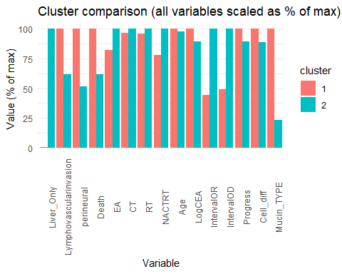

## HAC

# Pacchetti  
library(factoextra)  
library(dplyr)  
  
  
# Calcola distanza euclidea  
dist_mat <- dist(data, method = "euclidean")  
  
# Clustering gerarchico con metodo Ward  
hc <- hclust(dist_mat, method = "ward.D2")  
  
# Dendrogramma con taglio a k = 2  
fviz_dend(hc, k = 2,   
 rect = TRUE,   
 rect_border = "jco",  
 rect_fill = TRUE,  
 show_labels = FALSE)

## Warning: The `<scale>` argument of `guides()` cannot be `FALSE`. Use "none" instead as  
## of ggplot2 3.3.4.  
## ℹ The deprecated feature was likely used in the factoextra package.  
## Please report the issue at <https://github.com/kassambara/factoextra/issues>.  
## This warning is displayed once every 8 hours.  
## Call `lifecycle::last_lifecycle_warnings()` to see where this warning was  
## generated.

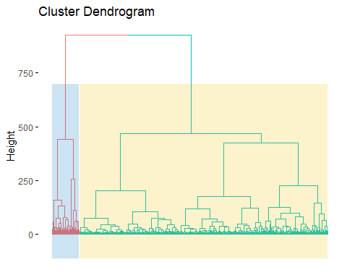

# Assegna i cluster al dataset  
data$cluster_hc <- cutree(hc, k = 2)

### METRICHE INTERNE per Kmeans e HAC

library(cluster) # silhouette  
library(clusterSim) # Davies-Bouldin

## Warning: package 'clusterSim' was built under R version 4.3.3

## Loading required package: MASS

##   
## Attaching package: 'MASS'

## The following object is masked from 'package:dplyr':  
##   
## select

library(factoextra) # fviz_silhouette  
library(dplyr) # per operazioni su dataframe  
  
# -----------------------------  
# SILHOUETTE SCORE  
# -----------------------------  
  
# HAC  
sil_hc <- silhouette(data$cluster_hc, dist(data_scaled))  
fviz_silhouette(sil_hc) + ggtitle("Silhouette - Hierarchical")

## cluster size ave.sil.width  
## 1 1 826 0.09  
## 2 2 90 0.11

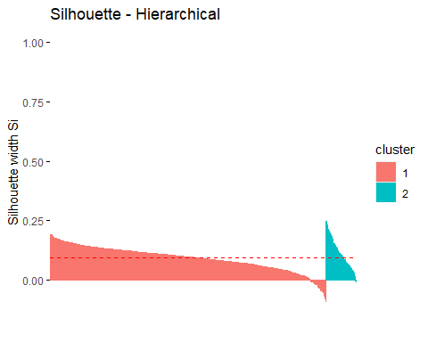

mean(sil_hc[, 3]) # Average silhouette for HAC

## [1] 0.09398352

# K-means  
sil_km <- silhouette(kmeans_res$cluster, dist(data_scaled))  
fviz_silhouette(sil_km) + ggtitle("Silhouette - K-means")

## cluster size ave.sil.width  
## 1 1 420 0.05  
## 2 2 496 0.08

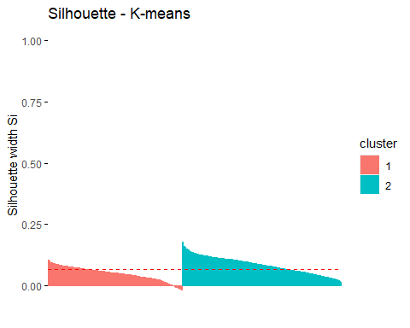

mean(sil_km[, 3]) # Average silhouette for K-means

## [1] 0.06879705

# -----------------------------  
# DAVIES-BOULDIN INDEX  
# -----------------------------  
  
# HAC  
db_hc <- index.DB(data_scaled, cl = data$cluster_hc, centrotypes = "centroids")$DB  
  
# K-means  
db_km <- index.DB(data_scaled, cl = kmeans_res$cluster, centrotypes = "centroids")$DB  
  
# -----------------------------  
# RISULTATI  
# -----------------------------  
  
cat("Silhouette HAC: ", mean(sil_hc[,3]), "\n")

## Silhouette HAC: 0.09398352

cat("Silhouette K-means: ", mean(sil_km[,3]), "\n\n")

## Silhouette K-means: 0.06879705

cat("Davies-Bouldin HAC: ", db_hc, "\n")

## Davies-Bouldin HAC: 2.792395

cat("Davies-Bouldin K-means: ", db_km, "\n")

## Davies-Bouldin K-means: 3.777504

Si conferma che i cluster non sono ben separati nello spazio originale ad alta dimensionalitá.

## RISULTATI CLUSTERING:

Si conclude che il dataset non presenza strutture di cluster. Le metriche Silhouette e Davies- Bouldin indicano che i cluster non sono ne ben separati ne ben definiti, senza coesione interna. A prescindere dall’algoritmo scelto, si conclude l’analisi inconcludente. Si sottoline ahce, nonstante il valore accettabile di 0.5 della UMAP + k-means, UMAP deforma lo spazio, quindi non édetto che i cluster trovati riflettano correttamente la separazione dei dati originali. Il dataset non mostra una struttura di cluster ben definita nello spazio originale o nello spazio ridotto da PCA. Solo dopo proiezioni non lineari (UMAP), è possibile forzare una divisione con significato visivo, ma non necessariamente supportata da buona separabilità intrinseca.

data$cluster2 <- NULL  
data$cluster_hc <- NULL  
data$cluster <- NULL

# LINEAR REGRESSION

summary(step(lm(Death ~., data = data)))

## Start: AIC=-1370.54  
## Death ~ Age + Gender + ASA3 + DM + CAD + HF + CVA + CKD + LogCEA +   
## Laparoscopic + TumorLOC + EA + Log2AT + RBC + Liver_Only +   
## Cell_diff + Mucin_TYPE + SignetRING + Lymphovascularinvasion +   
## perineural + CT + RT + NACTRT + Progress + IntervalOD + IntervalOR +   
## AJCC_bin  
##   
## Df Sum of Sq RSS AIC  
## - Gender 1 0.0013 193.00 -1372.5  
## - IntervalOR 1 0.0118 193.01 -1372.5  
## - Log2AT 1 0.0194 193.01 -1372.4  
## - perineural 1 0.0386 193.03 -1372.3  
## - Cell_diff 1 0.0400 193.03 -1372.3  
## - EA 1 0.0554 193.05 -1372.3  
## - CAD 1 0.0603 193.06 -1372.2  
## - Lymphovascularinvasion 1 0.0632 193.06 -1372.2  
## - Laparoscopic 1 0.0762 193.07 -1372.2  
## - HF 1 0.0765 193.07 -1372.2  
## - SignetRING 1 0.0814 193.08 -1372.2  
## - CT 1 0.0840 193.08 -1372.1  
## - TumorLOC 1 0.0968 193.09 -1372.1  
## - Liver_Only 1 0.1006 193.09 -1372.1  
## - DM 1 0.1014 193.10 -1372.0  
## - ASA3 1 0.1396 193.13 -1371.9  
## - CVA 1 0.1527 193.15 -1371.8  
## <none> 193.00 -1370.5  
## - CKD 1 0.4523 193.45 -1370.4  
## - Mucin_TYPE 1 0.6257 193.62 -1369.6  
## - Age 1 0.6837 193.68 -1369.3  
## - NACTRT 1 0.7449 193.74 -1369.0  
## - RT 1 0.7650 193.76 -1368.9  
## - AJCC_bin 1 1.0005 194.00 -1367.8  
## - LogCEA 1 1.4824 194.48 -1365.5  
## - RBC 1 1.5679 194.56 -1365.1  
## - IntervalOD 1 3.3085 196.30 -1357.0  
## - Progress 1 6.4634 199.46 -1342.4  
##   
## Step: AIC=-1372.53  
## Death ~ Age + ASA3 + DM + CAD + HF + CVA + CKD + LogCEA + Laparoscopic +   
## TumorLOC + EA + Log2AT + RBC + Liver_Only + Cell_diff + Mucin_TYPE +   
## SignetRING + Lymphovascularinvasion + perineural + CT + RT +   
## NACTRT + Progress + IntervalOD + IntervalOR + AJCC_bin  
##   
## Df Sum of Sq RSS AIC  
## - IntervalOR 1 0.0119 193.01 -1374.5  
## - Log2AT 1 0.0201 193.02 -1374.4  
## - perineural 1 0.0378 193.03 -1374.3  
## - Cell_diff 1 0.0412 193.04 -1374.3  
## - EA 1 0.0545 193.05 -1374.3  
## - CAD 1 0.0599 193.06 -1374.2  
## - Lymphovascularinvasion 1 0.0635 193.06 -1374.2  
## - HF 1 0.0765 193.07 -1374.2  
## - Laparoscopic 1 0.0769 193.07 -1374.2  
## - SignetRING 1 0.0828 193.08 -1374.1  
## - CT 1 0.0833 193.08 -1374.1  
## - TumorLOC 1 0.0955 193.09 -1374.1  
## - DM 1 0.1018 193.10 -1374.0  
## - Liver_Only 1 0.1041 193.10 -1374.0  
## - ASA3 1 0.1408 193.14 -1373.9  
## - CVA 1 0.1552 193.15 -1373.8  
## <none> 193.00 -1372.5  
## - CKD 1 0.4574 193.45 -1372.4  
## - Mucin_TYPE 1 0.6246 193.62 -1371.6  
## - Age 1 0.6835 193.68 -1371.3  
## - NACTRT 1 0.7438 193.74 -1371.0  
## - RT 1 0.7649 193.76 -1370.9  
## - AJCC_bin 1 1.0017 194.00 -1369.8  
## - LogCEA 1 1.4836 194.48 -1367.5  
## - RBC 1 1.5692 194.56 -1367.1  
## - IntervalOD 1 3.3100 196.31 -1359.0  
## - Progress 1 6.4799 199.48 -1344.3  
##   
## Step: AIC=-1374.47  
## Death ~ Age + ASA3 + DM + CAD + HF + CVA + CKD + LogCEA + Laparoscopic +   
## TumorLOC + EA + Log2AT + RBC + Liver_Only + Cell_diff + Mucin_TYPE +   
## SignetRING + Lymphovascularinvasion + perineural + CT + RT +   
## NACTRT + Progress + IntervalOD + AJCC_bin  
##   
## Df Sum of Sq RSS AIC  
## - Log2AT 1 0.0219 193.03 -1376.4  
## - perineural 1 0.0396 193.05 -1376.3  
## - Cell_diff 1 0.0435 193.05 -1376.3  
## - EA 1 0.0559 193.06 -1376.2  
## - CAD 1 0.0612 193.07 -1376.2  
## - Lymphovascularinvasion 1 0.0615 193.07 -1376.2  
## - HF 1 0.0755 193.08 -1376.1  
## - Laparoscopic 1 0.0763 193.08 -1376.1  
## - SignetRING 1 0.0844 193.09 -1376.1  
## - CT 1 0.0905 193.10 -1376.0  
## - TumorLOC 1 0.0968 193.10 -1376.0  
## - DM 1 0.1035 193.11 -1376.0  
## - Liver_Only 1 0.1062 193.11 -1376.0  
## - ASA3 1 0.1410 193.15 -1375.8  
## - CVA 1 0.1517 193.16 -1375.8  
## <none> 193.01 -1374.5  
## - CKD 1 0.4523 193.46 -1374.3  
## - Mucin_TYPE 1 0.6196 193.63 -1373.5  
## - Age 1 0.6777 193.69 -1373.3  
## - NACTRT 1 0.7459 193.75 -1372.9  
## - RT 1 0.7559 193.76 -1372.9  
## - AJCC_bin 1 1.0052 194.01 -1371.7  
## - LogCEA 1 1.4850 194.49 -1369.5  
## - RBC 1 1.5757 194.58 -1369.0  
## - IntervalOD 1 5.4653 198.47 -1350.9  
## - Progress 1 7.8893 200.90 -1339.8  
##   
## Step: AIC=-1376.37  
## Death ~ Age + ASA3 + DM + CAD + HF + CVA + CKD + LogCEA + Laparoscopic +   
## TumorLOC + EA + RBC + Liver_Only + Cell_diff + Mucin_TYPE +   
## SignetRING + Lymphovascularinvasion + perineural + CT + RT +   
## NACTRT + Progress + IntervalOD + AJCC_bin  
##   
## Df Sum of Sq RSS AIC  
## - perineural 1 0.0392 193.07 -1378.2  
## - Cell_diff 1 0.0446 193.07 -1378.2  
## - EA 1 0.0575 193.09 -1378.1  
## - Lymphovascularinvasion 1 0.0617 193.09 -1378.1  
## - CAD 1 0.0617 193.09 -1378.1  
## - HF 1 0.0735 193.10 -1378.0  
## - SignetRING 1 0.0787 193.11 -1378.0  
## - Laparoscopic 1 0.0792 193.11 -1378.0  
## - TumorLOC 1 0.0865 193.12 -1378.0  
## - CT 1 0.0967 193.13 -1377.9  
## - DM 1 0.1037 193.13 -1377.9  
## - Liver_Only 1 0.1146 193.15 -1377.8  
## - ASA3 1 0.1384 193.17 -1377.7  
## - CVA 1 0.1578 193.19 -1377.6  
## <none> 193.03 -1376.4  
## - CKD 1 0.4510 193.48 -1376.2  
## - Mucin_TYPE 1 0.6196 193.65 -1375.4  
## - Age 1 0.6963 193.73 -1375.1  
## - NACTRT 1 0.7263 193.76 -1374.9  
## - RT 1 0.7662 193.80 -1374.7  
## - AJCC_bin 1 1.0284 194.06 -1373.5  
## - LogCEA 1 1.4639 194.49 -1371.5  
## - RBC 1 1.8061 194.84 -1369.8  
## - IntervalOD 1 5.4453 198.47 -1352.9  
## - Progress 1 7.8791 200.91 -1341.7  
##   
## Step: AIC=-1378.18  
## Death ~ Age + ASA3 + DM + CAD + HF + CVA + CKD + LogCEA + Laparoscopic +   
## TumorLOC + EA + RBC + Liver_Only + Cell_diff + Mucin_TYPE +   
## SignetRING + Lymphovascularinvasion + CT + RT + NACTRT +   
## Progress + IntervalOD + AJCC_bin  
##   
## Df Sum of Sq RSS AIC  
## - Cell_diff 1 0.0429 193.11 -1380.0  
## - EA 1 0.0528 193.12 -1379.9  
## - CAD 1 0.0599 193.13 -1379.9  
## - SignetRING 1 0.0718 193.14 -1379.8  
## - HF 1 0.0731 193.14 -1379.8  
## - Laparoscopic 1 0.0836 193.15 -1379.8  
## - TumorLOC 1 0.0952 193.16 -1379.7  
## - CT 1 0.0978 193.17 -1379.7  
## - DM 1 0.1041 193.17 -1379.7  
## - Lymphovascularinvasion 1 0.1055 193.18 -1379.7  
## - Liver_Only 1 0.1107 193.18 -1379.7  
## - ASA3 1 0.1307 193.20 -1379.6  
## - CVA 1 0.1656 193.24 -1379.4  
## <none> 193.07 -1378.2  
## - CKD 1 0.4488 193.52 -1378.1  
## - Mucin_TYPE 1 0.6135 193.68 -1377.3  
## - Age 1 0.6806 193.75 -1377.0  
## - NACTRT 1 0.7344 193.80 -1376.7  
## - RT 1 0.7804 193.85 -1376.5  
## - AJCC_bin 1 1.0073 194.08 -1375.4  
## - LogCEA 1 1.4450 194.51 -1373.3  
## - RBC 1 1.8170 194.89 -1371.6  
## - IntervalOD 1 5.4208 198.49 -1354.8  
## - Progress 1 7.8583 200.93 -1343.6  
##   
## Step: AIC=-1379.98  
## Death ~ Age + ASA3 + DM + CAD + HF + CVA + CKD + LogCEA + Laparoscopic +   
## TumorLOC + EA + RBC + Liver_Only + Mucin_TYPE + SignetRING +   
## Lymphovascularinvasion + CT + RT + NACTRT + Progress + IntervalOD +   
## AJCC_bin  
##   
## Df Sum of Sq RSS AIC  
## - EA 1 0.0512 193.16 -1381.7  
## - CAD 1 0.0590 193.17 -1381.7  
## - HF 1 0.0713 193.18 -1381.6  
## - Laparoscopic 1 0.0849 193.20 -1381.6  
## - Lymphovascularinvasion 1 0.0889 193.20 -1381.6  
## - CT 1 0.0927 193.21 -1381.5  
## - TumorLOC 1 0.1001 193.21 -1381.5  
## - SignetRING 1 0.1040 193.22 -1381.5  
## - DM 1 0.1070 193.22 -1381.5  
## - Liver_Only 1 0.1098 193.22 -1381.5  
## - ASA3 1 0.1266 193.24 -1381.4  
## - CVA 1 0.1587 193.27 -1381.2  
## <none> 193.11 -1380.0  
## - CKD 1 0.4479 193.56 -1379.9  
## - Mucin_TYPE 1 0.6106 193.72 -1379.1  
## - Age 1 0.6860 193.80 -1378.7  
## - NACTRT 1 0.7260 193.84 -1378.5  
## - RT 1 0.7932 193.91 -1378.2  
## - AJCC_bin 1 1.0288 194.14 -1377.1  
## - LogCEA 1 1.4049 194.52 -1375.3  
## - RBC 1 1.8417 194.95 -1373.3  
## - IntervalOD 1 5.5669 198.68 -1356.0  
## - Progress 1 7.8463 200.96 -1345.5  
##   
## Step: AIC=-1381.74  
## Death ~ Age + ASA3 + DM + CAD + HF + CVA + CKD + LogCEA + Laparoscopic +   
## TumorLOC + RBC + Liver_Only + Mucin_TYPE + SignetRING + Lymphovascularinvasion +   
## CT + RT + NACTRT + Progress + IntervalOD + AJCC_bin  
##   
## Df Sum of Sq RSS AIC  
## - CAD 1 0.0584 193.22 -1383.5  
## - HF 1 0.0677 193.23 -1383.4  
## - Lymphovascularinvasion 1 0.0819 193.25 -1383.3  
## - Laparoscopic 1 0.0831 193.25 -1383.3  
## - CT 1 0.0906 193.25 -1383.3  
## - Liver_Only 1 0.1019 193.26 -1383.2  
## - TumorLOC 1 0.1036 193.27 -1383.2  
## - SignetRING 1 0.1047 193.27 -1383.2  
## - DM 1 0.1113 193.28 -1383.2  
## - ASA3 1 0.1251 193.29 -1383.1  
## - CVA 1 0.1589 193.32 -1383.0  
## <none> 193.16 -1381.7  
## - CKD 1 0.4642 193.63 -1381.5  
## - Mucin_TYPE 1 0.6001 193.76 -1380.9  
## - Age 1 0.6836 193.85 -1380.5  
## - NACTRT 1 0.6966 193.86 -1380.4  
## - RT 1 0.7763 193.94 -1380.1  
## - AJCC_bin 1 1.0084 194.17 -1379.0  
## - LogCEA 1 1.4123 194.58 -1377.1  
## - RBC 1 1.8461 195.01 -1375.0  
## - IntervalOD 1 5.6857 198.85 -1357.2  
## - Progress 1 7.8502 201.01 -1347.2  
##   
## Step: AIC=-1383.46  
## Death ~ Age + ASA3 + DM + HF + CVA + CKD + LogCEA + Laparoscopic +   
## TumorLOC + RBC + Liver_Only + Mucin_TYPE + SignetRING + Lymphovascularinvasion +   
## CT + RT + NACTRT + Progress + IntervalOD + AJCC_bin  
##   
## Df Sum of Sq RSS AIC  
## - HF 1 0.0490 193.27 -1385.2  
## - CT 1 0.0790 193.30 -1385.1  
## - Lymphovascularinvasion 1 0.0795 193.30 -1385.1  
## - Laparoscopic 1 0.0802 193.30 -1385.1  
## - DM 1 0.0968 193.32 -1385.0  
## - SignetRING 1 0.0974 193.32 -1385.0  
## - Liver_Only 1 0.0983 193.32 -1385.0  
## - TumorLOC 1 0.1024 193.32 -1385.0  
## - ASA3 1 0.1072 193.33 -1385.0  
## - CVA 1 0.1565 193.38 -1384.7  
## <none> 193.22 -1383.5  
## - CKD 1 0.4590 193.68 -1383.3  
## - Mucin_TYPE 1 0.5942 193.82 -1382.7  
## - NACTRT 1 0.7056 193.93 -1382.1  
## - Age 1 0.7270 193.95 -1382.0  
## - RT 1 0.7959 194.02 -1381.7  
## - AJCC_bin 1 1.0170 194.24 -1380.7  
## - LogCEA 1 1.4222 194.64 -1378.7  
## - RBC 1 1.8625 195.08 -1376.7  
## - IntervalOD 1 5.7334 198.96 -1358.7  
## - Progress 1 7.8586 201.08 -1348.9  
##   
## Step: AIC=-1385.23  
## Death ~ Age + ASA3 + DM + CVA + CKD + LogCEA + Laparoscopic +   
## TumorLOC + RBC + Liver_Only + Mucin_TYPE + SignetRING + Lymphovascularinvasion +   
## CT + RT + NACTRT + Progress + IntervalOD + AJCC_bin  
##   
## Df Sum of Sq RSS AIC  
## - CT 1 0.0699 193.34 -1386.9  
## - Lymphovascularinvasion 1 0.0796 193.35 -1386.8  
## - Laparoscopic 1 0.0819 193.35 -1386.8  
## - Liver_Only 1 0.0919 193.36 -1386.8  
## - DM 1 0.0986 193.37 -1386.8  
## - SignetRING 1 0.1005 193.37 -1386.8  
## - TumorLOC 1 0.1018 193.37 -1386.7  
## - ASA3 1 0.1277 193.40 -1386.6  
## - CVA 1 0.1486 193.42 -1386.5  
## <none> 193.27 -1385.2  
## - CKD 1 0.4737 193.74 -1385.0  
## - Mucin_TYPE 1 0.6034 193.87 -1384.4  
## - Age 1 0.7040 193.97 -1383.9  
## - NACTRT 1 0.7238 193.99 -1383.8  
## - RT 1 0.7899 194.06 -1383.5  
## - AJCC_bin 1 1.0045 194.28 -1382.5  
## - LogCEA 1 1.3969 194.67 -1380.6  
## - RBC 1 1.8651 195.14 -1378.4  
## - IntervalOD 1 5.7614 199.03 -1360.3  
## - Progress 1 7.9156 201.19 -1350.5  
##   
## Step: AIC=-1386.9  
## Death ~ Age + ASA3 + DM + CVA + CKD + LogCEA + Laparoscopic +   
## TumorLOC + RBC + Liver_Only + Mucin_TYPE + SignetRING + Lymphovascularinvasion +   
## RT + NACTRT + Progress + IntervalOD + AJCC_bin  
##   
## Df Sum of Sq RSS AIC  
## - Lymphovascularinvasion 1 0.0760 193.42 -1388.5  
## - Laparoscopic 1 0.0796 193.42 -1388.5  
## - Liver_Only 1 0.0991 193.44 -1388.4  
## - DM 1 0.1004 193.44 -1388.4  
## - TumorLOC 1 0.1006 193.44 -1388.4  
## - SignetRING 1 0.1032 193.44 -1388.4  
## - ASA3 1 0.1181 193.46 -1388.3  
## - CVA 1 0.1319 193.47 -1388.3  
## <none> 193.34 -1386.9  
## - CKD 1 0.4480 193.79 -1386.8  
## - Mucin_TYPE 1 0.5814 193.92 -1386.1  
## - NACTRT 1 0.7386 194.08 -1385.4  
## - Age 1 0.7614 194.10 -1385.3  
## - RT 1 0.7953 194.14 -1385.1  
## - AJCC_bin 1 1.0085 194.35 -1384.1  
## - LogCEA 1 1.3761 194.72 -1382.4  
## - RBC 1 1.8307 195.17 -1380.3  
## - IntervalOD 1 5.7163 199.06 -1362.2  
## - Progress 1 9.8422 203.18 -1343.4  
##   
## Step: AIC=-1388.54  
## Death ~ Age + ASA3 + DM + CVA + CKD + LogCEA + Laparoscopic +   
## TumorLOC + RBC + Liver_Only + Mucin_TYPE + SignetRING + RT +   
## NACTRT + Progress + IntervalOD + AJCC_bin  
##   
## Df Sum of Sq RSS AIC  
## - SignetRING 1 0.0813 193.50 -1390.2  
## - Laparoscopic 1 0.0839 193.50 -1390.1  
## - TumorLOC 1 0.0955 193.51 -1390.1  
## - Liver_Only 1 0.0958 193.51 -1390.1  
## - DM 1 0.1051 193.52 -1390.0  
## - ASA3 1 0.1179 193.53 -1390.0  
## - CVA 1 0.1264 193.54 -1389.9  
## <none> 193.42 -1388.5  
## - CKD 1 0.4450 193.86 -1388.4  
## - Mucin_TYPE 1 0.5601 193.98 -1387.9  
## - NACTRT 1 0.7060 194.12 -1387.2  
## - Age 1 0.7342 194.15 -1387.1  
## - RT 1 0.7894 194.21 -1386.8  
## - AJCC_bin 1 0.9620 194.38 -1386.0  
## - LogCEA 1 1.3972 194.81 -1383.9  
## - RBC 1 1.8515 195.27 -1381.8  
## - IntervalOD 1 5.6622 199.08 -1364.1  
## - Progress 1 9.7663 203.18 -1345.4  
##   
## Step: AIC=-1390.15  
## Death ~ Age + ASA3 + DM + CVA + CKD + LogCEA + Laparoscopic +   
## TumorLOC + RBC + Liver_Only + Mucin_TYPE + RT + NACTRT +   
## Progress + IntervalOD + AJCC_bin  
##   
## Df Sum of Sq RSS AIC  
## - Laparoscopic 1 0.0727 193.57 -1391.8  
## - Liver_Only 1 0.0945 193.59 -1391.7  
## - DM 1 0.0986 193.60 -1391.7  
## - ASA3 1 0.1101 193.61 -1391.6  
## - TumorLOC 1 0.1114 193.61 -1391.6  
## - CVA 1 0.1338 193.63 -1391.5  
## <none> 193.50 -1390.2  
## - CKD 1 0.4416 193.94 -1390.1  
## - Mucin_TYPE 1 0.4866 193.99 -1389.8  
## - NACTRT 1 0.7235 194.22 -1388.7  
## - Age 1 0.7691 194.27 -1388.5  
## - RT 1 0.7698 194.27 -1388.5  
## - AJCC_bin 1 1.0127 194.51 -1387.4  
## - LogCEA 1 1.3692 194.87 -1385.7  
## - RBC 1 1.8780 195.38 -1383.3  
## - IntervalOD 1 5.7015 199.20 -1365.5  
## - Progress 1 9.7176 203.22 -1347.3  
##   
## Step: AIC=-1391.81  
## Death ~ Age + ASA3 + DM + CVA + CKD + LogCEA + TumorLOC + RBC +   
## Liver_Only + Mucin_TYPE + RT + NACTRT + Progress + IntervalOD +   
## AJCC_bin  
##   
## Df Sum of Sq RSS AIC  
## - Liver_Only 1 0.0868 193.66 -1393.4  
## - DM 1 0.0920 193.66 -1393.4  
## - TumorLOC 1 0.1097 193.68 -1393.3  
## - ASA3 1 0.1199 193.69 -1393.2  
## - CVA 1 0.1393 193.71 -1393.2  
## <none> 193.57 -1391.8  
## - CKD 1 0.4387 194.01 -1391.7  
## - Mucin_TYPE 1 0.4935 194.06 -1391.5  
## - NACTRT 1 0.7087 194.28 -1390.5  
## - RT 1 0.7775 194.35 -1390.1  
## - Age 1 0.7869 194.36 -1390.1  
## - AJCC_bin 1 1.0227 194.59 -1389.0  
## - LogCEA 1 1.3570 194.93 -1387.4  
## - RBC 1 1.8875 195.46 -1384.9  
## - IntervalOD 1 5.6597 199.23 -1367.4  
## - Progress 1 9.6998 203.27 -1349.0  
##   
## Step: AIC=-1393.4  
## Death ~ Age + ASA3 + DM + CVA + CKD + LogCEA + TumorLOC + RBC +   
## Mucin_TYPE + RT + NACTRT + Progress + IntervalOD + AJCC_bin  
##   
## Df Sum of Sq RSS AIC  
## - DM 1 0.0819 193.74 -1395.0  
## - TumorLOC 1 0.1025 193.76 -1394.9  
## - ASA3 1 0.1117 193.77 -1394.9  
## - CVA 1 0.1348 193.79 -1394.8  
## <none> 193.66 -1393.4  
## - CKD 1 0.4257 194.08 -1393.4  
## - Mucin_TYPE 1 0.5130 194.17 -1393.0  
## - NACTRT 1 0.6964 194.35 -1392.1  
## - RT 1 0.7588 194.42 -1391.8  
## - Age 1 0.7770 194.43 -1391.7  
## - AJCC_bin 1 1.2260 194.88 -1389.6  
## - LogCEA 1 1.5229 195.18 -1388.2  
## - RBC 1 1.9763 195.63 -1386.1  
## - IntervalOD 1 5.7744 199.43 -1368.5  
## - Progress 1 9.6962 203.35 -1350.6  
##   
## Step: AIC=-1395.01  
## Death ~ Age + ASA3 + CVA + CKD + LogCEA + TumorLOC + RBC + Mucin_TYPE +   
## RT + NACTRT + Progress + IntervalOD + AJCC_bin  
##   
## Df Sum of Sq RSS AIC  
## - TumorLOC 1 0.1046 193.84 -1396.5  
## - ASA3 1 0.1340 193.87 -1396.4  
## - CVA 1 0.1392 193.88 -1396.3  
## <none> 193.74 -1395.0  
## - CKD 1 0.4282 194.17 -1395.0  
## - Mucin_TYPE 1 0.5261 194.26 -1394.5  
## - NACTRT 1 0.6858 194.43 -1393.8  
## - Age 1 0.7455 194.49 -1393.5  
## - RT 1 0.7529 194.49 -1393.5  
## - AJCC_bin 1 1.2516 194.99 -1391.1  
## - LogCEA 1 1.5388 195.28 -1389.8  
## - RBC 1 2.0011 195.74 -1387.6  
## - IntervalOD 1 5.7212 199.46 -1370.3  
## - Progress 1 9.6486 203.39 -1352.5  
##   
## Step: AIC=-1396.51  
## Death ~ Age + ASA3 + CVA + CKD + LogCEA + RBC + Mucin_TYPE +   
## RT + NACTRT + Progress + IntervalOD + AJCC_bin  
##   
## Df Sum of Sq RSS AIC  
## - ASA3 1 0.1439 193.99 -1397.8  
## - CVA 1 0.1446 193.99 -1397.8  
## - CKD 1 0.4128 194.26 -1396.6  
## <none> 193.84 -1396.5  
## - Mucin_TYPE 1 0.4984 194.34 -1396.2  
## - Age 1 0.7196 194.56 -1395.1  
## - RT 1 0.7692 194.61 -1394.9  
## - NACTRT 1 0.7779 194.62 -1394.8  
## - AJCC_bin 1 1.2644 195.11 -1392.6  
## - LogCEA 1 1.4954 195.34 -1391.5  
## - RBC 1 2.1326 195.98 -1388.5  
## - IntervalOD 1 5.7766 199.62 -1371.6  
## - Progress 1 9.5535 203.40 -1354.5  
##   
## Step: AIC=-1397.83  
## Death ~ Age + CVA + CKD + LogCEA + RBC + Mucin_TYPE + RT + NACTRT +   
## Progress + IntervalOD + AJCC_bin  
##   
## Df Sum of Sq RSS AIC  
## - CVA 1 0.1911 194.18 -1398.9  
## <none> 193.99 -1397.8  
## - CKD 1 0.4502 194.44 -1397.7  
## - Mucin_TYPE 1 0.4901 194.48 -1397.5  
## - Age 1 0.5881 194.58 -1397.1  
## - RT 1 0.7341 194.72 -1396.4  
## - NACTRT 1 0.8123 194.80 -1396.0  
## - AJCC_bin 1 1.2499 195.24 -1394.0  
## - LogCEA 1 1.5458 195.53 -1392.6  
## - RBC 1 2.3701 196.36 -1388.7  
## - IntervalOD 1 5.9881 199.98 -1372.0  
## - Progress 1 9.5871 203.57 -1355.7  
##   
## Step: AIC=-1398.93  
## Death ~ Age + CKD + LogCEA + RBC + Mucin_TYPE + RT + NACTRT +   
## Progress + IntervalOD + AJCC_bin  
##   
## Df Sum of Sq RSS AIC  
## <none> 194.18 -1398.9  
## - Mucin_TYPE 1 0.4979 194.68 -1398.6  
## - Age 1 0.5203 194.70 -1398.5  
## - CKD 1 0.5260 194.71 -1398.5  
## - RT 1 0.6989 194.88 -1397.6  
## - NACTRT 1 0.8683 195.05 -1396.8  
## - AJCC_bin 1 1.2217 195.40 -1395.2  
## - LogCEA 1 1.5209 195.70 -1393.8  
## - RBC 1 2.3623 196.54 -1389.9  
## - IntervalOD 1 5.9644 200.14 -1373.2  
## - Progress 1 9.5579 203.74 -1356.9

##   
## Call:  
## lm(formula = Death ~ Age + CKD + LogCEA + RBC + Mucin_TYPE +   
## RT + NACTRT + Progress + IntervalOD + AJCC_bin, data = data)  
##   
## Residuals:  
## Min 1Q Median 3Q Max   
## -0.7706 -0.4167 -0.1564 0.4701 0.9464   
##   
## Coefficients:  
## Estimate Std. Error t value Pr(>|t|)   
## (Intercept) 0.2888106 0.0975717 2.960 0.003157 **   
## Age -0.0018497 0.0011878 -1.557 0.119774   
## CKD 0.0726880 0.0464258 1.566 0.117773   
## LogCEA 0.0470387 0.0176678 2.662 0.007896 **   
## RBC 0.0763361 0.0230060 3.318 0.000942 ***  
## Mucin_TYPE -0.0899301 0.0590375 -1.523 0.128040   
## RT 0.0910109 0.0504252 1.805 0.071428 .   
## NACTRT -0.0869646 0.0432289 -2.012 0.044545 *   
## Progress 0.2581485 0.0386781 6.674 4.33e-11 ***  
## IntervalOD -0.0036237 0.0006873 -5.272 1.68e-07 ***  
## AJCC_bin 0.0786215 0.0329491 2.386 0.017230 *   
## ---  
## Signif. codes: 0 '***' 0.001 '**' 0.01 '*' 0.05 '.' 0.1 ' ' 1  
##   
## Residual standard error: 0.4632 on 905 degrees of freedom  
## Multiple R-squared: 0.1306, Adjusted R-squared: 0.121   
## F-statistic: 13.59 on 10 and 905 DF, p-value: < 2.2e-16

R^2 0.136, basso. solo il 13.6 percento della varianza di morte éspiegato dalle variabili indipendenti. AIC buono, piú basso meglio é. F statistics: 13.59 con pvalue nullo, il modello complessivo é statisticamente molto significativo. con 905 dof il modello érobusto.

INTERPRETAZIONE COEFFICENTI Intercept 0.289 ** Valore atteso di Death quando tutti i predittori sono a zero. LogCEA 0.047 ** Aumento del logaritmo del CEA (log10): associato ad aumento del rischio di morte. RBC 0.076 *** Più unità trasfuse, maggiore è la probabilità di morte. NACTRT -0.087 * Aver fatto chemio/radioterapia neoadiuvante è associato a minor rischio di morte. Progress 0.258 *** Malattia in progressione: fortemente associata a mortalità più alta. IntervalOD -0.0036 *** Intervallo tra intervento e morte: più lungo = rischio minore. AJCC_bin 0.0786 * Stadio AJCC binarizzato: stadio più avanzato → rischio maggiore.

## LOGISTIc REGRESSION

# GLM logistica binaria  
glm_model <- glm(  
 Death ~ .,  
 data = data,  
 family = binomial(link = "logit")  
)  
  
final <-(step(glm_model))

## Start: AIC=1159.51  
## Death ~ Age + Gender + ASA3 + DM + CAD + HF + CVA + CKD + LogCEA +   
## Laparoscopic + TumorLOC + EA + Log2AT + RBC + Liver_Only +   
## Cell_diff + Mucin_TYPE + SignetRING + Lymphovascularinvasion +   
## perineural + CT + RT + NACTRT + Progress + IntervalOD + IntervalOR +   
## AJCC_bin  
##   
## Df Deviance AIC  
## - Gender 1 1103.5 1157.5  
## - Cell_diff 1 1103.6 1157.6  
## - Log2AT 1 1103.7 1157.7  
## - perineural 1 1103.7 1157.7  
## - Liver_Only 1 1103.8 1157.8  
## - Laparoscopic 1 1103.8 1157.8  
## - CAD 1 1103.8 1157.8  
## - TumorLOC 1 1103.8 1157.8  
## - HF 1 1103.9 1157.9  
## - EA 1 1103.9 1157.9  
## - SignetRING 1 1104.0 1158.0  
## - CT 1 1104.0 1158.0  
## - DM 1 1104.0 1158.0  
## - Lymphovascularinvasion 1 1104.0 1158.0  
## - CVA 1 1104.1 1158.1  
## - ASA3 1 1104.1 1158.1  
## - CKD 1 1105.5 1159.5  
## <none> 1103.5 1159.5  
## - IntervalOR 1 1106.4 1160.4  
## - Mucin_TYPE 1 1106.4 1160.4  
## - Age 1 1106.5 1160.5  
## - AJCC_bin 1 1106.8 1160.8  
## - RT 1 1107.0 1161.0  
## - NACTRT 1 1107.2 1161.2  
## - LogCEA 1 1109.6 1163.6  
## - RBC 1 1109.9 1163.9  
## - IntervalOD 1 1117.5 1171.5  
## - Progress 1 1134.7 1188.7  
##   
## Step: AIC=1157.51  
## Death ~ Age + ASA3 + DM + CAD + HF + CVA + CKD + LogCEA + Laparoscopic +   
## TumorLOC + EA + Log2AT + RBC + Liver_Only + Cell_diff + Mucin_TYPE +   
## SignetRING + Lymphovascularinvasion + perineural + CT + RT +   
## NACTRT + Progress + IntervalOD + IntervalOR + AJCC_bin  
##   
## Df Deviance AIC  
## - Cell_diff 1 1103.6 1155.6  
## - Log2AT 1 1103.7 1155.7  
## - perineural 1 1103.7 1155.7  
## - Liver_Only 1 1103.8 1155.8  
## - CAD 1 1103.8 1155.8  
## - Laparoscopic 1 1103.8 1155.8  
## - TumorLOC 1 1103.8 1155.8  
## - HF 1 1103.9 1155.9  
## - EA 1 1103.9 1155.9  
## - SignetRING 1 1104.0 1156.0  
## - CT 1 1104.0 1156.0  
## - DM 1 1104.0 1156.0  
## - Lymphovascularinvasion 1 1104.0 1156.0  
## - CVA 1 1104.2 1156.2  
## - ASA3 1 1104.2 1156.2  
## <none> 1103.5 1157.5  
## - CKD 1 1105.5 1157.5  
## - IntervalOR 1 1106.4 1158.4  
## - Mucin_TYPE 1 1106.4 1158.4  
## - Age 1 1106.5 1158.5  
## - AJCC_bin 1 1106.8 1158.8  
## - RT 1 1107.0 1159.0  
## - NACTRT 1 1107.2 1159.2  
## - LogCEA 1 1109.6 1161.6  
## - RBC 1 1109.9 1161.9  
## - IntervalOD 1 1117.5 1169.5  
## - Progress 1 1134.8 1186.8  
##   
## Step: AIC=1155.63  
## Death ~ Age + ASA3 + DM + CAD + HF + CVA + CKD + LogCEA + Laparoscopic +   
## TumorLOC + EA + Log2AT + RBC + Liver_Only + Mucin_TYPE +   
## SignetRING + Lymphovascularinvasion + perineural + CT + RT +   
## NACTRT + Progress + IntervalOD + IntervalOR + AJCC_bin  
##   
## Df Deviance AIC  
## - Log2AT 1 1103.8 1153.8  
## - perineural 1 1103.8 1153.8  
## - Liver_Only 1 1103.9 1153.9  
## - CAD 1 1103.9 1153.9  
## - Laparoscopic 1 1103.9 1153.9  
## - TumorLOC 1 1104.0 1154.0  
## - HF 1 1104.0 1154.0  
## - EA 1 1104.0 1154.0  
## - CT 1 1104.1 1154.1  
## - Lymphovascularinvasion 1 1104.1 1154.1  
## - DM 1 1104.1 1154.1  
## - SignetRING 1 1104.2 1154.2  
## - CVA 1 1104.2 1154.2  
## - ASA3 1 1104.2 1154.2  
## - CKD 1 1105.6 1155.6  
## <none> 1103.6 1155.6  
## - IntervalOR 1 1106.5 1156.5  
## - Mucin_TYPE 1 1106.5 1156.5  
## - Age 1 1106.6 1156.6  
## - AJCC_bin 1 1107.0 1157.0  
## - RT 1 1107.2 1157.2  
## - NACTRT 1 1107.3 1157.3  
## - LogCEA 1 1109.6 1159.6  
## - RBC 1 1110.1 1160.1  
## - IntervalOD 1 1118.1 1168.1  
## - Progress 1 1135.0 1185.0  
##   
## Step: AIC=1153.77  
## Death ~ Age + ASA3 + DM + CAD + HF + CVA + CKD + LogCEA + Laparoscopic +   
## TumorLOC + EA + RBC + Liver_Only + Mucin_TYPE + SignetRING +   
## Lymphovascularinvasion + perineural + CT + RT + NACTRT +   
## Progress + IntervalOD + IntervalOR + AJCC_bin  
##   
## Df Deviance AIC  
## - perineural 1 1103.9 1151.9  
## - TumorLOC 1 1104.1 1152.1  
## - CAD 1 1104.1 1152.1  
## - Liver_Only 1 1104.1 1152.1  
## - Laparoscopic 1 1104.1 1152.1  
## - HF 1 1104.1 1152.1  
## - EA 1 1104.2 1152.2  
## - Lymphovascularinvasion 1 1104.2 1152.2  
## - CT 1 1104.2 1152.2  
## - DM 1 1104.3 1152.3  
## - SignetRING 1 1104.3 1152.3  
## - ASA3 1 1104.4 1152.4  
## - CVA 1 1104.4 1152.4  
## - CKD 1 1105.8 1153.8  
## <none> 1103.8 1153.8  
## - IntervalOR 1 1106.5 1154.5  
## - Mucin_TYPE 1 1106.7 1154.7  
## - Age 1 1106.9 1154.9  
## - AJCC_bin 1 1107.2 1155.2  
## - RT 1 1107.3 1155.3  
## - NACTRT 1 1107.3 1155.3  
## - LogCEA 1 1109.6 1157.6  
## - RBC 1 1111.4 1159.4  
## - IntervalOD 1 1118.2 1166.2  
## - Progress 1 1135.2 1183.2  
##   
## Step: AIC=1151.94  
## Death ~ Age + ASA3 + DM + CAD + HF + CVA + CKD + LogCEA + Laparoscopic +   
## TumorLOC + EA + RBC + Liver_Only + Mucin_TYPE + SignetRING +   
## Lymphovascularinvasion + CT + RT + NACTRT + Progress + IntervalOD +   
## IntervalOR + AJCC_bin  
##   
## Df Deviance AIC  
## - CAD 1 1104.2 1150.2  
## - Liver_Only 1 1104.2 1150.2  
## - TumorLOC 1 1104.3 1150.3  
## - Laparoscopic 1 1104.3 1150.3  
## - HF 1 1104.3 1150.3  
## - EA 1 1104.3 1150.3  
## - CT 1 1104.4 1150.4  
## - SignetRING 1 1104.4 1150.4  
## - DM 1 1104.5 1150.5  
## - ASA3 1 1104.5 1150.5  
## - CVA 1 1104.6 1150.6  
## - Lymphovascularinvasion 1 1104.7 1150.7  
## - CKD 1 1105.9 1151.9  
## <none> 1103.9 1151.9  
## - IntervalOR 1 1106.6 1152.6  
## - Mucin_TYPE 1 1106.8 1152.8  
## - Age 1 1107.0 1153.0  
## - AJCC_bin 1 1107.3 1153.3  
## - NACTRT 1 1107.6 1153.6  
## - RT 1 1107.6 1153.6  
## - LogCEA 1 1109.7 1155.7  
## - RBC 1 1111.6 1157.6  
## - IntervalOD 1 1118.4 1164.4  
## - Progress 1 1135.4 1181.4  
##   
## Step: AIC=1150.23  
## Death ~ Age + ASA3 + DM + HF + CVA + CKD + LogCEA + Laparoscopic +   
## TumorLOC + EA + RBC + Liver_Only + Mucin_TYPE + SignetRING +   
## Lymphovascularinvasion + CT + RT + NACTRT + Progress + IntervalOD +   
## IntervalOR + AJCC_bin  
##   
## Df Deviance AIC  
## - HF 1 1104.5 1148.5  
## - Liver_Only 1 1104.5 1148.5  
## - TumorLOC 1 1104.6 1148.6  
## - Laparoscopic 1 1104.6 1148.6  
## - EA 1 1104.6 1148.6  
## - CT 1 1104.7 1148.7  
## - DM 1 1104.7 1148.7  
## - SignetRING 1 1104.7 1148.7  
## - ASA3 1 1104.7 1148.7  
## - CVA 1 1104.9 1148.9  
## - Lymphovascularinvasion 1 1104.9 1148.9  
## - CKD 1 1106.2 1150.2  
## <none> 1104.2 1150.2  
## - IntervalOR 1 1106.9 1150.9  
## - Mucin_TYPE 1 1107.1 1151.1  
## - Age 1 1107.5 1151.5  
## - AJCC_bin 1 1107.7 1151.7  
## - NACTRT 1 1107.9 1151.9  
## - RT 1 1108.0 1152.0  
## - LogCEA 1 1110.0 1154.0  
## - RBC 1 1111.8 1155.8  
## - IntervalOD 1 1118.9 1162.9  
## - Progress 1 1135.8 1179.8  
##   
## Step: AIC=1148.5  
## Death ~ Age + ASA3 + DM + CVA + CKD + LogCEA + Laparoscopic +   
## TumorLOC + EA + RBC + Liver_Only + Mucin_TYPE + SignetRING +   
## Lymphovascularinvasion + CT + RT + NACTRT + Progress + IntervalOD +   
## IntervalOR + AJCC_bin  
##   
## Df Deviance AIC  
## - Liver_Only 1 1104.8 1146.8  
## - TumorLOC 1 1104.8 1146.8  
## - Laparoscopic 1 1104.8 1146.8  
## - CT 1 1104.9 1146.9  
## - EA 1 1104.9 1146.9  
## - DM 1 1105.0 1147.0  
## - SignetRING 1 1105.0 1147.0  
## - ASA3 1 1105.1 1147.1  
## - CVA 1 1105.1 1147.1  
## - Lymphovascularinvasion 1 1105.2 1147.2  
## <none> 1104.5 1148.5  
## - CKD 1 1106.5 1148.5  
## - IntervalOR 1 1107.2 1149.2  
## - Mucin_TYPE 1 1107.4 1149.4  
## - Age 1 1107.7 1149.7  
## - AJCC_bin 1 1107.9 1149.9  
## - RT 1 1108.2 1150.2  
## - NACTRT 1 1108.3 1150.3  
## - LogCEA 1 1110.1 1152.1  
## - RBC 1 1112.2 1154.2  
## - IntervalOD 1 1119.2 1161.2  
## - Progress 1 1136.2 1178.2  
##   
## Step: AIC=1146.76  
## Death ~ Age + ASA3 + DM + CVA + CKD + LogCEA + Laparoscopic +   
## TumorLOC + EA + RBC + Mucin_TYPE + SignetRING + Lymphovascularinvasion +   
## CT + RT + NACTRT + Progress + IntervalOD + IntervalOR + AJCC_bin  
##   
## Df Deviance AIC  
## - TumorLOC 1 1105.1 1145.1  
## - Laparoscopic 1 1105.1 1145.1  
## - EA 1 1105.1 1145.1  
## - CT 1 1105.2 1145.2  
## - DM 1 1105.2 1145.2  
## - SignetRING 1 1105.2 1145.2  
## - ASA3 1 1105.3 1145.3  
## - CVA 1 1105.4 1145.4  
## - Lymphovascularinvasion 1 1105.5 1145.5  
## - CKD 1 1106.8 1146.8  
## <none> 1104.8 1146.8  
## - IntervalOR 1 1107.5 1147.5  
## - Mucin_TYPE 1 1107.7 1147.7  
## - Age 1 1107.9 1147.9  
## - RT 1 1108.4 1148.4  
## - NACTRT 1 1108.5 1148.5  
## - AJCC_bin 1 1109.1 1149.1  
## - LogCEA 1 1111.0 1151.0  
## - RBC 1 1112.7 1152.7  
## - IntervalOD 1 1119.8 1159.8  
## - Progress 1 1136.4 1176.4  
##   
## Step: AIC=1145.06  
## Death ~ Age + ASA3 + DM + CVA + CKD + LogCEA + Laparoscopic +   
## EA + RBC + Mucin_TYPE + SignetRING + Lymphovascularinvasion +   
## CT + RT + NACTRT + Progress + IntervalOD + IntervalOR + AJCC_bin  
##   
## Df Deviance AIC  
## - Laparoscopic 1 1105.4 1143.4  
## - EA 1 1105.4 1143.4  
## - CT 1 1105.4 1143.4  
## - DM 1 1105.5 1143.5  
## - SignetRING 1 1105.6 1143.6  
## - ASA3 1 1105.7 1143.7  
## - CVA 1 1105.7 1143.7  
## - Lymphovascularinvasion 1 1105.7 1143.7  
## - CKD 1 1107.0 1145.0  
## <none> 1105.1 1145.1  
## - IntervalOR 1 1107.8 1145.8  
## - Mucin_TYPE 1 1108.0 1146.0  
## - Age 1 1108.1 1146.1  
## - RT 1 1108.8 1146.8  
## - NACTRT 1 1109.1 1147.1  
## - AJCC_bin 1 1109.4 1147.4  
## - LogCEA 1 1111.1 1149.1  
## - RBC 1 1113.3 1151.3  
## - IntervalOD 1 1120.3 1158.3  
## - Progress 1 1136.5 1174.5  
##   
## Step: AIC=1143.37  
## Death ~ Age + ASA3 + DM + CVA + CKD + LogCEA + EA + RBC + Mucin_TYPE +   
## SignetRING + Lymphovascularinvasion + CT + RT + NACTRT +   
## Progress + IntervalOD + IntervalOR + AJCC_bin  
##   
## Df Deviance AIC  
## - EA 1 1105.7 1141.7  
## - CT 1 1105.8 1141.8  
## - DM 1 1105.8 1141.8  
## - SignetRING 1 1105.8 1141.8  
## - ASA3 1 1106.0 1142.0  
## - CVA 1 1106.0 1142.0  
## - Lymphovascularinvasion 1 1106.1 1142.1  
## - CKD 1 1107.3 1143.3  
## <none> 1105.4 1143.4  
## - IntervalOR 1 1108.1 1144.1  
## - Mucin_TYPE 1 1108.2 1144.2  
## - Age 1 1108.5 1144.5  
## - RT 1 1109.1 1145.1  
## - NACTRT 1 1109.4 1145.4  
## - AJCC_bin 1 1109.9 1145.9  
## - LogCEA 1 1111.3 1147.3  
## - RBC 1 1113.7 1149.7  
## - IntervalOD 1 1120.5 1156.5  
## - Progress 1 1136.8 1172.8  
##   
## Step: AIC=1141.74  
## Death ~ Age + ASA3 + DM + CVA + CKD + LogCEA + RBC + Mucin_TYPE +   
## SignetRING + Lymphovascularinvasion + CT + RT + NACTRT +   
## Progress + IntervalOD + IntervalOR + AJCC_bin  
##   
## Df Deviance AIC  
## - CT 1 1106.1 1140.1  
## - DM 1 1106.2 1140.2  
## - SignetRING 1 1106.2 1140.2  
## - Lymphovascularinvasion 1 1106.4 1140.4  
## - ASA3 1 1106.4 1140.4  
## - CVA 1 1106.4 1140.4  
## - CKD 1 1107.7 1141.7  
## <none> 1105.7 1141.7  
## - IntervalOR 1 1108.4 1142.4  
## - Mucin_TYPE 1 1108.6 1142.6  
## - Age 1 1108.8 1142.8  
## - RT 1 1109.4 1143.4  
## - NACTRT 1 1109.5 1143.5  
## - AJCC_bin 1 1110.2 1144.2  
## - LogCEA 1 1111.8 1145.8  
## - RBC 1 1114.1 1148.1  
## - IntervalOD 1 1121.1 1155.1  
## - Progress 1 1137.2 1171.2  
##   
## Step: AIC=1140.1  
## Death ~ Age + ASA3 + DM + CVA + CKD + LogCEA + RBC + Mucin_TYPE +   
## SignetRING + Lymphovascularinvasion + RT + NACTRT + Progress +   
## IntervalOD + IntervalOR + AJCC_bin  
##   
## Df Deviance AIC  
## - DM 1 1106.5 1138.5  
## - SignetRING 1 1106.6 1138.6  
## - CVA 1 1106.7 1138.7  
## - ASA3 1 1106.7 1138.7  
## - Lymphovascularinvasion 1 1106.7 1138.7  
## - CKD 1 1108.0 1140.0  
## <none> 1106.1 1140.1  
## - IntervalOR 1 1108.7 1140.7  
## - Mucin_TYPE 1 1108.8 1140.8  
## - Age 1 1109.5 1141.5  
## - RT 1 1109.8 1141.8  
## - NACTRT 1 1110.0 1142.0  
## - AJCC_bin 1 1110.5 1142.5  
## - LogCEA 1 1112.1 1144.1  
## - RBC 1 1114.3 1146.3  
## - IntervalOD 1 1121.2 1153.2  
## - Progress 1 1146.2 1178.2  
##   
## Step: AIC=1138.55  
## Death ~ Age + ASA3 + CVA + CKD + LogCEA + RBC + Mucin_TYPE +   
## SignetRING + Lymphovascularinvasion + RT + NACTRT + Progress +   
## IntervalOD + IntervalOR + AJCC_bin  
##   
## Df Deviance AIC  
## - SignetRING 1 1107.0 1137.0  
## - CVA 1 1107.1 1137.1  
## - Lymphovascularinvasion 1 1107.2 1137.2  
## - ASA3 1 1107.3 1137.3  
## - CKD 1 1108.5 1138.5  
## <none> 1106.5 1138.5  
## - IntervalOR 1 1109.0 1139.0  
## - Mucin_TYPE 1 1109.4 1139.4  
## - Age 1 1109.8 1139.8  
## - RT 1 1110.2 1140.2  
## - NACTRT 1 1110.4 1140.4  
## - AJCC_bin 1 1111.1 1141.1  
## - LogCEA 1 1112.6 1142.6  
## - RBC 1 1114.8 1144.8  
## - IntervalOD 1 1121.6 1151.6  
## - Progress 1 1146.5 1176.5  
##   
## Step: AIC=1137.01  
## Death ~ Age + ASA3 + CVA + CKD + LogCEA + RBC + Mucin_TYPE +   
## Lymphovascularinvasion + RT + NACTRT + Progress + IntervalOD +   
## IntervalOR + AJCC_bin  
##   
## Df Deviance AIC  
## - Lymphovascularinvasion 1 1107.5 1135.5  
## - CVA 1 1107.6 1135.6  
## - ASA3 1 1107.7 1135.7  
## - CKD 1 1108.9 1136.9  
## <none> 1107.0 1137.0  
## - Mucin_TYPE 1 1109.4 1137.4  
## - IntervalOR 1 1109.5 1137.5  
## - Age 1 1110.4 1138.4  
## - RT 1 1110.5 1138.5  
## - NACTRT 1 1111.0 1139.0  
## - AJCC_bin 1 1111.8 1139.8  
## - LogCEA 1 1112.9 1140.9  
## - RBC 1 1115.4 1143.4  
## - IntervalOD 1 1122.2 1150.2  
## - Progress 1 1146.8 1174.8  
##   
## Step: AIC=1135.53  
## Death ~ Age + ASA3 + CVA + CKD + LogCEA + RBC + Mucin_TYPE +   
## RT + NACTRT + Progress + IntervalOD + IntervalOR + AJCC_bin  
##   
## Df Deviance AIC  
## - CVA 1 1108.1 1134.1  
## - ASA3 1 1108.2 1134.2  
## - CKD 1 1109.4 1135.4  
## <none> 1107.5 1135.5  
## - Mucin_TYPE 1 1109.9 1135.9  
## - IntervalOR 1 1110.0 1136.0  
## - Age 1 1110.7 1136.7  
## - RT 1 1111.0 1137.0  
## - NACTRT 1 1111.3 1137.3  
## - AJCC_bin 1 1112.0 1138.0  
## - LogCEA 1 1113.6 1139.6  
## - RBC 1 1116.1 1142.1  
## - IntervalOD 1 1122.2 1148.2  
## - Progress 1 1146.8 1172.8  
##   
## Step: AIC=1134.1  
## Death ~ Age + ASA3 + CKD + LogCEA + RBC + Mucin_TYPE + RT + NACTRT +   
## Progress + IntervalOD + IntervalOR + AJCC_bin  
##   
## Df Deviance AIC  
## - ASA3 1 1109.0 1133.0  
## <none> 1108.1 1134.1  
## - CKD 1 1110.2 1134.2  
## - Mucin_TYPE 1 1110.5 1134.5  
## - IntervalOR 1 1110.8 1134.8  
## - Age 1 1111.2 1135.2  
## - RT 1 1111.5 1135.5  
## - NACTRT 1 1112.0 1136.0  
## - AJCC_bin 1 1112.5 1136.5  
## - LogCEA 1 1114.0 1138.0  
## - RBC 1 1116.5 1140.5  
## - IntervalOD 1 1122.5 1146.5  
## - Progress 1 1147.0 1171.0  
##   
## Step: AIC=1132.96  
## Death ~ Age + CKD + LogCEA + RBC + Mucin_TYPE + RT + NACTRT +   
## Progress + IntervalOD + IntervalOR + AJCC_bin  
##   
## Df Deviance AIC  
## <none> 1109.0 1133.0  
## - Mucin_TYPE 1 1111.3 1133.3  
## - Age 1 1111.3 1133.3  
## - CKD 1 1111.3 1133.3  
## - IntervalOR 1 1111.7 1133.7  
## - RT 1 1112.1 1134.1  
## - NACTRT 1 1113.1 1135.1  
## - AJCC_bin 1 1113.3 1135.3  
## - LogCEA 1 1115.1 1137.1  
## - RBC 1 1118.5 1140.5  
## - IntervalOD 1 1123.8 1145.8  
## - Progress 1 1147.8 1169.8

summary(final)

##   
## Call:  
## glm(formula = Death ~ Age + CKD + LogCEA + RBC + Mucin_TYPE +   
## RT + NACTRT + Progress + IntervalOD + IntervalOR + AJCC_bin,   
## family = binomial(link = "logit"), data = data)  
##   
## Coefficients:  
## Estimate Std. Error z value Pr(>|z|)   
## (Intercept) -0.880876 0.468445 -1.880 0.060050 .   
## Age -0.008475 0.005552 -1.526 0.126900   
## CKD 0.333746 0.218141 1.530 0.126027   
## LogCEA 0.202194 0.082029 2.465 0.013705 *   
## RBC 0.337265 0.109720 3.074 0.002113 **   
## Mucin_TYPE -0.427789 0.282598 -1.514 0.130084   
## RT 0.410487 0.231822 1.771 0.076610 .   
## NACTRT -0.408753 0.203099 -2.013 0.044159 *   
## Progress 1.301195 0.217872 5.972 2.34e-09 ***  
## IntervalOD -0.017607 0.004852 -3.628 0.000285 ***  
## IntervalOR -0.015871 0.009828 -1.615 0.106346   
## AJCC_bin 0.314574 0.151810 2.072 0.038251 *   
## ---  
## Signif. codes: 0 '***' 0.001 '**' 0.01 '*' 0.05 '.' 0.1 ' ' 1  
##   
## (Dispersion parameter for binomial family taken to be 1)  
##   
## Null deviance: 1247.1 on 915 degrees of freedom  
## Residual deviance: 1109.0 on 904 degrees of freedom  
## AIC: 1133  
##   
## Number of Fisher Scoring iterations: 5

### ODDS RATIO

exp(cbind(OR= coef(final), confint(final)))

## Waiting for profiling to be done...

## OR 2.5 % 97.5 %  
## (Intercept) 0.4144195 0.1645328 1.0341418  
## Age 0.9915613 0.9807857 1.0023860  
## CKD 1.3961891 0.9103082 2.1439434  
## LogCEA 1.2240849 1.0427580 1.4387055  
## RBC 1.4011099 1.1309504 1.7395012  
## Mucin_TYPE 0.6519492 0.3707811 1.1272715  
## RT 1.5075518 0.9580658 2.3821487  
## NACTRT 0.6644785 0.4444137 0.9864588  
## Progress 3.6736842 2.4138468 5.6790901  
## IntervalOD 0.9825476 0.9728936 0.9916305  
## IntervalOR 0.9842540 0.9647861 1.0027095  
## AJCC_bin 1.3696754 1.0170982 1.8448146

# Calcola OR e intervalli di confidenza  
or_ci <- exp(cbind(OR= coef(final), confint(final)))

## Waiting for profiling to be done...

# Crea un data frame ordinato  
or_df <- as.data.frame(or_ci)  
or_df$Variable <- rownames(or_df)  
colnames(or_df) <- c("OR", "CI_low", "CI_high", "Variable")  
  
# Ordina per OR o per significatività, se preferisci  
or_df <- or_df[order(or_df$OR, decreasing = TRUE), ]  
  
# Carica ggplot2  
library(ggplot2)  
  
# Plot  
ggplot(or_df, aes(x = reorder(Variable, OR), y = OR)) +  
 geom_point(color = "orange4", size = 3) +  
 geom_errorbar(aes(ymin = CI_low, ymax = CI_high), width = 0.2, color = "grey40") +  
 geom_hline(yintercept = 1, linetype = "dashed", color = "red") +  
 coord_flip() + # Inverte gli assi per leggibilità  
 labs(title = "Odds Ratio con Intervallo di Confidenza (95%)",  
 x = "Variabile",  
 y = "Odds Ratio") +  
 theme_minimal(base_size = 12)

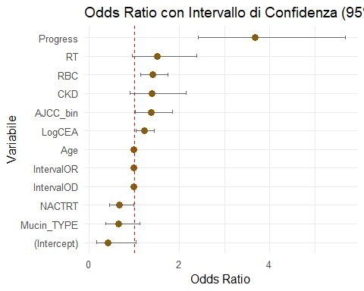

OR = 1 → Nessuna associazione con l’outcome. CEA, ID, ANESTIME, INTERVAL

OR > 1 → La variabile è associata a un aumento della probabilità dell’evento (es. progressione). ANESTIME, PROGRESS, RADIOTHERAPY, DIABETES, AJCC

OR < 1 → La variabile è associata a una diminuzione della probabilità dell’evento. INTERCETTA

# SURVIVAL ANALYSIS

## PREPARAZIONE DEL DATASET

library(survival)

## Warning: package 'survival' was built under R version 4.3.3

library(survminer)

## Warning: package 'survminer' was built under R version 4.3.3

## Loading required package: ggpubr

## Warning: package 'ggpubr' was built under R version 4.3.3

##   
## Attaching package: 'survminer'

## The following object is masked from 'package:survival':  
##   
## myeloma

library(dplyr)  
  
  
# senza le variabili tempo ed evento  
data_covariates <- subset(data, select = -c(IntervalOD, Death))

# Creazione dell'oggetto Surv: tempo = Interval (in mesi), evento = Death (1=evento, 0=censura)  
surv_object <- Surv(time = data$IntervalOD, event = data$Death)  
summary(surv_object)

## time status   
## Min. : 0.03285 Min. :0.0000   
## 1st Qu.: 8.11499 1st Qu.:0.0000   
## Median : 18.05339 Median :0.0000   
## Mean : 24.60655 Mean :0.4214   
## 3rd Qu.: 31.95072 3rd Qu.:1.0000   
## Max. :135.78645 Max. :1.0000

## KAPLAN MEIER CURVE - CURVA COMPLESSIVA SOPRAVVIVENZA

library(survival)  
library(survminer)  
  
# Opzione 1 - Con Surv e formula (raccomandata)  
km_fit <- survfit(Surv(IntervalOD, Death) ~ 1, data = data)  
ggsurvplot(km_fit, data = data, conf.int = TRUE, risk.table = TRUE, pval = TRUE,  
 ggtheme = theme_minimal(), title = "Kaplan-Meier curve - Overall Survival")

## Warning in .pvalue(fit, data = data, method = method, pval = pval, pval.coord = pval.coord, : There are no survival curves to be compared.   
## This is a null model.

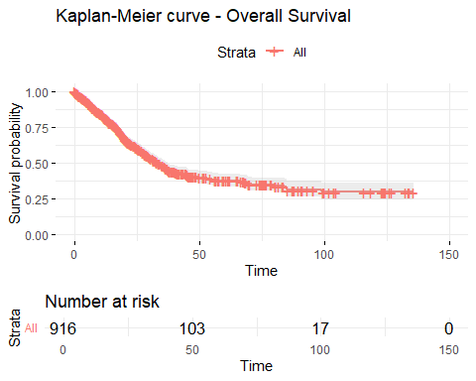

## KAPLAN MEIER - variabili

library(survival)  
library(survminer)  
  
# Controlla che la variabile sia presente e corretta  
colnames(data)

## [1] "Age" "Gender" "ASA3"   
## [4] "DM" "CAD" "HF"   
## [7] "CVA" "CKD" "LogCEA"   
## [10] "Laparoscopic" "TumorLOC" "EA"   
## [13] "Log2AT" "RBC" "Liver_Only"   
## [16] "Cell_diff" "Mucin_TYPE" "SignetRING"   
## [19] "Lymphovascularinvasion" "perineural" "CT"   
## [22] "RT" "NACTRT" "Death"   
## [25] "Progress" "IntervalOD" "IntervalOR"   
## [28] "AJCC_bin"

str(data$ASA3)

## num [1:916] 1 0 0 0 0 0 1 0 1 0 ...

# Se necessario, converti ASA3 in fattore  
data$ASA3 <- as.factor(data$ASA3)  
  
# Creazione formula e fit  
km_fit_ASA3 <- survfit(Surv(IntervalOD, Death) ~ ASA3, data = data)  
  
# Plot Kaplan-Meier  
ggsurvplot(km_fit_ASA3, data = data,  
 conf.int = TRUE, risk.table = TRUE, pval = TRUE,  
 ggtheme = theme_minimal(),  
 title = "Kaplan-Meier curve by ASA3",  
 legend.title = "ASA3")

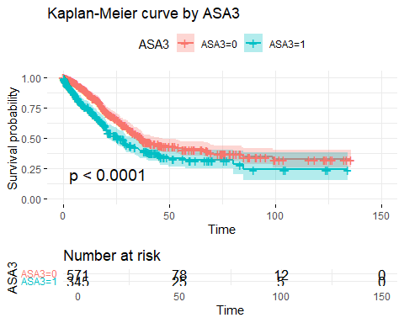

data$Gender <- as.factor(data$Gender)  
km_fit_Gender <- survfit(Surv(IntervalOD, Death) ~ Gender, data = data)  
ggsurvplot(km_fit_Gender, data = data,  
 conf.int = TRUE, risk.table = TRUE, pval = TRUE,  
 ggtheme = theme_minimal(),  
 title = "Kaplan-Meier curve by Gender",  
 legend.title = "Gender")

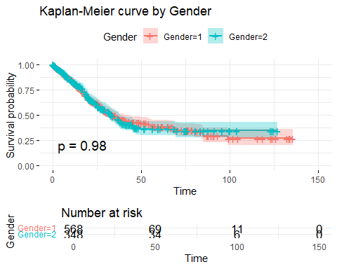

data$TumorLOC <- as.factor(data$TumorLOC)  
km_fit_TumorLOC <- survfit(Surv(IntervalOD, Death) ~ TumorLOC, data = data)  
ggsurvplot(km_fit_TumorLOC, data = data,  
 conf.int = TRUE, risk.table = TRUE, pval = TRUE,  
 ggtheme = theme_minimal(),  
 title = "Kaplan-Meier curve by Tumor Location",  
 legend.title = "TumorLOC")

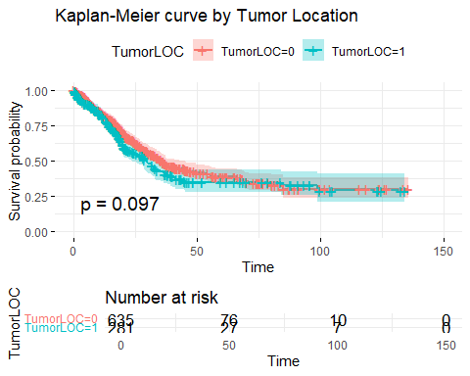

data$AJCC_bin <- as.factor(data$AJCC_bin)  
km_fit_AJCC <- survfit(Surv(IntervalOD, Death) ~ AJCC_bin, data = data)  
ggsurvplot(km_fit_AJCC, data = data,  
 conf.int = TRUE, risk.table = TRUE, pval = TRUE,  
 ggtheme = theme_minimal(),  
 title = "Kaplan-Meier curve by AJCC_bin",  
 legend.title = "AJCC_bin")

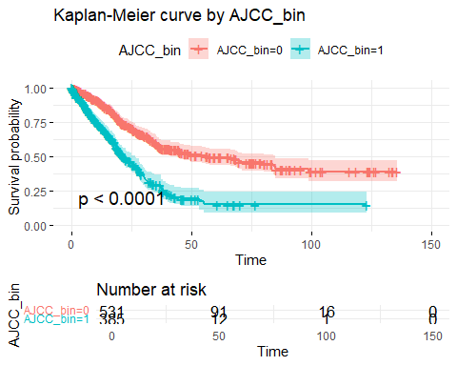

AJCC_bin

P-value < 0.0001 → differenza statisticamente significativa tra i gruppi 0 e 1.

Sopravvivenza marcatamente migliore per AJCC_bin=0. Interpretazione: Lo stadio AJCC è fortemente associato alla sopravvivenza, come atteso.

TumorLOC

P-value = 0.097 → non significativo.

Differenze modeste tra localizzazione colon/retto. Interpretazione: La sede del tumore sembra avere un impatto limitato sulla sopravvivenza.

Gender

P-value = 0.98 → non significativo.

Curve sovrapponibili. Interpretazione: Nessuna differenza di sopravvivenza tra uomini e donne.

ASA3

P-value < 0.0001 → differenza significativa.

Sopravvivenza inferiore nei pazienti ASA3=1 (compromessi). Interpretazione: Lo stato clinico pre-operatorio è un predittore importante.

Overall survival

Curve uniche, senza confronto. Interpretazione: Quadro generale di sopravvivenza della popolazione.

LOG RANK TEST

library(survival)  
  
# ASA3  
cat("\n=== Log-Rank Test per ASA3 ===\n")

##   
## === Log-Rank Test per ASA3 ===

survdiff(Surv(IntervalOD, Death) ~ ASA3, data = data)

## Call:  
## survdiff(formula = Surv(IntervalOD, Death) ~ ASA3, data = data)  
##   
## N Observed Expected (O-E)^2/E (O-E)^2/V  
## ASA3=0 571 228 265 5.12 16.4  
## ASA3=1 345 158 121 11.19 16.4  
##   
## Chisq= 16.4 on 1 degrees of freedom, p= 5e-05

# Gender  
cat("\n=== Log-Rank Test per Gender ===\n")

##   
## === Log-Rank Test per Gender ===

survdiff(Surv(IntervalOD, Death) ~ Gender, data = data)

## Call:  
## survdiff(formula = Surv(IntervalOD, Death) ~ Gender, data = data)  
##   
## N Observed Expected (O-E)^2/E (O-E)^2/V  
## Gender=1 568 237 237 0.000204 0.000528  
## Gender=2 348 149 149 0.000323 0.000528  
##   
## Chisq= 0 on 1 degrees of freedom, p= 1

# TumorLOC  
cat("\n=== Log-Rank Test per TumorLOC ===\n")

##   
## === Log-Rank Test per TumorLOC ===

survdiff(Surv(IntervalOD, Death) ~ TumorLOC, data = data)

## Call:  
## survdiff(formula = Surv(IntervalOD, Death) ~ TumorLOC, data = data)  
##   
## N Observed Expected (O-E)^2/E (O-E)^2/V  
## TumorLOC=0 635 263 278 0.77 2.75  
## TumorLOC=1 281 123 108 1.97 2.75  
##   
## Chisq= 2.7 on 1 degrees of freedom, p= 0.1

# AJCC_bin  
cat("\n=== Log-Rank Test per AJCC_bin ===\n")

##   
## === Log-Rank Test per AJCC_bin ===

survdiff(Surv(IntervalOD, Death) ~ AJCC_bin, data = data)

## Call:  
## survdiff(formula = Surv(IntervalOD, Death) ~ AJCC_bin, data = data)  
##   
## N Observed Expected (O-E)^2/E (O-E)^2/V  
## AJCC_bin=0 531 189 269 23.6 80.4  
## AJCC_bin=1 385 197 117 53.9 80.4  
##   
## Chisq= 80.4 on 1 degrees of freedom, p= <2e-16

LOG RANK TEST ANALISI:

1. ASA3 Chi-squared = 16.4, p = 5e-05 (molto significativo).

Interpretazione: La differenza di sopravvivenza tra pazienti ASA3=0 (basso rischio) e ASA3=1 (alto rischio) è significativa. I pazienti ASA3=1 hanno una sopravvivenza inferiore.

1. Gender Chi-squared ≈ 0, p = 1 (non significativo).

Interpretazione: Nessuna differenza di sopravvivenza tra uomini (Gender=1) e donne (Gender=2).

1. TumorLOC Chi-squared = 2.7, p ≈ 0.1 (non significativo).

Interpretazione: La localizzazione del tumore (colon vs retto) mostra una differenza non significativa. Potrebbe esserci una tendenza, ma non è statisticamente rilevante.

1. AJCC_bin Chi-squared = 80.4, p < 2e-16 (altamente significativo).

Interpretazione: Lo stadio AJCC è fortemente associato alla sopravvivenza. I pazienti con AJCC_bin=1 (stadio avanzato) hanno una sopravvivenza significativamente inferiore rispetto a quelli con AJCC_bin=0.

## COX MODEL MULTIVARIATO BASE

library(survival)  
# Costruisci il modello di Cox correttamente  
cox_model <- survival::coxph(Surv(time = data$IntervalOD, event = data$Death) ~ ., data = data_covariates)  
  
# Riepilogo  
summary(cox_model)

## Call:  
## survival::coxph(formula = Surv(time = data$IntervalOD, event = data$Death) ~   
## ., data = data_covariates)  
##   
## n= 916, number of events= 386   
##   
## coef exp(coef) se(coef) z Pr(>|z|)   
## Age 0.003871 1.003879 0.004420 0.876 0.381109   
## Gender -0.051848 0.949474 0.111083 -0.467 0.640682   
## ASA3 0.332491 1.394438 0.122490 2.714 0.006639 **   
## DM -0.102926 0.902194 0.128998 -0.798 0.424938   
## CAD -0.257736 0.772799 0.217288 -1.186 0.235563   
## HF -0.006674 0.993348 0.254941 -0.026 0.979115   
## CVA -0.097148 0.907421 0.226383 -0.429 0.667827   
## CKD 0.004420 1.004430 0.148534 0.030 0.976258   
## LogCEA 0.291469 1.338393 0.059650 4.886 1.03e-06 ***  
## Laparoscopic 0.136251 1.145970 0.278392 0.489 0.624543   
## TumorLOC 0.050862 1.052178 0.119640 0.425 0.670745   
## EA -0.133389 0.875124 0.146984 -0.908 0.364137   
## Log2AT -0.070096 0.932305 0.111543 -0.628 0.529728   
## RBC 0.276332 1.318285 0.081833 3.377 0.000733 ***  
## Liver_Only 0.310046 1.363487 0.171486 1.808 0.070607 .   
## Cell_diff 0.699494 2.012734 0.161757 4.324 1.53e-05 ***  
## Mucin_TYPE -0.100489 0.904395 0.219563 -0.458 0.647183   
## SignetRING 0.095302 1.099991 0.270049 0.353 0.724160   
## Lymphovascularinvasion 0.267522 1.306722 0.115471 2.317 0.020515 *   
## perineural -0.080879 0.922306 0.133749 -0.605 0.545375   
## CT -0.922426 0.397553 0.235829 -3.911 9.18e-05 ***  
## RT 0.096490 1.101299 0.157235 0.614 0.539432   
## NACTRT -0.018240 0.981925 0.154773 -0.118 0.906186   
## Progress -1.332024 0.263942 0.229387 -5.807 6.36e-09 ***  
## IntervalOR -0.098992 0.905750 0.008579 -11.539 < 2e-16 ***  
## AJCC_bin 0.798808 2.222889 0.167169 4.778 1.77e-06 ***  
## ---  
## Signif. codes: 0 '***' 0.001 '**' 0.01 '*' 0.05 '.' 0.1 ' ' 1  
##   
## exp(coef) exp(-coef) lower .95 upper .95  
## Age 1.0039 0.9961 0.9952 1.0126  
## Gender 0.9495 1.0532 0.7637 1.1804  
## ASA3 1.3944 0.7171 1.0968 1.7728  
## DM 0.9022 1.1084 0.7006 1.1617  
## CAD 0.7728 1.2940 0.5048 1.1831  
## HF 0.9933 1.0067 0.6027 1.6372  
## CVA 0.9074 1.1020 0.5823 1.4142  
## CKD 1.0044 0.9956 0.7507 1.3439  
## LogCEA 1.3384 0.7472 1.1907 1.5044  
## Laparoscopic 1.1460 0.8726 0.6641 1.9776  
## TumorLOC 1.0522 0.9504 0.8322 1.3302  
## EA 0.8751 1.1427 0.6561 1.1673  
## Log2AT 0.9323 1.0726 0.7492 1.1601  
## RBC 1.3183 0.7586 1.1229 1.5476  
## Liver_Only 1.3635 0.7334 0.9743 1.9082  
## Cell_diff 2.0127 0.4968 1.4659 2.7636  
## Mucin_TYPE 0.9044 1.1057 0.5881 1.3908  
## SignetRING 1.1000 0.9091 0.6479 1.8675  
## Lymphovascularinvasion 1.3067 0.7653 1.0421 1.6386  
## perineural 0.9223 1.0842 0.7096 1.1987  
## CT 0.3976 2.5154 0.2504 0.6312  
## RT 1.1013 0.9080 0.8092 1.4988  
## NACTRT 0.9819 1.0184 0.7250 1.3299  
## Progress 0.2639 3.7887 0.1684 0.4138  
## IntervalOR 0.9057 1.1041 0.8906 0.9211  
## AJCC_bin 2.2229 0.4499 1.6019 3.0847  
##   
## Concordance= 0.804 (se = 0.011 )  
## Likelihood ratio test= 432.5 on 26 df, p=<2e-16  
## Wald test = 320.9 on 26 df, p=<2e-16  
## Score (logrank) test = 324.6 on 26 df, p=<2e-16

library(car)  
vif(cox_model)

## Warning in vif.default(cox_model): No intercept: vifs may not be sensible.

## Age Gender ASA3   
## 1.314046 1.125176 1.365642   
## DM CAD HF   
## 1.089694 1.136872 1.162036   
## CVA CKD LogCEA   
## 1.139972 1.104450 1.156460   
## Laparoscopic TumorLOC EA   
## 1.043613 1.190184 1.055914   
## Log2AT RBC Liver_Only   
## 1.291902 1.288758 2.544038   
## Cell_diff Mucin_TYPE SignetRING   
## 1.185748 1.121536 1.305092   
## Lymphovascularinvasion perineural CT   
## 1.241031 1.255464 1.422660   
## RT NACTRT Progress   
## 1.104047 1.138847 1.595181   
## IntervalOR AJCC_bin   
## 1.283020 2.544302

* AJCC_bin e ASA3 sono predittori forti e confermano le curve Kaplan-Meier e il log-rank test.
* LogCEA e Cell_diff forniscono informazioni cliniche aggiuntive.
* CT e Progress mostrano effetti protettivi, da interpretare in chiave clinica.

| Variabile | HR | IC 95% | p-value | Interpretazione |
| --- | --- | --- | --- | --- |
| **ASA3** | 1.39 | (1.10 – 1.77) | 0.0066 (**) | Rischio +39% per ASA3=1 (alto rischio clinico) |
| **LogCEA** | 1.34 | (1.19 – 1.50) | 1e-06 (***) | Rischio +34% per unità di logCEA |
| **RBC** | 1.32 | (1.12 – 1.55) | 0.0007 (***) | Rischio +32% per trasfusioni più alte |
| **Cell_diff** | 2.01 | (1.47 – 2.76) | 1.5e-05 (***) | Rischio raddoppiato per differenziazione sfavorevole |
| **Lymphovascularinvasion** | 1.31 | (1.04 – 1.64) | 0.0205 (*) | Rischio +31% con invasione linfovascolare |
| **CT (chemioterapia)** | 0.40 | (0.25 – 0.63) | 9e-05 (***) | Rischio -60%, effetto protettivo |
| **Progress (progressione)** | 0.26 | (0.17 – 0.41) | 6e-09 (***) | Rischio -74%, effetto protettivo (attenzione: variabile temporale) |
| **IntervalOR (tempo)** | 0.91 | (0.89 – 0.92) | <2e-16 (***) | Effetto del tempo: con l’aumentare del follow-up, rischio decrescente |
| **AJCC_bin** | 2.22 | (1.60 – 3.08) | 1.7e-06 (***) | Rischio più che raddoppiato per AJCC_bin=1 |

BONTA DEL MODELLO

summary(cox_model)$concordance

## C se(C)   
## 0.80442454 0.01054447

modello discrimina molto bene, predice bene la sopravvivenza rispetto ai tempi osservati al 80%

### TEST DI PROPORZIONALITA DEI RISCHI nel tempo

cox.zph(cox_model)

## chisq df p  
## Age 2.03e-01 1 0.6527  
## Gender 4.71e-02 1 0.8282  
## ASA3 4.66e+00 1 0.0310  
## DM 3.28e-01 1 0.5667  
## CAD 2.82e-01 1 0.5957  
## HF 1.05e-01 1 0.7459  
## CVA 6.88e+00 1 0.0087  
## CKD 4.47e-01 1 0.5037  
## LogCEA 1.04e+00 1 0.3076  
## Laparoscopic 1.04e+00 1 0.3067  
## TumorLOC 4.81e-01 1 0.4882  
## EA 9.23e-01 1 0.3368  
## Log2AT 5.32e-03 1 0.9419  
## RBC 1.20e+00 1 0.2725  
## Liver_Only 7.78e-04 1 0.9777  
## Cell_diff 3.12e+00 1 0.0773  
## Mucin_TYPE 8.43e-01 1 0.3586  
## SignetRING 1.55e+00 1 0.2133  
## Lymphovascularinvasion 7.66e+00 1 0.0057  
## perineural 1.90e+00 1 0.1683  
## CT 2.02e+00 1 0.1548  
## RT 8.12e+00 1 0.0044  
## NACTRT 1.40e+00 1 0.2363  
## Progress 7.87e+00 1 0.0050  
## IntervalOR 7.58e+01 1 <2e-16  
## AJCC_bin 4.90e-01 1 0.4841  
## GLOBAL 1.41e+02 26 <2e-16

GLOBAL: il modello, nel suo complesso, viola la ipotesi di proporzionalitá dei rischi :(

Si visualizzana la curva di SCHOENFELD per una diagnosi grafica

cox.zph_test <- cox.zph(cox_model)  
  
  
ggcoxzph(cox.zph_test)

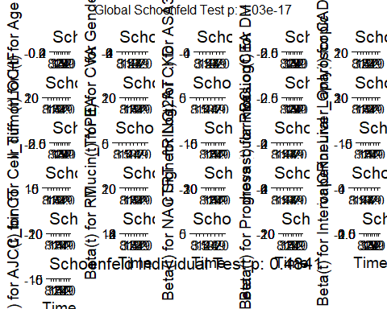

# Residui martingala (per outliers)  
ggcoxdiagnostics(cox_model, type = "martingale", linear.predictions = FALSE)

## `geom_smooth()` using formula = 'y ~ x'

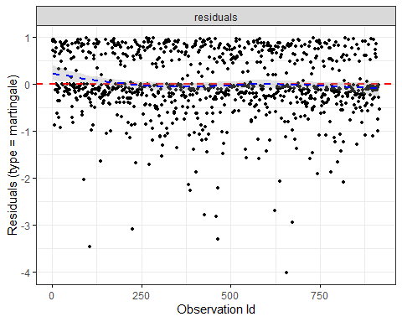

# Residui deviance (per influenze)  
ggcoxdiagnostics(cox_model, type = "deviance", linear.predictions = FALSE)

## `geom_smooth()` using formula = 'y ~ x'

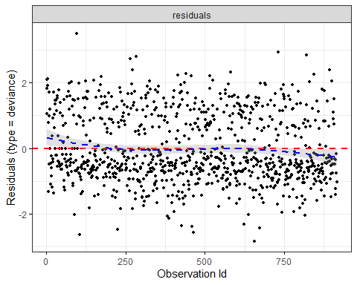

# Forest plot  
ggforest(cox_model, data = data)

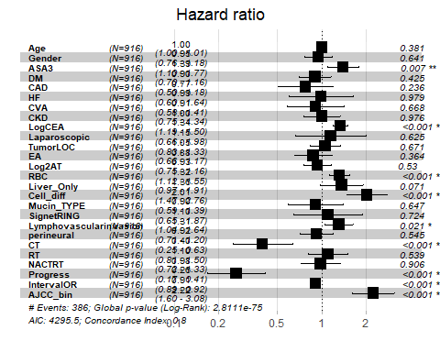

IPOTESI DI PROPORZIONALITÁ VIOLATA PER ALMENO UNA VARIABILE! Martingale residuals mostrano punti fuori dalla fascia ±3: possibili outlier o influenze estreme.Deviance residuals confermano questa tendenza: controlla osservazioni con residui estremi.

Variabili significative (es. con p < 0.05) mostrano:

* HR > 1 → aumento del rischio (ASA3, LogCEA, RBC, Cell_diff, AJCC_bin);
* HR < 1 → effetto protettivo (CT, Progress, IntervalOR).

Variabili come Gender, TumorLOC non significative.

## SEMPLIFICAZIONE COX - SIGNIFICATIVE VARIABLES

cox_simplified <- coxph(Surv(IntervalOD, Death) ~ ASA3 + LogCEA + RBC +   
 Cell_diff + Lymphovascularinvasion + CT +   
 Progress + IntervalOR + AJCC_bin, data = data)  
  
summary(cox_simplified)

## Call:  
## coxph(formula = Surv(IntervalOD, Death) ~ ASA3 + LogCEA + RBC +   
## Cell_diff + Lymphovascularinvasion + CT + Progress + IntervalOR +   
## AJCC_bin, data = data)  
##   
## n= 916, number of events= 386   
##   
## coef exp(coef) se(coef) z Pr(>|z|)   
## ASA31 0.286480 1.331732 0.108910 2.630 0.008528 **   
## LogCEA 0.316300 1.372042 0.056465 5.602 2.12e-08 ***  
## RBC 0.275427 1.317093 0.074254 3.709 0.000208 ***  
## Cell_diff 0.683911 1.981614 0.155899 4.387 1.15e-05 ***  
## Lymphovascularinvasion 0.278332 1.320924 0.106982 2.602 0.009277 **   
## CT -0.973865 0.377621 0.226980 -4.291 1.78e-05 ***  
## Progress -1.300823 0.272308 0.226292 -5.748 9.01e-09 ***  
## IntervalOR -0.097307 0.907277 0.008486 -11.466 < 2e-16 ***  
## AJCC_bin1 0.589113 1.802389 0.107473 5.482 4.22e-08 ***  
## ---  
## Signif. codes: 0 '***' 0.001 '**' 0.01 '*' 0.05 '.' 0.1 ' ' 1  
##   
## exp(coef) exp(-coef) lower .95 upper .95  
## ASA31 1.3317 0.7509 1.0758 1.6486  
## LogCEA 1.3720 0.7288 1.2283 1.5326  
## RBC 1.3171 0.7592 1.1387 1.5234  
## Cell_diff 1.9816 0.5046 1.4599 2.6898  
## Lymphovascularinvasion 1.3209 0.7570 1.0711 1.6291  
## CT 0.3776 2.6482 0.2420 0.5892  
## Progress 0.2723 3.6723 0.1748 0.4243  
## IntervalOR 0.9073 1.1022 0.8923 0.9225  
## AJCC_bin1 1.8024 0.5548 1.4600 2.2250  
##   
## Concordance= 0.804 (se = 0.011 )  
## Likelihood ratio test= 422.4 on 9 df, p=<2e-16  
## Wald test = 316.2 on 9 df, p=<2e-16  
## Score (logrank) test = 314 on 9 df, p=<2e-16

exp(coef(cox_simplified)) # HR

## ASA31 LogCEA RBC   
## 1.3317320 1.3720417 1.3170933   
## Cell_diff Lymphovascularinvasion CT   
## 1.9816136 1.3209243 0.3776206   
## Progress IntervalOR AJCC_bin1   
## 0.2723076 0.9072773 1.8023894

exp(confint(cox_simplified)) # IC 95%

## 2.5 % 97.5 %  
## ASA31 1.0757527 1.6486225  
## LogCEA 1.2283000 1.5326048  
## RBC 1.1387057 1.5234268  
## Cell_diff 1.4598809 2.6898033  
## Lymphovascularinvasion 1.0710616 1.6290762  
## CT 0.2420194 0.5891977  
## Progress 0.1747590 0.4243067  
## IntervalOR 0.8923114 0.9224942  
## AJCC_bin1 1.4600500 2.2249976

# Diagnostica proporzionalità  
cox.zph_test <- cox.zph(cox_simplified)  
print(cox.zph_test)

## chisq df p  
## ASA3 5.826 1 0.0158  
## LogCEA 0.852 1 0.3559  
## RBC 1.221 1 0.2692  
## Cell_diff 3.421 1 0.0644  
## Lymphovascularinvasion 7.225 1 0.0072  
## CT 1.988 1 0.1585  
## Progress 7.880 1 0.0050  
## IntervalOR 77.197 1 <2e-16  
## AJCC_bin 0.176 1 0.6751  
## GLOBAL 129.902 9 <2e-16

ggcoxzph(cox.zph_test)

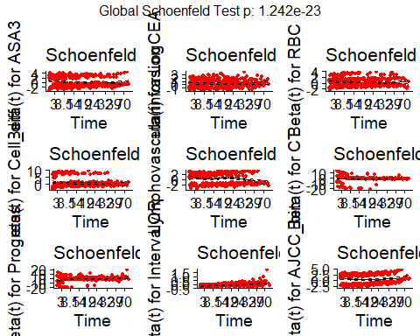

## STRATIFIED COX

si note cha le variabili IntervalOR, Progress e forse LogCEA e AJCC bin

# Modello Cox con stratificazione  
cox_stratified <- coxph(Surv(IntervalOD, Death) ~ ASA3 + LogCEA + RBC +   
 Cell_diff + Lymphovascularinvasion + CT +   
 strata(Progress) + strata(AJCC_bin) + strata(IntervalOR), data = data)  
  
summary(cox_stratified)

## Call:  
## coxph(formula = Surv(IntervalOD, Death) ~ ASA3 + LogCEA + RBC +   
## Cell_diff + Lymphovascularinvasion + CT + strata(Progress) +   
## strata(AJCC_bin) + strata(IntervalOR), data = data)  
##   
## n= 916, number of events= 386   
##   
## coef exp(coef) se(coef) z Pr(>|z|)   
## ASA31 0.6342 1.8856 0.3054 2.077 0.03784 *   
## LogCEA 0.4213 1.5239 0.1572 2.679 0.00738 **  
## RBC 0.3061 1.3581 0.1925 1.590 0.11185   
## Cell_diff 0.5225 1.6863 0.4722 1.107 0.26849   
## Lymphovascularinvasion -0.1475 0.8628 0.2891 -0.510 0.60988   
## CT -0.7464 0.4741 0.5537 -1.348 0.17769   
## ---  
## Signif. codes: 0 '***' 0.001 '**' 0.01 '*' 0.05 '.' 0.1 ' ' 1  
##   
## exp(coef) exp(-coef) lower .95 upper .95  
## ASA31 1.8856 0.5303 1.0363 3.431  
## LogCEA 1.5239 0.6562 1.1197 2.074  
## RBC 1.3581 0.7363 0.9312 1.981  
## Cell_diff 1.6863 0.5930 0.6683 4.255  
## Lymphovascularinvasion 0.8628 1.1590 0.4896 1.521  
## CT 0.4741 2.1093 0.1601 1.403  
##   
## Concordance= 0.626 (se = 0.059 )  
## Likelihood ratio test= 23.16 on 6 df, p=7e-04  
## Wald test = 18.62 on 6 df, p=0.005  
## Score (logrank) test = 21.61 on 6 df, p=0.001

cox.zph(cox_stratified)

## chisq df p  
## ASA3 7.26e-04 1 0.979  
## LogCEA 1.04e+00 1 0.309  
## RBC 4.51e+00 1 0.034  
## Cell_diff 1.93e-01 1 0.660  
## Lymphovascularinvasion 5.32e+00 1 0.021  
## CT 3.71e+00 1 0.054  
## GLOBAL 1.47e+01 6 0.022

* **LogCEA** e **ASA3** rimangono significativi anche nel modello stratificato.
* La stratificazione su **AJCC_bin** e **IntervalOR** riduce l’effetto apparente di altre variabili, perché il modello assume che queste abbiano effetti di base separati.

NOTA BENE: C = 68.1 %, la concordanza é scesa ripstto al modello precedente perce la stratificazione elimina l’effetto delle variabili stratificate dal calcolo del rischio.

## TIME DEPENDENT

IMPOSTANDO PROGRESSO 0 PRIMA DEL PROGRESSO E PROGRESSO 1 DOPO IL PROGRESSO. INtervallo da O (operazione) a R (recidiva) é il tempo continuo di follow up prima del progresso

library(survival)  
  
# Crea ID univoco per pazienti  
data$id <- 1:nrow(data)  
  
# Assicuriamoci che Progress sia 1=evento, 0=non avvenuto  
data$Progress_event <- ifelse(data$Progress == 1, 1, 0)

# Step 1: dataset iniziale per morte  
td_data <- tmerge(data1 = data, data2 = data,  
 id = id,  
 death = event(IntervalOD, Death))  
  
# Step 2: aggiungi Progress come evento time-dependent  
td_data <- tmerge(data1 = td_data, data2 = data,  
 id = id,  
 Progress_td = tdc(IntervalOR))  
  
# Step 3: controlla il dataset risultante  
head(td_data)

## Age Gender ASA3 DM CAD HF CVA CKD LogCEA Laparoscopic TumorLOC EA Log2AT  
## 1 52 1 1 0 0 0 0 0 2.971740 0 0 0 8.491853  
## 2 52 1 1 0 0 0 0 0 2.971740 0 0 0 8.491853  
## 3 85 2 0 0 1 0 0 0 2.127105 0 0 1 8.714246  
## 4 85 2 0 0 1 0 0 0 2.127105 0 0 1 8.714246  
## 5 45 2 0 0 0 0 0 0 3.057666 0 0 0 8.154818  
## 6 45 2 0 0 0 0 0 0 3.057666 0 0 0 8.154818  
## RBC Liver_Only Cell_diff Mucin_TYPE SignetRING Lymphovascularinvasion  
## 1 0 0 1 0 0 1  
## 2 0 0 1 0 0 1  
## 3 0 1 1 0 0 0  
## 4 0 1 1 0 0 0  
## 5 1 1 1 0 0 1  
## 6 1 1 1 0 0 1  
## perineural CT RT NACTRT Death Progress IntervalOD IntervalOR AJCC_bin id  
## 1 0 1 0 0 1 1 11.761807 9.856263 1 1  
## 2 0 1 0 0 1 1 11.761807 9.856263 1 1  
## 3 0 1 0 0 1 1 8.377823 7.063655 0 2  
## 4 0 1 0 0 1 1 8.377823 7.063655 0 2  
## 5 0 1 0 0 1 1 4.763860 2.792608 0 3  
## 6 0 1 0 0 1 1 4.763860 2.792608 0 3  
## Progress_event tstart tstop death Progress_td  
## 1 1 0.000000 9.856263 0 0  
## 2 1 9.856263 11.761807 1 1  
## 3 1 0.000000 7.063655 0 0  
## 4 1 7.063655 8.377823 1 1  
## 5 1 0.000000 2.792608 0 0  
## 6 1 2.792608 4.763860 1 1

cox_td <- coxph(Surv(tstart, tstop, death) ~ ASA3 + LogCEA + RBC +  
 Cell_diff + Lymphovascularinvasion + CT + Progress_td +  
 strata(AJCC_bin), data = td_data)  
  
summary(cox_td)

## Call:  
## coxph(formula = Surv(tstart, tstop, death) ~ ASA3 + LogCEA +   
## RBC + Cell_diff + Lymphovascularinvasion + CT + Progress_td +   
## strata(AJCC_bin), data = td_data)  
##   
## n= 1624, number of events= 386   
##   
## coef exp(coef) se(coef) z Pr(>|z|)   
## ASA31 0.27600 1.31785 0.10903 2.531 0.01136 *   
## LogCEA 0.33009 1.39110 0.05639 5.854 4.80e-09 ***  
## RBC 0.21258 1.23686 0.07460 2.850 0.00438 **   
## Cell_diff 0.65427 1.92374 0.15529 4.213 2.52e-05 ***  
## Lymphovascularinvasion 0.27871 1.32142 0.10809 2.579 0.00992 **   
## CT -1.49229 0.22486 0.20297 -7.352 1.95e-13 ***  
## Progress_td 2.37913 10.79554 0.19383 12.275 < 2e-16 ***  
## ---  
## Signif. codes: 0 '***' 0.001 '**' 0.01 '*' 0.05 '.' 0.1 ' ' 1  
##   
## exp(coef) exp(-coef) lower .95 upper .95  
## ASA31 1.3178 0.75881 1.0643 1.6318  
## LogCEA 1.3911 0.71886 1.2455 1.5537  
## RBC 1.2369 0.80850 1.0686 1.4316  
## Cell_diff 1.9237 0.51982 1.4189 2.6082  
## Lymphovascularinvasion 1.3214 0.75676 1.0691 1.6332  
## CT 0.2249 4.44729 0.1511 0.3347  
## Progress_td 10.7955 0.09263 7.3834 15.7845  
##   
## Concordance= 0.772 (se = 0.013 )  
## Likelihood ratio test= 355.2 on 7 df, p=<2e-16  
## Wald test = 294.6 on 7 df, p=<2e-16  
## Score (logrank) test = 330.6 on 7 df, p=<2e-16

table(td_data$Progress_td)

##   
## 0 1   
## 916 708

cox.zph(cox_td)

## chisq df p  
## ASA3 6.051 1 0.0139  
## LogCEA 0.604 1 0.4372  
## RBC 0.170 1 0.6798  
## Cell_diff 5.245 1 0.0220  
## Lymphovascularinvasion 5.949 1 0.0147  
## CT 1.813 1 0.1782  
## Progress_td 5.743 1 0.0166  
## GLOBAL 22.943 7 0.0017

ASA3 VIOLA, CELL_DIFF VIOLA, INVASIONE LINFO VIOLA, COMPLESSIVAMENTE VIOLATE

## PENALIZED COX

Si utilizza glmnet per penalizzazione ridge per ridurre varianza gestire multicoll. COX base é instabile, i coef saranno estretti con exp() per ottenere HR

library(glmnet)

## Warning: package 'glmnet' was built under R version 4.3.3

## Loading required package: Matrix

##   
## Attaching package: 'Matrix'

## The following objects are masked from 'package:tidyr':  
##   
## expand, pack, unpack

## Loaded glmnet 4.1-8

library(survival)  
  
# Prepara la matrice X e il vettore y (tempo + evento)  
X <- model.matrix(~ ASA3 + LogCEA + RBC + Cell_diff + Lymphovascularinvasion + CT + Progress_td, data=td_data)[,-1]  
y <- Surv(td_data$tstart, td_data$tstop, td_data$death)  
  
# Cox Lasso (alpha=1), puoi anche usare Ridge (alpha=0) o Elastic Net  
cvfit <- cv.glmnet(X, y, family="cox", alpha=1)

## Warning: cox.fit: algorithm did not converge

## Warning: cox.fit: algorithm did not converge  
  
## Warning: cox.fit: algorithm did not converge  
  
## Warning: cox.fit: algorithm did not converge  
  
## Warning: cox.fit: algorithm did not converge  
  
## Warning: cox.fit: algorithm did not converge  
  
## Warning: cox.fit: algorithm did not converge  
  
## Warning: cox.fit: algorithm did not converge  
  
## Warning: cox.fit: algorithm did not converge  
  
## Warning: cox.fit: algorithm did not converge  
  
## Warning: cox.fit: algorithm did not converge  
  
## Warning: cox.fit: algorithm did not converge  
  
## Warning: cox.fit: algorithm did not converge  
  
## Warning: cox.fit: algorithm did not converge  
  
## Warning: cox.fit: algorithm did not converge  
  
## Warning: cox.fit: algorithm did not converge  
  
## Warning: cox.fit: algorithm did not converge  
  
## Warning: cox.fit: algorithm did not converge  
  
## Warning: cox.fit: algorithm did not converge  
  
## Warning: cox.fit: algorithm did not converge  
  
## Warning: cox.fit: algorithm did not converge  
  
## Warning: cox.fit: algorithm did not converge  
  
## Warning: cox.fit: algorithm did not converge  
  
## Warning: cox.fit: algorithm did not converge  
  
## Warning: cox.fit: algorithm did not converge  
  
## Warning: cox.fit: algorithm did not converge  
  
## Warning: cox.fit: algorithm did not converge  
  
## Warning: cox.fit: algorithm did not converge  
  
## Warning: cox.fit: algorithm did not converge  
  
## Warning: cox.fit: algorithm did not converge  
  
## Warning: cox.fit: algorithm did not converge  
  
## Warning: cox.fit: algorithm did not converge  
  
## Warning: cox.fit: algorithm did not converge  
  
## Warning: cox.fit: algorithm did not converge  
  
## Warning: cox.fit: algorithm did not converge  
  
## Warning: cox.fit: algorithm did not converge  
  
## Warning: cox.fit: algorithm did not converge  
  
## Warning: cox.fit: algorithm did not converge  
  
## Warning: cox.fit: algorithm did not converge  
  
## Warning: cox.fit: algorithm did not converge  
  
## Warning: cox.fit: algorithm did not converge  
  
## Warning: cox.fit: algorithm did not converge  
  
## Warning: cox.fit: algorithm did not converge  
  
## Warning: cox.fit: algorithm did not converge  
  
## Warning: cox.fit: algorithm did not converge  
  
## Warning: cox.fit: algorithm did not converge  
  
## Warning: cox.fit: algorithm did not converge  
  
## Warning: cox.fit: algorithm did not converge  
  
## Warning: cox.fit: algorithm did not converge  
  
## Warning: cox.fit: algorithm did not converge  
  
## Warning: cox.fit: algorithm did not converge  
  
## Warning: cox.fit: algorithm did not converge  
  
## Warning: cox.fit: algorithm did not converge  
  
## Warning: cox.fit: algorithm did not converge  
  
## Warning: cox.fit: algorithm did not converge  
  
## Warning: cox.fit: algorithm did not converge  
  
## Warning: cox.fit: algorithm did not converge  
  
## Warning: cox.fit: algorithm did not converge  
  
## Warning: cox.fit: algorithm did not converge  
  
## Warning: cox.fit: algorithm did not converge  
  
## Warning: cox.fit: algorithm did not converge  
  
## Warning: cox.fit: algorithm did not converge  
  
## Warning: cox.fit: algorithm did not converge  
  
## Warning: cox.fit: algorithm did not converge  
  
## Warning: cox.fit: algorithm did not converge  
  
## Warning: cox.fit: algorithm did not converge  
  
## Warning: cox.fit: algorithm did not converge  
  
## Warning: cox.fit: algorithm did not converge  
  
## Warning: cox.fit: algorithm did not converge  
  
## Warning: cox.fit: algorithm did not converge  
  
## Warning: cox.fit: algorithm did not converge  
  
## Warning: cox.fit: algorithm did not converge  
  
## Warning: cox.fit: algorithm did not converge  
  
## Warning: cox.fit: algorithm did not converge  
  
## Warning: cox.fit: algorithm did not converge  
  
## Warning: cox.fit: algorithm did not converge  
  
## Warning: cox.fit: algorithm did not converge  
  
## Warning: cox.fit: algorithm did not converge  
  
## Warning: cox.fit: algorithm did not converge  
  
## Warning: cox.fit: algorithm did not converge  
  
## Warning: cox.fit: algorithm did not converge  
  
## Warning: cox.fit: algorithm did not converge  
  
## Warning: cox.fit: algorithm did not converge  
  
## Warning: cox.fit: algorithm did not converge  
  
## Warning: cox.fit: algorithm did not converge  
  
## Warning: cox.fit: algorithm did not converge  
  
## Warning: cox.fit: algorithm did not converge  
  
## Warning: cox.fit: algorithm did not converge  
  
## Warning: cox.fit: algorithm did not converge  
  
## Warning: cox.fit: algorithm did not converge  
  
## Warning: cox.fit: algorithm did not converge  
  
## Warning: cox.fit: algorithm did not converge  
  
## Warning: cox.fit: algorithm did not converge  
  
## Warning: cox.fit: algorithm did not converge  
  
## Warning: cox.fit: algorithm did not converge  
  
## Warning: cox.fit: algorithm did not converge  
  
## Warning: cox.fit: algorithm did not converge  
  
## Warning: cox.fit: algorithm did not converge  
  
## Warning: cox.fit: algorithm did not converge  
  
## Warning: cox.fit: algorithm did not converge  
  
## Warning: cox.fit: algorithm did not converge  
  
## Warning: cox.fit: algorithm did not converge  
  
## Warning: cox.fit: algorithm did not converge  
  
## Warning: cox.fit: algorithm did not converge  
  
## Warning: cox.fit: algorithm did not converge  
  
## Warning: cox.fit: algorithm did not converge  
  
## Warning: cox.fit: algorithm did not converge  
  
## Warning: cox.fit: algorithm did not converge  
  
## Warning: cox.fit: algorithm did not converge  
  
## Warning: cox.fit: algorithm did not converge  
  
## Warning: cox.fit: algorithm did not converge  
  
## Warning: cox.fit: algorithm did not converge  
  
## Warning: cox.fit: algorithm did not converge  
  
## Warning: cox.fit: algorithm did not converge  
  
## Warning: cox.fit: algorithm did not converge  
  
## Warning: cox.fit: algorithm did not converge  
  
## Warning: cox.fit: algorithm did not converge  
  
## Warning: cox.fit: algorithm did not converge  
  
## Warning: cox.fit: algorithm did not converge  
  
## Warning: cox.fit: algorithm did not converge  
  
## Warning: cox.fit: algorithm did not converge  
  
## Warning: cox.fit: algorithm did not converge  
  
## Warning: cox.fit: algorithm did not converge  
  
## Warning: cox.fit: algorithm did not converge  
  
## Warning: cox.fit: algorithm did not converge  
  
## Warning: cox.fit: algorithm did not converge  
  
## Warning: cox.fit: algorithm did not converge  
  
## Warning: cox.fit: algorithm did not converge  
  
## Warning: cox.fit: algorithm did not converge  
  
## Warning: cox.fit: algorithm did not converge  
  
## Warning: cox.fit: algorithm did not converge  
  
## Warning: cox.fit: algorithm did not converge  
  
## Warning: cox.fit: algorithm did not converge  
  
## Warning: cox.fit: algorithm did not converge  
  
## Warning: cox.fit: algorithm did not converge  
  
## Warning: cox.fit: algorithm did not converge  
  
## Warning: cox.fit: algorithm did not converge  
  
## Warning: cox.fit: algorithm did not converge  
  
## Warning: cox.fit: algorithm did not converge  
  
## Warning: cox.fit: algorithm did not converge  
  
## Warning: cox.fit: algorithm did not converge  
  
## Warning: cox.fit: algorithm did not converge  
  
## Warning: cox.fit: algorithm did not converge  
  
## Warning: cox.fit: algorithm did not converge  
  
## Warning: cox.fit: algorithm did not converge  
  
## Warning: cox.fit: algorithm did not converge  
  
## Warning: cox.fit: algorithm did not converge  
  
## Warning: cox.fit: algorithm did not converge  
  
## Warning: cox.fit: algorithm did not converge  
  
## Warning: cox.fit: algorithm did not converge  
  
## Warning: cox.fit: algorithm did not converge  
  
## Warning: cox.fit: algorithm did not converge  
  
## Warning: cox.fit: algorithm did not converge  
  
## Warning: cox.fit: algorithm did not converge  
  
## Warning: cox.fit: algorithm did not converge  
  
## Warning: cox.fit: algorithm did not converge  
  
## Warning: cox.fit: algorithm did not converge  
  
## Warning: cox.fit: algorithm did not converge  
  
## Warning: cox.fit: algorithm did not converge  
  
## Warning: cox.fit: algorithm did not converge  
  
## Warning: cox.fit: algorithm did not converge  
  
## Warning: cox.fit: algorithm did not converge  
  
## Warning: cox.fit: algorithm did not converge  
  
## Warning: cox.fit: algorithm did not converge  
  
## Warning: cox.fit: algorithm did not converge  
  
## Warning: cox.fit: algorithm did not converge  
  
## Warning: cox.fit: algorithm did not converge  
  
## Warning: cox.fit: algorithm did not converge  
  
## Warning: cox.fit: algorithm did not converge  
  
## Warning: cox.fit: algorithm did not converge  
  
## Warning: cox.fit: algorithm did not converge  
  
## Warning: cox.fit: algorithm did not converge  
  
## Warning: cox.fit: algorithm did not converge  
  
## Warning: cox.fit: algorithm did not converge  
  
## Warning: cox.fit: algorithm did not converge  
  
## Warning: cox.fit: algorithm did not converge  
  
## Warning: cox.fit: algorithm did not converge  
  
## Warning: cox.fit: algorithm did not converge  
  
## Warning: cox.fit: algorithm did not converge  
  
## Warning: cox.fit: algorithm did not converge  
  
## Warning: cox.fit: algorithm did not converge  
  
## Warning: cox.fit: algorithm did not converge  
  
## Warning: cox.fit: algorithm did not converge  
  
## Warning: cox.fit: algorithm did not converge  
  
## Warning: cox.fit: algorithm did not converge  
  
## Warning: cox.fit: algorithm did not converge  
  
## Warning: cox.fit: algorithm did not converge  
  
## Warning: cox.fit: algorithm did not converge

# Visualizza i coefficienti penalizzati  
coef(cvfit, s="lambda.min")

## 7 x 1 sparse Matrix of class "dgCMatrix"  
## 1  
## ASA31 0.2430918  
## LogCEA 0.3399611  
## RBC 0.2108039  
## Cell_diff 0.7074687  
## Lymphovascularinvasion 0.3425381  
## CT -1.5345704  
## Progress_td 2.4104211

RIDGE PENALIZED COX: i coeffcienti stimate rappresentano l’effetto delle covariate sul logaritmo dell rischio di un evento. Il coefficiente positivo indica un aumento del rischio associato all’aumento della covariata, negativo viceversa.

COEFFICIENTI: ASA31: 0.243 → HR ≈ exp(0.243) ≈ 1.275

LogCEA: 0.340 → HR ≈ exp(0.340) ≈ 1.405

RBC: 0.211 → HR ≈ exp(0.211) ≈ 1.235

Cell_diff: 0.707 → HR ≈ exp(0.707) ≈ 2.028

Lymphovascularinvasion: 0.343 → HR ≈ exp(0.343) ≈ 1.409

CT: -1.535 → HR ≈ exp(-1.535) ≈ 0.216, coefficiente negativo, suggerendo un effetto protettivo.

Progress_td: 2.410 → HR ≈ exp(2.410) ≈ 11.13, effetto molto forte, con un hazard ratio (HR) superiore a 11, indicando che la progressione della malattia è fortemente associata a un aumento del rischio di morte.

## Additive Aalen

permette di stimare effetti che variano nel tempo

library(timereg)

## Warning: package 'timereg' was built under R version 4.3.3

aalen_model <- aalen(Surv(tstart, tstop, death) ~ ASA3 + LogCEA + RBC + Cell_diff +   
 Lymphovascularinvasion + CT + Progress_td, data=td_data)  
summary(aalen_model)

## Additive Aalen Model   
##   
## Test for nonparametric terms   
##   
## Test for non-significant effects   
## Supremum-test of significance p-value H_0: B(t)=0  
## (Intercept) 1.30 0.939  
## ASA31 3.73 0.006  
## LogCEA 5.63 0.000  
## RBC 3.67 0.012  
## Cell_diff 4.11 0.000  
## Lymphovascularinvasion 3.96 0.003  
## CT 3.86 0.005  
## Progress_td 9.45 0.000  
##   
## Test for time invariant effects   
## Kolmogorov-Smirnov test  
## (Intercept) 0.360  
## ASA31 0.171  
## LogCEA 0.262  
## RBC 0.139  
## Cell_diff 0.556  
## Lymphovascularinvasion 0.358  
## CT 0.663  
## Progress_td 0.659  
## p-value H_0:constant effect  
## (Intercept) 0.407  
## ASA31 0.614  
## LogCEA 0.021  
## RBC 0.146  
## Cell_diff 0.000  
## Lymphovascularinvasion 0.001  
## CT 0.002  
## Progress_td 0.000  
## Cramer von Mises test  
## (Intercept) 3.670  
## ASA31 0.427  
## LogCEA 2.310  
## RBC 0.361  
## Cell_diff 9.100  
## Lymphovascularinvasion 5.210  
## CT 17.600  
## Progress_td 14.900  
## p-value H_0:constant effect  
## (Intercept) 0.241  
## ASA31 0.691  
## LogCEA 0.017  
## RBC 0.192  
## Cell_diff 0.000  
## Lymphovascularinvasion 0.000  
## CT 0.002  
## Progress_td 0.000  
##   
##   
##   
## Call:   
## aalen(formula = Surv(tstart, tstop, death) ~ ASA3 + LogCEA +   
## RBC + Cell_diff + Lymphovascularinvasion + CT + Progress_td,   
## data = td_data)

1- TEST SIGNIFICATIVITÁ

test del supremum mostra che le seguenti variabili hanno effetti significativamente diversi da zero:

ASA31: p = 0.013

LogCEA: p < 0.001

RBC: p = 0.008

Cell_diff: p < 0.001

Lymphovascularinvasion: p = 0.001

CT: p = 0.003

Progress_td: p < 0.001

2 - TEST COSTANZA EFFETTO NEL TEMPO

Kolmodoroff smirnov, indica che LOGCEA, CELL DIFF, LINFO VASCOLARIZZAZIONE, CT E PROGRESS TD anno effetti che variano nel tempo

Progress_td mostra un effetto significativamente variabile nel tempo, suggerendo che l’impatto della progressione della malattia sul rischio di morte cambia durante il follow-up.

CT e Cell_diff presentano effetti temporali non costanti, indicando che il loro impatto sul rischio varia nel tempo.

# Supervised learning SENZA BILANCIAMENTO

Logistic Regression

Random Forest

XGBoost

SVM

K-NN

## DIVISIONE TRAIN/TEST

set.seed(123)  
library(caret)

## Warning: package 'caret' was built under R version 4.3.3

## Loading required package: lattice

##   
## Attaching package: 'caret'

## The following object is masked from 'package:survival':  
##   
## cluster

train_index <- createDataPartition(data$Death, p = 0.8, list = FALSE)  
train_data <- data[train_index, ]  
test_data <- data[-train_index, ]  
  
#-----------aggiunta post   
train_data$Death <- as.factor(train_data$Death)  
test_data$Death <- as.factor(test_data$Death)

## LOGISTIC REGRESSION

# Training della logistic regression  
set.seed(123)  
logit_model <- train(  
 Death ~ .,   
 data = train_data,  
 method = "glm",  
 family = "binomial",  
 trControl = trainControl(method = "none") # niente cross-validation per ora, step successivo  
)

# Predizione delle classi  
pred_class <- predict(logit_model, newdata = test_data)

## Warning in predict.lm(object, newdata, se.fit, scale = 1, type = if (type == :  
## prediction from rank-deficient fit; attr(*, "non-estim") has doubtful cases

# Predizione delle probabilità (per AUC)  
pred_prob <- predict(logit_model, newdata = test_data, type = "prob")

## Warning in predict.lm(object, newdata, se.fit, scale = 1, type = if (type == :  
## prediction from rank-deficient fit; attr(*, "non-estim") has doubtful cases

# Confusion Matrix  
conf_mat <- confusionMatrix(pred_class, test_data$Death)  
print(conf_mat)

## Confusion Matrix and Statistics  
##   
## Reference  
## Prediction 0 1  
## 0 72 41  
## 1 39 31  
##   
## Accuracy : 0.5628   
## 95% CI : (0.4877, 0.6359)  
## No Information Rate : 0.6066   
## P-Value [Acc > NIR] : 0.9003   
##   
## Kappa : 0.0796   
##   
## Mcnemar's Test P-Value : 0.9110   
##   
## Sensitivity : 0.6486   
## Specificity : 0.4306   
## Pos Pred Value : 0.6372   
## Neg Pred Value : 0.4429   
## Prevalence : 0.6066   
## Detection Rate : 0.3934   
## Detection Prevalence : 0.6175   
## Balanced Accuracy : 0.5396   
##   
## 'Positive' Class : 0   
##

# AUC con pROC  
library(pROC)

## Warning: package 'pROC' was built under R version 4.3.3

## Type 'citation("pROC")' for a citation.

##   
## Attaching package: 'pROC'

## The following objects are masked from 'package:stats':  
##   
## cov, smooth, var

roc_obj <- roc(test_data$Death, pred_prob[, 2])

## Setting levels: control = 0, case = 1

## Setting direction: controls < cases

auc(roc_obj)

## Area under the curve: 0.6196

summary(logit_model$finalModel)

##   
## Call:  
## NULL  
##   
## Coefficients: (1 not defined because of singularities)  
## Estimate Std. Error z value Pr(>|z|)   
## (Intercept) -0.5597915 1.7240337 -0.325 0.745409   
## Age -0.0097777 0.0068488 -1.428 0.153393   
## Gender2 0.1344741 0.1779651 0.756 0.449877   
## ASA31 0.2218841 0.1952950 1.136 0.255895   
## DM 0.2961600 0.2068710 1.432 0.152254   
## CAD -0.2474317 0.3456455 -0.716 0.474082   
## HF -0.0496266 0.3887257 -0.128 0.898414   
## CVA 0.9000041 0.3824615 2.353 0.018613 *   
## CKD 0.5046835 0.2503024 2.016 0.043769 *   
## LogCEA 0.1537012 0.0967441 1.589 0.112119   
## Laparoscopic -0.3717732 0.4198880 -0.885 0.375935   
## TumorLOC1 0.0604544 0.1897793 0.319 0.750067   
## EA -0.2909285 0.2479113 -1.174 0.240588   
## Log2AT -0.0680888 0.1878700 -0.362 0.717035   
## RBC 0.3470738 0.1334364 2.601 0.009294 **   
## Liver_Only 0.3794461 0.2512146 1.510 0.130930   
## Cell_diff 0.2450865 0.2691399 0.911 0.362491   
## Mucin_TYPE -0.3372062 0.3443313 -0.979 0.327428   
## SignetRING 0.2779922 0.4411310 0.630 0.528576   
## Lymphovascularinvasion -0.1175056 0.1855072 -0.633 0.526454   
## perineural 0.0316183 0.2145761 0.147 0.882854   
## CT 0.1569898 0.3233707 0.485 0.627336   
## RT 0.4139675 0.2627090 1.576 0.115080   
## NACTRT -0.2536589 0.2445127 -1.037 0.299547   
## Progress 1.3646557 0.2769138 4.928 8.3e-07 ***  
## IntervalOD -0.0197915 0.0054928 -3.603 0.000314 ***  
## IntervalOR -0.0155006 0.0114291 -1.356 0.175025   
## AJCC_bin1 0.4593299 0.2504911 1.834 0.066696 .   
## id -0.0008913 0.0003675 -2.425 0.015297 *   
## Progress_event NA NA NA NA   
## ---  
## Signif. codes: 0 '***' 0.001 '**' 0.01 '*' 0.05 '.' 0.1 ' ' 1  
##   
## (Dispersion parameter for binomial family taken to be 1)  
##   
## Null deviance: 1001.06 on 732 degrees of freedom  
## Residual deviance: 865.88 on 704 degrees of freedom  
## AIC: 923.88  
##   
## Number of Fisher Scoring iterations: 5

Si nota che la maggior parte delle variabili non sono statisticamente significative. Si utilizza la funzione step() per fare una stepwise selection

# 1. Modello iniziale completo  
full_model <- glm(Death ~ ., data = train_data, family = "binomial")  
  
# 2. Selezione stepwise (AIC)  
step_model <- step(full_model, direction = "both", trace = FALSE)  
  
# 3. Sommario del modello selezionato  
summary(step_model)

##   
## Call:  
## glm(formula = Death ~ CVA + CKD + LogCEA + RBC + RT + Progress +   
## IntervalOD + IntervalOR + AJCC_bin + id, family = "binomial",   
## data = train_data)  
##   
## Coefficients:  
## Estimate Std. Error z value Pr(>|z|)   
## (Intercept) -1.1814318 0.3309172 -3.570 0.000357 ***  
## CVA 0.8725531 0.3646286 2.393 0.016712 *   
## CKD 0.4153874 0.2424035 1.714 0.086599 .   
## LogCEA 0.1896105 0.0910271 2.083 0.037250 *   
## RBC 0.3716770 0.1215958 3.057 0.002238 **   
## RT 0.3918939 0.2577716 1.520 0.128432   
## Progress 1.3520654 0.2450282 5.518 3.43e-08 ***  
## IntervalOD -0.0192654 0.0052142 -3.695 0.000220 ***  
## IntervalOR -0.0156049 0.0112493 -1.387 0.165384   
## AJCC_bin1 0.2468352 0.1696257 1.455 0.145621   
## id -0.0007727 0.0003093 -2.498 0.012488 *   
## ---  
## Signif. codes: 0 '***' 0.001 '**' 0.01 '*' 0.05 '.' 0.1 ' ' 1  
##   
## (Dispersion parameter for binomial family taken to be 1)  
##   
## Null deviance: 1001.06 on 732 degrees of freedom  
## Residual deviance: 878.75 on 722 degrees of freedom  
## AIC: 900.75  
##   
## Number of Fisher Scoring iterations: 5

# Predizioni su test  
pred_prob <- predict(step_model, newdata = test_data, type = "response")  
pred_class <- ifelse(pred_prob > 0.5, "1", "0")  
pred_class <- factor(pred_class, levels = levels(test_data$Death))  
  
# Confusion matrix  
confusionMatrix(pred_class, test_data$Death)

## Confusion Matrix and Statistics  
##   
## Reference  
## Prediction 0 1  
## 0 74 38  
## 1 37 34  
##   
## Accuracy : 0.5902   
## 95% CI : (0.5152, 0.6622)  
## No Information Rate : 0.6066   
## P-Value [Acc > NIR] : 0.7031   
##   
## Kappa : 0.1392   
##   
## Mcnemar's Test P-Value : 1.0000   
##   
## Sensitivity : 0.6667   
## Specificity : 0.4722   
## Pos Pred Value : 0.6607   
## Neg Pred Value : 0.4789   
## Prevalence : 0.6066   
## Detection Rate : 0.4044   
## Detection Prevalence : 0.6120   
## Balanced Accuracy : 0.5694   
##   
## 'Positive' Class : 0   
##

# AUC  
library(pROC)  
roc_obj <- roc(test_data$Death, pred_prob)

## Setting levels: control = 0, case = 1

## Setting direction: controls < cases

auc(roc_obj)

## Area under the curve: 0.6418

## RANDOM FOREST

Si inizia con una k fold

# Rinominare i livelli della variabile target  
train_data$Death <- factor(train_data$Death, levels = c("0", "1"), labels = c("No", "Yes"))  
test_data$Death <- factor(test_data$Death, levels = c("0", "1"), labels = c("No", "Yes"))

library(caret)  
set.seed(123)  
  
rf_model <- train(  
 Death ~ .,  
 data = train_data,  
 method = "rf",  
 trControl = trainControl(  
 method = "cv",  
 number = 5,  
 classProbs = TRUE,  
 summaryFunction = twoClassSummary  
 ),  
 metric = "ROC"  
)

# Predizioni  
pred_class <- predict(rf_model, newdata = test_data)  
pred_prob <- predict(rf_model, newdata = test_data, type = "prob")  
  
# Confusion matrix  
confusionMatrix(pred_class, test_data$Death)

## Confusion Matrix and Statistics  
##   
## Reference  
## Prediction No Yes  
## No 86 40  
## Yes 25 32  
##   
## Accuracy : 0.6448   
## 95% CI : (0.5708, 0.714)  
## No Information Rate : 0.6066   
## P-Value [Acc > NIR] : 0.16270   
##   
## Kappa : 0.2275   
##   
## Mcnemar's Test P-Value : 0.08248   
##   
## Sensitivity : 0.7748   
## Specificity : 0.4444   
## Pos Pred Value : 0.6825   
## Neg Pred Value : 0.5614   
## Prevalence : 0.6066   
## Detection Rate : 0.4699   
## Detection Prevalence : 0.6885   
## Balanced Accuracy : 0.6096   
##   
## 'Positive' Class : No   
##

# AUC  
library(pROC)  
roc_obj <- roc(test_data$Death, pred_prob[, "Yes"]) # o [, "1"] se usi 0/1

## Setting levels: control = No, case = Yes

## Setting direction: controls < cases

auc(roc_obj)

## Area under the curve: 0.6642

varImp(rf_model)

## rf variable importance  
##   
## only 20 most important variables shown (out of 29)  
##   
## Overall  
## IntervalOR 100.000  
## IntervalOD 99.214  
## LogCEA 88.674  
## id 88.407  
## Age 75.054  
## Log2AT 68.955  
## RBC 29.784  
## Progress 22.081  
## Progress_event 19.164  
## AJCC_bin1 16.530  
## ASA31 14.997  
## Gender2 11.822  
## DM 11.093  
## Lymphovascularinvasion 10.148  
## TumorLOC1 9.808  
## perineural 9.678  
## Liver_Only 9.314  
## CKD 8.606  
## RT 7.986  
## EA 6.942

Si procede facendo tuning degli iperparametri, con mtry, numero di alber etc. dopo il fit di base.

set.seed(123)  
mtry_grid <- expand.grid(mtry = c(2, 4, 6, 8, 10))

rf_model_tuned <- train(  
 Death ~ .,  
 data = train_data,  
 method = "rf",  
 trControl = trainControl(  
 method = "cv",  
 number = 5,  
 classProbs = TRUE,  
 summaryFunction = twoClassSummary,  
 verboseIter = TRUE  
 ),  
 metric = "ROC",  
 tuneGrid = mtry_grid,  
 ntree = 500   
)

## + Fold1: mtry= 2   
## - Fold1: mtry= 2   
## + Fold1: mtry= 4   
## - Fold1: mtry= 4   
## + Fold1: mtry= 6   
## - Fold1: mtry= 6   
## + Fold1: mtry= 8   
## - Fold1: mtry= 8   
## + Fold1: mtry=10   
## - Fold1: mtry=10   
## + Fold2: mtry= 2   
## - Fold2: mtry= 2   
## + Fold2: mtry= 4   
## - Fold2: mtry= 4   
## + Fold2: mtry= 6   
## - Fold2: mtry= 6   
## + Fold2: mtry= 8   
## - Fold2: mtry= 8   
## + Fold2: mtry=10   
## - Fold2: mtry=10   
## + Fold3: mtry= 2   
## - Fold3: mtry= 2   
## + Fold3: mtry= 4   
## - Fold3: mtry= 4   
## + Fold3: mtry= 6   
## - Fold3: mtry= 6   
## + Fold3: mtry= 8   
## - Fold3: mtry= 8   
## + Fold3: mtry=10   
## - Fold3: mtry=10   
## + Fold4: mtry= 2   
## - Fold4: mtry= 2   
## + Fold4: mtry= 4   
## - Fold4: mtry= 4   
## + Fold4: mtry= 6   
## - Fold4: mtry= 6   
## + Fold4: mtry= 8   
## - Fold4: mtry= 8   
## + Fold4: mtry=10   
## - Fold4: mtry=10   
## + Fold5: mtry= 2   
## - Fold5: mtry= 2   
## + Fold5: mtry= 4   
## - Fold5: mtry= 4   
## + Fold5: mtry= 6   
## - Fold5: mtry= 6   
## + Fold5: mtry= 8   
## - Fold5: mtry= 8   
## + Fold5: mtry=10   
## - Fold5: mtry=10   
## Aggregating results  
## Selecting tuning parameters  
## Fitting mtry = 6 on full training set

# Visualizza la tabella con performance per ciascun mtry  
print(rf_model_tuned)

## Random Forest   
##   
## 733 samples  
## 29 predictor  
## 2 classes: 'No', 'Yes'   
##   
## No pre-processing  
## Resampling: Cross-Validated (5 fold)   
## Summary of sample sizes: 586, 586, 587, 587, 586   
## Resampling results across tuning parameters:  
##   
## mtry ROC Sens Spec   
## 2 0.7004742 0.7899885 0.4236047  
## 4 0.7049238 0.7255881 0.5414747  
## 6 0.7079994 0.7088640 0.5701485  
## 8 0.6971334 0.7088067 0.5574501  
## 10 0.7003616 0.7111876 0.5764465  
##   
## ROC was used to select the optimal model using the largest value.  
## The final value used for the model was mtry = 6.

plot(rf_model_tuned)

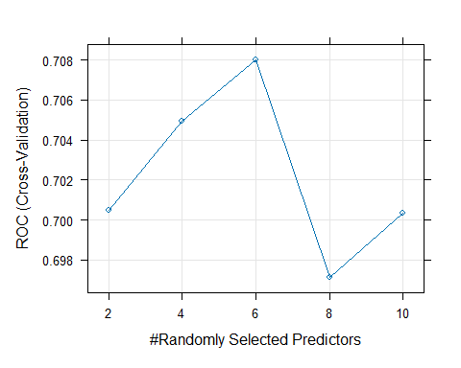

# Predizioni  
pred_rf <- predict(rf_model_tuned, newdata = test_data)  
probs_rf <- predict(rf_model_tuned, newdata = test_data, type = "prob")  
  
# Confusion matrix  
confusionMatrix(pred_rf, test_data$Death)

## Confusion Matrix and Statistics  
##   
## Reference  
## Prediction No Yes  
## No 78 34  
## Yes 33 38  
##   
## Accuracy : 0.6339   
## 95% CI : (0.5596, 0.7037)  
## No Information Rate : 0.6066   
## P-Value [Acc > NIR] : 0.2489   
##   
## Kappa : 0.231   
##   
## Mcnemar's Test P-Value : 1.0000   
##   
## Sensitivity : 0.7027   
## Specificity : 0.5278   
## Pos Pred Value : 0.6964   
## Neg Pred Value : 0.5352   
## Prevalence : 0.6066   
## Detection Rate : 0.4262   
## Detection Prevalence : 0.6120   
## Balanced Accuracy : 0.6152   
##   
## 'Positive' Class : No   
##

# AUC  
library(pROC)  
roc_obj <- roc(test_data$Death, probs_rf[,"Yes"])

## Setting levels: control = No, case = Yes

## Setting direction: controls < cases

auc(roc_obj)

## Area under the curve: 0.6714

varImp(rf_model_tuned)

## rf variable importance  
##   
## only 20 most important variables shown (out of 29)  
##   
## Overall  
## IntervalOD 100.000  
## IntervalOR 92.153  
## id 88.664  
## LogCEA 87.326  
## Age 73.749  
## Log2AT 65.815  
## RBC 21.316  
## Progress_event 13.317  
## AJCC_bin1 12.996  
## Progress 10.728  
## ASA31 10.635  
## Gender2 10.185  
## Liver_Only 9.065  
## Lymphovascularinvasion 8.709  
## DM 8.620  
## TumorLOC1 8.598  
## perineural 7.625  
## NACTRT 6.439  
## CKD 6.406  
## RT 6.024

## XGBoost

train_data$Death <- factor(train_data$Death, levels = c("No", "Yes"))  
test_data$Death <- factor(test_data$Death, levels = c("No", "Yes"))

set.seed(123)  
  
xgb_grid <- expand.grid(  
 nrounds = c(100, 200),  
 max_depth = c(3, 6),  
 eta = c(0.01, 0.1, 0.3),  
 gamma = 0,  
 colsample_bytree = 1,  
 min_child_weight = 1,  
 subsample = 1  
)  
  
xgb_model <- train(  
 Death ~ .,  
 data = train_data,  
 method = "xgbTree",  
 trControl = trainControl(  
 method = "cv",  
 number = 5,  
 classProbs = TRUE,  
 summaryFunction = twoClassSummary,  
 verboseIter = TRUE  
 ),  
 metric = "ROC",  
 tuneGrid = xgb_grid  
)

## + Fold1: eta=0.01, max_depth=3, gamma=0, colsample_bytree=1, min_child_weight=1, subsample=1, nrounds=200   
## [21:16:12] WARNING: src/c_api/c_api.cc:935: `ntree_limit` is deprecated, use `iteration_range` instead.  
## [21:16:12] WARNING: src/c_api/c_api.cc:935: `ntree_limit` is deprecated, use `iteration_range` instead.  
## - Fold1: eta=0.01, max_depth=3, gamma=0, colsample_bytree=1, min_child_weight=1, subsample=1, nrounds=200   
## + Fold1: eta=0.01, max_depth=6, gamma=0, colsample_bytree=1, min_child_weight=1, subsample=1, nrounds=200   
## [21:16:14] WARNING: src/c_api/c_api.cc:935: `ntree_limit` is deprecated, use `iteration_range` instead.  
## [21:16:14] WARNING: src/c_api/c_api.cc:935: `ntree_limit` is deprecated, use `iteration_range` instead.  
## - Fold1: eta=0.01, max_depth=6, gamma=0, colsample_bytree=1, min_child_weight=1, subsample=1, nrounds=200   
## + Fold1: eta=0.10, max_depth=3, gamma=0, colsample_bytree=1, min_child_weight=1, subsample=1, nrounds=200   
## [21:16:15] WARNING: src/c_api/c_api.cc:935: `ntree_limit` is deprecated, use `iteration_range` instead.  
## [21:16:15] WARNING: src/c_api/c_api.cc:935: `ntree_limit` is deprecated, use `iteration_range` instead.  
## - Fold1: eta=0.10, max_depth=3, gamma=0, colsample_bytree=1, min_child_weight=1, subsample=1, nrounds=200   
## + Fold1: eta=0.10, max_depth=6, gamma=0, colsample_bytree=1, min_child_weight=1, subsample=1, nrounds=200   
## [21:16:16] WARNING: src/c_api/c_api.cc:935: `ntree_limit` is deprecated, use `iteration_range` instead.  
## [21:16:16] WARNING: src/c_api/c_api.cc:935: `ntree_limit` is deprecated, use `iteration_range` instead.  
## - Fold1: eta=0.10, max_depth=6, gamma=0, colsample_bytree=1, min_child_weight=1, subsample=1, nrounds=200   
## + Fold1: eta=0.30, max_depth=3, gamma=0, colsample_bytree=1, min_child_weight=1, subsample=1, nrounds=200   
## [21:16:17] WARNING: src/c_api/c_api.cc:935: `ntree_limit` is deprecated, use `iteration_range` instead.  
## [21:16:17] WARNING: src/c_api/c_api.cc:935: `ntree_limit` is deprecated, use `iteration_range` instead.  
## - Fold1: eta=0.30, max_depth=3, gamma=0, colsample_bytree=1, min_child_weight=1, subsample=1, nrounds=200   
## + Fold1: eta=0.30, max_depth=6, gamma=0, colsample_bytree=1, min_child_weight=1, subsample=1, nrounds=200   
## [21:16:19] WARNING: src/c_api/c_api.cc:935: `ntree_limit` is deprecated, use `iteration_range` instead.  
## [21:16:19] WARNING: src/c_api/c_api.cc:935: `ntree_limit` is deprecated, use `iteration_range` instead.  
## - Fold1: eta=0.30, max_depth=6, gamma=0, colsample_bytree=1, min_child_weight=1, subsample=1, nrounds=200   
## + Fold2: eta=0.01, max_depth=3, gamma=0, colsample_bytree=1, min_child_weight=1, subsample=1, nrounds=200   
## [21:16:20] WARNING: src/c_api/c_api.cc:935: `ntree_limit` is deprecated, use `iteration_range` instead.  
## [21:16:20] WARNING: src/c_api/c_api.cc:935: `ntree_limit` is deprecated, use `iteration_range` instead.  
## - Fold2: eta=0.01, max_depth=3, gamma=0, colsample_bytree=1, min_child_weight=1, subsample=1, nrounds=200   
## + Fold2: eta=0.01, max_depth=6, gamma=0, colsample_bytree=1, min_child_weight=1, subsample=1, nrounds=200   
## [21:16:22] WARNING: src/c_api/c_api.cc:935: `ntree_limit` is deprecated, use `iteration_range` instead.  
## [21:16:22] WARNING: src/c_api/c_api.cc:935: `ntree_limit` is deprecated, use `iteration_range` instead.  
## - Fold2: eta=0.01, max_depth=6, gamma=0, colsample_bytree=1, min_child_weight=1, subsample=1, nrounds=200   
## + Fold2: eta=0.10, max_depth=3, gamma=0, colsample_bytree=1, min_child_weight=1, subsample=1, nrounds=200   
## [21:16:23] WARNING: src/c_api/c_api.cc:935: `ntree_limit` is deprecated, use `iteration_range` instead.  
## [21:16:23] WARNING: src/c_api/c_api.cc:935: `ntree_limit` is deprecated, use `iteration_range` instead.  
## - Fold2: eta=0.10, max_depth=3, gamma=0, colsample_bytree=1, min_child_weight=1, subsample=1, nrounds=200   
## + Fold2: eta=0.10, max_depth=6, gamma=0, colsample_bytree=1, min_child_weight=1, subsample=1, nrounds=200   
## [21:16:24] WARNING: src/c_api/c_api.cc:935: `ntree_limit` is deprecated, use `iteration_range` instead.  
## [21:16:24] WARNING: src/c_api/c_api.cc:935: `ntree_limit` is deprecated, use `iteration_range` instead.  
## - Fold2: eta=0.10, max_depth=6, gamma=0, colsample_bytree=1, min_child_weight=1, subsample=1, nrounds=200   
## + Fold2: eta=0.30, max_depth=3, gamma=0, colsample_bytree=1, min_child_weight=1, subsample=1, nrounds=200   
## [21:16:25] WARNING: src/c_api/c_api.cc:935: `ntree_limit` is deprecated, use `iteration_range` instead.  
## [21:16:25] WARNING: src/c_api/c_api.cc:935: `ntree_limit` is deprecated, use `iteration_range` instead.  
## - Fold2: eta=0.30, max_depth=3, gamma=0, colsample_bytree=1, min_child_weight=1, subsample=1, nrounds=200   
## + Fold2: eta=0.30, max_depth=6, gamma=0, colsample_bytree=1, min_child_weight=1, subsample=1, nrounds=200   
## [21:16:27] WARNING: src/c_api/c_api.cc:935: `ntree_limit` is deprecated, use `iteration_range` instead.  
## [21:16:27] WARNING: src/c_api/c_api.cc:935: `ntree_limit` is deprecated, use `iteration_range` instead.  
## - Fold2: eta=0.30, max_depth=6, gamma=0, colsample_bytree=1, min_child_weight=1, subsample=1, nrounds=200   
## + Fold3: eta=0.01, max_depth=3, gamma=0, colsample_bytree=1, min_child_weight=1, subsample=1, nrounds=200   
## [21:16:28] WARNING: src/c_api/c_api.cc:935: `ntree_limit` is deprecated, use `iteration_range` instead.  
## [21:16:28] WARNING: src/c_api/c_api.cc:935: `ntree_limit` is deprecated, use `iteration_range` instead.  
## - Fold3: eta=0.01, max_depth=3, gamma=0, colsample_bytree=1, min_child_weight=1, subsample=1, nrounds=200   
## + Fold3: eta=0.01, max_depth=6, gamma=0, colsample_bytree=1, min_child_weight=1, subsample=1, nrounds=200   
## [21:16:29] WARNING: src/c_api/c_api.cc:935: `ntree_limit` is deprecated, use `iteration_range` instead.  
## [21:16:29] WARNING: src/c_api/c_api.cc:935: `ntree_limit` is deprecated, use `iteration_range` instead.  
## - Fold3: eta=0.01, max_depth=6, gamma=0, colsample_bytree=1, min_child_weight=1, subsample=1, nrounds=200   
## + Fold3: eta=0.10, max_depth=3, gamma=0, colsample_bytree=1, min_child_weight=1, subsample=1, nrounds=200   
## [21:16:30] WARNING: src/c_api/c_api.cc:935: `ntree_limit` is deprecated, use `iteration_range` instead.  
## [21:16:30] WARNING: src/c_api/c_api.cc:935: `ntree_limit` is deprecated, use `iteration_range` instead.  
## - Fold3: eta=0.10, max_depth=3, gamma=0, colsample_bytree=1, min_child_weight=1, subsample=1, nrounds=200   
## + Fold3: eta=0.10, max_depth=6, gamma=0, colsample_bytree=1, min_child_weight=1, subsample=1, nrounds=200   
## [21:16:32] WARNING: src/c_api/c_api.cc:935: `ntree_limit` is deprecated, use `iteration_range` instead.  
## [21:16:32] WARNING: src/c_api/c_api.cc:935: `ntree_limit` is deprecated, use `iteration_range` instead.  
## - Fold3: eta=0.10, max_depth=6, gamma=0, colsample_bytree=1, min_child_weight=1, subsample=1, nrounds=200   
## + Fold3: eta=0.30, max_depth=3, gamma=0, colsample_bytree=1, min_child_weight=1, subsample=1, nrounds=200   
## [21:16:33] WARNING: src/c_api/c_api.cc:935: `ntree_limit` is deprecated, use `iteration_range` instead.  
## [21:16:33] WARNING: src/c_api/c_api.cc:935: `ntree_limit` is deprecated, use `iteration_range` instead.  
## - Fold3: eta=0.30, max_depth=3, gamma=0, colsample_bytree=1, min_child_weight=1, subsample=1, nrounds=200   
## + Fold3: eta=0.30, max_depth=6, gamma=0, colsample_bytree=1, min_child_weight=1, subsample=1, nrounds=200   
## [21:16:35] WARNING: src/c_api/c_api.cc:935: `ntree_limit` is deprecated, use `iteration_range` instead.  
## [21:16:35] WARNING: src/c_api/c_api.cc:935: `ntree_limit` is deprecated, use `iteration_range` instead.  
## - Fold3: eta=0.30, max_depth=6, gamma=0, colsample_bytree=1, min_child_weight=1, subsample=1, nrounds=200   
## + Fold4: eta=0.01, max_depth=3, gamma=0, colsample_bytree=1, min_child_weight=1, subsample=1, nrounds=200   
## [21:16:36] WARNING: src/c_api/c_api.cc:935: `ntree_limit` is deprecated, use `iteration_range` instead.  
## [21:16:36] WARNING: src/c_api/c_api.cc:935: `ntree_limit` is deprecated, use `iteration_range` instead.  
## - Fold4: eta=0.01, max_depth=3, gamma=0, colsample_bytree=1, min_child_weight=1, subsample=1, nrounds=200   
## + Fold4: eta=0.01, max_depth=6, gamma=0, colsample_bytree=1, min_child_weight=1, subsample=1, nrounds=200   
## [21:16:37] WARNING: src/c_api/c_api.cc:935: `ntree_limit` is deprecated, use `iteration_range` instead.  
## [21:16:37] WARNING: src/c_api/c_api.cc:935: `ntree_limit` is deprecated, use `iteration_range` instead.  
## - Fold4: eta=0.01, max_depth=6, gamma=0, colsample_bytree=1, min_child_weight=1, subsample=1, nrounds=200   
## + Fold4: eta=0.10, max_depth=3, gamma=0, colsample_bytree=1, min_child_weight=1, subsample=1, nrounds=200   
## [21:16:37] WARNING: src/c_api/c_api.cc:935: `ntree_limit` is deprecated, use `iteration_range` instead.  
## [21:16:38] WARNING: src/c_api/c_api.cc:935: `ntree_limit` is deprecated, use `iteration_range` instead.  
## - Fold4: eta=0.10, max_depth=3, gamma=0, colsample_bytree=1, min_child_weight=1, subsample=1, nrounds=200   
## + Fold4: eta=0.10, max_depth=6, gamma=0, colsample_bytree=1, min_child_weight=1, subsample=1, nrounds=200   
## [21:16:39] WARNING: src/c_api/c_api.cc:935: `ntree_limit` is deprecated, use `iteration_range` instead.  
## [21:16:39] WARNING: src/c_api/c_api.cc:935: `ntree_limit` is deprecated, use `iteration_range` instead.  
## - Fold4: eta=0.10, max_depth=6, gamma=0, colsample_bytree=1, min_child_weight=1, subsample=1, nrounds=200   
## + Fold4: eta=0.30, max_depth=3, gamma=0, colsample_bytree=1, min_child_weight=1, subsample=1, nrounds=200   
## [21:16:39] WARNING: src/c_api/c_api.cc:935: `ntree_limit` is deprecated, use `iteration_range` instead.  
## [21:16:39] WARNING: src/c_api/c_api.cc:935: `ntree_limit` is deprecated, use `iteration_range` instead.  
## - Fold4: eta=0.30, max_depth=3, gamma=0, colsample_bytree=1, min_child_weight=1, subsample=1, nrounds=200   
## + Fold4: eta=0.30, max_depth=6, gamma=0, colsample_bytree=1, min_child_weight=1, subsample=1, nrounds=200   
## [21:16:40] WARNING: src/c_api/c_api.cc:935: `ntree_limit` is deprecated, use `iteration_range` instead.  
## [21:16:40] WARNING: src/c_api/c_api.cc:935: `ntree_limit` is deprecated, use `iteration_range` instead.  
## - Fold4: eta=0.30, max_depth=6, gamma=0, colsample_bytree=1, min_child_weight=1, subsample=1, nrounds=200   
## + Fold5: eta=0.01, max_depth=3, gamma=0, colsample_bytree=1, min_child_weight=1, subsample=1, nrounds=200   
## [21:16:41] WARNING: src/c_api/c_api.cc:935: `ntree_limit` is deprecated, use `iteration_range` instead.  
## [21:16:41] WARNING: src/c_api/c_api.cc:935: `ntree_limit` is deprecated, use `iteration_range` instead.  
## - Fold5: eta=0.01, max_depth=3, gamma=0, colsample_bytree=1, min_child_weight=1, subsample=1, nrounds=200   
## + Fold5: eta=0.01, max_depth=6, gamma=0, colsample_bytree=1, min_child_weight=1, subsample=1, nrounds=200   
## [21:16:42] WARNING: src/c_api/c_api.cc:935: `ntree_limit` is deprecated, use `iteration_range` instead.  
## [21:16:42] WARNING: src/c_api/c_api.cc:935: `ntree_limit` is deprecated, use `iteration_range` instead.  
## - Fold5: eta=0.01, max_depth=6, gamma=0, colsample_bytree=1, min_child_weight=1, subsample=1, nrounds=200   
## + Fold5: eta=0.10, max_depth=3, gamma=0, colsample_bytree=1, min_child_weight=1, subsample=1, nrounds=200   
## [21:16:43] WARNING: src/c_api/c_api.cc:935: `ntree_limit` is deprecated, use `iteration_range` instead.  
## [21:16:43] WARNING: src/c_api/c_api.cc:935: `ntree_limit` is deprecated, use `iteration_range` instead.  
## - Fold5: eta=0.10, max_depth=3, gamma=0, colsample_bytree=1, min_child_weight=1, subsample=1, nrounds=200   
## + Fold5: eta=0.10, max_depth=6, gamma=0, colsample_bytree=1, min_child_weight=1, subsample=1, nrounds=200   
## [21:16:44] WARNING: src/c_api/c_api.cc:935: `ntree_limit` is deprecated, use `iteration_range` instead.  
## [21:16:44] WARNING: src/c_api/c_api.cc:935: `ntree_limit` is deprecated, use `iteration_range` instead.  
## - Fold5: eta=0.10, max_depth=6, gamma=0, colsample_bytree=1, min_child_weight=1, subsample=1, nrounds=200   
## + Fold5: eta=0.30, max_depth=3, gamma=0, colsample_bytree=1, min_child_weight=1, subsample=1, nrounds=200   
## [21:16:44] WARNING: src/c_api/c_api.cc:935: `ntree_limit` is deprecated, use `iteration_range` instead.  
## [21:16:44] WARNING: src/c_api/c_api.cc:935: `ntree_limit` is deprecated, use `iteration_range` instead.  
## - Fold5: eta=0.30, max_depth=3, gamma=0, colsample_bytree=1, min_child_weight=1, subsample=1, nrounds=200   
## + Fold5: eta=0.30, max_depth=6, gamma=0, colsample_bytree=1, min_child_weight=1, subsample=1, nrounds=200   
## [21:16:45] WARNING: src/c_api/c_api.cc:935: `ntree_limit` is deprecated, use `iteration_range` instead.  
## [21:16:45] WARNING: src/c_api/c_api.cc:935: `ntree_limit` is deprecated, use `iteration_range` instead.  
## - Fold5: eta=0.30, max_depth=6, gamma=0, colsample_bytree=1, min_child_weight=1, subsample=1, nrounds=200   
## Aggregating results  
## Selecting tuning parameters  
## Fitting nrounds = 200, max_depth = 6, eta = 0.01, gamma = 0, colsample_bytree = 1, min_child_weight = 1, subsample = 1 on full training set

# Predizioni  
pred_xgb <- predict(xgb_model, newdata = test_data)  
probs_xgb <- predict(xgb_model, newdata = test_data, type = "prob")  
  
# Confusion matrix  
confusionMatrix(pred_xgb, test_data$Death)

## Confusion Matrix and Statistics  
##   
## Reference  
## Prediction No Yes  
## No 75 32  
## Yes 36 40  
##   
## Accuracy : 0.6284   
## 95% CI : (0.554, 0.6986)  
## No Information Rate : 0.6066   
## P-Value [Acc > NIR] : 0.2996   
##   
## Kappa : 0.229   
##   
## Mcnemar's Test P-Value : 0.7160   
##   
## Sensitivity : 0.6757   
## Specificity : 0.5556   
## Pos Pred Value : 0.7009   
## Neg Pred Value : 0.5263   
## Prevalence : 0.6066   
## Detection Rate : 0.4098   
## Detection Prevalence : 0.5847   
## Balanced Accuracy : 0.6156   
##   
## 'Positive' Class : No   
##

# AUC  
library(pROC)  
roc_xgb <- roc(test_data$Death, probs_xgb[,"Yes"])

## Setting levels: control = No, case = Yes

## Setting direction: controls < cases

auc(roc_xgb)

## Area under the curve: 0.6607

## SVM - radial kernel

# Carica la libreria per SVM  
library(e1071)

## Warning: package 'e1071' was built under R version 4.3.3

##   
## Attaching package: 'e1071'

## The following object is masked from 'package:Hmisc':  
##   
## impute

# SVM Model  
svm_model <- svm(Death ~ ., data = train_data, kernel = "radial", probability = TRUE)  
  
# Predizioni per SVM  
pred_svm <- predict(svm_model, newdata = test_data, probability = TRUE)  
probs_svm <- attr(pred_svm, "probabilities")  
  
# SVM Metrics  
confusionMatrix(pred_svm, test_data$Death)

## Confusion Matrix and Statistics  
##   
## Reference  
## Prediction No Yes  
## No 80 45  
## Yes 31 27  
##   
## Accuracy : 0.5847   
## 95% CI : (0.5097, 0.6569)  
## No Information Rate : 0.6066   
## P-Value [Acc > NIR] : 0.7529   
##   
## Kappa : 0.0991   
##   
## Mcnemar's Test P-Value : 0.1359   
##   
## Sensitivity : 0.7207   
## Specificity : 0.3750   
## Pos Pred Value : 0.6400   
## Neg Pred Value : 0.4655   
## Prevalence : 0.6066   
## Detection Rate : 0.4372   
## Detection Prevalence : 0.6831   
## Balanced Accuracy : 0.5479   
##   
## 'Positive' Class : No   
##

roc(test_data$Death, probs_svm[, "Yes"])

## Setting levels: control = No, case = Yes

## Setting direction: controls < cases

##   
## Call:  
## roc.default(response = test_data$Death, predictor = probs_svm[, "Yes"])  
##   
## Data: probs_svm[, "Yes"] in 111 controls (test_data$Death No) < 72 cases (test_data$Death Yes).  
## Area under the curve: 0.6084

## KNN

# Carica la libreria per KNN  
library(caret)  
  
# KNN Model  
knn_model <- train(Death ~ ., data = train_data, method = "knn",   
 trControl = trainControl(method = "none"), tuneGrid = expand.grid(k = 5))  
  
# Predizioni per KNN  
pred_knn <- predict(knn_model, newdata = test_data)  
probs_knn <- predict(knn_model, newdata = test_data, type = "prob")  
  
# KNN Metrics  
confusionMatrix(pred_knn, test_data$Death)

## Confusion Matrix and Statistics  
##   
## Reference  
## Prediction No Yes  
## No 69 26  
## Yes 42 46  
##   
## Accuracy : 0.6284   
## 95% CI : (0.554, 0.6986)  
## No Information Rate : 0.6066   
## P-Value [Acc > NIR] : 0.29960   
##   
## Kappa : 0.2507   
##   
## Mcnemar's Test P-Value : 0.06891   
##   
## Sensitivity : 0.6216   
## Specificity : 0.6389   
## Pos Pred Value : 0.7263   
## Neg Pred Value : 0.5227   
## Prevalence : 0.6066   
## Detection Rate : 0.3770   
## Detection Prevalence : 0.5191   
## Balanced Accuracy : 0.6303   
##   
## 'Positive' Class : No   
##

roc(test_data$Death, probs_knn[, "Yes"])

## Setting levels: control = No, case = Yes

## Setting direction: controls < cases

##   
## Call:  
## roc.default(response = test_data$Death, predictor = probs_knn[, "Yes"])  
##   
## Data: probs_knn[, "Yes"] in 111 controls (test_data$Death No) < 72 cases (test_data$Death Yes).  
## Area under the curve: 0.6532

# Carica la libreria per KNN  
library(caret)  
  
# KNN Model  
knn_model <- train(Death ~ ., data = train_data, method = "knn",   
 trControl = trainControl(method = "none"), tuneGrid = expand.grid(k = 15))  
  
# Predizioni per KNN  
pred_knn <- predict(knn_model, newdata = test_data)  
probs_knn <- predict(knn_model, newdata = test_data, type = "prob")  
  
# KNN Metrics  
confusionMatrix(pred_knn, test_data$Death)

## Confusion Matrix and Statistics  
##   
## Reference  
## Prediction No Yes  
## No 69 30  
## Yes 42 42  
##   
## Accuracy : 0.6066   
## 95% CI : (0.5318, 0.6778)  
## No Information Rate : 0.6066   
## P-Value [Acc > NIR] : 0.5323   
##   
## Kappa : 0.1991   
##   
## Mcnemar's Test P-Value : 0.1949   
##   
## Sensitivity : 0.6216   
## Specificity : 0.5833   
## Pos Pred Value : 0.6970   
## Neg Pred Value : 0.5000   
## Prevalence : 0.6066   
## Detection Rate : 0.3770   
## Detection Prevalence : 0.5410   
## Balanced Accuracy : 0.6025   
##   
## 'Positive' Class : No   
##

roc(test_data$Death, probs_knn[, "Yes"])

## Setting levels: control = No, case = Yes

## Setting direction: controls < cases

##   
## Call:  
## roc.default(response = test_data$Death, predictor = probs_knn[, "Yes"])  
##   
## Data: probs_knn[, "Yes"] in 111 controls (test_data$Death No) < 72 cases (test_data$Death Yes).  
## Area under the curve: 0.6554

# Supervised learning CON BILANCIAMENTO

Logistic Regression

Random Forest

XGBoost

SVM

K-NN

## DIVISIONE TRAIN/TEST

# Controlla i livelli del target "Death"  
table(data$Death)

##   
## 0 1   
## 530 386

# Controlla il bilanciamento  
prop.table(table(y))

## y  
## ( 0.0000000, 0.03285421] ( 0.0000000, 0.13141684]   
## 0.0006157635 0.0006157635   
## ( 0.0000000, 0.13141684+] ( 0.0000000, 0.16427105+]   
## 0.0006157635 0.0006157635   
## ( 0.0000000, 0.22997947] ( 0.0000000, 0.22997947+]   
## 0.0006157635 0.0012315271   
## ( 0.0000000, 0.26283368] ( 0.0000000, 0.26283368+]   
## 0.0006157635 0.0018472906   
## ( 0.0000000, 0.29568789] ( 0.0000000, 0.29568789+]   
## 0.0006157635 0.0018472906   
## ( 0.0000000, 0.32854209+] ( 0.0000000, 0.39425051+]   
## 0.0018472906 0.0006157635   
## ( 0.0000000, 0.42710472+] ( 0.3942505, 0.49281314]   
## 0.0006157635 0.0006157635   
## ( 0.0000000, 0.49281314+] ( 0.0000000, 0.52566735+]   
## 0.0012315271 0.0018472906   
## ( 0.0000000, 0.55852156] ( 0.0000000, 0.55852156+]   
## 0.0006157635 0.0018472906   
## ( 0.0000000, 0.62422998+] ( 0.0000000, 0.65708419]   
## 0.0006157635 0.0006157635   
## ( 0.5256674, 0.65708419] ( 0.0000000, 0.65708419+]   
## 0.0006157635 0.0012315271   
## ( 0.0000000, 0.68993840] ( 0.0000000, 0.68993840+]   
## 0.0006157635 0.0024630542   
## ( 0.0000000, 0.72279261] ( 0.0000000, 0.72279261+]   
## 0.0006157635 0.0024630542   
## ( 0.0000000, 0.75564682] ( 0.0000000, 0.75564682+]   
## 0.0006157635 0.0043103448   
## ( 0.0000000, 0.78850103+] ( 0.0000000, 0.82135524+]   
## 0.0030788177 0.0024630542   
## ( 0.0000000, 0.88706366+] ( 0.0000000, 0.91991786]   
## 0.0024630542 0.0006157635   
## ( 0.0000000, 0.91991786+] ( 0.0000000, 0.95277207+]   
## 0.0024630542 0.0030788177   
## ( 0.0000000, 0.98562628] ( 0.0000000, 0.98562628+]   
## 0.0006157635 0.0036945813   
## ( 0.0000000, 1.01848049+] ( 0.0000000, 1.05133470+]   
## 0.0024630542 0.0006157635   
## ( 0.0000000, 1.08418891+] ( 0.0000000, 1.11704312]   
## 0.0024630542 0.0006157635   
## ( 0.0000000, 1.11704312+] ( 0.9199179, 1.14989733]   
## 0.0024630542 0.0006157635   
## ( 0.0000000, 1.14989733+] ( 0.0000000, 1.18275154+]   
## 0.0043103448 0.0024630542   
## ( 0.7227926, 1.21560575] ( 0.0000000, 1.24845996+]   
## 0.0006157635 0.0018472906   
## ( 0.0000000, 1.28131417] ( 0.0000000, 1.31416838]   
## 0.0006157635 0.0006157635   
## ( 0.0000000, 1.31416838+] ( 0.0000000, 1.34702259+]   
## 0.0006157635 0.0024630542   
## ( 0.0000000, 1.37987680+] ( 0.0000000, 1.41273101+]   
## 0.0018472906 0.0012315271   
## ( 0.0000000, 1.44558522+] ( 0.0000000, 1.51129363+]   
## 0.0012315271 0.0012315271   
## ( 0.0000000, 1.57700205] ( 0.0000000, 1.57700205+]   
## 0.0012315271 0.0012315271   
## ( 0.0000000, 1.60985626+] ( 0.0000000, 1.64271047]   
## 0.0006157635 0.0006157635   
## ( 0.0000000, 1.64271047+] ( 0.0000000, 1.67556468]   
## 0.0018472906 0.0006157635   
## ( 0.0000000, 1.67556468+] ( 0.7885010, 1.70841889]   
## 0.0006157635 0.0006157635   
## ( 1.1170431, 1.70841889] ( 0.0000000, 1.70841889+]   
## 0.0006157635 0.0018472906   
## ( 0.0000000, 1.74127310] ( 0.0000000, 1.74127310+]   
## 0.0012315271 0.0006157635   
## ( 0.8213552, 1.77412731] ( 0.0000000, 1.77412731+]   
## 0.0006157635 0.0006157635   
## ( 0.0000000, 1.80698152+] ( 0.0000000, 1.83983573+]   
## 0.0006157635 0.0006157635   
## ( 0.0000000, 1.87268994+] ( 0.0000000, 1.90554415]   
## 0.0006157635 0.0006157635   
## ( 1.6755647, 1.90554415] ( 0.0000000, 1.93839836+]   
## 0.0006157635 0.0006157635   
## ( 0.6899384, 1.93839836+] ( 0.0000000, 1.97125257+]   
## 0.0006157635 0.0012315271   
## ( 0.0000000, 2.03696099+] ( 0.0000000, 2.06981520]   
## 0.0018472906 0.0006157635   
## ( 0.0000000, 2.06981520+] ( 0.0000000, 2.10266940]   
## 0.0006157635 0.0006157635   
## ( 0.0000000, 2.10266940+] ( 0.0000000, 2.16837782+]   
## 0.0036945813 0.0012315271   
## ( 1.3470226, 2.16837782+] ( 0.0000000, 2.20123203+]   
## 0.0006157635 0.0012315271   
## ( 0.0000000, 2.23408624] ( 0.0000000, 2.23408624+]   
## 0.0006157635 0.0012315271   
## ( 0.0000000, 2.26694045+] ( 0.0000000, 2.29979466+]   
## 0.0012315271 0.0006157635   
## ( 0.0000000, 2.33264887+] ( 1.0184805, 2.33264887+]   
## 0.0024630542 0.0006157635   
## ( 0.0000000, 2.36550308+] ( 0.0000000, 2.39835729+]   
## 0.0024630542 0.0006157635   
## ( 0.0000000, 2.43121150+] ( 0.0000000, 2.46406571+]   
## 0.0024630542 0.0006157635   
## ( 0.0000000, 2.49691992+] ( 2.2012320, 2.52977413]   
## 0.0006157635 0.0006157635   
## ( 0.0000000, 2.52977413+] ( 1.7741273, 2.59548255]   
## 0.0012315271 0.0006157635   
## ( 0.0000000, 2.59548255+] ( 0.0000000, 2.62833676+]   
## 0.0012315271 0.0006157635   
## ( 0.0000000, 2.66119097+] ( 0.0000000, 2.69404517+]   
## 0.0006157635 0.0006157635   
## ( 0.0000000, 2.72689938+] ( 2.4969199, 2.75975359]   
## 0.0018472906 0.0006157635   
## ( 0.0000000, 2.75975359+] ( 0.0000000, 2.79260780+]   
## 0.0018472906 0.0030788177   
## ( 2.5297741, 2.79260780+] ( 0.0000000, 2.82546201+]   
## 0.0006157635 0.0036945813   
## ( 0.0000000, 2.85831622+] ( 0.0000000, 2.89117043]   
## 0.0018472906 0.0006157635   
## ( 0.0000000, 2.89117043+] ( 0.0000000, 2.92402464+]   
## 0.0012315271 0.0012315271   
## ( 2.0369610, 2.95687885] ( 0.0000000, 2.95687885+]   
## 0.0006157635 0.0018472906   
## ( 0.0000000, 2.98973306+] ( 0.0000000, 3.02258727]   
## 0.0006157635 0.0006157635   
## ( 0.0000000, 3.02258727+] ( 0.0000000, 3.05544148+]   
## 0.0043103448 0.0024630542   
## ( 2.7597536, 3.05544148+] ( 0.0000000, 3.08829569]   
## 0.0006157635 0.0006157635   
## ( 0.0000000, 3.08829569+] ( 2.6611910, 3.12114990]   
## 0.0024630542 0.0006157635   
## ( 0.0000000, 3.12114990+] ( 2.1026694, 3.15400411]   
## 0.0006157635 0.0006157635   
## ( 0.0000000, 3.15400411+] ( 0.0000000, 3.18685832+]   
## 0.0018472906 0.0030788177   
## ( 0.0000000, 3.21971253+] ( 0.0000000, 3.25256674+]   
## 0.0036945813 0.0018472906   
## ( 0.0000000, 3.28542094+] ( 0.0000000, 3.31827515+]   
## 0.0024630542 0.0024630542   
## ( 1.2484600, 3.31827515+] ( 3.0554415, 3.35112936]   
## 0.0006157635 0.0006157635   
## ( 0.0000000, 3.35112936+] ( 0.0000000, 3.38398357+]   
## 0.0024630542 0.0018472906   
## ( 0.0000000, 3.41683778+] ( 2.8583162, 3.44969199]   
## 0.0012315271 0.0006157635   
## ( 0.0000000, 3.44969199+] ( 0.0000000, 3.48254620+]   
## 0.0012315271 0.0030788177   
## ( 0.0000000, 3.51540041+] ( 0.2956879, 3.54825462]   
## 0.0012315271 0.0006157635   
## ( 0.0000000, 3.54825462+] ( 3.0882957, 3.58110883]   
## 0.0036945813 0.0006157635   
## ( 0.0000000, 3.58110883+] ( 0.0000000, 3.61396304+]   
## 0.0018472906 0.0018472906   
## ( 0.0000000, 3.64681725+] ( 0.0000000, 3.67967146+]   
## 0.0024630542 0.0036945813   
## ( 0.0000000, 3.71252567+] ( 0.0000000, 3.74537988]   
## 0.0036945813 0.0006157635   
## ( 0.0000000, 3.74537988+] ( 0.0000000, 3.77823409+]   
## 0.0018472906 0.0012315271   
## ( 1.7084189, 3.77823409+] ( 3.1868583, 3.81108830]   
## 0.0006157635 0.0006157635   
## ( 0.0000000, 3.81108830+] ( 0.9527721, 3.81108830+]   
## 0.0012315271 0.0006157635   
## ( 0.0000000, 3.84394251+] ( 0.0000000, 3.87679671+]   
## 0.0024630542 0.0030788177   
## ( 0.0000000, 3.90965092+] ( 0.0000000, 3.94250513+]   
## 0.0024630542 0.0012315271   
## ( 3.8110883, 3.94250513+] ( 0.0000000, 3.97535934+]   
## 0.0006157635 0.0012315271   
## ( 0.3285421, 4.00821355] ( 0.0000000, 4.00821355+]   
## 0.0006157635 0.0012315271   
## ( 2.8254620, 4.04106776] ( 0.0000000, 4.04106776+]   
## 0.0006157635 0.0006157635   
## ( 3.0882957, 4.04106776+] ( 0.0000000, 4.07392197+]   
## 0.0006157635 0.0036945813   
## ( 0.0000000, 4.10677618+] ( 3.2525667, 4.13963039]   
## 0.0024630542 0.0006157635   
## ( 0.0000000, 4.13963039+] ( 0.0000000, 4.17248460]   
## 0.0012315271 0.0006157635   
## ( 2.7268994, 4.17248460] ( 0.0000000, 4.17248460+]   
## 0.0006157635 0.0036945813   
## ( 0.0000000, 4.20533881] ( 0.0000000, 4.20533881+]   
## 0.0006157635 0.0006157635   
## ( 0.0000000, 4.23819302+] ( 2.4312115, 4.23819302+]   
## 0.0030788177 0.0006157635   
## ( 3.8767967, 4.23819302+] ( 1.1498973, 4.27104723]   
## 0.0006157635 0.0006157635   
## ( 0.0000000, 4.27104723+] ( 2.7268994, 4.30390144]   
## 0.0006157635 0.0006157635   
## ( 0.0000000, 4.30390144+] ( 0.0000000, 4.33675565+]   
## 0.0018472906 0.0030788177   
## ( 0.0000000, 4.36960986+] ( 2.3655031, 4.36960986+]   
## 0.0012315271 0.0006157635   
## ( 4.1067762, 4.36960986+] ( 0.0000000, 4.40246407+]   
## 0.0006157635 0.0024630542   
## ( 0.0000000, 4.43531828+] ( 2.3326489, 4.43531828+]   
## 0.0030788177 0.0006157635   
## ( 0.0000000, 4.46817248+] ( 2.2340862, 4.46817248+]   
## 0.0018472906 0.0006157635   
## ( 0.0000000, 4.50102669+] ( 0.0000000, 4.56673511+]   
## 0.0012315271 0.0006157635   
## ( 2.9897331, 4.56673511+] ( 0.0000000, 4.59958932+]   
## 0.0006157635 0.0036945813   
## ( 0.0000000, 4.63244353] ( 0.0000000, 4.63244353+]   
## 0.0006157635 0.0018472906   
## ( 0.0000000, 4.66529774+] ( 0.0000000, 4.69815195+]   
## 0.0012315271 0.0018472906   
## ( 0.0000000, 4.73100616+] ( 2.7926078, 4.76386037]   
## 0.0018472906 0.0006157635   
## ( 0.0000000, 4.76386037+] ( 3.8439425, 4.76386037+]   
## 0.0006157635 0.0006157635   
## ( 3.4496920, 4.79671458] ( 0.0000000, 4.79671458+]   
## 0.0006157635 0.0012315271   
## ( 2.8911704, 4.79671458+] ( 0.0000000, 4.82956879+]   
## 0.0006157635 0.0006157635   
## ( 4.1724846, 4.86242300] ( 4.4353183, 4.86242300]   
## 0.0006157635 0.0006157635   
## ( 0.0000000, 4.86242300+] ( 0.0000000, 4.89527721+]   
## 0.0018472906 0.0006157635   
## ( 0.0000000, 4.92813142+] ( 0.0000000, 4.96098563]   
## 0.0006157635 0.0006157635   
## ( 0.0000000, 4.99383984] ( 0.2628337, 4.99383984]   
## 0.0006157635 0.0006157635   
## ( 3.0225873, 4.99383984+] ( 3.1540041, 4.99383984+]   
## 0.0006157635 0.0006157635   
## ( 3.5482546, 5.02669405+] ( 0.0000000, 5.05954825+]   
## 0.0006157635 0.0006157635   
## ( 4.2381930, 5.09240246] ( 4.7967146, 5.09240246]   
## 0.0006157635 0.0006157635   
## ( 0.0000000, 5.09240246+] ( 0.0000000, 5.15811088+]   
## 0.0012315271 0.0012315271   
## ( 4.4681725, 5.15811088+] ( 0.0000000, 5.19096509+]   
## 0.0006157635 0.0018472906   
## ( 0.0000000, 5.22381930+] ( 1.3470226, 5.32238193]   
## 0.0006157635 0.0006157635   
## ( 0.0000000, 5.32238193+] ( 3.5482546, 5.32238193+]   
## 0.0012315271 0.0006157635   
## ( 0.0000000, 5.35523614+] ( 3.2197125, 5.38809035+]   
## 0.0006157635 0.0006157635   
## ( 4.3367556, 5.38809035+] ( 0.0000000, 5.42094456+]   
## 0.0006157635 0.0012315271   
## ( 0.0000000, 5.45379877+] ( 0.0000000, 5.48665298]   
## 0.0012315271 0.0006157635   
## ( 0.0000000, 5.48665298+] ( 0.0000000, 5.51950719+]   
## 0.0012315271 0.0018472906   
## ( 0.0000000, 5.55236140+] ( 2.1026694, 5.55236140+]   
## 0.0006157635 0.0006157635   
## ( 4.1724846, 5.58521561] ( 0.0000000, 5.58521561+]   
## 0.0006157635 0.0006157635   
## ( 3.0554415, 5.61806982] ( 0.0000000, 5.61806982+]   
## 0.0006157635 0.0012315271   
## ( 0.0000000, 5.65092402+] ( 0.0000000, 5.68377823+]   
## 0.0006157635 0.0012315271   
## ( 3.2854209, 5.74948665] ( 0.0000000, 5.74948665+]   
## 0.0006157635 0.0006157635   
## ( 0.0000000, 5.78234086] ( 1.0841889, 5.78234086+]   
## 0.0006157635 0.0006157635   
## ( 0.0000000, 5.81519507+] ( 2.7597536, 5.81519507+]   
## 0.0006157635 0.0006157635   
## ( 0.0000000, 5.84804928+] ( 4.0739220, 5.84804928+]   
## 0.0024630542 0.0006157635   
## ( 0.0000000, 5.88090349+] ( 0.8870637, 5.91375770]   
## 0.0006157635 0.0006157635   
## ( 5.6180698, 5.94661191] ( 0.0000000, 5.94661191+]   
## 0.0006157635 0.0006157635   
## ( 2.0369610, 5.94661191+] ( 3.9425051, 6.01232033]   
## 0.0006157635 0.0006157635   
## ( 5.6509240, 6.01232033] ( 0.0000000, 6.01232033+]   
## 0.0006157635 0.0012315271   
## ( 0.0000000, 6.07802875+] ( 0.0000000, 6.11088296+]   
## 0.0012315271 0.0012315271   
## ( 2.9568789, 6.11088296+] ( 1.4127310, 6.14373717]   
## 0.0006157635 0.0006157635   
## ( 0.0000000, 6.14373717+] ( 2.7597536, 6.17659138]   
## 0.0006157635 0.0006157635   
## ( 3.7782341, 6.17659138] ( 0.0000000, 6.17659138+]   
## 0.0006157635 0.0024630542   
## ( 0.0000000, 6.20944559+] ( 3.6796715, 6.20944559+]   
## 0.0024630542 0.0006157635   
## ( 3.0882957, 6.24229979] ( 0.0000000, 6.24229979+]   
## 0.0006157635 0.0006157635   
## ( 0.0000000, 6.27515400+] ( 0.0000000, 6.37371663+]   
## 0.0006157635 0.0024630542   
## ( 2.4312115, 6.40657084] ( 0.0000000, 6.40657084+]   
## 0.0006157635 0.0012315271   
## ( 0.0000000, 6.43942505+] ( 0.5256674, 6.47227926]   
## 0.0012315271 0.0006157635   
## ( 0.0000000, 6.47227926+] ( 0.7227926, 6.47227926+]   
## 0.0006157635 0.0006157635   
## ( 0.0000000, 6.50513347+] ( 4.0082136, 6.50513347+]   
## 0.0006157635 0.0006157635   
## ( 2.3655031, 6.53798768] ( 0.0000000, 6.53798768+]   
## 0.0006157635 0.0012315271   
## ( 0.9199179, 6.53798768+] ( 0.0000000, 6.60369610+]   
## 0.0006157635 0.0006157635   
## ( 3.3839836, 6.60369610+] ( 6.2422998, 6.63655031]   
## 0.0006157635 0.0006157635   
## ( 0.0000000, 6.63655031+] ( 0.0000000, 6.66940452]   
## 0.0012315271 0.0006157635   
## ( 0.0000000, 6.66940452+] ( 4.4353183, 6.70225873]   
## 0.0006157635 0.0006157635   
## ( 0.0000000, 6.70225873+] ( 3.0225873, 6.70225873+]   
## 0.0006157635 0.0006157635   
## ( 2.6940452, 6.73511294] ( 0.0000000, 6.73511294+]   
## 0.0006157635 0.0012315271   
## ( 0.0000000, 6.80082136+] ( 0.0000000, 6.83367556+]   
## 0.0006157635 0.0006157635   
## ( 3.6468172, 6.83367556+] ( 6.6365503, 6.86652977]   
## 0.0006157635 0.0006157635   
## ( 0.0000000, 6.86652977+] ( 3.3511294, 6.86652977+]   
## 0.0018472906 0.0006157635   
## ( 0.0000000, 6.89938398+] ( 0.0000000, 6.93223819+]   
## 0.0012315271 0.0012315271   
## ( 0.0000000, 6.96509240+] ( 1.6427105, 6.96509240+]   
## 0.0018472906 0.0006157635   
## ( 3.7125257, 6.99794661] ( 0.0000000, 6.99794661+]   
## 0.0006157635 0.0006157635   
## ( 0.0000000, 7.03080082+] ( 4.6981520, 7.06365503]   
## 0.0012315271 0.0006157635   
## ( 0.0000000, 7.06365503+] ( 3.6139630, 7.06365503+]   
## 0.0006157635 0.0006157635   
## ( 1.9383984, 7.09650924] ( 0.0000000, 7.09650924+]   
## 0.0006157635 0.0006157635   
## ( 0.9856263, 7.09650924+] ( 4.6324435, 7.12936345]   
## 0.0006157635 0.0006157635   
## ( 6.5379877, 7.12936345] ( 0.0000000, 7.12936345+]   
## 0.0006157635 0.0012315271   
## ( 5.3223819, 7.12936345+] ( 3.8110883, 7.16221766]   
## 0.0006157635 0.0006157635   
## ( 0.0000000, 7.19507187+] ( 3.4168378, 7.22792608]   
## 0.0006157635 0.0006157635   
## ( 6.5051335, 7.22792608] ( 0.0000000, 7.26078029+]   
## 0.0006157635 0.0006157635   
## ( 2.1026694, 7.29363450] ( 0.0000000, 7.29363450+]   
## 0.0006157635 0.0006157635   
## ( 7.1293634, 7.29363450+] ( 0.0000000, 7.32648871+]   
## 0.0006157635 0.0006157635   
## ( 0.0000000, 7.35934292+] ( 7.2936345, 7.39219713]   
## 0.0006157635 0.0006157635   
## ( 0.0000000, 7.39219713+] ( 6.2094456, 7.42505133]   
## 0.0006157635 0.0006157635   
## ( 0.0000000, 7.42505133+] ( 0.0000000, 7.45790554+]   
## 0.0006157635 0.0006157635   
## ( 0.0000000, 7.49075975+] ( 6.2094456, 7.49075975+]   
## 0.0006157635 0.0006157635   
## ( 0.0000000, 7.55646817+] ( 0.0000000, 7.58932238+]   
## 0.0018472906 0.0018472906   
## ( 0.0000000, 7.62217659+] ( 0.0000000, 7.68788501+]   
## 0.0024630542 0.0012315271   
## ( 3.4825462, 7.72073922+] ( 0.0000000, 7.78644764+]   
## 0.0006157635 0.0012315271   
## ( 6.2094456, 7.78644764+] ( 7.3593429, 7.78644764+]   
## 0.0006157635 0.0006157635   
## ( 0.0000000, 7.88501027+] ( 3.4496920, 7.91786448+]   
## 0.0012315271 0.0006157635   
## ( 0.7885010, 7.95071869] ( 0.0000000, 7.95071869+]   
## 0.0006157635 0.0006157635   
## ( 0.0000000, 7.98357290+] ( 0.0000000, 8.01642710+]   
## 0.0006157635 0.0006157635   
## ( 1.7084189, 8.08213552] ( 0.0000000, 8.08213552+]   
## 0.0006157635 0.0012315271   
## ( 2.2669405, 8.11498973] ( 0.0000000, 8.11498973+]   
## 0.0006157635 0.0030788177   
## ( 4.6652977, 8.14784394+] ( 4.5010267, 8.18069815]   
## 0.0006157635 0.0006157635   
## ( 0.0000000, 8.18069815+] ( 5.1909651, 8.21355236]   
## 0.0006157635 0.0006157635   
## ( 0.0000000, 8.24640657+] ( 0.0000000, 8.27926078+]   
## 0.0006157635 0.0012315271   
## ( 2.5954825, 8.31211499] ( 7.3921971, 8.31211499]   
## 0.0006157635 0.0006157635   
## ( 0.0000000, 8.31211499+] ( 5.8809035, 8.31211499+]   
## 0.0030788177 0.0006157635   
## ( 2.7926078, 8.34496920] ( 7.0636550, 8.37782341]   
## 0.0006157635 0.0006157635   
## ( 2.8254620, 8.37782341+] ( 3.2197125, 8.41067762]   
## 0.0006157635 0.0006157635   
## ( 0.0000000, 8.41067762+] ( 4.4024641, 8.41067762+]   
## 0.0024630542 0.0006157635   
## ( 0.0000000, 8.44353183+] ( 0.0000000, 8.47638604+]   
## 0.0012315271 0.0018472906   
## ( 0.0000000, 8.50924025+] ( 3.7125257, 8.50924025+]   
## 0.0006157635 0.0006157635   
## ( 7.6221766, 8.50924025+] ( 4.1724846, 8.54209446]   
## 0.0006157635 0.0006157635   
## ( 0.0000000, 8.54209446+] ( 3.1868583, 8.54209446+]   
## 0.0006157635 0.0006157635   
## ( 0.0000000, 8.57494867+] ( 0.0000000, 8.60780287+]   
## 0.0012315271 0.0012315271   
## ( 8.3121150, 8.64065708] ( 0.0000000, 8.64065708+]   
## 0.0006157635 0.0018472906   
## ( 0.9527721, 8.64065708+] ( 3.6796715, 8.64065708+]   
## 0.0006157635 0.0006157635   
## ( 2.4312115, 8.67351129] ( 3.0225873, 8.70636550]   
## 0.0006157635 0.0006157635   
## ( 2.8911704, 8.77207392] ( 0.0000000, 8.77207392+]   
## 0.0006157635 0.0006157635   
## ( 6.6694045, 8.77207392+] ( 0.0000000, 8.80492813+]   
## 0.0006157635 0.0006157635   
## ( 1.7084189, 8.83778234] ( 3.3839836, 8.83778234]   
## 0.0006157635 0.0006157635   
## ( 0.0000000, 8.83778234+] ( 0.0000000, 8.87063655+]   
## 0.0006157635 0.0018472906   
## ( 2.0369610, 8.90349076] ( 0.0000000, 8.90349076+]   
## 0.0006157635 0.0006157635   
## ( 0.0000000, 8.93634497+] ( 0.0000000, 9.00205339+]   
## 0.0012315271 0.0018472906   
## ( 6.2751540, 9.00205339+] ( 1.5112936, 9.03490760]   
## 0.0006157635 0.0006157635   
## ( 0.0000000, 9.03490760+] ( 0.0000000, 9.06776181+]   
## 0.0006157635 0.0006157635   
## ( 0.0000000, 9.10061602+] ( 0.0000000, 9.13347023+]   
## 0.0006157635 0.0018472906   
## ( 0.0000000, 9.16632444+] ( 5.9466119, 9.16632444+]   
## 0.0006157635 0.0006157635   
## ( 0.0000000, 9.19917864+] ( 0.0000000, 9.23203285+]   
## 0.0006157635 0.0006157635   
## ( 3.4825462, 9.23203285+] ( 4.0739220, 9.26488706]   
## 0.0006157635 0.0006157635   
## ( 0.0000000, 9.36344969+] ( 0.0000000, 9.39630390+]   
## 0.0012315271 0.0006157635   
## ( 0.0000000, 9.42915811+] ( 0.0000000, 9.46201232+]   
## 0.0006157635 0.0006157635   
## ( 8.6406571, 9.49486653] ( 7.0308008, 9.52772074+]   
## 0.0006157635 0.0006157635   
## ( 0.0000000, 9.59342916] ( 0.0000000, 9.65913758+]   
## 0.0006157635 0.0006157635   
## ( 4.0410678, 9.65913758+] ( 0.0000000, 9.69199179+]   
## 0.0006157635 0.0006157635   
## ( 0.0000000, 9.75770021+] ( 3.9753593, 9.75770021+]   
## 0.0012315271 0.0006157635   
## ( 0.0000000, 9.79055441+] ( 2.3983573, 9.82340862]   
## 0.0012315271 0.0006157635   
## ( 2.9240246, 9.85626283] ( 3.2525667, 9.85626283]   
## 0.0006157635 0.0006157635   
## ( 0.0000000, 9.85626283+] ( 0.0000000, 9.92197125+]   
## 0.0006157635 0.0006157635   
## ( 0.0000000, 9.95482546+] ( 4.4681725, 9.98767967]   
## 0.0006157635 0.0006157635   
## ( 0.0000000, 9.98767967+] ( 0.0000000, 10.02053388+]   
## 0.0018472906 0.0006157635   
## ( 0.0000000, 10.05338809+] ( 3.8439425, 10.08624230]   
## 0.0012315271 0.0006157635   
## ( 0.0000000, 10.08624230+] ( 0.0000000, 10.11909651+]   
## 0.0006157635 0.0012315271   
## ( 0.0000000, 10.15195072+] ( 0.0000000, 10.18480493+]   
## 0.0012315271 0.0006157635   
## ( 8.1149897, 10.18480493+] ( 0.0000000, 10.21765914+]   
## 0.0006157635 0.0012315271   
## ( 0.0000000, 10.25051335+] ( 0.0000000, 10.28336756+]   
## 0.0006157635 0.0012315271   
## ( 4.1067762, 10.31622177] ( 1.3798768, 10.31622177+]   
## 0.0006157635 0.0006157635   
## ( 3.0882957, 10.34907598] ( 6.4394251, 10.34907598+]   
## 0.0006157635 0.0006157635   
## ( 0.0000000, 10.38193018+] ( 0.0000000, 10.41478439+]   
## 0.0018472906 0.0006157635   
## ( 6.8336756, 10.48049281] ( 6.9650924, 10.48049281+]   
## 0.0006157635 0.0006157635   
## ( 0.0000000, 10.51334702+] ( 0.0000000, 10.54620123+]   
## 0.0012315271 0.0012315271   
## ( 2.7926078, 10.61190965] ( 0.0000000, 10.61190965+]   
## 0.0006157635 0.0024630542   
## ( 3.1868583, 10.61190965+] ( 4.2710472, 10.61190965+]   
## 0.0006157635 0.0006157635   
## ( 0.0000000, 10.64476386+] ( 3.5811088, 10.71047228]   
## 0.0006157635 0.0006157635   
## ( 6.3737166, 10.71047228] ( 0.0000000, 10.71047228+]   
## 0.0006157635 0.0006157635   
## ( 0.0000000, 10.77618070+] ( 4.1067762, 10.84188912+]   
## 0.0018472906 0.0006157635   
## ( 0.0000000, 10.87474333+] ( 0.0000000, 10.90759754+]   
## 0.0006157635 0.0024630542   
## ( 0.0000000, 10.94045175+] ( 3.2525667, 10.97330595+]   
## 0.0006157635 0.0006157635   
## ( 3.1540041, 11.00616016] ( 8.3121150, 11.00616016+]   
## 0.0006157635 0.0006157635   
## ( 8.2792608, 11.03901437] ( 4.7310062, 11.07186858]   
## 0.0006157635 0.0006157635   
## ( 6.8993840, 11.07186858+] ( 0.0000000, 11.10472279+]   
## 0.0006157635 0.0012315271   
## ( 1.8726899, 11.10472279+] ( 7.9835729, 11.13757700]   
## 0.0006157635 0.0006157635   
## ( 0.0000000, 11.13757700+] ( 0.0000000, 11.17043121+]   
## 0.0006157635 0.0006157635   
## ( 0.0000000, 11.20328542+] ( 0.0000000, 11.26899384+]   
## 0.0006157635 0.0006157635   
## ( 3.6796715, 11.30184805] ( 3.7125257, 11.30184805]   
## 0.0006157635 0.0006157635   
## ( 0.0000000, 11.30184805+] ( 4.1396304, 11.33470226+]   
## 0.0006157635 0.0006157635   
## ( 0.0000000, 11.36755647+] ( 0.0000000, 11.43326489+]   
## 0.0006157635 0.0006157635   
## ( 3.0225873, 11.46611910] ( 0.0000000, 11.46611910+]   
## 0.0006157635 0.0006157635   
## ( 5.7494867, 11.49897331] ( 0.0000000, 11.49897331+]   
## 0.0006157635 0.0012315271   
## ( 3.1211499, 11.53182752] ( 0.0000000, 11.53182752+]   
## 0.0006157635 0.0006157635   
## ( 4.4353183, 11.53182752+] ( 2.9568789, 11.56468172]   
## 0.0006157635 0.0006157635   
## ( 5.5195072, 11.63039014] ( 0.0000000, 11.63039014+]   
## 0.0006157635 0.0006157635   
## ( 0.0000000, 11.66324435+] ( 7.2607803, 11.72895277]   
## 0.0012315271 0.0006157635   
## ( 0.0000000, 11.72895277+] ( 9.0349076, 11.72895277+]   
## 0.0012315271 0.0006157635   
## ( 9.8562628, 11.76180698] ( 4.0739220, 11.76180698+]   
## 0.0006157635 0.0006157635   
## ( 6.9322382, 11.76180698+] ( 0.0000000, 11.79466119+]   
## 0.0006157635 0.0006157635   
## ( 6.1437372, 11.82751540] ( 6.9979466, 11.86036961]   
## 0.0006157635 0.0006157635   
## (11.1375770, 11.92607803] ( 5.8480493, 11.95893224+]   
## 0.0006157635 0.0006157635   
## ( 0.0000000, 11.99178645+] ( 1.1498973, 11.99178645+]   
## 0.0006157635 0.0006157635   
## ( 3.2197125, 11.99178645+] ( 0.0000000, 12.02464066+]   
## 0.0006157635 0.0006157635   
## (11.9917864, 12.05749487] ( 0.0000000, 12.05749487+]   
## 0.0006157635 0.0006157635   
## ( 0.4928131, 12.05749487+] ( 0.0000000, 12.09034908+]   
## 0.0006157635 0.0006157635   
## ( 4.7310062, 12.12320329] ( 0.0000000, 12.12320329+]   
## 0.0006157635 0.0006157635   
## ( 0.0000000, 12.15605749+] ( 1.1498973, 12.15605749+]   
## 0.0006157635 0.0006157635   
## ( 3.8767967, 12.15605749+] ( 4.9281314, 12.22176591]   
## 0.0006157635 0.0006157635   
## ( 0.0000000, 12.28747433+] ( 0.0000000, 12.35318275+]   
## 0.0006157635 0.0006157635   
## (10.5462012, 12.35318275+] ( 0.0000000, 12.38603696+]   
## 0.0006157635 0.0012315271   
## ( 0.6899384, 12.41889117] ( 0.0000000, 12.41889117+]   
## 0.0006157635 0.0012315271   
## ( 0.0000000, 12.45174538+] (11.3018480, 12.45174538+]   
## 0.0006157635 0.0006157635   
## ( 0.0000000, 12.48459959+] ( 2.4640657, 12.51745380+]   
## 0.0006157635 0.0006157635   
## ( 5.1581109, 12.55030801+] ( 0.0000000, 12.58316222+]   
## 0.0006157635 0.0006157635   
## ( 1.1170431, 12.61601643] ( 3.8767967, 12.61601643]   
## 0.0006157635 0.0006157635   
## ( 0.0000000, 12.61601643+] ( 0.0000000, 12.64887064+]   
## 0.0006157635 0.0006157635   
## ( 0.0000000, 12.68172485+] (12.3860370, 12.71457906]   
## 0.0006157635 0.0006157635   
## ( 0.0000000, 12.71457906+] ( 0.0000000, 12.78028747+]   
## 0.0018472906 0.0012315271   
## ( 4.0739220, 12.84599589] ( 0.0000000, 12.84599589+]   
## 0.0006157635 0.0006157635   
## ( 5.8480493, 12.87885010] ( 0.0000000, 12.87885010+]   
## 0.0006157635 0.0006157635   
## ( 9.1006160, 12.94455852+] ( 5.1909651, 12.97741273]   
## 0.0006157635 0.0006157635   
## ( 0.0000000, 12.97741273+] ( 6.3737166, 12.97741273+]   
## 0.0006157635 0.0006157635   
## ( 8.4106776, 12.97741273+] (10.1190965, 12.97741273+]   
## 0.0006157635 0.0006157635   
## ( 6.8665298, 13.01026694] ( 0.0000000, 13.01026694+]   
## 0.0006157635 0.0012315271   
## ( 0.0000000, 13.04312115+] ( 0.0000000, 13.07597536+]   
## 0.0006157635 0.0006157635   
## ( 3.9096509, 13.10882957] ( 4.8624230, 13.10882957]   
## 0.0006157635 0.0006157635   
## ( 0.0000000, 13.14168378+] ( 6.7351129, 13.14168378+]   
## 0.0012315271 0.0006157635   
## ( 0.0000000, 13.17453799+] ( 0.7556468, 13.20739220+]   
## 0.0012315271 0.0006157635   
## ( 0.0000000, 13.27310062+] ( 3.6796715, 13.27310062+]   
## 0.0006157635 0.0006157635   
## ( 5.1581109, 13.33880903+] ( 2.2340862, 13.37166324+]   
## 0.0006157635 0.0006157635   
## ( 6.4722793, 13.43737166] ( 0.0000000, 13.50308008+]   
## 0.0006157635 0.0012315271   
## ( 8.5749487, 13.53593429] ( 0.0000000, 13.53593429+]   
## 0.0006157635 0.0006157635   
## ( 9.9548255, 13.60164271] ( 0.0000000, 13.60164271+]   
## 0.0006157635 0.0012315271   
## ( 8.5420945, 13.60164271+] ( 0.0000000, 13.63449692+]   
## 0.0006157635 0.0006157635   
## ( 6.5379877, 13.63449692+] ( 3.2197125, 13.66735113+]   
## 0.0006157635 0.0006157635   
## ( 3.3511294, 13.66735113+] ( 0.0000000, 13.70020534+]   
## 0.0006157635 0.0006157635   
## ( 4.3696099, 13.70020534+] ( 0.0000000, 13.73305955+]   
## 0.0006157635 0.0006157635   
## ( 4.4024641, 13.76591376] ( 0.0000000, 13.76591376+]   
## 0.0006157635 0.0006157635   
## ( 2.5954825, 13.83162218] ( 3.2197125, 13.83162218+]   
## 0.0006157635 0.0006157635   
## (12.0246407, 13.89733060+] ( 1.6427105, 13.93018480]   
## 0.0006157635 0.0006157635   
## ( 5.6837782, 13.93018480] ( 4.4024641, 13.96303901]   
## 0.0006157635 0.0006157635   
## ( 0.0000000, 13.96303901+] ( 0.0000000, 13.99589322+]   
## 0.0006157635 0.0006157635   
## ( 1.1498973, 14.02874743] (10.9404517, 14.02874743]   
## 0.0006157635 0.0006157635   
## ( 4.5995893, 14.02874743+] ( 3.4825462, 14.06160164]   
## 0.0012315271 0.0006157635   
## ( 3.5482546, 14.06160164] ( 8.1806982, 14.06160164]   
## 0.0006157635 0.0006157635   
## ( 0.0000000, 14.06160164+] ( 7.5893224, 14.06160164+]   
## 0.0006157635 0.0006157635   
## ( 0.0000000, 14.09445585+] ( 7.7864476, 14.09445585+]   
## 0.0006157635 0.0006157635   
## ( 0.0000000, 14.12731006+] ( 0.9856263, 14.16016427]   
## 0.0006157635 0.0006157635   
## (10.5133470, 14.16016427+] ( 0.0000000, 14.22587269+]   
## 0.0006157635 0.0006157635   
## ( 0.0000000, 14.25872690+] ( 5.4209446, 14.25872690+]   
## 0.0012315271 0.0006157635   
## ( 0.0000000, 14.29158111+] ( 0.0000000, 14.32443532+]   
## 0.0006157635 0.0006157635   
## ( 0.0000000, 14.45585216+] ( 0.0000000, 14.48870637+]   
## 0.0006157635 0.0006157635   
## ( 0.0000000, 14.52156057+] ( 4.1396304, 14.62012320]   
## 0.0006157635 0.0006157635   
## ( 0.0000000, 14.65297741+] ( 5.0595483, 14.71868583+]   
## 0.0006157635 0.0006157635   
## ( 0.9199179, 14.78439425] ( 9.7905544, 14.81724846+]   
## 0.0006157635 0.0006157635   
## ( 8.4435318, 14.85010267] ( 0.0000000, 14.91581109+]   
## 0.0006157635 0.0006157635   
## (10.6119097, 14.94866530] ( 0.0000000, 14.94866530+]   
## 0.0006157635 0.0012315271   
## ( 2.3655031, 14.94866530+] ( 4.4353183, 14.94866530+]   
## 0.0006157635 0.0006157635   
## (12.4517454, 14.94866530+] ( 0.0000000, 15.14579055+]   
## 0.0006157635 0.0006157635   
## ( 0.0000000, 15.17864476+] ( 7.3264887, 15.21149897]   
## 0.0006157635 0.0006157635   
## ( 0.0000000, 15.21149897+] (13.5030801, 15.21149897+]   
## 0.0006157635 0.0006157635   
## ( 0.0000000, 15.24435318+] (13.0102669, 15.27720739]   
## 0.0006157635 0.0006157635   
## (14.2587269, 15.31006160] ( 4.0082136, 15.37577002+]   
## 0.0006157635 0.0006157635   
## ( 6.3737166, 15.37577002+] ( 0.0000000, 15.40862423+]   
## 0.0006157635 0.0018472906   
## (12.7145791, 15.47433265] ( 0.0000000, 15.47433265+]   
## 0.0006157635 0.0006157635   
## ( 2.8254620, 15.47433265+] ( 0.0000000, 15.54004107+]   
## 0.0006157635 0.0006157635   
## ( 3.7125257, 15.54004107+] ( 0.0000000, 15.57289528+]   
## 0.0006157635 0.0006157635   
## ( 4.8295688, 15.60574949] ( 0.0000000, 15.60574949+]   
## 0.0006157635 0.0012315271   
## ( 0.0000000, 15.63860370+] ( 3.7125257, 15.67145791]   
## 0.0006157635 0.0006157635   
## ( 0.0000000, 15.67145791+] ( 5.8480493, 15.73716632]   
## 0.0006157635 0.0006157635   
## ( 0.0000000, 15.73716632+] ( 5.0924025, 15.77002053]   
## 0.0006157635 0.0006157635   
## ( 0.0000000, 15.80287474+] ( 0.0000000, 15.86858316+]   
## 0.0006157635 0.0006157635   
## (15.1457906, 15.93429158] ( 0.0000000, 15.93429158+]   
## 0.0006157635 0.0006157635   
## ( 8.1149897, 15.93429158+] (15.6714579, 15.96714579+]   
## 0.0006157635 0.0006157635   
## ( 9.2320329, 16.00000000] ( 0.0000000, 16.03285421+]   
## 0.0006157635 0.0006157635   
## ( 3.6796715, 16.13141684] ( 0.0000000, 16.13141684+]   
## 0.0006157635 0.0006157635   
## ( 7.0965092, 16.16427105] ( 0.0000000, 16.16427105+]   
## 0.0006157635 0.0006157635   
## ( 0.0000000, 16.19712526+] (10.9075975, 16.32854209]   
## 0.0018472906 0.0006157635   
## ( 0.0000000, 16.32854209+] ( 0.0000000, 16.36139630+]   
## 0.0012315271 0.0012315271   
## (16.3285421, 16.36139630+] ( 0.0000000, 16.39425051+]   
## 0.0006157635 0.0006157635   
## ( 2.4312115, 16.39425051+] ( 0.0000000, 16.42710472+]   
## 0.0006157635 0.0006157635   
## ( 4.7638604, 16.49281314] ( 0.0000000, 16.52566735+]   
## 0.0006157635 0.0012315271   
## ( 4.8624230, 16.52566735+] ( 0.0000000, 16.55852156+]   
## 0.0006157635 0.0006157635   
## (11.3675565, 16.62422998] (16.1314168, 16.65708419+]   
## 0.0006157635 0.0006157635   
## ( 0.0000000, 16.68993840+] (13.1416838, 16.68993840+]   
## 0.0006157635 0.0006157635   
## (16.3613963, 16.72279261] ( 0.0000000, 16.72279261+]   
## 0.0006157635 0.0006157635   
## ( 0.0000000, 16.75564682+] ( 5.5523614, 16.85420945]   
## 0.0006157635 0.0006157635   
## (10.7761807, 16.95277207] ( 3.5482546, 16.95277207+]   
## 0.0006157635 0.0006157635   
## ( 2.1683778, 16.98562628] ( 0.0000000, 17.01848049+]   
## 0.0006157635 0.0006157635   
## ( 0.8870637, 17.05133470] ( 0.0000000, 17.05133470+]   
## 0.0006157635 0.0006157635   
## ( 8.8049281, 17.05133470+] (16.6899384, 17.11704312]   
## 0.0006157635 0.0006157635   
## ( 0.6242300, 17.14989733] ( 4.2381930, 17.14989733+]   
## 0.0006157635 0.0006157635   
## ( 9.4620123, 17.21560575] ( 0.0000000, 17.28131417+]   
## 0.0006157635 0.0006157635   
## ( 0.8870637, 17.31416838] ( 0.0000000, 17.31416838+]   
## 0.0006157635 0.0006157635   
## ( 3.7125257, 17.41273101] (11.4989733, 17.41273101]   
## 0.0006157635 0.0006157635   
## (11.6632444, 17.44558522] ( 7.9507187, 17.47843943]   
## 0.0006157635 0.0006157635   
## (10.2505133, 17.47843943] ( 0.0000000, 17.47843943+]   
## 0.0006157635 0.0012315271   
## ( 4.3367556, 17.47843943+] ( 8.4106776, 17.47843943+]   
## 0.0006157635 0.0006157635   
## ( 4.4681725, 17.51129363] ( 4.3039014, 17.54414784]   
## 0.0006157635 0.0006157635   
## ( 3.5482546, 17.57700205] ( 0.0000000, 17.64271047+]   
## 0.0006157635 0.0006157635   
## ( 4.6324435, 17.67556468] (11.1047228, 17.70841889]   
## 0.0006157635 0.0006157635   
## ( 0.0000000, 17.74127310+] ( 8.7720739, 17.74127310+]   
## 0.0006157635 0.0006157635   
## (10.5462012, 17.74127310+] ( 0.0000000, 17.77412731+]   
## 0.0006157635 0.0012315271   
## ( 1.5112936, 17.77412731+] (12.1560575, 17.83983573]   
## 0.0006157635 0.0006157635   
## (12.0903491, 17.83983573+] ( 6.8665298, 18.03696099]   
## 0.0006157635 0.0006157635   
## (10.2176591, 18.03696099] ( 0.0000000, 18.03696099+]   
## 0.0006157635 0.0006157635   
## ( 4.5667351, 18.06981520] ( 7.0308008, 18.13552361+]   
## 0.0006157635 0.0006157635   
## ( 4.3039014, 18.16837782] (17.4784394, 18.16837782]   
## 0.0006157635 0.0006157635   
## ( 3.9096509, 18.20123203] ( 8.6078029, 18.23408624]   
## 0.0006157635 0.0006157635   
## ( 0.0000000, 18.23408624+] ( 0.6570842, 18.26694045]   
## 0.0006157635 0.0006157635   
## ( 0.0000000, 18.26694045+] ( 0.0000000, 18.39835729+]   
## 0.0006157635 0.0006157635   
## ( 0.0000000, 18.43121150] ( 7.5893224, 18.43121150]   
## 0.0006157635 0.0006157635   
## ( 0.0000000, 18.43121150+] ( 0.0000000, 18.52977413+]   
## 0.0012315271 0.0012315271   
## ( 1.5770021, 18.56262834] ( 0.0000000, 18.59548255+]   
## 0.0006157635 0.0006157635   
## ( 0.0000000, 18.62833676+] ( 3.6468172, 18.66119097]   
## 0.0018472906 0.0006157635   
## ( 7.1950719, 18.66119097+] ( 7.5564682, 18.66119097+]   
## 0.0006157635 0.0006157635   
## (11.5318275, 18.66119097+] ( 0.0000000, 18.72689938]   
## 0.0006157635 0.0006157635   
## ( 2.1683778, 18.72689938+] ( 3.3182752, 18.79260780]   
## 0.0006157635 0.0006157635   
## ( 0.0000000, 18.85831622+] ( 9.4291581, 18.85831622+]   
## 0.0006157635 0.0006157635   
## ( 3.0554415, 18.89117043+] ( 0.9527721, 18.92402464]   
## 0.0006157635 0.0006157635   
## ( 8.8706366, 18.92402464] ( 4.1724846, 18.95687885]   
## 0.0006157635 0.0006157635   
## ( 9.1334702, 18.95687885] ( 0.0000000, 18.95687885+]   
## 0.0006157635 0.0006157635   
## (17.4784394, 19.05544148+] (18.2669405, 19.12114990+]   
## 0.0006157635 0.0006157635   
## ( 0.0000000, 19.18685832+] ( 9.1991786, 19.25256674]   
## 0.0006157635 0.0006157635   
## (16.1971253, 19.28542094] ( 3.7453799, 19.28542094+]   
## 0.0006157635 0.0006157635   
## ( 0.0000000, 19.44969199+] ( 3.5811088, 19.48254620+]   
## 0.0006157635 0.0006157635   
## ( 0.0000000, 19.51540041+] ( 5.5852156, 19.51540041+]   
## 0.0012315271 0.0006157635   
## ( 0.0000000, 19.54825462+] ( 3.8439425, 19.58110883]   
## 0.0006157635 0.0006157635   
## ( 3.9425051, 19.61396304] ( 5.4537988, 19.61396304+]   
## 0.0006157635 0.0006157635   
## ( 0.0000000, 19.67967146+] (13.7002053, 19.71252567]   
## 0.0006157635 0.0006157635   
## ( 1.3141684, 19.71252567+] (10.6119097, 19.71252567+]   
## 0.0006157635 0.0006157635   
## (19.5154004, 19.77823409] (11.7289528, 19.77823409+]   
## 0.0006157635 0.0006157635   
## ( 3.5154004, 19.84394251] ( 3.0225873, 19.87679671]   
## 0.0006157635 0.0006157635   
## (10.0533881, 19.87679671+] ( 3.9096509, 19.90965092+]   
## 0.0006157635 0.0006157635   
## ( 5.4866530, 19.94250513] ( 6.9650924, 19.97535934]   
## 0.0006157635 0.0006157635   
## (12.8788501, 19.97535934] ( 9.9219713, 20.00821355]   
## 0.0006157635 0.0006157635   
## (16.5585216, 20.00821355+] ( 0.0000000, 20.04106776+]   
## 0.0006157635 0.0006157635   
## ( 5.8480493, 20.07392197+] ( 4.7967146, 20.13963039]   
## 0.0006157635 0.0006157635   
## (15.4086242, 20.13963039] ( 9.0020534, 20.20533881]   
## 0.0006157635 0.0006157635   
## ( 4.8624230, 20.23819302] ( 0.0000000, 20.23819302+]   
## 0.0006157635 0.0006157635   
## ( 5.6837782, 20.27104723] ( 0.0000000, 20.27104723+]   
## 0.0006157635 0.0006157635   
## ( 0.8213552, 20.30390144] ( 0.0000000, 20.33675565+]   
## 0.0006157635 0.0006157635   
## ( 5.5195072, 20.40246407+] ( 1.8398357, 20.43531828]   
## 0.0006157635 0.0006157635   
## (14.9486653, 20.43531828] ( 0.3285421, 20.43531828+]   
## 0.0006157635 0.0006157635   
## ( 8.2792608, 20.46817248] ( 0.0000000, 20.46817248+]   
## 0.0006157635 0.0006157635   
## (15.4086242, 20.46817248+] ( 1.1498973, 20.50102669]   
## 0.0006157635 0.0006157635   
## ( 0.0000000, 20.56673511+] ( 7.5564682, 20.66529774]   
## 0.0006157635 0.0006157635   
## (10.2833676, 20.69815195+] ( 0.0000000, 20.82956879+]   
## 0.0006157635 0.0006157635   
## ( 0.0000000, 20.89527721+] ( 3.4825462, 20.96098563]   
## 0.0006157635 0.0006157635   
## (10.4147844, 21.02669405] ( 2.7268994, 21.05954825]   
## 0.0006157635 0.0006157635   
## ( 2.6283368, 21.09240246+] (13.6016427, 21.22381930]   
## 0.0006157635 0.0006157635   
## (17.7412731, 21.22381930] (14.6529774, 21.22381930+]   
## 0.0006157635 0.0006157635   
## ( 0.7885010, 21.28952772] ( 0.0000000, 21.32238193+]   
## 0.0006157635 0.0006157635   
## ( 3.6139630, 21.32238193+] ( 0.0000000, 21.35523614+]   
## 0.0006157635 0.0006157635   
## ( 6.0123203, 21.45379877] ( 0.0000000, 21.45379877+]   
## 0.0006157635 0.0006157635   
## ( 2.5297741, 21.45379877+] ( 6.6365503, 21.58521561+]   
## 0.0006157635 0.0006157635   
## ( 1.0184805, 21.61806982+] ( 9.9876797, 21.61806982+]   
## 0.0006157635 0.0006157635   
## ( 3.7453799, 21.68377823+] (14.1273101, 21.68377823+]   
## 0.0006157635 0.0006157635   
## ( 8.6406571, 21.91375770] ( 7.6221766, 21.94661191+]   
## 0.0006157635 0.0006157635   
## (13.0102669, 22.01232033] ( 1.1170431, 22.01232033+]   
## 0.0006157635 0.0006157635   
## ( 5.8151951, 22.01232033+] ( 0.0000000, 22.04517454+]   
## 0.0006157635 0.0006157635   
## ( 0.0000000, 22.07802875] ( 0.0000000, 22.11088296+]   
## 0.0006157635 0.0006157635   
## ( 3.3511294, 22.14373717+] (13.9630390, 22.27515400+]   
## 0.0006157635 0.0006157635   
## ( 8.9363450, 22.30800821] (22.1108830, 22.30800821+]   
## 0.0006157635 0.0006157635   
## ( 4.2053388, 22.34086242+] ( 8.8706366, 22.34086242+]   
## 0.0006157635 0.0006157635   
## (17.6427105, 22.40657084+] ( 0.9856263, 22.50513347]   
## 0.0006157635 0.0006157635   
## ( 5.2238193, 22.50513347] ( 0.0000000, 22.50513347+]   
## 0.0006157635 0.0006157635   
## ( 9.6919918, 22.57084189+] ( 6.3737166, 22.73511294]   
## 0.0006157635 0.0006157635   
## ( 0.0000000, 22.73511294+] (18.0369610, 22.76796715]   
## 0.0012315271 0.0006157635   
## ( 2.8254620, 22.76796715+] (19.4496920, 22.86652977+]   
## 0.0006157635 0.0006157635   
## ( 0.0000000, 22.96509240+] (13.9958932, 23.03080082]   
## 0.0006157635 0.0006157635   
## (13.1416838, 23.19507187+] (10.3819302, 23.26078029]   
## 0.0006157635 0.0006157635   
## ( 3.6796715, 23.32648871] ( 0.0000000, 23.42505133+]   
## 0.0006157635 0.0006157635   
## ( 0.0000000, 23.49075975] ( 0.0000000, 23.49075975+]   
## 0.0006157635 0.0006157635   
## (14.2258727, 23.68788501] ( 0.0000000, 23.68788501+]   
## 0.0006157635 0.0006157635   
## ( 4.1067762, 23.72073922+] ( 6.1765914, 23.72073922+]   
## 0.0006157635 0.0006157635   
## ( 0.0000000, 23.85215606+] ( 0.0000000, 23.88501027+]   
## 0.0012315271 0.0006157635   
## ( 6.4394251, 23.88501027+] ( 3.4825462, 23.91786448+]   
## 0.0006157635 0.0006157635   
## ( 5.4866530, 23.95071869+] (10.1519507, 23.98357290]   
## 0.0006157635 0.0006157635   
## ( 0.0000000, 23.98357290+] ( 0.0000000, 24.04928131+]   
## 0.0006157635 0.0006157635   
## ( 0.0000000, 24.11498973+] ( 9.0677618, 24.11498973+]   
## 0.0006157635 0.0006157635   
## ( 7.4907598, 24.18069815+] ( 9.1334702, 24.24640657]   
## 0.0006157635 0.0006157635   
## ( 2.9568789, 24.27926078+] (10.3819302, 24.27926078+]   
## 0.0006157635 0.0006157635   
## (11.2689938, 24.31211499] ( 2.8583162, 24.37782341]   
## 0.0006157635 0.0006157635   
## ( 0.0000000, 24.41067762+] (15.8028747, 24.44353183+]   
## 0.0006157635 0.0006157635   
## (18.6283368, 24.47638604] ( 0.0000000, 24.47638604+]   
## 0.0006157635 0.0006157635   
## (12.6160164, 24.47638604+] ( 3.0225873, 24.57494867]   
## 0.0006157635 0.0006157635   
## ( 0.0000000, 24.67351129+] ( 7.6221766, 24.67351129+]   
## 0.0006157635 0.0006157635   
## ( 3.6139630, 24.73921971+] ( 9.9876797, 24.73921971+]   
## 0.0006157635 0.0006157635   
## ( 7.4250513, 24.77207392+] (15.9342916, 24.83778234]   
## 0.0006157635 0.0006157635   
## ( 0.0000000, 24.83778234+] ( 0.0000000, 24.87063655+]   
## 0.0006157635 0.0006157635   
## ( 8.1149897, 24.90349076+] ( 0.0000000, 24.93634497+]   
## 0.0006157635 0.0006157635   
## ( 4.5995893, 24.96919918] ( 0.0000000, 25.10061602+]   
## 0.0006157635 0.0006157635   
## ( 6.1765914, 25.13347023] (10.7761807, 25.16632444]   
## 0.0006157635 0.0006157635   
## ( 7.8850103, 25.33059548+] ( 4.6324435, 25.36344969]   
## 0.0006157635 0.0006157635   
## (14.0616016, 25.36344969+] ( 0.0000000, 25.42915811+]   
## 0.0006157635 0.0006157635   
## (16.5256674, 25.42915811+] (14.4887064, 25.52772074]   
## 0.0006157635 0.0006157635   
## ( 0.7556468, 25.52772074+] (13.0431211, 25.59342916+]   
## 0.0006157635 0.0006157635   
## (13.5359343, 25.69199179] ( 3.3182752, 25.72484600]   
## 0.0006157635 0.0006157635   
## ( 8.4435318, 25.72484600+] ( 4.2381930, 25.85626283+]   
## 0.0006157635 0.0006157635   
## ( 1.1827515, 25.95482546+] ( 3.1868583, 25.95482546+]   
## 0.0006157635 0.0006157635   
## (23.9835729, 25.98767967] (12.7145791, 25.98767967+]   
## 0.0006157635 0.0006157635   
## ( 1.0184805, 26.05338809+] (10.9075975, 26.08624230+]   
## 0.0006157635 0.0006157635   
## ( 0.0000000, 26.21765914+] ( 0.0000000, 26.34907598+]   
## 0.0006157635 0.0006157635   
## (15.6057495, 26.54620123] (12.2874743, 26.61190965]   
## 0.0006157635 0.0006157635   
## (18.5297741, 26.64476386] (21.3223819, 26.64476386]   
## 0.0006157635 0.0006157635   
## ( 6.4065708, 26.74332649] ( 0.0000000, 26.77618070+]   
## 0.0006157635 0.0006157635   
## ( 0.0000000, 26.84188912+] (14.3244353, 26.84188912+]   
## 0.0006157635 0.0006157635   
## ( 1.1827515, 26.94045175+] ( 7.6878850, 27.07186858]   
## 0.0006157635 0.0006157635   
## (10.7104723, 27.07186858] (12.8459959, 27.10472279]   
## 0.0006157635 0.0006157635   
## ( 6.0123203, 27.13757700] (26.7761807, 27.17043121]   
## 0.0006157635 0.0006157635   
## (24.1149897, 27.23613963+] (12.4845996, 27.33470226+]   
## 0.0006157635 0.0006157635   
## (10.6119097, 27.40041068+] (17.3141684, 27.40041068+]   
## 0.0006157635 0.0006157635   
## ( 7.8850103, 27.66324435+] ( 6.7351129, 27.79466119]   
## 0.0006157635 0.0006157635   
## ( 3.2854209, 27.86036961+] (18.5954825, 27.92607803+]   
## 0.0006157635 0.0006157635   
## ( 2.2997947, 28.05749487] ( 7.1293634, 28.09034908]   
## 0.0006157635 0.0006157635   
## ( 0.0000000, 28.09034908+] ( 4.3696099, 28.12320329]   
## 0.0006157635 0.0006157635   
## ( 1.3470226, 28.15605749] ( 4.0739220, 28.15605749+]   
## 0.0006157635 0.0006157635   
## ( 9.3634497, 28.25462012] ( 0.0000000, 28.25462012+]   
## 0.0006157635 0.0006157635   
## ( 6.8993840, 28.25462012+] ( 2.7926078, 28.38603696+]   
## 0.0006157635 0.0006157635   
## ( 0.0000000, 28.41889117+] (15.2114990, 28.41889117+]   
## 0.0006157635 0.0006157635   
## ( 9.7905544, 28.45174538] ( 0.0000000, 28.51745380+]   
## 0.0006157635 0.0006157635   
## (23.8521561, 28.55030801+] ( 7.4579055, 28.58316222]   
## 0.0006157635 0.0006157635   
## (22.9650924, 28.64887064] ( 0.0000000, 28.71457906+]   
## 0.0006157635 0.0006157635   
## ( 3.9753593, 28.78028747+] (15.5728953, 28.87885010]   
## 0.0006157635 0.0006157635   
## ( 0.0000000, 29.01026694+] ( 7.6878850, 29.01026694+]   
## 0.0006157635 0.0006157635   
## ( 4.5995893, 29.04312115+] ( 3.2854209, 29.07597536+]   
## 0.0006157635 0.0006157635   
## ( 0.0000000, 29.10882957+] ( 4.3367556, 29.20739220+]   
## 0.0006157635 0.0006157635   
## (16.1971253, 29.24024641] (24.8377823, 29.24024641+]   
## 0.0006157635 0.0006157635   
## ( 8.9363450, 29.43737166] (10.0205339, 29.53593429+]   
## 0.0006157635 0.0006157635   
## (12.7145791, 29.63449692] ( 8.4763860, 29.70020534+]   
## 0.0006157635 0.0006157635   
## (13.1745380, 29.76591376] ( 8.6078029, 29.79876797]   
## 0.0006157635 0.0006157635   
## ( 0.0000000, 29.93018480+] (12.3531828, 30.02874743]   
## 0.0006157635 0.0006157635   
## ( 8.4763860, 30.22587269+] (14.4558522, 30.29158111]   
## 0.0006157635 0.0006157635   
## ( 8.5092402, 30.42299795] ( 0.7556468, 30.52156057]   
## 0.0006157635 0.0006157635   
## ( 1.1170431, 30.52156057] (13.2731006, 30.68583162+]   
## 0.0006157635 0.0006157635   
## ( 0.0000000, 30.71868583+] ( 1.0841889, 30.98151951]   
## 0.0006157635 0.0006157635   
## ( 9.7577002, 31.37577002+] (11.4332649, 31.44147844]   
## 0.0006157635 0.0006157635   
## ( 0.0000000, 31.70431211+] (11.6632444, 31.73716632]   
## 0.0006157635 0.0006157635   
## ( 0.2956879, 31.73716632+] ( 9.1663244, 31.73716632+]   
## 0.0006157635 0.0006157635   
## (15.6057495, 31.83572895] ( 5.0924025, 31.86858316]   
## 0.0006157635 0.0006157635   
## ( 8.4106776, 31.86858316+] (19.5154004, 31.90143737+]   
## 0.0006157635 0.0006157635   
## ( 3.8767967, 31.93429158+] ( 4.3367556, 32.00000000]   
## 0.0006157635 0.0006157635   
## ( 1.2484600, 32.03285421] ( 3.1540041, 32.06570842+]   
## 0.0006157635 0.0006157635   
## (12.0574949, 32.06570842+] ( 8.9034908, 32.49281314+]   
## 0.0006157635 0.0006157635   
## ( 3.3182752, 32.72279261] ( 2.2012320, 32.78850103+]   
## 0.0006157635 0.0006157635   
## (21.4537988, 32.82135524] ( 0.0000000, 32.82135524+]   
## 0.0006157635 0.0006157635   
## ( 8.3121150, 32.82135524+] ( 0.0000000, 32.85420945+]   
## 0.0006157635 0.0006157635   
## ( 9.6591376, 32.88706366] (26.2176591, 32.88706366+]   
## 0.0006157635 0.0006157635   
## ( 8.5749487, 33.05133470] ( 5.4209446, 33.05133470+]   
## 0.0006157635 0.0006157635   
## ( 0.0000000, 33.08418891+] ( 4.1724846, 33.11704312+]   
## 0.0006157635 0.0006157635   
## (14.0944559, 33.28131417] ( 0.0000000, 33.31416838+]   
## 0.0006157635 0.0006157635   
## ( 0.8870637, 33.34702259] ( 0.7885010, 33.57700205]   
## 0.0006157635 0.0006157635   
## ( 0.1642710, 33.64271047] (15.1786448, 33.74127310+]   
## 0.0006157635 0.0006157635   
## (11.4989733, 33.77412731+] ( 3.5154004, 33.83983573]   
## 0.0006157635 0.0006157635   
## ( 0.0000000, 33.93839836+] (21.3552361, 33.97125257+]   
## 0.0006157635 0.0006157635   
## (11.1704312, 34.00410678+] (12.4188912, 34.06981520+]   
## 0.0006157635 0.0006157635   
## ( 0.0000000, 34.10266940+] (24.9363450, 34.23408624+]   
## 0.0006157635 0.0006157635   
## ( 2.7926078, 34.52977413] (12.5831622, 34.75975359]   
## 0.0006157635 0.0006157635   
## ( 7.6221766, 34.79260780] (18.4312115, 35.15400411]   
## 0.0006157635 0.0006157635   
## ( 1.4127310, 35.21971253+] ( 2.1026694, 35.28542094+]   
## 0.0006157635 0.0006157635   
## ( 6.2094456, 35.31827515+] (12.1232033, 35.35112936+]   
## 0.0006157635 0.0006157635   
## (19.6796715, 35.44969199] ( 7.7864476, 35.48254620]   
## 0.0006157635 0.0006157635   
## ( 9.9876797, 35.48254620+] ( 1.2484600, 35.51540041]   
## 0.0006157635 0.0006157635   
## ( 1.0841889, 35.64681725] ( 0.0000000, 36.04106776+]   
## 0.0006157635 0.0006157635   
## ( 2.8254620, 36.10677618] (10.9075975, 36.13963039+]   
## 0.0006157635 0.0006157635   
## ( 0.0000000, 36.36960986+] (36.3696099, 36.40246407]   
## 0.0006157635 0.0006157635   
## ( 0.0000000, 36.46817248+] ( 6.9650924, 36.53388090+]   
## 0.0006157635 0.0006157635   
## (14.2915811, 36.56673511] ( 1.3798768, 36.59958932]   
## 0.0006157635 0.0006157635   
## (29.1088296, 36.63244353+] ( 3.9096509, 36.79671458]   
## 0.0006157635 0.0006157635   
## ( 0.0000000, 36.89527721+] (16.5256674, 37.05954825+]   
## 0.0006157635 0.0006157635   
## ( 0.0000000, 37.09240246+] ( 0.0000000, 37.25667351+]   
## 0.0006157635 0.0006157635   
## (20.2710472, 37.28952772] ( 5.5195072, 37.35523614]   
## 0.0006157635 0.0006157635   
## ( 6.7022587, 37.35523614] ( 5.3223819, 37.38809035+]   
## 0.0006157635 0.0006157635   
## ( 6.1765914, 37.45379877] (17.0184805, 37.45379877]   
## 0.0006157635 0.0006157635   
## (10.2176591, 37.65092402] (36.0410678, 37.81519507+]   
## 0.0006157635 0.0006157635   
## ( 0.0000000, 37.91375770+] (18.6283368, 38.04517454]   
## 0.0006157635 0.0006157635   
## (20.0410678, 38.11088296] (10.2833676, 38.17659138+]   
## 0.0006157635 0.0006157635   
## ( 8.1149897, 38.20944559+] ( 8.0821355, 38.24229979+]   
## 0.0006157635 0.0006157635   
## ( 0.0000000, 38.76796715+] (16.1971253, 38.86652977+]   
## 0.0006157635 0.0006157635   
## (10.6119097, 38.99794661+] (26.8418891, 39.19507187+]   
## 0.0006157635 0.0006157635   
## (20.3367556, 39.22792608+] (11.2032854, 39.35934292]   
## 0.0006157635 0.0006157635   
## ( 0.0000000, 39.52361396+] (26.3490760, 39.52361396+]   
## 0.0006157635 0.0006157635   
## (36.4681725, 39.75359343+] (18.8583162, 39.88501027+]   
## 0.0006157635 0.0006157635   
## ( 0.0000000, 40.11498973+] (13.0759754, 40.14784394+]   
## 0.0006157635 0.0006157635   
## (14.9486653, 40.21355236+] ( 4.6652977, 40.24640657]   
## 0.0006157635 0.0006157635   
## (12.3860370, 40.44353183+] (20.8295688, 40.54209446+]   
## 0.0006157635 0.0006157635   
## (10.6447639, 40.77207392+] (15.2443532, 40.93634497+]   
## 0.0006157635 0.0006157635   
## ( 0.9199179, 40.96919918] ( 5.3552361, 40.96919918+]   
## 0.0006157635 0.0006157635   
## ( 0.0000000, 41.03490760+] (14.9158111, 41.10061602]   
## 0.0006157635 0.0006157635   
## ( 0.0000000, 41.13347023+] ( 3.7782341, 41.19917864]   
## 0.0006157635 0.0006157635   
## (12.4188912, 41.19917864+] ( 0.0000000, 41.42915811+]   
## 0.0006157635 0.0006157635   
## (10.8747433, 41.65913758+] ( 0.0000000, 41.82340862+]   
## 0.0006157635 0.0006157635   
## ( 9.7577002, 41.88911704+] ( 0.0000000, 41.95482546+]   
## 0.0006157635 0.0006157635   
## (16.0328542, 42.67761807] (41.9548255, 42.77618070+]   
## 0.0006157635 0.0006157635   
## ( 0.0000000, 42.84188912+] ( 6.6036961, 43.03901437+]   
## 0.0006157635 0.0006157635   
## ( 0.0000000, 43.10472279+] (10.3819302, 43.10472279+]   
## 0.0006157635 0.0006157635   
## ( 7.5893224, 43.43326489+] ( 0.0000000, 43.49897331+]   
## 0.0006157635 0.0006157635   
## ( 0.0000000, 43.92607803+] ( 0.0000000, 44.58316222+]   
## 0.0006157635 0.0006157635   
## (14.2587269, 44.64887064+] (13.7330595, 44.81314168]   
## 0.0006157635 0.0006157635   
## (22.0451745, 44.87885010] (23.4907598, 44.97741273+]   
## 0.0006157635 0.0006157635   
## ( 0.0000000, 45.04312115+] ( 4.5010267, 45.07597536]   
## 0.0012315271 0.0006157635   
## (13.7659138, 45.33880903] ( 0.9527721, 45.40451745+]   
## 0.0006157635 0.0006157635   
## ( 5.4537988, 45.40451745+] ( 8.3121150, 45.50308008]   
## 0.0006157635 0.0006157635   
## ( 0.0000000, 45.53593429+] (41.0349076, 45.86447639+]   
## 0.0006157635 0.0006157635   
## (15.4743326, 45.93018480+] ( 0.0000000, 45.96303901+]   
## 0.0006157635 0.0006157635   
## ( 6.1765914, 46.19301848+] (15.8685832, 46.32443532+]   
## 0.0006157635 0.0006157635   
## ( 0.0000000, 46.52156057+] ( 0.0000000, 46.94866530]   
## 0.0006157635 0.0006157635   
## ( 3.0554415, 46.98151951+] (17.0513347, 47.37577002+]   
## 0.0006157635 0.0006157635   
## (40.1149897, 47.47433265+] (18.2340862, 47.50718686+]   
## 0.0006157635 0.0006157635   
## ( 0.0000000, 48.26283368+] ( 0.0000000, 48.42710472+]   
## 0.0006157635 0.0006157635   
## (20.2381930, 48.68993840+] ( 6.1108830, 49.41273101]   
## 0.0006157635 0.0006157635   
## ( 9.1334702, 49.74127310] ( 0.0000000, 50.03696099+]   
## 0.0006157635 0.0006157635   
## (12.6488706, 50.10266940+] (23.4250513, 51.48254620+]   
## 0.0006157635 0.0006157635   
## (25.1006160, 51.54825462+] (33.0841889, 52.00821355+]   
## 0.0006157635 0.0006157635   
## ( 4.7310062, 52.07392197+] ( 6.4065708, 52.86242300+]   
## 0.0006157635 0.0006157635   
## ( 6.1108830, 52.99383984] ( 0.0000000, 54.24229979+]   
## 0.0006157635 0.0006157635   
## (18.9568789, 54.30800821] (11.7289528, 55.03080082]   
## 0.0006157635 0.0006157635   
## (24.4106776, 55.85215606] ( 0.0000000, 56.14784394+]   
## 0.0006157635 0.0006157635   
## ( 8.0164271, 56.31211499+] ( 0.0000000, 56.87063655+]   
## 0.0006157635 0.0006157635   
## ( 1.4455852, 57.39630390] (16.1642710, 57.62628337+]   
## 0.0006157635 0.0006157635   
## ( 0.0000000, 57.92197125+] ( 3.2854209, 57.98767967+]   
## 0.0006157635 0.0006157635   
## (19.1868583, 59.30184805+] ( 0.0000000, 59.43326489+]   
## 0.0006157635 0.0006157635   
## ( 5.6180698, 59.49897331+] (22.5051335, 59.95893224+]   
## 0.0006157635 0.0006157635   
## (30.7186858, 60.84599589+] ( 0.0000000, 61.37166324+]   
## 0.0006157635 0.0006157635   
## (17.7741273, 61.37166324+] ( 8.2464066, 61.96303901+]   
## 0.0006157635 0.0006157635   
## ( 0.0000000, 62.02874743+] (24.0492813, 62.22587269+]   
## 0.0006157635 0.0006157635   
## ( 0.0000000, 65.05133470+] ( 0.0000000, 65.08418891+]   
## 0.0006157635 0.0006157635   
## (10.0533881, 65.47843943+] (13.5030801, 66.03696099]   
## 0.0006157635 0.0006157635   
## (16.3285421, 66.62833676+] ( 8.4106776, 67.61396304+]   
## 0.0006157635 0.0006157635   
## ( 0.0000000, 67.67967146+] (34.1026694, 67.90965092+]   
## 0.0006157635 0.0006157635   
## (43.9260780, 68.36960986] (12.9774127, 68.36960986+]   
## 0.0006157635 0.0006157635   
## ( 0.0000000, 68.73100616+] ( 0.0000000, 68.76386037+]   
## 0.0006157635 0.0006157635   
## (24.8706366, 69.02669405] ( 8.3121150, 69.32238193]   
## 0.0006157635 0.0006157635   
## (18.4312115, 69.74948665+] (29.9301848, 69.84804928+]   
## 0.0006157635 0.0006157635   
## (10.5133470, 70.27515400+] (24.6735113, 70.93223819]   
## 0.0006157635 0.0006157635   
## ( 3.3182752, 73.00205339+] (32.8213552, 74.21765914+]   
## 0.0006157635 0.0006157635   
## ( 4.2381930, 74.41478439+] (61.3716632, 74.94045175+]   
## 0.0006157635 0.0006157635   
## ( 0.0000000, 75.46611910+] ( 0.0000000, 75.66324435+]   
## 0.0006157635 0.0006157635   
## ( 3.6468172, 75.69609856+] ( 0.0000000, 76.12320329+]   
## 0.0006157635 0.0006157635   
## ( 0.4271047, 76.55030801+] (13.1745380, 76.91170431+]   
## 0.0006157635 0.0006157635   
## ( 0.0000000, 77.40451745+] (18.5297741, 78.45585216+]   
## 0.0006157635 0.0006157635   
## (13.6016427, 78.91581109+] (11.1047228, 79.93429158]   
## 0.0006157635 0.0006157635   
## (33.3141684, 80.39425051+] ( 0.8213552, 80.45995893+]   
## 0.0006157635 0.0006157635   
## ( 0.0000000, 80.62422998+] ( 8.8377823, 81.54414784+]   
## 0.0006157635 0.0006157635   
## (12.7802875, 83.12114990+] ( 1.0513347, 83.44969199+]   
## 0.0006157635 0.0006157635   
## (23.8521561, 83.81108830+] (23.8850103, 84.17248460]   
## 0.0006157635 0.0006157635   
## (77.4045175, 84.69815195] (10.1848049, 84.82956879]   
## 0.0006157635 0.0006157635   
## ( 0.0000000, 85.28952772+] ( 9.0020534, 87.12936345+]   
## 0.0006157635 0.0006157635   
## (46.5215606, 87.55646817+] ( 0.2299795, 87.68788501+]   
## 0.0006157635 0.0006157635   
## ( 0.0000000, 88.21355236+] (12.6817248, 89.72484600+]   
## 0.0006157635 0.0006157635   
## ( 0.0000000, 90.94045175+] ( 8.0821355, 91.10472279+]   
## 0.0006157635 0.0006157635   
## ( 0.0000000, 91.20328542+] ( 3.5811088, 93.04312115+]   
## 0.0006157635 0.0006157635   
## ( 2.8254620, 95.40862423+] ( 8.4763860, 95.77002053+]   
## 0.0006157635 0.0006157635   
## ( 4.5995893, 98.85831622] ( 0.0000000, 99.61396304+]   
## 0.0006157635 0.0006157635   
## ( 3.0225873, 99.67967146+] ( 3.6468172, 99.77823409+]   
## 0.0006157635 0.0006157635   
## ( 0.0000000, 99.94250513+] (23.6878850,101.88090349+]   
## 0.0006157635 0.0006157635   
## (33.9383984,103.81930185+] ( 6.0780287,104.04928131+]   
## 0.0006157635 0.0006157635   
## ( 4.1724846,104.70636550+] (10.0862423,115.77823409+]   
## 0.0006157635 0.0006157635   
## (10.7761807,118.60369610+] (16.3942505,122.77618070+]   
## 0.0006157635 0.0006157635   
## ( 0.0000000,123.40041068+] (45.0431211,123.63039014+]   
## 0.0006157635 0.0006157635   
## ( 0.0000000,124.28747433+] ( 0.0000000,124.58316222+]   
## 0.0006157635 0.0006157635   
## (22.7351129,126.29158111+] ( 0.0000000,126.85010267+]   
## 0.0006157635 0.0006157635   
## ( 0.0000000,132.50102669+] ( 0.0000000,133.45379877+]   
## 0.0006157635 0.0006157635   
## ( 0.0000000,134.20944559+] (37.0924025,135.78644764+]   
## 0.0006157635 0.0006157635

library(dplyr)  
  
# Conta le osservazioni per ciascuna classe  
table(data$Death)

##   
## 0 1   
## 530 386

# Numero di osservazioni nella classe minoritaria (Death==1)  
n_minority <- sum(data$Death == 1)  
  
# Prima di combinare (opzione 1)  
data_minority <- na.omit(data_minority)

## Error in eval(expr, envir, enclos): object 'data_minority' not found

data_majority_under <- na.omit(data_majority_under)

## Error in eval(expr, envir, enclos): object 'data_majority_under' not found

data_balanced <- bind_rows(data_minority, data_majority_under)

## Error in eval(expr, envir, enclos): object 'data_minority' not found

# Oppure dopo combinazione (opzione 2)  
data_balanced <- bind_rows(data_minority, data_majority_under)

## Error in eval(expr, envir, enclos): object 'data_minority' not found

data_balanced <- na.omit(data_balanced)

## Error in eval(expr, envir, enclos): object 'data_balanced' not found

# Controllo bilanciamento  
table(data_balanced$Death)

## Error in eval(expr, envir, enclos): object 'data_balanced' not found

# Controlla il nuovo bilanciamento  
table(data_balanced$Death)

## Error in eval(expr, envir, enclos): object 'data_balanced' not found

# Visualizza la proporzione riequilibrata  
prop.table(table(data_balanced$Death))

## Error in eval(expr, envir, enclos): object 'data_balanced' not found

summary(data_balanced)

## Error in h(simpleError(msg, call)): error in evaluating the argument 'object' in selecting a method for function 'summary': object 'data_balanced' not found

set.seed(123)  
library(caret)  
  
# Partizione corretta basata su data_balanced  
train_index <- createDataPartition(data_balanced$Death, p = 0.8, list = FALSE)

## Error in eval(expr, envir, enclos): object 'data_balanced' not found

train_data <- data_balanced[train_index, ]

## Error in eval(expr, envir, enclos): object 'data_balanced' not found

test_data <- data_balanced[-train_index, ]

## Error in eval(expr, envir, enclos): object 'data_balanced' not found

# Converti Death in fattore  
train_data$Death <- as.factor(train_data$Death)  
test_data$Death <- as.factor(test_data$Death)  
  
# Controlla se ci sono ancora NA  
sum(is.na(train_data))

## [1] 0

sum(is.na(test_data))

## [1] 0

## LOGISTIC REGRESSION

summary(train_data)

## Age Gender ASA3 DM CAD   
## Min. :18.00 1:461 0:457 Min. :0.0000 Min. :0.00000   
## 1st Qu.:55.00 2:272 1:276 1st Qu.:0.0000 1st Qu.:0.00000   
## Median :65.00 Median :0.0000 Median :0.00000   
## Mean :64.97 Mean :0.2087 Mean :0.07094   
## 3rd Qu.:76.00 3rd Qu.:0.0000 3rd Qu.:0.00000   
## Max. :95.00 Max. :1.0000 Max. :1.00000   
## HF CVA CKD LogCEA   
## Min. :0.00000 Min. :0.00000 Min. :0.0000 Min. :-0.3565   
## 1st Qu.:0.00000 1st Qu.:0.00000 1st Qu.:0.0000 1st Qu.: 0.5911   
## Median :0.00000 Median :0.00000 Median :0.0000 Median : 1.2420   
## Mean :0.04911 Mean :0.05593 Mean :0.1364 Mean : 1.3821   
## 3rd Qu.:0.00000 3rd Qu.:0.00000 3rd Qu.:0.0000 3rd Qu.: 1.9835   
## Max. :1.00000 Max. :1.00000 Max. :1.0000 Max. : 4.1797   
## Laparoscopic TumorLOC EA Log2AT RBC   
## Min. :0.00000 0:510 Min. :0.0000 Min. :5.644 Min. :0.0000   
## 1st Qu.:0.00000 1:223 1st Qu.:0.0000 1st Qu.:8.077 1st Qu.:0.0000   
## Median :0.00000 Median :0.0000 Median :8.299 Median :0.0000   
## Mean :0.04366 Mean :0.1583 Mean :8.341 Mean :0.5266   
## 3rd Qu.:0.00000 3rd Qu.:0.0000 3rd Qu.:8.626 3rd Qu.:1.0000   
## Max. :1.00000 Max. :1.0000 Max. :9.907 Max. :2.0000   
## Liver_Only Cell_diff Mucin_TYPE SignetRING   
## Min. :0.0000 Min. :1.000 Min. :0.00000 Min. :0.00000   
## 1st Qu.:0.0000 1st Qu.:1.000 1st Qu.:0.00000 1st Qu.:0.00000   
## Median :0.0000 Median :1.000 Median :0.00000 Median :0.00000   
## Mean :0.3888 Mean :1.128 Mean :0.06958 Mean :0.04502   
## 3rd Qu.:1.0000 3rd Qu.:1.000 3rd Qu.:0.00000 3rd Qu.:0.00000   
## Max. :1.0000 Max. :2.000 Max. :1.00000 Max. :1.00000   
## Lymphovascularinvasion perineural CT RT   
## Min. :0.000 Min. :0.0000 Min. :0.0000 Min. :0.0000   
## 1st Qu.:0.000 1st Qu.:0.0000 1st Qu.:1.0000 1st Qu.:0.0000   
## Median :1.000 Median :0.0000 Median :1.0000 Median :0.0000   
## Mean :0.513 Mean :0.2251 Mean :0.8881 Mean :0.1105   
## 3rd Qu.:1.000 3rd Qu.:0.0000 3rd Qu.:1.0000 3rd Qu.:0.0000   
## Max. :1.000 Max. :1.0000 Max. :1.0000 Max. :1.0000   
## NACTRT Death Progress IntervalOD   
## Min. :0.0000 No :419 Min. :0.000 Min. : 0.03285   
## 1st Qu.:0.0000 Yes:314 1st Qu.:1.000 1st Qu.: 8.08214   
## Median :0.0000 Median :1.000 Median : 17.83984   
## Mean :0.1623 Mean :0.794 Mean : 24.79991   
## 3rd Qu.:0.0000 3rd Qu.:1.000 3rd Qu.: 31.86858   
## Max. :1.0000 Max. :1.000 Max. :135.78645   
## IntervalOR AJCC_bin id Progress_event   
## Min. : 0.03285 0:424 Min. : 2.0 Min. :0.000   
## 1st Qu.: 3.02259 1:309 1st Qu.:226.0 1st Qu.:1.000   
## Median : 5.84805 Median :450.0 Median :1.000   
## Mean : 11.08083 Mean :456.3 Mean :0.794   
## 3rd Qu.: 12.61602 3rd Qu.:687.0 3rd Qu.:1.000   
## Max. :133.45380 Max. :916.0 Max. :1.000

# Training della logistic regression  
set.seed(123)  
logit_model <- train(  
 Death ~ .,   
 data = train_data,  
 method = "glm",  
 family = "binomial",  
 trControl = trainControl(method = "none") # niente cross-validation per ora, step successivo  
)

# Predizione delle classi  
pred_class <- predict(logit_model, newdata = test_data)

## Warning in predict.lm(object, newdata, se.fit, scale = 1, type = if (type == :  
## prediction from rank-deficient fit; attr(*, "non-estim") has doubtful cases

# Predizione delle probabilità (per AUC)  
pred_prob <- predict(logit_model, newdata = test_data, type = "prob")

## Warning in predict.lm(object, newdata, se.fit, scale = 1, type = if (type == :  
## prediction from rank-deficient fit; attr(*, "non-estim") has doubtful cases

# Confusion Matrix  
conf_mat <- confusionMatrix(pred_class, test_data$Death)  
print(conf_mat)

## Confusion Matrix and Statistics  
##   
## Reference  
## Prediction No Yes  
## No 72 41  
## Yes 39 31  
##   
## Accuracy : 0.5628   
## 95% CI : (0.4877, 0.6359)  
## No Information Rate : 0.6066   
## P-Value [Acc > NIR] : 0.9003   
##   
## Kappa : 0.0796   
##   
## Mcnemar's Test P-Value : 0.9110   
##   
## Sensitivity : 0.6486   
## Specificity : 0.4306   
## Pos Pred Value : 0.6372   
## Neg Pred Value : 0.4429   
## Prevalence : 0.6066   
## Detection Rate : 0.3934   
## Detection Prevalence : 0.6175   
## Balanced Accuracy : 0.5396   
##   
## 'Positive' Class : No   
##

# AUC con pROC  
library(pROC)  
  
  
roc_obj <- roc(test_data$Death, pred_prob[, 2])

## Setting levels: control = No, case = Yes

## Setting direction: controls < cases

auc(roc_obj)

## Area under the curve: 0.6196

summary(logit_model$finalModel)

##   
## Call:  
## NULL  
##   
## Coefficients: (1 not defined because of singularities)  
## Estimate Std. Error z value Pr(>|z|)   
## (Intercept) -0.5597915 1.7240337 -0.325 0.745409   
## Age -0.0097777 0.0068488 -1.428 0.153393   
## Gender2 0.1344741 0.1779651 0.756 0.449877   
## ASA31 0.2218841 0.1952950 1.136 0.255895   
## DM 0.2961600 0.2068710 1.432 0.152254   
## CAD -0.2474317 0.3456455 -0.716 0.474082   
## HF -0.0496266 0.3887257 -0.128 0.898414   
## CVA 0.9000041 0.3824615 2.353 0.018613 *   
## CKD 0.5046835 0.2503024 2.016 0.043769 *   
## LogCEA 0.1537012 0.0967441 1.589 0.112119   
## Laparoscopic -0.3717732 0.4198880 -0.885 0.375935   
## TumorLOC1 0.0604544 0.1897793 0.319 0.750067   
## EA -0.2909285 0.2479113 -1.174 0.240588   
## Log2AT -0.0680888 0.1878700 -0.362 0.717035   
## RBC 0.3470738 0.1334364 2.601 0.009294 **   
## Liver_Only 0.3794461 0.2512146 1.510 0.130930   
## Cell_diff 0.2450865 0.2691399 0.911 0.362491   
## Mucin_TYPE -0.3372062 0.3443313 -0.979 0.327428   
## SignetRING 0.2779922 0.4411310 0.630 0.528576   
## Lymphovascularinvasion -0.1175056 0.1855072 -0.633 0.526454   
## perineural 0.0316183 0.2145761 0.147 0.882854   
## CT 0.1569898 0.3233707 0.485 0.627336   
## RT 0.4139675 0.2627090 1.576 0.115080   
## NACTRT -0.2536589 0.2445127 -1.037 0.299547   
## Progress 1.3646557 0.2769138 4.928 8.3e-07 ***  
## IntervalOD -0.0197915 0.0054928 -3.603 0.000314 ***  
## IntervalOR -0.0155006 0.0114291 -1.356 0.175025   
## AJCC_bin1 0.4593299 0.2504911 1.834 0.066696 .   
## id -0.0008913 0.0003675 -2.425 0.015297 *   
## Progress_event NA NA NA NA   
## ---  
## Signif. codes: 0 '***' 0.001 '**' 0.01 '*' 0.05 '.' 0.1 ' ' 1  
##   
## (Dispersion parameter for binomial family taken to be 1)  
##   
## Null deviance: 1001.06 on 732 degrees of freedom  
## Residual deviance: 865.88 on 704 degrees of freedom  
## AIC: 923.88  
##   
## Number of Fisher Scoring iterations: 5

# 1. Modello iniziale completo  
full_model <- glm(Death ~ ., data = train_data, family = "binomial")  
  
# 2. Selezione stepwise (AIC)  
step_model <- step(full_model, direction = "both", trace = FALSE)  
  
# 3. Sommario del modello selezionato  
summary(step_model)

##   
## Call:  
## glm(formula = Death ~ CVA + CKD + LogCEA + RBC + RT + Progress +   
## IntervalOD + IntervalOR + AJCC_bin + id, family = "binomial",   
## data = train_data)  
##   
## Coefficients:  
## Estimate Std. Error z value Pr(>|z|)   
## (Intercept) -1.1814318 0.3309172 -3.570 0.000357 ***  
## CVA 0.8725531 0.3646286 2.393 0.016712 *   
## CKD 0.4153874 0.2424035 1.714 0.086599 .   
## LogCEA 0.1896105 0.0910271 2.083 0.037250 *   
## RBC 0.3716770 0.1215958 3.057 0.002238 **   
## RT 0.3918939 0.2577716 1.520 0.128432   
## Progress 1.3520654 0.2450282 5.518 3.43e-08 ***  
## IntervalOD -0.0192654 0.0052142 -3.695 0.000220 ***  
## IntervalOR -0.0156049 0.0112493 -1.387 0.165384   
## AJCC_bin1 0.2468352 0.1696257 1.455 0.145621   
## id -0.0007727 0.0003093 -2.498 0.012488 *   
## ---  
## Signif. codes: 0 '***' 0.001 '**' 0.01 '*' 0.05 '.' 0.1 ' ' 1  
##   
## (Dispersion parameter for binomial family taken to be 1)  
##   
## Null deviance: 1001.06 on 732 degrees of freedom  
## Residual deviance: 878.75 on 722 degrees of freedom  
## AIC: 900.75  
##   
## Number of Fisher Scoring iterations: 5

# Predizioni su test  
pred_prob <- predict(step_model, newdata = test_data, type = "response")  
pred_class <- ifelse(pred_prob > 0.5, "1", "0")  
pred_class <- factor(pred_class, levels = levels(test_data$Death))  
  
# Confusion matrix  
confusionMatrix(pred_class, test_data$Death)

## Confusion Matrix and Statistics  
##   
## Reference  
## Prediction No Yes  
## No 0 0  
## Yes 0 0  
##   
## Accuracy : NaN   
## 95% CI : (NA, NA)  
## No Information Rate : NA   
## P-Value [Acc > NIR] : NA   
##   
## Kappa : NaN   
##   
## Mcnemar's Test P-Value : NA   
##   
## Sensitivity : NA   
## Specificity : NA   
## Pos Pred Value : NA   
## Neg Pred Value : NA   
## Prevalence : NaN   
## Detection Rate : NaN   
## Detection Prevalence : NaN   
## Balanced Accuracy : NA   
##   
## 'Positive' Class : No   
##

# AUC  
library(pROC)  
roc_obj <- roc(test_data$Death, pred_prob)

## Setting levels: control = No, case = Yes

## Setting direction: controls < cases

auc(roc_obj)

## Area under the curve: 0.6418

### K fold

x <- train_data[, setdiff(names(train_data), "Death")]  
y <- train_data$Death

# Controllo per RFE con cross-validation  
ctrl <- rfeControl(functions = lrFuncs, # logistic regression  
 method = "cv",  
 number = 5) # 5-fold CV  
  
# Esecuzione di RFE  
set.seed(123)  
rfe_results <- rfe(x = x, y = y,  
 sizes = c(1:10, 15, 20, 30),   
 rfeControl = ctrl)

## Warning in predict.lm(object, newdata, se.fit, scale = 1, type = if (type == :  
## prediction from rank-deficient fit; attr(*, "non-estim") has doubtful cases

## Warning: rfe is expecting 29 importance values but only has 28. This may be  
## caused by having zero-variance predictors, excessively-correlated predictors,  
## factor predictors that were expanded into dummy variables or you may have  
## failed to drop one of your dummy variables.

## Warning: There were missing importance values. There may be linear dependencies  
## in your predictor variables

## Warning in predict.lm(object, newdata, se.fit, scale = 1, type = if (type == :  
## prediction from rank-deficient fit; attr(*, "non-estim") has doubtful cases

## Warning: rfe is expecting 29 importance values but only has 28. This may be  
## caused by having zero-variance predictors, excessively-correlated predictors,  
## factor predictors that were expanded into dummy variables or you may have  
## failed to drop one of your dummy variables.

## Warning: There were missing importance values. There may be linear dependencies  
## in your predictor variables

## Warning in predict.lm(object, newdata, se.fit, scale = 1, type = if (type == :  
## prediction from rank-deficient fit; attr(*, "non-estim") has doubtful cases

## Warning: rfe is expecting 29 importance values but only has 28. This may be  
## caused by having zero-variance predictors, excessively-correlated predictors,  
## factor predictors that were expanded into dummy variables or you may have  
## failed to drop one of your dummy variables.

## Warning: There were missing importance values. There may be linear dependencies  
## in your predictor variables

## Warning in predict.lm(object, newdata, se.fit, scale = 1, type = if (type == :  
## prediction from rank-deficient fit; attr(*, "non-estim") has doubtful cases

## Warning: rfe is expecting 29 importance values but only has 28. This may be  
## caused by having zero-variance predictors, excessively-correlated predictors,  
## factor predictors that were expanded into dummy variables or you may have  
## failed to drop one of your dummy variables.

## Warning: There were missing importance values. There may be linear dependencies  
## in your predictor variables

## Warning in predict.lm(object, newdata, se.fit, scale = 1, type = if (type == :  
## prediction from rank-deficient fit; attr(*, "non-estim") has doubtful cases

## Warning: rfe is expecting 29 importance values but only has 28. This may be  
## caused by having zero-variance predictors, excessively-correlated predictors,  
## factor predictors that were expanded into dummy variables or you may have  
## failed to drop one of your dummy variables.

## Warning: There were missing importance values. There may be linear dependencies  
## in your predictor variables

## Error in {: task 1 failed - "Can't subset columns that don't exist.  
## ✖ Columns `AJCC_bin1` and `ASA31` don't exist."

# Visualizza le variabili selezionate  
rfe_results$optVariables

## Error in eval(expr, envir, enclos): object 'rfe_results' not found

# Plot delle performance in base al numero di variabili  
plot(rfe_results)

## Error in eval(expr, envir, enclos): object 'rfe_results' not found

# Usa solo le variabili selezionate  
final_vars <- rfe_results$optVariables

## Error in eval(expr, envir, enclos): object 'rfe_results' not found

# Fit del modello su queste variabili  
final_logit <- glm(  
 as.formula(paste("Death ~", paste(final_vars, collapse = "+"))),  
 data = train_data,  
 family = "binomial"  
)

## Error in eval(mf, parent.frame()): object 'final_vars' not found

# Summary  
summary(final_logit)

## Error in h(simpleError(msg, call)): error in evaluating the argument 'object' in selecting a method for function 'summary': object 'final_logit' not found

# Predizione su test  
pred_prob <- predict(final_logit, newdata = test_data, type = "response")

## Error in eval(expr, envir, enclos): object 'final_logit' not found

pred_class <- ifelse(pred_prob > 0.5, "1", "0")  
pred_class <- factor(pred_class, levels = levels(test_data$Death))  
  
# Confusion matrix  
confusionMatrix(pred_class, test_data$Death)

## Confusion Matrix and Statistics  
##   
## Reference  
## Prediction No Yes  
## No 0 0  
## Yes 0 0  
##   
## Accuracy : NaN   
## 95% CI : (NA, NA)  
## No Information Rate : NA   
## P-Value [Acc > NIR] : NA   
##   
## Kappa : NaN   
##   
## Mcnemar's Test P-Value : NA   
##   
## Sensitivity : NA   
## Specificity : NA   
## Pos Pred Value : NA   
## Neg Pred Value : NA   
## Prevalence : NaN   
## Detection Rate : NaN   
## Detection Prevalence : NaN   
## Balanced Accuracy : NA   
##   
## 'Positive' Class : No   
##

# AUC  
roc_obj <- roc(test_data$Death, pred_prob)

## Setting levels: control = No, case = Yes

## Setting direction: controls < cases

auc(roc_obj)

## Area under the curve: 0.6418

set.seed(123)  
library(caret)  
train_index <- createDataPartition(data_balanced$Death, p = 0.8, list = FALSE)

## Error in eval(expr, envir, enclos): object 'data_balanced' not found

train_data <- data_balanced[train_index, ]

## Error in eval(expr, envir, enclos): object 'data_balanced' not found

test_data <- data_balanced[-train_index, ]

## Error in eval(expr, envir, enclos): object 'data_balanced' not found

skim_without_charts(train_data)

Data summary

|  |  |
| --- | --- |
| Name | train_data |
| Number of rows | 733 |
| Number of columns | 30 |
| _______________________ |  |
| Column type frequency: |  |
| factor | 5 |
| numeric | 25 |
| ________________________ |  |
| Group variables | None |

**Variable type: factor**

| skim_variable | n_missing | complete_rate | ordered | n_unique | top_counts |
| --- | --- | --- | --- | --- | --- |
| Gender | 0 | 1 | FALSE | 2 | 1: 461, 2: 272 |
| ASA3 | 0 | 1 | FALSE | 2 | 0: 457, 1: 276 |
| TumorLOC | 0 | 1 | FALSE | 2 | 0: 510, 1: 223 |
| Death | 0 | 1 | FALSE | 2 | No: 419, Yes: 314 |
| AJCC_bin | 0 | 1 | FALSE | 2 | 0: 424, 1: 309 |

**Variable type: numeric**

| skim_variable | n_missing | complete_rate | mean | sd | p0 | p25 | p50 | p75 | p100 |
| --- | --- | --- | --- | --- | --- | --- | --- | --- | --- |
| Age | 0 | 1 | 64.97 | 13.79 | 18.00 | 55.00 | 65.00 | 76.00 | 95.00 |
| DM | 0 | 1 | 0.21 | 0.41 | 0.00 | 0.00 | 0.00 | 0.00 | 1.00 |
| CAD | 0 | 1 | 0.07 | 0.26 | 0.00 | 0.00 | 0.00 | 0.00 | 1.00 |
| HF | 0 | 1 | 0.05 | 0.22 | 0.00 | 0.00 | 0.00 | 0.00 | 1.00 |
| CVA | 0 | 1 | 0.06 | 0.23 | 0.00 | 0.00 | 0.00 | 0.00 | 1.00 |
| CKD | 0 | 1 | 0.14 | 0.34 | 0.00 | 0.00 | 0.00 | 0.00 | 1.00 |
| LogCEA | 0 | 1 | 1.38 | 0.91 | -0.36 | 0.59 | 1.24 | 1.98 | 4.18 |
| Laparoscopic | 0 | 1 | 0.04 | 0.20 | 0.00 | 0.00 | 0.00 | 0.00 | 1.00 |
| EA | 0 | 1 | 0.16 | 0.37 | 0.00 | 0.00 | 0.00 | 0.00 | 1.00 |
| Log2AT | 0 | 1 | 8.34 | 0.49 | 5.64 | 8.08 | 8.30 | 8.63 | 9.91 |
| RBC | 0 | 1 | 0.53 | 0.69 | 0.00 | 0.00 | 0.00 | 1.00 | 2.00 |
| Liver_Only | 0 | 1 | 0.39 | 0.49 | 0.00 | 0.00 | 0.00 | 1.00 | 1.00 |
| Cell_diff | 0 | 1 | 1.13 | 0.33 | 1.00 | 1.00 | 1.00 | 1.00 | 2.00 |
| Mucin_TYPE | 0 | 1 | 0.07 | 0.25 | 0.00 | 0.00 | 0.00 | 0.00 | 1.00 |
| SignetRING | 0 | 1 | 0.05 | 0.21 | 0.00 | 0.00 | 0.00 | 0.00 | 1.00 |
| Lymphovascularinvasion | 0 | 1 | 0.51 | 0.50 | 0.00 | 0.00 | 1.00 | 1.00 | 1.00 |
| perineural | 0 | 1 | 0.23 | 0.42 | 0.00 | 0.00 | 0.00 | 0.00 | 1.00 |
| CT | 0 | 1 | 0.89 | 0.32 | 0.00 | 1.00 | 1.00 | 1.00 | 1.00 |
| RT | 0 | 1 | 0.11 | 0.31 | 0.00 | 0.00 | 0.00 | 0.00 | 1.00 |
| NACTRT | 0 | 1 | 0.16 | 0.37 | 0.00 | 0.00 | 0.00 | 0.00 | 1.00 |
| Progress | 0 | 1 | 0.79 | 0.40 | 0.00 | 1.00 | 1.00 | 1.00 | 1.00 |
| IntervalOD | 0 | 1 | 24.80 | 24.67 | 0.03 | 8.08 | 17.84 | 31.87 | 135.79 |
| IntervalOR | 0 | 1 | 11.08 | 16.66 | 0.03 | 3.02 | 5.85 | 12.62 | 133.45 |
| id | 0 | 1 | 456.31 | 265.73 | 2.00 | 226.00 | 450.00 | 687.00 | 916.00 |
| Progress_event | 0 | 1 | 0.79 | 0.40 | 0.00 | 1.00 | 1.00 | 1.00 | 1.00 |

## RANDOM FOREST

Si inizia con una k fold

# Rinominare i livelli della variabile target  
train_data$Death <- factor(train_data$Death, levels = c("0", "1"), labels = c("No", "Yes"))  
test_data$Death <- factor(test_data$Death, levels = c("0", "1"), labels = c("No", "Yes"))

library(caret)  
set.seed(123)  
  
rf_model <- train(  
 Death ~ .,  
 data = train_data,  
 method = "rf",  
 trControl = trainControl(  
 method = "cv",  
 number = 5,  
 classProbs = TRUE,  
 summaryFunction = twoClassSummary  
 ),  
 metric = "ROC"  
)

## Error in na.fail.default(structure(list(Death = structure(c(NA_integer_, : missing values in object

# Predizioni  
pred_class <- predict(rf_model, newdata = test_data)  
pred_prob <- predict(rf_model, newdata = test_data, type = "prob")  
  
# Confusion matrix  
confusionMatrix(pred_class, test_data$Death)

## Confusion Matrix and Statistics  
##   
## Reference  
## Prediction No Yes  
## No 0 0  
## Yes 0 0  
##   
## Accuracy : NaN   
## 95% CI : (NA, NA)  
## No Information Rate : NA   
## P-Value [Acc > NIR] : NA   
##   
## Kappa : NaN   
##   
## Mcnemar's Test P-Value : NA   
##   
## Sensitivity : NA   
## Specificity : NA   
## Pos Pred Value : NA   
## Neg Pred Value : NA   
## Prevalence : NaN   
## Detection Rate : NaN   
## Detection Prevalence : NaN   
## Balanced Accuracy : NA   
##   
## 'Positive' Class : No   
##

# AUC  
library(pROC)  
roc_obj <- roc(test_data$Death, pred_prob[, "Yes"]) # o [, "1"] se usi 0/1

## Setting levels: control = No, case = Yes

## Error in roc.default(test_data$Death, pred_prob[, "Yes"]): No control observation.

auc(roc_obj)

## Area under the curve: 0.6418

varImp(rf_model)

## rf variable importance  
##   
## only 20 most important variables shown (out of 29)  
##   
## Overall  
## IntervalOR 100.000  
## IntervalOD 99.214  
## LogCEA 88.674  
## id 88.407  
## Age 75.054  
## Log2AT 68.955  
## RBC 29.784  
## Progress 22.081  
## Progress_event 19.164  
## AJCC_bin1 16.530  
## ASA31 14.997  
## Gender2 11.822  
## DM 11.093  
## Lymphovascularinvasion 10.148  
## TumorLOC1 9.808  
## perineural 9.678  
## Liver_Only 9.314  
## CKD 8.606  
## RT 7.986  
## EA 6.942

Si procede facendo tuning degli iperparametri, con mtry, numero di alber etc. dopo il fit di base.

set.seed(123)  
mtry_grid <- expand.grid(mtry = c(2, 4, 6, 8, 10))

rf_model_tuned <- train(  
 Death ~ .,  
 data = train_data,  
 method = "rf",  
 trControl = trainControl(  
 method = "cv",  
 number = 5,  
 classProbs = TRUE,  
 summaryFunction = twoClassSummary,  
 verboseIter = TRUE  
 ),  
 metric = "ROC",  
 tuneGrid = mtry_grid,  
 ntree = 500   
)

## Error in na.fail.default(structure(list(Death = structure(c(NA_integer_, : missing values in object

# Visualizza la tabella con performance per ciascun mtry  
print(rf_model_tuned)

## Random Forest   
##   
## 733 samples  
## 29 predictor  
## 2 classes: 'No', 'Yes'   
##   
## No pre-processing  
## Resampling: Cross-Validated (5 fold)   
## Summary of sample sizes: 586, 586, 587, 587, 586   
## Resampling results across tuning parameters:  
##   
## mtry ROC Sens Spec   
## 2 0.7004742 0.7899885 0.4236047  
## 4 0.7049238 0.7255881 0.5414747  
## 6 0.7079994 0.7088640 0.5701485  
## 8 0.6971334 0.7088067 0.5574501  
## 10 0.7003616 0.7111876 0.5764465  
##   
## ROC was used to select the optimal model using the largest value.  
## The final value used for the model was mtry = 6.

plot(rf_model_tuned)



# Predizioni  
pred_rf <- predict(rf_model_tuned, newdata = test_data)  
probs_rf <- predict(rf_model_tuned, newdata = test_data, type = "prob")  
  
# Confusion matrix  
confusionMatrix(pred_rf, test_data$Death)

## Confusion Matrix and Statistics  
##   
## Reference  
## Prediction No Yes  
## No 0 0  
## Yes 0 0  
##   
## Accuracy : NaN   
## 95% CI : (NA, NA)  
## No Information Rate : NA   
## P-Value [Acc > NIR] : NA   
##   
## Kappa : NaN   
##   
## Mcnemar's Test P-Value : NA   
##   
## Sensitivity : NA   
## Specificity : NA   
## Pos Pred Value : NA   
## Neg Pred Value : NA   
## Prevalence : NaN   
## Detection Rate : NaN   
## Detection Prevalence : NaN   
## Balanced Accuracy : NA   
##   
## 'Positive' Class : No   
##

# AUC  
library(pROC)  
roc_obj <- roc(test_data$Death, probs_rf[,"Yes"])

## Setting levels: control = No, case = Yes

## Error in roc.default(test_data$Death, probs_rf[, "Yes"]): No control observation.

auc(roc_obj)

## Area under the curve: 0.6418

varImp(rf_model_tuned)

## rf variable importance  
##   
## only 20 most important variables shown (out of 29)  
##   
## Overall  
## IntervalOD 100.000  
## IntervalOR 92.153  
## id 88.664  
## LogCEA 87.326  
## Age 73.749  
## Log2AT 65.815  
## RBC 21.316  
## Progress_event 13.317  
## AJCC_bin1 12.996  
## Progress 10.728  
## ASA31 10.635  
## Gender2 10.185  
## Liver_Only 9.065  
## Lymphovascularinvasion 8.709  
## DM 8.620  
## TumorLOC1 8.598  
## perineural 7.625  
## NACTRT 6.439  
## CKD 6.406  
## RT 6.024

## XGBoost

train_data$Death <- factor(train_data$Death, levels = c("No", "Yes"))  
test_data$Death <- factor(test_data$Death, levels = c("No", "Yes"))

set.seed(123)  
  
xgb_grid <- expand.grid(  
 nrounds = c(100, 200),  
 max_depth = c(3, 6),  
 eta = c(0.01, 0.1, 0.3),  
 gamma = 0,  
 colsample_bytree = 1,  
 min_child_weight = 1,  
 subsample = 1  
)  
  
xgb_model <- train(  
 Death ~ .,  
 data = train_data,  
 method = "xgbTree",  
 trControl = trainControl(  
 method = "cv",  
 number = 5,  
 classProbs = TRUE,  
 summaryFunction = twoClassSummary,  
 verboseIter = TRUE  
 ),  
 metric = "ROC",  
 tuneGrid = xgb_grid  
)

## Error in na.fail.default(structure(list(Death = structure(c(NA_integer_, : missing values in object

# Predizioni  
pred_xgb <- predict(xgb_model, newdata = test_data)  
probs_xgb <- predict(xgb_model, newdata = test_data, type = "prob")  
  
# Confusion matrix  
confusionMatrix(pred_xgb, test_data$Death)

## Confusion Matrix and Statistics  
##   
## Reference  
## Prediction No Yes  
## No 0 0  
## Yes 0 0  
##   
## Accuracy : NaN   
## 95% CI : (NA, NA)  
## No Information Rate : NA   
## P-Value [Acc > NIR] : NA   
##   
## Kappa : NaN   
##   
## Mcnemar's Test P-Value : NA   
##   
## Sensitivity : NA   
## Specificity : NA   
## Pos Pred Value : NA   
## Neg Pred Value : NA   
## Prevalence : NaN   
## Detection Rate : NaN   
## Detection Prevalence : NaN   
## Balanced Accuracy : NA   
##   
## 'Positive' Class : No   
##

# AUC  
library(pROC)  
roc_xgb <- roc(test_data$Death, probs_xgb[,"Yes"])

## Setting levels: control = No, case = Yes

## Error in roc.default(test_data$Death, probs_xgb[, "Yes"]): No control observation.

auc(roc_xgb)

## Area under the curve: 0.6607

## SVM - radial kernel

# Carica la libreria per SVM  
library(e1071)  
  
# SVM Model  
svm_model <- svm(Death ~ ., data = train_data, kernel = "radial", probability = TRUE)

## Error in if (any(co)) {: missing value where TRUE/FALSE needed

# Predizioni per SVM  
pred_svm <- predict(svm_model, newdata = test_data, probability = TRUE)

## Error in matrix(ret$prob, nrow = nrow(newdata), byrow = TRUE, dimnames = list(rowns, : length of 'dimnames' [2] not equal to array extent

probs_svm <- attr(pred_svm, "probabilities")  
  
# SVM Metrics  
confusionMatrix(pred_svm, test_data$Death)

## Confusion Matrix and Statistics  
##   
## Reference  
## Prediction No Yes  
## No 0 0  
## Yes 0 0  
##   
## Accuracy : NaN   
## 95% CI : (NA, NA)  
## No Information Rate : NA   
## P-Value [Acc > NIR] : NA   
##   
## Kappa : NaN   
##   
## Mcnemar's Test P-Value : NA   
##   
## Sensitivity : NA   
## Specificity : NA   
## Pos Pred Value : NA   
## Neg Pred Value : NA   
## Prevalence : NaN   
## Detection Rate : NaN   
## Detection Prevalence : NaN   
## Balanced Accuracy : NA   
##   
## 'Positive' Class : No   
##

roc(test_data$Death, probs_svm[, "Yes"])

## Setting levels: control = No, case = Yes

## Error in roc.default(test_data$Death, probs_svm[, "Yes"]): No control observation.

## KNN

# Carica la libreria per KNN  
library(caret)  
  
# KNN Model  
knn_model <- train(Death ~ ., data = train_data, method = "knn",   
 trControl = trainControl(method = "none"), tuneGrid = expand.grid(k = 5))

## Error in na.fail.default(structure(list(Death = structure(c(NA_integer_, : missing values in object

# Predizioni per KNN  
pred_knn <- predict(knn_model, newdata = test_data)  
probs_knn <- predict(knn_model, newdata = test_data, type = "prob")  
  
# KNN Metrics  
confusionMatrix(pred_knn, test_data$Death)

## Confusion Matrix and Statistics  
##   
## Reference  
## Prediction No Yes  
## No 0 0  
## Yes 0 0  
##   
## Accuracy : NaN   
## 95% CI : (NA, NA)  
## No Information Rate : NA   
## P-Value [Acc > NIR] : NA   
##   
## Kappa : NaN   
##   
## Mcnemar's Test P-Value : NA   
##   
## Sensitivity : NA   
## Specificity : NA   
## Pos Pred Value : NA   
## Neg Pred Value : NA   
## Prevalence : NaN   
## Detection Rate : NaN   
## Detection Prevalence : NaN   
## Balanced Accuracy : NA   
##   
## 'Positive' Class : No   
##

roc(test_data$Death, probs_knn[, "Yes"])

## Setting levels: control = No, case = Yes

## Error in roc.default(test_data$Death, probs_knn[, "Yes"]): No control observation.

15 vicini non 5

# Carica la libreria per KNN  
library(caret)  
  
# KNN Model  
knn_model <- train(Death ~ ., data = train_data, method = "knn",   
 trControl = trainControl(method = "none"), tuneGrid = expand.grid(k = 15))

## Error in na.fail.default(structure(list(Death = structure(c(NA_integer_, : missing values in object

# Predizioni per KNN  
pred_knn <- predict(knn_model, newdata = test_data)  
probs_knn <- predict(knn_model, newdata = test_data, type = "prob")  
  
# KNN Metrics  
confusionMatrix(pred_knn, test_data$Death)

## Confusion Matrix and Statistics  
##   
## Reference  
## Prediction No Yes  
## No 0 0  
## Yes 0 0  
##   
## Accuracy : NaN   
## 95% CI : (NA, NA)  
## No Information Rate : NA   
## P-Value [Acc > NIR] : NA   
##   
## Kappa : NaN   
##   
## Mcnemar's Test P-Value : NA   
##   
## Sensitivity : NA   
## Specificity : NA   
## Pos Pred Value : NA   
## Neg Pred Value : NA   
## Prevalence : NaN   
## Detection Rate : NaN   
## Detection Prevalence : NaN   
## Balanced Accuracy : NA   
##   
## 'Positive' Class : No   
##

roc(test_data$Death, probs_knn[, "Yes"])

## Setting levels: control = No, case = Yes

## Error in roc.default(test_data$Death, probs_knn[, "Yes"]): No control observation.