Table of Content

**1.1 Site Plan2**

Audience Profile2

Goals and Objectives2

Functions and Features3

Navigation4

**1.2 Evaluation4**

Evaluation of competitors’ websites4

**1.3 Reference list6**

**1.4 Appendix9**

Usability test of web site9

**Go through the link:** <http://boomsi.me/index/> **to get to the web-site online**

**1.1 Site Plan:**

**Audience Profile:**

BoomSi (website brand name) provides content for both young and old generation of the internet users, who has interest in the latest released movies throughout the world. On the cover page of this website it is written that “BoomSi provides fresh, straight, primary and critical revision on up-to-date released movies” which stands for the elevator pitch and illustrates one main idea of the site in the brief text. Following this website, users can acquire detailed information about new released movies such as genre, language, duration, screenshots, etc., to grant determinative revision. The site is well designed, adaptable and intended to be the most favorable choice of the movie lovers because of its simplicity and user-friendliness.

**Goals and Objectives:**

One of the main purpose of this website is to attract as many followers and supporters as possible because a huge number of audience is the road to success in terms of both popularity and business. That is true, there are lots of analogues to this website, and it is going to be not an easy route to be unique and the most advantageous. To attract users` attention, BoomSi should not stand as a commercial platform for the movies but as a source with the fundamental aim to distribute reliable and trustworthy information. By getting people`s attention and interest, in terms of business BoomSi should suggest some VIP accounts for those who wants to be first to receive information but in no any case put advertising units all over the website which makes users annoyed and can lead to the decrescent number of visitors.

**Functions and Features:**

What really made this web-site user-friendly and responsive is “Bootstrap 4” framework and plugins such as carousel, lightbox and others that are used in building BoomSi.

This is an example of JavaScript, there are couple of functions on the “screen.1” 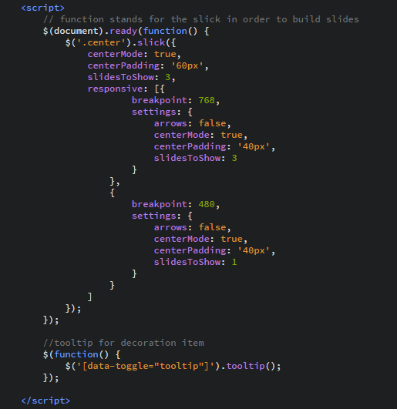that can be presented. The first function supports slides on the main page by using JS library, and the second one stands for the decoration item that plays an essential role to build an interesting atmosphere on the web page.

(screen.1)

Moreover, CSS was included immensely to produce visual effects and make the website adaptive and responsive.

The unique brand name and ignoring commercials makes this website the most favorable and sustainable among others.

**Navigation:**

From my point of view, the navigation style of this site is “simultaneous access” which is mostly used on the web by designers. It has something in common with hierarchical style and has constant links between basic scales. Likewise, BoomSi allows users to control or navigate from any pages to anywhere by providing many links in every page to make them feel comfortable and let them to access anywhere using couple of clicks. As the saying goes “Simplicity is powerful”, main goal was to make the web-site simple but powerful in terms of speed, constancy and approachability in conjunction with ease of use, stays for the “heuristics” principles of designing.

**1.2 Evaluation:**

**Evaluation of competitors’ websites (2 websites):**

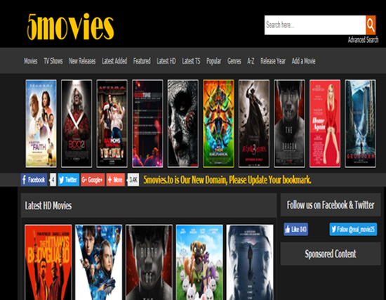 <http://5movies.to/latest-hd/><https://www.vudu.com/>

There are two websites(competitors) with the same aims and targets like “5movies” and “Vudu” illustrated above. To start with, both sites has an appropriate selection of colors, contents are attractive as well as correlate to the main idea, purpose of the websites, likewise all functions, links etc., works well and properly. The navigation schemes is one of the vital entity for the designers to build web-site, both “5movies” and “Vudu” has the same associative navigation structure which combines corresponding subjects and content. “Vudu” has a constant and sticky navigation bar which is good compare to the second site whereas users must scroll up all the time to reach navigation bar that is why this part suggested to be enhanced. Credits to “Vudu” for body and footer sectors, as they are clear and visible mentioned, but for “5movies” case, it would be nice to give more font-sizes to the links like (“DMCA |Privacy Policy| Contacts”) indicated below.

Adaptiveness level of these sites are not the same, “5movies” is usable and supports only one device (e.g. desktop) and is not user-friendly at this point, so it is worth to make some positive improvements in terms of mobility and flexibility of the site - when it comes to the screen-sizes, but another web-site “Vudu” is adaptable and comfortable to use in variety types of platforms. Functionality is like a bridge for the interaction of users and site, in the case with “5movies” it seems that only recognizable intercommunion is “search and advanced search” compare to the second website where lots of suggestions and services to make the website suitable for someone`s preference after creating an account. That is true that functionality should not be without any target, but designers and owners of the sites should do all the best to make users feel confident and reliable while navigating their web-pages, and once again “Vudu” surpasses its competitor. In my point of view, generally both websites are well-designed and doing best to be at the top of their rivals, however in this comparison of two sites with the same targets and goals “Vudu” overcomes “5movies” almost in all aspects.

**Reference list:**

IMDb. (2017). War for the Planet of the Apes (2017). Available from: <http://www.imdb.com/title/tt3450958/mediaindex?ref_=tt_pv_mi_sm> [Accessed 08 November. 2017].

IMDb. (2017). It (2017). Available from: <http://www.imdb.com/title/tt1396484/mediaindex?ref_=tt_pv_mi_sm> [Accessed 09 November 2017].

IMDb. (2017). The Mummy (2017). Available from: <http://www.imdb.com/title/tt2345759/mediaindex?ref_=tt_pv_mi_sm> [Accessed 09 November 2017].

IMDb. (2017). Pirates of the Caribbean: Dead Men Tell No Tales (2017). Available from: <http://www.imdb.com/title/tt1790809/mediaindex?ref_=tt_pv_mi_sm> [Accessed 10 November 2017].

IMDb. (2017). Spider-Man: Homecoming (2017). Available from: <http://www.imdb.com/title/tt2250912/mediaindex?ref_=tt_pv_mi_sm> [Accessed 09 November 2017].

IMDb. (2017). Transformers: The Last Knight (2017). Available from: <http://www.imdb.com/title/tt3371366/mediaindex?ref_=tt_pv_mi_sm> [Accessed 09 November 2017].

IMDb. (2017). King Arthur: Legend of the Sword (2017). Available from: <http://www.imdb.com/title/tt1972591/mediaindex?ref_=tt_pv_mi_sm> [Accessed 09 November 2017].

IMDb. (2017). The Space Between Us (2017). Available from: <http://www.imdb.com/title/tt3922818/mediaindex?ref_=tt_pv_mi_sm> [Accessed 09 November 2017].

MovieWeb. (2017). Transformers 5. Available from: <http://movieweb.com/movie/transformers-the-last-knight/> [Accessed 08 November.2017].

Pexels.com. (2017). Free stock photo of black wallpaper, dark, galaxy. Available from: <https://www.pexels.com/photo/stars-sky-night-galaxy-14676/> [Accessed 11 November 2017].

Rottentomatoes.com. (2017). War for the Planet of the Apes. Available from: <https://www.rottentomatoes.com/m/war_for_the_planet_of_the_apes/> [Accessed 07 November 2017].

Rottentomatoes.com. (2017). It. Available from: <https://www.rottentomatoes.com/m/it_2017> [Accessed 08 November 2017].

Rottentomatoes.com. (2017). The Space Between Us. Available from: <https://www.rottentomatoes.com/m/the_space_between_us> [Accessed 08 November. 2017].

Rottentomatoes.com. (2017). The Amazing Spiderman 4. Available from: <https://www.rottentomatoes.com/m/spider_man_homecoming> [Accessed 07 November 2017].

Rottentomatoes.com. (2017). King Arthur: Legend of the Sword. Available from: <https://www.rottentomatoes.com/m/king_arthur_legend_of_the_sword> [Accessed 07 November 2017].

Rottentomatoes.com. (2017). The Mummy. Available from: <https://www.rottentomatoes.com/m/the_mummy_2017>[ Accessed 08 November 2017].

Rottentomatoes.com. (2017). Pirates of the Caribbean: Salazar's Revenge. Available from: <https://www.rottentomatoes.com/m/pirates_of_the_caribbean_dead_men_tell_no_tales> [Accessed 09 November 2017].

**Appendix:**