Writing Task-1

Writing Introduction Sample (from Liz)

Writing a Suitable Introduction:

>> be more specific about the diagram.

>> be more specific about figures (like – numbers/years)

>> be more specific about names (like – shop/place)

>> mention the names (if they are few) or categories them (if they are more).

>> paraphrasing doesn’t mean – synonym of a word, rather rewriting the phrase in a smart and effective way.

>> give as much information as you can.

>> no repetition of information.

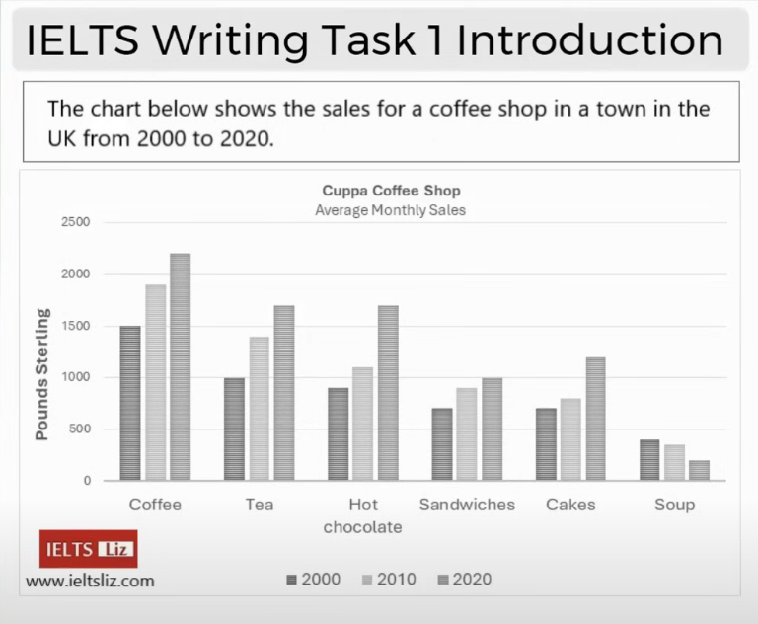

Introduction: The diagram below give the information for the sales of, for example tea, coffee, hot chocolate, food in a café, which locates in an English village, from 2000 to 2020. Units measure in Pounds Sterling.

Make Concentration:

>> the chart - be more specific about the diagram – the bar chart

>> below – there is nothing below when you are writing, so exclude it.

>> give – will be - gives

>> the – not required here

>> sales – (missing info) – would be – the monthly sales

>> for example – in the intro we don’t need example, we need info. so remove it

>> item/category – either name the items (if they are few) or make a category of x items. Item + category in the same sentence is not good

>> a café – (missing info) – name the coffee shop if it is given

>> which locates in – would be – which is located in

>> an English village – would be – a British town

>> from 2000 to 2020 – pharaphrase it – between 2000 and 2020

>> units measure – would be – units are measured

>> Pounds Sterling – would be – pounds sterling (in smaller letter when using in the sentence)

Revised Introduction:

The bar chart gives information about the typical monthly sales of coffee, tea, hot chocolate, sandwiches, cakes and soup for Cuppa Coffee shop, which is located in a British town, between 2000 and 2020. Units are measured in pounds sterling.

Further Modified Introduction:

The bar chart illustrates the amount of money made from the sales of coffee, tea, hot chocolate, sandwiches, cakes and soup in a typical month in Cuppa Coffee shop, located in a British town, in 2000, 2010 and 2020. Units are measured in pounds sterling.

Final Introduction:

The bar chart illustrates the typical monthly revenue of Cuppa Coffee shop, located in a British town, from the sales of six food and drink items in 2000, 2010 and 2020. Units are measured in pounds sterling.

**Fields Writing Task-1 Should Have:**

Fields in Writing Task-1:

>> Introduction

>> Overview  
>> Body Paragraph A

>> Body Paragraph B

Fields in Writing Task-1:

>> Introduction  
>> Body Paragraph A

>> Body Paragraph B

>> Overview

Or

Writing Introduction Exercise (from Cam-19)

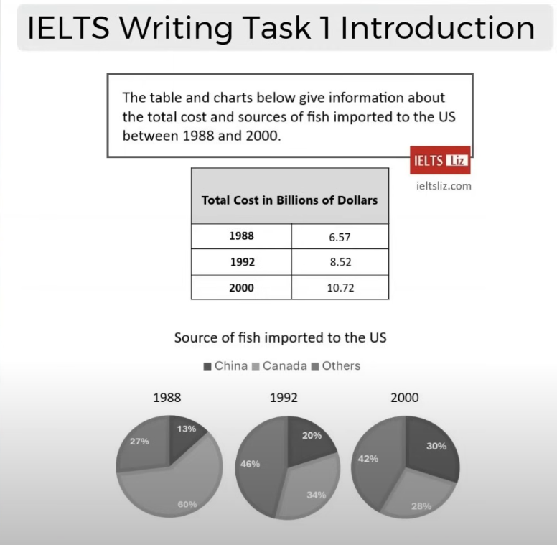

Got two charts (a table + a chart):

>> you can write them in separate sentences or connect them using a connector (like – while).

>> table – shows, chart – illustrates.

Introduction(mine):

The table and pie chart illustrate the overall expenses the US made and the countries where fish was imported from in 1988, 1992 and 2000. The measures are in billion dollars and in percentage.

Mine-2:

The table illustrates the costs the US spent on fish imported in 1988, 1992 and 2000 while the pie charts show the percentage of fish imported from China, Canada and other countries during the corresponding years.

Liz-1:

The table shows how much the US spent in total on imported fish in 1988, 1992 and 2000 while the pie charts illustrate the portion of fish brought in from China, Canada and other countries. Units are measured in billions of dollars in the table and percentage in the pie charts.

Liz-2:

The table shows how much the US spent in total, in billions of dollars, on imported fish in 1988, 1992 and 2000, while the pie charts illustrate the proportion of fish brought in from China, Canada and other countries.

Liz-3:

The table shows the total expenditure of the US, in billions of dollars, on imported fish in 1988, 1992 and 2000, while the three pie charts illustrate the proportion of fish that was sourced from China, Canada and other countries in the same years.

Mine*:

The total shows the total expenditure of the US, in billions of dollars, on imported fish in 1988, 1992 and 2000, which the pie charts illustrate the proportion of fish sourced from China, Canada and other countries in the same years.

**The table shows the value of fish (in billions of dollars) that was imported to the US in 1988, 1922 and 2000, while the three pie charts illustrate the proportion of fish that the US brought in from China, Canada and other countries in the same three years.**

**Overall, the value of imports rose by just under double over the period given. At the start of the period, the US imported fish predominantly from Canada but, by 1992 other countries became the main source.**

**Regarding the table, the value of imports started at $6.57 billion in the first year, increasing to $8.52 in 1992 and reaching $10.72 in the last year.**

**In terms of the source of fish importation, Canada supplied the overwhelming majority in 1988 (60%) compared to China and other countries which provided only 13% and 27% respectively. The imports from Canada then processed to fall to 28% in the final year. Conversely, by 1992, other countries had replaced Canada as the main supplier and made up 46% of all imports in 1992 and 42% by 2000. Likewise, imports from China rose over the period to reach 30% in 2010.**

Writing Introduction Exercise (Diagrams)

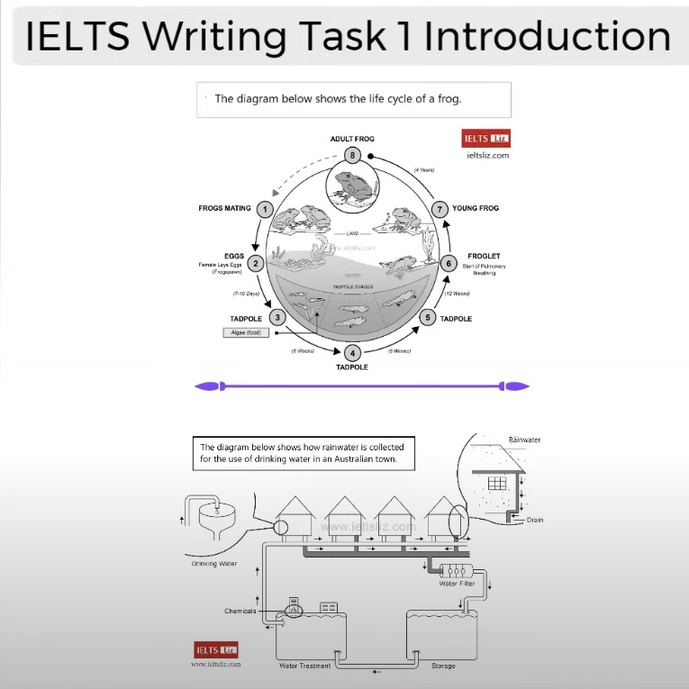

**Introduction**:

**Diagram-1**:

>> The diagram illustrates the stages in the life of a frog.

>> The diagram illustrates the phases a frog passes through during its life.

>> The diagram illustrates the stages of developments that a frog passes through during its life-time.

**Diagram-2**:

>> The diagram shows how rainwater is collected for the use of drinking water in as Australian town.

>> The diagram illustrates the way a town in Australia recycles rainwater to make it safe for drinking.  
>> The diagram illustrates the way in which a town in Australia harvests and recycles rainwater so that it can be safely consumed.

**Writing Task-1 (Overview)**

** Writing task-1 have an Overview, and writing task-2 have a conclusion.

>> Overview – contains all the key features of a chart or graph or whatever we get in task-1. And Conclusion – repeats and results the main parts. And of course, in a short report (like- task-1), we shouldn’t repeat any information.

Writing Task-1 (Body Paragraphs):

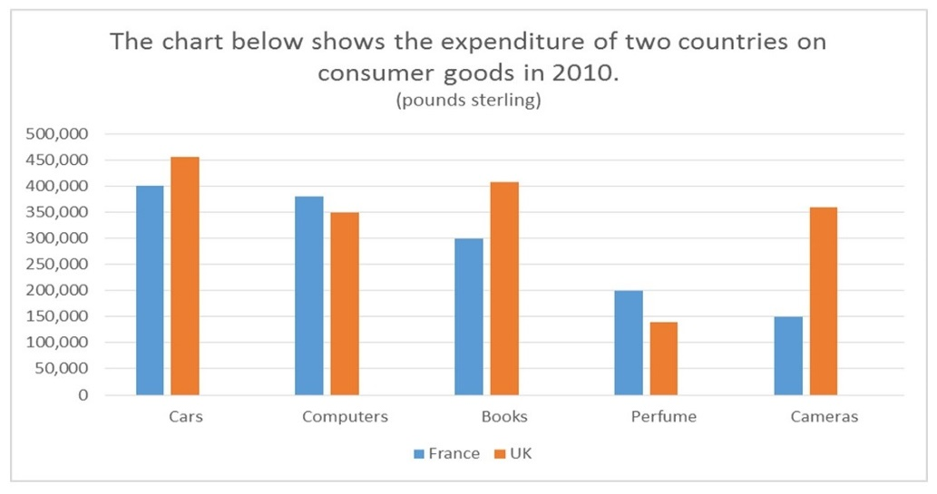

Organizations of Body Paragraphs:

Option-1: (focus on - UK expenses more than France in some items and opposite for others)

>> Body Paragraph-A: Cars + Books + Cameras

>> Body Paragraph-B: Computers + Perfumes

Option-2: (focus on – both countries spent the most on something and the least on something)

>> Body Paragraph-A: Cars + Books + Cameras

>> Body Paragraph-B: Computers + Perfumes

Important for Body Paragraph:

>> Organization – would be – logical

>> don’t miss the information

Writing Task-1:

The chart illustrates the amount of money spent on 5 consumer goods (cars, computers, books, perfumes and cameras) in France and the UK in 2010. Units are measured in pounds sterling.

Overall, the expenditure of the UK was higher than that of France. Both the French and the British spent the most of their money on cars while in the UK the least amount of money was spent on perfume compared to cameras in France. Furthermore, the most significant difference in expenditure between the two countries was on Cameras.

In terms of cars, people in the UK spent about 450 thousand pounds on this as opposed to the French at 400 thousand pounds. Similarly, the British expenditure was higher on books than the French (around 400 thousand and 300 thousand pounds respectively). In the UK, expenditure on cameras (just over 350 thousand pounds) was over double that of France, which was only 150 thousand pounds sterling.

On the other hand, the amount of money paid out on the remaining goods was higher in France. Above 350 thousand pounds was spent by the French on computers which was slightly more than the British who spent exactly 350 thousand pounds. Neither of the countries spent much on perfume which accounted for 200 thousand pounds of expenditure in France but under 150 thousand pounds in the UK.

Writing Task-1: Exercise

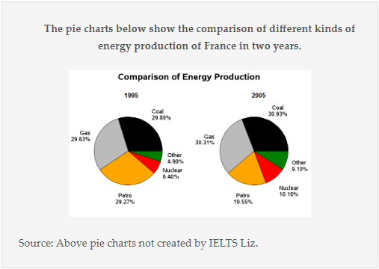

The two pie charts illustrate the proportion of five sources of energy production (coal, gas, nuclear, petrol and other sources) in France in the year 1995 and 2005.

Overall, in both years coal and gas had the most share, over half, of all energy production, while the least was other energy sources. Although there was only a very minimal increase in production from gas and coal, **the production from** nuclear and other sources on the other hand **became almost double. Petrol was the only energy source to decrease over the period.**

**Energy produced by coal comprised of 29.80% in 1995 and by 2005, it increased by about 1% to 30.9%. Likewise, the amount of energy generated by gas went up by approximately 1% from 29.63% in the first year to 30.1% by the final year. The user of nuclear power rose significantly from 6.40% in 1995 to 10.10% in 2005. Other sources of energy production accounted for 4.90% but then climbed to 9.10%.**

**Petrol, on the contrary, produced 29.80% of all energy in 1995 but 10 years later only 19.55% of energy came from this source.**

**Writing Task-1: Line Graph**

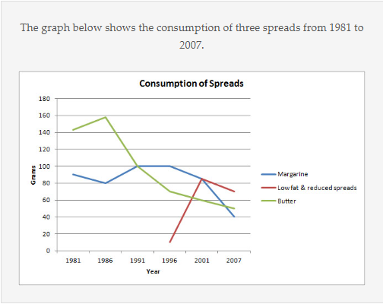

**The line graph illustrates the amount of there kinds of spreads (margarine, butter, and low fat and reduced spreads) which were consumed from 1981 to 2007. Units are measured in grams.**

**Overall, the consumption of margarine and the butter decreased over the period given, while for low fat and reduced spread. Margarine was the most widely consumed in the middle of the period but, by the end, low fat and reduced spreads was most popular.**

**With regards to the amount of butter used, it began at around 140 grams and then peaked at 160 grams in 1986 before falling dramatically to about 50 grams in the last year. Likewise, approximately 90 grams of margarine was eaten in the first year, after which the figure fluctuated slightly and dropped to a low of 40 grams in 2007.**

**On the other hand, the consumption of low fats and reduced spreads only started in 1996 at about 10 grams. This figure, which reached a high of just over 80 grams five years later, fell slightly in the final years to approximately 70 grams in 2017.**

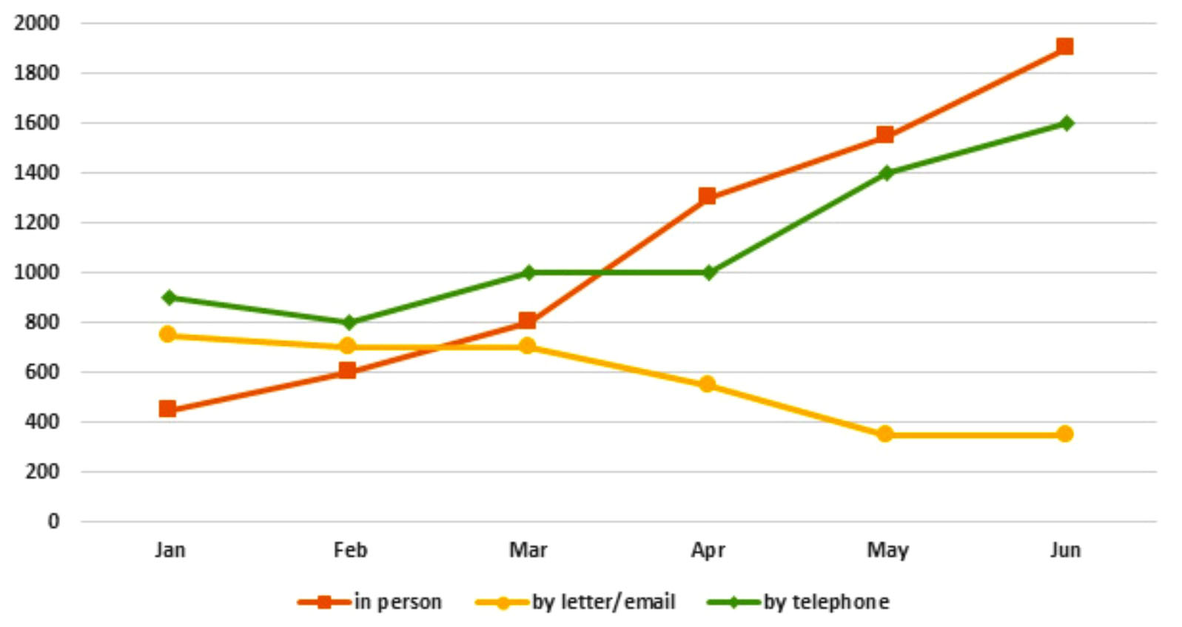

**The graph below shows the number of enquiries received by the Tourist Information Office in one city over a six-month period in 2011.**

**The graph demonstrates the total number of inquires the tourists are submitted to the Tourist Information Office by in person, by letter/email and by telephone. This information is for six-months from January to June in 2011 of a city.**

**Overall, the total number of inquiries are increased in six months. It seems that people are more likely dislike asking questions by letter or email. The inquiries through in person and by telephone is increased gradually by times.**

**For inquiries by letter/email, they were steady for first three months (January to March) on around 700 in numbers. And then dropped to bellow 400 in next two months and hold this number for the following month.**

**On the other hand, in person and by telephone inquiries increased gradually from 400 to around 1900 and 900 to 1600 respectively. The number of inquires by telephone was fluctuated between 900 to 100 for first four months (January to April) but afterwards hold an exponential growth from 1000 to 1600 inquiries like in person from 1300 to 1900 inquiries.**