Planning a Software Documentation Project
The hardest part of any project is getting started. A good best practice is to plan the structure of your software documentation project before you begin writing topics. You can always make adjustments as the project progresses, but having a plan will ensure that your topics can “stand alone” (make sense no matter how the user finds them), that your topics will work for context-sensitive help, and that no important information is missed.
There are five steps to structuring a software documentation project, but you don’t have to do them in order. In fact, you should do 1-4 concurrently. This method will work in Agile shops; you can drop your content into each iteration, and design the Table of Contents incrementally. The structure is suitable for manuals also ― so you won’t have any issues if you are single-sourcing. This method will also work as a guideline to evaluate an existing project.
- List functionality
- Review the User Interface
- Collect the “housekeeping” topics
- Determine reference resources
- Design the Table of Contents (the architecture)

When structuring a Help system remember:
- Help is architected much like a website. (It has all the same basic pieces: a TOC, Navigation, Topics, Search, etc.)
- Well structured Help projects include well structured topics. See Structuring Help Topics for more information and examples.

Customer Master File
This function is used to maintain or view records in the Customer Master File.
Records in this table (ARTCUST1) are keyed by the Customer Code, and are used to define attributes that are defined to a single Customer.
Please review the General Notes for File Maintenance for features which are common to all File Maintenance screens available from the menu.
Once a single customer is selected, this function will also permit maintenance and viewing of records that are associated to that customer in the following related tables:

The Customer Master Data is organized into the following sections:
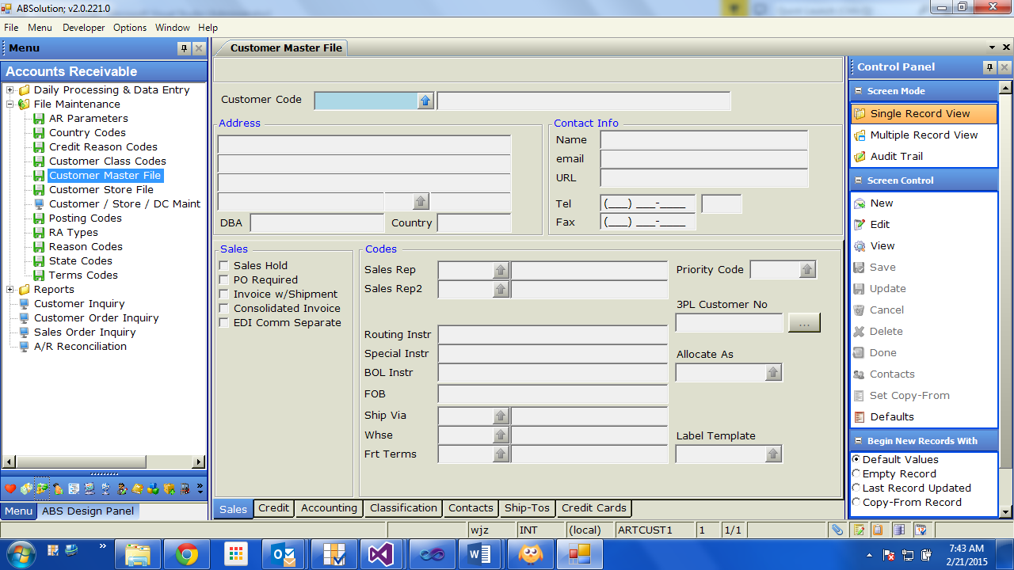

When writing the documentation, remember to use the language of the user — avoid jargon when possible.

Example topics:
- Creating Help Targets
- Creating Variables
- Creating Image Maps (graphics with links)

General Notes for File Maintenance
File Maintenance functions are identifiable on the menu by the green diskette icon: 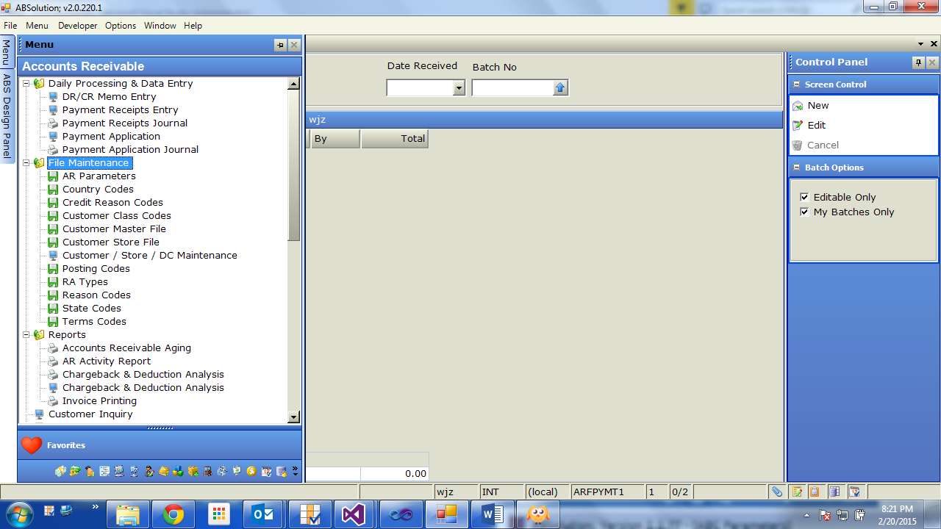

File Maintenance
Menu
Screen
Report
The screen is designed to maintain or view a single record at a time.
There is a feature to view the entire table contents at once in a grid, but changing data from the grid view is not supported unless enabled by custom development for the specific table.
All changes made to data are logged in an audit trail, detailing who changed the data, when it was changed, and the original and updated values for the changed data.

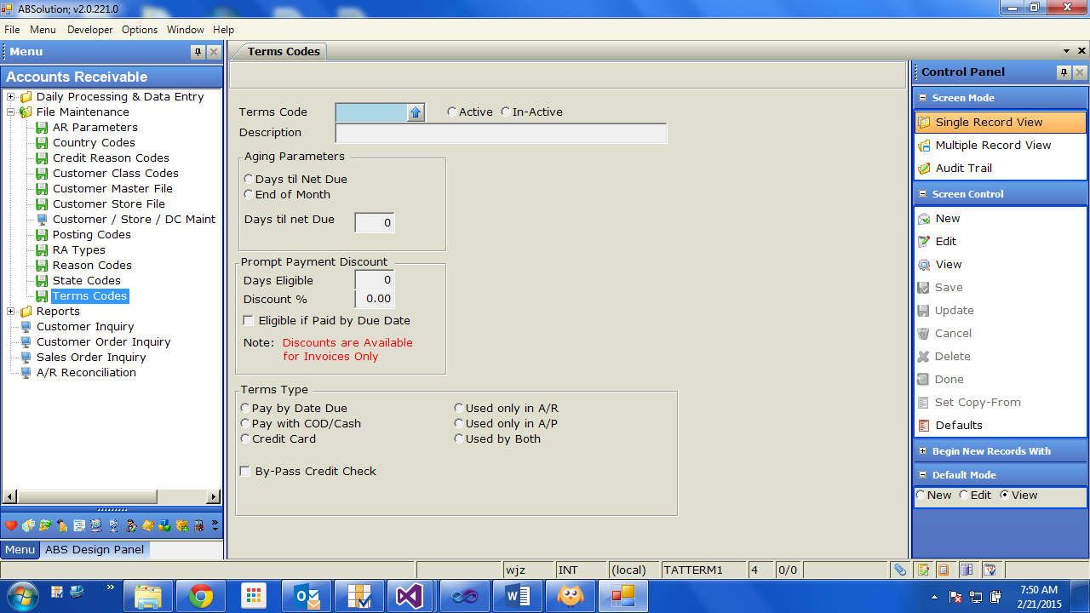  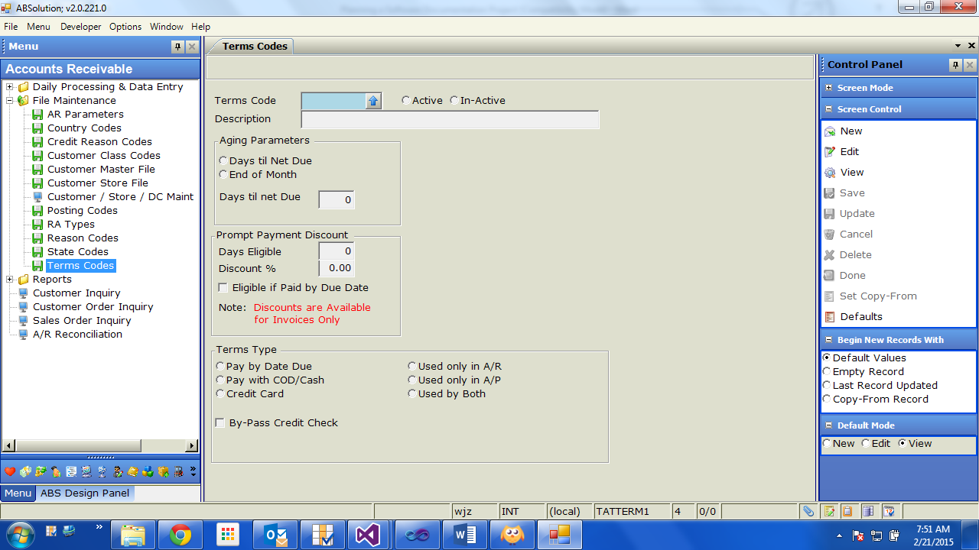 | Control Panel Options  Screen Mode Toggles what you will see in the main body of the screen  Single Record View To maintain single records (most common use)  Multiple Record View To maintain or view all records in the table (spreadsheet)  Audit Trail To view all changes to all fields ever made to data  Screen Control Covered below – these are commands used to edit data  Begin New Records With Default setting for how to start New records when adding  Default Values Use the Default values for each field  Empty Record Start with all fields blank  Last Record Updated Use the field values from the last record Updated  Copy-From Record Use the field values from the designated CF record  Default Mode Screen Mode after specifying a record key + Enter  New Assume that New command was clicked  Edit Assume that Edit command was clicked  View Assume that View command was clicked

 | Start a new record. Requires that you specify values for key fields  Edit the record with the key specified  Edit the record with the key specified  Save the record data on the screen, and then retrieve the record in View mode  Save the record data on the screen, and then clear the screen  Cancel all Edits, and clear the screen  Delete the record from the database – works only if the record has never been used  Clear screen after bringing up a record to View  Set the active record as the Copy-From record  Use the screen to set Default Values for each field

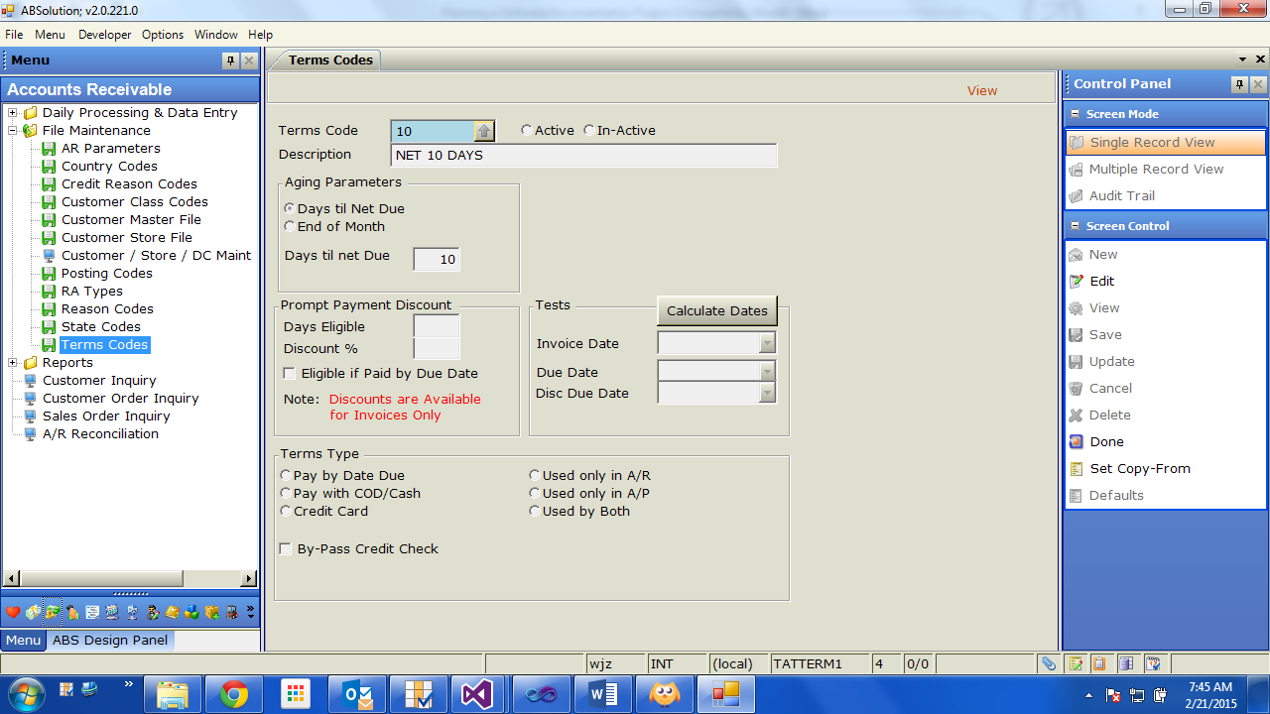
in this table (ARTCUST1) are keyed by the Customer Code, and are used to define attributes that are defined to a single Customer.
Please review the General Notes for File Maintenance for features which are common to all File Maintenance screens available from the menu.

TOC Design Notes
- “Functionality” is the most difficult category to structure. Some options include:
- Order of performance (if application is strict about this)
- Most popular (often used) to least popular
- Order of importance
- Build your TOC in a spreadsheet. Make sure to flag the topics that will be used as context-sensitive Help. Include everything in the spreadsheet, although you may not be able to deliver everything in the first release. Consider the inverted pyramid when deciding what topics to include.
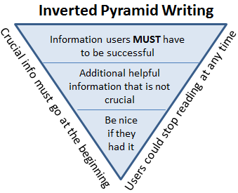
- When naming topics, avoid using the name of the dialog box in the title. This is not helpful for users (unless the dialog box is intuitively named, in which case … use it). If your Help is posted on the web, using meaningful naming techniques can improve SEO.

This structure also scales for a TOC that includes multiple products; you just need to add two more categories:
- “Overlapping functionality” — topics that are relevant to all products.
- “Consolidation functionality” (if necessary) — topics that explain how to use the products together.
Each of the individual products in the “Product” bucket would include the functionality topics for each product.

Example Table of Contents for “multi-product” documentation:
