#### INTRODUCTION

* 1. *Overview*

Thisprojecthelpsyoutomaintainandmanagetheschoolrelated problems which further can be modified based ontherequirements

* 1. *Purpose*

Thegoalissimpleimprovebusinessrelationship

1. ***ProblemDefinition&DesignThinking***
   1. *EmpathyMap*

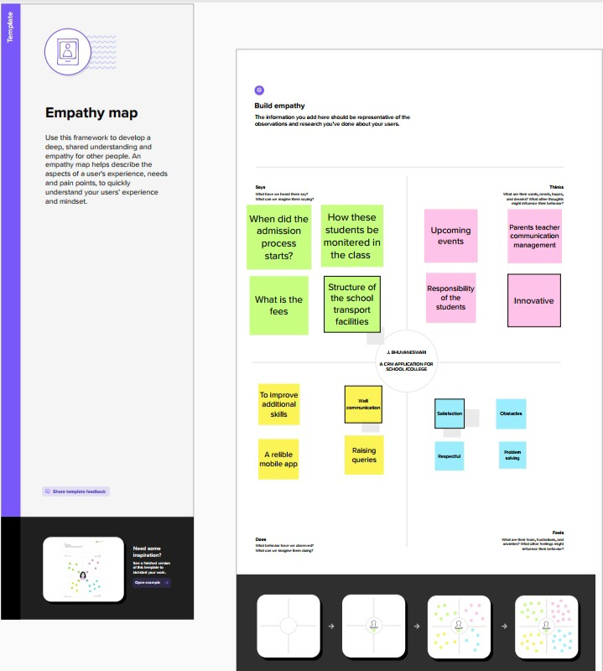

* 1. *Ideation&BrainstormingMap*

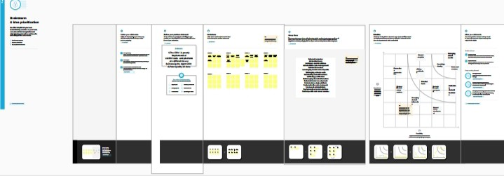

PastetheIdeation&brainstormingmapscreenshot

#### RESULT

* 1. *DataModel:*

|  |  |
| --- | --- |
| *Fieldlabel* | *Datatype* |
| *Nama* | *Autonumber* |
| *Results* | *Picklist* |

|  |  |
| --- | --- |
| ***Objectname*** | ***FieldsintheObject*** |
| *obj1Student* |  |
| *obj2Parent* |  |

* 1. ***Activity&Screenshot***

|  |  |
| --- | --- |
| *Fieldlabel* | *Datatype* |
| *ParentsAddress* | *Text* |
| *Parentsnumber* | *Phone* |

## Milestone:1

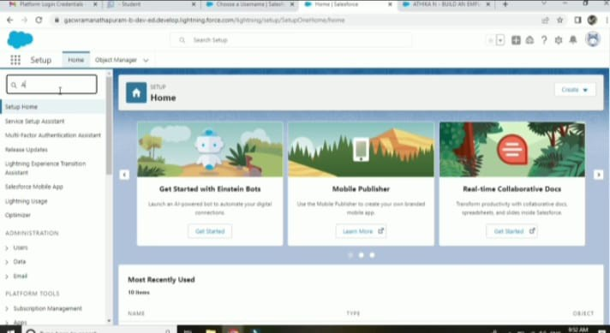WecreatedeveloperorginSalesforceandgiveusernameandpasswordtologin.Afterloginthisisthehomepagewhichyouwillsee

## Milestone:2

*Activity-1Creationofschoolobject*

### Navigatetosetupandselectobjectmanagerandlabelnameschoolanddatatypecheckboxandsaveit



*ProjectReportTemplate*

# Milestone:3Lightingapp

*Createtheschoolmanagementappgotosetupenterappmanagerclicknewlightningappenterschoolmanagementastheappnameclicknext*

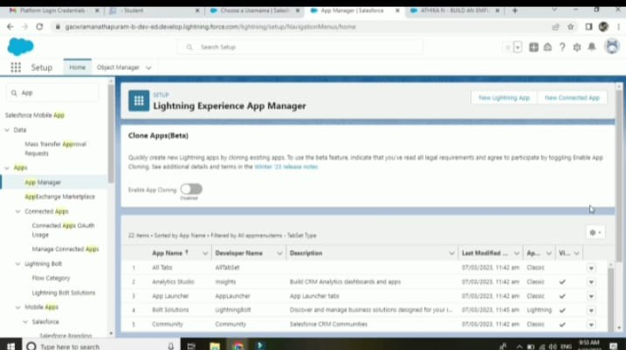

# Milestone:4

*FieldandRelationship*

### Selectthetextareaasthedatetypethenclicknext.Forfieldlabelenteraddressclickthethensave

*SelectthemasterobjectsummarizedasstudentsandselectMarksasfieldtoaggregateclicknextandsave*

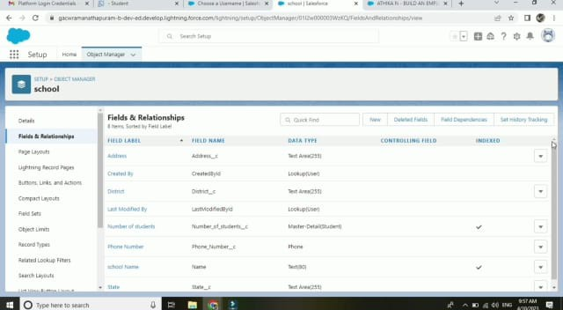

*Milestone:5Creationofprofile*

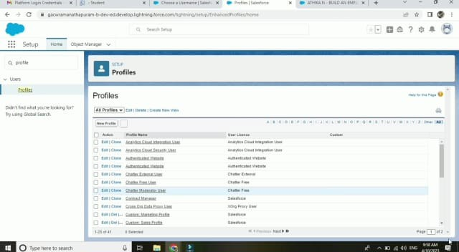*From setup entre profile in the quick find box,andselect profile from the list of profile findstandarduserclickscloneforprofilenameenterschoolprofilesaveit*

## Milestone:6Users

*Fromsetup in the quick findbox enter usersand then select usersenter the users nameparent and student email address and uniqueuser name check generated new password andnotifytheusersimmediatelytohavetheuserlogin*

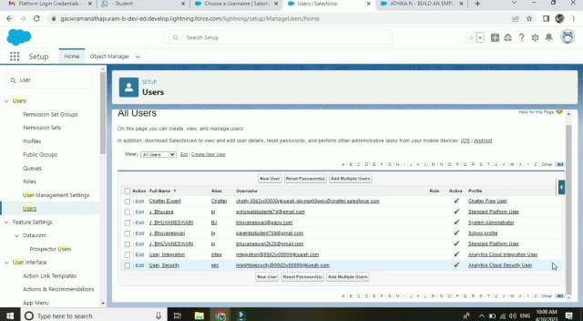

# Milestone:7

*Pemesionsets*

FROM set up enter permission set in the quick find box thenselect permission set s give the name of permission set namehas teacher permission and then under the object sets give theviewcreateandeditpermissiontoallcustomeobjectandassigntothe teacheruser

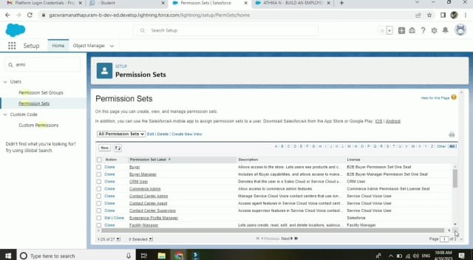

### Milestone:8Reports

From the report tab click new report we select the report typehas school with students and parents for the report and clickcreatecustomisedyourreportthensaveorrunit

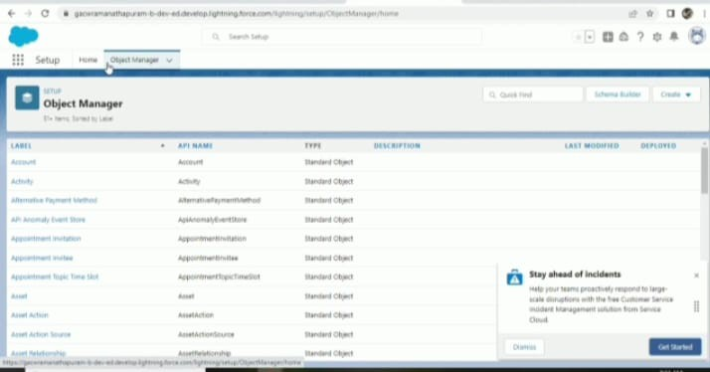

#### TrailheadProfilePublicURLTeamLead- <https://trailblazer.me/id/abarvin1>

#### TeamMember1- <https://trailblazer.me/id/a20036>

#### TeamMember2- <http://trailblazer.me/id/aabinaya11>

#### TeamMember3– <https://trailblazer.me/id/aanitha36>

#### TeamMember4- <https://trailblazer.me/id/venks74>

1. ***ADVANTAGES&DISADVANTAGE***

The advantages of a business using a CRM system greatlyoutweigh the disadvantages. However, there are pitfalls. For aCRM system to work, there needs to be buy-in across theorganisationandtheprocessesinplacetosupportit.Otherwise,your CRM may end up being an expensive waste of time. Here,we take a look at the strategic pros, cons, and importance ofCRM.

#### APPLICATIONS

Customer relationship management (CRM) is a technology formanagingallyourcompany'srelationshipsandinteractionswithcustomersandpotentialcustomers.

#### CONCLUSION

CRM in retail allows businesses to make smarter decisions tobetterservetheircustomersandmaximizeprofitsfromrepeatpurchases.

#### FUTURESCOPE

Customerswillbecomeacompany'sbestsalesrepsthroughsuperiorproductsandservicesaswellascustomer-orientedmessaging.ThefutureofCRMismorethanjustthefutureofCustomerRelationshipManagementsoftware.Itisreallythefutureof business.