# sql\_command

sql\_command ::= [to\_define\_data](http://cui.unige.ch/db-research/Enseignement/analyseinfo/SQL7/to_define_data.html)

| [to\_control\_data](http://cui.unige.ch/db-research/Enseignement/analyseinfo/SQL7/to_control_data.html)

| [to\_modify\_data](http://cui.unige.ch/db-research/Enseignement/analyseinfo/SQL7/to_modify_data.html)

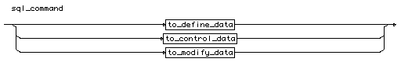  
[[rule list]](http://cui.unige.ch/db-research/Enseignement/analyseinfo/SQL7/BNFindex.html)

# to\_define\_data

to\_define\_data

::= [alter\_command](http://cui.unige.ch/db-research/Enseignement/analyseinfo/SQL7/alter_command.html)

| [comment\_command](http://cui.unige.ch/db-research/Enseignement/analyseinfo/SQL7/comment_command.html)

| [create\_command](http://cui.unige.ch/db-research/Enseignement/analyseinfo/SQL7/create_command.html)

| [drop\_command](http://cui.unige.ch/db-research/Enseignement/analyseinfo/SQL7/drop_command.html)

| [rename\_command](http://cui.unige.ch/db-research/Enseignement/analyseinfo/SQL7/rename_command.html)

| [analyze\_command](http://cui.unige.ch/db-research/Enseignement/analyseinfo/SQL7/analyze_command.html)

| [explain\_command](http://cui.unige.ch/db-research/Enseignement/analyseinfo/SQL7/explain_command.html)

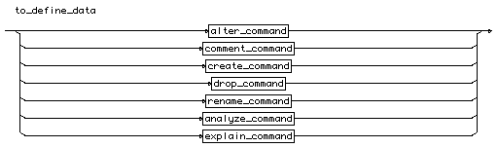  
[[rule list]](http://cui.unige.ch/db-research/Enseignement/analyseinfo/SQL7/BNFindex.html)

# to\_modify\_data

to\_modify\_data

::= [select\_command](http://cui.unige.ch/db-research/Enseignement/analyseinfo/SQL7/select_command.html)

| [insert\_command](http://cui.unige.ch/db-research/Enseignement/analyseinfo/SQL7/insert_command.html)

| [update\_command](http://cui.unige.ch/db-research/Enseignement/analyseinfo/SQL7/update_command.html)

| [delete\_command](http://cui.unige.ch/db-research/Enseignement/analyseinfo/SQL7/delete_command.html)

| [truncate\_command](http://cui.unige.ch/db-research/Enseignement/analyseinfo/SQL7/truncate_command.html)

| [transaction\_command](http://cui.unige.ch/db-research/Enseignement/analyseinfo/SQL7/transaction_command.html)

| [set\_transaction\_command](http://cui.unige.ch/db-research/Enseignement/analyseinfo/SQL7/set_transaction_command.html)

| [lock\_command](http://cui.unige.ch/db-research/Enseignement/analyseinfo/SQL7/lock_command.html)

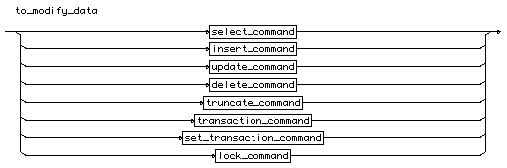  
[[rule list]](http://cui.unige.ch/db-research/Enseignement/analyseinfo/SQL7/BNFindex.html)

# to\_control\_data

to\_control\_data

::= [audit\_command](http://cui.unige.ch/db-research/Enseignement/analyseinfo/SQL7/audit_command.html)

| [noaudit\_command](http://cui.unige.ch/db-research/Enseignement/analyseinfo/SQL7/noaudit_command.html)

| [grant\_command](http://cui.unige.ch/db-research/Enseignement/analyseinfo/SQL7/grant_command.html)

| [revoke\_command](http://cui.unige.ch/db-research/Enseignement/analyseinfo/SQL7/revoke_command.html)

| [set\_role\_command](http://cui.unige.ch/db-research/Enseignement/analyseinfo/SQL7/set_role_command.html)

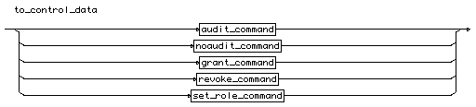  
[[rule list]](http://cui.unige.ch/db-research/Enseignement/analyseinfo/SQL7/BNFindex.html)

# select\_command

select\_command

::=

**"select"** [ **"all"** | **"distinct"** ]

( **"\*"** | ( [displayed\_column](http://cui.unige.ch/db-research/Enseignement/analyseinfo/SQL7/displayed_column.html) { **","** [displayed\_column](http://cui.unige.ch/db-research/Enseignement/analyseinfo/SQL7/displayed_column.html) } ) )

**"from"** ( [selected\_table](http://cui.unige.ch/db-research/Enseignement/analyseinfo/SQL7/selected_table.html) { **","** [selected\_table](http://cui.unige.ch/db-research/Enseignement/analyseinfo/SQL7/selected_table.html) } )

[ **"where"** [condition](http://cui.unige.ch/db-research/Enseignement/analyseinfo/SQL7/condition.html) ]

{ [connect\_clause](http://cui.unige.ch/db-research/Enseignement/analyseinfo/SQL7/connect_clause.html) }

{ [group\_clause](http://cui.unige.ch/db-research/Enseignement/analyseinfo/SQL7/group_clause.html) }

{ [set\_clause](http://cui.unige.ch/db-research/Enseignement/analyseinfo/SQL7/set_clause.html) }

{ [order\_clause](http://cui.unige.ch/db-research/Enseignement/analyseinfo/SQL7/order_clause.html) }

{ [update\_clause](http://cui.unige.ch/db-research/Enseignement/analyseinfo/SQL7/update_clause.html) }

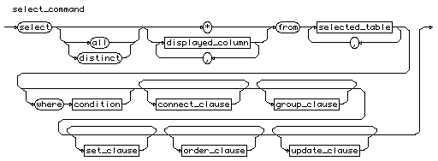  
[[rule list]](http://cui.unige.ch/db-research/Enseignement/analyseinfo/SQL7/BNFindex.html)

# displayed\_column

displayed\_column

::=

( [ [schema\_name](http://cui.unige.ch/db-research/Enseignement/analyseinfo/SQL7/schema_name.html) **"."** ] [table\_name](http://cui.unige.ch/db-research/Enseignement/analyseinfo/SQL7/table_name.html) **"."** **"\*"** )

| ( [exp\_simple](http://cui.unige.ch/db-research/Enseignement/analyseinfo/SQL7/exp_simple.html) [ [alias](http://cui.unige.ch/db-research/Enseignement/analyseinfo/SQL7/alias.html) ] )

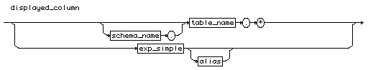  
[[rule list]](http://cui.unige.ch/db-research/Enseignement/analyseinfo/SQL7/BNFindex.html)

# schema\_name

schema\_name

::= [identifier](http://cui.unige.ch/db-research/Enseignement/analyseinfo/SQL7/identifier.html)

schema_name  
[[rule list]](http://cui.unige.ch/db-research/Enseignement/analyseinfo/SQL7/BNFindex.html)

# identifier

identifier

::=

( **"letter"** { **"letter"** | **"digit"** | **"underline"** | **"dollar"** | **"sharp"** } )

| **"quote"** { **"any character"** } **"quote"**

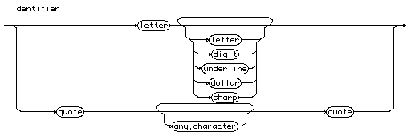  
[[rule list]](http://cui.unige.ch/db-research/Enseignement/analyseinfo/SQL7/BNFindex.html)

# table\_name

table\_name

::= [identifier](http://cui.unige.ch/db-research/Enseignement/analyseinfo/SQL7/identifier.html)

table_name  
[[rule list]](http://cui.unige.ch/db-research/Enseignement/analyseinfo/SQL7/BNFindex.html)

# exp\_simple

same syntax as expression, but you are not allowed to use all the possibitities.

expression

::= [ **"+"** | **"-"** ] [term](http://cui.unige.ch/db-research/Enseignement/analyseinfo/SQL7/term.html) { ( **"+"** | **"-"** ) [term](http://cui.unige.ch/db-research/Enseignement/analyseinfo/SQL7/term.html) }

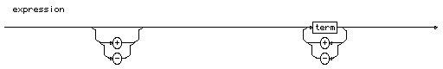  
[[rule list]](http://cui.unige.ch/db-research/Enseignement/analyseinfo/SQL7/BNFindex.html)

# term

term

::= [factor](http://cui.unige.ch/db-research/Enseignement/analyseinfo/SQL7/factor.html) { ( **"\*"** | **"/"** ) [factor](http://cui.unige.ch/db-research/Enseignement/analyseinfo/SQL7/factor.html) }

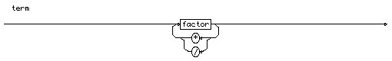  
[[rule list]](http://cui.unige.ch/db-research/Enseignement/analyseinfo/SQL7/BNFindex.html)

# factor

factor

::= [constante\_nonsigne](http://cui.unige.ch/db-research/Enseignement/analyseinfo/SQL7/constante_nonsigne.html)

| [variable](http://cui.unige.ch/db-research/Enseignement/analyseinfo/SQL7/variable.html)

| ( [function](http://cui.unige.ch/db-research/Enseignement/analyseinfo/SQL7/function.html) ( [ **"("** [expression](http://cui.unige.ch/db-research/Enseignement/analyseinfo/SQL7/expression.html) { **","** [expression](http://cui.unige.ch/db-research/Enseignement/analyseinfo/SQL7/expression.html) } **")"** ] ) )

| ( [group\_function](http://cui.unige.ch/db-research/Enseignement/analyseinfo/SQL7/group_function.html) **"("** [ **"\*"** | **"all"** | **"distinct"** ] [expression](http://cui.unige.ch/db-research/Enseignement/analyseinfo/SQL7/expression.html) **")"** )

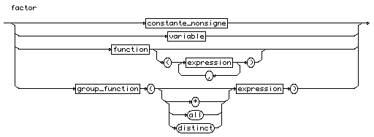  
[[rule list]](http://cui.unige.ch/db-research/Enseignement/analyseinfo/SQL7/BNFindex.html)

# variable

variable

::= [ [table\_name](http://cui.unige.ch/db-research/Enseignement/analyseinfo/SQL7/table_name.html) **"."** ] [column\_name](http://cui.unige.ch/db-research/Enseignement/analyseinfo/SQL7/column_name.html) [ **"(+)"** ]

variable  
[[rule list]](http://cui.unige.ch/db-research/Enseignement/analyseinfo/SQL7/BNFindex.html)

# column\_name

column\_name

::= [identifier](http://cui.unige.ch/db-research/Enseignement/analyseinfo/SQL7/identifier.html)

column_name  
[[rule list]](http://cui.unige.ch/db-research/Enseignement/analyseinfo/SQL7/BNFindex.html)

# function

function

::=

[number\_function](http://cui.unige.ch/db-research/Enseignement/analyseinfo/SQL7/number_function.html)

| [char\_function](http://cui.unige.ch/db-research/Enseignement/analyseinfo/SQL7/char_function.html)

| [group\_function](http://cui.unige.ch/db-research/Enseignement/analyseinfo/SQL7/group_function.html)

| [conversion\_function](http://cui.unige.ch/db-research/Enseignement/analyseinfo/SQL7/conversion_function.html)

| [other\_function](http://cui.unige.ch/db-research/Enseignement/analyseinfo/SQL7/other_function.html)

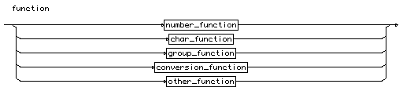  
[[rule list]](http://cui.unige.ch/db-research/Enseignement/analyseinfo/SQL7/BNFindex.html)

# number\_function

number\_function

::=

**"abs"** | **"ceil"** | **"floor"** | **"mod"** | **"power"** | **"round"**

| **"sign"** | **"sqrt"** | **"trunc"**

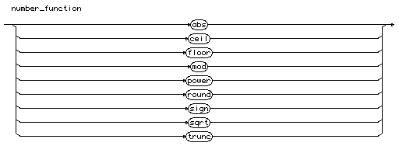  
[[rule list]](http://cui.unige.ch/db-research/Enseignement/analyseinfo/SQL7/BNFindex.html)

# char\_function

char\_function

::=

**"chr"** | **"initcap"** | **"lower"** | **"lpad"** | **"ltrim"** | **"replace"**

| **"rpad"** | **"rtrim"** | **"soundex"** | **"substr"** | **"translate"** | **"upper"**

| **"ascii"** | **"instr"** | **"length"**

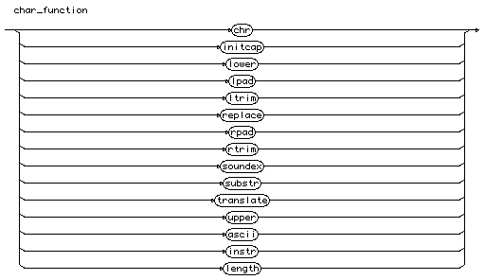  
[[rule list]](http://cui.unige.ch/db-research/Enseignement/analyseinfo/SQL7/BNFindex.html)

# group\_function

group\_function

::=

**"avg"** | **"count"** | **"max"** | **"min"** | **"stddev"** | **"sum"**

| **"variance"**

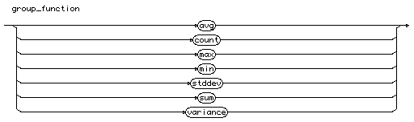  
[[rule list]](http://cui.unige.ch/db-research/Enseignement/analyseinfo/SQL7/BNFindex.html)

# conversion\_function

conversion\_function

::=

**"chartorowid"** | **"convert"** | **"hextoraw"** | **"rawtohex"** | **"rowidtochar"**

| **"to\_char"** | **"to\_date"** | **"to\_number"**

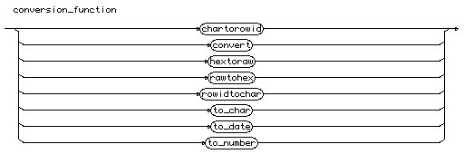  
[[rule list]](http://cui.unige.ch/db-research/Enseignement/analyseinfo/SQL7/BNFindex.html)

# other\_function

other\_function

::=

**"decode"** | **"dump"** | **"greatest"** | **"least"** | **"nvl"**

| **"uid"** | **"user"** | **"userenv"** | **"vsize"**

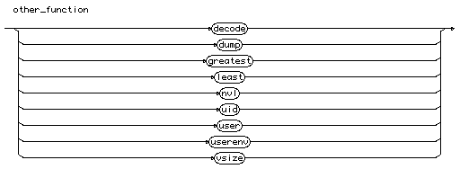  
[[rule list]](http://cui.unige.ch/db-research/Enseignement/analyseinfo/SQL7/BNFindex.html)

# expression

expression

::= [ **"+"** | **"-"** ] [term](http://cui.unige.ch/db-research/Enseignement/analyseinfo/SQL7/term.html) { ( **"+"** | **"-"** ) [term](http://cui.unige.ch/db-research/Enseignement/analyseinfo/SQL7/term.html) }

  
[[rule list]](http://cui.unige.ch/db-research/Enseignement/analyseinfo/SQL7/BNFindex.html)

# alias

alias

::= [identifier](http://cui.unige.ch/db-research/Enseignement/analyseinfo/SQL7/identifier.html)

alias  
[[rule list]](http://cui.unige.ch/db-research/Enseignement/analyseinfo/SQL7/BNFindex.html)

# selected\_table

selected\_table

::=

[ [schema\_name](http://cui.unige.ch/db-research/Enseignement/analyseinfo/SQL7/schema_name.html) **"."** ] [table\_name](http://cui.unige.ch/db-research/Enseignement/analyseinfo/SQL7/table_name.html) [ **"@"** [link\_name](http://cui.unige.ch/db-research/Enseignement/analyseinfo/SQL7/link_name.html) ] [ [alias](http://cui.unige.ch/db-research/Enseignement/analyseinfo/SQL7/alias.html) ]

selected_table  
[[rule list](http://cui.unige.ch/db-research/Enseignement/analyseinfo/SQL7/BNFindex.html)

# condition

condition

::= [ **"not"** ] [logical\_term](http://cui.unige.ch/db-research/Enseignement/analyseinfo/SQL7/logical_term.html)

{ **"or"** [logical\_term](http://cui.unige.ch/db-research/Enseignement/analyseinfo/SQL7/logical_term.html) }

condition  
[[rule list]](http://cui.unige.ch/db-research/Enseignement/analyseinfo/SQL7/BNFindex.html)

# logical\_term

logical\_term

::= [logical\_factor](http://cui.unige.ch/db-research/Enseignement/analyseinfo/SQL7/logical_factor.html) { **"and"** [logical\_factor](http://cui.unige.ch/db-research/Enseignement/analyseinfo/SQL7/logical_factor.html) }

logical_term  
[[rule list]](http://cui.unige.ch/db-research/Enseignement/analyseinfo/SQL7/BNFindex.html)

# logical\_factor

logical\_factor

::=

( [exp\_simple](http://cui.unige.ch/db-research/Enseignement/analyseinfo/SQL7/exp_simple.html) [comparaison\_op](http://cui.unige.ch/db-research/Enseignement/analyseinfo/SQL7/comparaison_op.html) [exp\_simple](http://cui.unige.ch/db-research/Enseignement/analyseinfo/SQL7/exp_simple.html) )

| ( [ **"not"** ] **"in"** [exp\_set](http://cui.unige.ch/db-research/Enseignement/analyseinfo/SQL7/exp_set.html) )

| ( [ **"not"** ] **"like"** [match\_string](http://cui.unige.ch/db-research/Enseignement/analyseinfo/SQL7/match_string.html) )

| ( [ **"not"** ] **"between"** [exp\_simple](http://cui.unige.ch/db-research/Enseignement/analyseinfo/SQL7/exp_simple.html) **"and"** [exp\_simple](http://cui.unige.ch/db-research/Enseignement/analyseinfo/SQL7/exp_simple.html) )

| ( **"is"** [ **"not"** ] **"null"** )

| [quantified\_factor](http://cui.unige.ch/db-research/Enseignement/analyseinfo/SQL7/quantified_factor.html)

| ( **"("** [condition](http://cui.unige.ch/db-research/Enseignement/analyseinfo/SQL7/condition.html) **")"** )

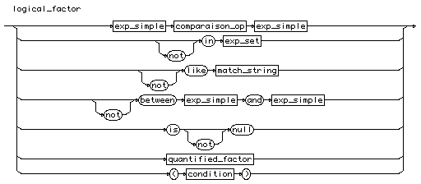  
[[rule list]](http://cui.unige.ch/db-research/Enseignement/analyseinfo/SQL7/BNFindex.html)

# comparaison\_op

comparaison\_op

::=

**"="** | **"<"** | **">"** | **"<>"** | **"!="** | **"^="** | **"<="** | **">="**

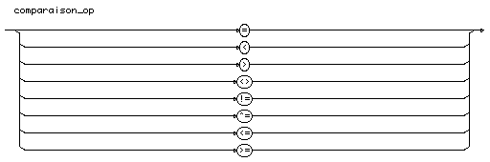  
[[rule list](http://cui.unige.ch/db-research/Enseignement/analyseinfo/SQL7/BNFindex.html)

# exp\_set

exp\_set

::= ( ( [number](http://cui.unige.ch/db-research/Enseignement/analyseinfo/SQL7/number.html) | [quoted\_string](http://cui.unige.ch/db-research/Enseignement/analyseinfo/SQL7/quoted_string.html) ) { **","** ( [number](http://cui.unige.ch/db-research/Enseignement/analyseinfo/SQL7/number.html) | [quoted\_string](http://cui.unige.ch/db-research/Enseignement/analyseinfo/SQL7/quoted_string.html) ) } )

| [subquery](http://cui.unige.ch/db-research/Enseignement/analyseinfo/SQL7/subquery.html)

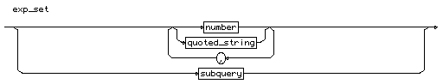  
[[rule list]](http://cui.unige.ch/db-research/Enseignement/analyseinfo/SQL7/BNFindex.html)

# number

number

::= [n](http://cui.unige.ch/db-research/Enseignement/analyseinfo/SQL7/n.html) [ **"."** [ [n](http://cui.unige.ch/db-research/Enseignement/analyseinfo/SQL7/n.html) ] ] [ **"E"** [ **"+"** | **"-"** ] [n](http://cui.unige.ch/db-research/Enseignement/analyseinfo/SQL7/n.html) ]

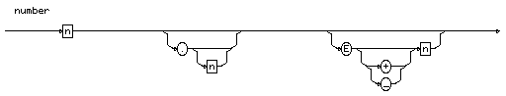  
[[rule list]](http://cui.unige.ch/db-research/Enseignement/analyseinfo/SQL7/BNFindex.html)

# quoted\_string

quoted\_string

::= **"'"** { **"any\_character"** } **"'"**

quoted_string  
[[rule list]](http://cui.unige.ch/db-research/Enseignement/analyseinfo/SQL7/BNFindex.html)

# subquery

subquery

::= **"("** [select\_command](http://cui.unige.ch/db-research/Enseignement/analyseinfo/SQL7/select_command.html) **")"**

subquery  
[[rule list]](http://cui.unige.ch/db-research/Enseignement/analyseinfo/SQL7/BNFindex.html)

# match\_string

match\_string

::= **"'"** { **"any\_character"** | **"\_"** | **"%"** } **"'"**

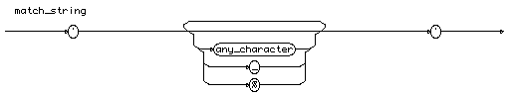  
[[rule list]](http://cui.unige.ch/db-research/Enseignement/analyseinfo/SQL7/BNFindex.html)

# quantified\_factor

quantified\_factor

::=

( [exp\_simple](http://cui.unige.ch/db-research/Enseignement/analyseinfo/SQL7/exp_simple.html) [comparaison\_op](http://cui.unige.ch/db-research/Enseignement/analyseinfo/SQL7/comparaison_op.html) [ **"all"** | **"any"** ] [subquery](http://cui.unige.ch/db-research/Enseignement/analyseinfo/SQL7/subquery.html) )

| ( [ **"not"** ] **"exists"** [subquery](http://cui.unige.ch/db-research/Enseignement/analyseinfo/SQL7/subquery.html) )

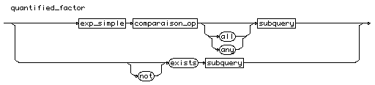  
[[rule list]](http://cui.unige.ch/db-research/Enseignement/analyseinfo/SQL7/BNFindex.html)

# connect\_clause

connect\_clause

::=

**"connect"** **"by"**

( ( **"prior"** [exp\_simple](http://cui.unige.ch/db-research/Enseignement/analyseinfo/SQL7/exp_simple.html) [comparaison\_op](http://cui.unige.ch/db-research/Enseignement/analyseinfo/SQL7/comparaison_op.html) [exp\_simple](http://cui.unige.ch/db-research/Enseignement/analyseinfo/SQL7/exp_simple.html) )

| ( [exp\_simple](http://cui.unige.ch/db-research/Enseignement/analyseinfo/SQL7/exp_simple.html) [comparaison\_op](http://cui.unige.ch/db-research/Enseignement/analyseinfo/SQL7/comparaison_op.html) [exp\_simple](http://cui.unige.ch/db-research/Enseignement/analyseinfo/SQL7/exp_simple.html) **"prior"** ) )

[ **"start"** **"with"** [condition](http://cui.unige.ch/db-research/Enseignement/analyseinfo/SQL7/condition.html) ]

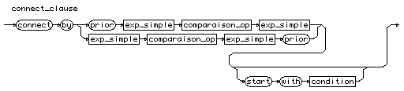  
[[rule list]](http://cui.unige.ch/db-research/Enseignement/analyseinfo/SQL7/BNFindex.html)

# group\_clause

group\_clause

::=

**"group"** **"by"** [expression](http://cui.unige.ch/db-research/Enseignement/analyseinfo/SQL7/expression.html) { **","** [expression](http://cui.unige.ch/db-research/Enseignement/analyseinfo/SQL7/expression.html) } [ **"having"** [condition](http://cui.unige.ch/db-research/Enseignement/analyseinfo/SQL7/condition.html) ]

group_clause  
[[rule list]](http://cui.unige.ch/db-research/Enseignement/analyseinfo/SQL7/BNFindex.html)

# set\_clause

set\_clause

::=

( ( **"union"** **"all"** ) | **"intersect"** | **"minus"** ) [select\_command](http://cui.unige.ch/db-research/Enseignement/analyseinfo/SQL7/select_command.html)

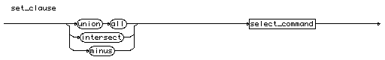  
[[rule list]](http://cui.unige.ch/db-research/Enseignement/analyseinfo/SQL7/BNFindex.html)

# order\_clause

order\_clause

::=

**"order"** **"by"** [sorted\_def](http://cui.unige.ch/db-research/Enseignement/analyseinfo/SQL7/sorted_def.html) { **","** [sorted\_def](http://cui.unige.ch/db-research/Enseignement/analyseinfo/SQL7/sorted_def.html) }

order_clause  
[[rule list]](http://cui.unige.ch/db-research/Enseignement/analyseinfo/SQL7/BNFindex.html)

# sorted\_def

sorted\_def

::=

( [expression](http://cui.unige.ch/db-research/Enseignement/analyseinfo/SQL7/expression.html) | [n](http://cui.unige.ch/db-research/Enseignement/analyseinfo/SQL7/n.html) ) ( **"asc"** | **"desc"** )

sorted_def  
[[rule list]](http://cui.unige.ch/db-research/Enseignement/analyseinfo/SQL7/BNFindex.html)

# n

n

::= **"digit"** { **"digit"** }

n  
[[rule list]](http://cui.unige.ch/db-research/Enseignement/analyseinfo/SQL7/BNFindex.html)

# update\_clause

update\_clause

::=

**"for"** **"update"** **"of"** [column\_name](http://cui.unige.ch/db-research/Enseignement/analyseinfo/SQL7/column_name.html) { **","** [column\_name](http://cui.unige.ch/db-research/Enseignement/analyseinfo/SQL7/column_name.html) } [ **"nowait"** ]

update_clause  
[[rule list]](http://cui.unige.ch/db-research/Enseignement/analyseinfo/SQL7/BNFindex.html)

# insert\_command

insert\_command

::=

**"insert"** **"into"** ( [ [schema\_name](http://cui.unige.ch/db-research/Enseignement/analyseinfo/SQL7/schema_name.html) **"."** ]

( [table\_name](http://cui.unige.ch/db-research/Enseignement/analyseinfo/SQL7/table_name.html) | [view\_name](http://cui.unige.ch/db-research/Enseignement/analyseinfo/SQL7/view_name.html) ) [ **"@"** [link\_name](http://cui.unige.ch/db-research/Enseignement/analyseinfo/SQL7/link_name.html) ] )

**"("** [column\_list](http://cui.unige.ch/db-research/Enseignement/analyseinfo/SQL7/column_list.html) **")"**

( ( **"("** [value\_list](http://cui.unige.ch/db-research/Enseignement/analyseinfo/SQL7/value_list.html) **")"** ) | [query](http://cui.unige.ch/db-research/Enseignement/analyseinfo/SQL7/query.html) )

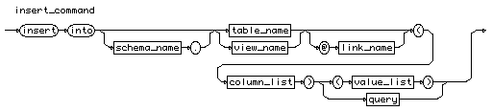  
[[rule list]](http://cui.unige.ch/db-research/Enseignement/analyseinfo/SQL7/BNFindex.html)

# view\_name

view\_name

::= [identifier](http://cui.unige.ch/db-research/Enseignement/analyseinfo/SQL7/identifier.html)

view_name  
[[rule list]](http://cui.unige.ch/db-research/Enseignement/analyseinfo/SQL7/BNFindex.html)

# link\_name

link\_name

::= [identifier](http://cui.unige.ch/db-research/Enseignement/analyseinfo/SQL7/identifier.html)

link_name  
[[rule list]](http://cui.unige.ch/db-research/Enseignement/analyseinfo/SQL7/BNFindex.html)

# column\_list

column\_list

::= [column\_name](http://cui.unige.ch/db-research/Enseignement/analyseinfo/SQL7/column_name.html) { **","** [column\_name](http://cui.unige.ch/db-research/Enseignement/analyseinfo/SQL7/column_name.html) }

column_list  
[[rule list]](http://cui.unige.ch/db-research/Enseignement/analyseinfo/SQL7/BNFindex.html)

# value\_list

value\_list

::= **"values"** **"("** [value](http://cui.unige.ch/db-research/Enseignement/analyseinfo/SQL7/value.html) { **","** [value](http://cui.unige.ch/db-research/Enseignement/analyseinfo/SQL7/value.html) }

value_list  
[[rule list]](http://cui.unige.ch/db-research/Enseignement/analyseinfo/SQL7/BNFindex.html)

# value

value

::= ( [ **"+"** | **"-"** ] ( [identifier](http://cui.unige.ch/db-research/Enseignement/analyseinfo/SQL7/identifier.html) | [n](http://cui.unige.ch/db-research/Enseignement/analyseinfo/SQL7/n.html) ) ) | [quoted\_string](http://cui.unige.ch/db-research/Enseignement/analyseinfo/SQL7/quoted_string.html)

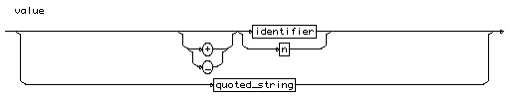  
[[rule list]](http://cui.unige.ch/db-research/Enseignement/analyseinfo/SQL7/BNFindex.html)

# query

query

::= [select\_command](http://cui.unige.ch/db-research/Enseignement/analyseinfo/SQL7/select_command.html)

query  
[[rule list]](http://cui.unige.ch/db-research/Enseignement/analyseinfo/SQL7/BNFindex.html)

# update\_command

update\_command

::=

[simple\_update](http://cui.unige.ch/db-research/Enseignement/analyseinfo/SQL7/simple_update.html) | [subquery\_update](http://cui.unige.ch/db-research/Enseignement/analyseinfo/SQL7/subquery_update.html)

update_command  
[[rule list]](http://cui.unige.ch/db-research/Enseignement/analyseinfo/SQL7/BNFindex.html)

# simple\_update

simple\_update

::=

**"update"** [ [schema\_name](http://cui.unige.ch/db-research/Enseignement/analyseinfo/SQL7/schema_name.html) **"."** ] [table\_name](http://cui.unige.ch/db-research/Enseignement/analyseinfo/SQL7/table_name.html) [ **"@"** [link\_name](http://cui.unige.ch/db-research/Enseignement/analyseinfo/SQL7/link_name.html) ]

[ [alias](http://cui.unige.ch/db-research/Enseignement/analyseinfo/SQL7/alias.html) ]

**"set"** [column](http://cui.unige.ch/db-research/Enseignement/analyseinfo/SQL7/column.html) **"="** ( [expression](http://cui.unige.ch/db-research/Enseignement/analyseinfo/SQL7/expression.html) | [subquery](http://cui.unige.ch/db-research/Enseignement/analyseinfo/SQL7/subquery.html) )

{ **","** [column](http://cui.unige.ch/db-research/Enseignement/analyseinfo/SQL7/column.html) **"="** ( [expression](http://cui.unige.ch/db-research/Enseignement/analyseinfo/SQL7/expression.html) | [subquery](http://cui.unige.ch/db-research/Enseignement/analyseinfo/SQL7/subquery.html) ) }

**"where"** [condition](http://cui.unige.ch/db-research/Enseignement/analyseinfo/SQL7/condition.html)

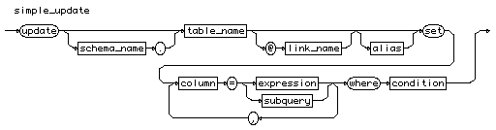  
[[rule list]](http://cui.unige.ch/db-research/Enseignement/analyseinfo/SQL7/BNFindex.html)

# subquery\_update

subquery\_update

::=

**"update"** [ [schema\_name](http://cui.unige.ch/db-research/Enseignement/analyseinfo/SQL7/schema_name.html) **"."** ] [table\_name](http://cui.unige.ch/db-research/Enseignement/analyseinfo/SQL7/table_name.html) [ [alias](http://cui.unige.ch/db-research/Enseignement/analyseinfo/SQL7/alias.html) ] [ **"@"** [link\_name](http://cui.unige.ch/db-research/Enseignement/analyseinfo/SQL7/link_name.html) ]

**"set"** **"("** [column\_name](http://cui.unige.ch/db-research/Enseignement/analyseinfo/SQL7/column_name.html) { **","** [column\_name](http://cui.unige.ch/db-research/Enseignement/analyseinfo/SQL7/column_name.html) } **")"** **"="** [subquery](http://cui.unige.ch/db-research/Enseignement/analyseinfo/SQL7/subquery.html)

**"where"** [condition](http://cui.unige.ch/db-research/Enseignement/analyseinfo/SQL7/condition.html)

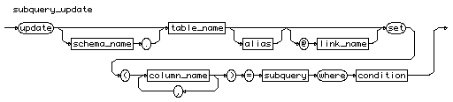  
[[rule list]](http://cui.unige.ch/db-research/Enseignement/analyseinfo/SQL7/BNFindex.html)

# delete\_command

delete\_command

::=

**"delete"** **"from"** [ [schema\_name](http://cui.unige.ch/db-research/Enseignement/analyseinfo/SQL7/schema_name.html) **"."** ] [table\_name](http://cui.unige.ch/db-research/Enseignement/analyseinfo/SQL7/table_name.html)

[ **"@"** [link\_name](http://cui.unige.ch/db-research/Enseignement/analyseinfo/SQL7/link_name.html) ]

[ **"where"** [condition](http://cui.unige.ch/db-research/Enseignement/analyseinfo/SQL7/condition.html) ]

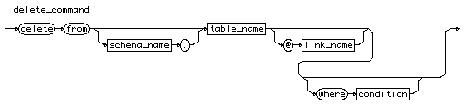  
[[rule list]](http://cui.unige.ch/db-research/Enseignement/analyseinfo/SQL7/BNFindex.html)

# truncate\_command

truncate\_command

::=

**"truncate"**

( ( **"table"** [ [schema\_name](http://cui.unige.ch/db-research/Enseignement/analyseinfo/SQL7/schema_name.html) **"."** ] [table\_name](http://cui.unige.ch/db-research/Enseignement/analyseinfo/SQL7/table_name.html) )

| ( **"cluster"** [ [schema\_name](http://cui.unige.ch/db-research/Enseignement/analyseinfo/SQL7/schema_name.html) **"."** ] [cluster\_name](http://cui.unige.ch/db-research/Enseignement/analyseinfo/SQL7/cluster_name.html) ) )

[ ( **"drop"** | **"reuse"** ) **"storage"** ]

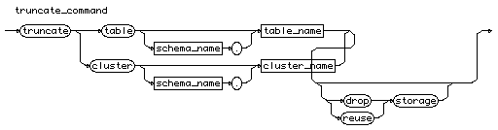  
[[rule list]](http://cui.unige.ch/db-research/Enseignement/analyseinfo/SQL7/BNFindex.html)

# cluster\_name

cluster\_name

::= [identifier](http://cui.unige.ch/db-research/Enseignement/analyseinfo/SQL7/identifier.html)

cluster_name  
[[rule list]](http://cui.unige.ch/db-research/Enseignement/analyseinfo/SQL7/BNFindex.html)

# transaction\_command

transaction\_command

::=

( **"commit"** [ **"work"** ] [ ( **"comment"** [quoted\_string](http://cui.unige.ch/db-research/Enseignement/analyseinfo/SQL7/quoted_string.html) )

| ( **"force"** [quoted\_string](http://cui.unige.ch/db-research/Enseignement/analyseinfo/SQL7/quoted_string.html) [ **","** [n](http://cui.unige.ch/db-research/Enseignement/analyseinfo/SQL7/n.html) ] ) ] )

| ( **"set"** **"transaction"** **"read"** **"only"** )

| ( **"savepoint"** [savepoint\_name](http://cui.unige.ch/db-research/Enseignement/analyseinfo/SQL7/savepoint_name.html) )

| ( **"rollback"** [ **"work"** ] [ ( **"to"** [ **"savepoint"** [savepoint\_name](http://cui.unige.ch/db-research/Enseignement/analyseinfo/SQL7/savepoint_name.html) ] )

| ( **"force"** [quoted\_string](http://cui.unige.ch/db-research/Enseignement/analyseinfo/SQL7/quoted_string.html) ) ] )

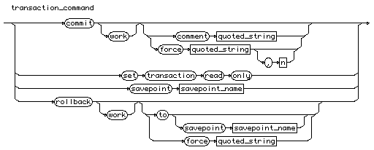  
[[rule list]](http://cui.unige.ch/db-research/Enseignement/analyseinfo/SQL7/BNFindex.html)

# savepoint\_name

savepoint\_name

::= [identifier](http://cui.unige.ch/db-research/Enseignement/analyseinfo/SQL7/identifier.html)

savepoint_name  
[[rule list]](http://cui.unige.ch/db-research/Enseignement/analyseinfo/SQL7/BNFindex.html)

# set\_transaction\_command

set\_transaction\_command

::=

**"set"** **"transaction"**

( ( **"read"** **"only"** )

| ( **"read"** **"write"** )

| ( **"use"** **"rollback"** **"segment"** [rollback\_name](http://cui.unige.ch/db-research/Enseignement/analyseinfo/SQL7/rollback_name.html) ) )

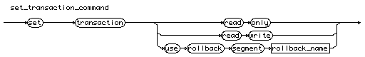  
[[rule list]](http://cui.unige.ch/db-research/Enseignement/analyseinfo/SQL7/BNFindex.html)

# rollback\_name

rollback\_name

::= [identifier](http://cui.unige.ch/db-research/Enseignement/analyseinfo/SQL7/identifier.html)

rollback_name  
[[rule list]](http://cui.unige.ch/db-research/Enseignement/analyseinfo/SQL7/BNFindex.html)

# lock\_command

lock\_command

::=

**"lock"** **"table"**

[ [schema\_name](http://cui.unige.ch/db-research/Enseignement/analyseinfo/SQL7/schema_name.html) **"."** ] [table\_name](http://cui.unige.ch/db-research/Enseignement/analyseinfo/SQL7/table_name.html) [ **"@"** [link\_name](http://cui.unige.ch/db-research/Enseignement/analyseinfo/SQL7/link_name.html) ]

{ **","** [ [schema\_name](http://cui.unige.ch/db-research/Enseignement/analyseinfo/SQL7/schema_name.html) **"."** ] [table\_name](http://cui.unige.ch/db-research/Enseignement/analyseinfo/SQL7/table_name.html) [ **"@"** [link\_name](http://cui.unige.ch/db-research/Enseignement/analyseinfo/SQL7/link_name.html) ] }

**"in"** [lock\_mode](http://cui.unige.ch/db-research/Enseignement/analyseinfo/SQL7/lock_mode.html) **"mode"** [ **"nowait"** ]

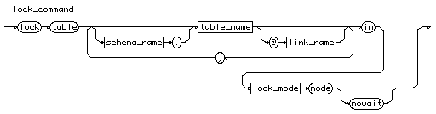  
[[rule list]](http://cui.unige.ch/db-research/Enseignement/analyseinfo/SQL7/BNFindex.html)

# lock\_mode

lock\_mode

::=

**"share"**

| **"exclusive"**

| ( **"row"** ( **"share"** | **"exclusive"** ) )

| ( **"share"** ( **"update"** | ( **"row"** **"exclusive"** ) ) )

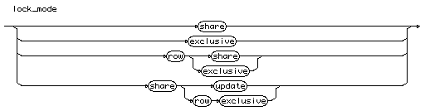  
[[rule list]](http://cui.unige.ch/db-research/Enseignement/analyseinfo/SQL7/BNFindex.html)

# alter\_command

alter\_command

::= [alter\_cluster](http://cui.unige.ch/db-research/Enseignement/analyseinfo/SQL7/alter_cluster.html)

| [alter\_database](http://cui.unige.ch/db-research/Enseignement/analyseinfo/SQL7/alter_database.html)

| [alter\_index](http://cui.unige.ch/db-research/Enseignement/analyseinfo/SQL7/alter_index.html)

| [alter\_profile](http://cui.unige.ch/db-research/Enseignement/analyseinfo/SQL7/alter_profile.html)

| [alter\_cost](http://cui.unige.ch/db-research/Enseignement/analyseinfo/SQL7/alter_cost.html)

| [alter\_role](http://cui.unige.ch/db-research/Enseignement/analyseinfo/SQL7/alter_role.html)

| [alter\_rollback](http://cui.unige.ch/db-research/Enseignement/analyseinfo/SQL7/alter_rollback.html)

| [alter\_sequence](http://cui.unige.ch/db-research/Enseignement/analyseinfo/SQL7/alter_sequence.html)

| [alter\_session](http://cui.unige.ch/db-research/Enseignement/analyseinfo/SQL7/alter_session.html)

| [alter\_snapshot](http://cui.unige.ch/db-research/Enseignement/analyseinfo/SQL7/alter_snapshot.html)

| [alter\_snapshot\_log](http://cui.unige.ch/db-research/Enseignement/analyseinfo/SQL7/alter_snapshot_log.html)

| [alter\_system](http://cui.unige.ch/db-research/Enseignement/analyseinfo/SQL7/alter_system.html)

| [alter\_table](http://cui.unige.ch/db-research/Enseignement/analyseinfo/SQL7/alter_table.html)

| [alter\_tablespace](http://cui.unige.ch/db-research/Enseignement/analyseinfo/SQL7/alter_tablespace.html)

| [alter\_trigger](http://cui.unige.ch/db-research/Enseignement/analyseinfo/SQL7/alter_trigger.html)

| [alter\_user](http://cui.unige.ch/db-research/Enseignement/analyseinfo/SQL7/alter_user.html)

| [alter\_view](http://cui.unige.ch/db-research/Enseignement/analyseinfo/SQL7/alter_view.html)

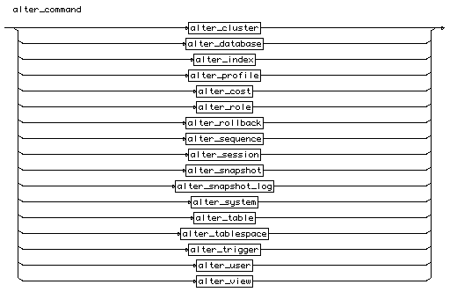  
[[rule list]](http://cui.unige.ch/db-research/Enseignement/analyseinfo/SQL7/BNFindex.html)

# alter\_cluster

alter\_cluster

::=

**"alter"** **"cluster"** [ [schema\_name](http://cui.unige.ch/db-research/Enseignement/analyseinfo/SQL7/schema_name.html) **"."** ] [cluster\_name](http://cui.unige.ch/db-research/Enseignement/analyseinfo/SQL7/cluster_name.html)

[alter\_cluster\_spec](http://cui.unige.ch/db-research/Enseignement/analyseinfo/SQL7/alter_cluster_spec.html) { [alter\_cluster\_spec](http://cui.unige.ch/db-research/Enseignement/analyseinfo/SQL7/alter_cluster_spec.html) }

alter_cluster  
[[rule list]](http://cui.unige.ch/db-research/Enseignement/analyseinfo/SQL7/BNFindex.html)

# alter\_database

alter\_database

::=

**"alter"** **"database"** [ [database\_name](http://cui.unige.ch/db-research/Enseignement/analyseinfo/SQL7/database_name.html) ]

( ( **"mount"** [ **"parallel"** | **"exclusive"** ] )

| ( **"convert"** )

| ( **"open"** [ **"resetlogs"** | **"noresetlogs"** ] )

| ( **"archive"** | **"noarchive"** )

| ( **"recover"** [recover\_clause](http://cui.unige.ch/db-research/Enseignement/analyseinfo/SQL7/recover_clause.html) )

| ( **"add"** **"logfile"** [logfile\_clause](http://cui.unige.ch/db-research/Enseignement/analyseinfo/SQL7/logfile_clause.html) )

| ( **"add"** **"logfile"** **"member"** [logmember\_clause](http://cui.unige.ch/db-research/Enseignement/analyseinfo/SQL7/logmember_clause.html)

{ **","** [logmember\_clause](http://cui.unige.ch/db-research/Enseignement/analyseinfo/SQL7/logmember_clause.html) } )

| ( **"drop"** **"logfile"** [group\_file\_list](http://cui.unige.ch/db-research/Enseignement/analyseinfo/SQL7/group_file_list.html) )

| ( **"rename"** **"file"** [file\_list](http://cui.unige.ch/db-research/Enseignement/analyseinfo/SQL7/file_list.html)

**"to"** [file\_list](http://cui.unige.ch/db-research/Enseignement/analyseinfo/SQL7/file_list.html) )

| ( **"backup"** **"controlfile"** **"to"** [file\_reuse](http://cui.unige.ch/db-research/Enseignement/analyseinfo/SQL7/file_reuse.html) )

| ( **"create"** **"datafile"** [file\_list](http://cui.unige.ch/db-research/Enseignement/analyseinfo/SQL7/file_list.html) [ **"as"** [file\_spec\_list](http://cui.unige.ch/db-research/Enseignement/analyseinfo/SQL7/file_spec_list.html) ] )

| ( **"datafile"** **"'"** [file\_name](http://cui.unige.ch/db-research/Enseignement/analyseinfo/SQL7/file_name.html) **"'"**

[ **"online"** | ( **"offline"** [ **"drop"** ] ) ] )

| ( **"enable"** [ **"public"** ] **"thread"** [n](http://cui.unige.ch/db-research/Enseignement/analyseinfo/SQL7/n.html) )

| ( **"disable"** **"thread"** [n](http://cui.unige.ch/db-research/Enseignement/analyseinfo/SQL7/n.html) )

| ( **"rename"** **"global\_name"** **"to"** [database\_name](http://cui.unige.ch/db-research/Enseignement/analyseinfo/SQL7/database_name.html)

{ **"."** [domain\_name](http://cui.unige.ch/db-research/Enseignement/analyseinfo/SQL7/domain_name.html) } ) )

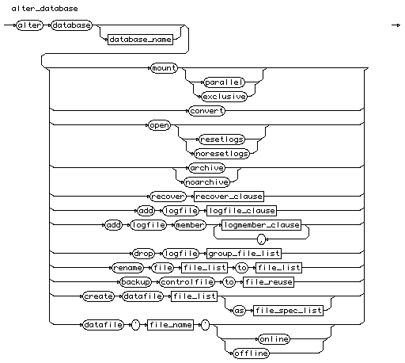  
[[rule list]](http://cui.unige.ch/db-research/Enseignement/analyseinfo/SQL7/BNFindex.html)

# alter\_index

alter\_index

::=

**"alter"** **"index"** [ [schema\_name](http://cui.unige.ch/db-research/Enseignement/analyseinfo/SQL7/schema_name.html) **"."** ] [index\_name](http://cui.unige.ch/db-research/Enseignement/analyseinfo/SQL7/index_name.html)

[alter\_index\_spec](http://cui.unige.ch/db-research/Enseignement/analyseinfo/SQL7/alter_index_spec.html) { [alter\_index\_spec](http://cui.unige.ch/db-research/Enseignement/analyseinfo/SQL7/alter_index_spec.html) }

alter_index  
[[rule list]](http://cui.unige.ch/db-research/Enseignement/analyseinfo/SQL7/BNFindex.html)

# create\_command

create\_command

::=

[create\_cluster](http://cui.unige.ch/db-research/Enseignement/analyseinfo/SQL7/create_cluster.html)

| [create\_controlfile](http://cui.unige.ch/db-research/Enseignement/analyseinfo/SQL7/create_controlfile.html)

| [create\_database](http://cui.unige.ch/db-research/Enseignement/analyseinfo/SQL7/create_database.html)

| [create\_databaselink](http://cui.unige.ch/db-research/Enseignement/analyseinfo/SQL7/create_databaselink.html)

| [create\_index](http://cui.unige.ch/db-research/Enseignement/analyseinfo/SQL7/create_index.html)

| [create\_profile](http://cui.unige.ch/db-research/Enseignement/analyseinfo/SQL7/create_profile.html)

| [create\_role](http://cui.unige.ch/db-research/Enseignement/analyseinfo/SQL7/create_role.html)

| [create\_rollback](http://cui.unige.ch/db-research/Enseignement/analyseinfo/SQL7/create_rollback.html)

| [create\_schema](http://cui.unige.ch/db-research/Enseignement/analyseinfo/SQL7/create_schema.html)

| [create\_sequence](http://cui.unige.ch/db-research/Enseignement/analyseinfo/SQL7/create_sequence.html)

| [create\_synonym](http://cui.unige.ch/db-research/Enseignement/analyseinfo/SQL7/create_synonym.html)

| [create\_snapshot](http://cui.unige.ch/db-research/Enseignement/analyseinfo/SQL7/create_snapshot.html)

| [create\_snapshotlog](http://cui.unige.ch/db-research/Enseignement/analyseinfo/SQL7/create_snapshotlog.html)

| [create\_table](http://cui.unige.ch/db-research/Enseignement/analyseinfo/SQL7/create_table.html)

| [create\_tablespace](http://cui.unige.ch/db-research/Enseignement/analyseinfo/SQL7/create_tablespace.html)

| [create\_trigger](http://cui.unige.ch/db-research/Enseignement/analyseinfo/SQL7/create_trigger.html)

| [create\_user](http://cui.unige.ch/db-research/Enseignement/analyseinfo/SQL7/create_user.html)

| [create\_view](http://cui.unige.ch/db-research/Enseignement/analyseinfo/SQL7/create_view.html)

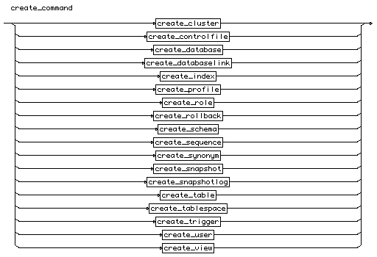  
[[rule list]](http://cui.unige.ch/db-research/Enseignement/analyseinfo/SQL7/BNFindex.html)

# create\_cluster

create\_cluster

::=

**"create"** **"cluster"** [ [schema\_name](http://cui.unige.ch/db-research/Enseignement/analyseinfo/SQL7/schema_name.html) **"."** ] [cluster\_name](http://cui.unige.ch/db-research/Enseignement/analyseinfo/SQL7/cluster_name.html)

**"("** [column\_name](http://cui.unige.ch/db-research/Enseignement/analyseinfo/SQL7/column_name.html) [datatype](http://cui.unige.ch/db-research/Enseignement/analyseinfo/SQL7/datatype.html) { **","** [column\_name](http://cui.unige.ch/db-research/Enseignement/analyseinfo/SQL7/column_name.html) [datatype](http://cui.unige.ch/db-research/Enseignement/analyseinfo/SQL7/datatype.html) } **")"**

[create\_cluster\_spec](http://cui.unige.ch/db-research/Enseignement/analyseinfo/SQL7/create_cluster_spec.html) { [create\_cluster\_spec](http://cui.unige.ch/db-research/Enseignement/analyseinfo/SQL7/create_cluster_spec.html) }

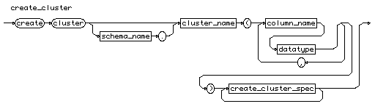  
[[rule list]](http://cui.unige.ch/db-research/Enseignement/analyseinfo/SQL7/BNFindex.html)

# datatype

datatype

::=

[character\_type](http://cui.unige.ch/db-research/Enseignement/analyseinfo/SQL7/character_type.html)

| [date\_type](http://cui.unige.ch/db-research/Enseignement/analyseinfo/SQL7/date_type.html)

| [float\_type](http://cui.unige.ch/db-research/Enseignement/analyseinfo/SQL7/float_type.html)

| [decimal\_type](http://cui.unige.ch/db-research/Enseignement/analyseinfo/SQL7/decimal_type.html)

| [integer\_type](http://cui.unige.ch/db-research/Enseignement/analyseinfo/SQL7/integer_type.html)

| [binary\_type](http://cui.unige.ch/db-research/Enseignement/analyseinfo/SQL7/binary_type.html)

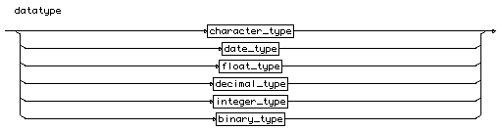  
[[rule list]](http://cui.unige.ch/db-research/Enseignement/analyseinfo/SQL7/BNFindex.html)

# character\_type

character\_type

::=

( ( **"char"** | **"varchar"**

| **"varchar2"** | **"character"** | **"character"** **"varying"** )

**"("** ( [n](http://cui.unige.ch/db-research/Enseignement/analyseinfo/SQL7/n.html) ) **")"** )

| ( **"long"** )

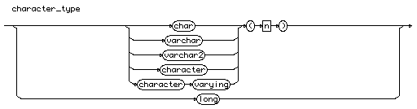  
[[rule list]](http://cui.unige.ch/db-research/Enseignement/analyseinfo/SQL7/BNFindex.html)

# date\_type

date\_type

::=

**"date"**

date_type  
[[rule list]](http://cui.unige.ch/db-research/Enseignement/analyseinfo/SQL7/BNFindex.html)

# float\_type

float\_type

::=

**"number"**

| **"float"** | **"real"** | ( **"double"** **"precision"** )

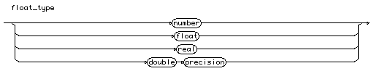  
[[rule list]](http://cui.unige.ch/db-research/Enseignement/analyseinfo/SQL7/BNFindex.html)

# decimal\_type

decimal\_type

::=

( **"number"** **"("** [n](http://cui.unige.ch/db-research/Enseignement/analyseinfo/SQL7/n.html) **","** [n](http://cui.unige.ch/db-research/Enseignement/analyseinfo/SQL7/n.html) **")"** )

| ( **"decimal"** **"("** [n](http://cui.unige.ch/db-research/Enseignement/analyseinfo/SQL7/n.html) **","** [n](http://cui.unige.ch/db-research/Enseignement/analyseinfo/SQL7/n.html) **")"** )

| ( **"dec"** **"("** [n](http://cui.unige.ch/db-research/Enseignement/analyseinfo/SQL7/n.html) **","** [n](http://cui.unige.ch/db-research/Enseignement/analyseinfo/SQL7/n.html) **")"** )

| ( **"numeric"** **"("** [n](http://cui.unige.ch/db-research/Enseignement/analyseinfo/SQL7/n.html) **","** [n](http://cui.unige.ch/db-research/Enseignement/analyseinfo/SQL7/n.html) **")"** )

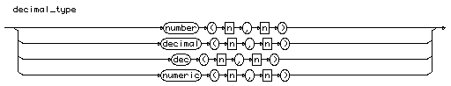  
[[rule list]](http://cui.unige.ch/db-research/Enseignement/analyseinfo/SQL7/BNFindex.html)

# integer\_type

integer\_type

::=

( **"number"** **"("** [n](http://cui.unige.ch/db-research/Enseignement/analyseinfo/SQL7/n.html) **")"** )

| **"integer"**

| **"int"**

| **"smallint"**

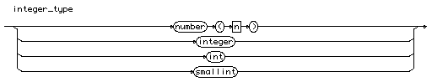  
[[rule list]](http://cui.unige.ch/db-research/Enseignement/analyseinfo/SQL7/BNFindex.html)

# binary\_type

binary\_type

::=

( **"raw"** **"("** [n](http://cui.unige.ch/db-research/Enseignement/analyseinfo/SQL7/n.html) **")"** )

| ( **"rowid"** )

| ( **"long"** **"raw"** )

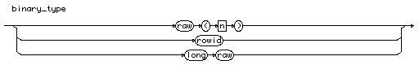  
[[rule list]](http://cui.unige.ch/db-research/Enseignement/analyseinfo/SQL7/BNFindex.html)

# create\_cluster\_spec

create\_cluster\_spec

::=

( **"pctused"** [n](http://cui.unige.ch/db-research/Enseignement/analyseinfo/SQL7/n.html) ) | ( **"pctfree"** [n](http://cui.unige.ch/db-research/Enseignement/analyseinfo/SQL7/n.html) )

| ( **"size"** [n](http://cui.unige.ch/db-research/Enseignement/analyseinfo/SQL7/n.html) [ **"k"** | **"m"** ] )

| ( **"initrans"** [n](http://cui.unige.ch/db-research/Enseignement/analyseinfo/SQL7/n.html) ) | ( **"maxtrans"** [n](http://cui.unige.ch/db-research/Enseignement/analyseinfo/SQL7/n.html) )

| ( **"tablespace"** [tablespace\_name](http://cui.unige.ch/db-research/Enseignement/analyseinfo/SQL7/tablespace_name.html) )

| ( **"storage"** **"("** [storage\_spec](http://cui.unige.ch/db-research/Enseignement/analyseinfo/SQL7/storage_spec.html) { [storage\_spec](http://cui.unige.ch/db-research/Enseignement/analyseinfo/SQL7/storage_spec.html) } **")"** )

| ( **"index"** )

| ( [ **"hash"** **"is"** [column\_name](http://cui.unige.ch/db-research/Enseignement/analyseinfo/SQL7/column_name.html) ] **"hashkeys"** [n](http://cui.unige.ch/db-research/Enseignement/analyseinfo/SQL7/n.html) )

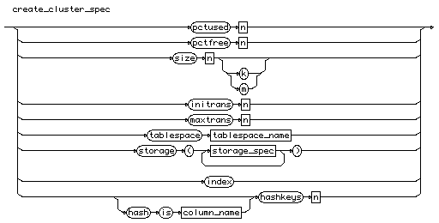  
[[rule list]](http://cui.unige.ch/db-research/Enseignement/analyseinfo/SQL7/BNFindex.html)

# tablespace\_name

tablespace\_name

::= [identifier](http://cui.unige.ch/db-research/Enseignement/analyseinfo/SQL7/identifier.html)

tablespace_name  
[[rule list]](http://cui.unige.ch/db-research/Enseignement/analyseinfo/SQL7/BNFindex.html)

# storage\_spec

storage\_spec

::=

( **"initial"** [n](http://cui.unige.ch/db-research/Enseignement/analyseinfo/SQL7/n.html) [ **"k"** | **"m"** ] ) | ( **"next"** [n](http://cui.unige.ch/db-research/Enseignement/analyseinfo/SQL7/n.html) [ **"k"** | **"m"** ] )

| ( **"minextents"** [n](http://cui.unige.ch/db-research/Enseignement/analyseinfo/SQL7/n.html) ) | ( **"maxextents"** [n](http://cui.unige.ch/db-research/Enseignement/analyseinfo/SQL7/n.html) )

| ( **"pctincrease"** [n](http://cui.unige.ch/db-research/Enseignement/analyseinfo/SQL7/n.html) )

| ( **"optimal"** ( **"null"** | ( [n](http://cui.unige.ch/db-research/Enseignement/analyseinfo/SQL7/n.html) [ **"k"** | **"m"** ] ) ) )

| ( **"freelist"** [n](http://cui.unige.ch/db-research/Enseignement/analyseinfo/SQL7/n.html) )

| ( **"freelist"** **"groups"** [n](http://cui.unige.ch/db-research/Enseignement/analyseinfo/SQL7/n.html) )

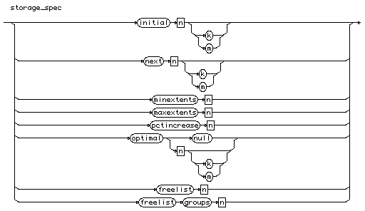  
[[rule list]](http://cui.unige.ch/db-research/Enseignement/analyseinfo/SQL7/BNFindex.html)

# create\_controlfile

create\_controlfile

::=

**"create"** **"controlfile"** [ **"reuse"** ] [ **"set"** ]

**"database"** [database\_name](http://cui.unige.ch/db-research/Enseignement/analyseinfo/SQL7/database_name.html)

**"logfile"** { [group\_file\_spec](http://cui.unige.ch/db-research/Enseignement/analyseinfo/SQL7/group_file_spec.html) } ( **"resetlogs"** **"noresetlogs"** )

**"datafile"** [file\_spec\_list](http://cui.unige.ch/db-research/Enseignement/analyseinfo/SQL7/file_spec_list.html)

{ [controlfile\_spec](http://cui.unige.ch/db-research/Enseignement/analyseinfo/SQL7/controlfile_spec.html) }

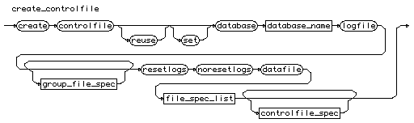  
[[rule list]](http://cui.unige.ch/db-research/Enseignement/analyseinfo/SQL7/BNFindex.html)

# database\_name

database\_name

::= [identifier](http://cui.unige.ch/db-research/Enseignement/analyseinfo/SQL7/identifier.html)

database_name  
[[rule list]](http://cui.unige.ch/db-research/Enseignement/analyseinfo/SQL7/BNFindex.html)

# group\_file\_spec

group\_file\_spec

::=

[ **"group"** [n](http://cui.unige.ch/db-research/Enseignement/analyseinfo/SQL7/n.html) ] [file\_spec\_redo](http://cui.unige.ch/db-research/Enseignement/analyseinfo/SQL7/file_spec_redo.html)

group_file_spec  
[[rule list]](http://cui.unige.ch/db-research/Enseignement/analyseinfo/SQL7/BNFindex.html)

# file\_spec\_redo

file\_spec\_redo

::= ( **"'"** [file\_name](http://cui.unige.ch/db-research/Enseignement/analyseinfo/SQL7/file_name.html) **"'"**

| ( **"("** [file\_list](http://cui.unige.ch/db-research/Enseignement/analyseinfo/SQL7/file_list.html) **")"** ) )

[ **"size"** [n](http://cui.unige.ch/db-research/Enseignement/analyseinfo/SQL7/n.html) [ **"k"** | **"m"** ] ] [ **"reuse"** ]

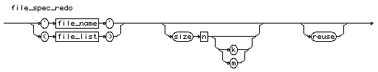  
[[rule list]](http://cui.unige.ch/db-research/Enseignement/analyseinfo/SQL7/BNFindex.html)

# file\_name

file\_name

::= [file\_name\_in\_your\_system](http://cui.unige.ch/db-research/Enseignement/analyseinfo/SQL7/file_name_in_your_system.html)

file_name  
[[rule list]](http://cui.unige.ch/db-research/Enseignement/analyseinfo/SQL7/BNFindex.html)

# file\_list

file\_list

::= **"'"** [file\_name](http://cui.unige.ch/db-research/Enseignement/analyseinfo/SQL7/file_name.html) **"'"** { **","** **"'"** [file\_name](http://cui.unige.ch/db-research/Enseignement/analyseinfo/SQL7/file_name.html) **"'"** }

file_list  
[[rule list]](http://cui.unige.ch/db-research/Enseignement/analyseinfo/SQL7/BNFindex.html)

# file\_spec\_list

file\_spec\_list

::= [file\_spec](http://cui.unige.ch/db-research/Enseignement/analyseinfo/SQL7/file_spec.html) { **","** [file\_spec](http://cui.unige.ch/db-research/Enseignement/analyseinfo/SQL7/file_spec.html) }

file_spec_list  
[[rule list]](http://cui.unige.ch/db-research/Enseignement/analyseinfo/SQL7/BNFindex.html)

# file\_spec

file\_spec

::= **"'"** [file\_name](http://cui.unige.ch/db-research/Enseignement/analyseinfo/SQL7/file_name.html) **"'"** [ **"size"** [n](http://cui.unige.ch/db-research/Enseignement/analyseinfo/SQL7/n.html) [ **"k"** | **"m"** ] ] [ **"reuse"** ]

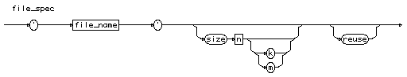  
[[rule list]](http://cui.unige.ch/db-research/Enseignement/analyseinfo/SQL7/BNFindex.html)

# controlfile\_spec

controlfile\_spec

::=

( **"maxlogfiles"** [n](http://cui.unige.ch/db-research/Enseignement/analyseinfo/SQL7/n.html) )

| ( **"maxlogmembers"** [n](http://cui.unige.ch/db-research/Enseignement/analyseinfo/SQL7/n.html) )

| ( **"maxloghistory"** [n](http://cui.unige.ch/db-research/Enseignement/analyseinfo/SQL7/n.html) )

| ( **"maxdatafiles"** [n](http://cui.unige.ch/db-research/Enseignement/analyseinfo/SQL7/n.html) )

| ( **"maxinstances"** [n](http://cui.unige.ch/db-research/Enseignement/analyseinfo/SQL7/n.html) )

| ( **"archivelog"** )

| ( **"noarchivelog"** )

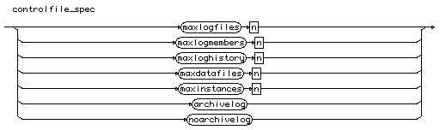  
[[rule list]](http://cui.unige.ch/db-research/Enseignement/analyseinfo/SQL7/BNFindex.html)

# create\_database

create\_database

::=

**"create"** **"database"** [ [database\_name](http://cui.unige.ch/db-research/Enseignement/analyseinfo/SQL7/database_name.html) ]

{ [create\_database\_spec](http://cui.unige.ch/db-research/Enseignement/analyseinfo/SQL7/create_database_spec.html) }

create_database  
[[rule list]](http://cui.unige.ch/db-research/Enseignement/analyseinfo/SQL7/BNFindex.html)

# create\_database\_spec

create\_database\_spec

::=

( **"controlile"** **"reuse"** )

| ( **"logfile"** { [group\_file\_spec](http://cui.unige.ch/db-research/Enseignement/analyseinfo/SQL7/group_file_spec.html) } )

| ( **"maxlogfiles"** [n](http://cui.unige.ch/db-research/Enseignement/analyseinfo/SQL7/n.html) )

| ( **"maxlogmembers"** [n](http://cui.unige.ch/db-research/Enseignement/analyseinfo/SQL7/n.html) )

| ( **"maxloghistory"** [n](http://cui.unige.ch/db-research/Enseignement/analyseinfo/SQL7/n.html) )

| ( **"datafile"** [file\_spec\_list](http://cui.unige.ch/db-research/Enseignement/analyseinfo/SQL7/file_spec_list.html) )

| ( **"maxdatafiles"** [n](http://cui.unige.ch/db-research/Enseignement/analyseinfo/SQL7/n.html) )

| ( **"maxinstances"** [n](http://cui.unige.ch/db-research/Enseignement/analyseinfo/SQL7/n.html) )

| ( **"archivelog"** | **"noarchivelog"** )

| ( **"character"** **"set"** [char\_set\_name](http://cui.unige.ch/db-research/Enseignement/analyseinfo/SQL7/char_set_name.html) )

| ( **"exclusive"** )

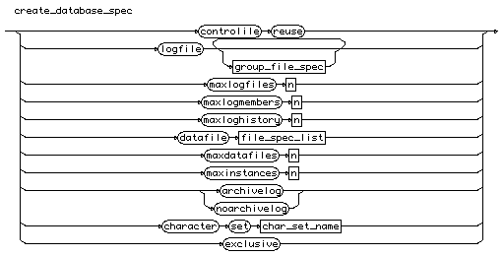  
[[rule list]](http://cui.unige.ch/db-research/Enseignement/analyseinfo/SQL7/BNFindex.html)

# char\_set\_name

char\_set\_name

::= [identifier](http://cui.unige.ch/db-research/Enseignement/analyseinfo/SQL7/identifier.html)

char_set_name  
[[rule list]](http://cui.unige.ch/db-research/Enseignement/analyseinfo/SQL7/BNFindex.html)

# create\_table

create\_table

::=

**"create"** **"table"** [ [schema\_name](http://cui.unige.ch/db-research/Enseignement/analyseinfo/SQL7/schema_name.html) **"."** ] [table\_name](http://cui.unige.ch/db-research/Enseignement/analyseinfo/SQL7/table_name.html)

**"("** ( [new\_column\_list](http://cui.unige.ch/db-research/Enseignement/analyseinfo/SQL7/new_column_list.html) |

[new\_constraint\_list](http://cui.unige.ch/db-research/Enseignement/analyseinfo/SQL7/new_constraint_list.html) ) **")"**

{ [storage\_parameter](http://cui.unige.ch/db-research/Enseignement/analyseinfo/SQL7/storage_parameter.html) }

[ ( **"cluster"** [cluster\_name](http://cui.unige.ch/db-research/Enseignement/analyseinfo/SQL7/cluster_name.html) **"("** [column\_list](http://cui.unige.ch/db-research/Enseignement/analyseinfo/SQL7/column_list.html) **")"** ) ]

[ **"enable"** [enable\_spec](http://cui.unige.ch/db-research/Enseignement/analyseinfo/SQL7/enable_spec.html) ]

[ **"disable"** [disable\_spec](http://cui.unige.ch/db-research/Enseignement/analyseinfo/SQL7/disable_spec.html) ]

[ **"as"** [query](http://cui.unige.ch/db-research/Enseignement/analyseinfo/SQL7/query.html) ]

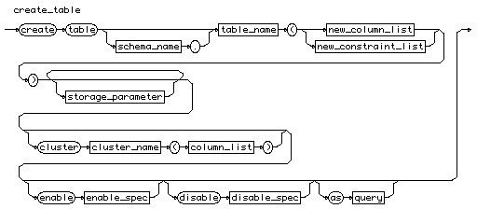  
[[rule list]](http://cui.unige.ch/db-research/Enseignement/analyseinfo/SQL7/BNFindex.html)

# new\_column\_list

new\_column\_list

::=

[column\_name](http://cui.unige.ch/db-research/Enseignement/analyseinfo/SQL7/column_name.html) [datatype](http://cui.unige.ch/db-research/Enseignement/analyseinfo/SQL7/datatype.html) [ **"default"** [expression](http://cui.unige.ch/db-research/Enseignement/analyseinfo/SQL7/expression.html) ]

{ [column\_constraint](http://cui.unige.ch/db-research/Enseignement/analyseinfo/SQL7/column_constraint.html) }

{ **","** [column\_name](http://cui.unige.ch/db-research/Enseignement/analyseinfo/SQL7/column_name.html) [datatype](http://cui.unige.ch/db-research/Enseignement/analyseinfo/SQL7/datatype.html) [ **"default"** [expression](http://cui.unige.ch/db-research/Enseignement/analyseinfo/SQL7/expression.html) ]

{ [column\_constraint](http://cui.unige.ch/db-research/Enseignement/analyseinfo/SQL7/column_constraint.html) } }

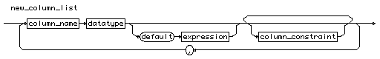  
[[rule list]](http://cui.unige.ch/db-research/Enseignement/analyseinfo/SQL7/BNFindex.html)

# column\_constraint

column\_constraint

::=

[ **"constraint"** [constraint\_name](http://cui.unige.ch/db-research/Enseignement/analyseinfo/SQL7/constraint_name.html) ] [def\_column\_constraint](http://cui.unige.ch/db-research/Enseignement/analyseinfo/SQL7/def_column_constraint.html)

column_constraint  
[[rule list]](http://cui.unige.ch/db-research/Enseignement/analyseinfo/SQL7/BNFindex.html)

# def\_column\_constraint

def\_column\_constraint

::=

( ( [ **"not"** ] **"null"** )

| ( **"unique"** | ( **"primary"** **"key"** ) )

| ( **"references"** [ [schema\_name](http://cui.unige.ch/db-research/Enseignement/analyseinfo/SQL7/schema_name.html) **"."** ] [table\_name](http://cui.unige.ch/db-research/Enseignement/analyseinfo/SQL7/table_name.html)

[ **"("** [column\_name](http://cui.unige.ch/db-research/Enseignement/analyseinfo/SQL7/column_name.html) **")"** ]

[ **"on"** **"delete"** **"cascade"** ] )

| ( **"chek"** **"("** [condition](http://cui.unige.ch/db-research/Enseignement/analyseinfo/SQL7/condition.html) **")"** )

| ( [ **"using"** **"index"** [index\_storage](http://cui.unige.ch/db-research/Enseignement/analyseinfo/SQL7/index_storage.html) { [index\_storage](http://cui.unige.ch/db-research/Enseignement/analyseinfo/SQL7/index_storage.html) } ]

[ **"exceptions"** **"into"** [ [schema\_name](http://cui.unige.ch/db-research/Enseignement/analyseinfo/SQL7/schema_name.html) **"."** ] [table\_name](http://cui.unige.ch/db-research/Enseignement/analyseinfo/SQL7/table_name.html) ] )

| ( **"disable"** )

)

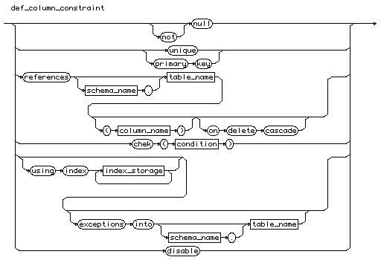  
[[rule list]](http://cui.unige.ch/db-research/Enseignement/analyseinfo/SQL7/BNFindex.html)

# index\_storage

index\_storage

::=

( **"pctfree"** [n](http://cui.unige.ch/db-research/Enseignement/analyseinfo/SQL7/n.html) )

| ( **"initrans"** [n](http://cui.unige.ch/db-research/Enseignement/analyseinfo/SQL7/n.html) ) | ( **"maxtrans"** [n](http://cui.unige.ch/db-research/Enseignement/analyseinfo/SQL7/n.html) )

| ( **"tablespace"** [tablespace\_name](http://cui.unige.ch/db-research/Enseignement/analyseinfo/SQL7/tablespace_name.html) )

| ( **"storage"** **"("** [storage\_spec](http://cui.unige.ch/db-research/Enseignement/analyseinfo/SQL7/storage_spec.html) { [storage\_spec](http://cui.unige.ch/db-research/Enseignement/analyseinfo/SQL7/storage_spec.html) } **")"** )

| ( **"nosort"** )

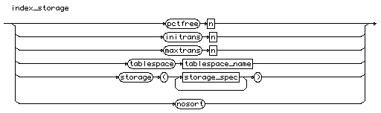  
[[rule list]](http://cui.unige.ch/db-research/Enseignement/analyseinfo/SQL7/BNFindex.html)

# new\_constraint\_list

new\_constraint\_list

::=

[table\_constraint](http://cui.unige.ch/db-research/Enseignement/analyseinfo/SQL7/table_constraint.html) { **","** [table\_constraint](http://cui.unige.ch/db-research/Enseignement/analyseinfo/SQL7/table_constraint.html) }

new_constraint_list  
[[rule list]](http://cui.unige.ch/db-research/Enseignement/analyseinfo/SQL7/BNFindex.html)

# table\_constraint

table\_constraint

::=

[ **"constraint"** [constraint\_name](http://cui.unige.ch/db-research/Enseignement/analyseinfo/SQL7/constraint_name.html) ] [def\_table\_constraint](http://cui.unige.ch/db-research/Enseignement/analyseinfo/SQL7/def_table_constraint.html)

table_constraint  
[[rule list]](http://cui.unige.ch/db-research/Enseignement/analyseinfo/SQL7/BNFindex.html)

# def\_table\_constraint

def\_table\_constraint

::=

( ( ( **"unique"** | ( **"primary"** **"key"** ) ) **"("** [column\_list](http://cui.unige.ch/db-research/Enseignement/analyseinfo/SQL7/column_list.html) **")"** )

| ( **"foreign"** **"key"** **"("** [column\_list](http://cui.unige.ch/db-research/Enseignement/analyseinfo/SQL7/column_list.html) **")"**

**"references"** [ [schema\_name](http://cui.unige.ch/db-research/Enseignement/analyseinfo/SQL7/schema_name.html) **"."** ] [table\_name](http://cui.unige.ch/db-research/Enseignement/analyseinfo/SQL7/table_name.html)

[ **"("** [column\_list](http://cui.unige.ch/db-research/Enseignement/analyseinfo/SQL7/column_list.html) **")"** ]

[ **"on"** **"delete"** **"cascade"** ] )

| ( **"chek"** **"("** [condition](http://cui.unige.ch/db-research/Enseignement/analyseinfo/SQL7/condition.html) **")"** )

| ( [ **"using"** **"index"** [index\_storage](http://cui.unige.ch/db-research/Enseignement/analyseinfo/SQL7/index_storage.html) { [index\_storage](http://cui.unige.ch/db-research/Enseignement/analyseinfo/SQL7/index_storage.html) } ]

[ **"exceptions"** **"into"** [ [schema\_name](http://cui.unige.ch/db-research/Enseignement/analyseinfo/SQL7/schema_name.html) **"."** ] [table\_name](http://cui.unige.ch/db-research/Enseignement/analyseinfo/SQL7/table_name.html) ] )

| ( **"disable"** )

)

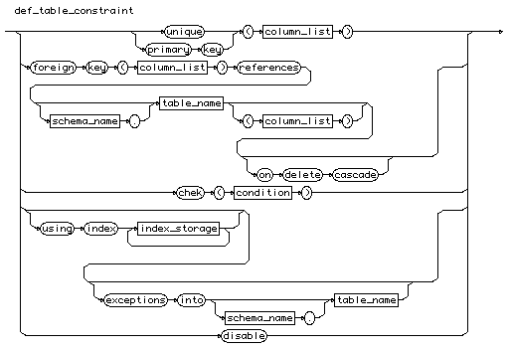  
[[rule list]](http://cui.unige.ch/db-research/Enseignement/analyseinfo/SQL7/BNFindex.html)

# storage\_parameter

storage\_parameter

::=

( ( **"pctfree"** [n](http://cui.unige.ch/db-research/Enseignement/analyseinfo/SQL7/n.html) )

| ( **"pctused"** [n](http://cui.unige.ch/db-research/Enseignement/analyseinfo/SQL7/n.html) )

| ( **"initrans"** [n](http://cui.unige.ch/db-research/Enseignement/analyseinfo/SQL7/n.html) )

| ( **"maxtrans"** [n](http://cui.unige.ch/db-research/Enseignement/analyseinfo/SQL7/n.html) )

| ( **"storage"** **"("** [storage\_spec](http://cui.unige.ch/db-research/Enseignement/analyseinfo/SQL7/storage_spec.html) { [storage\_spec](http://cui.unige.ch/db-research/Enseignement/analyseinfo/SQL7/storage_spec.html) } **")"** ) )

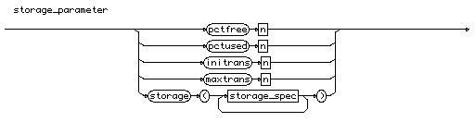  
[[rule list]](http://cui.unige.ch/db-research/Enseignement/analyseinfo/SQL7/BNFindex.html)

# enable\_spec

enable\_spec

::=

( ( ( **"unique"** **"("** [column\_list](http://cui.unige.ch/db-research/Enseignement/analyseinfo/SQL7/column_list.html) **")"** )

| ( **"primary"** **"key"** )

| ( **"constraint"** [constraint\_name](http://cui.unige.ch/db-research/Enseignement/analyseinfo/SQL7/constraint_name.html) ) )

[ **"using"** **"index"** [index\_storage](http://cui.unige.ch/db-research/Enseignement/analyseinfo/SQL7/index_storage.html) { [index\_storage](http://cui.unige.ch/db-research/Enseignement/analyseinfo/SQL7/index_storage.html) } ]

[ **"exceptions"** **"into"** [ [schema\_name](http://cui.unige.ch/db-research/Enseignement/analyseinfo/SQL7/schema_name.html) **"."** ] [table\_name](http://cui.unige.ch/db-research/Enseignement/analyseinfo/SQL7/table_name.html) ] )

| ( **"all"** **"triggers"** )

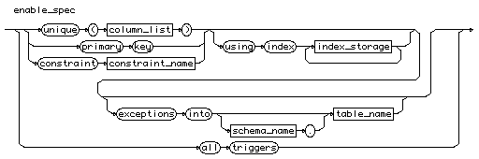  
[[rule list]](http://cui.unige.ch/db-research/Enseignement/analyseinfo/SQL7/BNFindex.html)

# disable\_spec

disable\_spec

::=

( ( **"unique"**

| ( **"primary"** **"key"** )

| ( **"constraint"** [constraint\_name](http://cui.unige.ch/db-research/Enseignement/analyseinfo/SQL7/constraint_name.html) ) )

[ **"cascade"** ] )

| ( **"all"** **"triggers"** )

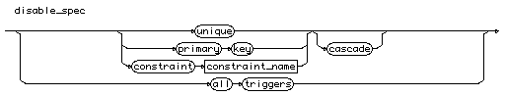  
[[rule list]](http://cui.unige.ch/db-research/Enseignement/analyseinfo/SQL7/BNFindex.html)

# create\_index

create\_index

::=

**"create"** **"index"** [ [schema\_name](http://cui.unige.ch/db-research/Enseignement/analyseinfo/SQL7/schema_name.html) **"."** ] [index\_name](http://cui.unige.ch/db-research/Enseignement/analyseinfo/SQL7/index_name.html) **"on"**

( ( [table\_name](http://cui.unige.ch/db-research/Enseignement/analyseinfo/SQL7/table_name.html) **"("** [indexed\_column](http://cui.unige.ch/db-research/Enseignement/analyseinfo/SQL7/indexed_column.html) **")"** )

| ( **"cluster"** [ [schema\_name](http://cui.unige.ch/db-research/Enseignement/analyseinfo/SQL7/schema_name.html) **"."** ] [cluster\_name](http://cui.unige.ch/db-research/Enseignement/analyseinfo/SQL7/cluster_name.html) ) )

{ [index\_storage](http://cui.unige.ch/db-research/Enseignement/analyseinfo/SQL7/index_storage.html) }

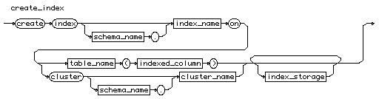  
[[rule list]](http://cui.unige.ch/db-research/Enseignement/analyseinfo/SQL7/BNFindex.html)

# index\_name

index\_name

::= [identifier](http://cui.unige.ch/db-research/Enseignement/analyseinfo/SQL7/identifier.html)

index_name  
[[rule list]](http://cui.unige.ch/db-research/Enseignement/analyseinfo/SQL7/BNFindex.html)

# create\_schema

create\_schema

::=

**"create"** **"schema"** **"authorization"** [schema\_name](http://cui.unige.ch/db-research/Enseignement/analyseinfo/SQL7/schema_name.html)

{ [create\_table](http://cui.unige.ch/db-research/Enseignement/analyseinfo/SQL7/create_table.html) | [create\_view](http://cui.unige.ch/db-research/Enseignement/analyseinfo/SQL7/create_view.html) | [grant\_command](http://cui.unige.ch/db-research/Enseignement/analyseinfo/SQL7/grant_command.html) }

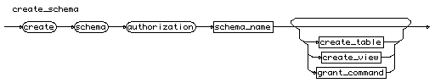  
[[rule list]](http://cui.unige.ch/db-research/Enseignement/analyseinfo/SQL7/BNFindex.html)

# create\_view

create\_view

::=

**"create"** [ **"or"** **"replace"** ] [ **"force"** | **"noforce"** ] **"view"**

[ [schema\_name](http://cui.unige.ch/db-research/Enseignement/analyseinfo/SQL7/schema_name.html) **"."** ] [view\_name](http://cui.unige.ch/db-research/Enseignement/analyseinfo/SQL7/view_name.html)

[ **"("** [alias](http://cui.unige.ch/db-research/Enseignement/analyseinfo/SQL7/alias.html) { **","** [alias](http://cui.unige.ch/db-research/Enseignement/analyseinfo/SQL7/alias.html) } **")"** ]

**"as"** [query](http://cui.unige.ch/db-research/Enseignement/analyseinfo/SQL7/query.html)

[ **"with"** **"check"** **"option"** [ **"constraint"** [constraint\_name](http://cui.unige.ch/db-research/Enseignement/analyseinfo/SQL7/constraint_name.html) ] ]

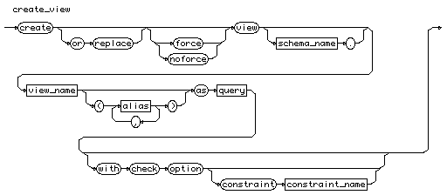  
[[rule list]](http://cui.unige.ch/db-research/Enseignement/analyseinfo/SQL7/BNFindex.html)

# grant\_command

grant\_command

::=

[grant\_priv](http://cui.unige.ch/db-research/Enseignement/analyseinfo/SQL7/grant_priv.html)

| [grant\_object](http://cui.unige.ch/db-research/Enseignement/analyseinfo/SQL7/grant_object.html)

grant_command  
[[rule list]](http://cui.unige.ch/db-research/Enseignement/analyseinfo/SQL7/BNFindex.html)

# grant\_priv

grant\_priv

::=

**"grant"** ( [priv\_granted](http://cui.unige.ch/db-research/Enseignement/analyseinfo/SQL7/priv_granted.html) { **","** [priv\_granted](http://cui.unige.ch/db-research/Enseignement/analyseinfo/SQL7/priv_granted.html) } )

**"to"** [distribution\_list](http://cui.unige.ch/db-research/Enseignement/analyseinfo/SQL7/distribution_list.html)

[ **"with"** **"admin"** **"option"** ]

grant_priv  
[[rule list]](http://cui.unige.ch/db-research/Enseignement/analyseinfo/SQL7/BNFindex.html)

# distribution\_list

distribution\_list

::=

( [user\_name](http://cui.unige.ch/db-research/Enseignement/analyseinfo/SQL7/user_name.html) | [role\_name](http://cui.unige.ch/db-research/Enseignement/analyseinfo/SQL7/role_name.html) | **"public"** )

{ **","** ( [user\_name](http://cui.unige.ch/db-research/Enseignement/analyseinfo/SQL7/user_name.html) | [role\_name](http://cui.unige.ch/db-research/Enseignement/analyseinfo/SQL7/role_name.html) | **"public"** ) }

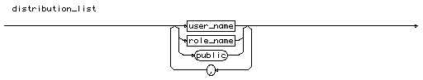  
[[rule list]](http://cui.unige.ch/db-research/Enseignement/analyseinfo/SQL7/BNFindex.html)

# user\_name

user\_name

::= [identifier](http://cui.unige.ch/db-research/Enseignement/analyseinfo/SQL7/identifier.html)

user_name  
[[rule list]](http://cui.unige.ch/db-research/Enseignement/analyseinfo/SQL7/BNFindex.html)

# grant\_object

grant\_object

::=

**"grant"** ( ( [privilege](http://cui.unige.ch/db-research/Enseignement/analyseinfo/SQL7/privilege.html) { **","** [privilege](http://cui.unige.ch/db-research/Enseignement/analyseinfo/SQL7/privilege.html) } )

| **"all"** [ **"privilege"** ] )

[ **"("** [column\_list](http://cui.unige.ch/db-research/Enseignement/analyseinfo/SQL7/column_list.html) **")"** ]

**"on"** ( [ [schema\_name](http://cui.unige.ch/db-research/Enseignement/analyseinfo/SQL7/schema_name.html) **"."** ] **"object\_name"** )

**"to"** [distribution\_list](http://cui.unige.ch/db-research/Enseignement/analyseinfo/SQL7/distribution_list.html) [ **"with"** **"grant"** **"option"** ]

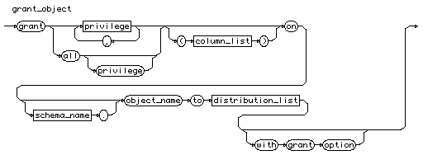  
[[rule list]](http://cui.unige.ch/db-research/Enseignement/analyseinfo/SQL7/BNFindex.html)

# privilege

privilege

::=

[table\_privilege](http://cui.unige.ch/db-research/Enseignement/analyseinfo/SQL7/table_privilege.html) | [view\_privilege](http://cui.unige.ch/db-research/Enseignement/analyseinfo/SQL7/view_privilege.html) | [sequence\_privilege](http://cui.unige.ch/db-research/Enseignement/analyseinfo/SQL7/sequence_privilege.html)

[prog\_privilege](http://cui.unige.ch/db-research/Enseignement/analyseinfo/SQL7/prog_privilege.html) | [snapshot\_privilege](http://cui.unige.ch/db-research/Enseignement/analyseinfo/SQL7/snapshot_privilege.html)

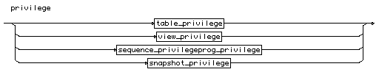  
[[rule list]](http://cui.unige.ch/db-research/Enseignement/analyseinfo/SQL7/BNFindex.html)

# table\_privilege

table\_privilege

::=

**"alter"** | **"delete"**

| **"index"** | **"insert"** | **"references"** | **"select"**

| **"update"**

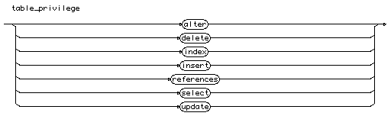  
[[rule list]](http://cui.unige.ch/db-research/Enseignement/analyseinfo/SQL7/BNFindex.html)

# view\_privilege

view\_privilege

::=

**"delete"** | **"insert"** | **"select"**

| **"update"**

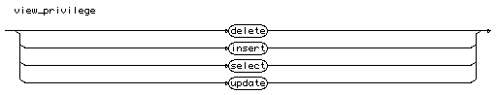  
[[rule list]](http://cui.unige.ch/db-research/Enseignement/analyseinfo/SQL7/BNFindex.html)

# sequence\_privilege

sequence\_privilege

::=

**"alter"** | **"select"**

sequence_privilege  
[[rule list]](http://cui.unige.ch/db-research/Enseignement/analyseinfo/SQL7/BNFindex.html)

# prog\_privilege

prog\_privilege

::=

**"execute"**

prog_privilege  
[[rule list]](http://cui.unige.ch/db-research/Enseignement/analyseinfo/SQL7/BNFindex.html)

# snapshot\_privilege

snapshot\_privilege

::=

**"select"**

snapshot_privilege  
[[rule list]](http://cui.unige.ch/db-research/Enseignement/analyseinfo/SQL7/BNFindex.html)

# create\_sequence

create\_sequence

::=

**"create"** **"sequence"** [ [schema\_name](http://cui.unige.ch/db-research/Enseignement/analyseinfo/SQL7/schema_name.html) **"."** ] [sequence\_name](http://cui.unige.ch/db-research/Enseignement/analyseinfo/SQL7/sequence_name.html)

[create\_sequence\_spec](http://cui.unige.ch/db-research/Enseignement/analyseinfo/SQL7/create_sequence_spec.html) { [create\_sequence\_spec](http://cui.unige.ch/db-research/Enseignement/analyseinfo/SQL7/create_sequence_spec.html) }

create_sequence  
[[rule list]](http://cui.unige.ch/db-research/Enseignement/analyseinfo/SQL7/BNFindex.html)

# sequence\_name

sequence\_name

::= [identifier](http://cui.unige.ch/db-research/Enseignement/analyseinfo/SQL7/identifier.html)

sequence_name  
[[rule list]](http://cui.unige.ch/db-research/Enseignement/analyseinfo/SQL7/BNFindex.html)

# create\_sequence\_spec

create\_sequence\_spec

::=

( ( **"increment"** **"by"** [n](http://cui.unige.ch/db-research/Enseignement/analyseinfo/SQL7/n.html) )

| ( **"start"** **"with"** [n](http://cui.unige.ch/db-research/Enseignement/analyseinfo/SQL7/n.html) )

| ( **"maxvalue"** [n](http://cui.unige.ch/db-research/Enseignement/analyseinfo/SQL7/n.html) ) | ( **"nomaxvalue"** )

| ( **"minvalue"** [n](http://cui.unige.ch/db-research/Enseignement/analyseinfo/SQL7/n.html) ) | ( **"nominvalue"** )

| ( **"cycle"** | **"nocycle"** )

| ( **"cache"** [n](http://cui.unige.ch/db-research/Enseignement/analyseinfo/SQL7/n.html) ) | ( **"nocache"** )

| ( **"order"** | **"noorder"** ) )

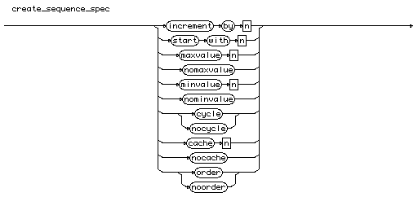  
[[rule list]](http://cui.unige.ch/db-research/Enseignement/analyseinfo/SQL7/BNFindex.html)

# explain\_command

explain\_command

::=

**"explain"** **"plan"**

[ **"set"** **"statement\_id"** **"="** [quoted\_string](http://cui.unige.ch/db-research/Enseignement/analyseinfo/SQL7/quoted_string.html) ]

[ **"into"** [ [schema\_name](http://cui.unige.ch/db-research/Enseignement/analyseinfo/SQL7/schema_name.html) **"."** ] [table\_name](http://cui.unige.ch/db-research/Enseignement/analyseinfo/SQL7/table_name.html) [ **"@"** [link\_name](http://cui.unige.ch/db-research/Enseignement/analyseinfo/SQL7/link_name.html) ] ]

**"for"**

( [select\_command](http://cui.unige.ch/db-research/Enseignement/analyseinfo/SQL7/select_command.html)

| [insert\_command](http://cui.unige.ch/db-research/Enseignement/analyseinfo/SQL7/insert_command.html)

| [update\_command](http://cui.unige.ch/db-research/Enseignement/analyseinfo/SQL7/update_command.html)

| [delete\_command](http://cui.unige.ch/db-research/Enseignement/analyseinfo/SQL7/delete_command.html) )

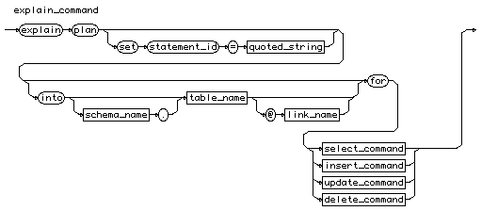  
[[rule list]](http://cui.unige.ch/db-research/Enseignement/analyseinfo/SQL7/BNFindex.html)

# drop\_command

drop\_command

::=

[drop\_cluster](http://cui.unige.ch/db-research/Enseignement/analyseinfo/SQL7/drop_cluster.html)

| [drop\_databaselink](http://cui.unige.ch/db-research/Enseignement/analyseinfo/SQL7/drop_databaselink.html)

| [drop\_index](http://cui.unige.ch/db-research/Enseignement/analyseinfo/SQL7/drop_index.html)

| [drop\_profile](http://cui.unige.ch/db-research/Enseignement/analyseinfo/SQL7/drop_profile.html)

| [drop\_role](http://cui.unige.ch/db-research/Enseignement/analyseinfo/SQL7/drop_role.html)

| [drop\_rollback](http://cui.unige.ch/db-research/Enseignement/analyseinfo/SQL7/drop_rollback.html)

| [drop\_snapshot](http://cui.unige.ch/db-research/Enseignement/analyseinfo/SQL7/drop_snapshot.html)

| [drop\_snapshotlog](http://cui.unige.ch/db-research/Enseignement/analyseinfo/SQL7/drop_snapshotlog.html)

| [drop\_sequence](http://cui.unige.ch/db-research/Enseignement/analyseinfo/SQL7/drop_sequence.html)

| [drop\_synonym](http://cui.unige.ch/db-research/Enseignement/analyseinfo/SQL7/drop_synonym.html)

| [drop\_table](http://cui.unige.ch/db-research/Enseignement/analyseinfo/SQL7/drop_table.html)

| [drop\_tablespace](http://cui.unige.ch/db-research/Enseignement/analyseinfo/SQL7/drop_tablespace.html)

| [drop\_trigger](http://cui.unige.ch/db-research/Enseignement/analyseinfo/SQL7/drop_trigger.html)

| [drop\_user](http://cui.unige.ch/db-research/Enseignement/analyseinfo/SQL7/drop_user.html)

| [drop\_view](http://cui.unige.ch/db-research/Enseignement/analyseinfo/SQL7/drop_view.html)

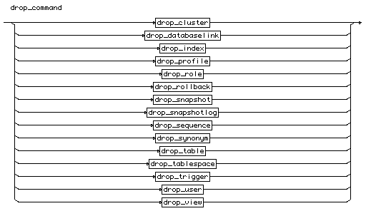  
[[rule list]](http://cui.unige.ch/db-research/Enseignement/analyseinfo/SQL7/BNFindex.html)

# allocate\_spec

allocate\_spec

::=

( **"size"** [n](http://cui.unige.ch/db-research/Enseignement/analyseinfo/SQL7/n.html) [ **"k"** | **"m"** ] )

| ( **"datafile"** **"'"** [file\_name](http://cui.unige.ch/db-research/Enseignement/analyseinfo/SQL7/file_name.html) **"'"** )

| ( **"instance"** [n](http://cui.unige.ch/db-research/Enseignement/analyseinfo/SQL7/n.html) )

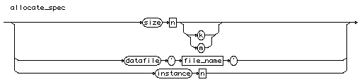  
[[rule list]](http://cui.unige.ch/db-research/Enseignement/analyseinfo/SQL7/BNFindex.html)

# alter\_cluster

alter\_cluster

::=

**"alter"** **"cluster"** [ [schema\_name](http://cui.unige.ch/db-research/Enseignement/analyseinfo/SQL7/schema_name.html) **"."** ] [cluster\_name](http://cui.unige.ch/db-research/Enseignement/analyseinfo/SQL7/cluster_name.html)

[alter\_cluster\_spec](http://cui.unige.ch/db-research/Enseignement/analyseinfo/SQL7/alter_cluster_spec.html) { [alter\_cluster\_spec](http://cui.unige.ch/db-research/Enseignement/analyseinfo/SQL7/alter_cluster_spec.html) }

alter_cluster  
[[rule list]](http://cui.unige.ch/db-research/Enseignement/analyseinfo/SQL7/BNFindex.html)

# alter\_cluster\_spec

alter\_cluster\_spec

::=

( **"pctused"** [n](http://cui.unige.ch/db-research/Enseignement/analyseinfo/SQL7/n.html) ) | ( **"pctfree"** [n](http://cui.unige.ch/db-research/Enseignement/analyseinfo/SQL7/n.html) )

| ( **"size"** [n](http://cui.unige.ch/db-research/Enseignement/analyseinfo/SQL7/n.html) [ **"k"** | **"m"** ] )

| ( **"initrans"** [n](http://cui.unige.ch/db-research/Enseignement/analyseinfo/SQL7/n.html) ) | ( **"maxtrans"** [n](http://cui.unige.ch/db-research/Enseignement/analyseinfo/SQL7/n.html) )

| ( **"storage"** **"("** [storage\_spec](http://cui.unige.ch/db-research/Enseignement/analyseinfo/SQL7/storage_spec.html) { [storage\_spec](http://cui.unige.ch/db-research/Enseignement/analyseinfo/SQL7/storage_spec.html) } **")"** )

| ( **"allocate"** **"extent"** { [allocate\_spec](http://cui.unige.ch/db-research/Enseignement/analyseinfo/SQL7/allocate_spec.html) } )

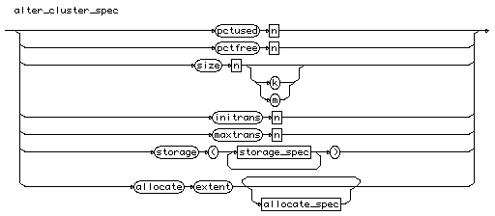  
[[rule list]](http://cui.unige.ch/db-research/Enseignement/analyseinfo/SQL7/BNFindex.html)

# alter\_command

alter\_command

::= [alter\_cluster](http://cui.unige.ch/db-research/Enseignement/analyseinfo/SQL7/alter_cluster.html)

| [alter\_database](http://cui.unige.ch/db-research/Enseignement/analyseinfo/SQL7/alter_database.html)

| [alter\_index](http://cui.unige.ch/db-research/Enseignement/analyseinfo/SQL7/alter_index.html)

| [alter\_profile](http://cui.unige.ch/db-research/Enseignement/analyseinfo/SQL7/alter_profile.html)

| [alter\_cost](http://cui.unige.ch/db-research/Enseignement/analyseinfo/SQL7/alter_cost.html)

| [alter\_role](http://cui.unige.ch/db-research/Enseignement/analyseinfo/SQL7/alter_role.html)

| [alter\_rollback](http://cui.unige.ch/db-research/Enseignement/analyseinfo/SQL7/alter_rollback.html)

| [alter\_sequence](http://cui.unige.ch/db-research/Enseignement/analyseinfo/SQL7/alter_sequence.html)

| [alter\_session](http://cui.unige.ch/db-research/Enseignement/analyseinfo/SQL7/alter_session.html)

| [alter\_snapshot](http://cui.unige.ch/db-research/Enseignement/analyseinfo/SQL7/alter_snapshot.html)

| [alter\_snapshot\_log](http://cui.unige.ch/db-research/Enseignement/analyseinfo/SQL7/alter_snapshot_log.html)

| [alter\_system](http://cui.unige.ch/db-research/Enseignement/analyseinfo/SQL7/alter_system.html)

| [alter\_table](http://cui.unige.ch/db-research/Enseignement/analyseinfo/SQL7/alter_table.html)

| [alter\_tablespace](http://cui.unige.ch/db-research/Enseignement/analyseinfo/SQL7/alter_tablespace.html)

| [alter\_trigger](http://cui.unige.ch/db-research/Enseignement/analyseinfo/SQL7/alter_trigger.html)

| [alter\_user](http://cui.unige.ch/db-research/Enseignement/analyseinfo/SQL7/alter_user.html)

| [alter\_view](http://cui.unige.ch/db-research/Enseignement/analyseinfo/SQL7/alter_view.html)

  
[[rule list]](http://cui.unige.ch/db-research/Enseignement/analyseinfo/SQL7/BNFindex.html)

# alter\_cost

alter\_cost

::=

**"alter"** **"resource"** **"cost"** [resource\_cost\_name](http://cui.unige.ch/db-research/Enseignement/analyseinfo/SQL7/resource_cost_name.html) [n](http://cui.unige.ch/db-research/Enseignement/analyseinfo/SQL7/n.html)

alter_cost  
[[rule list]](http://cui.unige.ch/db-research/Enseignement/analyseinfo/SQL7/BNFindex.html)

# alter\_database

alter\_database

::=

**"alter"** **"database"** [ [database\_name](http://cui.unige.ch/db-research/Enseignement/analyseinfo/SQL7/database_name.html) ]

( ( **"mount"** [ **"parallel"** | **"exclusive"** ] )

| ( **"convert"** )

| ( **"open"** [ **"resetlogs"** | **"noresetlogs"** ] )

| ( **"archive"** | **"noarchive"** )

| ( **"recover"** [recover\_clause](http://cui.unige.ch/db-research/Enseignement/analyseinfo/SQL7/recover_clause.html) )

| ( **"add"** **"logfile"** [logfile\_clause](http://cui.unige.ch/db-research/Enseignement/analyseinfo/SQL7/logfile_clause.html) )

| ( **"add"** **"logfile"** **"member"** [logmember\_clause](http://cui.unige.ch/db-research/Enseignement/analyseinfo/SQL7/logmember_clause.html)

{ **","** [logmember\_clause](http://cui.unige.ch/db-research/Enseignement/analyseinfo/SQL7/logmember_clause.html) } )

| ( **"drop"** **"logfile"** [group\_file\_list](http://cui.unige.ch/db-research/Enseignement/analyseinfo/SQL7/group_file_list.html) )

| ( **"rename"** **"file"** [file\_list](http://cui.unige.ch/db-research/Enseignement/analyseinfo/SQL7/file_list.html)

**"to"** [file\_list](http://cui.unige.ch/db-research/Enseignement/analyseinfo/SQL7/file_list.html) )

| ( **"backup"** **"controlfile"** **"to"** [file\_reuse](http://cui.unige.ch/db-research/Enseignement/analyseinfo/SQL7/file_reuse.html) )

| ( **"create"** **"datafile"** [file\_list](http://cui.unige.ch/db-research/Enseignement/analyseinfo/SQL7/file_list.html) [ **"as"** [file\_spec\_list](http://cui.unige.ch/db-research/Enseignement/analyseinfo/SQL7/file_spec_list.html) ] )

| ( **"datafile"** **"'"** [file\_name](http://cui.unige.ch/db-research/Enseignement/analyseinfo/SQL7/file_name.html) **"'"**

[ **"online"** | ( **"offline"** [ **"drop"** ] ) ] )

| ( **"enable"** [ **"public"** ] **"thread"** [n](http://cui.unige.ch/db-research/Enseignement/analyseinfo/SQL7/n.html) )

| ( **"disable"** **"thread"** [n](http://cui.unige.ch/db-research/Enseignement/analyseinfo/SQL7/n.html) )

| ( **"rename"** **"global\_name"** **"to"** [database\_name](http://cui.unige.ch/db-research/Enseignement/analyseinfo/SQL7/database_name.html)

{ **"."** [domain\_name](http://cui.unige.ch/db-research/Enseignement/analyseinfo/SQL7/domain_name.html) } ) )

  
[[rule list]](http://cui.unige.ch/db-research/Enseignement/analyseinfo/SQL7/BNFindex.html)

# alter\_index

alter\_index

::=

**"alter"** **"index"** [ [schema\_name](http://cui.unige.ch/db-research/Enseignement/analyseinfo/SQL7/schema_name.html) **"."** ] [index\_name](http://cui.unige.ch/db-research/Enseignement/analyseinfo/SQL7/index_name.html)

[alter\_index\_spec](http://cui.unige.ch/db-research/Enseignement/analyseinfo/SQL7/alter_index_spec.html) { [alter\_index\_spec](http://cui.unige.ch/db-research/Enseignement/analyseinfo/SQL7/alter_index_spec.html) }

alter_index  
[[rule list]](http://cui.unige.ch/db-research/Enseignement/analyseinfo/SQL7/BNFindex.html)

# alter\_index\_spec

alter\_index\_spec

::=

( **"initrans"** [n](http://cui.unige.ch/db-research/Enseignement/analyseinfo/SQL7/n.html) )

| ( **"maxtrans"** [n](http://cui.unige.ch/db-research/Enseignement/analyseinfo/SQL7/n.html) )

| ( **"storage"** **"("** [storage\_spec](http://cui.unige.ch/db-research/Enseignement/analyseinfo/SQL7/storage_spec.html) { [storage\_spec](http://cui.unige.ch/db-research/Enseignement/analyseinfo/SQL7/storage_spec.html) } **")"** )

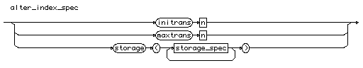  
[[rule list]](http://cui.unige.ch/db-research/Enseignement/analyseinfo/SQL7/BNFindex.html)

# alter\_profile

alter\_profile

::=

**"alter"** **"profile"** [profile\_name](http://cui.unige.ch/db-research/Enseignement/analyseinfo/SQL7/profile_name.html) **"limit"**

[profile\_spec](http://cui.unige.ch/db-research/Enseignement/analyseinfo/SQL7/profile_spec.html) { [profile\_spec](http://cui.unige.ch/db-research/Enseignement/analyseinfo/SQL7/profile_spec.html) }

alter_profile  
[[rule list]](http://cui.unige.ch/db-research/Enseignement/analyseinfo/SQL7/BNFindex.html)

# alter\_role

alter\_role

::=

**"alter"** **"role"** [role\_name](http://cui.unige.ch/db-research/Enseignement/analyseinfo/SQL7/role_name.html)

( ( **"not"** **"identified"** )

| ( **"identified"** ( **"by"** [password](http://cui.unige.ch/db-research/Enseignement/analyseinfo/SQL7/password.html) | **"externally"** ) ) )

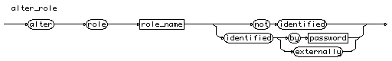  
[[rule list]](http://cui.unige.ch/db-research/Enseignement/analyseinfo/SQL7/BNFindex.html)

# alter\_rollback

alter\_rollback

::=

**"alter"** **"rollback"** **"segment"** [rollback\_name](http://cui.unige.ch/db-research/Enseignement/analyseinfo/SQL7/rollback_name.html)

( **"online"**

| **"offline"**

| ( **"storage"** **"("** [storage\_spec](http://cui.unige.ch/db-research/Enseignement/analyseinfo/SQL7/storage_spec.html) { [storage\_spec](http://cui.unige.ch/db-research/Enseignement/analyseinfo/SQL7/storage_spec.html) } **")"** ) )

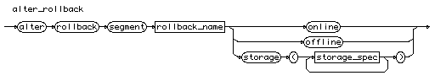  
[[rule list]](http://cui.unige.ch/db-research/Enseignement/analyseinfo/SQL7/BNFindex.html)

# alter\_sequence

alter\_sequence

::=

**"alter"** **"sequence"** [ [schema\_name](http://cui.unige.ch/db-research/Enseignement/analyseinfo/SQL7/schema_name.html) **"."** ] [sequence\_name](http://cui.unige.ch/db-research/Enseignement/analyseinfo/SQL7/sequence_name.html)

[alter\_sequence\_spec](http://cui.unige.ch/db-research/Enseignement/analyseinfo/SQL7/alter_sequence_spec.html) { [alter\_sequence\_spec](http://cui.unige.ch/db-research/Enseignement/analyseinfo/SQL7/alter_sequence_spec.html) }

alter_sequence  
[[rule list]](http://cui.unige.ch/db-research/Enseignement/analyseinfo/SQL7/BNFindex.html)

# alter\_sequence\_spec

alter\_sequence\_spec

::=

( ( **"increment"** **"by"** [n](http://cui.unige.ch/db-research/Enseignement/analyseinfo/SQL7/n.html) )

| ( **"maxvalue"** [n](http://cui.unige.ch/db-research/Enseignement/analyseinfo/SQL7/n.html) ) | ( **"nomaxvalue"** )

| ( **"minvalue"** [n](http://cui.unige.ch/db-research/Enseignement/analyseinfo/SQL7/n.html) ) | ( **"nominvalue"** )

| ( **"cycle"** | **"nocycle"** )

| ( **"cache"** [n](http://cui.unige.ch/db-research/Enseignement/analyseinfo/SQL7/n.html) ) | ( **"nocache"** )

| ( **"order"** | **"noorder"** ) )

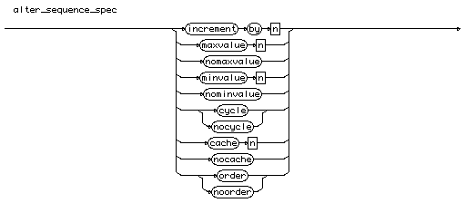  
[[rule list]](http://cui.unige.ch/db-research/Enseignement/analyseinfo/SQL7/BNFindex.html)

# alter\_session

alter\_session

::=

**"alter"** **"session"**

( ( **"set"** [set\_session\_spec](http://cui.unige.ch/db-research/Enseignement/analyseinfo/SQL7/set_session_spec.html) { [set\_session\_spec](http://cui.unige.ch/db-research/Enseignement/analyseinfo/SQL7/set_session_spec.html) } )

| ( **"close"** **"database"** **"link"** [link\_name](http://cui.unige.ch/db-research/Enseignement/analyseinfo/SQL7/link_name.html) )

| ( **"advise"** ( **"commit"** | **"rollback"** | **"nothing"** ) )

| ( ( **"enable"** | **"disable"** ) **"commit"** **"in"** **"procedure"** ) )

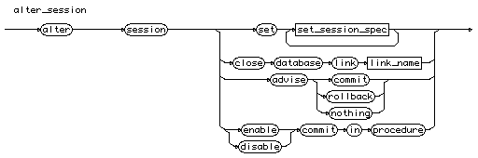  
[[rule list]](http://cui.unige.ch/db-research/Enseignement/analyseinfo/SQL7/BNFindex.html)

# alter\_snapshot

alter\_snapshot

::=

**"alter"** **"snapshot"** [ [schema\_name](http://cui.unige.ch/db-research/Enseignement/analyseinfo/SQL7/schema_name.html) **"."** ] [snapshot\_name](http://cui.unige.ch/db-research/Enseignement/analyseinfo/SQL7/snapshot_name.html)

[storage\_parameter](http://cui.unige.ch/db-research/Enseignement/analyseinfo/SQL7/storage_parameter.html) { [storage\_parameter](http://cui.unige.ch/db-research/Enseignement/analyseinfo/SQL7/storage_parameter.html) }

[ **"refresh"** [ **"fast"** | **"complete"** | **"force"** ]

[ **"start"** **"with"** [date](http://cui.unige.ch/db-research/Enseignement/analyseinfo/SQL7/date.html) ]

[ **"next"** [date](http://cui.unige.ch/db-research/Enseignement/analyseinfo/SQL7/date.html) ] ]

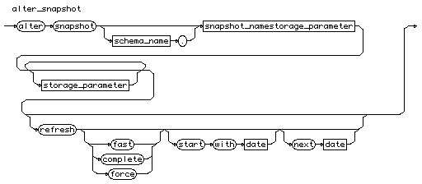  
[[rule list]](http://cui.unige.ch/db-research/Enseignement/analyseinfo/SQL7/BNFindex.html)

# alter\_snapshot\_log

alter\_snapshot\_log

::=

**"alter"** **"snapshot"** **"log"** **"on"** [ [schema\_name](http://cui.unige.ch/db-research/Enseignement/analyseinfo/SQL7/schema_name.html) **"."** ] [table\_name](http://cui.unige.ch/db-research/Enseignement/analyseinfo/SQL7/table_name.html)

[storage\_parameter](http://cui.unige.ch/db-research/Enseignement/analyseinfo/SQL7/storage_parameter.html) { [storage\_parameter](http://cui.unige.ch/db-research/Enseignement/analyseinfo/SQL7/storage_parameter.html) }

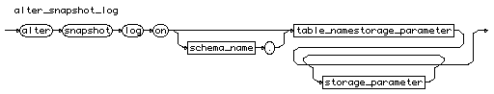  
[[rule list]](http://cui.unige.ch/db-research/Enseignement/analyseinfo/SQL7/BNFindex.html)

# alter\_system

alter\_system

::=

( ( ( **"enable"** | **"disable"** ) **"restricted"** **"session"** )

| ( **"flush"** **"shared\_pool"** )

| ( ( **"checkpoint"** | ( **"check"** **"datafiles"** ) ) [ **"global"** | **"local"** ] )

| ( **"set"** [system\_spec](http://cui.unige.ch/db-research/Enseignement/analyseinfo/SQL7/system_spec.html) { [system\_spec](http://cui.unige.ch/db-research/Enseignement/analyseinfo/SQL7/system_spec.html) } )

| ( **"switch"** **"logfile"** )

| ( ( **"enable"** | **"disable"** ) **"distributed"** **"recovery"** )

| ( **"archive"** **"log"** [archive\_log\_spec](http://cui.unige.ch/db-research/Enseignement/analyseinfo/SQL7/archive_log_spec.html) )

| ( **"kill"** **"session"** [n](http://cui.unige.ch/db-research/Enseignement/analyseinfo/SQL7/n.html) **","** [n](http://cui.unige.ch/db-research/Enseignement/analyseinfo/SQL7/n.html) )

)

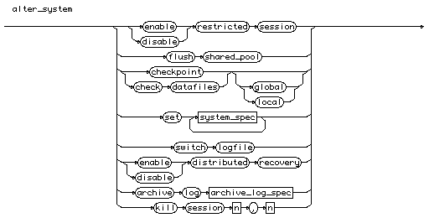  
[[rule list]](http://cui.unige.ch/db-research/Enseignement/analyseinfo/SQL7/BNFindex.html)

# alter\_table

alter\_table

::=

**"alter"** **"table"** [ [schema\_name](http://cui.unige.ch/db-research/Enseignement/analyseinfo/SQL7/schema_name.html) **"."** ] [table\_name](http://cui.unige.ch/db-research/Enseignement/analyseinfo/SQL7/table_name.html)

[alter\_table\_spec](http://cui.unige.ch/db-research/Enseignement/analyseinfo/SQL7/alter_table_spec.html) { [alter\_table\_spec](http://cui.unige.ch/db-research/Enseignement/analyseinfo/SQL7/alter_table_spec.html) }

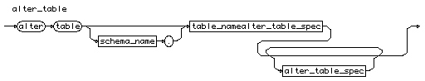  
[[rule list]](http://cui.unige.ch/db-research/Enseignement/analyseinfo/SQL7/BNFindex.html)

# alter\_tablespace

alter\_tablespace

::=

**"alter"** **"tablespace"** [tablespace\_name](http://cui.unige.ch/db-research/Enseignement/analyseinfo/SQL7/tablespace_name.html)

( ( **"add"** **"datafile"** [file\_spec\_list](http://cui.unige.ch/db-research/Enseignement/analyseinfo/SQL7/file_spec_list.html) )

| ( **"rename"** **"datafile"** [file\_list](http://cui.unige.ch/db-research/Enseignement/analyseinfo/SQL7/file_list.html)

**"to"** [file\_list](http://cui.unige.ch/db-research/Enseignement/analyseinfo/SQL7/file_list.html) )

| ( **"default"** **"storage"** [storage\_spec](http://cui.unige.ch/db-research/Enseignement/analyseinfo/SQL7/storage_spec.html) )

| ( [system\_status](http://cui.unige.ch/db-research/Enseignement/analyseinfo/SQL7/system_status.html) ) )

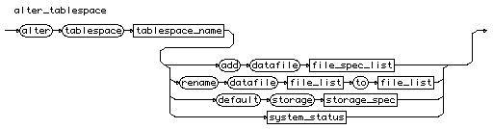  
[[rule list]](http://cui.unige.ch/db-research/Enseignement/analyseinfo/SQL7/BNFindex.html)

# alter\_table\_spec

alter\_table\_spec

::=

( ( **"add"** **"("** ( [new\_column\_list](http://cui.unige.ch/db-research/Enseignement/analyseinfo/SQL7/new_column_list.html)

| [new\_constraint\_list](http://cui.unige.ch/db-research/Enseignement/analyseinfo/SQL7/new_constraint_list.html) ) **")"** )

| ( **"modify"** **"("** [modified\_column\_list](http://cui.unige.ch/db-research/Enseignement/analyseinfo/SQL7/modified_column_list.html) **")"** )

| ( **"drop"** **"constraint"** **"("** [constraint\_list](http://cui.unige.ch/db-research/Enseignement/analyseinfo/SQL7/constraint_list.html) **")"** )

| ( [storage\_parameter](http://cui.unige.ch/db-research/Enseignement/analyseinfo/SQL7/storage_parameter.html) { [storage\_parameter](http://cui.unige.ch/db-research/Enseignement/analyseinfo/SQL7/storage_parameter.html) } )

| ( **"allocate"** **"extent"** { [allocate\_spec](http://cui.unige.ch/db-research/Enseignement/analyseinfo/SQL7/allocate_spec.html) } )

| ( **"enable"** [enable\_spec](http://cui.unige.ch/db-research/Enseignement/analyseinfo/SQL7/enable_spec.html) )

| ( **"disable"** [disable\_spec](http://cui.unige.ch/db-research/Enseignement/analyseinfo/SQL7/disable_spec.html) )

)

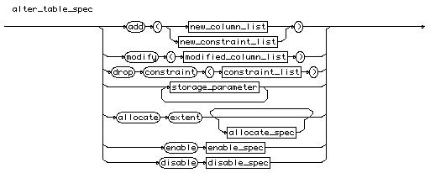  
[[rule list]](http://cui.unige.ch/db-research/Enseignement/analyseinfo/SQL7/BNFindex.html)

# alter\_trigger

alter\_trigger

::=

**"alter"** **"trigger"** [ [schema\_name](http://cui.unige.ch/db-research/Enseignement/analyseinfo/SQL7/schema_name.html) **"."** ] [trigger\_name](http://cui.unige.ch/db-research/Enseignement/analyseinfo/SQL7/trigger_name.html)

( **"enable"** | **"disable"** )

alter_trigger  
[[rule list]](http://cui.unige.ch/db-research/Enseignement/analyseinfo/SQL7/BNFindex.html)

# alter\_user

alter\_user

::=

**"alter"** **"user"** [user\_name](http://cui.unige.ch/db-research/Enseignement/analyseinfo/SQL7/user_name.html)

[alter\_user\_spec](http://cui.unige.ch/db-research/Enseignement/analyseinfo/SQL7/alter_user_spec.html) { [alter\_user\_spec](http://cui.unige.ch/db-research/Enseignement/analyseinfo/SQL7/alter_user_spec.html) }

alter_user  
[[rule list]](http://cui.unige.ch/db-research/Enseignement/analyseinfo/SQL7/BNFindex.html)

# alter\_user\_spec

alter\_user\_spec

::=

( ( **"identified"** **"by"** [password](http://cui.unige.ch/db-research/Enseignement/analyseinfo/SQL7/password.html) )

| ( **"default"** **"tablespace"** [tablespace\_name](http://cui.unige.ch/db-research/Enseignement/analyseinfo/SQL7/tablespace_name.html) )

| ( **"temporary"** **"tablespace"** [tablespace\_name](http://cui.unige.ch/db-research/Enseignement/analyseinfo/SQL7/tablespace_name.html) )

| ( **"quota"** ( ( [n](http://cui.unige.ch/db-research/Enseignement/analyseinfo/SQL7/n.html) **"k"** | **"m"** ) | **"unlimited"** )

**"on"** [tablespace\_name](http://cui.unige.ch/db-research/Enseignement/analyseinfo/SQL7/tablespace_name.html) )

| ( **"profile"** [profile\_name](http://cui.unige.ch/db-research/Enseignement/analyseinfo/SQL7/profile_name.html) )

| ( **"default"** ( [role\_list](http://cui.unige.ch/db-research/Enseignement/analyseinfo/SQL7/role_list.html)

| ( **"all"** [ **"except"** [role\_list](http://cui.unige.ch/db-research/Enseignement/analyseinfo/SQL7/role_list.html) ] )

| **"none"** ) )

)

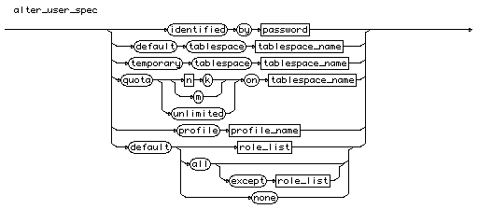  
[[rule list]](http://cui.unige.ch/db-research/Enseignement/analyseinfo/SQL7/BNFindex.html)

# alter\_view

alter\_view

::=

**"alter"** **"view"** [ [schema\_name](http://cui.unige.ch/db-research/Enseignement/analyseinfo/SQL7/schema_name.html) **"."** ] [view\_name](http://cui.unige.ch/db-research/Enseignement/analyseinfo/SQL7/view_name.html) **"compile"**

alter_view  
[[rule list]](http://cui.unige.ch/db-research/Enseignement/analyseinfo/SQL7/BNFindex.html)

# analyze\_command

analyze\_command

::=

**"analyze"**

( ( **"index"** [ [schema\_name](http://cui.unige.ch/db-research/Enseignement/analyseinfo/SQL7/schema_name.html) **"."** ] [index\_name](http://cui.unige.ch/db-research/Enseignement/analyseinfo/SQL7/index_name.html) )

| ( **"table"** [ [schema\_name](http://cui.unige.ch/db-research/Enseignement/analyseinfo/SQL7/schema_name.html) **"."** ] [table\_name](http://cui.unige.ch/db-research/Enseignement/analyseinfo/SQL7/table_name.html) )

| ( **"cluster"** [ [schema\_name](http://cui.unige.ch/db-research/Enseignement/analyseinfo/SQL7/schema_name.html) **"."** ] [cluster\_name](http://cui.unige.ch/db-research/Enseignement/analyseinfo/SQL7/cluster_name.html) )

) [analyze\_spec](http://cui.unige.ch/db-research/Enseignement/analyseinfo/SQL7/analyze_spec.html)

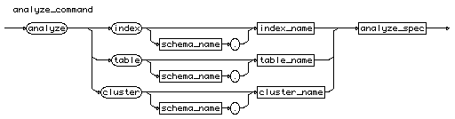  
[[rule list]](http://cui.unige.ch/db-research/Enseignement/analyseinfo/SQL7/BNFindex.html)

# analyze\_spec

analyze\_spec

::=

( ( ( **"compute"**

| ( **"estimate"** [ **"sample"** [n](http://cui.unige.ch/db-research/Enseignement/analyseinfo/SQL7/n.html) ( **"rows"** | **"percent"** ) ] )

| **"delete"**

)

**"statistics"**

)

| ( **"validate"** **"structure"** [ **"cascade"** ] )

| ( **"list"** **"chained"** **"rows"**

[ **"into"** [ [schema\_name](http://cui.unige.ch/db-research/Enseignement/analyseinfo/SQL7/schema_name.html) **"."** ] [table\_name](http://cui.unige.ch/db-research/Enseignement/analyseinfo/SQL7/table_name.html) ] )

)

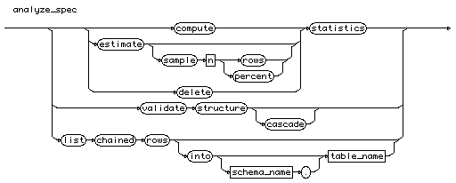  
[[rule list]](http://cui.unige.ch/db-research/Enseignement/analyseinfo/SQL7/BNFindex.html)

# archive\_log\_spec

archive\_log\_spec

::=

[ **"thread"** [n](http://cui.unige.ch/db-research/Enseignement/analyseinfo/SQL7/n.html) ]

**"stop"**

| ( ( ( **"seq"** [n](http://cui.unige.ch/db-research/Enseignement/analyseinfo/SQL7/n.html) )

| ( **"change"** [n](http://cui.unige.ch/db-research/Enseignement/analyseinfo/SQL7/n.html) )

| ( **"current"** )

| ( **"group"** [n](http://cui.unige.ch/db-research/Enseignement/analyseinfo/SQL7/n.html) )

| ( **"logfile"** **"'"** [file\_name](http://cui.unige.ch/db-research/Enseignement/analyseinfo/SQL7/file_name.html) **"'"** )

| ( **"next"** )

| ( **"all"** )

| ( **"start"** )

)

[ **"to"** [location\_name](http://cui.unige.ch/db-research/Enseignement/analyseinfo/SQL7/location_name.html) ] )

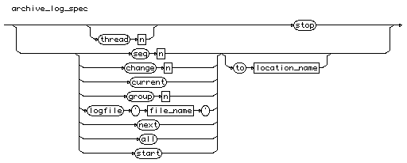  
[[rule list]](http://cui.unige.ch/db-research/Enseignement/analyseinfo/SQL7/BNFindex.html)

# audit\_command

audit\_command

::=

[audit\_sql](http://cui.unige.ch/db-research/Enseignement/analyseinfo/SQL7/audit_sql.html)

| [audit\_object](http://cui.unige.ch/db-research/Enseignement/analyseinfo/SQL7/audit_object.html)

audit_command  
[[rule list]](http://cui.unige.ch/db-research/Enseignement/analyseinfo/SQL7/BNFindex.html)

# audit\_object

audit\_object

::=

**"audit"** ( ( [obj\_command](http://cui.unige.ch/db-research/Enseignement/analyseinfo/SQL7/obj_command.html) { **","** [command](http://cui.unige.ch/db-research/Enseignement/analyseinfo/SQL7/command.html) } ) | **"all"** )

**"on"** ( ( [ [schema\_name](http://cui.unige.ch/db-research/Enseignement/analyseinfo/SQL7/schema_name.html) **"."** ] [object\_name](http://cui.unige.ch/db-research/Enseignement/analyseinfo/SQL7/object_name.html) ) | **"default"** )

[ **"by"** ( **"access"** | **"session"** ) ]

[ **"whenever"** [ **"not"** ] **"successful"** ]

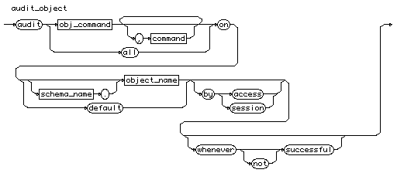  
[[rule list]](http://cui.unige.ch/db-research/Enseignement/analyseinfo/SQL7/BNFindex.html)

# audit\_sql

audit\_sql

::=

**"audit"** ( ( [stat\_command](http://cui.unige.ch/db-research/Enseignement/analyseinfo/SQL7/stat_command.html) { **","** [stat\_command](http://cui.unige.ch/db-research/Enseignement/analyseinfo/SQL7/stat_command.html) } ) | **"all"** )

[ **"by"** [user\_list](http://cui.unige.ch/db-research/Enseignement/analyseinfo/SQL7/user_list.html) ]

[ **"by"** ( **"access"** | **"session"** ) ]

[ **"whenever"** [ **"not"** ] **"successful"** ]

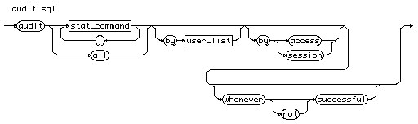  
[[rule list]](http://cui.unige.ch/db-research/Enseignement/analyseinfo/SQL7/BNFindex.html)

# binary\_type

binary\_type

::=

( **"raw"** **"("** [n](http://cui.unige.ch/db-research/Enseignement/analyseinfo/SQL7/n.html) **")"** )

| ( **"rowid"** )

| ( **"long"** **"raw"** )

  
[[rule list]](http://cui.unige.ch/db-research/Enseignement/analyseinfo/SQL7/BNFindex.html)

# character\_type

character\_type

::=

( ( **"char"** | **"varchar"**

| **"varchar2"** | **"character"** | **"character"** **"varying"** )

**"("** ( [n](http://cui.unige.ch/db-research/Enseignement/analyseinfo/SQL7/n.html) ) **")"** )

| ( **"long"** )

  
[[rule list]](http://cui.unige.ch/db-research/Enseignement/analyseinfo/SQL7/BNFindex.html)

# char\_function

char\_function

::=

**"chr"** | **"initcap"** | **"lower"** | **"lpad"** | **"ltrim"** | **"replace"**

| **"rpad"** | **"rtrim"** | **"soundex"** | **"substr"** | **"translate"** | **"upper"**

| **"ascii"** | **"instr"** | **"length"**

  
[[rule list]](http://cui.unige.ch/db-research/Enseignement/analyseinfo/SQL7/BNFindex.html)

# char\_set\_name

char\_set\_name

::= [identifier](http://cui.unige.ch/db-research/Enseignement/analyseinfo/SQL7/identifier.html)

char_set_name  
[[rule list]](http://cui.unige.ch/db-research/Enseignement/analyseinfo/SQL7/BNFindex.html)

# cluster\_name

cluster\_name

::= [identifier](http://cui.unige.ch/db-research/Enseignement/analyseinfo/SQL7/identifier.html)

cluster_name  
[[rule list]](http://cui.unige.ch/db-research/Enseignement/analyseinfo/SQL7/BNFindex.html)

# column\_constraint

column\_constraint

::=

[ **"constraint"** [constraint\_name](http://cui.unige.ch/db-research/Enseignement/analyseinfo/SQL7/constraint_name.html) ] [def\_column\_constraint](http://cui.unige.ch/db-research/Enseignement/analyseinfo/SQL7/def_column_constraint.html)

column_constraint  
[[rule list]](http://cui.unige.ch/db-research/Enseignement/analyseinfo/SQL7/BNFindex.html)

# column\_list

column\_list

::= [column\_name](http://cui.unige.ch/db-research/Enseignement/analyseinfo/SQL7/column_name.html) { **","** [column\_name](http://cui.unige.ch/db-research/Enseignement/analyseinfo/SQL7/column_name.html) }

# column_list column\_name

column\_name

::= [identifier](http://cui.unige.ch/db-research/Enseignement/analyseinfo/SQL7/identifier.html)

column_name

# comment\_command

comment\_command

::=

**"comment"** **"on"**

( ( **"table"** [ [schema\_name](http://cui.unige.ch/db-research/Enseignement/analyseinfo/SQL7/schema_name.html) **"."** ] [relation\_name](http://cui.unige.ch/db-research/Enseignement/analyseinfo/SQL7/relation_name.html) )

| ( **"column"** [ [schema\_name](http://cui.unige.ch/db-research/Enseignement/analyseinfo/SQL7/schema_name.html) **"."** ] [relation\_name](http://cui.unige.ch/db-research/Enseignement/analyseinfo/SQL7/relation_name.html)

**"."** [column\_name](http://cui.unige.ch/db-research/Enseignement/analyseinfo/SQL7/column_name.html) ) )

**"is"** **"'"** [string](http://cui.unige.ch/db-research/Enseignement/analyseinfo/SQL7/string.html) **"'"**

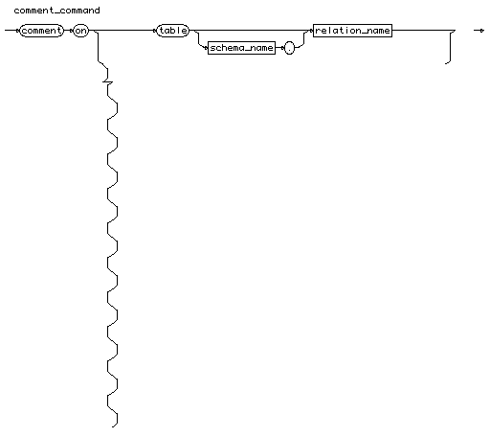  
[[rule list]](http://cui.unige.ch/db-research/Enseignement/analyseinfo/SQL7/BNFindex.html)

# comparaison\_op

comparaison\_op

::=

**"="** | **"<"** | **">"** | **"<>"** | **"!="** | **"^="** | **"<="** | **">="**



# condition

condition

::= [ **"not"** ] [logical\_term](http://cui.unige.ch/db-research/Enseignement/analyseinfo/SQL7/logical_term.html)

{ **"or"** [logical\_term](http://cui.unige.ch/db-research/Enseignement/analyseinfo/SQL7/logical_term.html) }

condition

# connect\_clause

connect\_clause

::=

**"connect"** **"by"**

( ( **"prior"** [exp\_simple](http://cui.unige.ch/db-research/Enseignement/analyseinfo/SQL7/exp_simple.html) [comparaison\_op](http://cui.unige.ch/db-research/Enseignement/analyseinfo/SQL7/comparaison_op.html) [exp\_simple](http://cui.unige.ch/db-research/Enseignement/analyseinfo/SQL7/exp_simple.html) )

| ( [exp\_simple](http://cui.unige.ch/db-research/Enseignement/analyseinfo/SQL7/exp_simple.html) [comparaison\_op](http://cui.unige.ch/db-research/Enseignement/analyseinfo/SQL7/comparaison_op.html) [exp\_simple](http://cui.unige.ch/db-research/Enseignement/analyseinfo/SQL7/exp_simple.html) **"prior"** ) )

[ **"start"** **"with"** [condition](http://cui.unige.ch/db-research/Enseignement/analyseinfo/SQL7/condition.html) ]



# constant

constant

::= [number](http://cui.unige.ch/db-research/Enseignement/analyseinfo/SQL7/number.html) | [quoted\_string](http://cui.unige.ch/db-research/Enseignement/analyseinfo/SQL7/quoted_string.html)

constant

# constraint\_list

constraint\_list

::= [constraint\_name](http://cui.unige.ch/db-research/Enseignement/analyseinfo/SQL7/constraint_name.html) { **","** [constraint\_name](http://cui.unige.ch/db-research/Enseignement/analyseinfo/SQL7/constraint_name.html) }

constraint_list

# controlfile\_spec

controlfile\_spec

::=

( **"maxlogfiles"** [n](http://cui.unige.ch/db-research/Enseignement/analyseinfo/SQL7/n.html) )

| ( **"maxlogmembers"** [n](http://cui.unige.ch/db-research/Enseignement/analyseinfo/SQL7/n.html) )

| ( **"maxloghistory"** [n](http://cui.unige.ch/db-research/Enseignement/analyseinfo/SQL7/n.html) )

| ( **"maxdatafiles"** [n](http://cui.unige.ch/db-research/Enseignement/analyseinfo/SQL7/n.html) )

| ( **"maxinstances"** [n](http://cui.unige.ch/db-research/Enseignement/analyseinfo/SQL7/n.html) )

| ( **"archivelog"** )

| ( **"noarchivelog"** )



# conversion\_function

conversion\_function

::=

**"chartorowid"** | **"convert"** | **"hextoraw"** | **"rawtohex"** | **"rowidtochar"**

| **"to\_char"** | **"to\_date"** | **"to\_number"**



# create\_cluster

create\_cluster

::=

**"create"** **"cluster"** [ [schema\_name](http://cui.unige.ch/db-research/Enseignement/analyseinfo/SQL7/schema_name.html) **"."** ] [cluster\_name](http://cui.unige.ch/db-research/Enseignement/analyseinfo/SQL7/cluster_name.html)

**"("** [column\_name](http://cui.unige.ch/db-research/Enseignement/analyseinfo/SQL7/column_name.html) [datatype](http://cui.unige.ch/db-research/Enseignement/analyseinfo/SQL7/datatype.html) { **","** [column\_name](http://cui.unige.ch/db-research/Enseignement/analyseinfo/SQL7/column_name.html) [datatype](http://cui.unige.ch/db-research/Enseignement/analyseinfo/SQL7/datatype.html) } **")"**

[create\_cluster\_spec](http://cui.unige.ch/db-research/Enseignement/analyseinfo/SQL7/create_cluster_spec.html) { [create\_cluster\_spec](http://cui.unige.ch/db-research/Enseignement/analyseinfo/SQL7/create_cluster_spec.html) }



# create\_cluster\_spec

create\_cluster\_spec

::=

( **"pctused"** [n](http://cui.unige.ch/db-research/Enseignement/analyseinfo/SQL7/n.html) ) | ( **"pctfree"** [n](http://cui.unige.ch/db-research/Enseignement/analyseinfo/SQL7/n.html) )

| ( **"size"** [n](http://cui.unige.ch/db-research/Enseignement/analyseinfo/SQL7/n.html) [ **"k"** | **"m"** ] )

| ( **"initrans"** [n](http://cui.unige.ch/db-research/Enseignement/analyseinfo/SQL7/n.html) ) | ( **"maxtrans"** [n](http://cui.unige.ch/db-research/Enseignement/analyseinfo/SQL7/n.html) )

| ( **"tablespace"** [tablespace\_name](http://cui.unige.ch/db-research/Enseignement/analyseinfo/SQL7/tablespace_name.html) )

| ( **"storage"** **"("** [storage\_spec](http://cui.unige.ch/db-research/Enseignement/analyseinfo/SQL7/storage_spec.html) { [storage\_spec](http://cui.unige.ch/db-research/Enseignement/analyseinfo/SQL7/storage_spec.html) } **")"** )

| ( **"index"** )

| ( [ **"hash"** **"is"** [column\_name](http://cui.unige.ch/db-research/Enseignement/analyseinfo/SQL7/column_name.html) ] **"hashkeys"** [n](http://cui.unige.ch/db-research/Enseignement/analyseinfo/SQL7/n.html) )



# create\_command

create\_command

::=

[create\_cluster](http://cui.unige.ch/db-research/Enseignement/analyseinfo/SQL7/create_cluster.html)

| [create\_controlfile](http://cui.unige.ch/db-research/Enseignement/analyseinfo/SQL7/create_controlfile.html)

| [create\_database](http://cui.unige.ch/db-research/Enseignement/analyseinfo/SQL7/create_database.html)

| [create\_databaselink](http://cui.unige.ch/db-research/Enseignement/analyseinfo/SQL7/create_databaselink.html)

| [create\_index](http://cui.unige.ch/db-research/Enseignement/analyseinfo/SQL7/create_index.html)

| [create\_profile](http://cui.unige.ch/db-research/Enseignement/analyseinfo/SQL7/create_profile.html)

| [create\_role](http://cui.unige.ch/db-research/Enseignement/analyseinfo/SQL7/create_role.html)

| [create\_rollback](http://cui.unige.ch/db-research/Enseignement/analyseinfo/SQL7/create_rollback.html)

| [create\_schema](http://cui.unige.ch/db-research/Enseignement/analyseinfo/SQL7/create_schema.html)

| [create\_sequence](http://cui.unige.ch/db-research/Enseignement/analyseinfo/SQL7/create_sequence.html)

| [create\_synonym](http://cui.unige.ch/db-research/Enseignement/analyseinfo/SQL7/create_synonym.html)

| [create\_snapshot](http://cui.unige.ch/db-research/Enseignement/analyseinfo/SQL7/create_snapshot.html)

| [create\_snapshotlog](http://cui.unige.ch/db-research/Enseignement/analyseinfo/SQL7/create_snapshotlog.html)

| [create\_table](http://cui.unige.ch/db-research/Enseignement/analyseinfo/SQL7/create_table.html)

| [create\_tablespace](http://cui.unige.ch/db-research/Enseignement/analyseinfo/SQL7/create_tablespace.html)

| [create\_trigger](http://cui.unige.ch/db-research/Enseignement/analyseinfo/SQL7/create_trigger.html)

| [create\_user](http://cui.unige.ch/db-research/Enseignement/analyseinfo/SQL7/create_user.html)

| [create\_view](http://cui.unige.ch/db-research/Enseignement/analyseinfo/SQL7/create_view.html)



# create\_controlfile

create\_controlfile

::=

**"create"** **"controlfile"** [ **"reuse"** ] [ **"set"** ]

**"database"** [database\_name](http://cui.unige.ch/db-research/Enseignement/analyseinfo/SQL7/database_name.html)

**"logfile"** { [group\_file\_spec](http://cui.unige.ch/db-research/Enseignement/analyseinfo/SQL7/group_file_spec.html) } ( **"resetlogs"** **"noresetlogs"** )

**"datafile"** [file\_spec\_list](http://cui.unige.ch/db-research/Enseignement/analyseinfo/SQL7/file_spec_list.html)

{ [controlfile\_spec](http://cui.unige.ch/db-research/Enseignement/analyseinfo/SQL7/controlfile_spec.html) }



# create\_database

create\_database

::=

**"create"** **"database"** [ [database\_name](http://cui.unige.ch/db-research/Enseignement/analyseinfo/SQL7/database_name.html) ]

{ [create\_database\_spec](http://cui.unige.ch/db-research/Enseignement/analyseinfo/SQL7/create_database_spec.html) }

create_database

# create\_databaselink

create\_databaselink

::=

**"create"** [ **"public"** ] **"database"** **"link"** [link\_name](http://cui.unige.ch/db-research/Enseignement/analyseinfo/SQL7/link_name.html)

[ **"connect"** **"to"** [user\_name](http://cui.unige.ch/db-research/Enseignement/analyseinfo/SQL7/user_name.html) **"identified"** **"by"** [password](http://cui.unige.ch/db-research/Enseignement/analyseinfo/SQL7/password.html) ]

**"using"** **"'"** [connect\_string](http://cui.unige.ch/db-research/Enseignement/analyseinfo/SQL7/connect_string.html) **"'"**

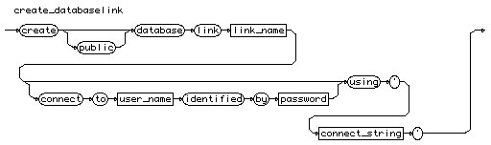

# create\_database\_spec

create\_database\_spec

::=

( **"controlile"** **"reuse"** )

| ( **"logfile"** { [group\_file\_spec](http://cui.unige.ch/db-research/Enseignement/analyseinfo/SQL7/group_file_spec.html) } )

| ( **"maxlogfiles"** [n](http://cui.unige.ch/db-research/Enseignement/analyseinfo/SQL7/n.html) )

| ( **"maxlogmembers"** [n](http://cui.unige.ch/db-research/Enseignement/analyseinfo/SQL7/n.html) )

| ( **"maxloghistory"** [n](http://cui.unige.ch/db-research/Enseignement/analyseinfo/SQL7/n.html) )

| ( **"datafile"** [file\_spec\_list](http://cui.unige.ch/db-research/Enseignement/analyseinfo/SQL7/file_spec_list.html) )

| ( **"maxdatafiles"** [n](http://cui.unige.ch/db-research/Enseignement/analyseinfo/SQL7/n.html) )

| ( **"maxinstances"** [n](http://cui.unige.ch/db-research/Enseignement/analyseinfo/SQL7/n.html) )

| ( **"archivelog"** | **"noarchivelog"** )

| ( **"character"** **"set"** [char\_set\_name](http://cui.unige.ch/db-research/Enseignement/analyseinfo/SQL7/char_set_name.html) )

| ( **"exclusive"** )



# create\_index

create\_index

::=

**"create"** **"index"** [ [schema\_name](http://cui.unige.ch/db-research/Enseignement/analyseinfo/SQL7/schema_name.html) **"."** ] [index\_name](http://cui.unige.ch/db-research/Enseignement/analyseinfo/SQL7/index_name.html) **"on"**

( ( [table\_name](http://cui.unige.ch/db-research/Enseignement/analyseinfo/SQL7/table_name.html) **"("** [indexed\_column](http://cui.unige.ch/db-research/Enseignement/analyseinfo/SQL7/indexed_column.html) **")"** )

| ( **"cluster"** [ [schema\_name](http://cui.unige.ch/db-research/Enseignement/analyseinfo/SQL7/schema_name.html) **"."** ] [cluster\_name](http://cui.unige.ch/db-research/Enseignement/analyseinfo/SQL7/cluster_name.html) ) )

{ [index\_storage](http://cui.unige.ch/db-research/Enseignement/analyseinfo/SQL7/index_storage.html) }



# create\_profile

create\_profile

::=

**"create"** **"profile"** [profile\_name](http://cui.unige.ch/db-research/Enseignement/analyseinfo/SQL7/profile_name.html) **"limit"**

[profile\_spec](http://cui.unige.ch/db-research/Enseignement/analyseinfo/SQL7/profile_spec.html) { [profile\_spec](http://cui.unige.ch/db-research/Enseignement/analyseinfo/SQL7/profile_spec.html) }

create_profile

# create\_role

create\_role

::=

**"create"** **"role"** [role\_name](http://cui.unige.ch/db-research/Enseignement/analyseinfo/SQL7/role_name.html)

( ( **"not"** **"identified"** )

| ( **"identified"** ( **"by"** [password](http://cui.unige.ch/db-research/Enseignement/analyseinfo/SQL7/password.html) | **"externally"** ) ) )

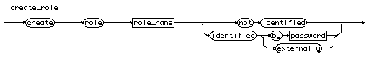

# create\_rollback

create\_rollback

::=

**"create"** [ **"public"** ] **"rollback"** **"segment"** [rollback\_name](http://cui.unige.ch/db-research/Enseignement/analyseinfo/SQL7/rollback_name.html)

[ **"tablespace"** [tablespace\_name](http://cui.unige.ch/db-research/Enseignement/analyseinfo/SQL7/tablespace_name.html) ]

[ **"storage"** [storage\_spec](http://cui.unige.ch/db-research/Enseignement/analyseinfo/SQL7/storage_spec.html) ]

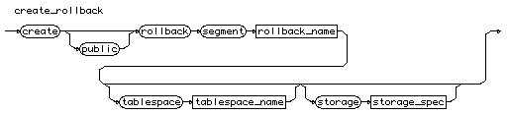

# create\_schema

create\_schema

::=

**"create"** **"schema"** **"authorization"** [schema\_name](http://cui.unige.ch/db-research/Enseignement/analyseinfo/SQL7/schema_name.html)

{ [create\_table](http://cui.unige.ch/db-research/Enseignement/analyseinfo/SQL7/create_table.html) | [create\_view](http://cui.unige.ch/db-research/Enseignement/analyseinfo/SQL7/create_view.html) | [grant\_command](http://cui.unige.ch/db-research/Enseignement/analyseinfo/SQL7/grant_command.html) }



# create\_sequence

create\_sequence

::=

**"create"** **"sequence"** [ [schema\_name](http://cui.unige.ch/db-research/Enseignement/analyseinfo/SQL7/schema_name.html) **"."** ] [sequence\_name](http://cui.unige.ch/db-research/Enseignement/analyseinfo/SQL7/sequence_name.html)

[create\_sequence\_spec](http://cui.unige.ch/db-research/Enseignement/analyseinfo/SQL7/create_sequence_spec.html) { [create\_sequence\_spec](http://cui.unige.ch/db-research/Enseignement/analyseinfo/SQL7/create_sequence_spec.html) }

create_sequence

# create\_sequence\_spec

create\_sequence\_spec

::=

( ( **"increment"** **"by"** [n](http://cui.unige.ch/db-research/Enseignement/analyseinfo/SQL7/n.html) )

| ( **"start"** **"with"** [n](http://cui.unige.ch/db-research/Enseignement/analyseinfo/SQL7/n.html) )

| ( **"maxvalue"** [n](http://cui.unige.ch/db-research/Enseignement/analyseinfo/SQL7/n.html) ) | ( **"nomaxvalue"** )

| ( **"minvalue"** [n](http://cui.unige.ch/db-research/Enseignement/analyseinfo/SQL7/n.html) ) | ( **"nominvalue"** )

| ( **"cycle"** | **"nocycle"** )

| ( **"cache"** [n](http://cui.unige.ch/db-research/Enseignement/analyseinfo/SQL7/n.html) ) | ( **"nocache"** )

| ( **"order"** | **"noorder"** ) )



# create\_snapshot

create\_snapshot

::=

**"create "** **"snapshot "** [ [schema\_name](http://cui.unige.ch/db-research/Enseignement/analyseinfo/SQL7/schema_name.html) **". "** ] [snapshot\_name](http://cui.unige.ch/db-research/Enseignement/analyseinfo/SQL7/snapshot_name.html)

{ [storage\_parameter](http://cui.unige.ch/db-research/Enseignement/analyseinfo/SQL7/storage_parameter.html) }

[ **"cluster"** [cluster\_name](http://cui.unige.ch/db-research/Enseignement/analyseinfo/SQL7/cluster_name.html) **"("** [column\_list](http://cui.unige.ch/db-research/Enseignement/analyseinfo/SQL7/column_list.html) **")"** ]

[ **"refresh"** [ **"fast"** | **"complete"** | **"force"** ]

[ **"start"** **"with"** [date](http://cui.unige.ch/db-research/Enseignement/analyseinfo/SQL7/date.html) ]

[ **"next"** [date](http://cui.unige.ch/db-research/Enseignement/analyseinfo/SQL7/date.html) ] ]

[ **"as"** [query](http://cui.unige.ch/db-research/Enseignement/analyseinfo/SQL7/query.html) ]

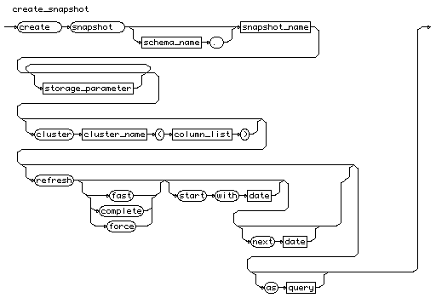

# create\_snapshot\_log

create\_snapshot\_log

::=

**"create"** **"snapshot"** **"log"** **"on"** [ [schema\_name](http://cui.unige.ch/db-research/Enseignement/analyseinfo/SQL7/schema_name.html) **"."** ] [snapshot\_name](http://cui.unige.ch/db-research/Enseignement/analyseinfo/SQL7/snapshot_name.html)

{ [storage\_parameter](http://cui.unige.ch/db-research/Enseignement/analyseinfo/SQL7/storage_parameter.html) }

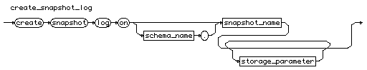

# create\_synonym

create\_synonym

::=

**"create"** [ **"public"** ] **"synonym"** [ [schema\_name](http://cui.unige.ch/db-research/Enseignement/analyseinfo/SQL7/schema_name.html) **"."** ] [synonym](http://cui.unige.ch/db-research/Enseignement/analyseinfo/SQL7/synonym.html)

**"for"** [ [schema\_name](http://cui.unige.ch/db-research/Enseignement/analyseinfo/SQL7/schema_name.html) **"."** ] [table\_name](http://cui.unige.ch/db-research/Enseignement/analyseinfo/SQL7/table_name.html) [ **"@"** [databaselink\_name](http://cui.unige.ch/db-research/Enseignement/analyseinfo/SQL7/databaselink_name.html) ]

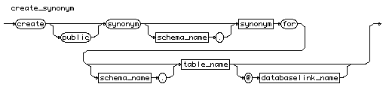

# create\_table

create\_table

::=

**"create"** **"table"** [ [schema\_name](http://cui.unige.ch/db-research/Enseignement/analyseinfo/SQL7/schema_name.html) **"."** ] [table\_name](http://cui.unige.ch/db-research/Enseignement/analyseinfo/SQL7/table_name.html)

**"("** ( [new\_column\_list](http://cui.unige.ch/db-research/Enseignement/analyseinfo/SQL7/new_column_list.html) |

[new\_constraint\_list](http://cui.unige.ch/db-research/Enseignement/analyseinfo/SQL7/new_constraint_list.html) ) **")"**

{ [storage\_parameter](http://cui.unige.ch/db-research/Enseignement/analyseinfo/SQL7/storage_parameter.html) }

[ ( **"cluster"** [cluster\_name](http://cui.unige.ch/db-research/Enseignement/analyseinfo/SQL7/cluster_name.html) **"("** [column\_list](http://cui.unige.ch/db-research/Enseignement/analyseinfo/SQL7/column_list.html) **")"** ) ]

[ **"enable"** [enable\_spec](http://cui.unige.ch/db-research/Enseignement/analyseinfo/SQL7/enable_spec.html) ]

[ **"disable"** [disable\_spec](http://cui.unige.ch/db-research/Enseignement/analyseinfo/SQL7/disable_spec.html) ]

[ **"as"** [query](http://cui.unige.ch/db-research/Enseignement/analyseinfo/SQL7/query.html) ]



# create\_tablespace

create\_tablespace

::=

**"create"** **"tablespace"** [tablespace\_name](http://cui.unige.ch/db-research/Enseignement/analyseinfo/SQL7/tablespace_name.html)

[ **"datafile"** [file\_spec\_list](http://cui.unige.ch/db-research/Enseignement/analyseinfo/SQL7/file_spec_list.html) ]

[ **"default"** **"storage"** **"("** [storage\_spec](http://cui.unige.ch/db-research/Enseignement/analyseinfo/SQL7/storage_spec.html) { [storage\_spec](http://cui.unige.ch/db-research/Enseignement/analyseinfo/SQL7/storage_spec.html) } **")"** ]

[ **"online"** | **"offline"** ]

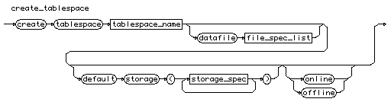

# create\_trigger

create\_trigger

::=

**"create"** [ **"or"** **"replace"** ] **"trigger"**

[ [schema\_name](http://cui.unige.ch/db-research/Enseignement/analyseinfo/SQL7/schema_name.html) **"."** ] [trigger\_name](http://cui.unige.ch/db-research/Enseignement/analyseinfo/SQL7/trigger_name.html)

[trigger\_sync](http://cui.unige.ch/db-research/Enseignement/analyseinfo/SQL7/trigger_sync.html)

[trigger\_ref](http://cui.unige.ch/db-research/Enseignement/analyseinfo/SQL7/trigger_ref.html)

[trigger\_when](http://cui.unige.ch/db-research/Enseignement/analyseinfo/SQL7/trigger_when.html)

[plsql\_block](http://cui.unige.ch/db-research/Enseignement/analyseinfo/SQL7/plsql_block.html)

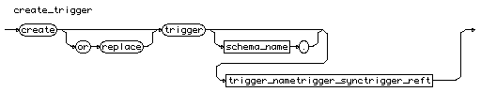

# create\_user

create\_user

::=

**"create"** **"user"** [user\_name](http://cui.unige.ch/db-research/Enseignement/analyseinfo/SQL7/user_name.html) **"identified"**

( **"by"** [password](http://cui.unige.ch/db-research/Enseignement/analyseinfo/SQL7/password.html) | **"externally"** )

[create\_user\_spec](http://cui.unige.ch/db-research/Enseignement/analyseinfo/SQL7/create_user_spec.html) { [create\_user\_spec](http://cui.unige.ch/db-research/Enseignement/analyseinfo/SQL7/create_user_spec.html) }

create_user

# create\_user\_spec

create\_user\_spec

::=

( ( **"default"** **"tablespace"** [tablespace\_name](http://cui.unige.ch/db-research/Enseignement/analyseinfo/SQL7/tablespace_name.html) )

| ( **"temporary"** **"tablespace"** [tablespace\_name](http://cui.unige.ch/db-research/Enseignement/analyseinfo/SQL7/tablespace_name.html) )

| ( **"quota"** ( ( [n](http://cui.unige.ch/db-research/Enseignement/analyseinfo/SQL7/n.html) **"k"** | **"m"** ) | **"unlimited"** )

**"on"** [tablespace\_name](http://cui.unige.ch/db-research/Enseignement/analyseinfo/SQL7/tablespace_name.html) )

| ( **"profile"** [profile\_name](http://cui.unige.ch/db-research/Enseignement/analyseinfo/SQL7/profile_name.html) )

)

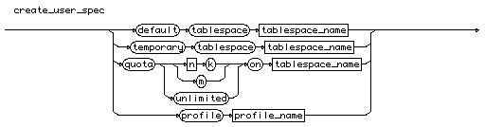

# create\_view

create\_view

::=

**"create"** [ **"or"** **"replace"** ] [ **"force"** | **"noforce"** ] **"view"**

[ [schema\_name](http://cui.unige.ch/db-research/Enseignement/analyseinfo/SQL7/schema_name.html) **"."** ] [view\_name](http://cui.unige.ch/db-research/Enseignement/analyseinfo/SQL7/view_name.html)

[ **"("** [alias](http://cui.unige.ch/db-research/Enseignement/analyseinfo/SQL7/alias.html) { **","** [alias](http://cui.unige.ch/db-research/Enseignement/analyseinfo/SQL7/alias.html) } **")"** ]

**"as"** [query](http://cui.unige.ch/db-research/Enseignement/analyseinfo/SQL7/query.html)

[ **"with"** **"check"** **"option"** [ **"constraint"** [constraint\_name](http://cui.unige.ch/db-research/Enseignement/analyseinfo/SQL7/constraint_name.html) ] ]

  
[[rule list]](http://cui.unige.ch/db-research/Enseignement/analyseinfo/SQL7/BNFindex.html)

# database\_name

database\_name

::= [identifier](http://cui.unige.ch/db-research/Enseignement/analyseinfo/SQL7/identifier.html)

database_name

# datatype

datatype

::=

[character\_type](http://cui.unige.ch/db-research/Enseignement/analyseinfo/SQL7/character_type.html)

| [date\_type](http://cui.unige.ch/db-research/Enseignement/analyseinfo/SQL7/date_type.html)

| [float\_type](http://cui.unige.ch/db-research/Enseignement/analyseinfo/SQL7/float_type.html)

| [decimal\_type](http://cui.unige.ch/db-research/Enseignement/analyseinfo/SQL7/decimal_type.html)

| [integer\_type](http://cui.unige.ch/db-research/Enseignement/analyseinfo/SQL7/integer_type.html)

| [binary\_type](http://cui.unige.ch/db-research/Enseignement/analyseinfo/SQL7/binary_type.html)



# date\_format

date\_format

::= [quoted\_string](http://cui.unige.ch/db-research/Enseignement/analyseinfo/SQL7/quoted_string.html)

date_format

# date\_function

date\_function

::=

**"add\_months"** | **"last\_day"** | **"months\_between"** | **"new\_time"** | **"next\_day"**

| **"round"** | **"sysdate"** | **"trunc"**

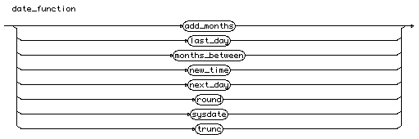

# date\_type

date\_type

::=

**"date"**

date_type

# decimal\_type

decimal\_type

::=

( **"number"** **"("** [n](http://cui.unige.ch/db-research/Enseignement/analyseinfo/SQL7/n.html) **","** [n](http://cui.unige.ch/db-research/Enseignement/analyseinfo/SQL7/n.html) **")"** )

| ( **"decimal"** **"("** [n](http://cui.unige.ch/db-research/Enseignement/analyseinfo/SQL7/n.html) **","** [n](http://cui.unige.ch/db-research/Enseignement/analyseinfo/SQL7/n.html) **")"** )

| ( **"dec"** **"("** [n](http://cui.unige.ch/db-research/Enseignement/analyseinfo/SQL7/n.html) **","** [n](http://cui.unige.ch/db-research/Enseignement/analyseinfo/SQL7/n.html) **")"** )

| ( **"numeric"** **"("** [n](http://cui.unige.ch/db-research/Enseignement/analyseinfo/SQL7/n.html) **","** [n](http://cui.unige.ch/db-research/Enseignement/analyseinfo/SQL7/n.html) **")"** )



# def\_column\_constraint

def\_column\_constraint

::=

( ( [ **"not"** ] **"null"** )

| ( **"unique"** | ( **"primary"** **"key"** ) )

| ( **"references"** [ [schema\_name](http://cui.unige.ch/db-research/Enseignement/analyseinfo/SQL7/schema_name.html) **"."** ] [table\_name](http://cui.unige.ch/db-research/Enseignement/analyseinfo/SQL7/table_name.html)

[ **"("** [column\_name](http://cui.unige.ch/db-research/Enseignement/analyseinfo/SQL7/column_name.html) **")"** ]

[ **"on"** **"delete"** **"cascade"** ] )

| ( **"chek"** **"("** [condition](http://cui.unige.ch/db-research/Enseignement/analyseinfo/SQL7/condition.html) **")"** )

| ( [ **"using"** **"index"** [index\_storage](http://cui.unige.ch/db-research/Enseignement/analyseinfo/SQL7/index_storage.html) { [index\_storage](http://cui.unige.ch/db-research/Enseignement/analyseinfo/SQL7/index_storage.html) } ]

[ **"exceptions"** **"into"** [ [schema\_name](http://cui.unige.ch/db-research/Enseignement/analyseinfo/SQL7/schema_name.html) **"."** ] [table\_name](http://cui.unige.ch/db-research/Enseignement/analyseinfo/SQL7/table_name.html) ] )

| ( **"disable"** )

)



# def\_table\_constraint

def\_table\_constraint

::=

( ( ( **"unique"** | ( **"primary"** **"key"** ) ) **"("** [column\_list](http://cui.unige.ch/db-research/Enseignement/analyseinfo/SQL7/column_list.html) **")"** )

| ( **"foreign"** **"key"** **"("** [column\_list](http://cui.unige.ch/db-research/Enseignement/analyseinfo/SQL7/column_list.html) **")"**

**"references"** [ [schema\_name](http://cui.unige.ch/db-research/Enseignement/analyseinfo/SQL7/schema_name.html) **"."** ] [table\_name](http://cui.unige.ch/db-research/Enseignement/analyseinfo/SQL7/table_name.html)

[ **"("** [column\_list](http://cui.unige.ch/db-research/Enseignement/analyseinfo/SQL7/column_list.html) **")"** ]

[ **"on"** **"delete"** **"cascade"** ] )

| ( **"chek"** **"("** [condition](http://cui.unige.ch/db-research/Enseignement/analyseinfo/SQL7/condition.html) **")"** )

| ( [ **"using"** **"index"** [index\_storage](http://cui.unige.ch/db-research/Enseignement/analyseinfo/SQL7/index_storage.html) { [index\_storage](http://cui.unige.ch/db-research/Enseignement/analyseinfo/SQL7/index_storage.html) } ]

[ **"exceptions"** **"into"** [ [schema\_name](http://cui.unige.ch/db-research/Enseignement/analyseinfo/SQL7/schema_name.html) **"."** ] [table\_name](http://cui.unige.ch/db-research/Enseignement/analyseinfo/SQL7/table_name.html) ] )

| ( **"disable"** )

)



# delete\_command

delete\_command

::=

**"delete"** **"from"** [ [schema\_name](http://cui.unige.ch/db-research/Enseignement/analyseinfo/SQL7/schema_name.html) **"."** ] [table\_name](http://cui.unige.ch/db-research/Enseignement/analyseinfo/SQL7/table_name.html)

[ **"@"** [link\_name](http://cui.unige.ch/db-research/Enseignement/analyseinfo/SQL7/link_name.html) ]

[ **"where"** [condition](http://cui.unige.ch/db-research/Enseignement/analyseinfo/SQL7/condition.html) ]



# disable\_spec

disable\_spec

::=

( ( **"unique"**

| ( **"primary"** **"key"** )

| ( **"constraint"** [constraint\_name](http://cui.unige.ch/db-research/Enseignement/analyseinfo/SQL7/constraint_name.html) ) )

[ **"cascade"** ] )

| ( **"all"** **"triggers"** )



# displayed\_column

displayed\_column

::=

( [ [schema\_name](http://cui.unige.ch/db-research/Enseignement/analyseinfo/SQL7/schema_name.html) **"."** ] [table\_name](http://cui.unige.ch/db-research/Enseignement/analyseinfo/SQL7/table_name.html) **"."** **"\*"** )

| ( [exp\_simple](http://cui.unige.ch/db-research/Enseignement/analyseinfo/SQL7/exp_simple.html) [ [alias](http://cui.unige.ch/db-research/Enseignement/analyseinfo/SQL7/alias.html) ] )



# distribution\_list

distribution\_list

::=

( [user\_name](http://cui.unige.ch/db-research/Enseignement/analyseinfo/SQL7/user_name.html) | [role\_name](http://cui.unige.ch/db-research/Enseignement/analyseinfo/SQL7/role_name.html) | **"public"** )

{ **","** ( [user\_name](http://cui.unige.ch/db-research/Enseignement/analyseinfo/SQL7/user_name.html) | [role\_name](http://cui.unige.ch/db-research/Enseignement/analyseinfo/SQL7/role_name.html) | **"public"** ) }



# domain\_name

domain\_name

::= [identifier](http://cui.unige.ch/db-research/Enseignement/analyseinfo/SQL7/identifier.html)

domain_name

# drop\_cluster

drop\_cluster

::=

**"drop"** **"cluster"** [ [schema\_name](http://cui.unige.ch/db-research/Enseignement/analyseinfo/SQL7/schema_name.html) **"."** ] [cluster\_name](http://cui.unige.ch/db-research/Enseignement/analyseinfo/SQL7/cluster_name.html)

[ **"including"** **"tables"** ] [ **"cascade"** **"constraints"** ]

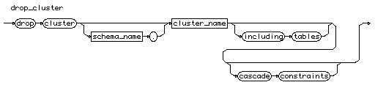

# drop\_command

drop\_command

::=

[drop\_cluster](http://cui.unige.ch/db-research/Enseignement/analyseinfo/SQL7/drop_cluster.html)

| [drop\_databaselink](http://cui.unige.ch/db-research/Enseignement/analyseinfo/SQL7/drop_databaselink.html)

| [drop\_index](http://cui.unige.ch/db-research/Enseignement/analyseinfo/SQL7/drop_index.html)

| [drop\_profile](http://cui.unige.ch/db-research/Enseignement/analyseinfo/SQL7/drop_profile.html)

| [drop\_role](http://cui.unige.ch/db-research/Enseignement/analyseinfo/SQL7/drop_role.html)

| [drop\_rollback](http://cui.unige.ch/db-research/Enseignement/analyseinfo/SQL7/drop_rollback.html)

| [drop\_snapshot](http://cui.unige.ch/db-research/Enseignement/analyseinfo/SQL7/drop_snapshot.html)

| [drop\_snapshotlog](http://cui.unige.ch/db-research/Enseignement/analyseinfo/SQL7/drop_snapshotlog.html)

| [drop\_sequence](http://cui.unige.ch/db-research/Enseignement/analyseinfo/SQL7/drop_sequence.html)

| [drop\_synonym](http://cui.unige.ch/db-research/Enseignement/analyseinfo/SQL7/drop_synonym.html)

| [drop\_table](http://cui.unige.ch/db-research/Enseignement/analyseinfo/SQL7/drop_table.html)

| [drop\_tablespace](http://cui.unige.ch/db-research/Enseignement/analyseinfo/SQL7/drop_tablespace.html)

| [drop\_trigger](http://cui.unige.ch/db-research/Enseignement/analyseinfo/SQL7/drop_trigger.html)

| [drop\_user](http://cui.unige.ch/db-research/Enseignement/analyseinfo/SQL7/drop_user.html)

| [drop\_view](http://cui.unige.ch/db-research/Enseignement/analyseinfo/SQL7/drop_view.html)



# drop\_databaselink

drop\_databaselink

::=

**"drop"** [ **"public"** ] **"database"** **"link"** [link\_name](http://cui.unige.ch/db-research/Enseignement/analyseinfo/SQL7/link_name.html)

drop_databaselink

# drop\_index

drop\_index

::=

**"drop"** **"index"** [ [schema\_name](http://cui.unige.ch/db-research/Enseignement/analyseinfo/SQL7/schema_name.html) **"."** ] [index\_name](http://cui.unige.ch/db-research/Enseignement/analyseinfo/SQL7/index_name.html)

drop_index

# drop\_profile

drop\_profile

::=

**"drop"** **"profile"** [profile\_name](http://cui.unige.ch/db-research/Enseignement/analyseinfo/SQL7/profile_name.html) [ **"cascade"** ]

drop_profile

# drop\_role

drop\_role

::=

**"drop"** **"role"** [role\_name](http://cui.unige.ch/db-research/Enseignement/analyseinfo/SQL7/role_name.html)

drop_role

# drop\_rollback

drop\_rollback

::=

**"drop"** **"rollback"** **"segment"** [rollback\_name](http://cui.unige.ch/db-research/Enseignement/analyseinfo/SQL7/rollback_name.html)

drop_rollback

# drop\_sequence

drop\_sequence

::=

**"drop"** **"sequence"** [ [schema\_name](http://cui.unige.ch/db-research/Enseignement/analyseinfo/SQL7/schema_name.html) **"."** ] [sequence\_name](http://cui.unige.ch/db-research/Enseignement/analyseinfo/SQL7/sequence_name.html)

drop_sequence

# drop\_snapshot

drop\_snapshot

::=

**"drop"** **"snapshot"** [ [schema\_name](http://cui.unige.ch/db-research/Enseignement/analyseinfo/SQL7/schema_name.html) **"."** ] [snapshot\_name](http://cui.unige.ch/db-research/Enseignement/analyseinfo/SQL7/snapshot_name.html)

drop_snapshot

# drop\_snapshotlog

drop\_snapshotlog

::=

**"drop"** **"snapshot"** **"log"** **"on"** [ [schema\_name](http://cui.unige.ch/db-research/Enseignement/analyseinfo/SQL7/schema_name.html) **"."** ] [table\_name](http://cui.unige.ch/db-research/Enseignement/analyseinfo/SQL7/table_name.html)

drop_snapshotlog

# drop\_synonym

drop\_synonym

::=

**"drop"** [ **"public"** ] **"synonym"** [ [schema\_name](http://cui.unige.ch/db-research/Enseignement/analyseinfo/SQL7/schema_name.html) **"."** ] [synonym](http://cui.unige.ch/db-research/Enseignement/analyseinfo/SQL7/synonym.html)

drop_synonym

# drop\_table

drop\_table

::=

**"drop"** **"table"** [ [schema\_name](http://cui.unige.ch/db-research/Enseignement/analyseinfo/SQL7/schema_name.html) **"."** ] [table\_name](http://cui.unige.ch/db-research/Enseignement/analyseinfo/SQL7/table_name.html)

[ **"cascade"** **"constraints"** ]

drop_table

# drop\_tablespace

drop\_tablespace

::=

**"drop"** **"tablespace"** [tablespace\_name](http://cui.unige.ch/db-research/Enseignement/analyseinfo/SQL7/tablespace_name.html)

[ **"including"** **"contents"** ] [ **"cascade"** **"constraints"** ]

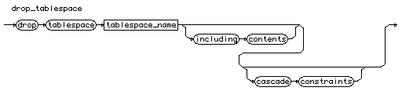

# drop\_trigger

drop\_trigger

::=

**"drop"** **"trigger"** [ [schema\_name](http://cui.unige.ch/db-research/Enseignement/analyseinfo/SQL7/schema_name.html) **"."** ] [trigger\_name](http://cui.unige.ch/db-research/Enseignement/analyseinfo/SQL7/trigger_name.html)

# drop_triggerdrop\_user

drop\_user

::=

**"drop"** **"user"** [user\_name](http://cui.unige.ch/db-research/Enseignement/analyseinfo/SQL7/user_name.html) [ **"cascade"** ]

drop_user

# drop\_view

drop\_view

::=

**"drop"** **"view"** [ [schema\_name](http://cui.unige.ch/db-research/Enseignement/analyseinfo/SQL7/schema_name.html) **"."** ] [view\_name](http://cui.unige.ch/db-research/Enseignement/analyseinfo/SQL7/view_name.html)

drop_view

# enable\_spec

enable\_spec

::=

( ( ( **"unique"** **"("** [column\_list](http://cui.unige.ch/db-research/Enseignement/analyseinfo/SQL7/column_list.html) **")"** )

| ( **"primary"** **"key"** )

| ( **"constraint"** [constraint\_name](http://cui.unige.ch/db-research/Enseignement/analyseinfo/SQL7/constraint_name.html) ) )

[ **"using"** **"index"** [index\_storage](http://cui.unige.ch/db-research/Enseignement/analyseinfo/SQL7/index_storage.html) { [index\_storage](http://cui.unige.ch/db-research/Enseignement/analyseinfo/SQL7/index_storage.html) } ]

[ **"exceptions"** **"into"** [ [schema\_name](http://cui.unige.ch/db-research/Enseignement/analyseinfo/SQL7/schema_name.html) **"."** ] [table\_name](http://cui.unige.ch/db-research/Enseignement/analyseinfo/SQL7/table_name.html) ] )

| ( **"all"** **"triggers"** )



# explain\_command

explain\_command

::=

**"explain"** **"plan"**

[ **"set"** **"statement\_id"** **"="** [quoted\_string](http://cui.unige.ch/db-research/Enseignement/analyseinfo/SQL7/quoted_string.html) ]

[ **"into"** [ [schema\_name](http://cui.unige.ch/db-research/Enseignement/analyseinfo/SQL7/schema_name.html) **"."** ] [table\_name](http://cui.unige.ch/db-research/Enseignement/analyseinfo/SQL7/table_name.html) [ **"@"** [link\_name](http://cui.unige.ch/db-research/Enseignement/analyseinfo/SQL7/link_name.html) ] ]

**"for"**

( [select\_command](http://cui.unige.ch/db-research/Enseignement/analyseinfo/SQL7/select_command.html)

| [insert\_command](http://cui.unige.ch/db-research/Enseignement/analyseinfo/SQL7/insert_command.html)

| [update\_command](http://cui.unige.ch/db-research/Enseignement/analyseinfo/SQL7/update_command.html)

| [delete\_command](http://cui.unige.ch/db-research/Enseignement/analyseinfo/SQL7/delete_command.html) )



# expression

expression

::= [ **"+"** | **"-"** ] [term](http://cui.unige.ch/db-research/Enseignement/analyseinfo/SQL7/term.html) { ( **"+"** | **"-"** ) [term](http://cui.unige.ch/db-research/Enseignement/analyseinfo/SQL7/term.html) }



# exp\_set

exp\_set

::= ( ( [number](http://cui.unige.ch/db-research/Enseignement/analyseinfo/SQL7/number.html) | [quoted\_string](http://cui.unige.ch/db-research/Enseignement/analyseinfo/SQL7/quoted_string.html) ) { **","** ( [number](http://cui.unige.ch/db-research/Enseignement/analyseinfo/SQL7/number.html) | [quoted\_string](http://cui.unige.ch/db-research/Enseignement/analyseinfo/SQL7/quoted_string.html) ) } )

| [subquery](http://cui.unige.ch/db-research/Enseignement/analyseinfo/SQL7/subquery.html)



# factor

factor

::= [constante\_nonsigne](http://cui.unige.ch/db-research/Enseignement/analyseinfo/SQL7/constante_nonsigne.html)

| [variable](http://cui.unige.ch/db-research/Enseignement/analyseinfo/SQL7/variable.html)

| ( [function](http://cui.unige.ch/db-research/Enseignement/analyseinfo/SQL7/function.html) ( [ **"("** [expression](http://cui.unige.ch/db-research/Enseignement/analyseinfo/SQL7/expression.html) { **","** [expression](http://cui.unige.ch/db-research/Enseignement/analyseinfo/SQL7/expression.html) } **")"** ] ) )

| ( [group\_function](http://cui.unige.ch/db-research/Enseignement/analyseinfo/SQL7/group_function.html) **"("** [ **"\*"** | **"all"** | **"distinct"** ] [expression](http://cui.unige.ch/db-research/Enseignement/analyseinfo/SQL7/expression.html) **")"** )



# file\_list

file\_list

::= **"'"** [file\_name](http://cui.unige.ch/db-research/Enseignement/analyseinfo/SQL7/file_name.html) **"'"** { **","** **"'"** [file\_name](http://cui.unige.ch/db-research/Enseignement/analyseinfo/SQL7/file_name.html) **"'"** }

file_list

# file\_name

file\_name

::= [file\_name\_in\_your\_system](http://cui.unige.ch/db-research/Enseignement/analyseinfo/SQL7/file_name_in_your_system.html)

file_name

# file\_reuse

file\_reuse

::= **"'"** [file\_name](http://cui.unige.ch/db-research/Enseignement/analyseinfo/SQL7/file_name.html) **"'"** [ **"reuse"** ]

file_reuse

# file\_reuse\_list

file\_reuse\_list

::= [file\_reuse](http://cui.unige.ch/db-research/Enseignement/analyseinfo/SQL7/file_reuse.html) { **","** [file\_reuse](http://cui.unige.ch/db-research/Enseignement/analyseinfo/SQL7/file_reuse.html) }

file_reuse_list

# file\_spec

file\_spec

::= **"'"** [file\_name](http://cui.unige.ch/db-research/Enseignement/analyseinfo/SQL7/file_name.html) **"'"** [ **"size"** [n](http://cui.unige.ch/db-research/Enseignement/analyseinfo/SQL7/n.html) [ **"k"** | **"m"** ] ] [ **"reuse"** ]



# file\_spec\_list

file\_spec\_list

::= [file\_spec](http://cui.unige.ch/db-research/Enseignement/analyseinfo/SQL7/file_spec.html) { **","** [file\_spec](http://cui.unige.ch/db-research/Enseignement/analyseinfo/SQL7/file_spec.html) }

file_spec_list

# file\_spec\_redo

file\_spec\_redo

::= ( **"'"** [file\_name](http://cui.unige.ch/db-research/Enseignement/analyseinfo/SQL7/file_name.html) **"'"**

| ( **"("** [file\_list](http://cui.unige.ch/db-research/Enseignement/analyseinfo/SQL7/file_list.html) **")"** ) )

[ **"size"** [n](http://cui.unige.ch/db-research/Enseignement/analyseinfo/SQL7/n.html) [ **"k"** | **"m"** ] ] [ **"reuse"** ]



# float\_type

float\_type

::=

**"number"**

| **"float"** | **"real"** | ( **"double"** **"precision"** )



# function

function

::=

[number\_function](http://cui.unige.ch/db-research/Enseignement/analyseinfo/SQL7/number_function.html)

| [char\_function](http://cui.unige.ch/db-research/Enseignement/analyseinfo/SQL7/char_function.html)

| [group\_function](http://cui.unige.ch/db-research/Enseignement/analyseinfo/SQL7/group_function.html)

| [conversion\_function](http://cui.unige.ch/db-research/Enseignement/analyseinfo/SQL7/conversion_function.html)

| [other\_function](http://cui.unige.ch/db-research/Enseignement/analyseinfo/SQL7/other_function.html)



# function\_name

function\_name

::= [identifier](http://cui.unige.ch/db-research/Enseignement/analyseinfo/SQL7/identifier.html)

function_name

# grant\_command

grant\_command

::=

[grant\_priv](http://cui.unige.ch/db-research/Enseignement/analyseinfo/SQL7/grant_priv.html)

| [grant\_object](http://cui.unige.ch/db-research/Enseignement/analyseinfo/SQL7/grant_object.html)

grant_command

# grant\_object

grant\_object

::=

**"grant"** ( ( [privilege](http://cui.unige.ch/db-research/Enseignement/analyseinfo/SQL7/privilege.html) { **","** [privilege](http://cui.unige.ch/db-research/Enseignement/analyseinfo/SQL7/privilege.html) } )

| **"all"** [ **"privilege"** ] )

[ **"("** [column\_list](http://cui.unige.ch/db-research/Enseignement/analyseinfo/SQL7/column_list.html) **")"** ]

**"on"** ( [ [schema\_name](http://cui.unige.ch/db-research/Enseignement/analyseinfo/SQL7/schema_name.html) **"."** ] **"object\_name"** )

**"to"** [distribution\_list](http://cui.unige.ch/db-research/Enseignement/analyseinfo/SQL7/distribution_list.html) [ **"with"** **"grant"** **"option"** ]



# grant\_priv

grant\_priv

::=

**"grant"** ( [priv\_granted](http://cui.unige.ch/db-research/Enseignement/analyseinfo/SQL7/priv_granted.html) { **","** [priv\_granted](http://cui.unige.ch/db-research/Enseignement/analyseinfo/SQL7/priv_granted.html) } )

**"to"** [distribution\_list](http://cui.unige.ch/db-research/Enseignement/analyseinfo/SQL7/distribution_list.html)

[ **"with"** **"admin"** **"option"** ]

grant_priv

# group\_clause

group\_clause

::=

**"group"** **"by"** [expression](http://cui.unige.ch/db-research/Enseignement/analyseinfo/SQL7/expression.html) { **","** [expression](http://cui.unige.ch/db-research/Enseignement/analyseinfo/SQL7/expression.html) } [ **"having"** [condition](http://cui.unige.ch/db-research/Enseignement/analyseinfo/SQL7/condition.html) ]

group_clause

# group\_file

group\_file

::=

( **"group"** [n](http://cui.unige.ch/db-research/Enseignement/analyseinfo/SQL7/n.html) )

| ( **"'"** [file\_name](http://cui.unige.ch/db-research/Enseignement/analyseinfo/SQL7/file_name.html) **"'"**

| ( **"("** [file\_list](http://cui.unige.ch/db-research/Enseignement/analyseinfo/SQL7/file_list.html) **")"** ) )

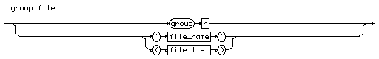

# group\_file\_list

group\_file\_list

::= [group\_file](http://cui.unige.ch/db-research/Enseignement/analyseinfo/SQL7/group_file.html) { **","** [group\_file](http://cui.unige.ch/db-research/Enseignement/analyseinfo/SQL7/group_file.html) }

group_file_list

# group\_file\_spec

group\_file\_spec

::=

[ **"group"** [n](http://cui.unige.ch/db-research/Enseignement/analyseinfo/SQL7/n.html) ] [file\_spec\_redo](http://cui.unige.ch/db-research/Enseignement/analyseinfo/SQL7/file_spec_redo.html)

group_file_spec

# group\_function

group\_function

::=

**"avg"** | **"count"** | **"max"** | **"min"** | **"stddev"** | **"sum"**

| **"variance"**



# identifier

identifier

::=

( **"letter"** { **"letter"** | **"digit"** | **"underline"** | **"dollar"** | **"sharp"** } )

| **"quote"** { **"any character"** } **"quote"**



# indexed\_column\_list

indexed\_column\_list

::=

[column\_name](http://cui.unige.ch/db-research/Enseignement/analyseinfo/SQL7/column_name.html) [ **"asc"** | **"desc"** ]

{ [column\_name](http://cui.unige.ch/db-research/Enseignement/analyseinfo/SQL7/column_name.html) [ **"asc"** | **"desc"** ] }

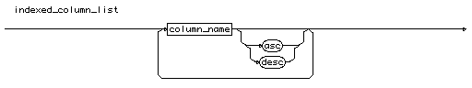

# index\_name

index\_name

::= [identifier](http://cui.unige.ch/db-research/Enseignement/analyseinfo/SQL7/identifier.html)

index_name

# index\_storage

index\_storage

::=

( **"pctfree"** [n](http://cui.unige.ch/db-research/Enseignement/analyseinfo/SQL7/n.html) )

| ( **"initrans"** [n](http://cui.unige.ch/db-research/Enseignement/analyseinfo/SQL7/n.html) ) | ( **"maxtrans"** [n](http://cui.unige.ch/db-research/Enseignement/analyseinfo/SQL7/n.html) )

| ( **"tablespace"** [tablespace\_name](http://cui.unige.ch/db-research/Enseignement/analyseinfo/SQL7/tablespace_name.html) )

| ( **"storage"** **"("** [storage\_spec](http://cui.unige.ch/db-research/Enseignement/analyseinfo/SQL7/storage_spec.html) { [storage\_spec](http://cui.unige.ch/db-research/Enseignement/analyseinfo/SQL7/storage_spec.html) } **")"** )

| ( **"nosort"** )



# insert\_command

insert\_command

::=

**"insert"** **"into"** ( [ [schema\_name](http://cui.unige.ch/db-research/Enseignement/analyseinfo/SQL7/schema_name.html) **"."** ]

( [table\_name](http://cui.unige.ch/db-research/Enseignement/analyseinfo/SQL7/table_name.html) | [view\_name](http://cui.unige.ch/db-research/Enseignement/analyseinfo/SQL7/view_name.html) ) [ **"@"** [link\_name](http://cui.unige.ch/db-research/Enseignement/analyseinfo/SQL7/link_name.html) ] )

**"("** [column\_list](http://cui.unige.ch/db-research/Enseignement/analyseinfo/SQL7/column_list.html) **")"**

( ( **"("** [value\_list](http://cui.unige.ch/db-research/Enseignement/analyseinfo/SQL7/value_list.html) **")"** ) | [query](http://cui.unige.ch/db-research/Enseignement/analyseinfo/SQL7/query.html) )



# integer\_type

integer\_type

::=

( **"number"** **"("** [n](http://cui.unige.ch/db-research/Enseignement/analyseinfo/SQL7/n.html) **")"** )

| **"integer"**

| **"int"**

| **"smallint"**



# language\_name

language\_name

::= [identifier](http://cui.unige.ch/db-research/Enseignement/analyseinfo/SQL7/identifier.html)

language_name

# link\_name

link\_name

::= [identifier](http://cui.unige.ch/db-research/Enseignement/analyseinfo/SQL7/identifier.html)

link_name

# location\_name

location\_name

::= [quoted\_string](http://cui.unige.ch/db-research/Enseignement/analyseinfo/SQL7/quoted_string.html)

location_name

# lock\_command

lock\_command

::=

**"lock"** **"table"**

[ [schema\_name](http://cui.unige.ch/db-research/Enseignement/analyseinfo/SQL7/schema_name.html) **"."** ] [table\_name](http://cui.unige.ch/db-research/Enseignement/analyseinfo/SQL7/table_name.html) [ **"@"** [link\_name](http://cui.unige.ch/db-research/Enseignement/analyseinfo/SQL7/link_name.html) ]

{ **","** [ [schema\_name](http://cui.unige.ch/db-research/Enseignement/analyseinfo/SQL7/schema_name.html) **"."** ] [table\_name](http://cui.unige.ch/db-research/Enseignement/analyseinfo/SQL7/table_name.html) [ **"@"** [link\_name](http://cui.unige.ch/db-research/Enseignement/analyseinfo/SQL7/link_name.html) ] }

**"in"** [lock\_mode](http://cui.unige.ch/db-research/Enseignement/analyseinfo/SQL7/lock_mode.html) **"mode"** [ **"nowait"** ]



# lock\_mode

lock\_mode

::=

**"share"**

| **"exclusive"**

| ( **"row"** ( **"share"** | **"exclusive"** ) )

| ( **"share"** ( **"update"** | ( **"row"** **"exclusive"** ) ) )



# logfile\_clause

logfile\_clause

::=

[ **"thread"** [n](http://cui.unige.ch/db-research/Enseignement/analyseinfo/SQL7/n.html) ]

[group\_file\_spec](http://cui.unige.ch/db-research/Enseignement/analyseinfo/SQL7/group_file_spec.html) { **","** [group\_file\_spec](http://cui.unige.ch/db-research/Enseignement/analyseinfo/SQL7/group_file_spec.html) }

# logfile_clauselogical\_factor

logical\_factor

::=

( [exp\_simple](http://cui.unige.ch/db-research/Enseignement/analyseinfo/SQL7/exp_simple.html) [comparaison\_op](http://cui.unige.ch/db-research/Enseignement/analyseinfo/SQL7/comparaison_op.html) [exp\_simple](http://cui.unige.ch/db-research/Enseignement/analyseinfo/SQL7/exp_simple.html) )

| ( [ **"not"** ] **"in"** [exp\_set](http://cui.unige.ch/db-research/Enseignement/analyseinfo/SQL7/exp_set.html) )

| ( [ **"not"** ] **"like"** [match\_string](http://cui.unige.ch/db-research/Enseignement/analyseinfo/SQL7/match_string.html) )

| ( [ **"not"** ] **"between"** [exp\_simple](http://cui.unige.ch/db-research/Enseignement/analyseinfo/SQL7/exp_simple.html) **"and"** [exp\_simple](http://cui.unige.ch/db-research/Enseignement/analyseinfo/SQL7/exp_simple.html) )

| ( **"is"** [ **"not"** ] **"null"** )

| [quantified\_factor](http://cui.unige.ch/db-research/Enseignement/analyseinfo/SQL7/quantified_factor.html)

| ( **"("** [condition](http://cui.unige.ch/db-research/Enseignement/analyseinfo/SQL7/condition.html) **")"** )



# logical\_term

logical\_term

::= [logical\_factor](http://cui.unige.ch/db-research/Enseignement/analyseinfo/SQL7/logical_factor.html) { **"and"** [logical\_factor](http://cui.unige.ch/db-research/Enseignement/analyseinfo/SQL7/logical_factor.html) }

logical_term

# logmember\_clause

logmember\_clause

::=

[file\_reuse\_list](http://cui.unige.ch/db-research/Enseignement/analyseinfo/SQL7/file_reuse_list.html) **"to"** [group\_file](http://cui.unige.ch/db-research/Enseignement/analyseinfo/SQL7/group_file.html)

logmember_clause

# match\_string

match\_string

::= **"'"** { **"any\_character"** | **"\_"** | **"%"** } **"'"**



# modified\_column\_list

modified\_column\_list

::=

[column\_name](http://cui.unige.ch/db-research/Enseignement/analyseinfo/SQL7/column_name.html) [ [datatype](http://cui.unige.ch/db-research/Enseignement/analyseinfo/SQL7/datatype.html) ] [ **"default"** [expression](http://cui.unige.ch/db-research/Enseignement/analyseinfo/SQL7/expression.html) ]

{ [column\_constraint](http://cui.unige.ch/db-research/Enseignement/analyseinfo/SQL7/column_constraint.html) }

{ **","** [column\_name](http://cui.unige.ch/db-research/Enseignement/analyseinfo/SQL7/column_name.html) [ [datatype](http://cui.unige.ch/db-research/Enseignement/analyseinfo/SQL7/datatype.html) ] [ **"default"** [expression](http://cui.unige.ch/db-research/Enseignement/analyseinfo/SQL7/expression.html) ]

{ [column\_constraint](http://cui.unige.ch/db-research/Enseignement/analyseinfo/SQL7/column_constraint.html) } }

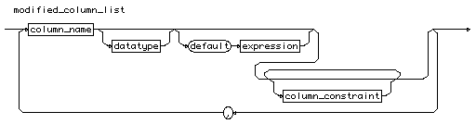

# n

n

::= **"digit"** { **"digit"** }

n

# new\_column\_list

new\_column\_list

::=

[column\_name](http://cui.unige.ch/db-research/Enseignement/analyseinfo/SQL7/column_name.html) [datatype](http://cui.unige.ch/db-research/Enseignement/analyseinfo/SQL7/datatype.html) [ **"default"** [expression](http://cui.unige.ch/db-research/Enseignement/analyseinfo/SQL7/expression.html) ]

{ [column\_constraint](http://cui.unige.ch/db-research/Enseignement/analyseinfo/SQL7/column_constraint.html) }

{ **","** [column\_name](http://cui.unige.ch/db-research/Enseignement/analyseinfo/SQL7/column_name.html) [datatype](http://cui.unige.ch/db-research/Enseignement/analyseinfo/SQL7/datatype.html) [ **"default"** [expression](http://cui.unige.ch/db-research/Enseignement/analyseinfo/SQL7/expression.html) ]

{ [column\_constraint](http://cui.unige.ch/db-research/Enseignement/analyseinfo/SQL7/column_constraint.html) } }



# new\_constraint\_list

new\_constraint\_list

::=

[table\_constraint](http://cui.unige.ch/db-research/Enseignement/analyseinfo/SQL7/table_constraint.html) { **","** [table\_constraint](http://cui.unige.ch/db-research/Enseignement/analyseinfo/SQL7/table_constraint.html) }

new_constraint_list

# new\_name

new\_name

::= [identifier](http://cui.unige.ch/db-research/Enseignement/analyseinfo/SQL7/identifier.html)

new_name

# noaudit\_command

noaudit\_command

::=

[noaudit\_sql](http://cui.unige.ch/db-research/Enseignement/analyseinfo/SQL7/noaudit_sql.html)

| [noaudit\_object](http://cui.unige.ch/db-research/Enseignement/analyseinfo/SQL7/noaudit_object.html)

noaudit_command

# noaudit\_object

noaudit\_object

::=

**"noaudit"** ( ( [obj\_command](http://cui.unige.ch/db-research/Enseignement/analyseinfo/SQL7/obj_command.html) { **","** [command](http://cui.unige.ch/db-research/Enseignement/analyseinfo/SQL7/command.html) } ) | **"all"** )

**"on"** ( ( [ [schema\_name](http://cui.unige.ch/db-research/Enseignement/analyseinfo/SQL7/schema_name.html) **"."** ] [object\_name](http://cui.unige.ch/db-research/Enseignement/analyseinfo/SQL7/object_name.html) ) | **"default"** )

[ **"by"** ( **"access"** | **"session"** ) ]

[ **"whenever"** [ **"not"** ] **"successful"** ]

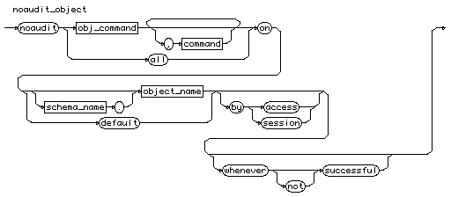

# noaudit\_sql

noaudit\_sql

::=

**"noaudit"** ( ( [stat\_command](http://cui.unige.ch/db-research/Enseignement/analyseinfo/SQL7/stat_command.html) { **","** [stat\_command](http://cui.unige.ch/db-research/Enseignement/analyseinfo/SQL7/stat_command.html) } ) | **"all"** )

[ **"by"** [user\_list](http://cui.unige.ch/db-research/Enseignement/analyseinfo/SQL7/user_list.html) ]

[ **"by"** ( **"access"** | **"session"** ) ]

[ **"whenever"** [ **"not"** ] **"successful"** ]

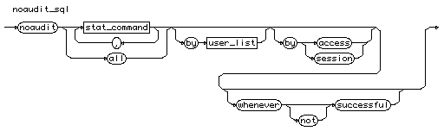

# number

number

::= [n](http://cui.unige.ch/db-research/Enseignement/analyseinfo/SQL7/n.html) [ **"."** [ [n](http://cui.unige.ch/db-research/Enseignement/analyseinfo/SQL7/n.html) ] ] [ **"E"** [ **"+"** | **"-"** ] [n](http://cui.unige.ch/db-research/Enseignement/analyseinfo/SQL7/n.html) ]



# number\_function

number\_function

::=

**"abs"** | **"ceil"** | **"floor"** | **"mod"** | **"power"** | **"round"**

| **"sign"** | **"sqrt"** | **"trunc"**



# object\_name

object\_name

::= [identifier](http://cui.unige.ch/db-research/Enseignement/analyseinfo/SQL7/identifier.html)

object_name

# obj\_command

obj\_command

::=

[table\_command](http://cui.unige.ch/db-research/Enseignement/analyseinfo/SQL7/table_command.html) | [view\_command](http://cui.unige.ch/db-research/Enseignement/analyseinfo/SQL7/view_command.html) | [sequence\_command](http://cui.unige.ch/db-research/Enseignement/analyseinfo/SQL7/sequence_command.html)

[prog\_command](http://cui.unige.ch/db-research/Enseignement/analyseinfo/SQL7/prog_command.html) | [snapshot\_commandd](http://cui.unige.ch/db-research/Enseignement/analyseinfo/SQL7/snapshot_commandd.html)

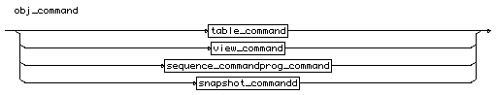

# old\_name

old\_name

::= [identifier](http://cui.unige.ch/db-research/Enseignement/analyseinfo/SQL7/identifier.html)

old_name

# order\_clause

order\_clause

::=

**"order"** **"by"** [sorted\_def](http://cui.unige.ch/db-research/Enseignement/analyseinfo/SQL7/sorted_def.html) { **","** [sorted\_def](http://cui.unige.ch/db-research/Enseignement/analyseinfo/SQL7/sorted_def.html) }

order_clause

# other\_function

other\_function

::=

**"decode"** | **"dump"** | **"greatest"** | **"least"** | **"nvl"**

| **"uid"** | **"user"** | **"userenv"** | **"vsize"**



# package\_name

package\_name

::= [identifier](http://cui.unige.ch/db-research/Enseignement/analyseinfo/SQL7/identifier.html)

package_name

# partition\_name

partition\_name

::= [identifier](http://cui.unige.ch/db-research/Enseignement/analyseinfo/SQL7/identifier.html)

partition_name

# password

password

::= [identifier](http://cui.unige.ch/db-research/Enseignement/analyseinfo/SQL7/identifier.html)

password

# pass\_role\_list

pass\_role\_list

::=

[role\_name](http://cui.unige.ch/db-research/Enseignement/analyseinfo/SQL7/role_name.html) [ **"identified"** **"by"** [password](http://cui.unige.ch/db-research/Enseignement/analyseinfo/SQL7/password.html) ]

{ **","** [role\_name](http://cui.unige.ch/db-research/Enseignement/analyseinfo/SQL7/role_name.html) [ **"identified"** **"by"** [password](http://cui.unige.ch/db-research/Enseignement/analyseinfo/SQL7/password.html) ] }

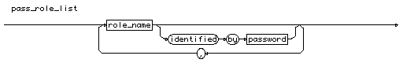

# privilege

privilege

::=

[table\_privilege](http://cui.unige.ch/db-research/Enseignement/analyseinfo/SQL7/table_privilege.html) | [view\_privilege](http://cui.unige.ch/db-research/Enseignement/analyseinfo/SQL7/view_privilege.html) | [sequence\_privilege](http://cui.unige.ch/db-research/Enseignement/analyseinfo/SQL7/sequence_privilege.html)

[prog\_privilege](http://cui.unige.ch/db-research/Enseignement/analyseinfo/SQL7/prog_privilege.html) | [snapshot\_privilege](http://cui.unige.ch/db-research/Enseignement/analyseinfo/SQL7/snapshot_privilege.html)



# procedure\_name

procedure\_name

::= [identifier](http://cui.unige.ch/db-research/Enseignement/analyseinfo/SQL7/identifier.html)

procedure_name

# profile\_name

profile\_name

::= [identifier](http://cui.unige.ch/db-research/Enseignement/analyseinfo/SQL7/identifier.html)

profile_name

# profile\_spec

profile\_spec

::=

( [resource\_name](http://cui.unige.ch/db-research/Enseignement/analyseinfo/SQL7/resource_name.html) ( [n](http://cui.unige.ch/db-research/Enseignement/analyseinfo/SQL7/n.html) | **"unlimited"** | **"default"** ) )

| ( **"private\_sga"** ( ( [n](http://cui.unige.ch/db-research/Enseignement/analyseinfo/SQL7/n.html) [ **"k"** | **"m"** ] ) | **"unlimited"** | **"default"** ) )

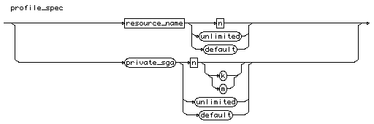

# prog\_command

prog\_command

::=

**"execute"** | **"audit"** | **"grant"** | **"rename"**

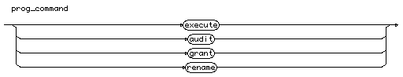

# prog\_privilege

prog\_privilege

::=

**"execute"**

prog_privilege

# quantified\_factor

quantified\_factor

::=

( [exp\_simple](http://cui.unige.ch/db-research/Enseignement/analyseinfo/SQL7/exp_simple.html) [comparaison\_op](http://cui.unige.ch/db-research/Enseignement/analyseinfo/SQL7/comparaison_op.html) [ **"all"** | **"any"** ] [subquery](http://cui.unige.ch/db-research/Enseignement/analyseinfo/SQL7/subquery.html) )

| ( [ **"not"** ] **"exists"** [subquery](http://cui.unige.ch/db-research/Enseignement/analyseinfo/SQL7/subquery.html) )



# query

query

::= [select\_command](http://cui.unige.ch/db-research/Enseignement/analyseinfo/SQL7/select_command.html)

query

# quoted\_string

quoted\_string

::= **"'"** { **"any\_character"** } **"'"**

quoted_string

# recover\_clause

recover\_clause

::=

**"recover"** [ **"automatic"** ] [ **"from"** **"'"** [file\_name](http://cui.unige.ch/db-research/Enseignement/analyseinfo/SQL7/file_name.html) **"'"** ]

( ( [ **"database"** ] [ [until\_spec](http://cui.unige.ch/db-research/Enseignement/analyseinfo/SQL7/until_spec.html) ] )

| ( **"tablespace"** [tablespace\_list](http://cui.unige.ch/db-research/Enseignement/analyseinfo/SQL7/tablespace_list.html) )

| ( **"datafile"** [file\_list](http://cui.unige.ch/db-research/Enseignement/analyseinfo/SQL7/file_list.html) )

| ( **"logfile"** [file\_name](http://cui.unige.ch/db-research/Enseignement/analyseinfo/SQL7/file_name.html) )

| ( **"continue"** [ **"default"** ] )

| ( **"cancel"** ) )

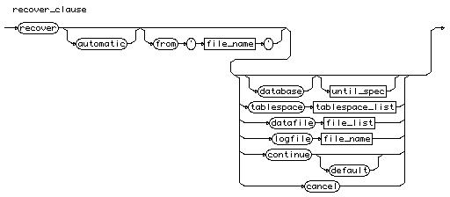

# relation\_name

relation\_name

::= [table\_name](http://cui.unige.ch/db-research/Enseignement/analyseinfo/SQL7/table_name.html) | [view\_name](http://cui.unige.ch/db-research/Enseignement/analyseinfo/SQL7/view_name.html) | [snapshot\_name](http://cui.unige.ch/db-research/Enseignement/analyseinfo/SQL7/snapshot_name.html)

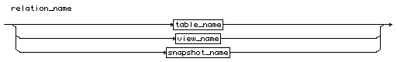

# rename\_command

rename\_command

::=

**"rename"** [old\_name](http://cui.unige.ch/db-research/Enseignement/analyseinfo/SQL7/old_name.html) **"to"** [new\_name](http://cui.unige.ch/db-research/Enseignement/analyseinfo/SQL7/new_name.html)

rename_command

# resource\_cost\_name

resource\_cost\_name

::=

**"cpu\_per\_session"**

| **"connect\_time"**

| **"private\_sga"**

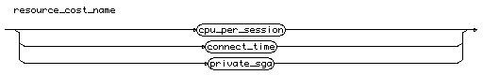

# resource\_name

resource\_name

::=

**"sessions\_per\_user"**

| **"cpu\_per\_session"**

| **"cpu\_per\_call"**

| **"connect\_time"**

| **"idle\_time"**

| **"logical\_reads\_per\_session"**

| **"logical\_reads\_per\_call"**

| **"composite\_limit"**

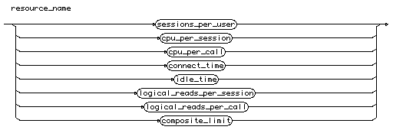

# revoke\_command

revoke\_command

::=

[revoke\_priv](http://cui.unige.ch/db-research/Enseignement/analyseinfo/SQL7/revoke_priv.html)

| [revoke\_object](http://cui.unige.ch/db-research/Enseignement/analyseinfo/SQL7/revoke_object.html)

revoke_command

# revoke\_object

revoke\_object

::=

**"revoke"** ( ( [privilege](http://cui.unige.ch/db-research/Enseignement/analyseinfo/SQL7/privilege.html) { **","** [privilege](http://cui.unige.ch/db-research/Enseignement/analyseinfo/SQL7/privilege.html) } )

| **"all"** [ **"privilege"** ] )

**"on"** ( [ [schema\_name](http://cui.unige.ch/db-research/Enseignement/analyseinfo/SQL7/schema_name.html) **"."** ] **"object\_name"** )

**"to"** [distribution\_list](http://cui.unige.ch/db-research/Enseignement/analyseinfo/SQL7/distribution_list.html) [ **"cascade"** **"constraints"** ]

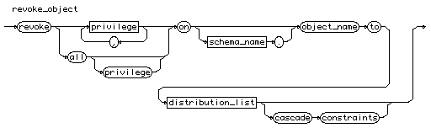

# revoke\_priv

revoke\_priv

::=

**"revoke"** ( [priv\_granted](http://cui.unige.ch/db-research/Enseignement/analyseinfo/SQL7/priv_granted.html) { **","** [priv\_granted](http://cui.unige.ch/db-research/Enseignement/analyseinfo/SQL7/priv_granted.html) } )

**"from"** [distribution\_list](http://cui.unige.ch/db-research/Enseignement/analyseinfo/SQL7/distribution_list.html)

revoke_priv

# role\_list

role\_list

::= [role\_name](http://cui.unige.ch/db-research/Enseignement/analyseinfo/SQL7/role_name.html) { **","** [role\_name](http://cui.unige.ch/db-research/Enseignement/analyseinfo/SQL7/role_name.html) }

role_list

# rollback\_name

rollback\_name

::= [identifier](http://cui.unige.ch/db-research/Enseignement/analyseinfo/SQL7/identifier.html)

rollback_name

# savepoint\_name

savepoint\_name

::= [identifier](http://cui.unige.ch/db-research/Enseignement/analyseinfo/SQL7/identifier.html)

savepoint_name

# schema\_name

schema\_name

::= [identifier](http://cui.unige.ch/db-research/Enseignement/analyseinfo/SQL7/identifier.html)

schema_name

# selected\_table

selected\_table

::=

[ [schema\_name](http://cui.unige.ch/db-research/Enseignement/analyseinfo/SQL7/schema_name.html) **"."** ] [table\_name](http://cui.unige.ch/db-research/Enseignement/analyseinfo/SQL7/table_name.html) [ **"@"** [link\_name](http://cui.unige.ch/db-research/Enseignement/analyseinfo/SQL7/link_name.html) ] [ [alias](http://cui.unige.ch/db-research/Enseignement/analyseinfo/SQL7/alias.html) ]

selected_table

# select\_command

select\_command

::=

**"select"** [ **"all"** | **"distinct"** ]

( **"\*"** | ( [displayed\_column](http://cui.unige.ch/db-research/Enseignement/analyseinfo/SQL7/displayed_column.html) { **","** [displayed\_column](http://cui.unige.ch/db-research/Enseignement/analyseinfo/SQL7/displayed_column.html) } ) )

**"from"** ( [selected\_table](http://cui.unige.ch/db-research/Enseignement/analyseinfo/SQL7/selected_table.html) { **","** [selected\_table](http://cui.unige.ch/db-research/Enseignement/analyseinfo/SQL7/selected_table.html) } )

[ **"where"** [condition](http://cui.unige.ch/db-research/Enseignement/analyseinfo/SQL7/condition.html) ]

{ [connect\_clause](http://cui.unige.ch/db-research/Enseignement/analyseinfo/SQL7/connect_clause.html) }

{ [group\_clause](http://cui.unige.ch/db-research/Enseignement/analyseinfo/SQL7/group_clause.html) }

{ [set\_clause](http://cui.unige.ch/db-research/Enseignement/analyseinfo/SQL7/set_clause.html) }

{ [order\_clause](http://cui.unige.ch/db-research/Enseignement/analyseinfo/SQL7/order_clause.html) }

{ [update\_clause](http://cui.unige.ch/db-research/Enseignement/analyseinfo/SQL7/update_clause.html) }



# self

self

::= [identifier](http://cui.unige.ch/db-research/Enseignement/analyseinfo/SQL7/identifier.html)

self

# sequence\_command

sequence\_command

::=

**"alter"** | **"audit"** | **"grant"** | **"select"**

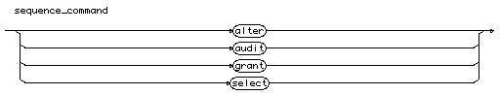

# sequence\_name

sequence\_name

::= [identifier](http://cui.unige.ch/db-research/Enseignement/analyseinfo/SQL7/identifier.html)

sequence_name

# sequence\_privilege

sequence\_privilege

::=

**"alter"** | **"select"**

sequence_privilege

# set\_clause

set\_clause

::=

( ( **"union"** **"all"** ) | **"intersect"** | **"minus"** ) [select\_command](http://cui.unige.ch/db-research/Enseignement/analyseinfo/SQL7/select_command.html)



# set\_role\_command

set\_role\_command

::=

**"set"** **"role"**

( [pass\_role\_list](http://cui.unige.ch/db-research/Enseignement/analyseinfo/SQL7/pass_role_list.html)

| ( **"all"** [ [except](http://cui.unige.ch/db-research/Enseignement/analyseinfo/SQL7/except.html) [role\_list](http://cui.unige.ch/db-research/Enseignement/analyseinfo/SQL7/role_list.html) ] )

| **"none"** )

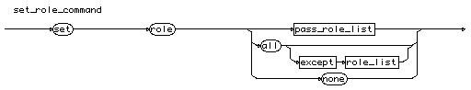

# set\_session\_spec

set\_session\_spec

::=

( ( ( **"sql\_trace"** | **"global\_names"** ) **"="** ( **"true"** | **"false"** ) )

| ( **"nls\_language"** **"="** [language\_name](http://cui.unige.ch/db-research/Enseignement/analyseinfo/SQL7/language_name.html) )

| ( **"nls\_territory"** **"="** [territory\_name](http://cui.unige.ch/db-research/Enseignement/analyseinfo/SQL7/territory_name.html) )

| ( **"nls\_date\_format"** **"="** [date\_format](http://cui.unige.ch/db-research/Enseignement/analyseinfo/SQL7/date_format.html) )

| ( **"nls\_date\_language"** **"="** [language\_name](http://cui.unige.ch/db-research/Enseignement/analyseinfo/SQL7/language_name.html) )

| ( **"nls\_numeric\_character"** **"="** [quoted\_string](http://cui.unige.ch/db-research/Enseignement/analyseinfo/SQL7/quoted_string.html) )

| ( **"nls\_iso\_currency"** **"="** [territory\_name](http://cui.unige.ch/db-research/Enseignement/analyseinfo/SQL7/territory_name.html) )

| ( **"nls\_currency"** **"="** [quoted\_string](http://cui.unige.ch/db-research/Enseignement/analyseinfo/SQL7/quoted_string.html) )

| ( **"nls\_sort"** **"="** ( [sort\_name](http://cui.unige.ch/db-research/Enseignement/analyseinfo/SQL7/sort_name.html) | **"binary"** ) )

| ( **"optimizer"** **"goal"** **"="** ( **"all\_rows"** | **"first\_rows"**

| **"choose"** | **"rule"** ) ) )

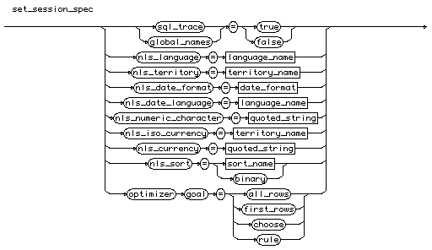

# set\_transaction\_command

set\_transaction\_command

::=

**"set"** **"transaction"**

( ( **"read"** **"only"** )

| ( **"read"** **"write"** )

| ( **"use"** **"rollback"** **"segment"** [rollback\_name](http://cui.unige.ch/db-research/Enseignement/analyseinfo/SQL7/rollback_name.html) ) )



# simple\_update

simple\_update

::=

**"update"** [ [schema\_name](http://cui.unige.ch/db-research/Enseignement/analyseinfo/SQL7/schema_name.html) **"."** ] [table\_name](http://cui.unige.ch/db-research/Enseignement/analyseinfo/SQL7/table_name.html) [ **"@"** [link\_name](http://cui.unige.ch/db-research/Enseignement/analyseinfo/SQL7/link_name.html) ]

[ [alias](http://cui.unige.ch/db-research/Enseignement/analyseinfo/SQL7/alias.html) ]

**"set"** [column](http://cui.unige.ch/db-research/Enseignement/analyseinfo/SQL7/column.html) **"="** ( [expression](http://cui.unige.ch/db-research/Enseignement/analyseinfo/SQL7/expression.html) | [subquery](http://cui.unige.ch/db-research/Enseignement/analyseinfo/SQL7/subquery.html) )

{ **","** [column](http://cui.unige.ch/db-research/Enseignement/analyseinfo/SQL7/column.html) **"="** ( [expression](http://cui.unige.ch/db-research/Enseignement/analyseinfo/SQL7/expression.html) | [subquery](http://cui.unige.ch/db-research/Enseignement/analyseinfo/SQL7/subquery.html) ) }

**"where"** [condition](http://cui.unige.ch/db-research/Enseignement/analyseinfo/SQL7/condition.html)



# snapshot\_command

snapshot\_command

::=

**"select"**

snapshot_command

# snapshot\_name

snapshot\_name

::= [identifier](http://cui.unige.ch/db-research/Enseignement/analyseinfo/SQL7/identifier.html)

snapshot_name

# snapshot\_privilege

snapshot\_privilege

::=

**"select"**

snapshot_privilege

# sorted\_def

sorted\_def

::=

( [expression](http://cui.unige.ch/db-research/Enseignement/analyseinfo/SQL7/expression.html) | [n](http://cui.unige.ch/db-research/Enseignement/analyseinfo/SQL7/n.html) ) ( **"asc"** | **"desc"** )

sorted_def

# sql\_command

sql\_command ::= [to\_define\_data](http://cui.unige.ch/db-research/Enseignement/analyseinfo/SQL7/to_define_data.html)

| [to\_control\_data](http://cui.unige.ch/db-research/Enseignement/analyseinfo/SQL7/to_control_data.html)

| [to\_modify\_data](http://cui.unige.ch/db-research/Enseignement/analyseinfo/SQL7/to_modify_data.html)



# statement\_opt

statement\_opt

::=

**"cluster"** | **"database link"** | **"exists"** | **"index"** | **"not exists"**

| **"procedure"** | **"profile"** | **"..."** |

**"see table 4\_7 of SQL ref. manual"**

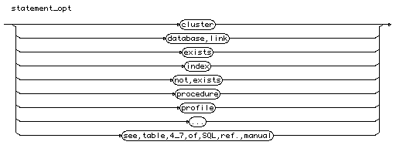

# stat\_command

stat\_command

::=

[statement\_opt](http://cui.unige.ch/db-research/Enseignement/analyseinfo/SQL7/statement_opt.html) | [system\_priv](http://cui.unige.ch/db-research/Enseignement/analyseinfo/SQL7/system_priv.html)

stat_command

# storage\_parameter

storage\_parameter

::=

( ( **"pctfree"** [n](http://cui.unige.ch/db-research/Enseignement/analyseinfo/SQL7/n.html) )

| ( **"pctused"** [n](http://cui.unige.ch/db-research/Enseignement/analyseinfo/SQL7/n.html) )

| ( **"initrans"** [n](http://cui.unige.ch/db-research/Enseignement/analyseinfo/SQL7/n.html) )

| ( **"maxtrans"** [n](http://cui.unige.ch/db-research/Enseignement/analyseinfo/SQL7/n.html) )

| ( **"storage"** **"("** [storage\_spec](http://cui.unige.ch/db-research/Enseignement/analyseinfo/SQL7/storage_spec.html) { [storage\_spec](http://cui.unige.ch/db-research/Enseignement/analyseinfo/SQL7/storage_spec.html) } **")"** ) )



# storage\_spec

storage\_spec

::=

( **"initial"** [n](http://cui.unige.ch/db-research/Enseignement/analyseinfo/SQL7/n.html) [ **"k"** | **"m"** ] ) | ( **"next"** [n](http://cui.unige.ch/db-research/Enseignement/analyseinfo/SQL7/n.html) [ **"k"** | **"m"** ] )

| ( **"minextents"** [n](http://cui.unige.ch/db-research/Enseignement/analyseinfo/SQL7/n.html) ) | ( **"maxextents"** [n](http://cui.unige.ch/db-research/Enseignement/analyseinfo/SQL7/n.html) )

| ( **"pctincrease"** [n](http://cui.unige.ch/db-research/Enseignement/analyseinfo/SQL7/n.html) )

| ( **"optimal"** ( **"null"** | ( [n](http://cui.unige.ch/db-research/Enseignement/analyseinfo/SQL7/n.html) [ **"k"** | **"m"** ] ) ) )

| ( **"freelist"** [n](http://cui.unige.ch/db-research/Enseignement/analyseinfo/SQL7/n.html) )

| ( **"freelist"** **"groups"** [n](http://cui.unige.ch/db-research/Enseignement/analyseinfo/SQL7/n.html) )



# subquery

subquery

::= **"("** [select\_command](http://cui.unige.ch/db-research/Enseignement/analyseinfo/SQL7/select_command.html) **")"**

subquery

# subquery\_update

subquery\_update

::=

**"update"** [ [schema\_name](http://cui.unige.ch/db-research/Enseignement/analyseinfo/SQL7/schema_name.html) **"."** ] [table\_name](http://cui.unige.ch/db-research/Enseignement/analyseinfo/SQL7/table_name.html) [ [alias](http://cui.unige.ch/db-research/Enseignement/analyseinfo/SQL7/alias.html) ] [ **"@"** [link\_name](http://cui.unige.ch/db-research/Enseignement/analyseinfo/SQL7/link_name.html) ]

**"set"** **"("** [column\_name](http://cui.unige.ch/db-research/Enseignement/analyseinfo/SQL7/column_name.html) { **","** [column\_name](http://cui.unige.ch/db-research/Enseignement/analyseinfo/SQL7/column_name.html) } **")"** **"="** [subquery](http://cui.unige.ch/db-research/Enseignement/analyseinfo/SQL7/subquery.html)

**"where"** [condition](http://cui.unige.ch/db-research/Enseignement/analyseinfo/SQL7/condition.html)



# synonym

synonym

::= [identifier](http://cui.unige.ch/db-research/Enseignement/analyseinfo/SQL7/identifier.html)

# system\_priv

system\_priv

::=

**"alter any cluster"** | **"alter any index"**

| **"alter any procedure"** | **"alter any role"**

| **"alter any sequence"**

| **"alter any snapshot"** | **"alter any table"** | **"..."** |

**"see table 4\_11 of SQL ref. manual"**

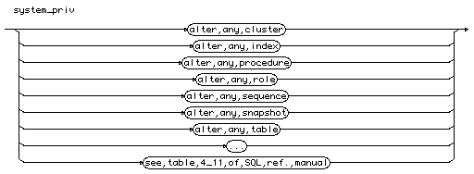

# system\_spec

system\_spec

::=

( ( ( **"resource\_limit"** | **"global\_names"** ) **"="** ( **"true"** | **"false"** ) )

| ( **"mts\_servers"** **"="** [n](http://cui.unige.ch/db-research/Enseignement/analyseinfo/SQL7/n.html) )

| ( **"mts\_dispatcher"** **"="** [protocol](http://cui.unige.ch/db-research/Enseignement/analyseinfo/SQL7/protocol.html) **","** [n](http://cui.unige.ch/db-research/Enseignement/analyseinfo/SQL7/n.html) )

| ( **"license\_max\_session"** **"="** [n](http://cui.unige.ch/db-research/Enseignement/analyseinfo/SQL7/n.html) )

| ( **"license\_session\_warning"** **"="** [n](http://cui.unige.ch/db-research/Enseignement/analyseinfo/SQL7/n.html) )

| ( **"license\_max\_users"** **"="** [n](http://cui.unige.ch/db-research/Enseignement/analyseinfo/SQL7/n.html) )

)

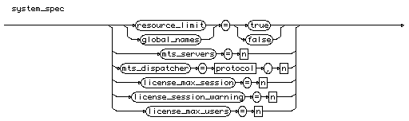

# system\_status

system\_status

::=

( ( **"online"** | **"offline"** )

[ **"normal"** | **"temporary"** | **"immediate"** ] )

| ( ( **"begin"** | **"end"** ) **"backup"** )

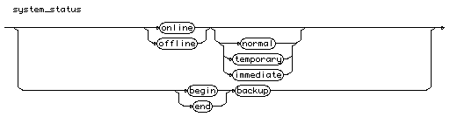

# tablespace\_list

tablespace\_list

::= [tablespace\_name](http://cui.unige.ch/db-research/Enseignement/analyseinfo/SQL7/tablespace_name.html) { **","** [tablespace\_name](http://cui.unige.ch/db-research/Enseignement/analyseinfo/SQL7/tablespace_name.html) }

tablespace_list

# tablespace\_name

tablespace\_name

::= [identifier](http://cui.unige.ch/db-research/Enseignement/analyseinfo/SQL7/identifier.html)

tablespace_name

# table\_command

table\_command

::=

**"alter"** | **"audit"** | **"comment"** | **"delete"** | **"grant"**

| **"index"** | **"insert"** | **"lock"** | **"rename"** | **"select"** | **"update"**

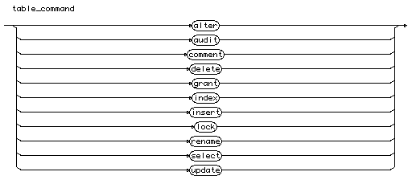

# table\_constraint

table\_constraint

::=

[ **"constraint"** [constraint\_name](http://cui.unige.ch/db-research/Enseignement/analyseinfo/SQL7/constraint_name.html) ] [def\_table\_constraint](http://cui.unige.ch/db-research/Enseignement/analyseinfo/SQL7/def_table_constraint.html)

table_constraint

# table\_name

table\_name

::= [identifier](http://cui.unige.ch/db-research/Enseignement/analyseinfo/SQL7/identifier.html)

table_name

# table\_privilege

table\_privilege

::=

**"alter"** | **"delete"**

| **"index"** | **"insert"** | **"references"** | **"select"**

| **"update"**



# term

term

::= [factor](http://cui.unige.ch/db-research/Enseignement/analyseinfo/SQL7/factor.html) { ( **"\*"** | **"/"** ) [factor](http://cui.unige.ch/db-research/Enseignement/analyseinfo/SQL7/factor.html) }



# territory\_name

territory\_name

::= [identifier](http://cui.unige.ch/db-research/Enseignement/analyseinfo/SQL7/identifier.html)

territory_name

# to\_control\_data

to\_control\_data

::= [audit\_command](http://cui.unige.ch/db-research/Enseignement/analyseinfo/SQL7/audit_command.html)

| [noaudit\_command](http://cui.unige.ch/db-research/Enseignement/analyseinfo/SQL7/noaudit_command.html)

| [grant\_command](http://cui.unige.ch/db-research/Enseignement/analyseinfo/SQL7/grant_command.html)

| [revoke\_command](http://cui.unige.ch/db-research/Enseignement/analyseinfo/SQL7/revoke_command.html)

| [set\_role\_command](http://cui.unige.ch/db-research/Enseignement/analyseinfo/SQL7/set_role_command.html)



# to\_define\_data

to\_define\_data

::= [alter\_command](http://cui.unige.ch/db-research/Enseignement/analyseinfo/SQL7/alter_command.html)

| [comment\_command](http://cui.unige.ch/db-research/Enseignement/analyseinfo/SQL7/comment_command.html)

| [create\_command](http://cui.unige.ch/db-research/Enseignement/analyseinfo/SQL7/create_command.html)

| [drop\_command](http://cui.unige.ch/db-research/Enseignement/analyseinfo/SQL7/drop_command.html)

| [rename\_command](http://cui.unige.ch/db-research/Enseignement/analyseinfo/SQL7/rename_command.html)

| [analyze\_command](http://cui.unige.ch/db-research/Enseignement/analyseinfo/SQL7/analyze_command.html)

| [explain\_command](http://cui.unige.ch/db-research/Enseignement/analyseinfo/SQL7/explain_command.html)



# to\_modify\_data

to\_modify\_data

::= [select\_command](http://cui.unige.ch/db-research/Enseignement/analyseinfo/SQL7/select_command.html)

| [insert\_command](http://cui.unige.ch/db-research/Enseignement/analyseinfo/SQL7/insert_command.html)

| [update\_command](http://cui.unige.ch/db-research/Enseignement/analyseinfo/SQL7/update_command.html)

| [delete\_command](http://cui.unige.ch/db-research/Enseignement/analyseinfo/SQL7/delete_command.html)

| [truncate\_command](http://cui.unige.ch/db-research/Enseignement/analyseinfo/SQL7/truncate_command.html)

| [transaction\_command](http://cui.unige.ch/db-research/Enseignement/analyseinfo/SQL7/transaction_command.html)

| [set\_transaction\_command](http://cui.unige.ch/db-research/Enseignement/analyseinfo/SQL7/set_transaction_command.html)

| [lock\_command](http://cui.unige.ch/db-research/Enseignement/analyseinfo/SQL7/lock_command.html)



# transaction\_command

transaction\_command

::=

( **"commit"** [ **"work"** ] [ ( **"comment"** [quoted\_string](http://cui.unige.ch/db-research/Enseignement/analyseinfo/SQL7/quoted_string.html) )

| ( **"force"** [quoted\_string](http://cui.unige.ch/db-research/Enseignement/analyseinfo/SQL7/quoted_string.html) [ **","** [n](http://cui.unige.ch/db-research/Enseignement/analyseinfo/SQL7/n.html) ] ) ] )

| ( **"set"** **"transaction"** **"read"** **"only"** )

| ( **"savepoint"** [savepoint\_name](http://cui.unige.ch/db-research/Enseignement/analyseinfo/SQL7/savepoint_name.html) )

| ( **"rollback"** [ **"work"** ] [ ( **"to"** [ **"savepoint"** [savepoint\_name](http://cui.unige.ch/db-research/Enseignement/analyseinfo/SQL7/savepoint_name.html) ] )

| ( **"force"** [quoted\_string](http://cui.unige.ch/db-research/Enseignement/analyseinfo/SQL7/quoted_string.html) ) ] )



# trigger\_name

trigger\_name

::= [identifier](http://cui.unige.ch/db-research/Enseignement/analyseinfo/SQL7/identifier.html)

trigger_name

# trigger\_ref

trigger\_ref

::=

**"referencing"**

[ **"old"** [ **"as"** ] [identifier](http://cui.unige.ch/db-research/Enseignement/analyseinfo/SQL7/identifier.html) ]

[ **"new"** [ **"as"** ] [identifier](http://cui.unige.ch/db-research/Enseignement/analyseinfo/SQL7/identifier.html) ]

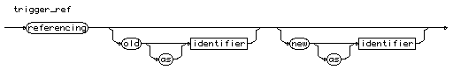

# trigger\_sync

trigger\_sync

::=

( **"before"** | **"after"** )

( **"delete"** | **"insert"** | **"update"** [ **"of"** [column\_list](http://cui.unige.ch/db-research/Enseignement/analyseinfo/SQL7/column_list.html) ] )

{ **"or"** ( **"delete"** | **"insert"** | **"update"** [ **"of"** [column\_list](http://cui.unige.ch/db-research/Enseignement/analyseinfo/SQL7/column_list.html) ] ) }

**"on"** [ [schema\_name](http://cui.unige.ch/db-research/Enseignement/analyseinfo/SQL7/schema_name.html) **"."** ] [table\_name](http://cui.unige.ch/db-research/Enseignement/analyseinfo/SQL7/table_name.html)

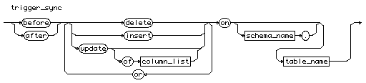

# trigger\_when

trigger\_when

::=

**"for"** **"each"** **"row"** [ **"when"** **"("** [condition](http://cui.unige.ch/db-research/Enseignement/analyseinfo/SQL7/condition.html) **")"** ]

trigger_when

# truncate\_command

truncate\_command

::=

**"truncate"**

( ( **"table"** [ [schema\_name](http://cui.unige.ch/db-research/Enseignement/analyseinfo/SQL7/schema_name.html) **"."** ] [table\_name](http://cui.unige.ch/db-research/Enseignement/analyseinfo/SQL7/table_name.html) )

| ( **"cluster"** [ [schema\_name](http://cui.unige.ch/db-research/Enseignement/analyseinfo/SQL7/schema_name.html) **"."** ] [cluster\_name](http://cui.unige.ch/db-research/Enseignement/analyseinfo/SQL7/cluster_name.html) ) )

[ ( **"drop"** | **"reuse"** ) **"storage"** ]



# until\_spec

until\_spec

::=

( **"until"** ( **"cancel"** | ( **"time"** [date](http://cui.unige.ch/db-research/Enseignement/analyseinfo/SQL7/date.html) ) | ( **"change"** [n](http://cui.unige.ch/db-research/Enseignement/analyseinfo/SQL7/n.html) ) ) )

| ( **"using"** **"backup"** **"controlfile"** )

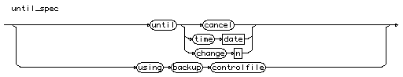

# update\_clause

update\_clause

::=

**"for"** **"update"** **"of"** [column\_name](http://cui.unige.ch/db-research/Enseignement/analyseinfo/SQL7/column_name.html) { **","** [column\_name](http://cui.unige.ch/db-research/Enseignement/analyseinfo/SQL7/column_name.html) } [ **"nowait"** ]

update_clause

# update\_command

update\_command

::=

[simple\_update](http://cui.unige.ch/db-research/Enseignement/analyseinfo/SQL7/simple_update.html) | [subquery\_update](http://cui.unige.ch/db-research/Enseignement/analyseinfo/SQL7/subquery_update.html)

update_command

# user\_list

user\_list

::= [user\_name](http://cui.unige.ch/db-research/Enseignement/analyseinfo/SQL7/user_name.html) { **","** [user\_name](http://cui.unige.ch/db-research/Enseignement/analyseinfo/SQL7/user_name.html) }

user_list

# user\_name

user\_name

::= [identifier](http://cui.unige.ch/db-research/Enseignement/analyseinfo/SQL7/identifier.html)

user_name

# value

value

::= ( [ **"+"** | **"-"** ] ( [identifier](http://cui.unige.ch/db-research/Enseignement/analyseinfo/SQL7/identifier.html) | [n](http://cui.unige.ch/db-research/Enseignement/analyseinfo/SQL7/n.html) ) ) | [quoted\_string](http://cui.unige.ch/db-research/Enseignement/analyseinfo/SQL7/quoted_string.html)



# value\_list

value\_list

::= **"values"** **"("** [value](http://cui.unige.ch/db-research/Enseignement/analyseinfo/SQL7/value.html) { **","** [value](http://cui.unige.ch/db-research/Enseignement/analyseinfo/SQL7/value.html) }

value_list

# variable

variable

::= [ [table\_name](http://cui.unige.ch/db-research/Enseignement/analyseinfo/SQL7/table_name.html) **"."** ] [column\_name](http://cui.unige.ch/db-research/Enseignement/analyseinfo/SQL7/column_name.html) [ **"(+)"** ]

variable

# view\_command

view\_command

::=

**"audit"** | **"comment"** | **"delete"** | **"grant"**

| **"insert"** | **"lock"** | **"rename"** | **"select"** | **"update"**

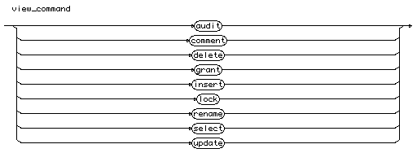

# view\_name

view\_name

::= [identifier](http://cui.unige.ch/db-research/Enseignement/analyseinfo/SQL7/identifier.html)

# view\_privilege

view\_privilege

::=

**"delete"** | **"insert"** | **"select"**

| **"update"**



plsql block ::=

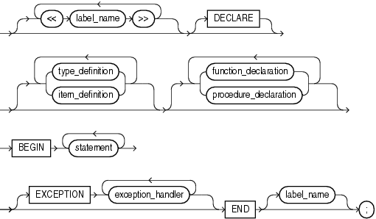

[ << label\_name >> [ << label\_name >> ] ...]

[ DECLARE ]

[ { type\_definition | item\_definition }

[ type\_definition | item\_definition ] ... ]

[ {function\_declaration | procedure\_declaration }

[ function\_declaration | procedure\_declaration] ... ]

BEGIN

statement [statement ...]

[ EXCEPTION exception\_handler [exception\_handler ...] ]

END [ label\_name ] ;

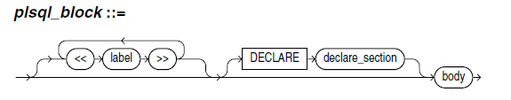

# plsql\_block

plsql\_block

::= [ “<<” label “>>” { “<<” label “>>” }]

[ “DECLARE” declare\_section] body

label

::= [identifier](http://cui.unige.ch/db-research/Enseignement/analyseinfo/SQL7/identifier.html)

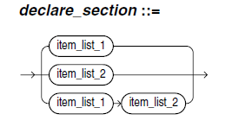

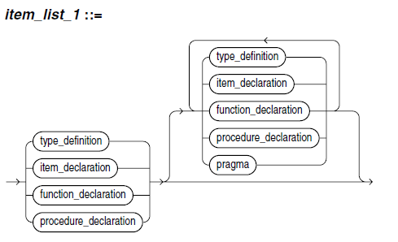

# item\_list1

item\_list1

::= type\_definition | item\_declaration |

function\_declaration | procedure\_declaration

[ { type\_definition | item\_declaration |

function\_declaration | procedure\_declaration |

pragma } ]

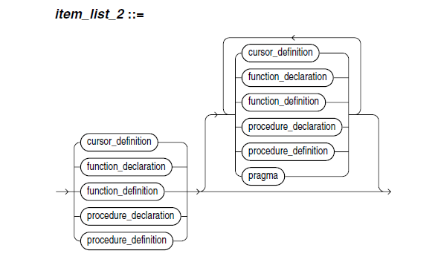

# item\_list2

item\_list2

::= cursor\_definition | function\_declaration |

function\_definition | procedure\_declaration |

procedure\_definition

[ { cursor\_definition | function\_declaration |

function\_definition | procedure\_declaration |

procedure\_definition |pragma } ]

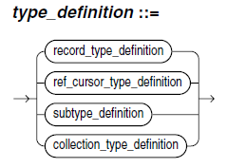

# type\_definition

type\_definition

::= record\_type\_definition | ref\_cursor\_definition |

subtype\_definition | collection\_type\_definition

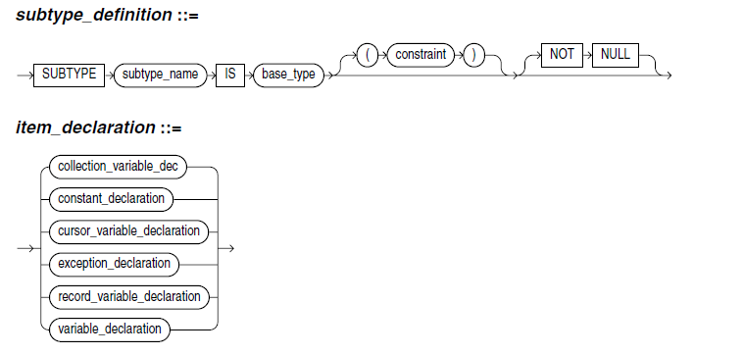

# subtype\_declaration

subtype\_definition

::= “SUBTYPE” subtype\_name “IS” base\_type

[ “(“ constraint “)” ] [ “NOT” “NULL” ]

# Item\_definition

item\_declaration

::= collection\_variable\_dec |

constant\_declaration

cursor\_variable\_declaration

exception\_declaration

record\_variable\_declaration

variable\_declaration

