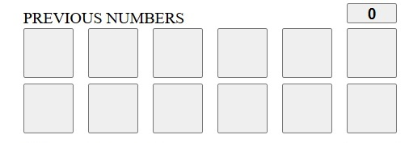
This is the “PREVIOUS NUMBERS” panel. It shows the latest 12 buttons pressed. The counter shows the number of the buttons. At the beginning it equals 0.

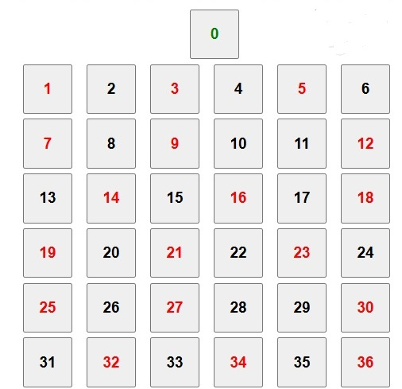
This is the “BUTTONS” panel to press when a spin comes out.

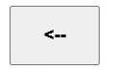
This is the “BACK BUTTON” to press when by error a mistaken button is pressed, it cancels it.
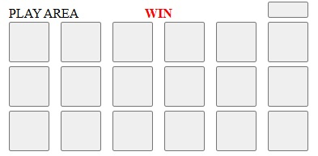
This is the “PLAY AREA” panel. It shows the numbers to bet. It shows WIN when there is a win.

