Lazarus Lex and Yacc

Lazarus Tokenizer and Parser

The Compiler Writer's Tools for Lazarus, FPC and other object pascal dialects

Version 1.0 Design Manual

Thierry Coq
E-mail: coq.t.87m@centraliens.fr, tcoq@free.fr
December 2009

Contents
1 Contents 2
2 Introduction 3
3 Bibliography and references 4
4 Glossary of terms 5
5 Design Principles 5
6 Use cases 5
7 Architecture 6
8 Design 6
9 Unresolved Design Issues 7
9.1 Design Issues 7
9.2 Measuring Software quality 7
10 Indexes 8
10.1 List of figures 8

Introduction
This document describes the Lazarus Lex and Yacc compiler generator toolset design.
For references, glossary and bibliography, please refer to the user manual.

Bibliography and references
See User Manual.

Glossary of terms
See User Manual

Design Principles
The following design principles are used to design the Lazarus Lex and Yacc tools for devising compilers:
- Introduce modern component-based design methodologies for devising compilers, promoting reuse,
- Provide a long term, sustainable tool,
- Provide an Object Pascal –based tool, providing ease-of-use for both students and professionals,
- Provide portability to multiple platforms, processors and operating systems,
- Separate the concerns of writing the grammar and performing actions on the parsed grammar,
- Allow easy introduction of non-regression testing for most grammars

Use cases
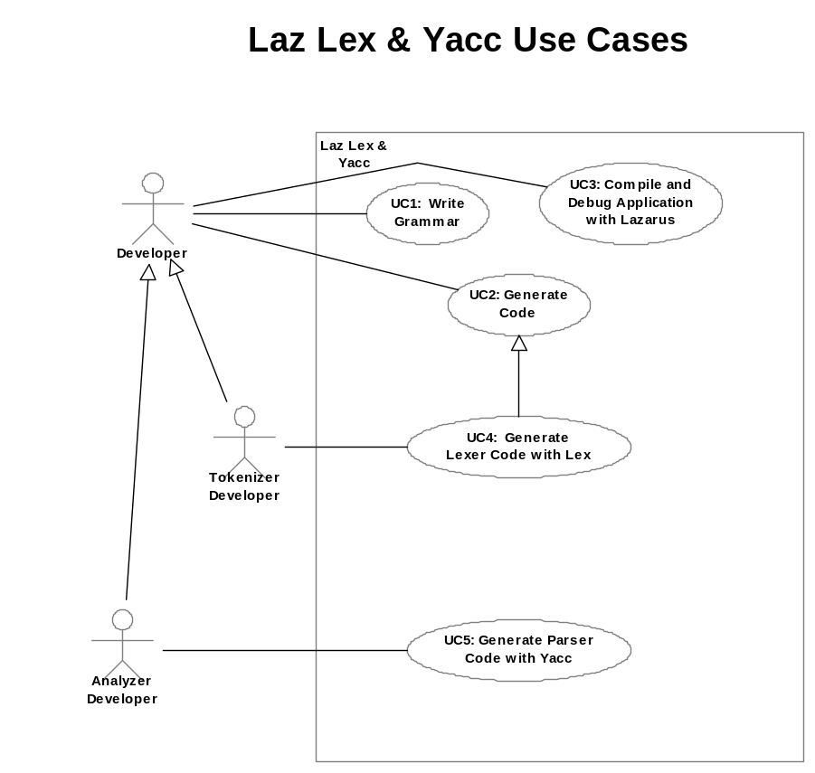
Figure 1: Lazarus Lex and Yacc Use Cases
The use cases for the Lex and Yacc tools are rather standard:
- UC1: Write a grammar. Currently this is an external activity not taken into account by the tools. Hopefully a future editor could help here.
- UC2: Generate Code. This is the generic use case for the Lex and Yacc tools, whichever dialect.
- UC3: Compile and debug with Lazarus. This use case is the particular need for a Lazarus Lex and Yacc. Compiling and debugging with FPC and Lazarus may be a great help over more traditional ways of compiling and debugging tokenizers and parsers.
- UC4: Generate Lexer code. A specialized case of UC2.
- UC5: Generate Parser code. A specialized case of UC2.

Architecture

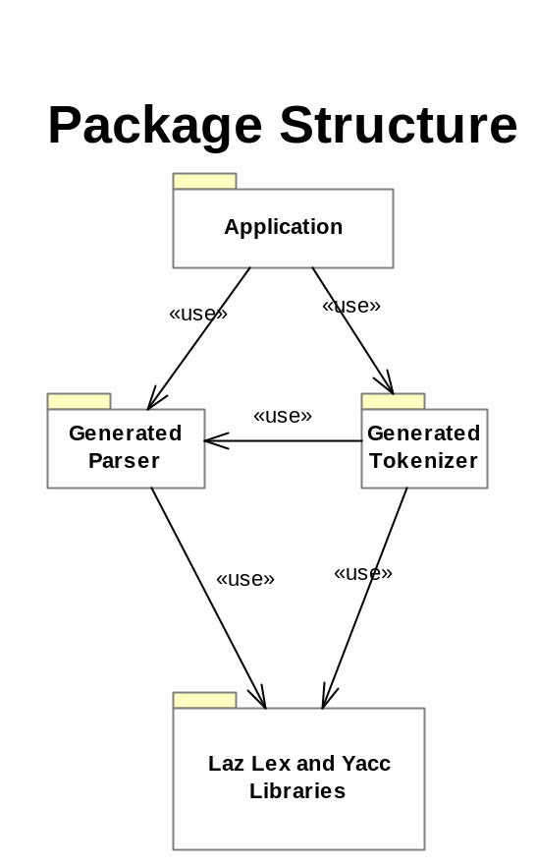
Figure 2: Lazarus Lex and Yacc Package Structure
In this architecture diagram, one “package” represents one or several Object Pascal Units. The architecture idea is that parser and tokenizer components depend (moderately) on the Lex and Yacc libraries. The tokenizer depends on the parser to define the token values (not the ideal situation, but is the current limitation of Lex and Yacc).

Design
Components generated by Lex and Yacc are structured in the following manner:
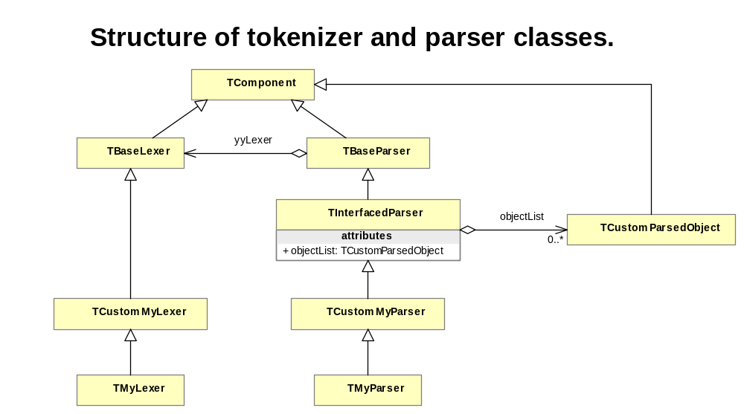
Figure 3: Tokenizer and parser class structure
A tokenizer (lexer) should be broken down over three different classes:
- The TBaseLexer class is provided by the Lex and Yacc library, and provides basic Lexer mechanisms. This class should be reused as-is and not be changed.
- The TCustomMyLexer is written by the developer of the lexer in order to store the Object Pascal code that is not generated by the grammar. Most verbatim code should not be put in the grammar, but in this tool. This neatly separates the grammar analysis from the actions to be taken.
- The TMyLexer class is generated by the developer using the Lex tool and the grammar he/she has devised.
- The same hierarchy of three classes applies to the parser. In addition, the TInterfacedParser provides mechanisms to show the parsing results on the standard debugging form provided by the distribution.

Unresolved Design Issues
There are several problems here, mainly coming from lack of time. I may have time to tackle them later. And yet, somebody may have ideas to tackle the issues more easily. It may already be done elsewhere. Ideas, suggestions and help are welcome.

Design Issues
See the User Manual for a first list.

Measuring Software quality
I have Pascal Analyzer, haven’t had time to generate the report in an easy-to-read manner. This will be done later.

Indexes

List of figures

Figure 1: Lazarus Lex and Yacc Use Cases 5
Figure 2: Lazarus Lex and Yacc Package Structure 6
Figure 3: Tokenizer and parser class structure 7

