**Building Phases and Components of LLM Chat Application**

**Introduction**

The LLM Chat Application project aimed to create a fully-functional web-based chat application utilizing LangChain and Streamlit frameworks, with the core functionality powered by the Google Gemini API. The project successfully achieved its objectives by implementing various phases of development, each focusing on specific components and functionalities.

**Phase 1: Project Setup and Environment Configuration**

In this initial phase, the development environment was set up, and necessary frameworks and tools were configured. Python and required libraries such as Streamlit, LangChain, and PyPDF2 were installed. Additionally, the Google Gemini API key was configured, and the project directory structure was established.

**Phase 2: Implementing LLM Chat Functionality**

The core functionality of the chat application was developed in this phase. LangChain Gemini API was initialized for LLM interaction, and a Streamlit user interface was created to facilitate user interactions. Integration with LangChain Gemini API enabled the generation of responses based on user input, and user interactions were handled effectively.

**Phase 3: Integrating PDF Document Handling**

To enhance user experience, the application was extended to support PDF document handling alongside chat functionality. Users were enabled to upload PDF documents, and text extraction was implemented using the PyPDF2 library. Text processing and splitting into manageable chunks were performed, and embeddings and vector store were created for PDF text chunks. Integration with LangChain Google Generative AI enabled the generation of responses based on both PDF content and user input.

**Phase 4: User Interface Enhancement and Error Handling**

The user interface was enhanced in this phase to improve user experience. UI improvements such as adding icons, titles, and styling were implemented using Streamlit. Robust error handling mechanisms were put in place to handle invalid inputs and API failures effectively. Additional features such as clearing and resetting chat history were implemented, and loading indicators were added for processing-intensive tasks.

**Phase 5: Testing and Deployment**

Comprehensive testing was conducted to ensure the application's functionality and reliability. Individual components and end-to-end functionality were tested thoroughly, and any issues or errors encountered during testing were debugged and fixed. The application was deployed on a web server or cloud platform for online access, and continuous monitoring and maintenance were performed post-deployment to ensure optimal performance.

**Data Structures Used:**

|  |  |
| --- | --- |
| **Data Structure Used** | **Purpose of Using it** |
| List | Storing chat messages and history |
| Dictionary | Organizing chat messages with roles |
| Text Chunks | Splitting and processing PDF text |
| Embeddings | Representing text data in a vector space |

**Test Cases:**

1. **Chat with LLM:**
   * **Scenario:** User inputs a message and receives a response from the LLM.
   * **Expected Outcome:** User should see their message displayed in the chat area, and a response generated by the LLM should be displayed.

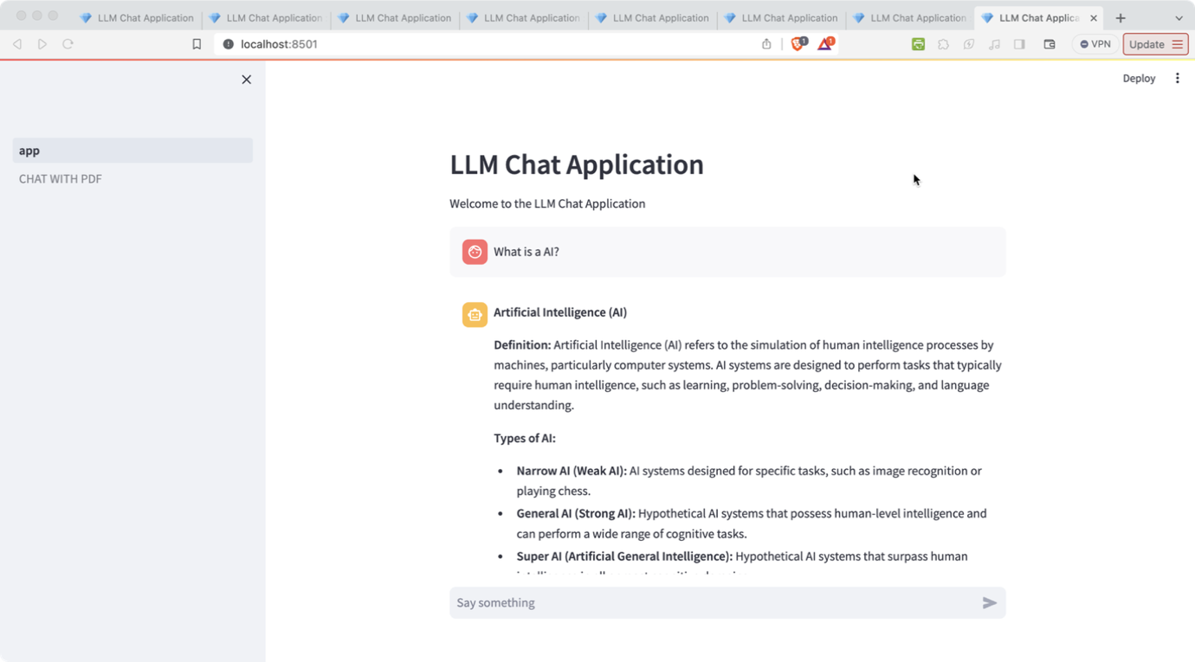

1. **Upload PDF and Chat:**
   * **Scenario:** User uploads a PDF document and interacts with the LLM based on the content of the PDF.
   * **Expected Outcome:** User should be able to upload the PDF document, ask questions based on the content, and receive responses from the LLM.

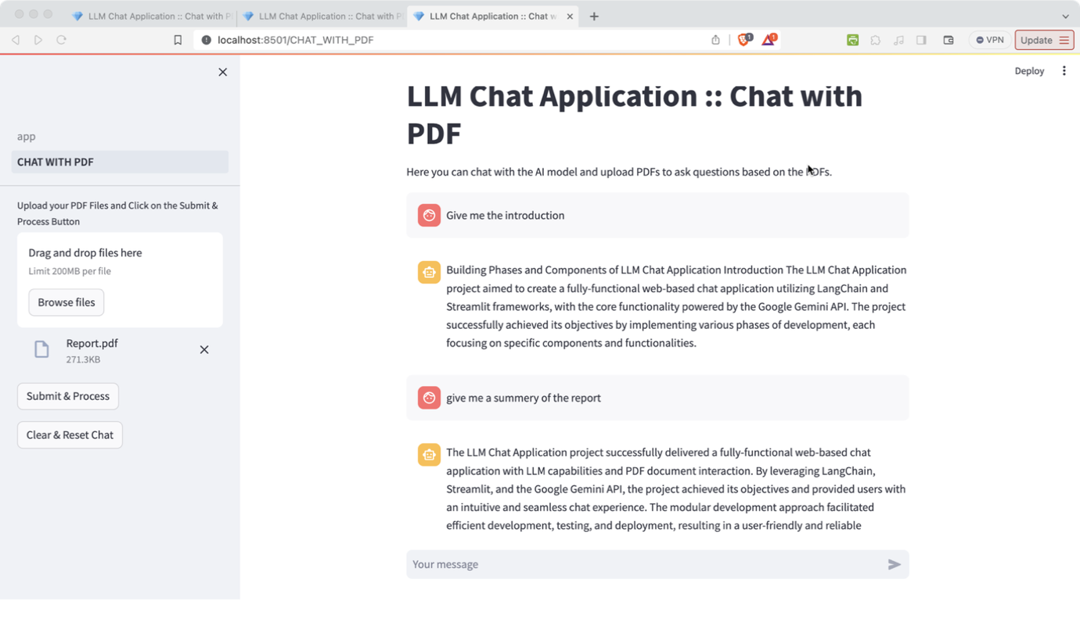

1. **Error Handling - Invalid PDF Upload:**
   * **Scenario:** User attempts to upload an invalid or corrupted PDF document.
   * **Expected Outcome:** User should receive an error message indicating that the uploaded file is invalid and should be prompted to upload a valid PDF.

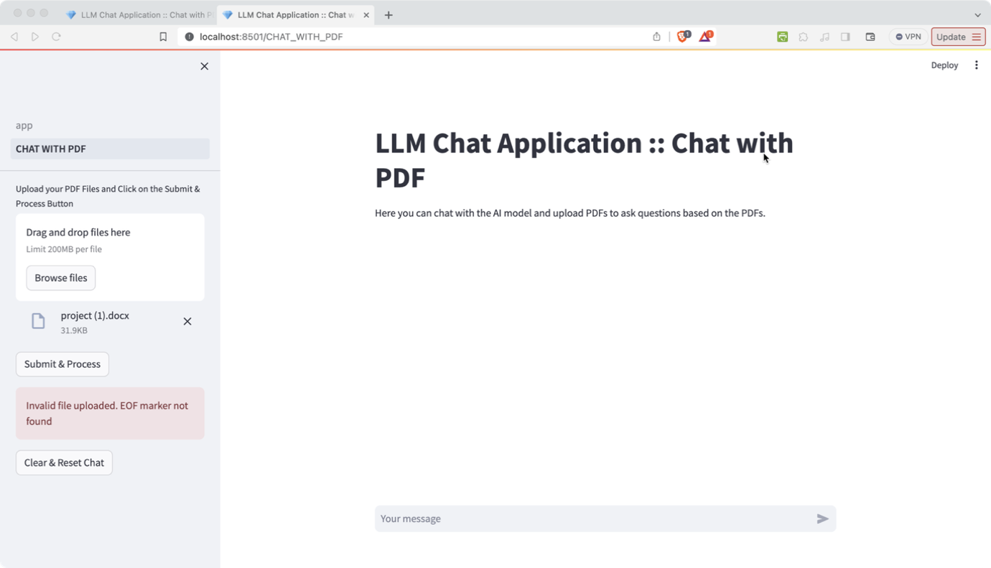

1. **Error Handling - Empty Chat Input:**
   * **Scenario:** User attempts to send an empty message in the chat.
   * **Expected Outcome:** User should see message indicating that they need to enter something in the chat input area before sending.

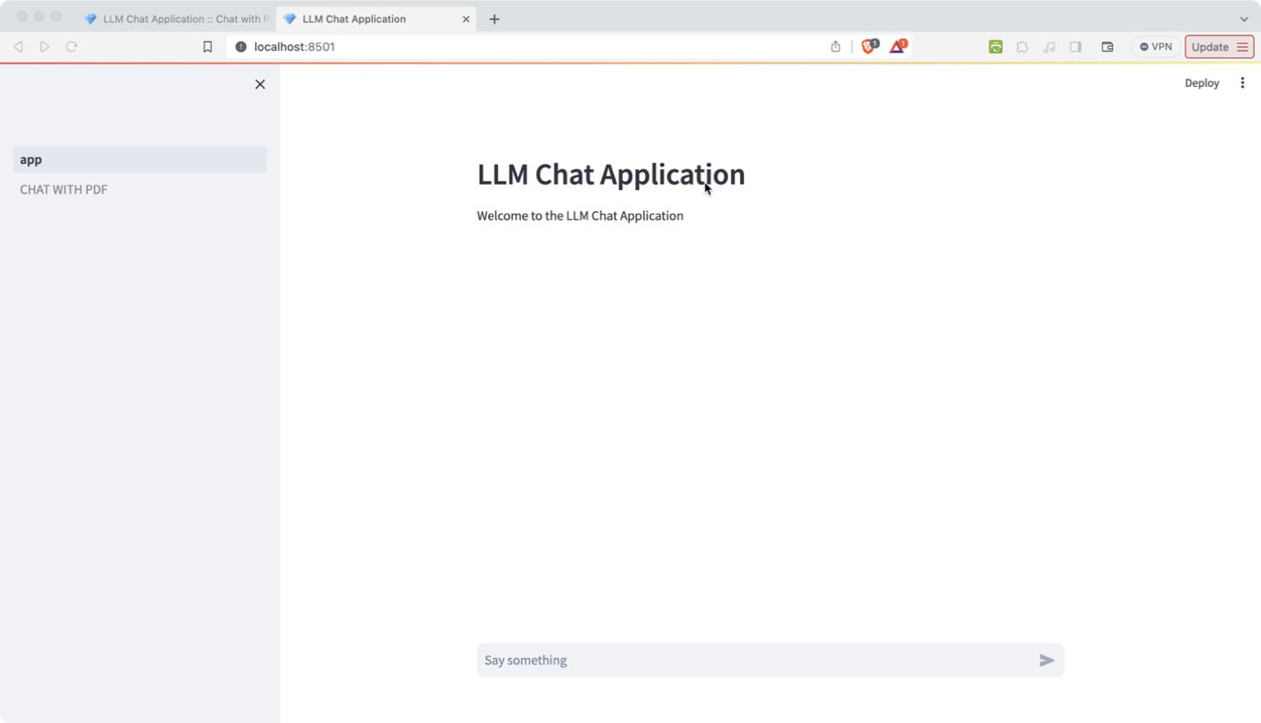

1. **Clear Chat History:**
   * **Scenario:** User clears the chat history.
   * **Expected Outcome:** All chat messages should be removed from the chat area, and the chat history should be reset.

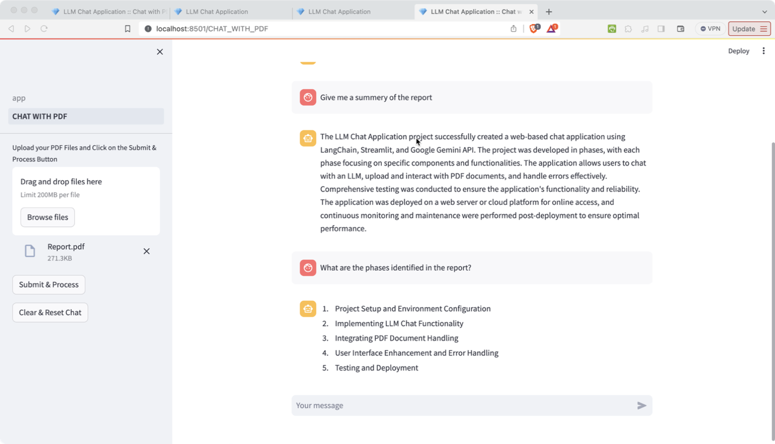

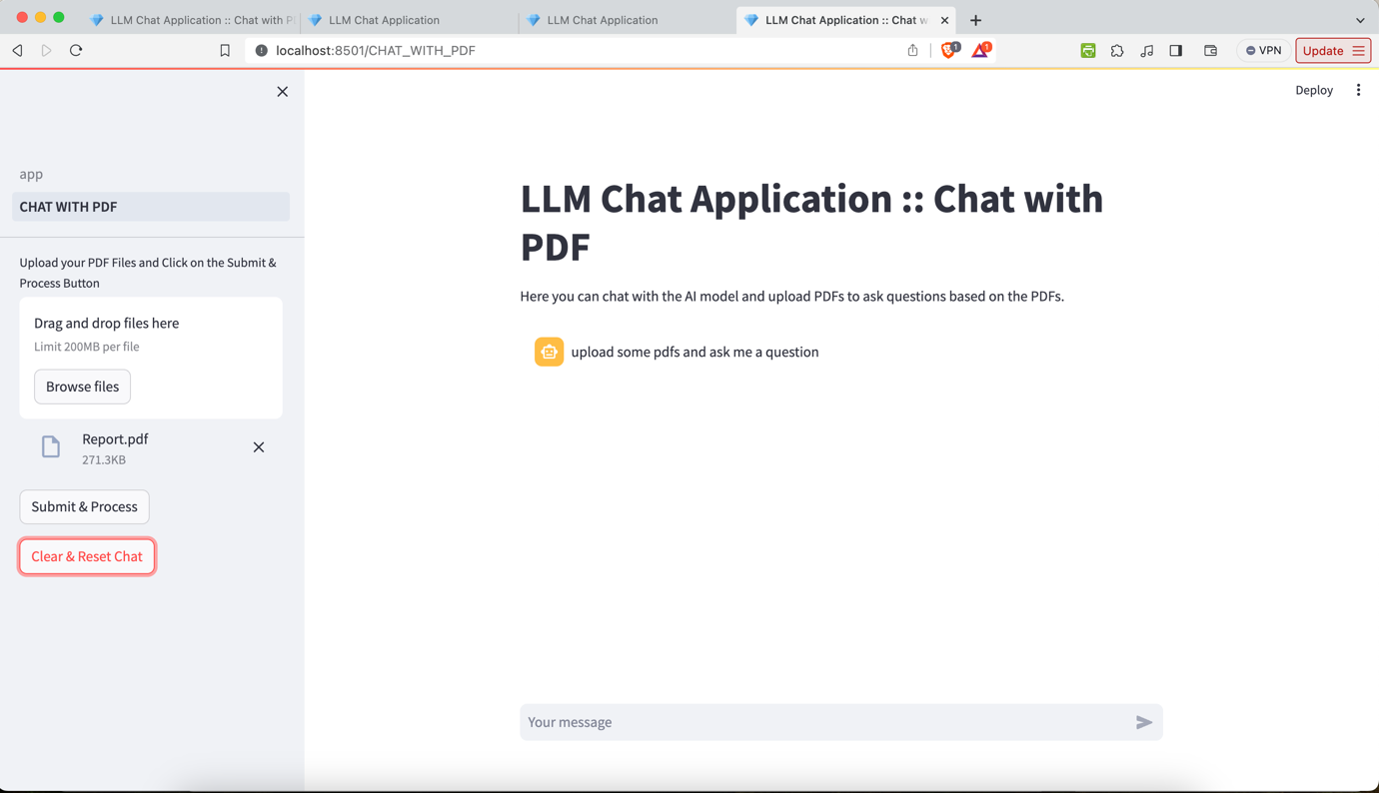

**Conclusion**

The LLM Chat Application project successfully delivered a fully-functional web-based chat application with LLM capabilities and PDF document interaction. By leveraging LangChain, Streamlit, and the Google Gemini API, the project achieved its objectives and provided users with an intuitive and seamless chat experience. The modular development approach facilitated efficient development, testing, and deployment, resulting in a user-friendly and reliable application.

**References**

Streamlit. (n.d.). Streamlit Documentation. Retrieved from <https://docs.streamlit.io/>

LangChain. (n.d.). LangChain Documentation. Retrieved from <https://langchain.github.io/>

Google. (n.d.). Gemini API: Quickstart with Python. Retrieved from <https://ai.google.dev/tutorials/gemini_python_quickstart>

Thoma, M. (Maintainer). (n.d.). PyPDF2: A Pure-Python library built as a PDF toolkit. Retrieved from <https://pypi.org/project/PyPDF2/>