Theme 1: Reflections on level of coding and emergency
The key participants reflected in writing on the level of emergency and coding of patients upon triage. They indicated that obstetric emergencies that falls in priority 1, 2, 3 and 4. Among the conditions were vaginal bleeding, eclampsia, cord prolapse, and eclampsia categorised in priority 1. These are reflected on the figure below.
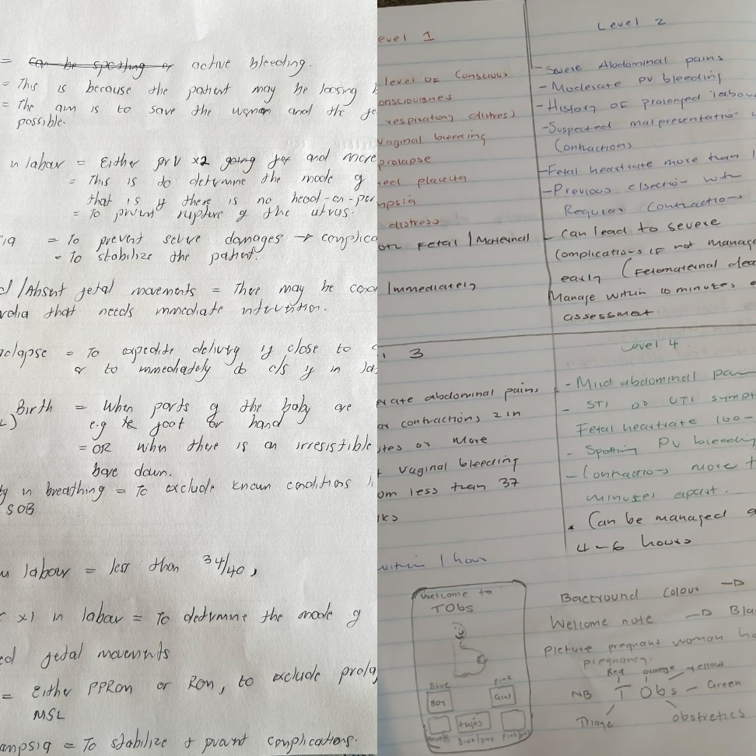
Figure 7.5: Pictures reflecting on coding and level of emergency.
In support of the proposed ideas, the participants consensually agreed that the triage system should have prioritize obstetric conditions as eclampsia, seizure, meconium-stained liquor grade 3, previous c/section more than twice and antepartum haemorrhage as priority 1. The level of coding and emergency are detailed in a highest to lowest ranking order in table 7.3. The highest ranked conditions in alignment to their level priority are depicted below.
“First priority should include women with eclampsia/seizures, antepartum haemorrhage, prelabour rupture of membranes will meconium-stained liquor grade 3 and previous c/section more than twice in labour” All participants
“Stabilized pre-eclampsia, hypertension and gestational diabetes should be priority two.” All participants
“Priority three should be all the conditions that doesn't need immediate attention, like Anaemia, postdates and controlled Pregnancy Induced Hypertension” All participants
Theme 2: reflections on management of emergencies
For this theme, the participants highlighted on the management of obstetrics emergencies; they indicated that some of the emergencies have to be managed within labour suites with the assistance of advanced midwives. One of midwives indicated in writing that in the triage area, they should identify the emergencies and send them labour suites to be managed there as a matter of emergency by the advanced midwives in priority 1. In addition, priority 2, 3 and 4 should be also managed in the labour suites, following the management of the emergency cases. This is reflected in the figure below.

Figure 7.6: Picture reflecting management of obstetric emergencies
In consistent to the ideas of the midwives, the voting and ranking revealed that the midwives consensually agree that the emergencies should be urgently transferred to the labour suites within maternity units. This is reflected in table 7.3 below.
“Emergencies should be quickly transferred to labour suites…” All participants
In addition, 86.1% of the participants consensually agreed the emergency cases should be managed within the labour suites.
Table 7.3: Ranking order of coding and management results
Items | Voting and ranking  N (%)
First priority should be women with eclampsia/seizures | 7 (100%)
First priority should also include antepartum haemorrhage | 7 (100%)
First priority should also include prelabour rupture of membranes will meconium-stained liquor grade 3 and previous c/section more than twice in labour | 7 (100%)
Stabilized pre-eclampsia, hypertension and gestational diabetes should be priority two | 7 (100%)
priority three should be all the conditions that doesn't need immediate attention, like Anaemia, postdates and controlled Pregnancy Induced Hypertension | 7 (100%)
Emergencies should be quickly transferred to labour suites | 7 (100%)
Priority four should include low risk pregnancies like false labour, UTI and normal labour | 6 (86.1%)
Some of the emergency cases should be managed in the triage room | 6 (86.1%)
Preterm should also be included as first priority | 5 (71.4%)
Second priority should include condition like preterm labour | 5 (71.4%)
Decreased/ Absent fetal movements should be priority one | 4 (57.1%)

Theme 3: Co-designing of the triage system
During the workshop engagement the participants reflected in their drawings that the triage system should include features such as log in, picture of pregnant women, white background and a sharing option. In support of this, drawing from frame 1 and 2 of the figure below; the midwives shared similar insights and ideas that a picture of the pregnant woman should be a representative feature in the digital triage. These features were identified to be contributing towards the make and feel of the artefact. The pictures below display some of the designs by the participants.
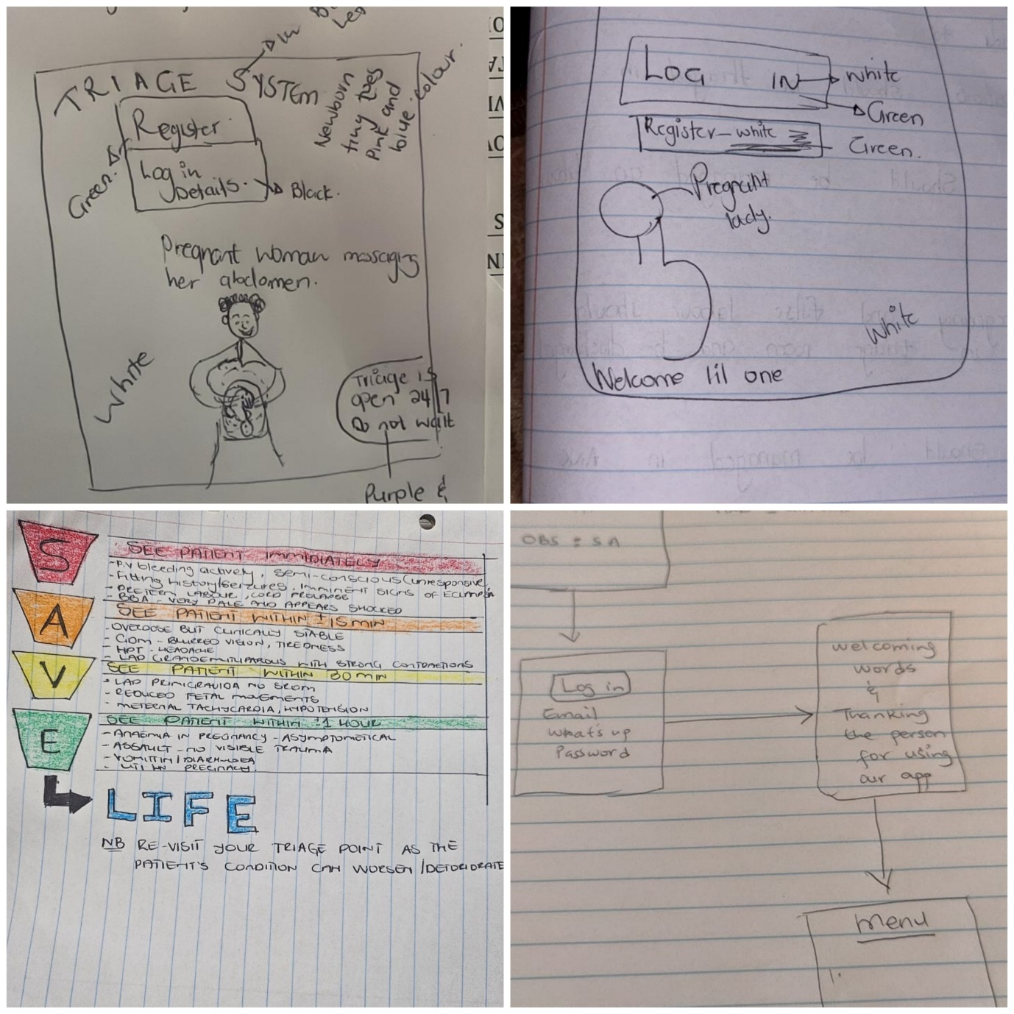
3
2
1
4
Figure 7.7: Pictures reflecting the designs of the participants
In support of the above, the participants reached a consensus on the make and feel of the triage system. Items such as logging welcome messages, and sharing option were ranked the highest by the participants. The table below reflects the ranking order on the items that the participants reached consensus on. They are ranked from the highest to lowest order.
“After logging in the triage system should show a welcome and thank you message and It should indicate option of sharing” All participants
Table 7.4: Ranking order on co-design results
Items | Voting and Ranking  N (%)
After logging in the triage system should show a welcome and thank you message | 7 (100%)
It should indicate option of sharing | 7 (100%)
The triage system background should be white | 6 (86.1%)
The triage system should have a register button | 6 (86.1%)
The register and log in button should be in green | 6 (86.1%)
The triage name should be in the colors of the priority system | 6 (86.1%)
The triage application should have a picture of a pregnant women rubbing her belly | 5 (71.4%)
The triage application should have footprints of babies in pink and blue on the welcome page | 5 (71.4%)
The triage system should use email and password to log in | 4 (57.1%)
The name of the triage should be ObSAtriage | 4 (57.1%)
The picture of the pregnant women should be purple in color | 4 (57.1%)
Feedback responses about the workshop
“Morning everyone. Okay, for me thanks… Thank you so much for this. I'm really happy because this might be really helpful if our institutions can adopt this. It might really be helpful to us instead of picking patients from the waiting area. It might really help us to have somebody in the triage room to be able to triage our patients so we can manage them accordingly. it was really helpful. Thank you so much.”
“Thank you so much. Nami (Me, also), I'd like to say something a little bit though… It will be help, helpful if we use this page things. It will work for us and when we are using it will reduce the perinatal mortality rate to be below the target, target because we'll be prioritizing the high-risk patients and those patients will be managed early than late.”

7.6. PRE-REQUISITE AND EXPECTED OUTCOMES OF THE MIDWIFE-LED TRIAGE

7.6.1. Pre-requisite of the midwife-led system
The midwife-led triage system proposes integrated treatment pathways of managing high-risk obstetric emergencies. Therefore, the following are the pre-requisites for the adoption of the triage system in maternity units.
- The users should possess background knowledge, skills, and be trained in managing high-risk pregnancies and obstetric emergencies.
- The user should have the ability to identify and recognize emergency signs.
- The users should be midwives/accoucheurs registered with South African Nursing Council as a professional nurse and midwife/Accoucheur.

7.6.2. Expected outcomes of the midwife-led triage system
The system features structured triage pathways, priority tagging, emergency referral prompts, and automated alerts for red-flag conditions such as eclampsia, maternal collapse, antepartum haemorrhage, and abnormal foetal heart rate. It serves as both a decision support and educational platform. Through participatory co-design, it delivers a digital interface that not only standardizes emergency response protocols but also reinforces clinical autonomy and situational awareness for maternal health workers. The triage is deeply aligned with the South African National Digital Health Strategy (2019– 2024), which emphasizes the localization of digital solutions to address systemic inefficiencies, including maternal and neonatal mortality. As a potential tool for national implementation, it represents a scalable, context-sensitive, and policy-aligned innovation for improving maternal care delivery. Therefore, the expected outcomes of the triage are as follows;
- Reduction of maternal and perinatal mortalities and morbidities associated with the third delay.
- Optimize appropriate resources utilization and allocation.
- To possible reduce litigation cases linked to substandard maternal care
- To enhance patient satisfaction and foster positive perceptions of maternal healthcare in South Africa

7.7. CYCLE I: CONTENT CREATION AND DEVELOPMENT
Below, the elements of triage are described in relevance to the identified findings in this contemporary study and existing literature. The existing South African guidelines and global guidelines and recommendations related to maternal care during pregnancy and intrapartum were consulted to explain in detail the elements of triage.

7.7.1. Coding and level of emergency
As previously mentioned, triage is process of classifying patients in terms of their level of medical urgency, including the severity of injury. The level of emergency and priority of the patient is based on the established international triage coding system. This system allows the triage officers to determine the level of priority, appropriate time of care and the plan of management (Yancey & O’Rourke, 2023, SATS, 2012). In this study, the triage system adheres to the international triage coding systems, SATS and national South Africa guidelines on patient waiting times (2023). According to the national waiting time guidelines (2023), the coding system ranges from red subsequently related to priority 1, no waiting to green where a patient can wait a maximum of 1 hour. The waiting times in this triage system will slightly differ from the ones adopted in emergency and accident departments of South Africa. The coding system will be adopted as shown in table 7.5 below. The categorization of the conditions and management is further detailed in table 7.6 and 7.7 respectively.

Table 7.5: Coding system of the triage (SATS, 2012)
Priority | Priority colour | Target time | Possible obstetric conditions | Interventions | Rationale
P1 | Red | Immediately | This is inclusive of conditions such as eclampsia, antepartum haemorrhage (confirmed vaginal bleeding in pregnancy), pre-eclampsia with imminent signs and absent foetal movements/ foetal distress, possible cephalopelvic disproportion cases from local clinics, prolonged second stage of labour. Also, spontaneously rupture of membranes with meconium-stained liquor more than grade 3. | Transfer to labour suite/ manage in triage room only when necessary | For emergency care and resuscitation.
P2 | Orange | 10 minutes | This includes conditions such as severe pre-eclampsia and cases of preterm labour, preterm prelabour rupture of membranes and spontaneously rupture of membranes with meconium-stained liquor grade 1 & 2. | Refer to the designated floor advanced midwife. | Very urgent, for clinical management by midwifery specialist.
P3 | Yellow | 30 minutes | In this category, multigravida with no surgical history can form part of this category. This also includes grand multiparity women in latent-active phase of labour. | In this category, refer to the designated waiting area. However, provide with supportive measures; particularly the pregnant women in latent-active phase of labour with minimal risk. These women can be advised on non-pharmacological pain relief methods and other measures of self-care during labour. Such as proceeding normal diet only if they don’t have underlying conditions. | It’s an urgent case, however the patient can wait at least thirty minutes in the waiting after triage
P4 | Green | 1 hour | Normally, this category includes low-risk pregnancies. This includes condition such as false labour, urinary tract infections in pregnancy and primigravida & multiparous women in latent phase of labour | In this category, the pregnant women can be referred to waiting area. They can also be referred to the medical officers for comprehensive assessment. Thereafter, upon the discretion of the medical officer, they can be down-referred. | Low-risk and non-urgent, it can be for discharge

Table 7.6: Classifications of triage algorithms and level of priorities
Algorithms |  | Priority 1 | Priority 2 | Priority 3 | Priority 4
Clinical profile | Vital signs | - Blood pressure (BP) >160/110mmHg  - Heart rate (HR) >140 bpm and <50bpm  - Respiratory rate (RR) >60bpm and <10bpm | - BP 150/100-159/109mmHg  - RR >30 bpm | - BP 149/99-140/90mmHg  - HR 120-130bpm  - RR 11-14bpm | - BP 110/60-139/89mmHg  - HR 60-110bpm  - RR 16-24bpm
 | Foetal monitoring | - Absent/ Decreased foetal movement | - Foetal heart rate <110bpm and >160bpm |  | - Normal foetal heart rate (140-160bpm)
 | Vaginal examination | - Cervical dilation of >8cm | - Cervical dilation of 8 cm | - Cervical dilation of 6-7 cm | - Cervical dilation of 1-5 cm
Risk factors |  | - Previous c/section  - Advanced maternal age  - Chronic hypertension  - Diabetes mellitus  - Grand multiparity  - Rhesus incompatibility  - Multiple pregnancy  - Previous stillbirths  - High body mass index
Obstetric conditions |  | - Eclampsia  - Imminent eclampsia  - Active antepartum haemorrhage  - Cord prolapses.  - Loss of consciousness  - Previous c/section more than twice in labour  - Fresh scar in labour  - Prelabour rupture of membranes with MSL grade 3  - Absent/decreased foetal movements  - Advanced stage of labour | - Shortness of breath, acute  - Preterm labour  - Severe-Moderate lower abdominal pains  - Multiple pregnancy in labour  - Preterm Prelabour Rupture of Membranes (PPROM) | - Pre-eclampsia  - Gestational diabetes  - Gestational hypertension  - Previous c/section (VBAC) in labour | - False labour  - Urinary tract infections  - Vomiting  - Diarrhoea  - Mild uterine contractions

Table 7.7: Categorization of coding and management of conditions

EMERGENCY
PRIORITY 1
Conditions |  |  | Eclampsia |  |  | Imminent eclampsia | Active antepartum haemorrhage | Cord prolapses
Clinical profile |  |  | Vital signs |  | Bp >160/110mmHg | Bp >160/110mmHg | Bp <110/60mmHg | N/A
 |  |  | Signs & Symptoms |  | - Proteinuria 2+  - Fitting/seizures  - Generalized oedema.  - Visual disturbances  - Epigastric pain | - Proteinuria 2+  - Generalized oedema.  - Visual disturbances  - Epigastric pain | - Active vaginal bleeding  - Hypotensive <110/60mmHg | - Prolapse cord, can be noted on vaginal exam
Management |  |  | Triage |  | See immediately for emergency care and stabilization.
 |  |  |  |  | - Call for help.  - Keep patient on left side, suction airway and insert oral airway if necessary.  - Insert foley catheter.  - Oxygen per face mask to keep saturation >90%  - Administer a loading dose of 4g Magnesium sulphate (MgSO₄) diluted in 200ml normal saline 0.9%.  - If >160/110mmHg, give 10mg Nifedipine. Repeat dose after 30 minutes if Bp is >160/110mmHg.  - If seizures persist, give 2g MgSO₄ intravenously (IV) over 10 minutes.  - If restless and agitative, give lorazepam 4mg IV/ Intramuscular (IM). Repeat after 10-15 minutes, maximum dose 8 mg  - If not available, give clonazepam 2mg and may be repeated in 5 minutes  OR  - Diazepam 10-20mg not faster 2mg/minute  - For maintenance, administer 5 g MgSO₄ IM every four hours in alternative buttocks.  - Fluid restriction | - Insert foley catheter and monitor urine.  - Insert an IV line and give restricted fluids.  - Administer a loading dose of 4g MgSO₄ diluted in 200ml normal saline 0.9%, followed by 5g of MgSO₄ in each buttocks IM.  - If >160/110mmHg, give 10mg Nifedipine. Repeat dose after 30 minutes if Bp is >160/110mmHg. | - Call for help  - Insert two IV lines  - Start the patient on 1 litre sodium chloride 0.9%  - If in shock, resuscitate with 1 or 2 litres of sodium chloride 0.9%  - Don’t perform vaginal exam until placenta previa excluded.  - Perform speculum examination to exclude any local causes  - Insert foley urinary catheter.  - Monitor uterine contractions. | - Call for help  - Briefly explain to the patient  - Perform vaginal exam, check if cord is pulsating  - If foetus alive and viable gestation;  - If fully dilated, proceed vaginal delivery immediately.  - If not fully dilated, prepare for c/section  - Replace the cord in the vagina and attempt to keep it in place using sanitary pads while keeping the mother's thighs closed.  - Handle with care, to avoid occluding blood supply  - If presenting is compressing the cord, push it up with fingers  - Advise and turn the women in knee-chest position while the fingers are continuing pushing the presenting part  - Insert an 18G urinary catheter to empty the bladder  - Thereafter, fill the bladder with 400ml of normal saline and clamp the catheter  - Establish IV line and administer normal saline 0.9%  - Initiate tocolysis using salbutamol if available 250mcg over 2 minutes, reconstitute as guidelines advised.
References
National department of Health. National integrated maternal and perinatal care guidelines for South Africa national integrated maternal and perinatal care guidelines for south africa. (2020). Available at: https://knowledgehub.health.gov.za/system/files/elibdownloads/2024-10/Integrated%20Maternal%20and%20Perinatal%20Care%20Guideline_23_10_2024_0.pdf.
Marshall, J.E. and Raynor, M.D. eds., 2020. Myles' Textbook for Midwives E-Book: Myles' Textbook for Midwives E-Book. Elsevier Health Sciences.
Sellers, P.M., 2018. Midwifery: A textbook and reference book for midwives in South Africa. Juda þ Co.: Cape Town, South Africa.

VERY URGENT
PRIORITY 2
Conditions |  |  | Shortness of breath, Acute |  |  | Preterm labour | PPROM | Multiple pregnancy in labour
Clinical profile |  |  | Vital signs | - Saturation <95%  - Respiration rate 24bpm |  | N/A | N/A | N/A
 |  |  | Signs & symptoms | Warning signs  Altered mental status.  Stridor  Difficulty in breathing  Diffuse crackles  Respiration rate 24bpm  Heart rate >120bpm  Saturation <95% |  | Painful regular contractions  Cervical dilation  Cervical shortening | Ruptured membranes | Painful regular contractions  Cervical dilation  Cervical shortening
Management |  |  | - Manage within 10 minutes, refer to the designated floor advanced midwife.  - Very urgent, for clinical management by midwifery specialist.
 |  |  | - Women presenting with the warning signs mentioned above, need oxygen per face mask  - Women exhibiting signs of fluid overload or pulmonary oedema need 40mg furosemide IVI  - Admit in ward for managing underlying conditions |  |  | Gestation <24 weeks  - Treat and manage as miscarriage  Gestation 24-25 weeks  - Transfer to the ward and consult senior doctor  Gestation 26-33 weeks  - Monitor vital signs  - Pre-hydrate with 0.9 Normal saline 200ml IV fluid  - Tocolyse with 20mg of Adalat/nifedipine unless contra-indicated  - If contractions persist, continue tocolysis with nefidipine, 10mg after 30 minutes and 10mg 4 hourly up to 48 hours  - For lung maturity, give 12mg betamethasone and give 2nd dose after 12 hours (total dose of 24mg)  - Alternatively, 8mg dexamethasone can be given 8 hourly for total of 3 doses  - If cervix is ≥6cm dilation with strong contractions allow labour to progress.  - If cervix is ≤6cm dilation, continue with tocolysis and suppression of labour until 48 hours of betamethasone has passed.  Gestation >34 weeks  - Allow labour to progress  - Manage as term labour | - Exclude cord prolapse  - If in labour, manage as preterm labour according to their gestational age  Gestation 26-33 weeks  - Give antibiotics, 1g ampicillin 6hlry for 48 hours.  - Followed with amoxicillin 8hrly for 5 days  - Azithromycin 1g as single dose  Gestation ≥34 weeks  - Allow to progress if having contractions  - Induce labour, if not in labour within 12-16 hours  - Give antibiotics as indicated above. | - Confirm presentation and lie of the twins.  - If cephalic presentation, proceed as normal labour  - If transverse lie and first twin breech after 37 weeks, prepare for c/section delivery
References
National department of Health. National integrated maternal and perinatal care guidelines for South Africa national integrated maternal and perinatal care guidelines for south africa. (2020). Available at: https://knowledgehub.health.gov.za/system/files/elibdownloads/2024-10/Integrated%20Maternal%20and%20Perinatal%20Care%20Guideline_23_10_2024_0.pdf.
Marshall, J.E. and Raynor, M.D. eds., 2020. Myles' Textbook for Midwives E-Book: Myles' Textbook for Midwives E-Book. Elsevier Health Sciences.
Sellers, P.M., 2018. Midwifery: A textbook and reference book for midwives in South Africa. Juda þ Co.: Cape Town, South Africa

URGENT
PRIORITY 3
Conditions |  |  | Pre-eclampsia |  |  | Gestational hypertension | Gestational diabetes | Previous c/section for Vaginal Birth After C/section (VBAC)
Clinical profile | Vital signs |  | - Bp >140/90mmHg |  |  | - Bp >140/90mmHg | - Glucose level >10g/dl
 | Signs and symptoms |  | - Proteinuria 2+ |  |  | - None | - Glycosuria | - Painful regular contractions  - Cervical dilation  - Cervical shortening  - Previous c/section x1
Management |  |  | - It’s an urgent case, however the patient can wait at least thirty minutes in the waiting after triage
 |  |  | - If stabilized and with no signs of imminent eclampsia  - Advise on continuing methyldopa treatment as prescribed.  - If in labour, manage as normal labour.  - Monitor the vital signs.  - IV fluid restriction to avoid fluid overload |  |  | - If stabilized and with no signs of imminent eclampsia  - Advise on continuing methyldopa treatment as prescribed.  - If in labour, manage as normal labour.  - Monitor the vital signs | - If stabilized and with no diabetic ketoacidosis signs  - Advise on continuation of treatment  - If in labour, manage as normal labour in ward as per protocol  - Monitor the vital signs particularly the glucose | - Exclude all contra-indications of VBAC delivery  - Once labour confirmed, insert iv line.  - Start on normal saline 0.9% run at 80-120ml/hr  - Insert urinary catheter  - Monitor CTG continuously  - Do not argument labour  - Monitor closely for any signs of imminent uterine rupture.
References
National department of Health. National integrated maternal and perinatal care guidelines for South Africa national integrated maternal and perinatal care guidelines for south africa. (2020). Available at: https://knowledgehub.health.gov.za/system/files/elibdownloads/2024-10/Integrated%20Maternal%20and%20Perinatal%20Care%20Guideline_23_10_2024_0.pdf.
Marshall, J.E. and Raynor, M.D. eds., 2020. Myles' Textbook for Midwives E-Book: Myles' Textbook for Midwives E-Book. Elsevier Health Sciences.
Sellers, P.M., 2018. Midwifery: A textbook and reference book for midwives in South Africa. Juda þ Co.: Cape Town, South Africa

NON-URGENT
PRIORITY 4
Conditions |  |  | - False labour  - Urinary tract infections  - Vomiting  - Diarrhoea  - Low risk pregnancies
Clinical profile |  |  | - No significant symptoms and danger signs  - Vomiting  - Diarrhoea  - Haematuria  - Dysuria  - Irregular contractions  - Mild-moderate contractions, with no risk factors
Management |  |  | - See patient within an hour of triage.  - Manage as per guidelines and hospital protocols

In the process of designing the triage system as informed by the findings from phase 1 and participatory workshop outcomes; similarities across other triage systems developed in Birmingham and Ghana was noted. For instance, although this study prioritized the designing and contextualizing a triage system for South African maternity units; the obstetric emergencies identified by the midwives in the workshop are similar to the BSOTS and Midwife-led triage in Ghana. Among the obstetric conditions were imminent labour, eclampsia, loss of consciousness, abnormal vital signs and antepartum haemorrhage (Kenyon et al., 2017; Floyd et al.,2018). The identified obstetric emergencies were similar to other several literature and guidelines. They were identified as most common causes of maternal mortalities (WHO 2019, Diogo Aryes-de-Campos 2017; National department of health 2023). The researcher concludes that it evidently clear that antepartum haemorrhage, abnormal vital data, maternal collapse and hypertensive disorders are emergent case requiring special attention across the globe.
On same wavelength, the researcher noted across all the triage systems; there are pathways and algorithms to guide the triage process. However, they don’t provide specific management of the obstetric emergencies, but detailed the proper approaches to manage the emergencies from first priority to the last (Kenyon et al., 2017; Floyd et al., 2018). Unlike the other triage systems, the designed MTS offers generated condition specific management to assist the midwives with management of the priority 1 emergencies. This comes after, the midwives suggested that the triage system should provide guidance in management of obstetric emergencies and be incorporated with maternal guidelines. Thus, in this case, the evidence-based management integrated to the triage system aims to improve the skills of the midwives in managing obstetric emergencies. Although, it is a pragmatic approach to improve midwives’ competency. The clinical management provided in the triage will require frequent updates in alignment with the maternal guidelines in South Africa. This will enhance the implementation of evidence-based practice in the maternity units as supported by the WHO framework and Iowa Model of evidence-based practice (WHO, 2016; Titler et al., 2001).
On the other hand, in comparison to other triage systems; the designed triage system left out some other conditions, including postnatal conditions. For example, the maternity BSOTS guidelines compiled by Leslie, Lovegrove and Gawley (2024) included postnatal conditions and practical approach to manage those conditions when triaging. However, drawing from the methodology of this study; this was mainly because the triage was developed in line with the midwives’ suggestions. The midwives play a crucial role in provision of quality maternal care in maternity units. As the end-users of the triage system, they reflected on their daily practices and the challenges faced during practice. Thus, it was imperative to contextualize the triage system looking at the midwives needs and preferences of a digital triage. In addition, the triage system, contextualized the level of coding and emergency in relevance to the South African national guidelines on patient waiting times (2023), which are slightly different from the other triage systems.
On this basis, the researcher concludes that the needs and preferences of the midwives play a major role in contextualizing the triage system. However, it is not confined only on the requirement gathering. Existing evidence was synthesized to benchmark the design and development of this triage system. With the technology advancements and changing times, advancements may be made on the triage system to fit both the midwives and patients’ needs. As we argued in chapter 2, leveraging of digital health technologies may be considered a promising aspect to remediate the quality of maternal care in South Africa.
DESIGN
Nonetheless, based on the midwives’ perspective, the midwife-led triage system is an interconnected communication system. It uniquely integrates obstetric emergency care logic and maternity-specific triage algorithms within a system co-designed by midwives in the South African public health context. Unlike existing general triage tools or remote maternal monitoring apps, this system digitises priority-based obstetric care pathways and embeds real-time decision logic grounded in national emergency protocols. The midwife-led triage system is in two integral parts that is linked into multiple components of patient-centred care, namely midwife-led mobile triage system and the central monitoring desktop. This detailed in the diagram below.
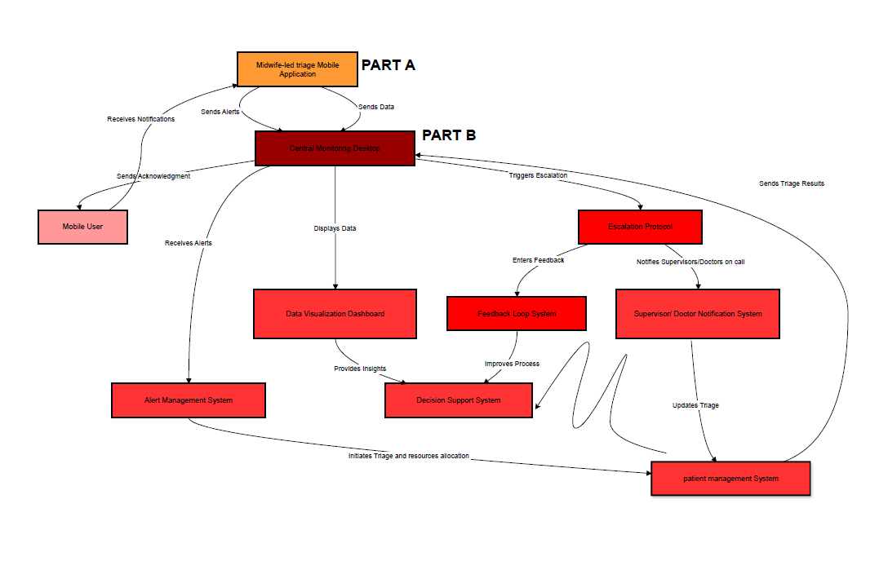

CORE FEATURES OF THE MTS
Table 7.8 below outlines the core features as identified by the study findings and provide description along with the level of priority for the feature.
Table 7.8: Core features of the MTS
Feature | Description | Priority
User Authentication & Security | Develop secure login and signup flows for patients and medical staff. Implement password encryption (bcrypt/argon2). Assign roles and permissions (patients vs medical staff). Add basic security checks (account lockout after multiple failed attempts). | HIGH
Landing Screen & User Interface (UI/UX) | Design an intuitive dashboard for patients (submit symptoms, view results) and staff (manage patients, review diagnostic suggestions). Build simple navigation menus for quick access. Responsive design for mobile and desktop compatibility. | HIGH
Data Sharing & Privacy Compliance | Design and implement a structured database (SQL or NoSQL). Storage for patient records, reported symptoms, diagnostic results. Implement data backup & recovery strategy. | HIGH
AI-Powered Diagnosis Engine | Build a machine learning model that analyzes symptoms to suggest possible outcomes aligned to the maternity care guidelines. Train with sample datasets (initial version). Provide a mechanism for continuous learning and updates as more patient data is collected. Ensure explainability (medical staff can see why a suggestion was made). | HIGH
Testing, Documentation & Deployment | Conduct unit testing, integration testing, and user acceptance testing. Create user guides (patients + medical staff). Deploy the application and ensure smooth onboarding. Provide 1-month post-deployment support for bug fixes and adjustments. | MEDIUM

7.8.2. PART A: MIDWIFE-LED TRIAGE MOBILE APPLICATION
This research project builds upon the foundational premise that sustainable improvements in maternal healthcare require collaborative innovation, including cost-effective approaches. Rather than adopting externally developed frameworks that may not align with local realities, this project co-designs a triage system with midwives and for midwives. By co-designing with midwives, the project ensured that the resulting midwife-led triage system is contextually relevant, practically usable, and widely acceptable. Equally important, midwife-led triage system is crucial especially where systemic limitations often hinder the delivery of timely and effective maternal care. Therefore, the proposed midwife-led triage invention will enhance clinical decision-making, streamline emergency response, and ultimately support midwives in providing high-quality, equitable care. Nonetheless, the first integral part of the midwife-led triage system, it’s the mobile triage application. In essence, the mobile triage application is designed with integrated obstetric emergencies care and treatment pathways. The treatment pathways leverage the tacit knowledge and practical experience of midwives working in frontline healthcare settings. Furthermore, it is grounded on national guidelines and protocols in managing obstetric emergencies. The clinical pathways are detailed in the table 7.6 and 7.7 above. The visualization of the mobile triage system is displayed in figure. The mobile triage system is guided by four algorithms as indicated by the midwives, demographic data, risk factors, clinical profile and potential diagnosis and management. Below, we delineate on how the mobile triage system is envisaged to work, referencing to the figure 7.8.
- Step 1: the mobile user (midwife/Accoucheur) captures the details and clinical information of the patient after clinical assessment of the pregnant women in the midwife-led mobile application. This will automatically send notifications to the mobile application.
- Step 2: the midwife-led triage system will automatically generate algorithms and provide the treatment pathways to the mobile user based on the evidence-based treatment algorithms in table 7.6 and 7.7. Simultaneously, the midwife-led triage mobile application will send alerts and the generated data to the central monitoring desktop.
- Step 3: the central monitoring desktop will visualize the data to the midwives and healthcare professionals alerting them of the urgent case in the triage room. Visualizing the clinical data to provide insights to the healthcare professionals within the unit and to allow them to make informed clinical decisions to which patient is urgent or non-urgent from the waiting area. In this manner, they will be able to prioritise the patients. In addition, during the message of acknowledgment will be send to the mobile user.

7.8.3. PART B: CENTRAL MONITORING DESKTOP
The second integral part of the triage system is the central monitoring system, which is crucial to transmit information to the supervisors and doctors on call. Moreover, the central monitoring system will also receive alerts from other hospitals following triage on the decision to refer patients for further treatment. The steps below continue from part A.
- Step 4: Meanwhile, the central monitoring desktop displays the data. It will trigger the escalation protocol to notify the doctors and supervisors on call of patient’s condition. Thereafter, the doctor will assign tasks and further management of the patient to add up to the generated management by the mobile triage applications. This will then update the triage and send the results to the central monitoring desktop for the midwives to carry out the additional orders.
- Step 5: simultaneously, the system will automatically enter feedback to whether the doctor was reached in this particular moment. The feedback will be entered in the feedback loop system. This will further assist by making the midwives aware and proceed with the management of the patient as it seems fit their scope of practice.
- NB: The alert management system will only work when patient was referred from and being referred to other facilities for patient care. This will alert the facility that the patient is being referred for them to prepare in advance for the patient. This will facilitate proper clinical workflow of the patients.

7.8.4. RISK ASSESSMENT AND MITIGATION
The midwives identified common risks that may impact the optimal implementation of the midwife-led triage system. Table 7.9 below describe the risks and the impact associated with the risks.
Table 7.9: Risk assessment and mitigation
Risk | Priority | Impact | Mitigation strategy
Digital literacy | HIGH | This may reduce the implementation of MTS by the midwives. | Create user guides and train the midwives on the use of the triage system.
Network connection issues | HIGH | Inability to effective triage patients, compromising patient care | Seek long term funding for assistance with network and data coverage. Acquire local servers for network support.
Maintenance and sustainability | HIGH | May affect proper implementation of the MTS | Engage department of Health IT experts, and funders for technology transfer and continuous support for implementation.
Infrastructure concerns | MEDIUM | Unavailability of physical compromising quality triage | Engage the department of Health for adequate infrastructure support.
Resistance to change concerns | MEDIUM | This increases the risk of rejection and poor implementation. | Engage the end-users throughout the process and provide training on the use of the MTS.

7.8.5. FUTURE MAPPING TO THEMATIC FINDINGS
The table 7.10 below highlights the themes and user needs which were not covered during the triage system development. However, design implications were indicated for future expansion of the triage system.
Table 7.10: future mapping to thematic findings.
Theme | User needs | Suggested features | Design implications
Application and functionality features of the midwife-led triage system | Ability to communicate with other healthcare professionals. | Ability to communicate with other colleagues via the triage system | Creation of an encrypted line of communication in between the healthcare professionals, whilst ensuring privacy.
 | Ability to access patient clinical records from prenatal care | Access health records from prenatal care  Interconnected system | Establish an electronic health system and database in all levels of healthcare.
 | Ability to capture pictures | Take pictures of patient condition and CTG tracings | Establish an additional patient role in the triage system for patient to be able to self-triage and send evidence.
Patient results link: https://trakcarelabwebview.nhls.ac.za/trakcarelab/csp/system.Home.cls#/Component/SSUser.Logon
IMPORTANT PARAMETERS
VITAL SIGNS
blood pressure
Blood glucose (3.5mmol-7.5mmol)
Heart rate
Respiration
Urinalysis- Protein- 1+, 2+, 3+
-Leukocytes 1+, 2+, 3+
-Haematuria 1+, 2+, 3+

REGISTRATION
Title
Name
Surname
Profession: Doctor/Midwife/midwifery specialist
HPCSA/ SANC Nr:
Cell Nr:

