Lab 4 – Exercise SQL-2

# Creating Database

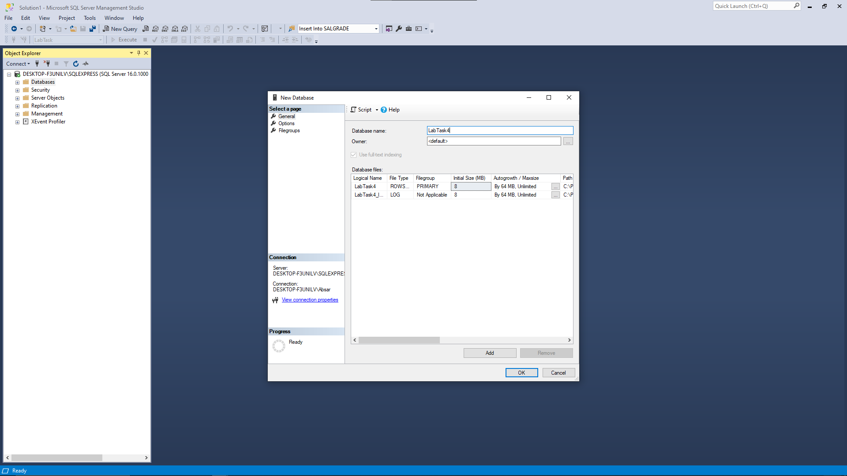

# Creating Tables

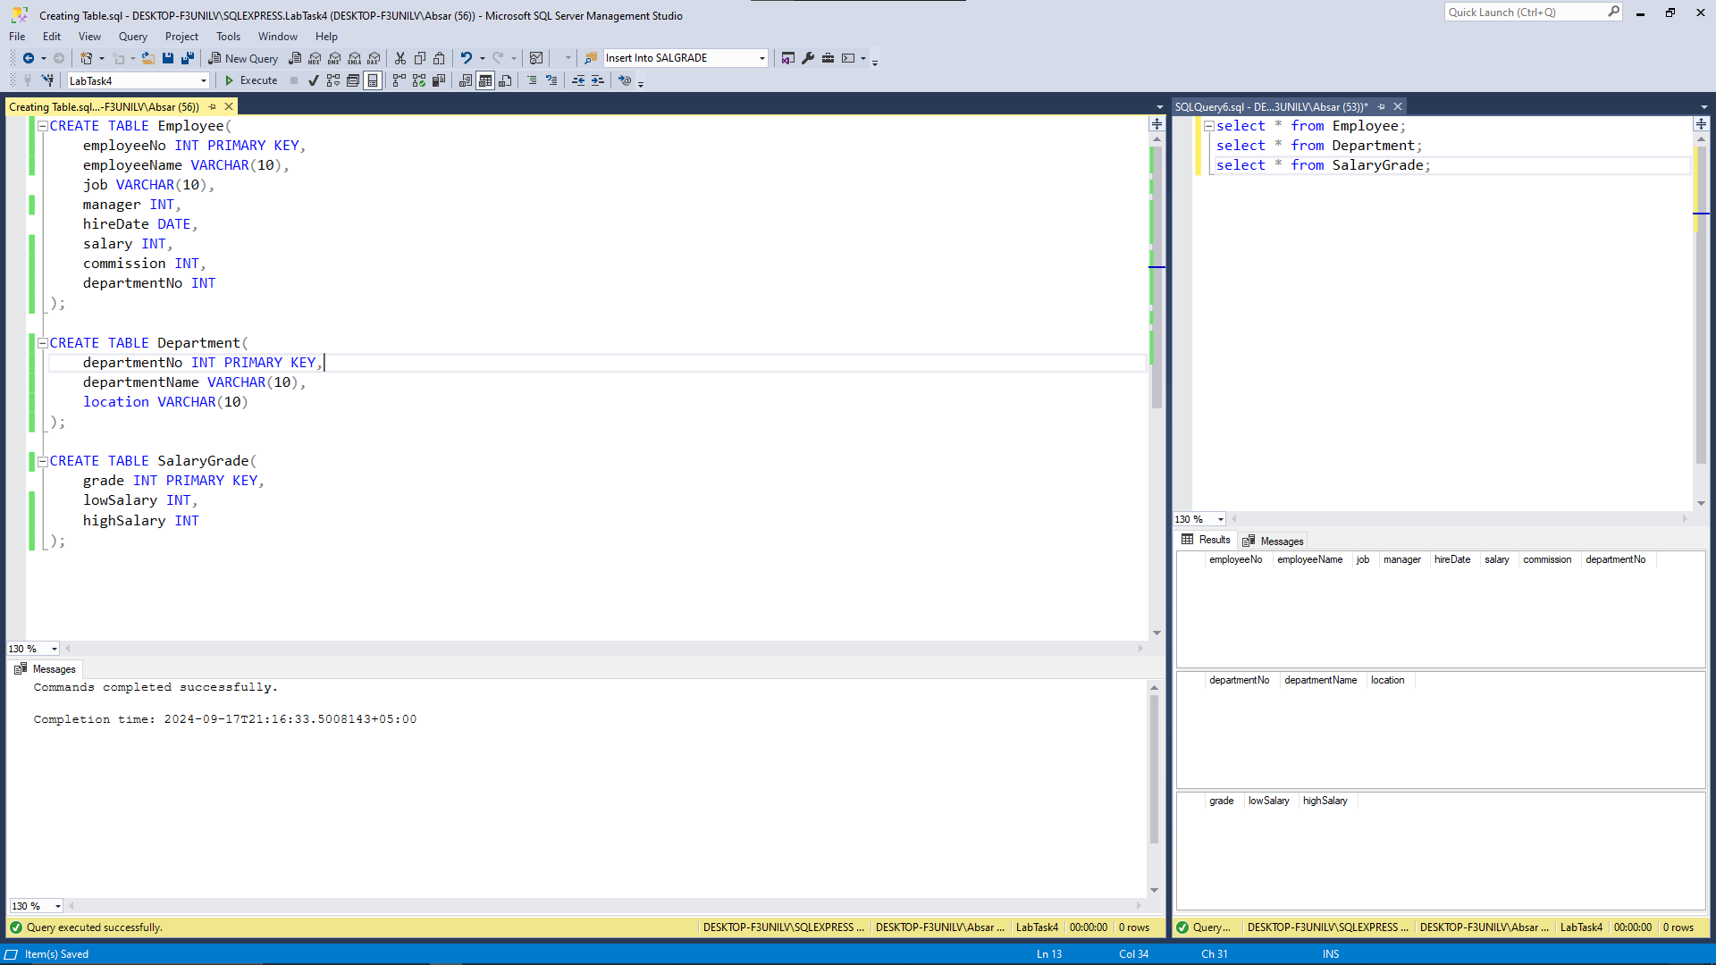

# Inserting Into Employee

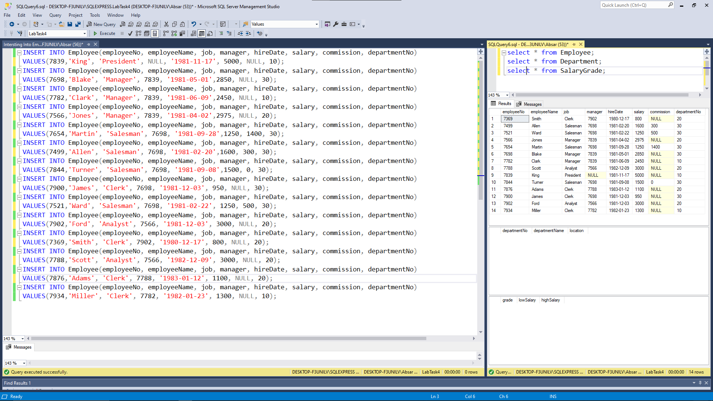

# Inserting Into Department

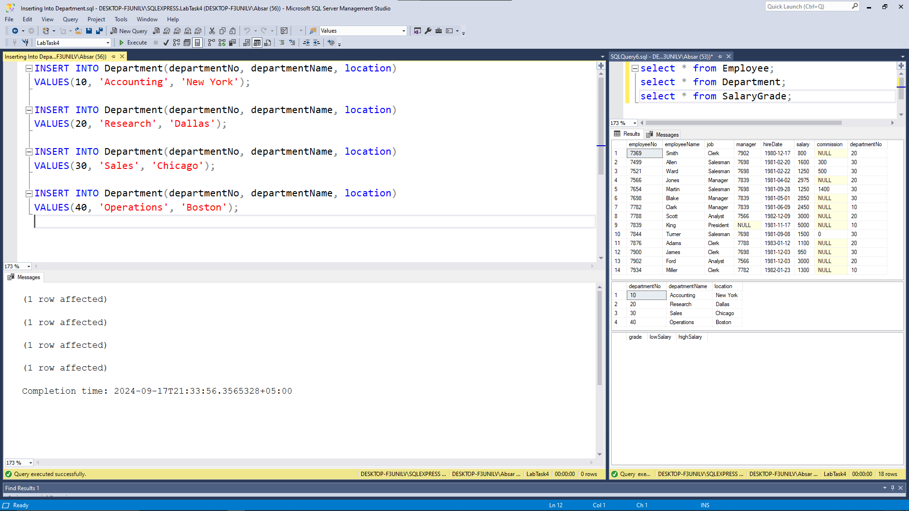

# Inserting Into SalaryGrade

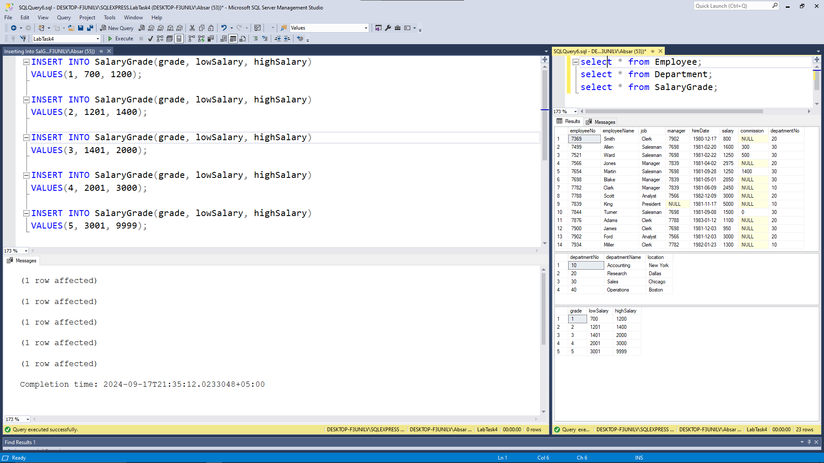

Queries

## 1. Display the complete data of Employee, Departments and salary-Grade tables.

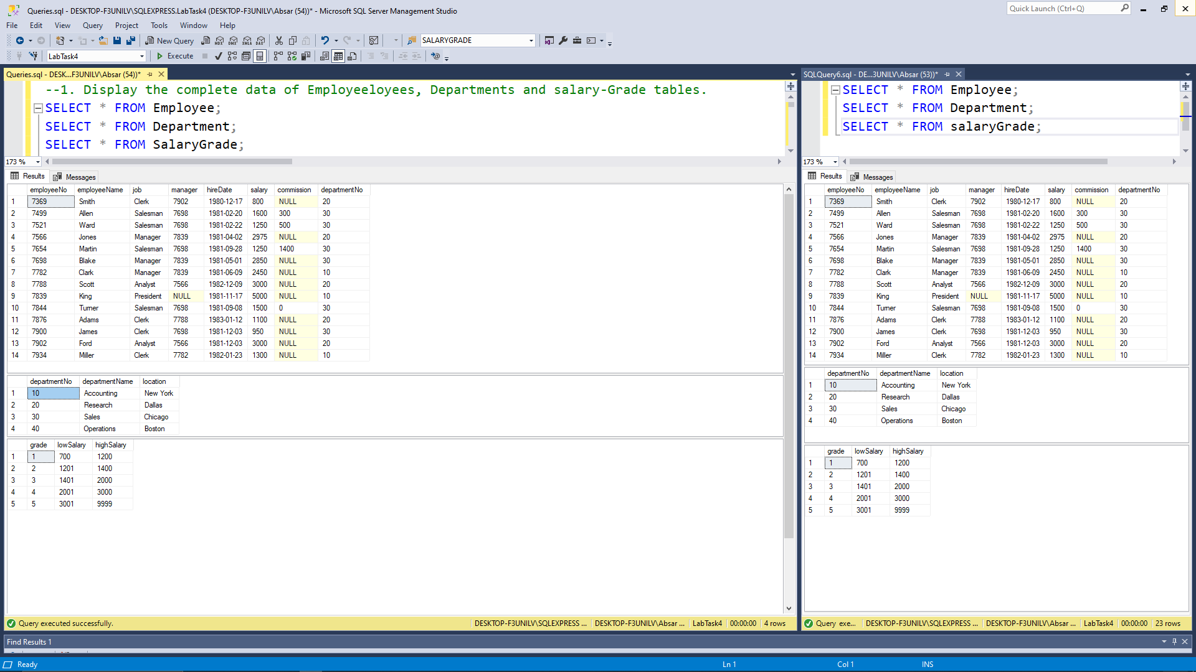

## 2. Display the data of Employees whose name is James.

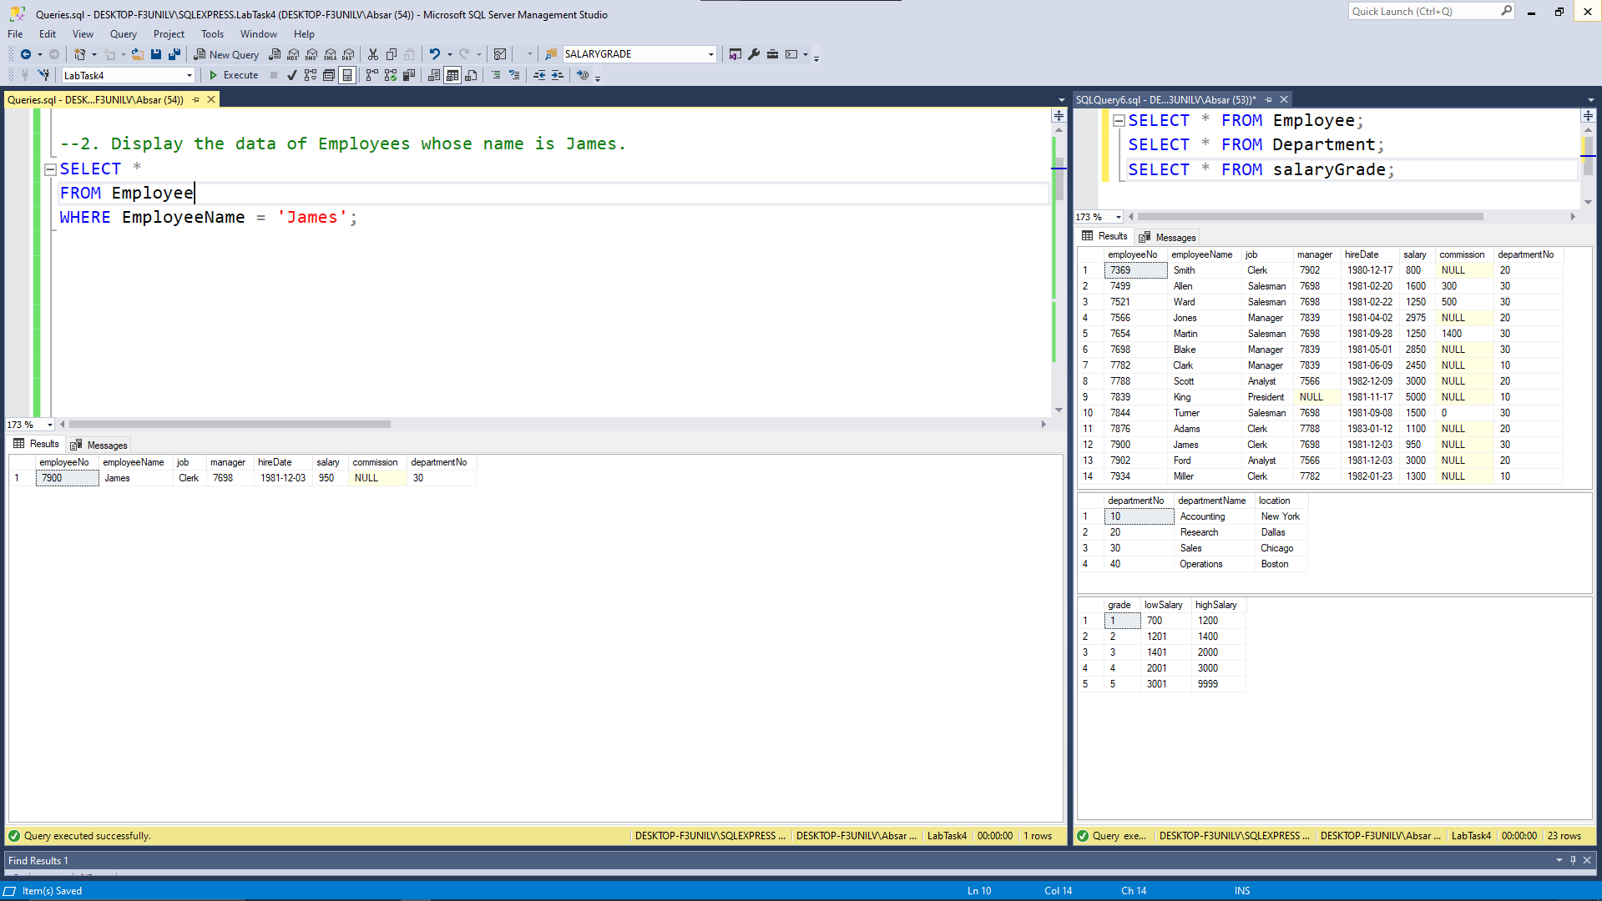

## 3. Display the data of Employees whose name has ‘a’ on its second position like “James, Hassan”.

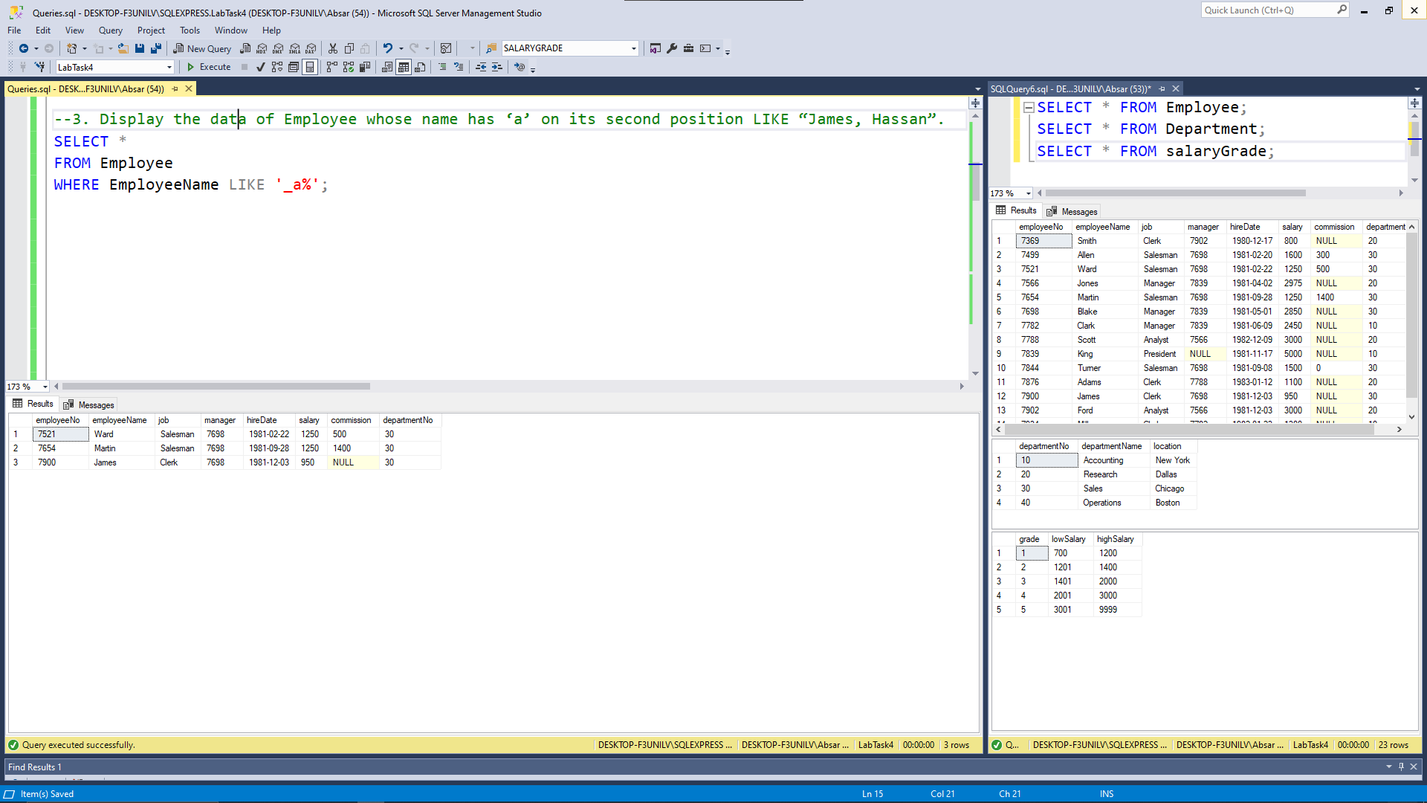

## 4. Display the data of Employees whose JOB ends with ‘MAN’.

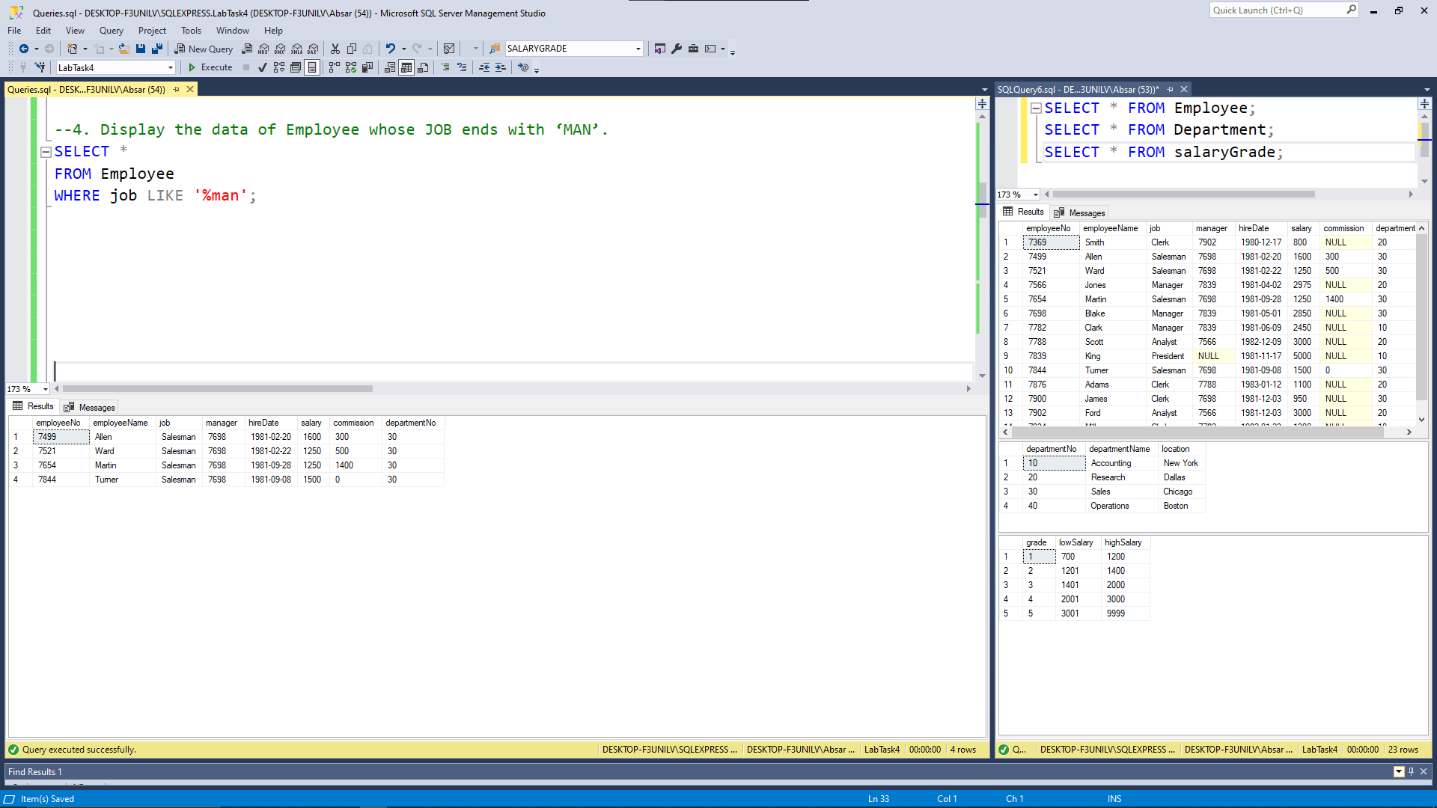

## 5. Display the data of Employees whose name starts with ‘A’.

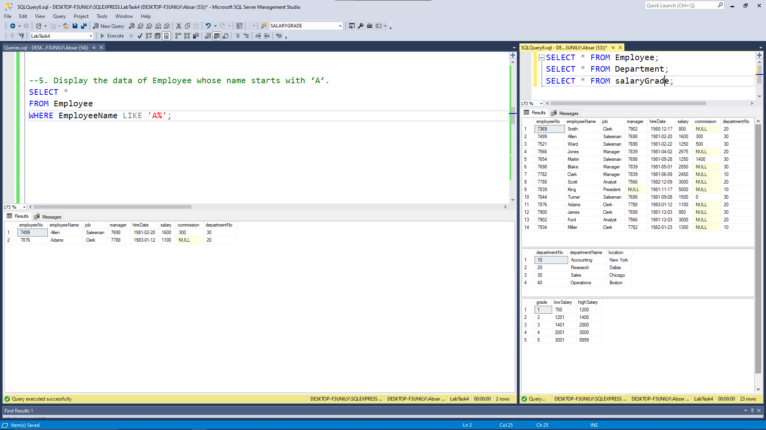

## 6. Display the list of employees where department id is not equal to 30. (Using <> operator).

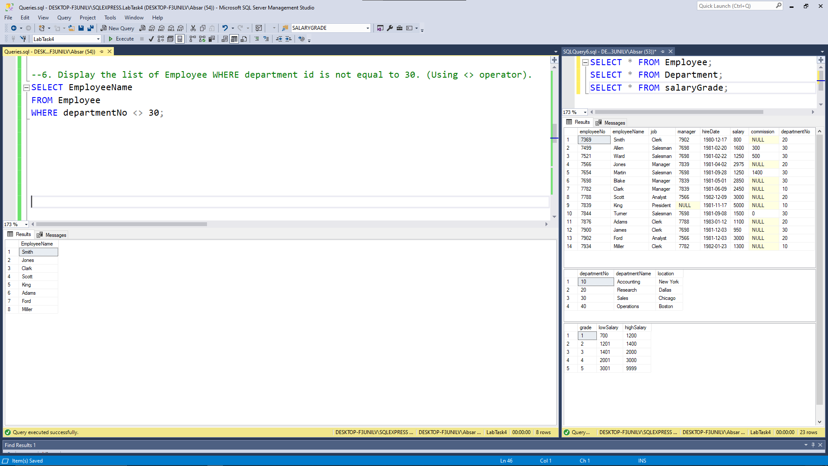

## 7. Select the list of employees that work in department 10 and 30.

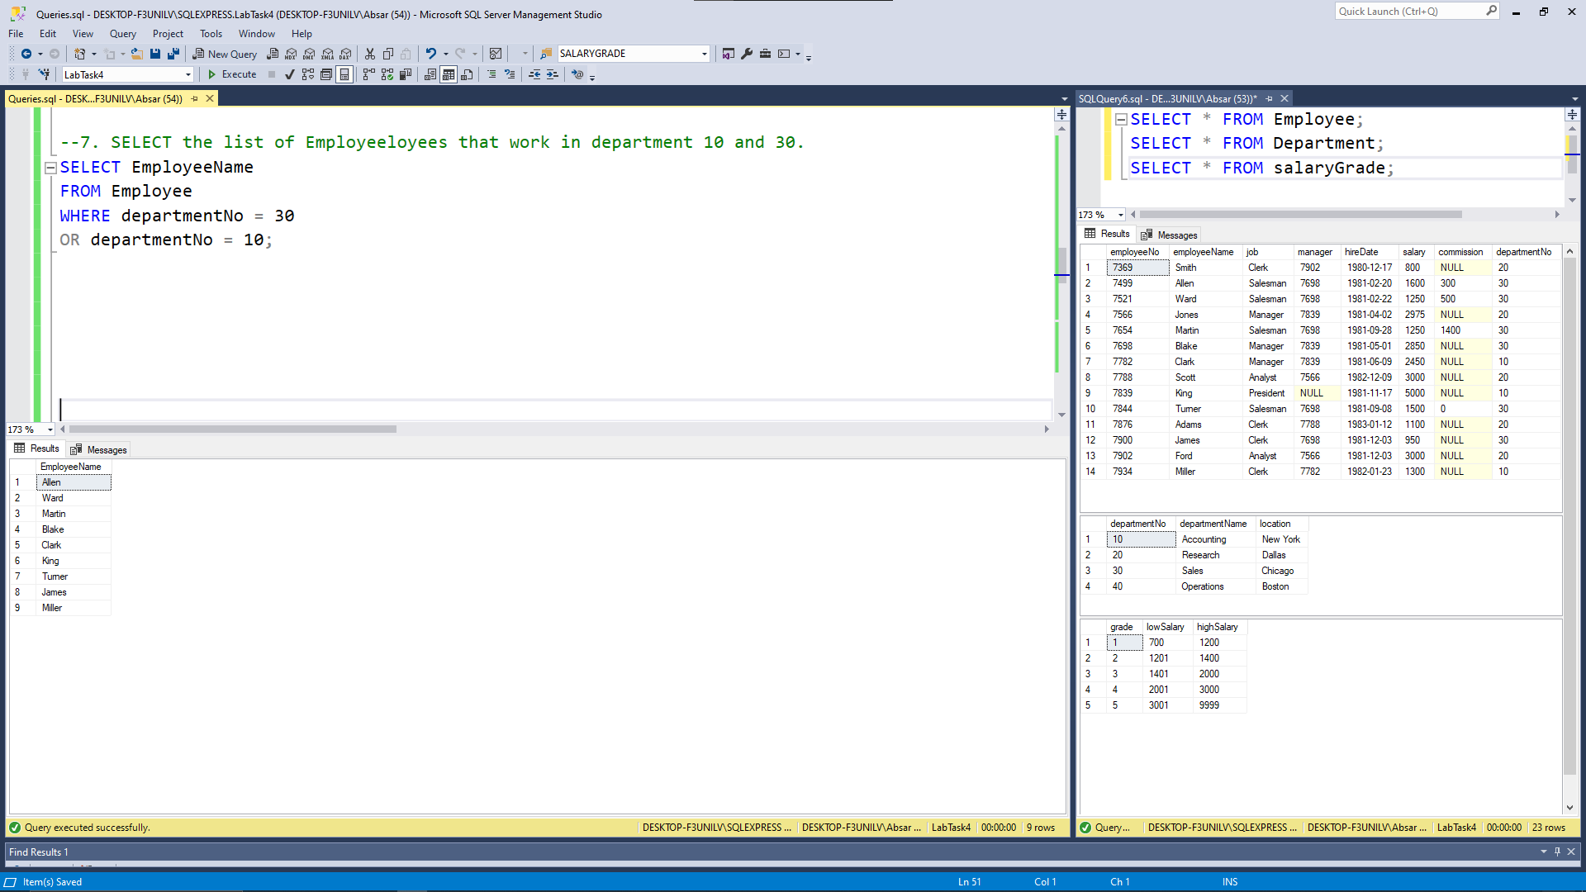

## 8. Select the data of employees where commission is known and salary lies in the range 12000 and 47000.

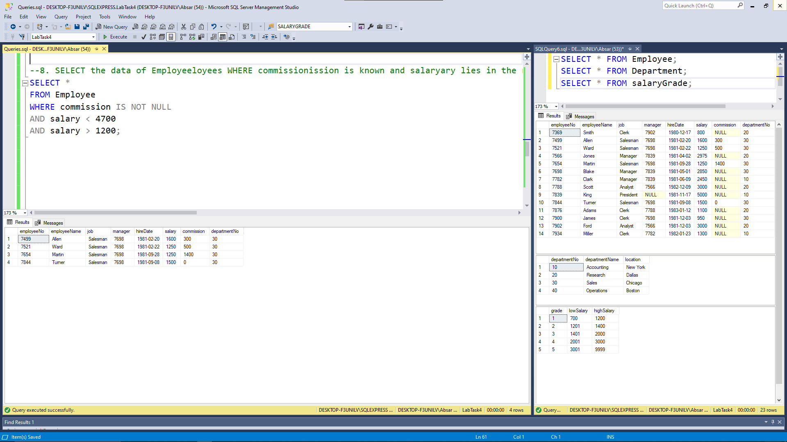

## 9. Select the data of employees where commission is unknown.

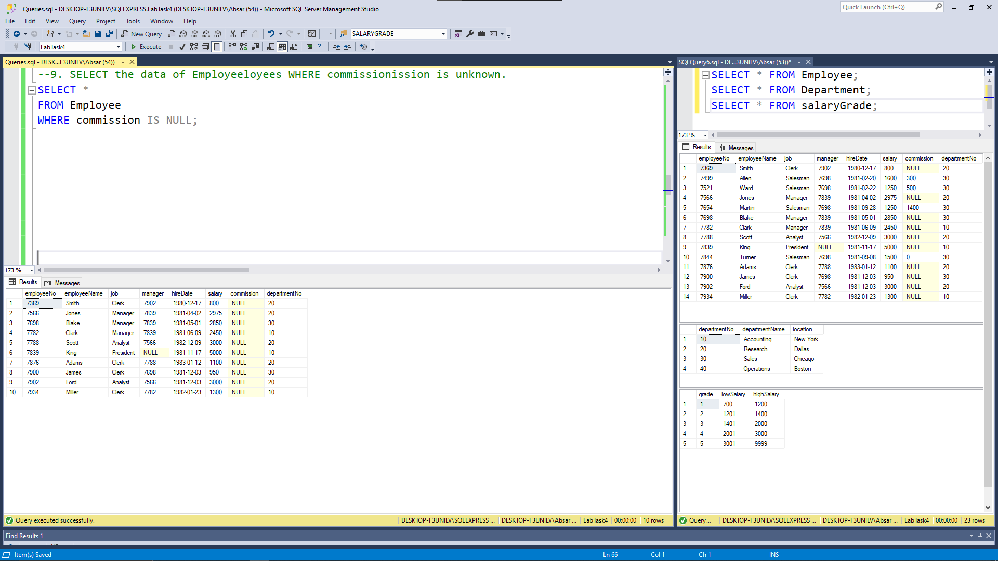

## 10. Display the list of employees whose employee id lies in 7566 and 7900 and salary is greater than 3700.

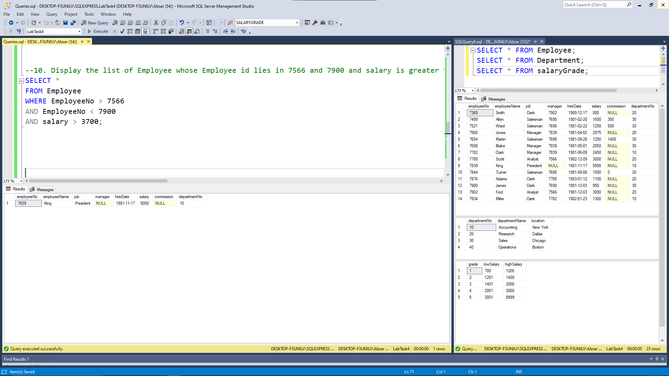

## 11. Write a query which will retrieve the values of job of all employees getting job in employee table without any repeats job title.

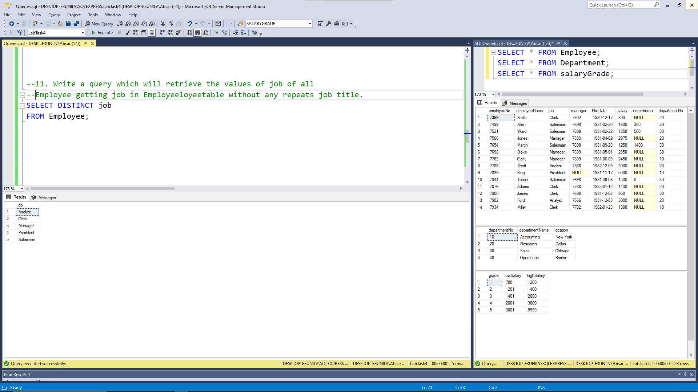

## 12. Write a SQL query to display the department ID followed by department name that is holding the location Chicago.

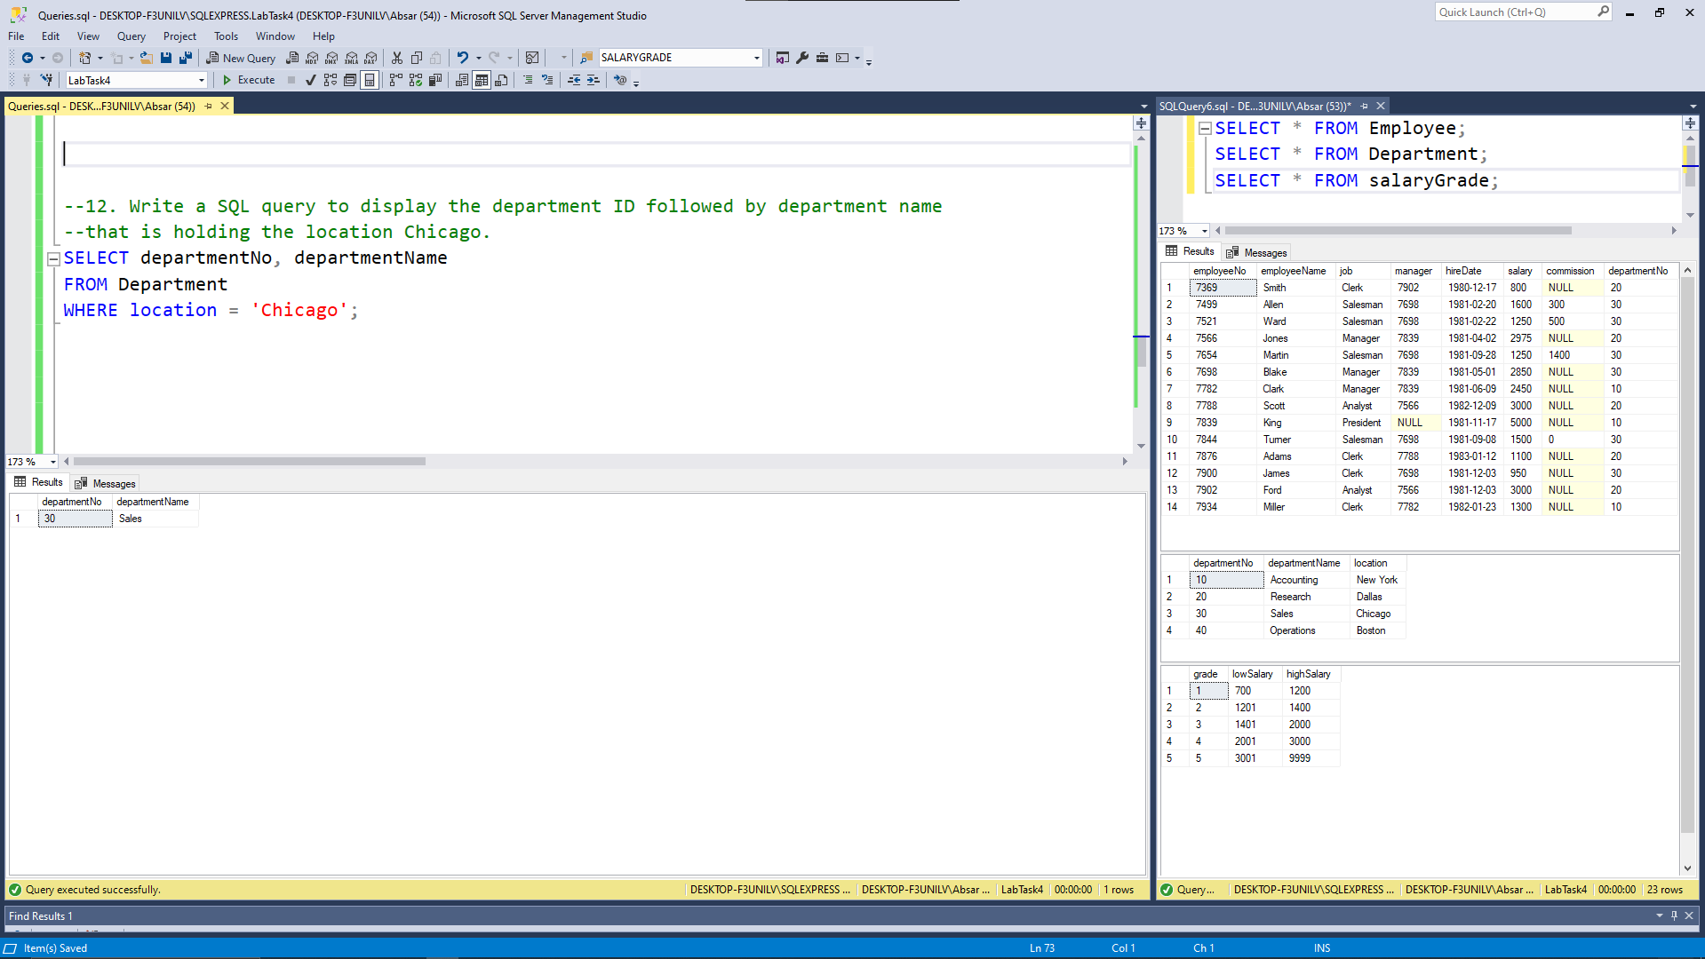

## 13. Write a SQL query to give the higher-grade salary since 1400.

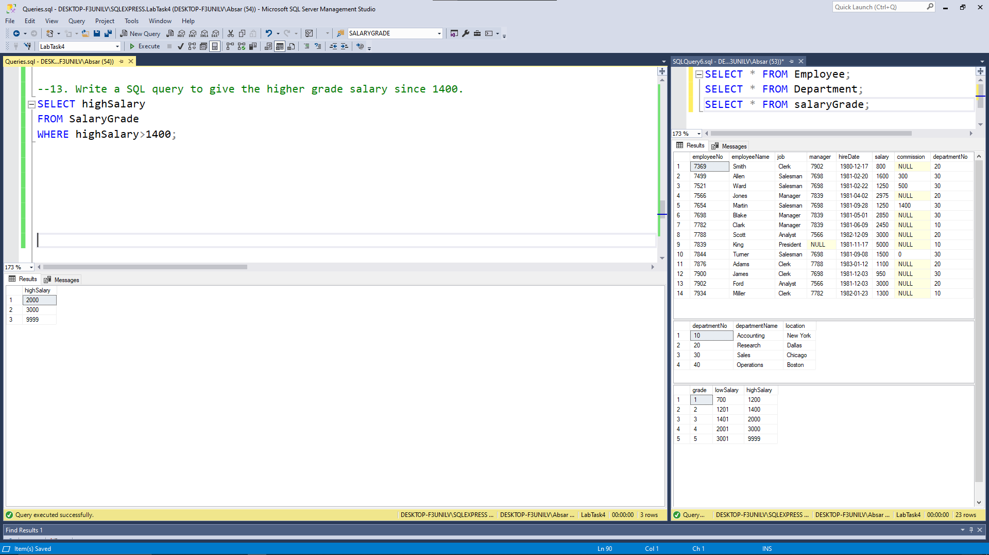

## 14. Write a SQL query to show all the department number data of MGR 7698 except the job title Clerk.

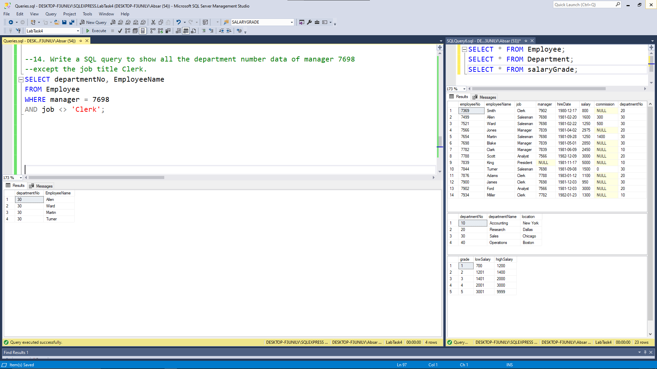

## 15. Write a SQL query to display all employee names where employee salary is less than 1500 or exclude those employee names whose hiring date is on or greater than 2nd April, 81 and employee id is below 7566. (DATE - format YYYY-MM-DD)

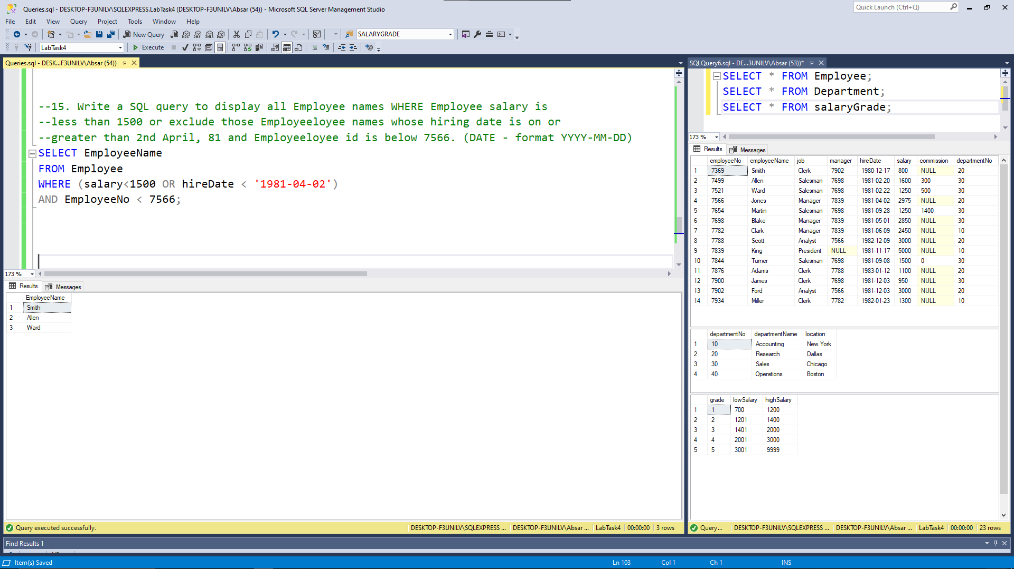

## 16. Write a SQL statement to display all the employee names which are either belongs to the unknown community or not had a salary above 1500.

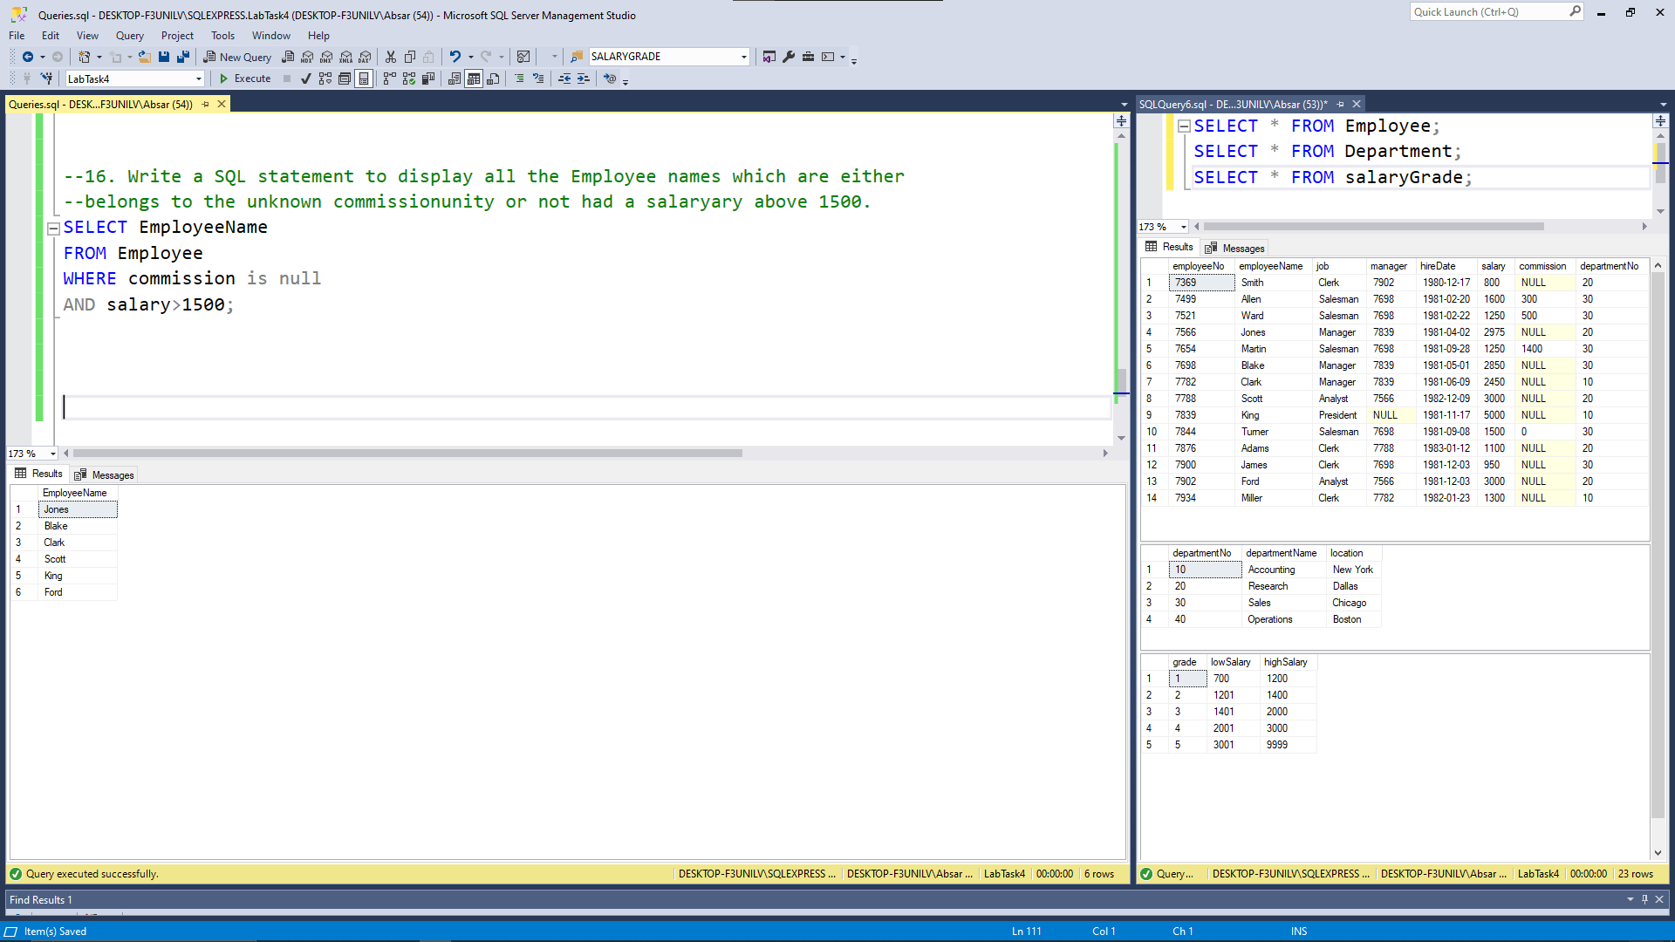

## 17. Display the names of Employees who have hiring date 09-June-81.

