**National Institute Of Technology Raipur**

**INTERNET WEB TECHNOLOGIES**

**LAB RECORD**

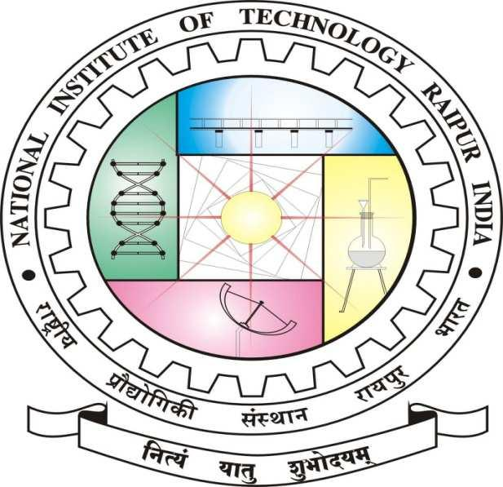

**DEPARTMENT OF INFORMATION TECHNOLOGY**

**National Institute of Technology Raipur**

|  |  |
| --- | --- |
| Name | Mayank Deshlahara |
| Branch & Section | IT “E” |
| Roll. No. | 15118909 |