**1. Create a HTML static web page which shows the use of different tags.**

<!DOCTYPE html>

<html>

<head>

<title>TITLE here!</title>

</head>

<body>

<h1>My First Heading</h1>

<h2>This is heading 2</h2>

<h3>This is heading 3</h3>

<p>My first paragraph followed by line break.<br> and some random text</p>

<p>This is another paragraph with random text.<br>All HTML documents must start with a document type declaration: <b>!DOCTYPE html</b>.<br>The HTML document itself begins with html tag and ends with <i>html</i> tag.<br>The visible part of the HTML document is between opening and closing <u>body</u> tag.</p>

<p>This is a paragraph followed by horizantal rule!</p>

<hr>

<img src="icon.png" alt="Shooting Star" width="144" height="144">

<a href="https://www.google.com">This is a link to google</a>

</body>

</html>

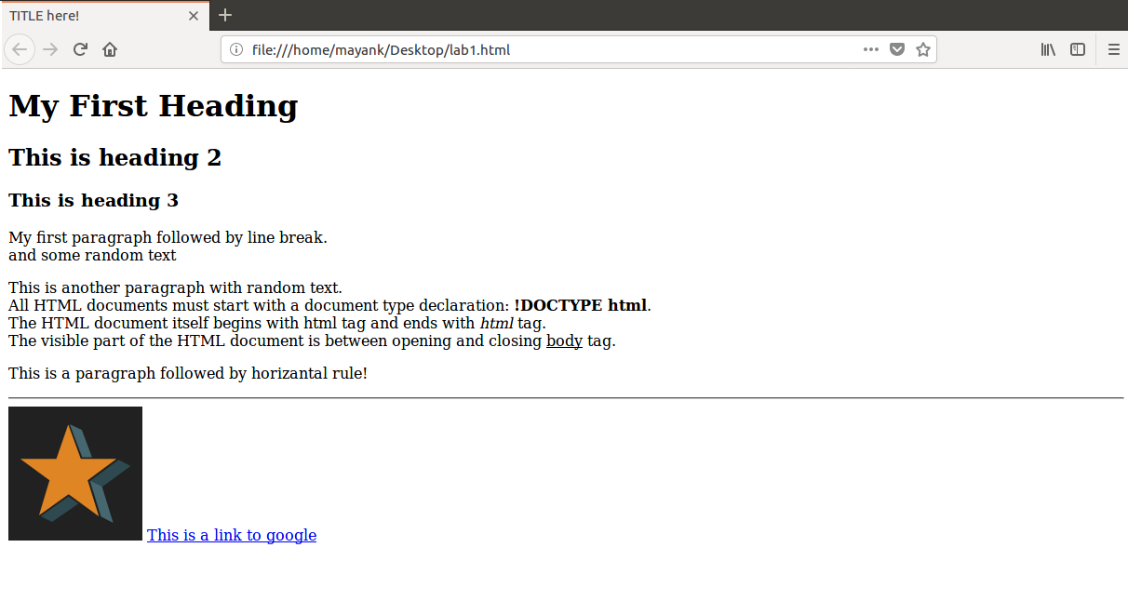

**2. Create a HTML page using TABLE tag.**

<!DOCTYPE html>

<html>

<head>

<style>

table, th, td {border: 1px solid black;}

</style>

</head>

<body>

<h2>Basic HTML Table</h2>

<table style="width:100%;">

<tr>

<th>Firstname</th>

<th>Lastname</th>

<th>Age</th>

</tr>

<tr>

<td>Jill</td>

<td>Smith</td>

<td>50</td>

</tr>

<tr>

<td>Eve</td>

<td>Jackson</td>

<td>94</td>

</tr>

<tr>

<td>John</td>

<td>Doe</td>

<td>80</td>

</tr>

</table>

</body>

</html>

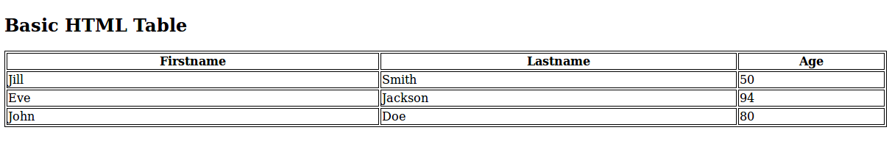

**3. Create a framed HTML page using FRAMESET tag.**

<!DOCTYPE html>

<html>

<frameset cols="25%,50%,25%">

<frame src="http://www.nitrr.ac.in">

<frame src="https://www.bing.com">

<frame src="https://iiitnr.ac.in">

</frameset>

</html>

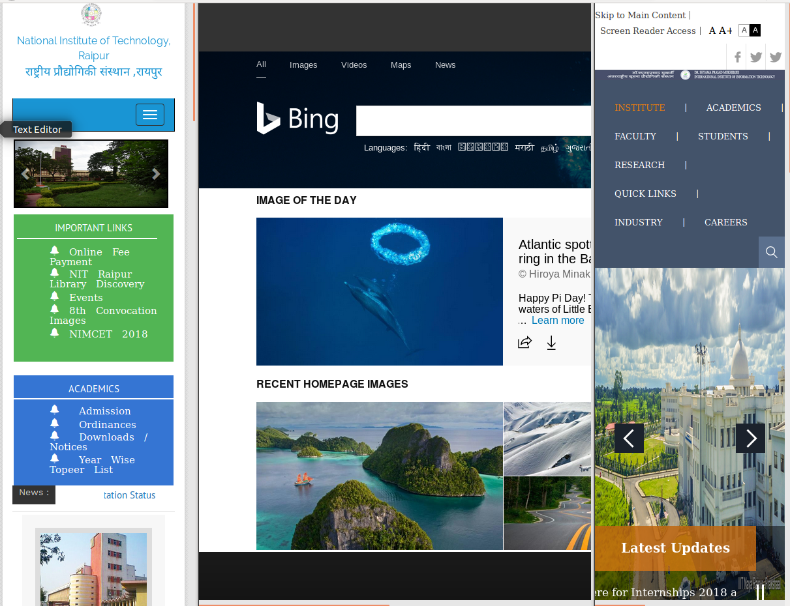

**4. Create a webpage with the following using HTML**

* 1. **To embed an image in web page.**
  2. **To fix the hot spots.**
  3. **Show all the related information when a hotspot is clicked in the map.**

<!DOCTYPE html>

<html>

<body>

<p>Click on the sun or on one of the planets to watch it closer:</p>

<img src="planets.gif" width="145" height="126" alt="Planets" usemap="#planetmap">

<map name="planetmap">

<area shape="rect" coords="0,0,82,126" alt="Sun" href="sun.html">

<area shape="circle" coords="90,58,3" alt="Mercury" href="mercur.htm">

<area shape="circle" coords="124,58,8" alt="Venus" href="venus.htm">

</map>

</body>

</html>

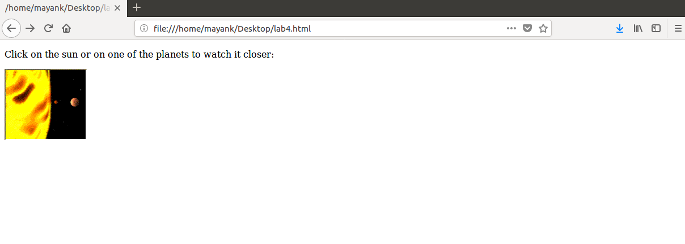

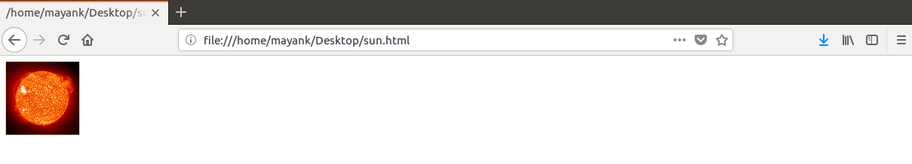

**5.Create a DHTML form for the dynamic use of records in a web form.**

<!DOCTYPE html>

<html>

<body>

<h1>Course Registeration</h1>

<form>

First name:<br>

<input type="text" name="firstname"><br>

Last name:<br>

<input type="text" name="lastname"><br>

<hr>

Gender:<br>

<input type="radio" name="gender" value="male" checked> Male<br>

<input type="radio" name="gender" value="female"> Female<br>

<input type="radio" name="gender" value="other"> Other<br>

<hr>

Branch:<br>

<select name="Branch">

<option value="CS">CS</option>

<option value="IT">IT</option>

<option value="META">META</option>

<option value="ELEX">ELEX</option>

</select>

<hr>

Courses:<br>

<select name="Courses" multiple>

<option value="CD">CD</option>

<option value="SE">SE</option>

<option value="IWT">IWT</option>

<option value="ITC">ITC</option>

<option value="MC">MC</option>

<option value="NNFL">NNFL</option>

</select>

<br><br>

<input type="submit">

</select>

</form>

</body>

</html>

