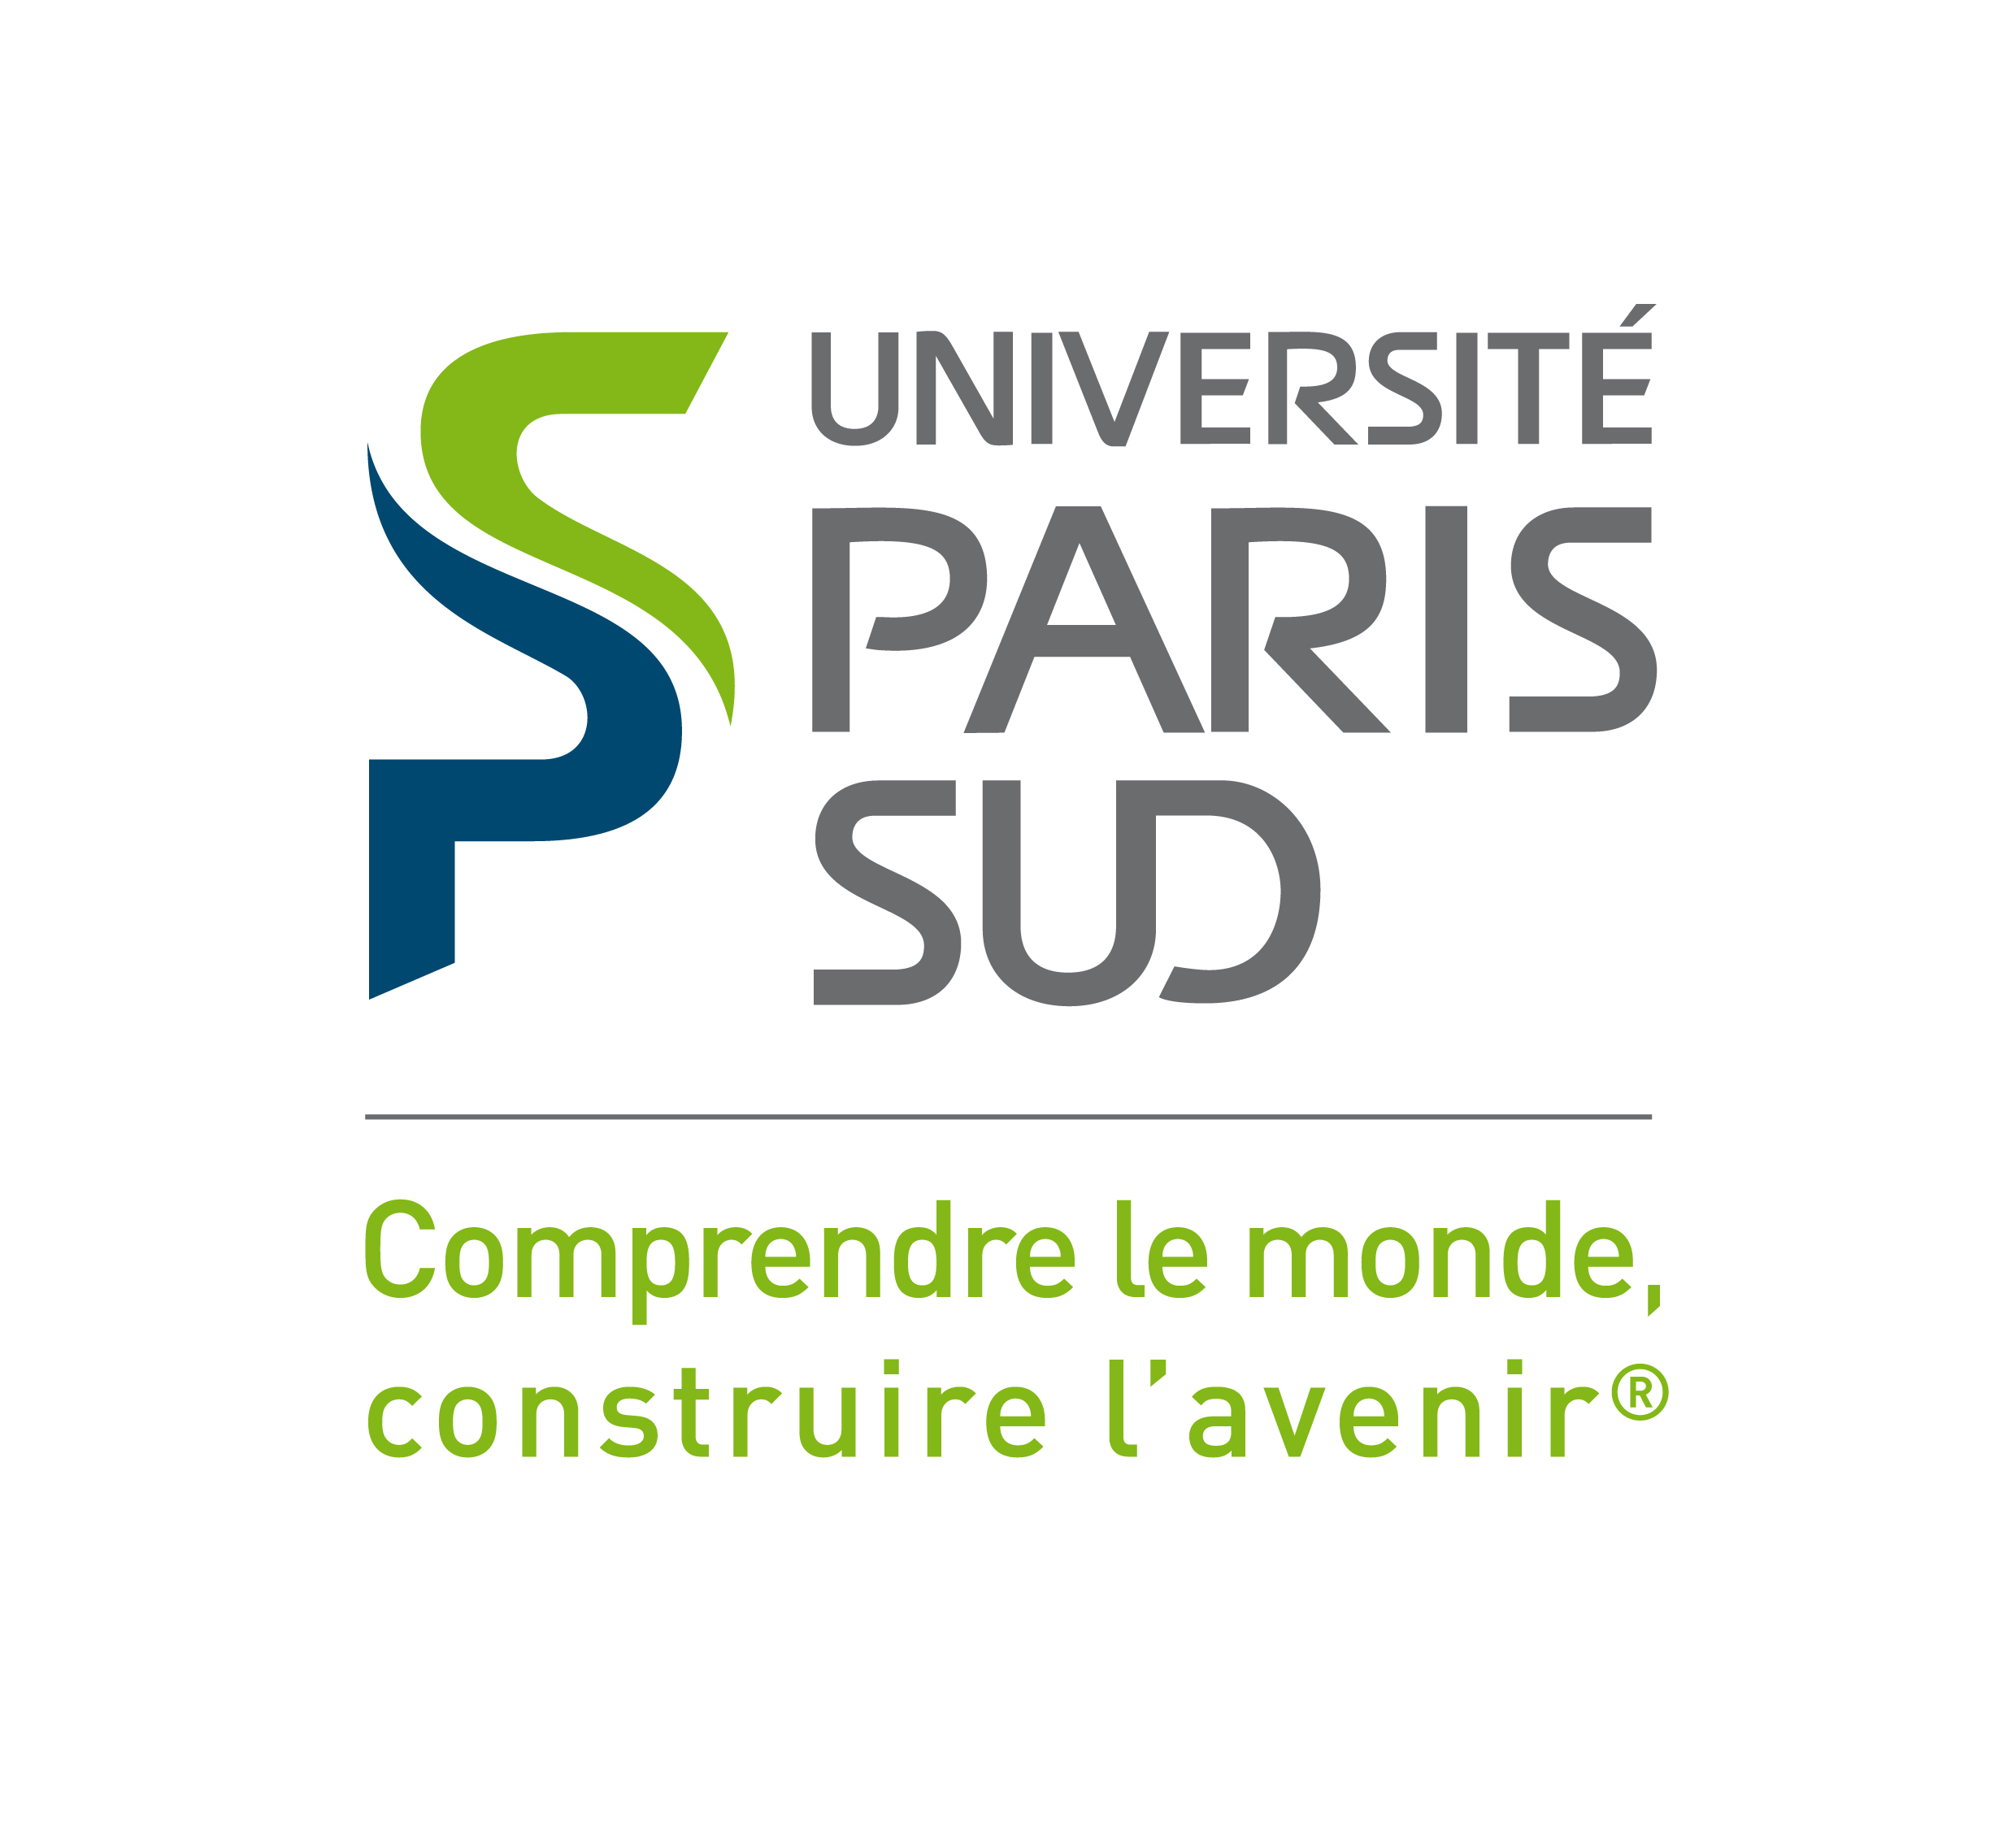

PARIS-SUD UNIVERSITY

Master 2 Data & Knowledge

2017-2018

Introduction to Research and Business

par

TANG Kexin
TANG Xucheng
SUN Rui
ZHAO Mengzi

Enseignant: Emmanuel Waller, Université Paris-Sud
I – Five ideas
We have 5 business ideas.

Living recipe App (TANG XUCHENG)
This App can give recipes on the ingredient which the user gives by photo. Users can just take a picture with their smartphone in the supermarket and then they can find out which side dishes or special spices are needed for the cooking. They don’t even need to know the name of the ingredient cause we run image recognition system in our App.

Signal lamp with Smart room System (SUN RUI)
The idea is to design the embedded signal lamps outside each room. It help us identify the status(locked, occupied, free...) of each room without trying entering. The system is designed for management the rooms in buildings. For example, the school classroom or some public utilities are suitable objects. There’s no need to stop step for verifying the room for both administrators and users. all At the same time, the smart system offer the illumination to save resource.

Safe Baby Carriage (SUN RUI)
The idea is to design a new baby carriage in order to guarantee the safety. Different from other product, the safe baby carriage has a ‘tumbler’ design, which means it’s stable and not easy to rollover. What’s more, it can memorise the parents’ fingerprints after a root password correction. The baby Carriage has also a function that it could make a automatic braking without external control.

Ring for wireless communication (TANG KEXIN)
This idea aims to design a digital ring connected with your telephone by bluetooth, Wifi or NFC for wireless communication. The principle purpose of this idea is to make our life more convenient and more private. The first advantage of this design is, obviously, that our digital ring is much more portative compared with the headset for there is no need for us to look for the headset every time when we want to call the others. The second main advantage is that we can keep our call more personal and safer. The ring can recognize the voice of host and remember it. So with this device, you will be able to communicate in very low voice even in a noisy crowd because it can automatically remove the noise in the background.

Disease diagnosis application (ZHAO MENGZI)
This application can be applied to smart phones, smart watches and some other smart electronic devices. This application uses users’ data about the body on their electronic devices, such as height, weight, daily exercise, even there’s the record of the heartbeat on some smart watches. This application can use the long-term accumulation of data to determine whether users are healthy, this application can provide some devices to help people to become healthy. Of course, users can also enter or choose their own symptoms to know whether they are sick. This application offers the service to recommend by the doctor according to users’ symptoms and users can also make an appointment with doctor on this application.

At last we choosed the business idea of TANG Xucheng and we created the business model canavas.

