Vishwakarma Government Engg College, Chandkheda
Information Technology Department
Laboratory Work
Subject: Wireless Communication (3171608) Sem-VII
Name of Student _______________________________ Enrollment No: . Academic Term: July -2022 to Nov 2022
Sr No | Experiments | Page No |  | Date | Marks out of  10 | Sign
 |  | From | to
1 | Prepare a case study on latest wireless technology being  developed.
2 | Write a MATLAB program based on Free space  Propagation Model & Frequency Selective Fading Model.
3 | Write a MATLAB program based on WLANs.
4 | Write a MATLAB program based on Cellular systems.
5 | Study the implementation of – GMSK modulation, OQPSK detection. (Using MATLAB)  - Observe phase response of Tx and Rx and Spectrum of Tx and Rx.  - Measure the BER value  - GSM AT Commands
6 | Study the performance of DS-CDMA system under multi- path condition for single user case (Using MATLAB)  - Using RAKE receiver with MRC method and EGC method  - Observation of SNR vs BER curve for two  different combining techniques.
7 | Study OFDM system synchronization requirement  (Using MATLAB)  - Observe the performance of Schmidl-Cox algorithm used for timing acquisition and fractional freq offset estimation  - Integer Frequency offset estimation

Date of submission: / /2022

Signature of Subject teacher Signature of Head of Dept

Vishwakarma Government Engineering College, Chandkheda Information Technology Department

B.E. Semester 7, Academic Year: 2022-23 (Odd Term) Assessment sheet of 3171608: Wireless Communication

Student Name:- Enrollment No.:- Batch:-

EVALUATION SHEET BASED ON RUBRICS

Practical No. | Total Allotted  Marks | Criteria 1 | Criteria 2 | Criteria 3 | Criteria 4 | Total | Faculty Sign
1 | 10
2 | 15
3 | 10
4 | 10
5 | 20
6 | 10
7 | 25

Practical-1 Date: / /

Aim: Prepare a case study on latest wireless technology being developed.

Abstract:
In this current generation, technology is at its best. Many improved technologies are more facile than they have been before. WI-FI, which stands for wireless-fidelity, is a wireless way to handle networking. This functionality allows computers, smartphones, or other contrivances to connect to the Internet or communicate with one another wirelessly within a particular area. This paper explicates information about different communication modules such as Bluetooth, RF, and Zig bee in industrial applications. In this paper, an overall comparison of these three modules are made, which are predicated upon their industrial applications and characteristics such as standards, bandwidth, battery life, data rate, maximum transmission range, etc.

INTRODUCTION:
Wireless is a term that describes telecommunications where the electromagnetic waves carry the signals over part or all of the communication path. In the early twentieth century, there were wireless transmitters that went on air using Morse code through radiotelegraphy. It was called “radio” because modulation was made possible. Modulation is used to transmit voices and music via this wireless medium radio. Wireless technology is the biggest contribution to mankind thus far, and it is rapidly evolving. Already a large number of people rely on the technology directly or indirectly. Wireless technology is used for transferring data over long distances efficiently. When wireless technology was created, many new applications were available to designers. Since wireless technology is an electromagnetic transmission medium, it does not require cables and is emitted through the air by wave frequencies that can be used by satellites and infrared rays. This is a promising technology that allows people to do things easier over long distances. It is especially useful when cables cannot physically fit and it is fast and easy to install. It has great advantages in industrial applications, like greater mobility and the possibility to move devices and connect to smart phones and tablets freely without constraining cables. Depending upon the range, Wi-Fi can be classified in different ways and each wireless technology is developed to serve specific usage segments that are based on a variety of variables, like bandwidth, distance, and power needs.

WIRELESS TECHNOLOGIES:
Before wireless was invented and implemented, many industries used wired technologies for communication, which has many disadvantages. Also, it was impossible for communication to be established over the longer distances and also was not reliable. Due to this, wireless technology was introduced. There are many benefits and advantages to wireless when compared with wired technologies.

Different types of wireless technologies
There are many different types of wireless devices that have been introduced for use with wireless communication, so users can communicate even from remote areas. For example, a satellite is used for communicating over the world using wireless communications. In closed environments like colleges, banks, offices, industries, etc., the communication or the transfer of the data is done with the help of wireless sensor networks such as RF modems, Bluetooth, Wi-Fi, and Zig bee.

When we use wireless sensor networks over cabled networks, there are many advantages
like:
- It is reliable.
- It is authenticated.
- Cables are not used.
- It costs less than wired method.

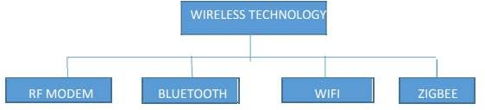

RF MODULE
The RF module is used to operate the radio frequency and usually the frequency range varies between 30 KHz AND 300 GHz. The RF module is much better than the IR infrared in transmission because the signals through RF can travel through larger distances, which useful for long-range applications. Also, IR doesn’t travel through obstructions, but RF signals can travel even when there is no obstruction between transmitter and receiver.
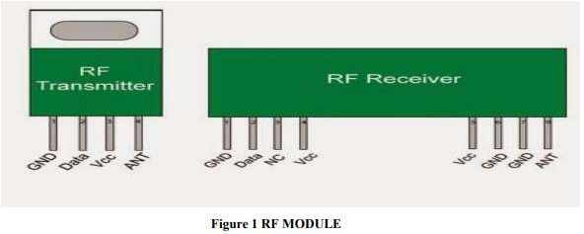

BLUETOOTH
Bluetooth was initially developed in 1994 by a Swedish mobile phone maker, Ericsson, to let laptop/computers make calls over a mobile phone. Since then, many different companies have planned to make Bluetooth the low power short-range wireless standard for a wide range of devices. Bluetooth is a short-range technology used for Wireless Personal Area Networks (WPAN) and supports ad-hoc networks. The main aim of Bluetooth is to provide universal short-range wireless capability. With a 2.4 GHz band, two Bluetooth devices can share up to 720 Kbps within 10m of each other. It is also used to support a wide range of applications that are open-ended, including data, audio, graphics, video, etc. Authentication is also possible with

this technology by sending the acknowledgement from the receiver to the transmitter before making a connection between devices. There is a limitation, however, where only eight devices can communicate on a single network. Bluetooth was designed to be as secure as a wire with up to 128-bit public/private key authentication.

WI-FI
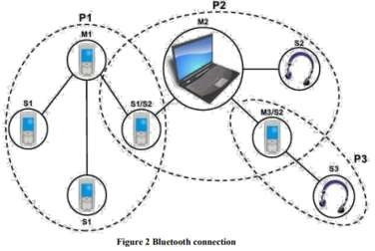

WIFI is a short for wireless fidelity, which is a way for wireless devices to communicate. It is also a WI-FI alliance name for wireless standard or a protocol that is used for wireless communication. WIFI devices are certified interoperable, which can run on the medium range networking standard 802.11, which runs at speeds roughly comparable to those of wired networks. It also runs on “free” portions of the radio spectrum, meaning that, unlike cell telephone communications, no license is required to broadcast using 802.11.
To allow high speed data transfer over short distances, the wireless technology uses waves. There is a problem called multipath interference, which is due to reflection of signals from walls, signals from walls and other obstacles. WIFI provides internet access for many modern devices like laptops, mobiles, tablets, and computers with authentication and increases the devices on a single WIFI connection. The signal strength will be reduced and the connection may get lost, however. Millions of users use WIFI to connect to the internet and private networks without wires.
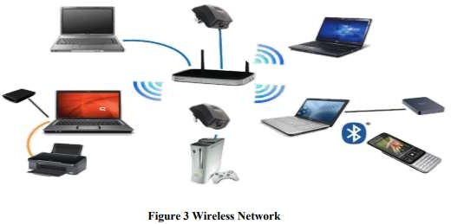

ZIGBEE
Zigbee is the wireless technology developed to address the needs of low-cost, low-power wireless Machine to Machine (M2M) networks and operates on the IEEE 802.15.4 physical radio specification. The frequency bands on which zigbee operates are 868MHz, 915MHz, and 2.4GHz and the maximum data rate is 250k bits per second. One of the major advantages of using zigbee is that these devices are capable of operating for several years before their batteries need to be replaced.

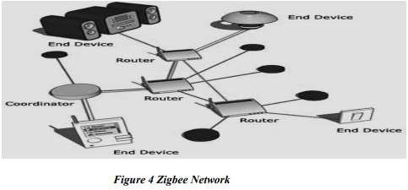

Date: Signature

Practical-2 Date: / /

Aim: Write a MATLAB program based on Free space Propagation Model & Frequency Selective Fading Model.

Free space Propagation Model:
clc; close all;
f = input("Enter carrier frequency(MHz)"); c = 300;
d = 1:1:10000;
Lp = ((4*pi*d*f)/c).^2; subplot(2,1,1);
plot(d,Lp,'b');
xlabel('x-->D (distance in Km)'); ylabel('y-->Lp (path loss)'); title('Free space model');
grid on; subplot(2,1,2);
plot(d, 10*log(Lp), 'r');
xlabel('x-->D (distance in meter)'); ylabel('y-->Lp (Path loss in dB)'); title('Free space model');
grid on;

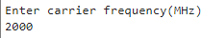
Output:

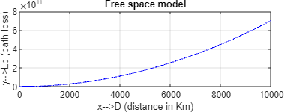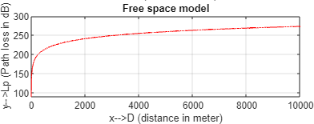

Frequency Selective Fading Model:

It affects different spectral components of a radio signal with different amplitudes. Hence the name selective fading.

- Signal BW > Channel BW
- Symbol period < Delay Spread
Based on doppler spread there are two types of fading viz. fast fading and slow fading. These doppler spread fading types depend on mobile speed i.e., speed of receiver with respect to transmitter.

Code:

clc; clear all; close all;
load file_ldacstxpkt; % baseband IQ vector Tx_Packet=Tx_Packet.';
KFactor = 3; % Rician K-factor Ts=1e-4; % sampling time in second Fd=100; % doppler frequency in Hz
Tau=[0 1.5e-4 2.5e-4]; % delay for the three paths PdB=[0, -2, -6]; % power in each of the three paths pkt_allones=ones(1,480)+i*ones(1,480);
% rician channel model
h = ricianchan(Ts, Fd, KFactor, Tau, PdB); h.StoreHistory = true;
Rx_pkt_allones = filter(h, pkt_allones);
Rx_Packet = filter(h, Tx_Packet); % passing baseband IQ vector through rician channel figure;plot(h);
figure;plot(abs(Tx_Packet)); title('baseband IQ packet without rician channel'); figure;plot(abs(Rx_Packet)); title('baseband IQ packet with rician channel');
figure;plot(abs(Rx_pkt_allones)); title('baseband IQ of all ones after passing through rician channel');

Output:

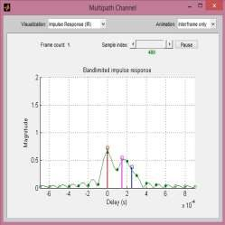
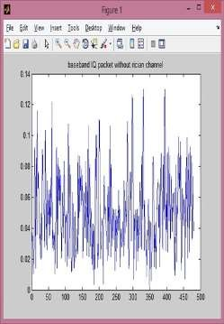

Date: Signature

EXPERIMENT NO: 3 Date: / /

TITLE: Write a MATLAB program based on WLANs.

A wireless local area network (WLAN) is a wireless distribution method for two or more devices. WLANs use high-frequency radio waves and often include an access point to the Internet. A WLAN allows users to move around the coverage area, often a home or small office, while maintaining a network connection.

Every component that connects to a WLAN is considered a station, and falls into one of two categories: access points (APs) and clients.

- Access points or APs transmit and receive radio frequency signals with devices able to receive transmitted signals; they normally function as routers.

- Clients, on the other hand, may include a variety of devices, such as desktop computers, workstations, laptop computers, IP phones and other cell phones and smartphone devices.

All stations able to communicate with each other are called basic service sets (BSSs), of which there are two types: independent and infrastructure. Independent BSSs (IBSS) exist when two clients communicate without using APs, but cannot connect to any other BSS. Such WLANs are called a peer-to-peer or an ad-hoc WLANs. The second BSS is called an infrastructure BSS. It may communicate with other stations but only in other BSSs and it must use Aps.
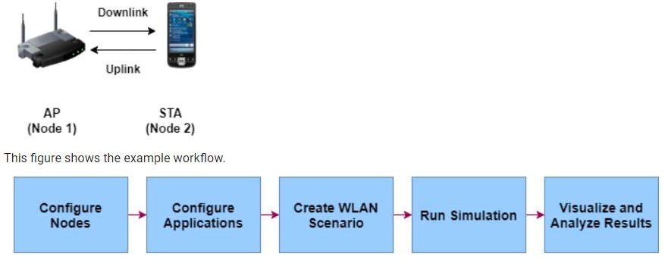

Program:

rng(1,'combRecursive'); % Seed for random number generator simulationTime = 1000; % Simulation time in milliseconds showLiveStateTransitionPlot = true; % Enable live state transition plot for all nodes displayStatistics = true; % Display statistics at the end of the simulation

% To access all of the helper files in this example, add the
% mlWLANSystemSimulation folder to the MATLAB path addpath(genpath(fullfile(pwd,'mlWLANSystemSimulation')));

numNodes = 2;
nodePositions = [10 0 0; 20 0 0]; % In meters

nodeConfig(1).NodeName = apNodeName; nodeConfig(1).NodePosition = nodePositions(1,:); nodeConfig(1).TxFormat = 'HE_SU'; nodeConfig(1).BandAndChannel = {[5 36]}; nodeConfig(1).Bandwidth = 20; % MHz nodeConfig(1).MPDUAggregation = true; nodeConfig(1).NumTxChains = 1;
nodeConfig(1).TxNumSTS = 1;
nodeConfig(1).TxMCS = 2; nodeConfig(1).DisableRTS = false; nodeConfig(1).DisableAck = false;

% Configure the STA nodeConfig(2).NodeName = staNodeName;
nodeConfig(2).NodePosition = nodePositions(2,:); nodeConfig(2).TxFormat = 'HE_SU'; nodeConfig(2).BandAndChannel = {[5 36]}; nodeConfig(2).Bandwidth = 20; % MHz nodeConfig(2).MPDUAggregation = true; nodeConfig(2).NumTxChains = 1;
nodeConfig(2).TxNumSTS = 1;
nodeConfig(2).TxMCS = 2; nodeConfig(2).DisableRTS = false; nodeConfig(2).DisableAck = false;

% Load the application traffic configuration for WLAN nodes load('wlanTrafficConfig.mat');

% Copy the default configuration for all of the nodes trafficConfig = repmat(wlanTrafficConfig,1,numNodes);

% Configure downlink application traffic trafficConfig(1).SourceNode = apNodeName; % AP node name
trafficConfig(1).DestinationNode = staNodeName; % STA node name trafficConfig(1).DataRateKbps = 100000;
trafficConfig(1).PacketSize = 1500; % In bytes
trafficConfig(1).AccessCategory = 0; % Best Effort (0), Background (1), Video (2), and Voice (3)

% Configure uplink application traffic
trafficConfig(2).SourceNode = staNodeName; % STA node name trafficConfig(2).DestinationNode = apNodeName; % AP node name trafficConfig(2).DataRateKbps = 100000; trafficConfig(2).PacketSize = 1500; % In bytes
trafficConfig(2).AccessCategory = 0; % Best Effort (0), Background (1), Video (2), and Voice (3)

% Initialize the visualization parameters visualizationInfo = struct; visualizationInfo.Nodes = wlanNodes;
statsLogger = hWLANStatsLogger(visualizationInfo);

% Configure state transition visualization if showLiveStateTransitionPlot
hPlotStateTransition(visualizationInfo); end

% Initialize the wireless network simulator
networkSimulator = hWirelessNetworkSimulator(wlanNodes);

Output:
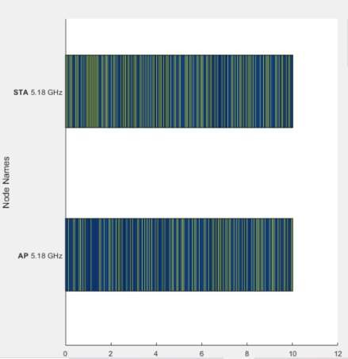

Date: Signature

EXPERIMENT NO: 4 Date: / /

TITLE: Write a MATLAB program based on Cellular systems.

THEORY:
Cellular mobile communication (CMC) is one of the fastest growing sectors in telecommunication industry worldwide. The users of CMC increased rapidly in the last two decades globally. To address the high demand of CMC services, hands-on experienced workforce is a prerequisite that are primarily supposed to be provided by the universities. However, because most universities lack heavily from sufficient funding, resources, and facilities, it is difficult to setup physical laboratory of CMC to provide students with hands-on experiences. This huge investment for physical setup can be saved by developing a virtual environment using MATLAB software tools. With a soft CMC laboratory, students can model many features of CMC, analyze and evaluate the performance in both link and system level.

Program:
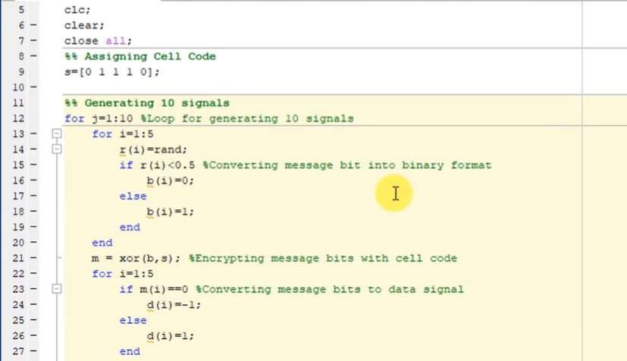

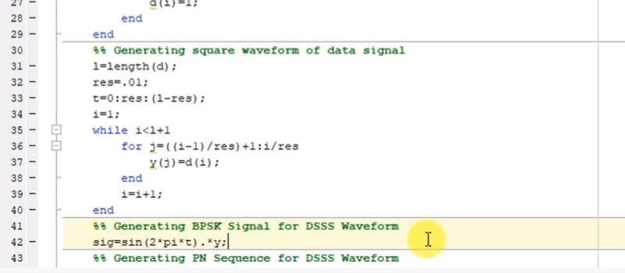
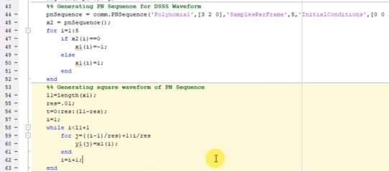
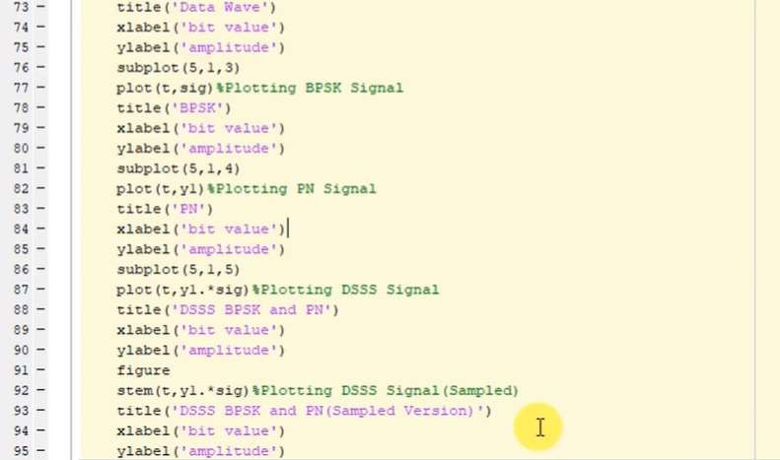

Output:
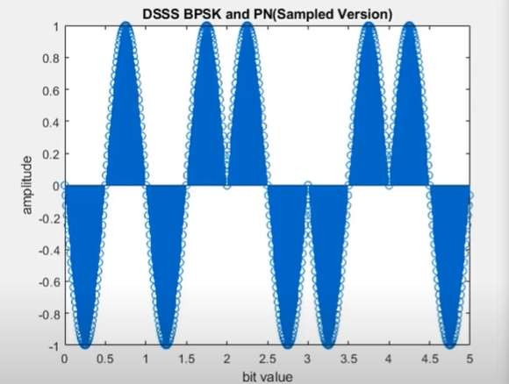
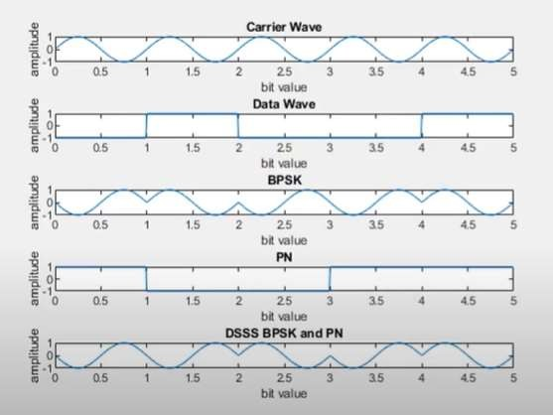

Date: Signature

EXPERIMENT NO: 5 Date: / /

TITLE: Study the implementation of GMSK modulation, OQPSK detection. (Using MATLAB)
- Observe phase response of Tx and Rx and Spectrum of Tx and Rx.
- Measure the BER value
- GSM AT Commands

THEORY:

The Modulation of GMSK:
- GMSK Modulation with FM Modulator
The GMSK modulation was founded by Murota. He propose that, using a Gaussian filter on a 2 PAM signal, and then using an FM modulator with a modulation index h = 0.5, as shown in Figure 3.3, produce a GMSK modulated signal.

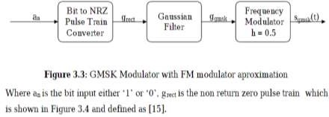

- GMSK Modulation with I/Q Modulator
In digital communications, modulations are often expressed in terms of I and Q. On a polar diagram which is a way to show I and Q parts of a signal, the I axis lies on the zero degree phase reference and the Q axis is the orthogonal axis to the I axis. The signal vector projection onto the I axis is its “I” component which means “In-phase” and the projection onto the Q axis is its “Q” component which stands for the “Quadrature” component of the signal. Figure 3.7 shows a visual explanation of I/Q representation of signal.
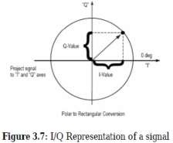

The Laurent decomposition can be applied to the GMSK signal with the approximation of finite impulse response of Gaussian filter [17]. As these decomposition’s results shows that GMSK modulated signal is actually superposition of two OQPSK signals[14]. Hence, by using I-Q modulating technics, GMSK modulator can be implemented as well. The block diagram of the modulator which is obtained by this approximation is given in Figure 3.8.

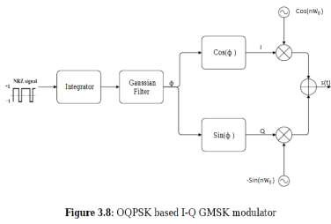

OQPSK Detection:

Offset QPSK (OQPSK)
Offset quadrature phase-shift keying (OQPSK) is a variant of phase-shift keying modulation using four different values of the phase to transmit. It is sometimes called staggered quadrature phase-shift keying (SQPSK).
Taking four values of the phase (two bits) at a time to construct a QPSK symbol can allow the phase of the signal to jump by as much as 180° at a time. When the signal is low-pass filtered (as is typical in a transmitter), these phase-shifts result in large amplitude fluctuations, an undesirable quality in communication systems. By offsetting the timing of the odd and even bits by one bit-period, or half a symbol-period, the in-phase and quadrature components will never change at the same time. The picture on the below shows the difference in the behavior of the phase between ordinary QPSK and OQPSK. It can be seen that in the first plot the phase can change by 180° at once, while in OQPSK the changes are never greater than 90°.

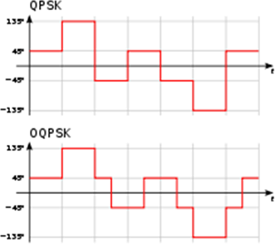

Difference of the phase between QPSK and OQPSK
The modulated signal is shown below for a short segment of a random binary data-stream. Note the half symbol-period offset between the two component waves. The sudden phase-shifts occur about twice as often as for QPSK (since the signals no longer change together), but they are less severe. In other words, the magnitude of jumps is smaller in OQPSK when compared to QPSK.

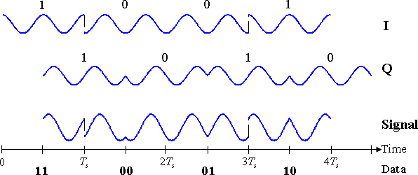

Timing diagram for offset-QPSK. The binary data stream is shown beneath the time axis. The two signal components with their bit assignments are shown the top and the total, combined signal at the bottom. Note the half-period offset between the two signal components.

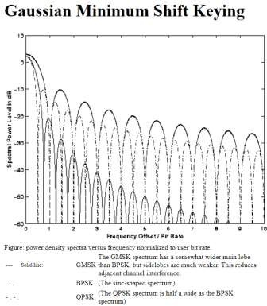
Matlab code:

The above figure is generated by MATLAB using the following code:
%
% matlab/spectra.m
% author: J.P. Linnartz
% created December, 1996
% This program computes power spectra of
% Several Digital Modulation Methods

% pi = 3.141592;
sqrpi = pi²;

GMSK = [];
GBPSK = [];
GQPSK = [];
xaxis = [];

for i=1:1000 f = i/100;
% f is frequency normalized to to 1/(bit duration) xaxis = [xaxis, f ];
ymsk = 16/sqrpi * (cos(6.2832 * f))²/ (1- 16 * f²)²; GMSK = [GMSK, 10 * log10(ymsk)];

ybpsk = 2 * (sin(pi*f)/(pi*f))²;
GBPSK = [GBPSK, 10 * log10(ybpsk)]; yqpsk = 2 * (sin(2*pi* f)/(2*pi*f))²; GQPSK = [GQPSK, 10 * log10(yqpsk)];

end
plot(xaxis,GMSK, 'y-',xaxis,GBPSK, 'c.',xaxis,GQPSK, 'c-.'); axis([0 10 -60 10]);
ylabel('Spectral Power Level in dB'); xlabel('Frequency Offset / Bit Rate');

MATLAB CODE for OQPSK:
clear all; close all; clc;
SNR = 0.09; %Signal to noise ratio
w=2*pi*5; %Frequency
t=0.01:0.01:0.2; %Time Vector
N=20; %Number of Bits E_s=1;
No = E_s^2/SNR; %Noise Power
sig_n = sqrt(No/2); %Noise standard deviation data=floor(2*rand(1,N));
data_p=2*data-1;
disp("Polar NRZ-level Encoder"); disp(data_p) data_dem=reshape(data_p,2,N/2); disp("Odd and Even dibits")

disp(data_dem) y_in=[];
y_qd=[]; for i=1:N/2
y1=data_dem(1,i)*E_s*cos(w*t); % inphase component y2=data_dem(2,i)*E_s*sin(w*t) ; % Quadrature component y_in=[y_in y1]; % inphase signal vector
y_qd=[y_qd y2]; %quadrature signal vector end
tt=0.01:0.01:(0.2*N/2)+0.1;
y_in1=[y_in zeros(1,10)]; y_qd1=[zeros(1,10) y_qd]; y=[];
y=y_in1+y_qd1; % modulated signal vector figure(1)
subplot(3,1,1); plot(tt,y_in1), grid on;
title(' waveform for inphase component in OQPSK modulation '); xlabel('time(sec)');
ylabel(' amplitude(volt)'); subplot(3,1,2); plot(tt,y_qd1), grid on;
title(' waveform for Quadrature component in OQPSK modulation '); xlabel('time(sec)');
ylabel(' amplitude(volt)'); subplot(3,1,3);
plot(tt,y), grid on;
title('OQPSK modulated signal (sum of inphase and Quadrature phase signal)'); xlabel('time(sec)');
ylabel(' amplitude(volt)'); n=sig_n*randn(1, length(y)); Rx_sig=[];
Rx_sig=y+n; figure(2) plot(tt, y); hold on;
plot(tt, Rx_sig); grid on;
title('Transmitted and recieved signals'); legend('Transmitted waveform','Recieved waveform');
sigma1 = E_s*cos(w*t); %Create basis functions sigma2 = E_s*sin(w*t);
index = 1:length(t);
for ii=0:N/2-1 %detect the signal X(ii+1) = sum(sigma1.*Rx_sig(ii*length(t) + index)); Y(ii+1) = sum(sigma2.*Rx_sig(ii*length(t) + index+10)); end
currFig = figure; %double buffer so window set(currFig,'DoubleBuffer','on'); %does not flash

title('Detections and decision regions for OQPSK') ; %Plot the detections hold on;
axlim = 30;
axis([-axlim axlim -axlim axlim]);
plot([0 0],[-axlim axlim],[-axlim axlim],[0 0]); rx=[];ry=[];
for ii=1:N/2 %Make decisions on received bits if(X(ii) < 0&& Y(ii)<0)
rx(ii)=-1;ry(ii)=-1;
elseif (X(ii) < 0&& Y(ii)>0) rx(ii)=-1;ry(ii)=1;
elseif (X(ii) > 0&& Y(ii)<0) rx(ii)=1;ry(ii)=-1;
else rx(ii)=1;ry(ii)=1; end
figure(currFig); %Constellation diagram if (and((rx(ii)-data_dem(1,ii)),1)||and((ry(ii)-data_dem(2,ii)),1)) plot(X(ii),Y(ii),'ro');
else plot(X(ii),Y(ii),'bx'); end
hold on pause(0.1); end
xe=rx-data_dem(1,:); ye=ry-data_dem(2,:); q=0;
for i=1:N/2 a=and(xe(i),1);
b=and(ye(i),1); if(a||b)
q=q+1; end end
disp('Number of Errors'); disp(q);
%Calculate the percentage error p_error =( 2*q / N )*100; disp('Probability of error in %') disp(p_error);

Output:
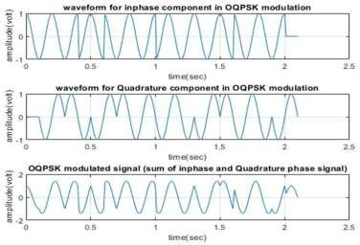
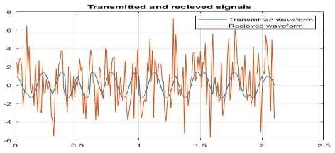
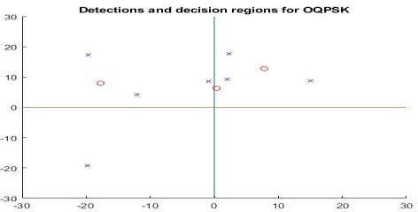

SNR=0.09
Number of Errors :3 Probability of error in 30%

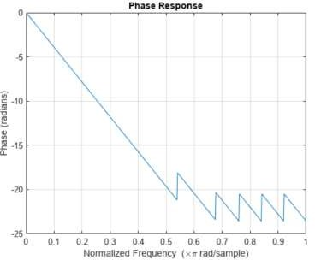
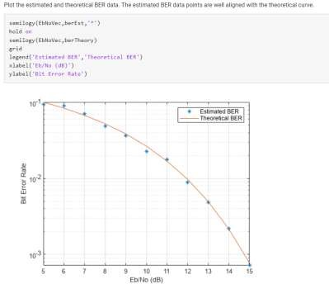

Date: Signature

