Computational Study 1: All-Pairs Shortest Paths
Table of Contents

All-pairs shortest paths: n x Dijkstra vs Floyd-Warshall on five real networks
MMIE 7372, Network Flows: Computational Study 1.

1. Summary
We computed all-pairs shortest paths (APSP) on five real networks in two ways: by running Dijkstra's algorithm once from every node ("n x Dijkstra") and by Floyd-Warshall (FW). Both were implemented from scratch in Python (plus a vectorized numpy FW) and also run through the compiled scipy.sparse.csgraph library. A controlled experiment on random networks then isolated the effect of density.
- n x Dijkstra was faster on every real dataset, in every implementation. In the compiled (scipy) implementation, FW was 3.4x slower on US Airports, 5.1x on Adolescent Health and 16.7x on Advogato.
- FW could not run on the two large networks (Slashdot Zoo, n = 69,995; Wiki Conflict, n = 116,836). It must keep the full n x n distance table in memory: 36.5 GiB and 101.7 GiB, against 24 GiB of RAM. Even with enough memory, its measured speed predicts roughly 13-22 hours and 4-6 days. n x Dijkstra finished them in 3.2 and 30.5 minutes (scipy) using at most 1.2 GiB. Our own pure-Python Dijkstra finished Slashdot in 24.8 minutes and is estimated at 7.7 hours for Wiki Conflict.
- The gap widens with network size. FW's work grows as n^3 whatever the number of edges, while Dijkstra's grows with n x m, and all five networks are sparse (density 0.008% to 1.1%).
- Density decides the winner. On random networks with a fixed number of nodes, compiled FW only becomes faster than n x Dijkstra above about 21-27% density. That is 20 times denser than the densest real network studied. In pure Python the crossover is at about 98%.
- Implementation changes the size of the gap, not the winner on the real data: FW was 3.4x slower in scipy and 35x slower in pure Python on the same network.

2. Datasets and network characteristics
Raw data came from the sources named in the assignment (KONECT, Netzschleuder, Canvas). Download URLs and SHA-256 checksums are in data/SOURCES.md. Each dataset needed decisions about what an edge weight means as a distance; these are documented in docs/decisions.md (D1-D6) and summarized here.

2.1 Raw data
Dataset | Nodes | Edges (rows) | Directed | Weights
US Airports (2010) | 1,574 | 28,236 | yes | passengers per route (1 to 1,489,618)
Adolescent Health | 2,539 | 12,969 | yes | 1..6 = 1 + number of shared activities
Advogato | 6,541 | 51,127 | yes | trust level 0.6 / 0.8 / 1.0
Slashdot Zoo | 79,120 | 515,397 | yes | +1 friend / -1 foe
Wiki Conflict | 118,100 | 2,917,785 | no | signed, +-ln(k)

2.2 From weights to distances
- Strength weights (passengers, shared activities, trust): bigger means closer, so distance = 1 / weight (Opsahl, Agneessens and Skvoretz, 2010).
- Signed weights cannot be distances. Both signed networks contain negative cycles (Slashdot: 4,497 pairs of users who mark each other as foes; Wiki Conflict: every negative edge, because the network is undirected), so shortest paths are undefined for any algorithm. Slashdot Zoo keeps friend edges only; Wiki Conflict keeps every interacting pair. Both use hop counts.
- Nodes with no links, self-loops and repeated edges are removed; none of them can change a shortest path.

2.3 Networks as used in the benchmark
Dataset | n | m (one-way edges) | Density m / (n(n-1)) | Mean out-degree m/n | Max degree (out / in) | Reciprocity | Reachable ordered pairs | Distance
US Airports | 1,574 | 28,236 | 1.14% | 17.9 | 302 / 294 | 78% | 89.3% | 1 / passengers
Adolescent Health | 2,539 | 12,969 | 0.20% | 5.1 | 10 / 27 | 39% | 84.9% | 1 / weight
Advogato | 5,155 | 47,135 | 0.18% | 9.1 | 785 / 721 | 33% | 60.9% | 1 / trust level
Slashdot Zoo | 69,995 | 392,179 | 0.008% | 5.6 | 426 / 2,498 | 21% | 36.3% | hops (friend edges)
Wiki Conflict | 116,836 | 4,055,742 | 0.030% | 34.7 | 20,153 (undirected) | (undirected) | 93.8% | hops
Wiki Conflict is undirected; each of its 2,027,871 editor pairs is stored as two one-way edges, which is what the algorithms scan.
Structure worth noting. All five networks are very sparse. US Airports, Advogato, Slashdot and Wiki Conflict have heavy-tailed degree distributions (a few hubs with hundreds to tens of thousands of links). Adolescent Health has no hubs, because the survey limited each student to 10 friends. Slashdot has low reachability: 41% of its users never tagged anyone as a friend, so no path starts from them. Degree and weight distributions per dataset: results/distributions_<dataset>.png.

3. Implementations and method

3.1 Implementations
Version | n x Dijkstra | Floyd-Warshall
pure (our code, plain Python) | binary heap (heapq) with lazy deletion | textbook triple loop, k outermost
numpy (our code, vectorized) | (none: Dijkstra is sequential and does not vectorize) | k loop in Python; each sweep is one broadcast np.minimum over the whole table
scipy (scipy.sparse.csgraph, compiled) | dijkstra (Fibonacci heap) | floyd_warshall
All versions were tested against networkx (Bellman-Ford) on a hand-checked graph and on random graphs with zero weights, self-loops, multi-edges, negative edges and negative cycles (402 tests).
Algorithm variants (stated explicitly, as they affect complexity or fairness):
- Our pure Dijkstra uses lazy deletion instead of decrease-key: still O(m log n) per source.
- scipy's Dijkstra uses a Fibonacci heap: O(m + n log n) per source.
- scipy's Dijkstra only warns on negative weights and then re-processes nodes, which is no longer Dijkstra's algorithm. Our wrappers reject negative weights, so every Dijkstra timing here is genuine Dijkstra. (No dataset as used has negative weights.)
- On the hop-count networks (Slashdot, Wiki Conflict), breadth-first search would be the optimal single-source method. We time Dijkstra anyway, to compare like with like.
- The pure tier is not purely interpreted: Python's heapq is written in C, which favors Dijkstra within that tier.
- Our pure FW skips the inner loop when node i cannot reach node k (same result; still Theta(n^3) in the worst case). scipy's FW evidently does the same: on random networks with n = 1,000 it took 0.005 s at 0.1% density but about 0.46 s at 2% density or more, while a strict triple loop would take the same time at every density. FW's real cost is therefore about n x (number of node pairs i, k with a path from i to k), at most n^3. Our numpy FW has no such skip.
- scipy's FW time includes converting the sparse input to a dense table (O(n^2), negligible next to n^3).

3.2 Measurement
- One measurement per fresh Python process, so peak memory belongs to that run alone.
- Time = the shortest-path computation only. Loading data and building the input are not timed.
- Short runs (< 10 s): one warm-up run, then median of 5. Longer runs: a single run.
- Single thread for every library.
- Dijkstra is run streaming: a batch of sources is solved, summarized and discarded, so the n x n table is never stored. Every run produces the same summary (number of reachable pairs, mean and maximum distance), which is how all versions are cross-checked at full scale.
- Sampling (one case): our pure Dijkstra on Wiki Conflict was timed on 1,000 randomly chosen sources (fixed seed) and scaled by n / 1,000. This is an estimate and is labelled as such.
- Feasibility pre-check: a run is not started if its estimated memory exceeds 60% of RAM. FW needs n^2 cells: 8 bytes each (scipy), 16 (numpy: table plus one temporary per sweep), up to 32 (pure Python objects).
- Machine: Apple M2, 24 GiB RAM, macOS 26.7.1; Python 3.11.8, numpy 2.4.6, scipy 1.17.1.

4. Results on the five datasets

4.1 Running time
Dataset | n | m | scipy Dijkstra | scipy FW | numpy FW | pure Dijkstra | pure FW
US Airports | 1,574 | 28,236 | 0.37 s | 1.25 s | 3.11 s | 2.13 s | 74 s
Adolescent Health | 2,539 | 12,969 | 0.70 s | 3.54 s | 24 s | 2.95 s | 3.3 min
Advogato | 5,155 | 47,135 | 1.85 s | 31 s | 3.7 min | 10.4 s | 29.3 min
Slashdot Zoo | 69,995 | 392,179 | 3.2 min | infeasible | infeasible | 24.8 min | infeasible
Wiki Conflict | 116,836 | 4,055,742 | 30.5 min | infeasible | infeasible | ~7.7 h (estimated from 1,000 sources) | infeasible
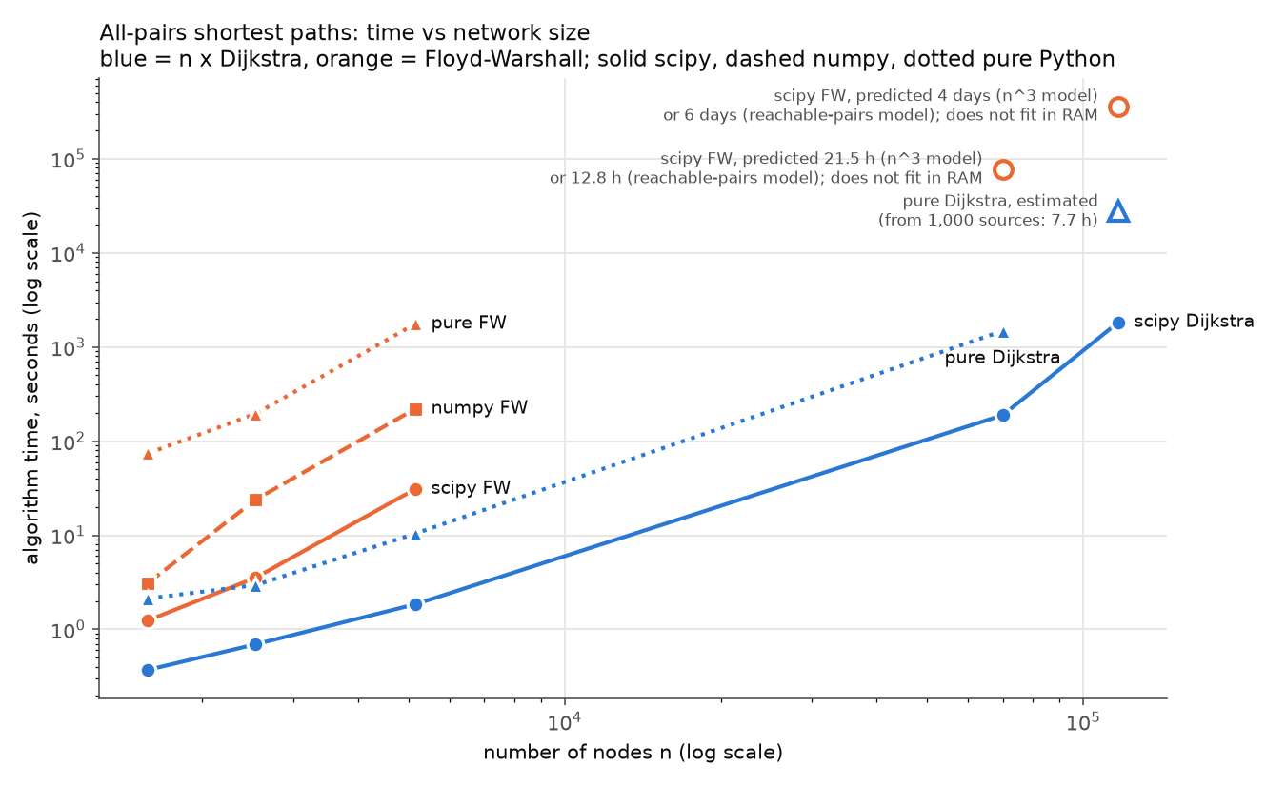
Figure 1. Algorithm time against n (both axes logarithmic). Blue: n x Dijkstra; orange: Floyd-Warshall. Hollow markers: predicted or estimated, not measured.

4.2 How many times slower Floyd-Warshall is
Dataset | Theory n^3 / (n m log2 n) | scipy | pure Python
US Airports | 8.3x | 3.4x | 35x
Adolescent Health | 44x | 5.1x | 66x
Advogato | 46x | 16.7x | 169x
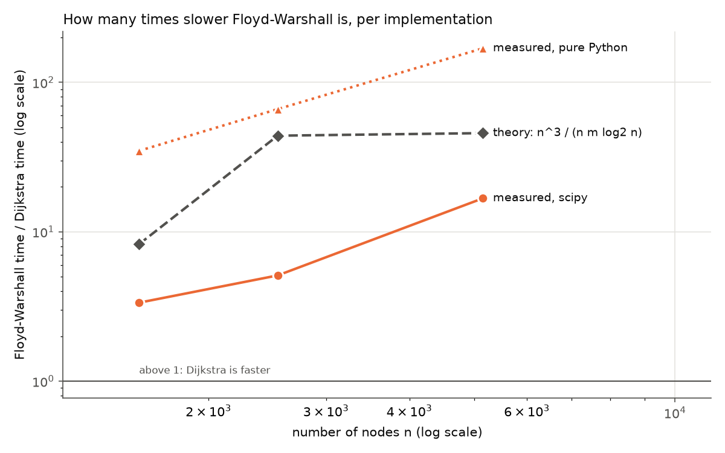
Figure 2. FW time divided by Dijkstra time. Above 1 means Dijkstra is faster. The step-count theory is shown for reference.

4.3 Correctness
On each of the three small networks, all five versions found exactly the same number of reachable pairs (2,209,653; 5,473,916; 16,177,614), and their mean distances agree to within 2e-15 (floating point rounding). On Slashdot Zoo, our pure Dijkstra and scipy's both found exactly 1,777,768,126 reachable pairs with the same mean distance (4.8811). On Wiki Conflict, scipy found 12,796,704,262 reachable pairs (93.8%); our 1,000-source sample gives 93.1% and a mean distance of 3.330 (full run: 3.322). All reachable fractions match those computed independently from the network structure.

4.4 Memory
Dataset | FW table (n^2 x 8 bytes) | Peak memory, scipy Dijkstra | Peak memory, pure Dijkstra
Advogato | 203 MiB | 440 MiB | 92 MiB
Slashdot Zoo | 36.5 GiB (not run) | 801 MiB | 193 MiB
Wiki Conflict | 101.7 GiB (not run) | 1,192 MiB | 1,183 MiB (sampled run)
Pure Dijkstra, which handles one source at a time, never rose above the memory needed to hold the network itself. On the small networks the scipy figures mostly reflect our 256 MiB batch size (the whole n x n table fits in one batch there), so they do not separate the two algorithms; the decisive memory evidence is the large networks. Full per-run table: results/report_tables.md (Table 3).

5. Runs that could not complete, explained by complexity
Dataset | Version | Memory needed | Available (60% of 24 GiB) | Predicted time if it fitted (n^3 model / reachable-pairs model)
Slashdot Zoo | scipy FW | 36.5 GiB | 14.4 GiB | 21.5 h / 12.8 h
Wiki Conflict | scipy FW | 101.7 GiB | 14.4 GiB | 4 days / 6 days
numpy FW (twice the memory) and pure FW (up to four times) are infeasible for the same reason.
Why: memory. FW works on the full n x n table. Each of its n sweeps reads and may update every cell, so the whole table must stay in memory for the entire run: Theta(n^2) space, independent of how many edges the network has. For n = 116,836 that is 13.65 billion cells, or 101.7 GiB at 8 bytes each. Keeping the table on disk does not help: n sweeps over 36.5 GiB (Slashdot) would mean roughly 70,000 full passes, about 2.5 petabytes of disk traffic.
Why: time. FW performs n^3 relaxation checks in the worst case: 3.4 x 10^14 for Slashdot and 1.6 x 10^15 for Wiki Conflict. Both prediction models are calibrated on Advogato's measured scipy time. The n^3 model predicted the other two measured FW times to within 0.96x-1.41x. The reachable-pairs model accounts for scipy skipping node pairs that cannot reach each other (Section 3.1): it predicts less for Slashdot, where only 36% of pairs are connected, and more for Wiki Conflict, where 94% are. Either way the answer is many hours to days.
Why n x Dijkstra still works. Each single-source run needs only the network plus one row of distances: O(n + m) memory. Rows can be summarized and discarded as they are produced, so the n x n table never has to exist. Its time, n x O(m log n), stays small because m is small.

6. Density experiment: where does Floyd-Warshall start to win?
In the five real networks, size and density vary together (the largest are also the sparsest), so they cannot show the effect of density alone. We therefore generated random directed networks with a fixed number of nodes n, each possible edge present with probability p (weights uniform on [1, 10), fixed seed), and ran both algorithms with the same measurement harness for ten densities from 0.1% to 100%.
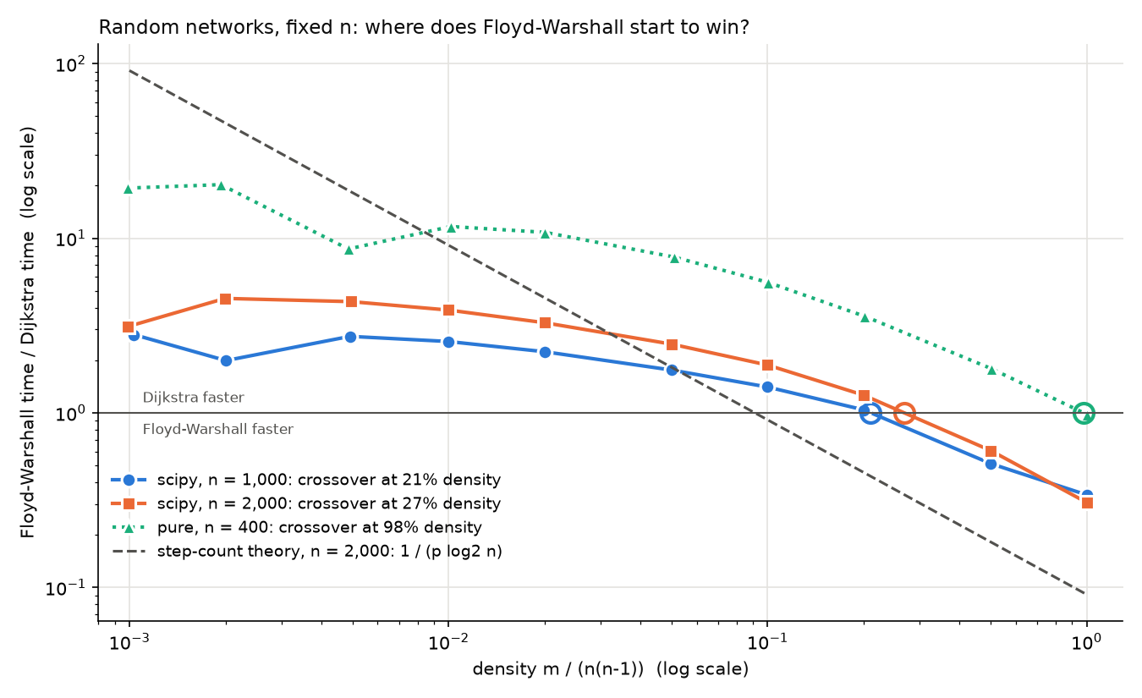
Figure 3. FW time divided by Dijkstra time on random networks. Above 1, Dijkstra is faster; hollow circles mark where each line crosses 1.
Setting | Density where FW becomes faster | Step-count theory: p = 1 / log2 n
scipy, n = 1,000 | 21% | 10%
scipy, n = 2,000 | 27% | 9%
pure Python, n = 400 | 98% | 12%
Selected times (scipy, n = 2,000):
Density | 0.1% | 1% | 10% | 20% | 50% | 100%
n x Dijkstra | 0.21 s | 0.83 s | 1.87 s | 2.74 s | 5.68 s | 10.8 s
Floyd-Warshall | 0.65 s | 3.24 s | 3.52 s | 3.46 s | 3.45 s | 3.33 s
What the experiment shows:
- Dijkstra's time grows with density; FW's does not. Once the network is connected (from about 1% density), FW's time is flat at its n^3 cost, while Dijkstra's keeps growing with m.
- FW does win on dense networks, but only well above 20% density in compiled code. The crossover is later than the step-count theory predicts (9-10%) because an FW step is several times cheaper than a Dijkstra edge relaxation, and scipy's Fibonacci-heap Dijkstra does not pay log n per edge.
- In pure Python the crossover moves to about 98% (almost a complete graph), because every FW step is interpreted while Dijkstra's heap runs in C.
- At very low density, FW is fast too (it skips pairs that cannot reach each other) but still slower than Dijkstra.
Raw results: results/density_sweep.csv, ratios: results/density_ratios.csv.

7. Discussion

(a) Performance of each algorithm across the five datasets
n x Dijkstra was the faster method on every dataset and in every implementation where both could run. Floyd-Warshall's disadvantage grew from 3.4x (US Airports) to 16.7x (Advogato) in scipy, and from 35x to 169x in pure Python. On the two large networks Floyd-Warshall could not run at all, while n x Dijkstra finished in minutes with the compiled library, and in 24.8 minutes (Slashdot) and an estimated 7.7 hours (Wiki Conflict) with our own pure-Python code.
The measured gaps are smaller than the step-count theory in scipy (3.4x measured vs 8.3x predicted on US Airports) and larger in pure Python (35x). The reason is the cost of a single step. An FW step ("add, compare, maybe overwrite") is about as cheap as an operation can be, and it walks through memory in order, so compiled FW does better than its step count suggests. In pure Python, every FW step goes through the interpreter, while Dijkstra's priority-queue work runs in C (heapq). The complexity predicts the winner correctly on every real dataset; the size of the win depends on the implementation.

(b) How performance changes with network size and density
- Size. FW's time followed n^3 closely: calibrated on one dataset, n^3 predicted the others to within a factor of 1.5 for scipy and pure Python (2 for numpy), even though their densities differ about sixfold. Doubling n multiplies FW's time by about 8, and its memory by 4. n x Dijkstra grows much more slowly on sparse networks: 116,836 searches over 4 million edges took 30.5 minutes. Its times follow n x m x log n less closely (0.4x-3x of the prediction), mainly because a search only explores what it can reach (on Slashdot only 36% of pairs are connected), and log n is a worst-case bound.
- Density. With n fixed (Section 6), n x Dijkstra slows down roughly in proportion to the number of edges, while FW stays flat once the network is connected. Higher density therefore shrinks Dijkstra's advantage, and above about 21-27% density (compiled code) FW becomes faster. The real networks are at 0.008-1.1% density, far on Dijkstra's side; consistently, the densest one (US Airports) shows the smallest gap.

(c) Which network structures favor which algorithm
n x Dijkstra is better for:
- Sparse networks (m much smaller than n^2): below about 20% density in compiled code, which includes all five networks studied here and most real networks.
- Large networks. FW's n^2 memory alone rules it out beyond about n = 44,000 on a 24 GiB machine (where n^2 x 8 bytes reaches 60% of RAM). Dijkstra's memory is O(n + m).
- Networks with limited reachability (many sources reach only part of the network, as in Slashdot). Dijkstra's searches stop early. FW (with the skip) saves work too, but still needs the full n^2 table.
- When only some sources are needed: Dijkstra can be run for just those.
Floyd-Warshall is better for:
- Dense networks: above about 21-27% density in our compiled measurements (n = 1,000-2,000). There n x Dijkstra costs about O(n^3) as well, and FW's simple, memory-friendly inner loop wins on constants.
- Small networks, where the n x n table fits easily and simplicity matters more.
- Negative edge weights without negative cycles. FW handles them directly; Dijkstra does not (Johnson's algorithm, Bellman-Ford plus reweighting plus n x Dijkstra, is the alternative). Negative cycles defeat every method; FW at least detects them.
Neither is ideal for unweighted networks (hop counts, as in Slashdot and Wiki Conflict): n x BFS solves them in O(n(n + m)) time without a priority queue.

8. Reproducing the results
From the repository root:
python3 -m venv .venv && source .venv/bin/activate
pip install -r computational-study-1-apsp/requirements.txt
pip install -e computational-study-1-apsp
cd computational-study-1-apsp
python scripts/preprocess_datasets.py # raw data -> distance graphs (fill data/raw first; see data/SOURCES.md)
python scripts/describe_dataset.py # network characteristics and distribution figures
python scripts/run_benchmarks.py # benchmark on the five datasets (~1.5 h)
python scripts/run_pure_large.py --stages slashdot,sample # our Dijkstra on the two large networks
python scripts/run_density_sweep.py # density experiment (~10 min)
python scripts/make_report.py # tables and figures
python scripts/build_word_report.py # this report as .docx (needs pandoc)
pytest -q # 402 correctness tests
Code (deliverables):
- src/apsp/pure.py: our Dijkstra and Floyd-Warshall in plain Python.
- src/apsp/vectorized.py: our numpy Floyd-Warshall.
- src/apsp/scipy_tier.py: guarded scipy wrappers.
- src/apsp/loaders.py, src/apsp/preprocess.py: dataset loading and the decisions in docs/decisions.md.
- src/apsp/characteristics.py: network characteristics.
- src/apsp/synthetic.py: random networks for the density experiment.
- src/apsp/bench.py, src/apsp/bench_worker.py: the benchmark harness.
- scripts/: the entry points listed above.
- tests/: correctness tests.

9. Limitations
- Our pure-Python Dijkstra on Wiki Conflict is an estimate from 1,000 random sources, scaled to all 116,836. A full run takes about 7.7 hours.
- Long runs (over 10 s) were measured once rather than as a median of five.
- On the small networks, peak memory reflects our batch size more than the algorithm (Section 4.4).
- Results are from one machine (Apple M2, single thread); absolute times will differ elsewhere, but the ratios and the complexity arguments do not depend on the machine.

