**Internship Web Development**

**Day-2 Assignment**

**SE-ITB-06**

**Abhishek Pandita**

**Q1.**

**<!DOCTYPE HTML>**

**<html>**

**<head>**

**<title>FORM PAGE</title>**

**</head>**

**<body>**

**<form>**

**<table>**

**<tr>**

**<td>First Name :</td>**

**<td><input type="text"></td>**

**</tr>**

**<tr>**

**<td> Last Name :</td>**

**<td><input type="text"></td>**

**</tr>**

**<tr>**

**<td> Username :</td>**

**<td><input type="text"></td>**

**</tr>**

**<tr>**

**<td>Password :</td>**

**<td><input type="password"></td>**

**</tr>**

**<tr>**

**<td> Gender :</td>**

**<td>**

**<input type="radio" name="Gender"> Male**

**<input type="radio" name="Gender"> Female**

**</td>**

**</tr>**

**<td>**

**<select>**

**<option>volvo</option>**

**<option>02</option>**

**<option>03</option>**

**<option>04</option>**

**</select>**

**</td>**

**</tr>**

**</table>**

**<button type="button">Click Me!</button><br>**

**<button type="button">===</button><br>**

**<button type="button">submit</button>**

**</form>**

**</body>**

**</html>**

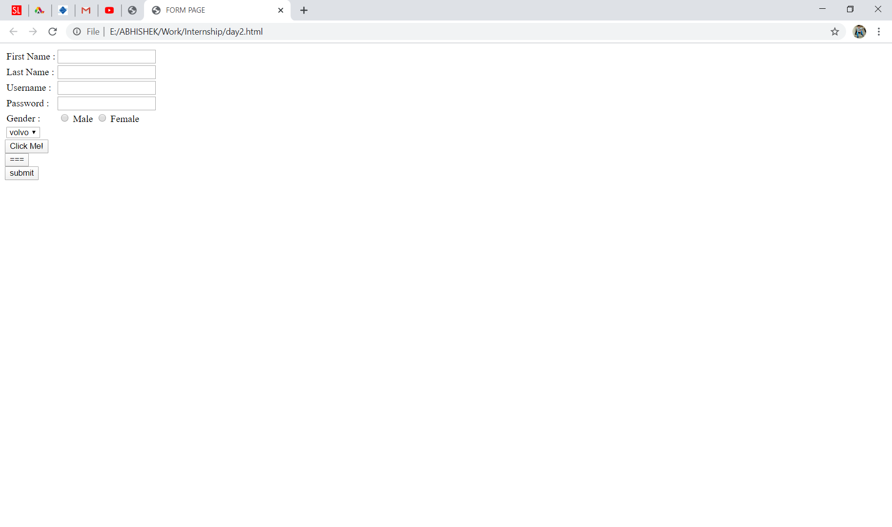

**Q2.**

**<!DOCTYPE html>**

**<html>**

**<head>**

**<title>Third Page</title>**

**</head>**

**<body>**

**<h1>An Unordered HTML List</h1>**

**<ul>**

**<li>Cofee</li>**

**<li>Tea</li>**

**<li>Milk</li>**

**</ul>**

**<h1>An Ordered HTML List</h1>**

**<ol>**

**<li>Cofee</li>**

**<li>Tea</li>**

**<li>Milk</li>**

**</ol>**

**</body>**

**</html>**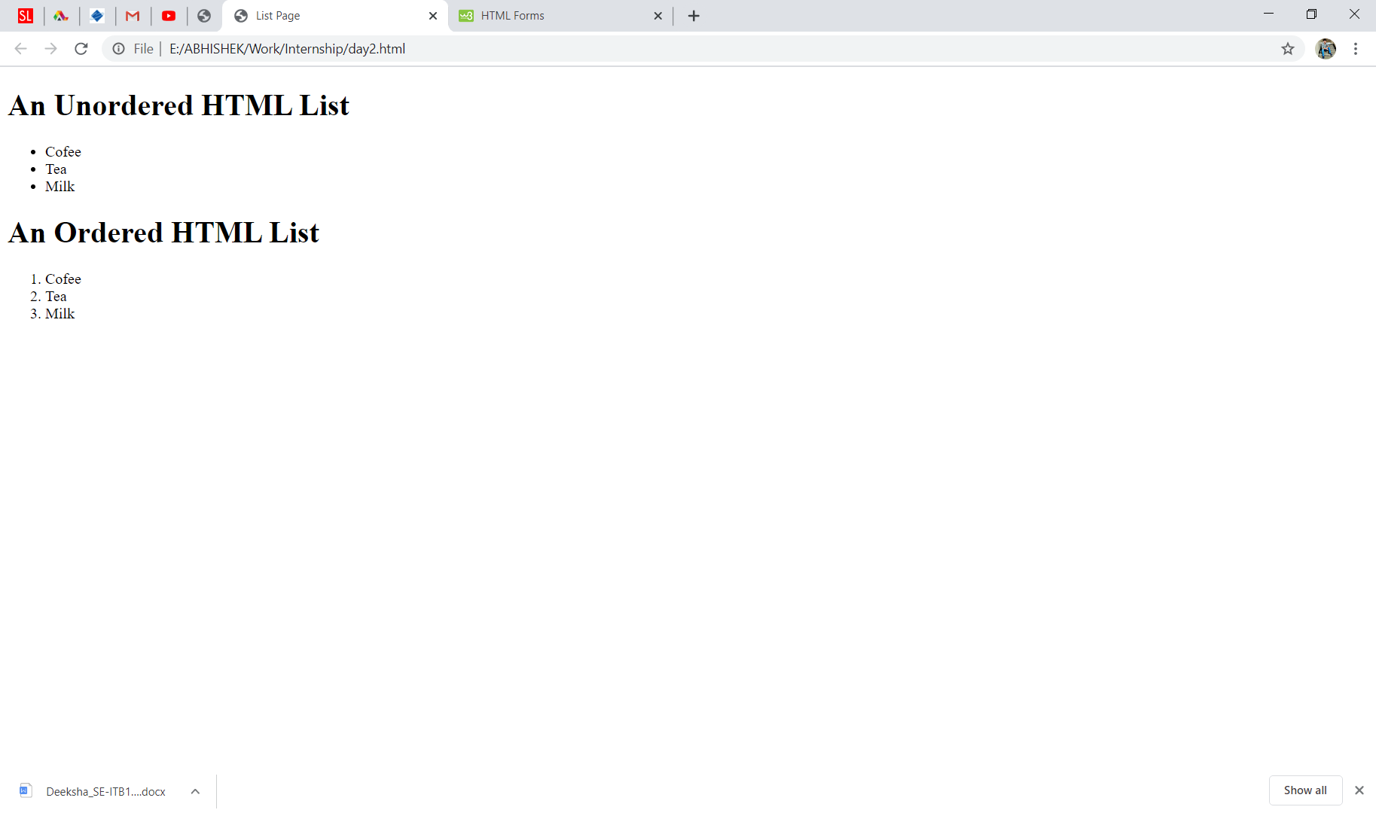

**Q4.**

**<!DOCTYPE html>**

**<html>**

**<head>**

**<title> nested</title>**

**</head>**

**<body**

**<H1>Nested List</H1>**

**<ul>**

**<li>Coffee</li>**

**<li>Tea**

**<ul>**

**<li>Black Tea</li>**

**<li>Green Tea**

**<ul>**

**<li>China</li>**

**<li>Africa</li>**

**</ul>**

**</ul>**

**</li>**

**<li>Milk</li>**

**</body>**

**</html>**

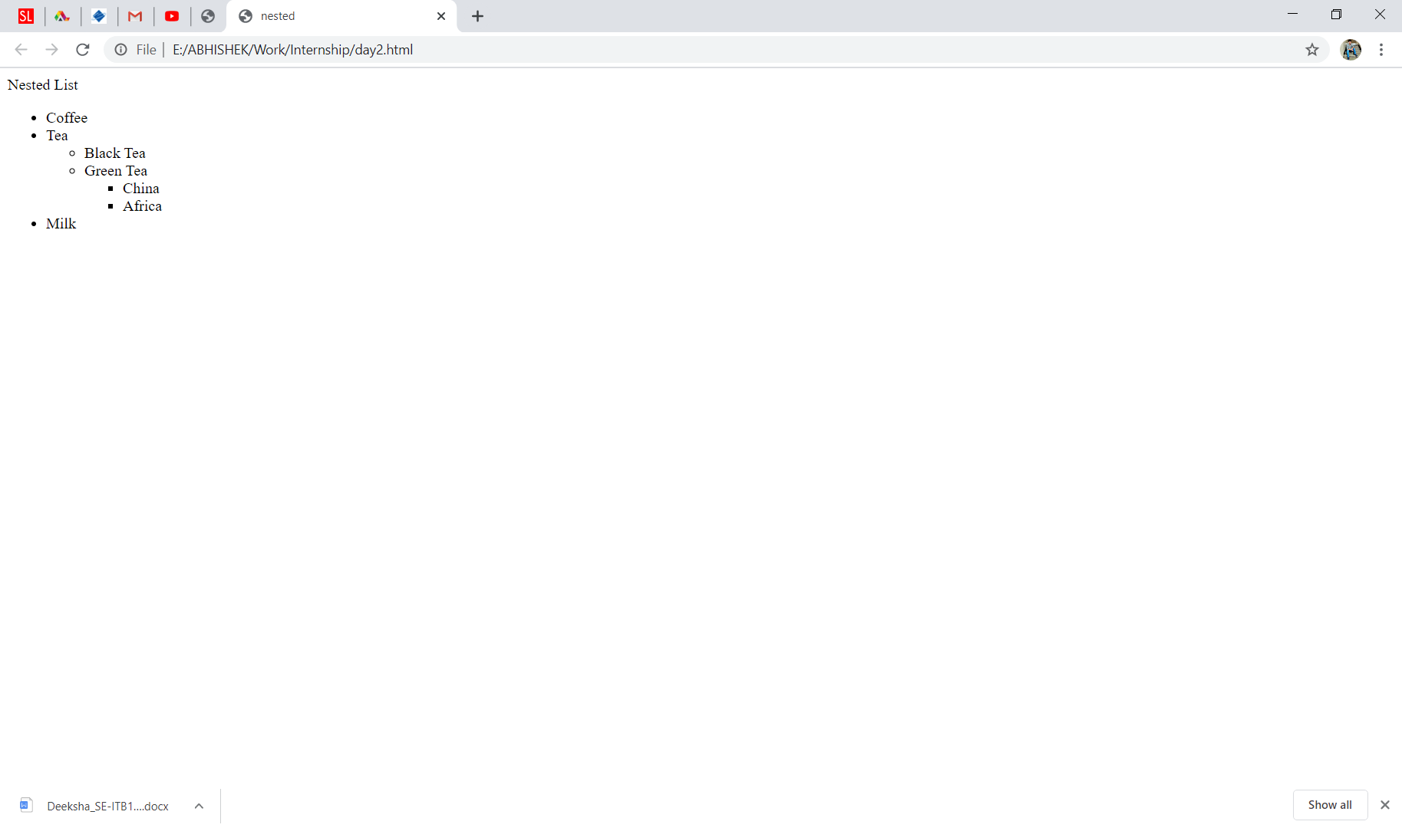

**Q3.**

**<!DOCTYPE html>**

**<html>**

**<body>**

**<h2>Table</h2>**

**<table border="2" cellpadding="5" cellspacing="2">**

**<tr>**

**<th>Firstname </th>**

**<th>Lastname </th>**

**<th>Age </th>**

**</tr>**

**<tr>**

**<td>Jill </td>**

**<td>Smith </td>**

**<td>50 </td>**

**</tr>**

**<tr>**

**<td>Eve </td>**

**<td>Jackson </td>**

**<td>94 </td>**

**</tr>**

**<tr>**

**<td>John </td>**

**<td>Doe </td>**

**<td>80 </td>**

**</tr>**

**</table>**

**</body>**

**</html>**

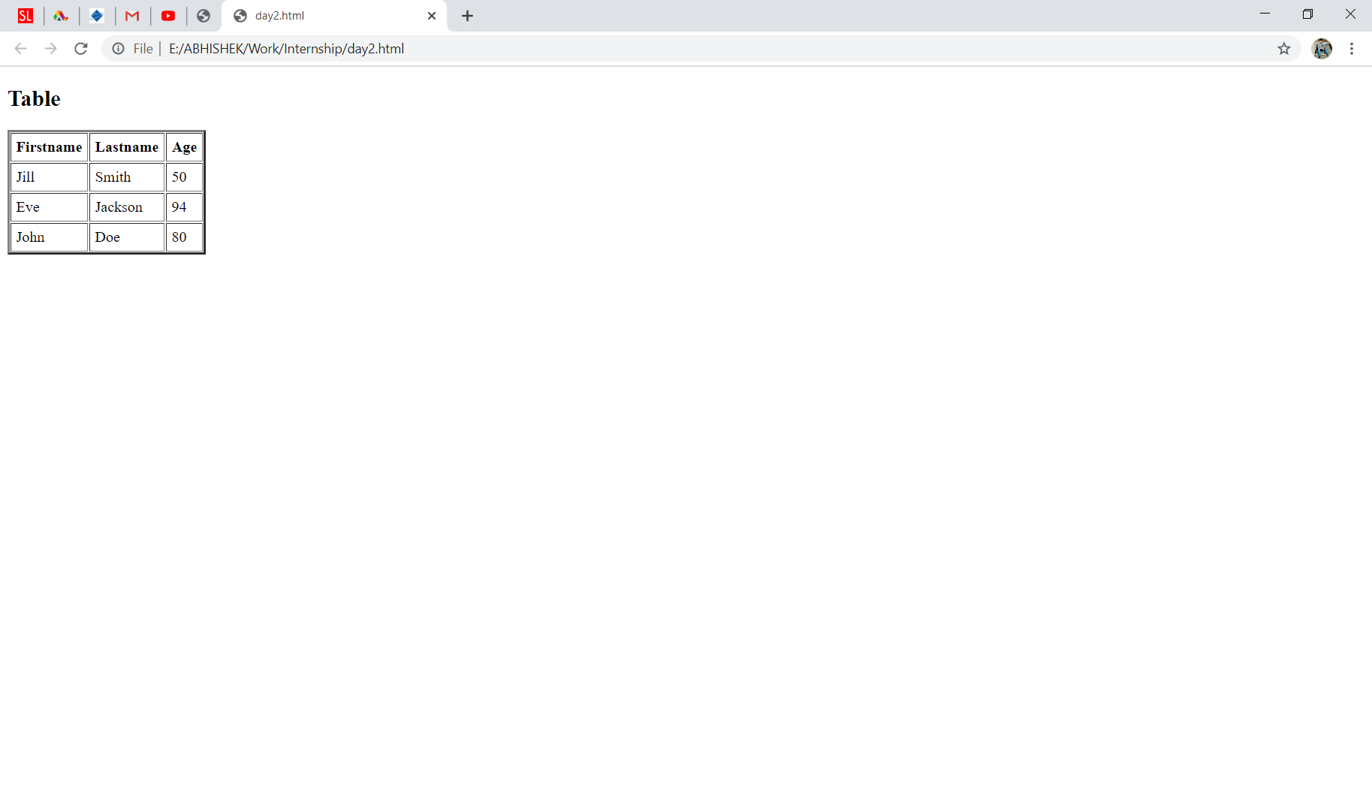

**Q5.**

**<!DOCTYPE html>**

**<html>**

**<head>**

**<title>Link Page</title>**

**</head>**

**<body>**

**<a href="https://www.w3schools.com/" target="_blank">W3Schools!</a><br>**

**<a href="https://www.youtube.com/" target="_blank">Youtube</a><br>**

**<a href="https://www.coursera.com/" target="_blank">Coursera</a><br>**

**<a href="https://www.udemy.com/" target="_blank">Udemy</a><br>**

**<a href="https://github.com/" target="_blank">Github</a>**

**</body>**

**</html>**