**Web Development Internship**

**Day-3 Assignment**

SE-ITB-06

Abhishek Pandita

**Q1.Print square of numbers from 1 to 10.**

**Ans.**

<!DOCTYPE HTML>

<head>

<title> Square </title>

<script type="text/javascript">

function square()

{

var n=10;

var msg="";

var res= "0";

for(var x= 1; x<=n;x++)

{

res = x * x;

msg = msg + " " + x + " * "+ x + " = " + res + "<br>";

}

document.write(msg);

}

</script>

</head>

<body onload = "square()">

<h2 > Javascript to generate squares of 1 to 'N' numbers</h2>

</body>

</html>

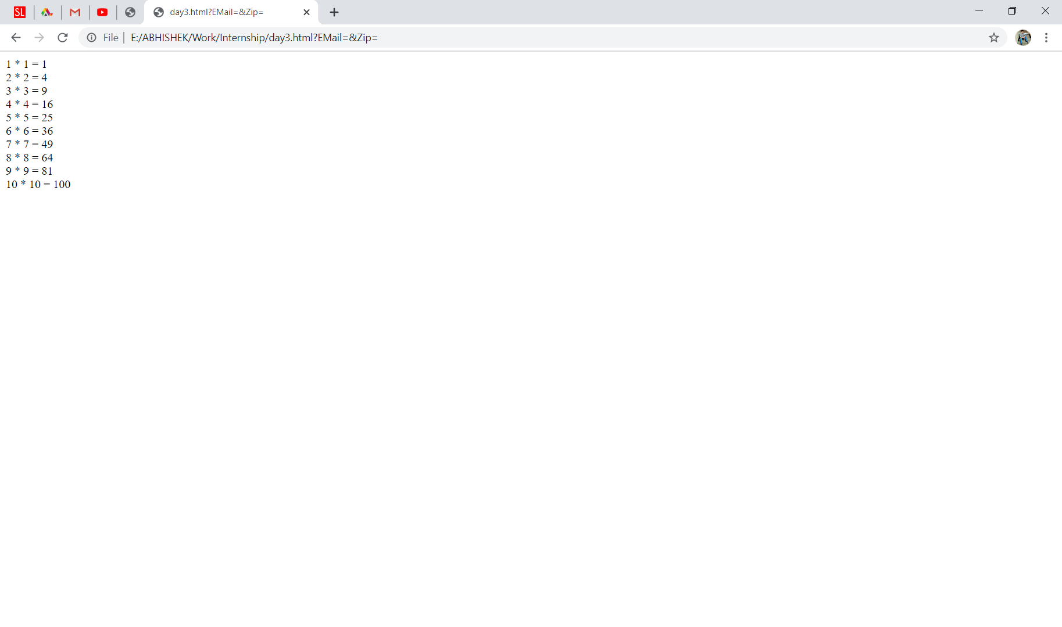

**Q2.Display calculator using switch case in html by javascript.**

**Ans.**

<!DOCTYPE html>

<html>

<head>

<title>Calculator</title>

</head>

<body>

<script type="text/javascript">

function plus(a,b) {

return (a + b);

}

function minus(a,b) {

return (a - b);

}

function multiply(a,b) {

return (a * b);

}

function divide(a,b) {

return (a / b);

}

function calc() {

var x = document.getElementById("oper1").value;

var y = document.getElementById("operx").value;

var z = document.getElementById("oper2").value;

var w = document.getElementById("resul").value;

switch (y) {

case '0':

w = plus(x, z);

break;

case '1':

w = minus(x, z);

break;

case '2':

w = multiply(x, z);

break;

case '3':

w = divide(x, z);

break;

default:

w = "";

}

}

</script>

<input type="text" id="oper1" value="">

<select id="operx">

<option value="0">SUMAR</option>

<option value="1">RESTAR</option>

<option value="2">MULTIPLICAR</option>

<option value="3">DIVIDIR</option>

</select>

<input type="text" id="oper2" value="">

<input type="button" onClick="calc()" value="=">

<input type="text" id="resul" value="">

</body>

</html>

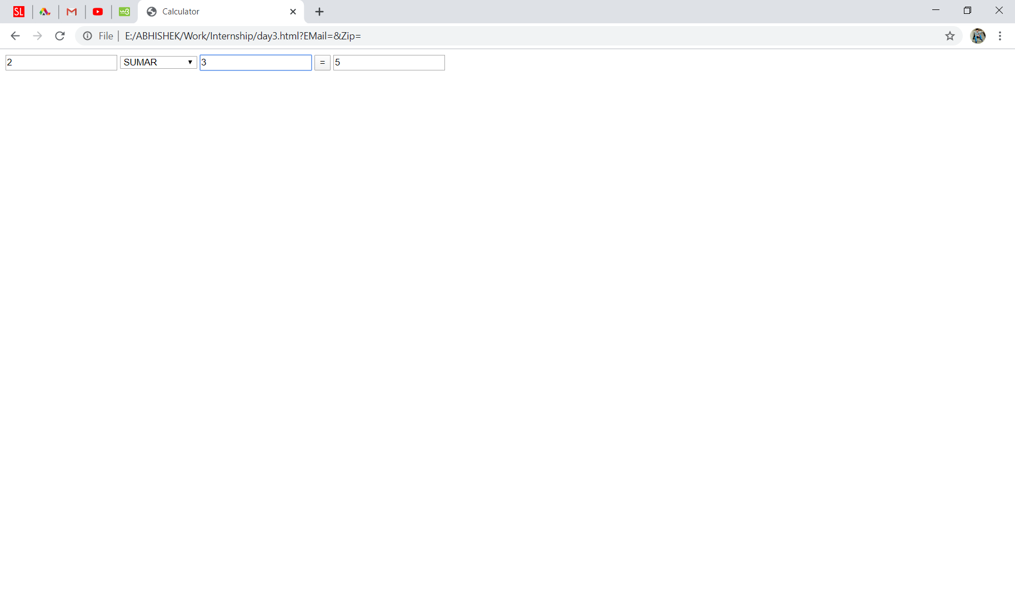

**Q3.Do form validation using javascript.**

**Ans.**

<!DOCTYPE html>

<html>

<head>

<title>Form Validation</title>

<script type = "text/javascript">

function validate() {

if( document.myForm.EMail.value == "" ) {

document.write( "Please provide your Email!" );

}

if( document.myForm.Zip.value == ""||document.myForm.Zip.value.length != 5 )

{

document.write( "Please provide a zip in the format #####." );

}

</script>

</head>

<body>

<form name = "myForm" onsubmit = "validate()">

<table cellspacing = "2" cellpadding = "2" border = "1">

<tr>

<td align = "right">EMail</td>

<td><input type = "text" name = "EMail" /></td>

</tr>

<tr>

<td align = "right">Zip Code</td>

<td><input type = "text" name = "Zip" /></td>

</tr>

<tr>

<td align = "right"></td>

<td><input type = "submit" value = "Submit" /></td>

</tr>

</table>

</form>

</body>

</html>

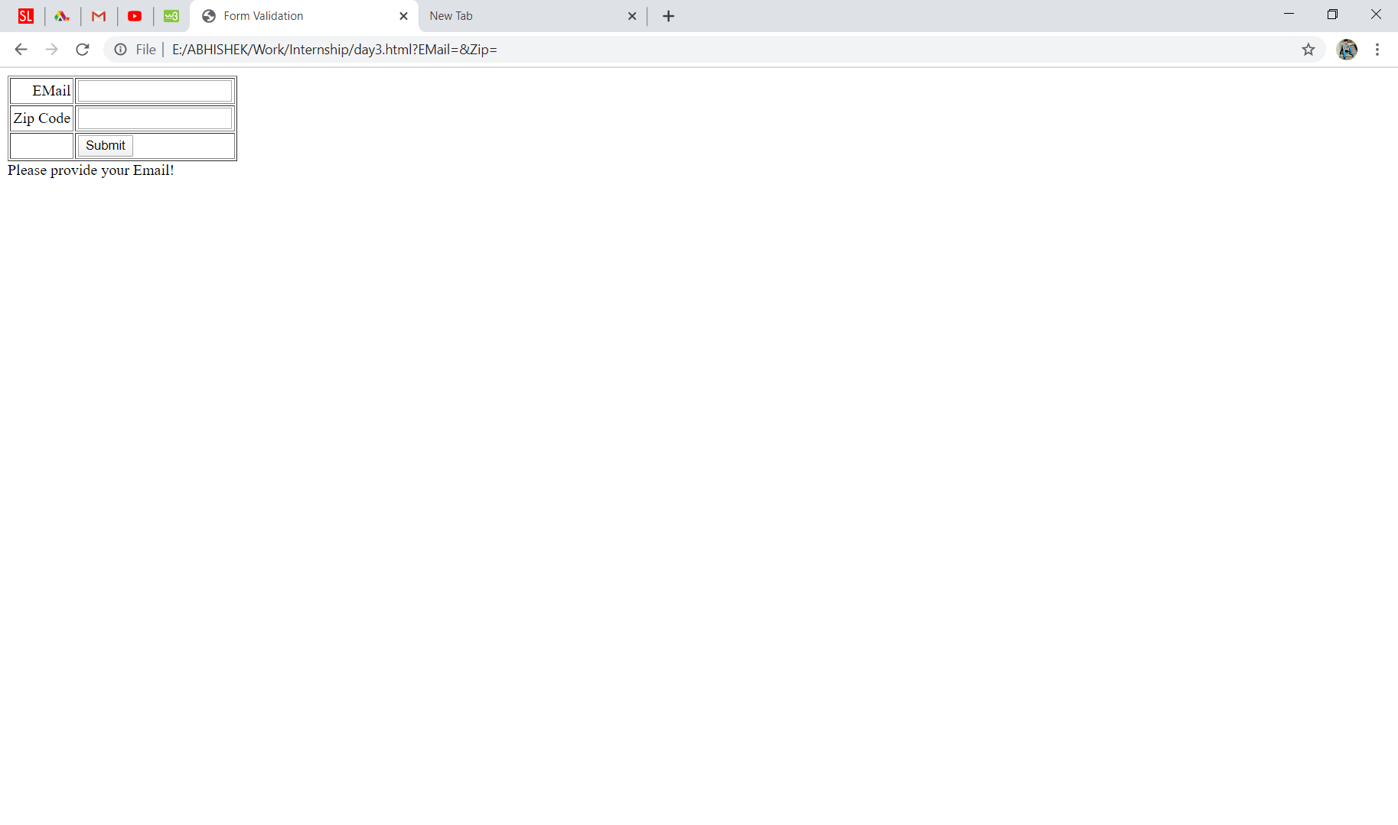

**Q4.Show the average marks of student and grade using java script.**

**Ans.**

<!DOCTYPE html>

<html>

<head>

<title>Average marks and Grades</title>

<h2>Marks of student and grade</h2>

<br>

<script type="text/javascript">

var students = [60,50,80,90,85];

var Avgmarks = 0;

for (var i=0; i < students.length; i++) {

Avgmarks += students[i];

var avg = (Avgmarks/students.length);

}

document.write("Average grade: " +avg);

if (avg < 60){

document.write("Grade : F");

}

else if (avg < 70) {

document.write("Grade : D");

}

else if (avg < 80)

{

document.write("Grade : C");

} else if (avg < 90) {

document.write("Grade : B");

} else if (avg < 100) {

document.write("Grade : A");

}

</script>

</head>

<body>

</body>

</html>

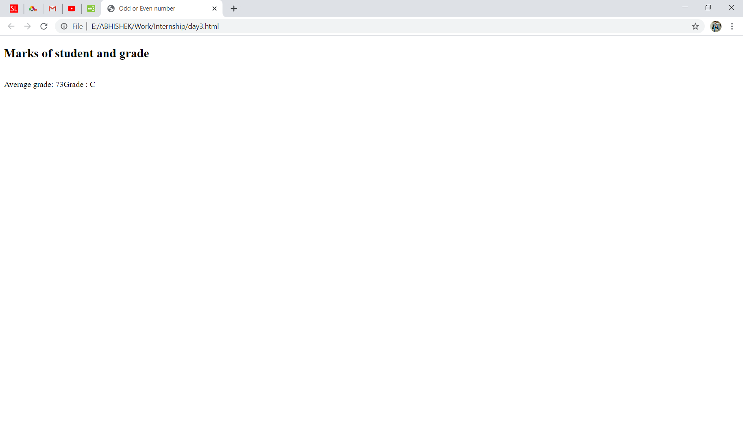

**Q5.Display if the number is odd or even using javascript.**

**Ans.**

<!DOCTYPE html>

<html>

<head>

<title>Odd or Even number</title>

<script type="text/javascript">

function findOddEven(numb){

if ( numb % 2 == 0)

{

document.write("Even Number");

}

else

{

document.write('Odd Number');

}

</script>

</head>

<body>

<h2>Odd or Even number!</h2>

Enter a number: <input type="text" id="num" value="num" />

<input type="button" value="Find Odd or Even" onclick="findOddEven(num)"/>

</body>

</html>

