**Web Development Internship**

**Day4 Assignment**

**SE-IT-B-06**

**Abhishek Pandita**

**Q1.**

**Ans.**

HTML (Hyper Text Markup Language) was created to help programmers describe the content on a website like <this is a heading>, <this is a paragraph>. HTML uses tags to help you add paragraphs, headers, pictures, bullets and other pieces of structure. Just like you would write something on a word document, HTML helps you write something on a website.

CSS (Cascading Style Sheets) is what makes a website look and feel amazing. Presentation and ease of use have been some of the qualities CSS has brought to web development. It is more involved with changing a websites style rather than its content. Kind of like changing the font size, font color and positioning on a word document. CSS is in charge of the way the content looks on a page and what else goes on it to compliment that content.

**Q2.**

**Ans.**

In CSS, the term "box model" is used when talking about design and layout.

The CSS box model is essentially a box that wraps around every HTML element. It consists of: margins, borders, padding, and the actual content.

Content - The content of the box, where text and images appear

Padding - Clears an area around the content. The padding is transparent

Border - A border that goes around the padding and content

Margin - Clears an area outside the border. The margin is transparent.

<!DOCTYPE html>

<html>

<head>

<style>

div {

background-color: lightgrey;

width: 300px;

border: 15px solid green;

padding: 50px;

margin: 20px;

}

</style>

</head>

<body>

<h2>Box Model</h2>

<p> It consists of: borders, padding, margins, and the actual content.</p>

<div>This text is the content of the box. </div>

</body>

</html>

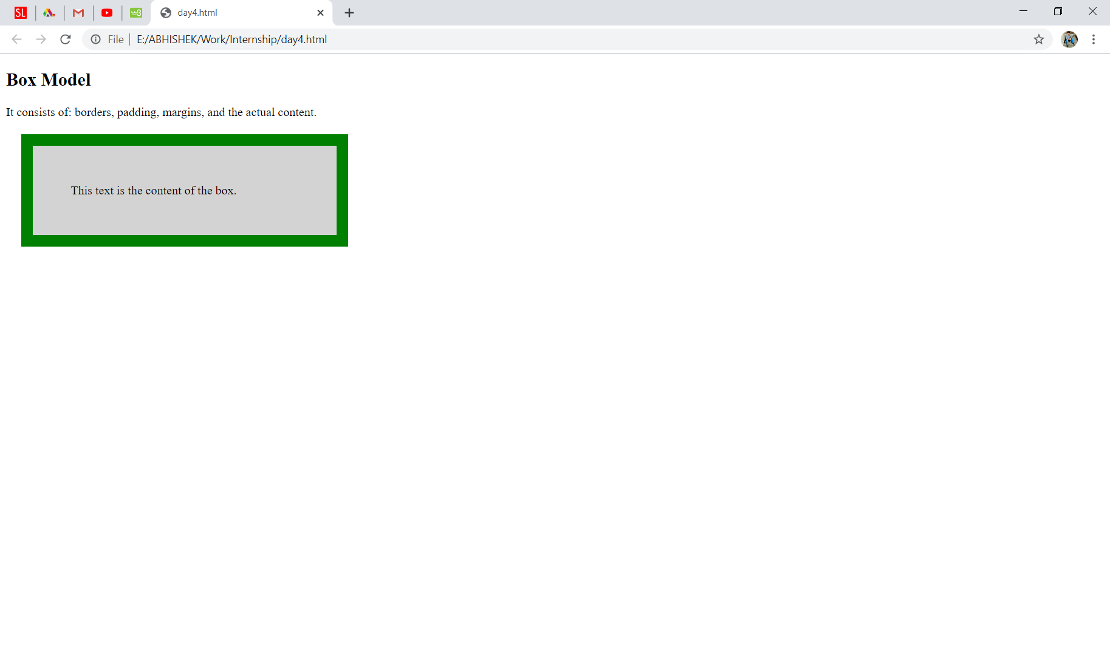

**Q3.**

**Ans.**

CSS can either be attached as a separate document or embedded in the HTML document itself. There are three methods of including CSS in an HTML document:

**Inline styles** — Using the style attribute in the HTML start tag.

<h1 style="color:red; font-size:30px;">This is a heading</h1>

<p style="color:green; font-size:22px;">This is a paragraph.</p>

**Embedded styles** — Using the [<style>](https://www.tutorialrepublic.com/html-reference/html-style-tag.php) element in the head section of a document.

<!DOCTYPE html>

<html>

<head>

<title>My HTML Document</title>

<style> body { background-color: YellowGreen; }

p { color: #fff; }

</style>

</head>

<body> <h1>This is a heading</h1> <p>This is a paragraph of text.</p> </body>

</html>

**External style sheets**— Using the [<link>](https://www.tutorialrepublic.com/html-reference/html-link-tag.php) element, pointing to an external CSS file.

body { background: lightyellow;

font: 18px Arial, sans-serif; }

h1 { color: orange; }

<!DOCTYPE html>

<html>

<head>

<title>My HTML Document</title>

<link rel="stylesheet" href="css/style.css">

</head>

<body>

<h1>This is a heading</h1>

<p>This is a paragraph of text.</p>

</body>

</html>

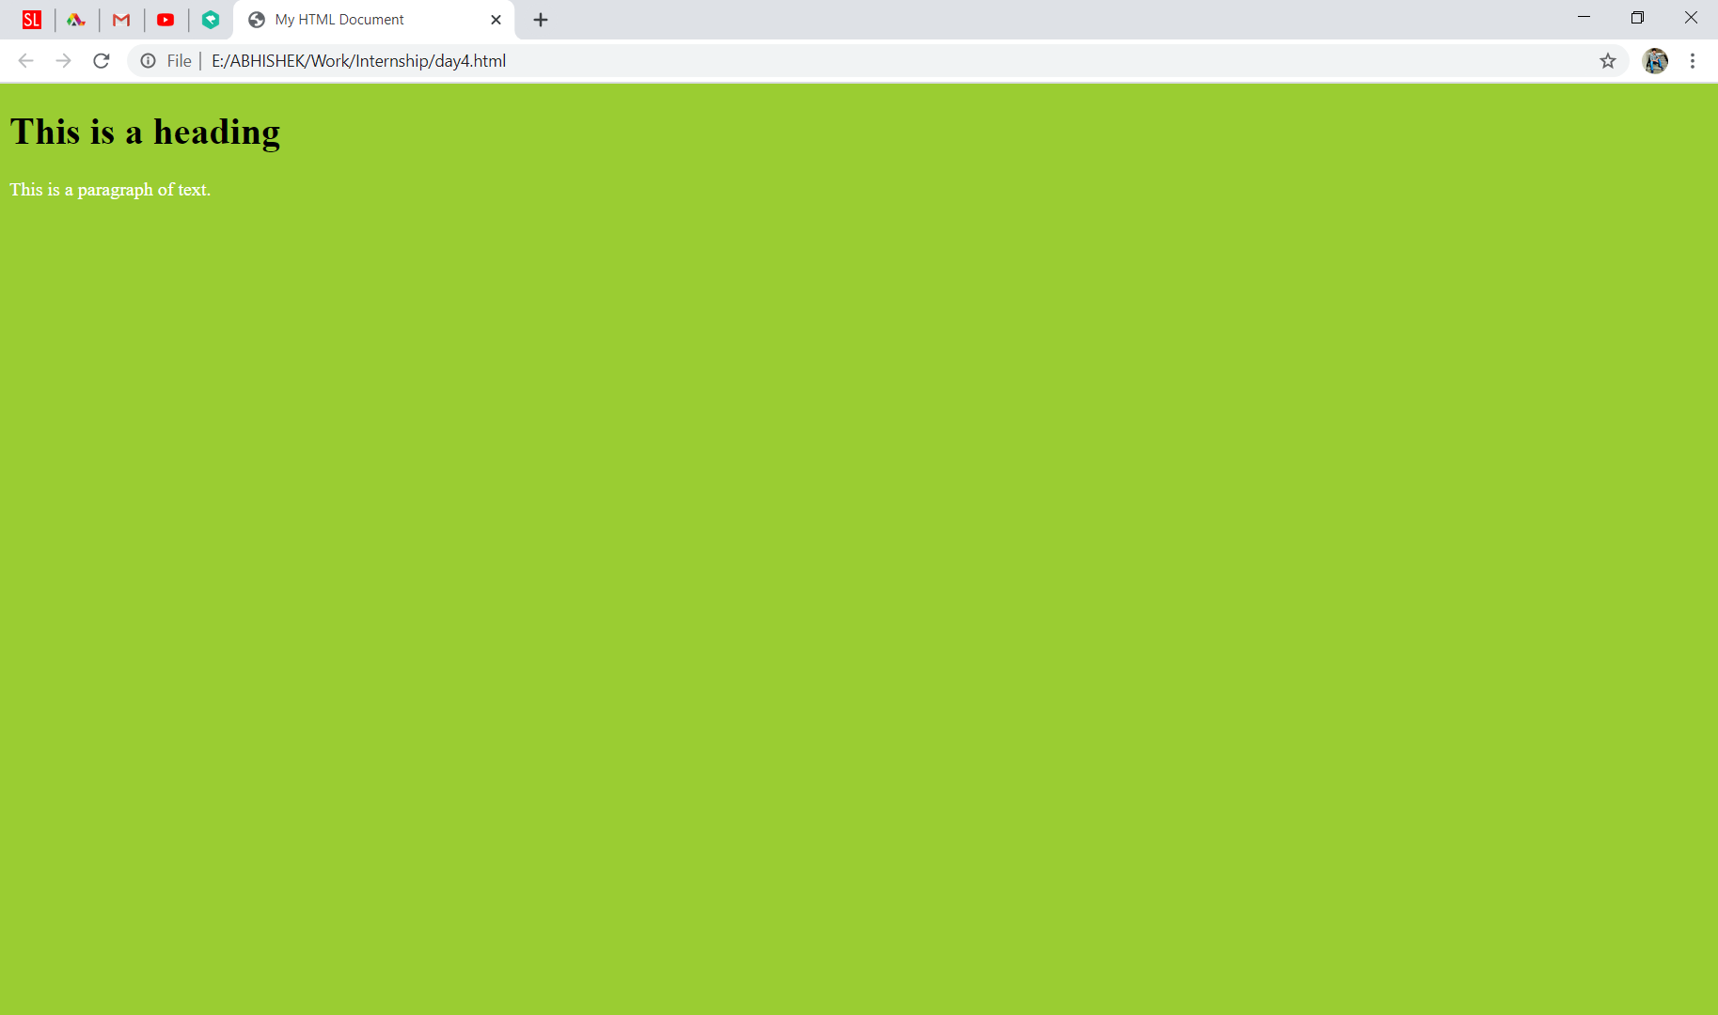

**Q4.**

**Ans.**

**Html**

It didn’t support audio and video without the use of flash player support.

It uses cookies to store temporary data.

Does not allow JavaScript to run in browser.

Vector graphics is possible in HTML with the help of various technologies such as VML, Silver-light, Flash, etc.

It does not allow drag and drop effects.

Not possible to draw shapes like circle, rectangle, triangle etc.

It works with all old browsers.

**Html5**

It supports audio and video controls with the use of <audio> and <video> tags.

It uses SQL databases and application cache to store offline data.

Allows JavaScript to run in background. This is possible due to JS Web worker API in HTML5.

Vector graphics is additionally an integral a part of HTML5 like SVG and canvas.

It allows drag and drop effects.

HTML5 allows to draw shapes like circle, rectangle, triangle etc.

It supported by all new browser like Firefox, Mozilla, Chrome, Safari, etc.

**Q5.**

**Ans.**

<header> - Defines a header for a document or a section

<nav> - Defines a container for navigation links

<section> - Defines a section in a document

<article> - Defines an independent self-contained article

<aside> - Defines content aside from the content (like a sidebar)

<footer> - Defines a footer for a document or a section

<details> - Defines additional details

<summary> - Defines a heading for the <details> element

<!DOCTYPE html>

<html>

<head>

<title>Layout Element</title>

<style>

* {

box-sizing: border-box;

}

header {

background-color: #666;

padding: 30px;

text-align: center;

font-size: 35px;

color: white;

}

nav {

float: left;

width: 30%;

height: 300px; /* only for demonstration, should be removed */

background: #ccc;

padding: 20px;

}

article {

float: left;

padding: 20px;

width: 70%;

background-color: #f1f1f1;

height: 300px; /* only for demonstration, should be removed */

}

section:after {

content: "";

display: table;

clear: both;

}

footer {

background-color: #777;

padding: 10px;

text-align: center;

color: white;

}

@media (max-width: 600px) {

nav, article {

width: 100%;

height: auto;

}

}

</style>

</head>

<body>

<h2>CSS Layout</h2>

<p>Created a header, two columns/boxes and a footer.</p>

<header>

<h2>Hello</h2>

</header>

<section>

<nav>

<ul>

<li><a href="#">1</a></li>

<li><a href="#">2</a></li>

<li><a href="#">3</a></li>

</ul>

</nav>

<article>

<h1>Hey</h1>

<p>This is an article.</p>

</article>

</section>

<footer>

<p>Footer</p>

</footer>

</body>

</html>

