**Web Development Internship**

**Day 5 Assignment**

**SE-IT-B-06**

**Abhishek Pandita**

**Q1.**

**Ans.**

<!DOCTYPE html>

<html>

<head>

<style>

h1{

color:lightgreen;

}

body{

background-color:linen;

}

</style>

</head>

<body>

<h1>The border-radius Property</h1>

</body>

</html>

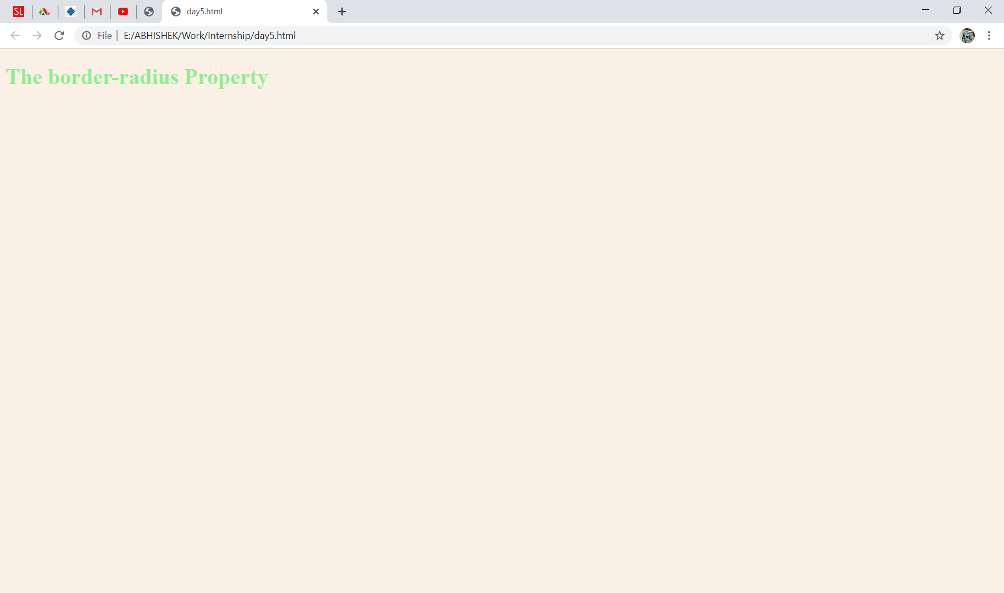

**Q2.**

**Ans.**

<!DOCTYPE html>

<html>

<head>

<style>

p{

border-style:dotted;

border-size:4px;

}

div{

border-radius: 25px;

background: #73AD21;

}

</style></head>

<body>

<h1>The border</h1>

<p>Rounded corners for an element with a specified background color:</p>

<div>

Rounded corners!

</div>

</body>

</html>

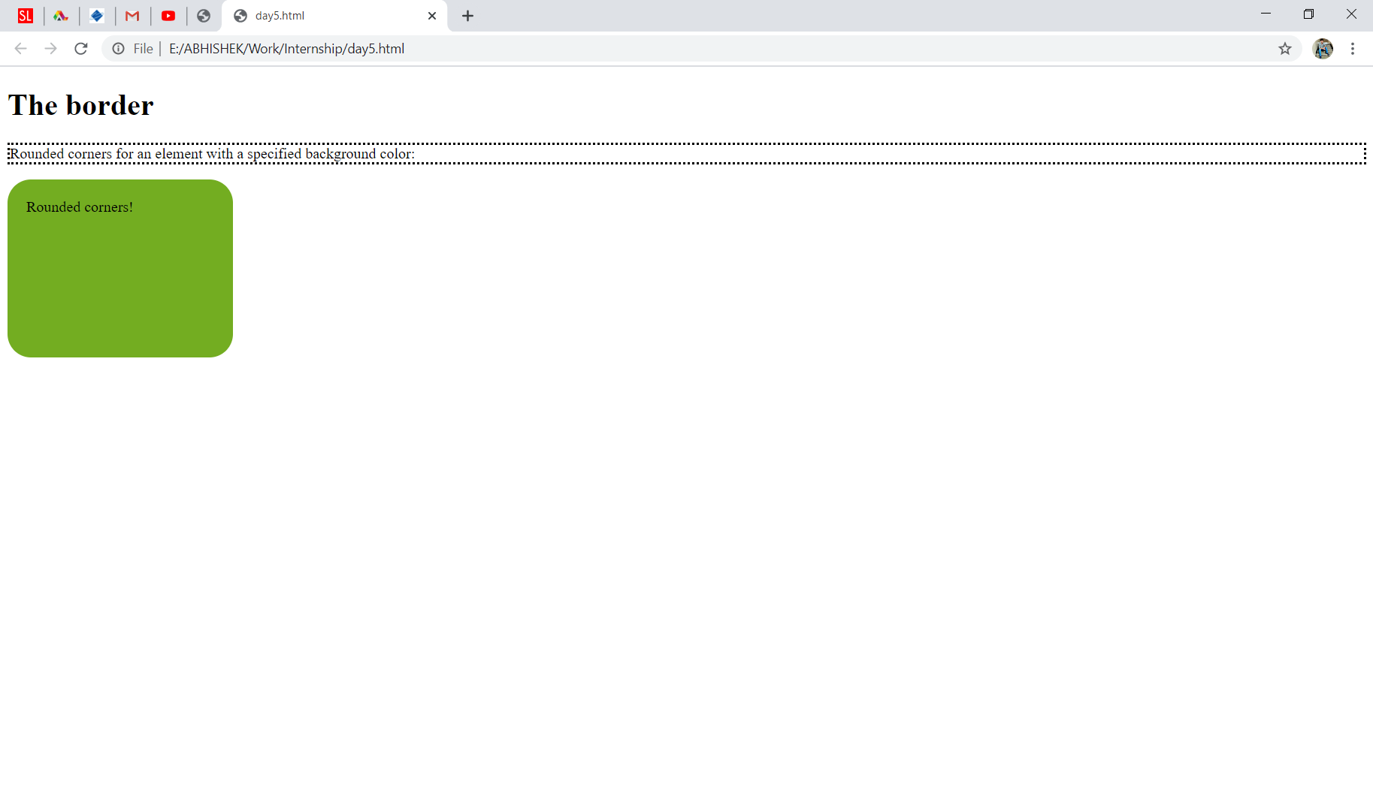

**Q3.**

**Ans**.

<!DOCTYPE html>

<html>

<head>

<style>

div {

width: 300px;

height: 100px;

background-color: red;

border: solid black;

}

div#myDiv {

transform: rotate(45deg);

}

</style></head>

<body>

<h1>The rotate() Method</h1>

<p>The rotate() method rotates an element clockwise or counter-clockwise.</p>

<div>

This a normal div element.

</div>

<div id="myDiv">

This div element is rotated 45 degrees.

</div>

</body>

</html>

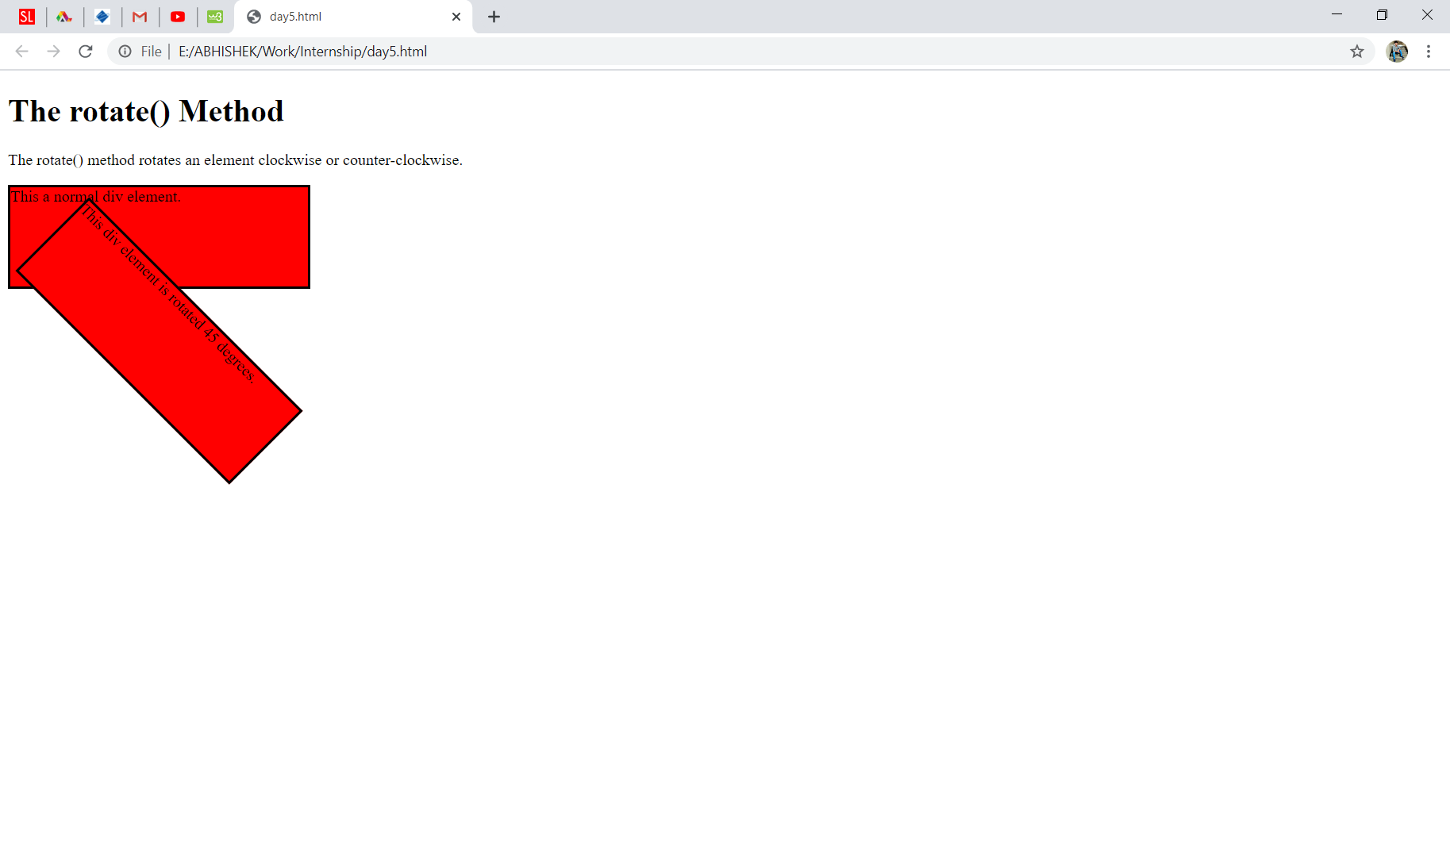

**Q4.**

**Ans**.

<!DOCTYPE html>

<html>

<head>

<style>

div {

width: 100px;

height: 100px;

background: red;

transition: width 2s;

transition: width 2s, height 4s;

transition-delay: 1s;

}

div:hover {

width: 300px;

}

</style>

</head>

<body>

<h1>The transition Property</h1>

<p>Hover over the div element below, to see the transition effect:</p>

<div><p>

Transition

</p>

</div>

</body>

</html>

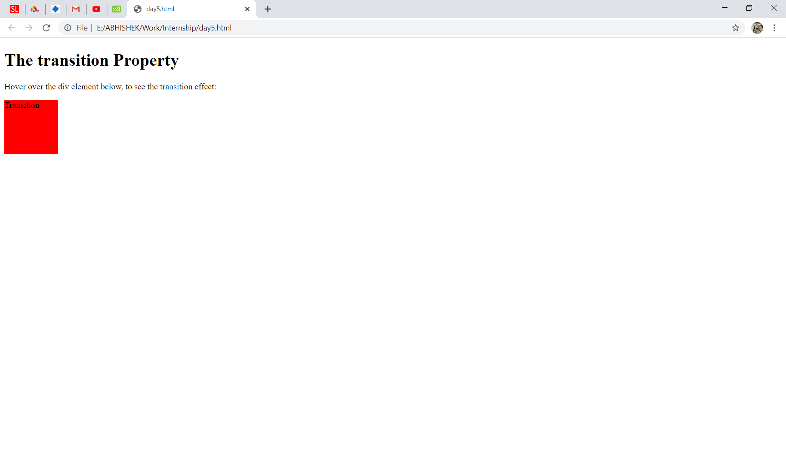

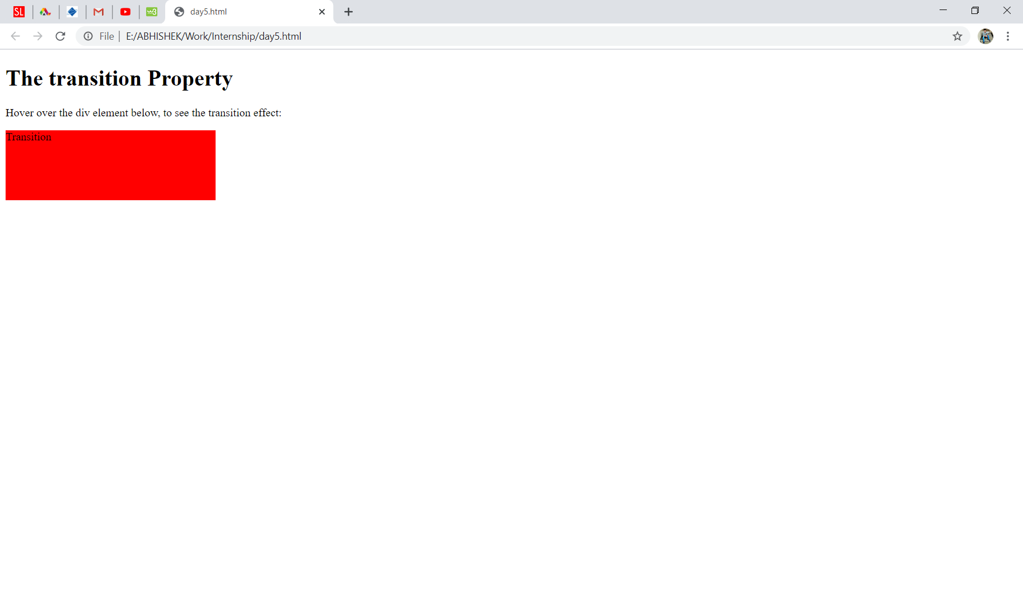

**Q5.**

**Ans.**

<!DOCTYPE html>

<html><head><style>

div {

width: 100px;

height: 100px;

background-color: red;

position: relative;

animation-name: example;

animation-duration: 4s;

animation-iteration-count: 3;

}

@keyframes example {

0% {background-color:red; left:0px; top:0px;}

25% {background-color:blue; left:0px; top:200px;}

50% {background-color:green; left:200px; top:200px;}

75% {background-color:yellow; left:200px; top:0px;}

100% {background-color:red; left:0px; top:0px;}

}

</style>

</head>

<body>

<div></div>

</body>

</html>

