Online Summer Internship

Web Development

Name-Abhishek Pandita

Roll No-06

SEIT-B

Date-28/05/20

1) Create a user defined function in PHP to check whether entered

no. is armstrong or not.

<!Doctype html>

<html>

<body>

<form method="post">

Enter the Number:

<input type="number" name="number">

<input type="submit" value="Submit">

</form>

</body>

</html>

<?php

if($_POST)

{

//get the number entered

$number = $_POST['number'];

//store entered number in a variable

$num1 = $number;

$sum = 0;

//run loop till the quotient is 0

while( $num1 != 0 )

{

$rem = $num1 % 10; //find reminder

$sum = $sum + ( $rem * $rem * $rem ); //cube the reminder and add it to the sum variable till the loop ends

$num1s = $num1 / 10; //find quotient. if 0 then loop again

}

//if the entered number and $sum value matches then it is an armstrong number

if( $number == $sum )

{

echo "Yes $number an Armstrong Number";

}else

{

echo "$number is not an Armstrong Number";

}

}

?>

Output:

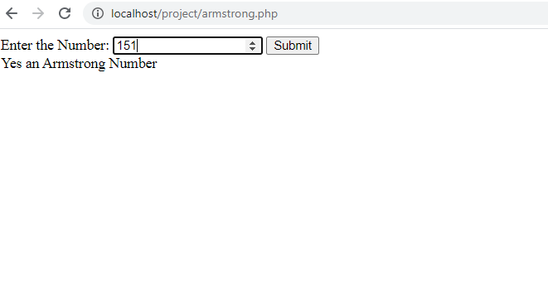

2) Create a user defined function in PHP to display fibonacci series.

<html>

<body>

<form method="post">

<input type="text" name="Number" >

<button name="submit">Submit</button>

</form>

</body>

</html>

<?php

if (isset($_POST['submit'])) {

$n=$_POST['Number'];

$number1 = 0;

$number2 = 1;

echo "Fibonacci Series \n";

echo $number1.' '.$number2.' ';

for($i = 2; $i < $n; $i++){

$number3= $number1 + $number2;

echo $number3.' ';

$number1 = $number2;

$number2 = $number3;

}

}

?>

Output:

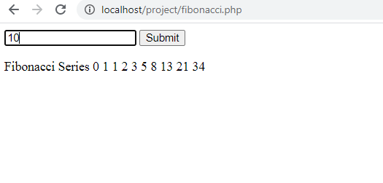

Q3.

<!DOCTYPE html>

<html lang="en">

<head>

<meta charset="UTF-8">

<meta name="viewport" content="width=device-width, initial-scale=1.0">

<title>doctor login</title>

<link rel="stylesheet" href="first.css">

</head>

<body>

<div class="navbar">

<img src="heart.png" id="heart">

<div class="nav">

<ul>

<li>

<a href="first.html">Home</a>

<a href="services.html">Services</a>

<a href="doctors.html">Doctors</a>

<a href="contact.html">Contact Us</a>

</li>

</ul>

</div>

</div>

<div class="text4">

<form action="log2.php" method="post">

<h1>Doctors &nbsp Login &nbsp here</h1>

<input type="text" placeholder="Enter your Email Id" name="email"><br>

<input type="text" placeholder="Enter your password" name="pass"><br>

<button type="submit" id="submit" name="submit">Submit</button>

</form>

</div>

</body>

</html>

log2.php

<?php

include("connection.php");

error_reporting(0);

session_start();

$username = $_POST['email'];

$password = $_POST['pass'];

$sql = "SELECT * FROM docreg WHERE email LIKE '{$username}' AND pass LIKE '{$password}' LIMIT 1";

$result = $mysqli->query($sql);

if($result->num_rows == 1) {

$_SESSION['login_user'] = $username;

header("Location:http://localhost/hospital/appointment.html");

}

else {

echo "Wrong email or password";

header("Location:http://localhost/hospital/doclog.html");

}

?>

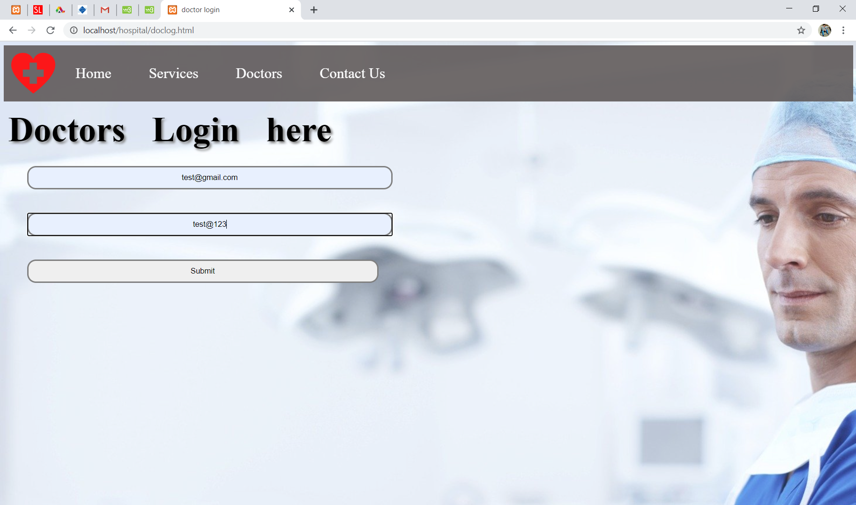

Q4.

Ans.

<?php

include("connection.php");

error_reporting(0);

session_start();

$username = $_POST['email'];

$password = $_POST['pass'];

$sql = "SELECT * FROM docreg WHERE email LIKE '{$username}' AND pass LIKE '{$password}' LIMIT 1";

$result = $mysqli->query($sql);

if($result->num_rows == 1) {

$_SESSION['login_user'] = $username;

header("Location:http://localhost/hospital/appointment.html");

}

else {

echo "Wrong email or password";

header("Location:http://localhost/hospital/doclog.html");

}

?>

logout.php

<?php

session_start();

if(session_destroy()){

header("location:http://localhost/hospital/first.html");

}

?>