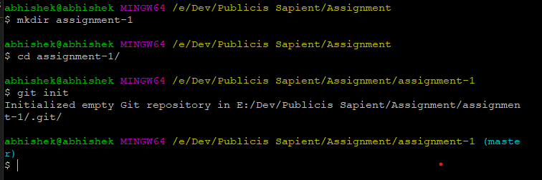Assignment 1

1. 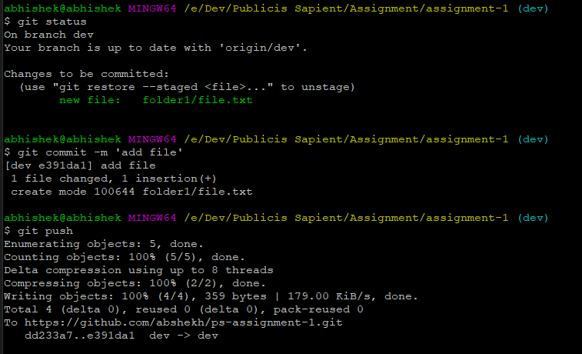Sdfnsdk
   1. 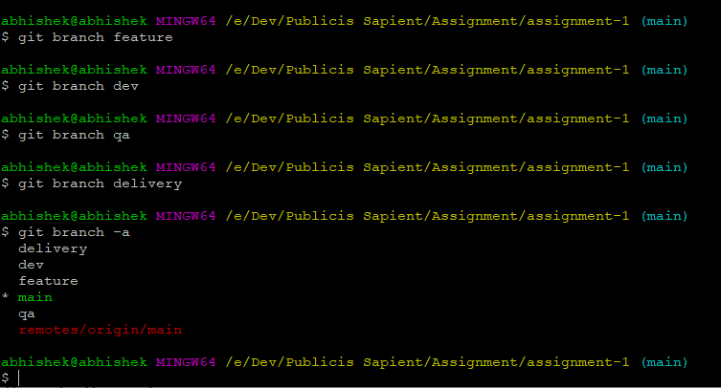Dsnfjknsd
      1. Setup local repo
      2. Setup a remote repository
      3. Local branches
      4. Remote branches
      5. 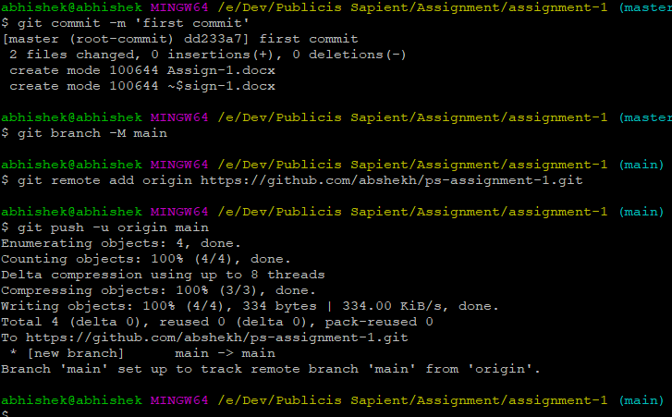add files, make changes, add folders, remove folders, remove files:
      6. 