University of Roehampton London
MSc Data Science

Mathematics and Statistics for Data Science (CMP-L045-0)
Part 1: Applied Problem-Solving Activity
Global Income, Health and Development: A Mathematical Analysis of World Development Indicators, 2015–2025

Student name: ____________________
Student ID: ____________________
Module leader: Michael Ng
Submission date: 6 November 2026
Word count: 2,299 (Task 1: 401; Task 2: 1,724; Task 3: 174) (excluding cover, contents, screenshots, captions, references and the AI declaration)

Code (GitHub): https://github.com/abshivks-ass/CMP-L045-0-WDI-analysis
Dataset: https://databank.worldbank.org/source/world-development-indicators
Notebook: StudentName.ipynb (renamed to your name before submission)
Table of Contents
Task 1 – Dataset Selection and Justification 3
Task 2 – Mathematical Application 5
2.1 Linear Algebra – Vectors 5
2.2 Linear Algebra – Matrices 6
2.3 Descriptive Statistics and EDA 8
2.4 Random Variables and Probability 11
2.5 Interval Estimates 13
Task 3 – Critical Reflection 15
References 16
Declaration of Generative AI Use 17

Task 1 – Dataset Selection and Justification
Provenance. The data come from the World Bank’s World Development Indicators (WDI) DataBank [1], an official open-data portal that brings together figures from national statistical offices, the UN Population Division, the WHO and the OECD. I downloaded the extract on 2 November 2026; the database was last updated on 8 October 2026, and the data are published under a CC BY-4.0 licence. This is not a pre-cleaned teaching file. It arrives in wide format (one column per year), marks missing values with “..”, adds footer text, and mixes 218 economies with 48 regional and income aggregates such as “World” and “High income”, which would double-count countries if they were kept.
Variables. The extract contains six annual series for 2015–2025: GDP per capita (current US$), life expectancy at birth (years), current health expenditure (% of GDP), urban population (% of total), internet users (% of population) and fertility rate (births per woman). I reshaped it with pandas [2] into a panel of 218 economies × 11 years = 2,398 rows, with six numeric variables plus country, code and year (Table 1). All figures were drawn with Matplotlib [3].
Why 2024 is the analysis year. Using the latest data matters, but the newest year is not complete. Life expectancy and fertility stop at 2024, and health expenditure is published only to 2023 for most countries (Table 1). I therefore use 2024, the most recent year in which every indicator except health spending is available, and take each country’s latest health-expenditure value (2023 for 171 countries, 2024 for 22 and 2021 for one).
Why it is meaningful. One of the big questions in development policy is how far health and opportunity in poor countries lag behind rich ones. Income and longevity are strongly but not perfectly linked, as the classic Preston curve shows [4]. The panel lets me test how well the module’s tools capture this inequality, the digital divide, and the COVID-19 shock of 2020–2021, which the WHO estimates wiped out almost a decade of progress in global life expectancy [5], together with the recovery that followed.
Self-defined criteria. I split countries at the 2024 median GDP per capita (US$7,754) into a Higher-income group (101 countries) and a Lower-income group (100 countries); 17 economies have no 2024 GDP figure. I also define two yes/no attributes: internet use by at least 75% of the population, and health spending of at least 6% of GDP.
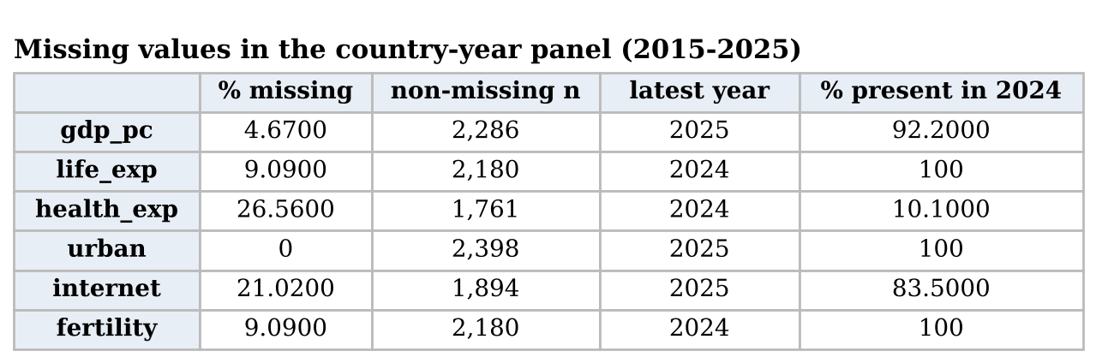
Table 1. Missing values and latest available year in the 2,398-row panel

Task 2 – Mathematical Application

2.1 Linear Algebra – Vectors
Each variable is a vector in ℝ^{n}, with one component per country. Let a and b be life expectancy in 2019 (the last year before COVID-19) and in 2024 (the latest year), for n = 218 countries. The operations follow the definitions in [6] and are computed with NumPy [7] (Table 2):
- Dot product a·b = Σa_{i}b_{i} = 1,188,922. The norms are ‖a‖ = √(a·a) = 1,084.0 and ‖b‖ = 1,097.2.
- Cosine similarity cos θ = a·b / (‖a‖‖b‖) = 0.99963, an angle of only 1.56°.
- The projection coefficient c = (a·b)/(a·a) = 1.012 is the multiple of a that comes closest to b: on average, 2024 values are about 1.2% above 2019 values.
- The difference vector d = b − a has mean 0.99 years, ‖d‖ = 32.55 and root-mean-square change ‖d‖/√n = 2.20 years.
The raw cosine is close to 1 for almost any two positive variables, because both vectors lie in the positive orthant, so it mostly measures their common level rather than their association. Centring each vector (subtracting x̄1) turns the cosine into Pearson’s correlation, which is 0.972: the ranking of countries hardly changed over the pandemic. The difference vector tells a richer story. 197 of 218 countries (90.4%) are now above their 2019 level, but the RMS change (2.20 years) is more than twice the mean change (0.99 years), so individual changes are widely spread, from −6.6 years in the West Bank and Gaza to +26.1 years in the Central African Republic, whose 2019 value of 31.5 years reflected a crisis. For ln GDP per capita and life expectancy in 2024, the centred cosine is 0.862.
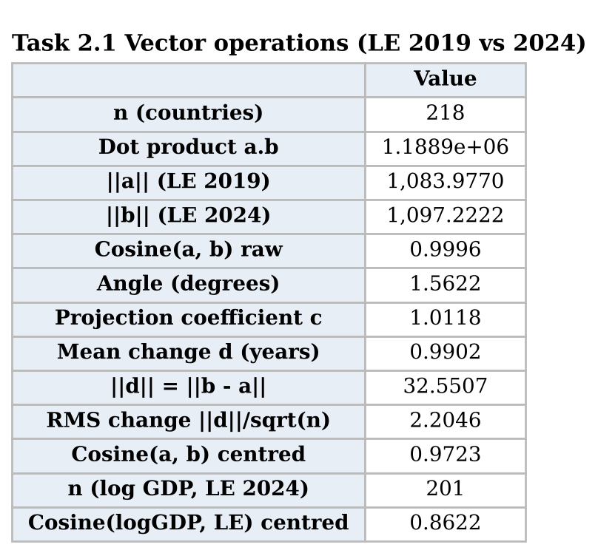
Table 2. Vector operations (notebook output)

2.2 Linear Algebra – Matrices
Data matrix. X is a 178 × 6 matrix (2024 complete cases) whose columns are ln GDP per capita, life expectancy, health expenditure, urban %, internet % and fertility.
Pre-processing with matrix operations. Columns are centred with H = I − (1/n)11^{T}, which is symmetric and idempotent (H² = H), and scaled by D⁻¹ with D = diag(s₁, …, s₆), giving Z = HXD⁻¹ [6]. Min–max scaling is the affine map (X − 1min^{T})diag(1/range). The code confirms that Z has zero column means and unit standard deviations.
Gram matrix X^{T}X. The 6 × 6 Gram matrix holds sums of squares on its diagonal and cross-products off it (Table 3). On raw data it is driven by units: the life-expectancy entry (973,136) mostly reflects the level of about 74 years, not how much countries differ. After standardising, Z^{T}Z/(n − 1) = R, the correlation matrix (Figure 1). Life expectancy correlates 0.86 with ln GDP and −0.83 with fertility, and internet use correlates 0.85 with ln GDP and −0.85 with fertility. Health expenditure is only weakly related to the others (|r| ≤ 0.29), because both rich and poor countries spend very different shares of GDP on health.
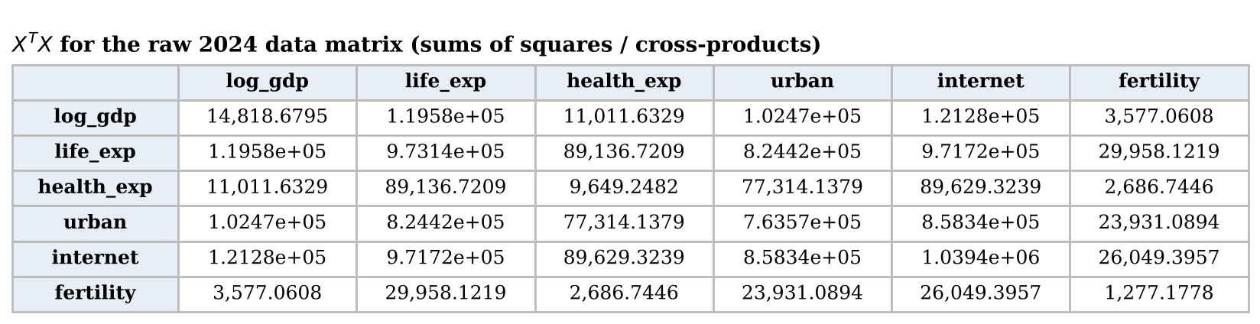
Table 3. X^{T}X for the raw 2024 data matrix
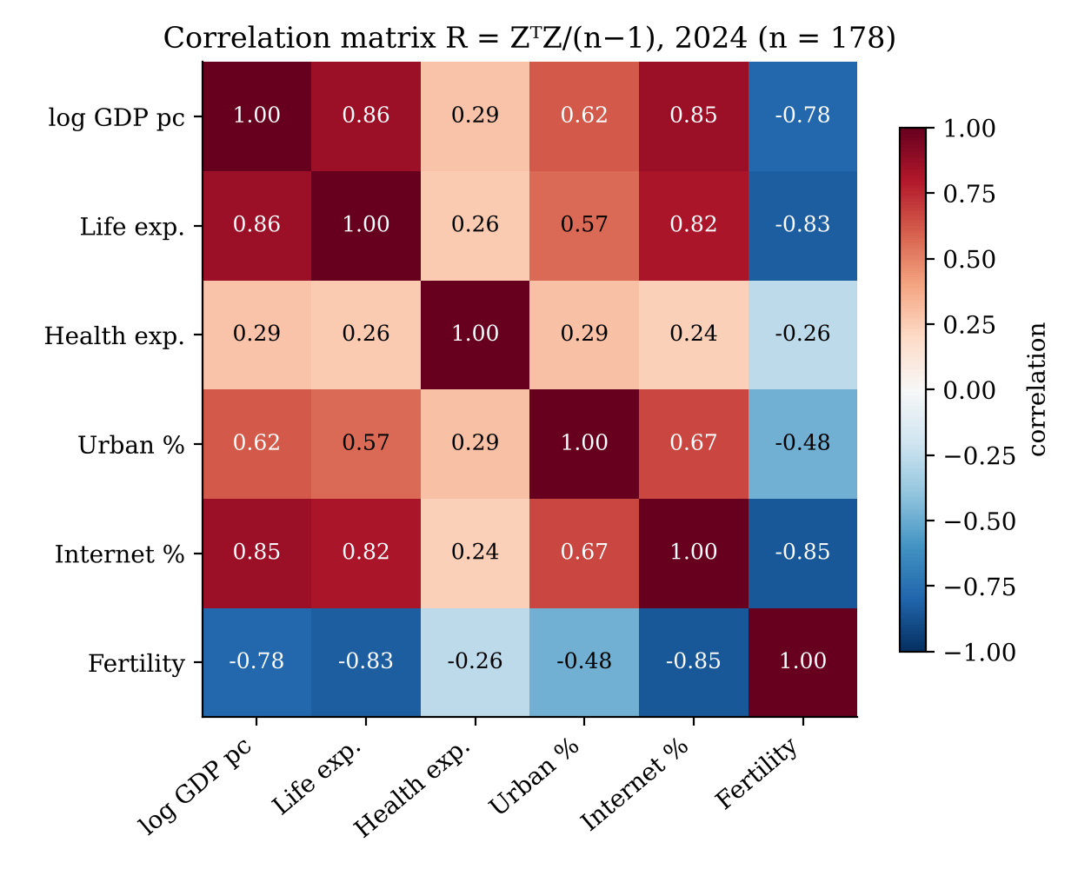
Figure 1. Correlation matrix R = Z^{T}Z/(n − 1)
Determinant. det(X^{T}X) = 4.3 × 10²² changes whenever the units change, so I interpret it through R instead: det R = Πλ_{k} = 0.0066 (Table 4). det R lies between 0 and 1 and equals 1 only when the columns are uncorrelated, so a value below 1% means the six columns occupy a thin slice of ℝ⁶: their generalised variance is less than 1% of that of six independent variables. The eigenvalues show why. λ₁ = 4.07 carries 67.8% of the total variance, a single “development” dimension in the language of principal component analysis [8], while λ₆ = 0.095 is close to zero and the condition number is 42.7. For one pair of variables the 2 × 2 determinant equals 1 − r²; for ln GDP and internet it is 0.273, so only 27% of their variation is not shared.
In practice. Least-squares regression solves the normal equations β̂ = (A^{T}A)⁻¹A^{T}y. Predicting standardised life expectancy from the other five variables gives R² = 0.80. Yet internet use, which on its own correlates 0.82 with life expectancy, receives a coefficient of only 0.03, because ln GDP (β = 0.49) and fertility (β = −0.39) already carry the same information; its variance inflation factor, read from the diagonal of R⁻¹, is 6.4. A small determinant therefore leads to unstable, hard-to-interpret coefficients [9], which is an argument for using principal components or dropping overlapping variables.
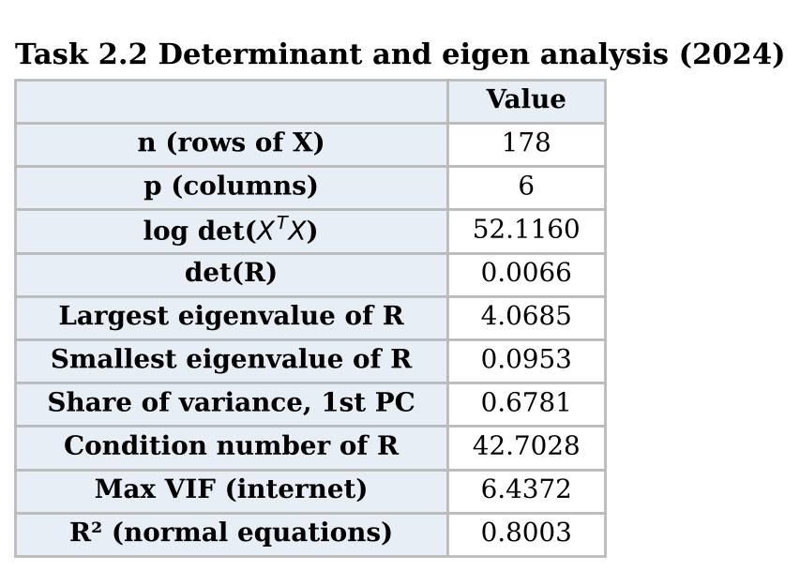
Table 4. Determinant, eigenvalue and regression results

2.3 Descriptive Statistics and EDA
Summary statistics use the moment formulas s² = Σ(x_{i} − x̄)²/(n − 1), g₁ = m₃/m₂^{3/2} and g₂ = m₄/m₂² − 3 (excess kurtosis) [10], implemented by hand and checked against SciPy [11] (Table 5).
Life expectancy (2024): mean 73.97 years, below the median of 74.70; s = 7.12; g₁ = −0.41; g₂ = −0.61. The distribution is mildly left-skewed, with a longer tail towards low values (Nigeria, at 54.6 years, is the lowest), and flatter than a normal curve (Figure 2). The 2022 column of Table 5 shows why the choice of year matters: in 2022 the Central African Republic was recorded at 18.8 years, which on its own pushed skewness to −1.71 and kurtosis to 8.58. Because the third and fourth moments raise deviations to high powers, one extreme value can dominate them.
GDP per capita: the mean (US$22,262) is almost three times the median (US$7,754), and g₁ = 3.81 and g₂ = 20.48 show strong right skew and very heavy tails, with Monaco at US$288,000. This is typical of income, which grows multiplicatively. Taking logs gives g₁ = −0.05 and g₂ = −0.75 (Figure 3), which is close to symmetric, so ln GDP is used in the rest of the analysis.
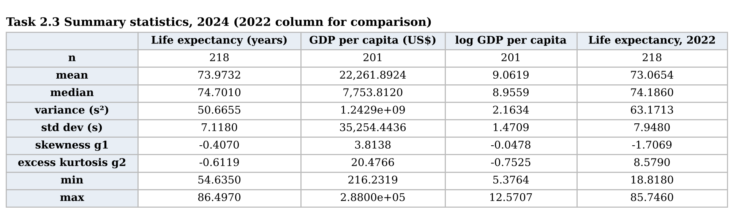
Table 5. Summary statistics, 2024 (with 2022 life expectancy for comparison)
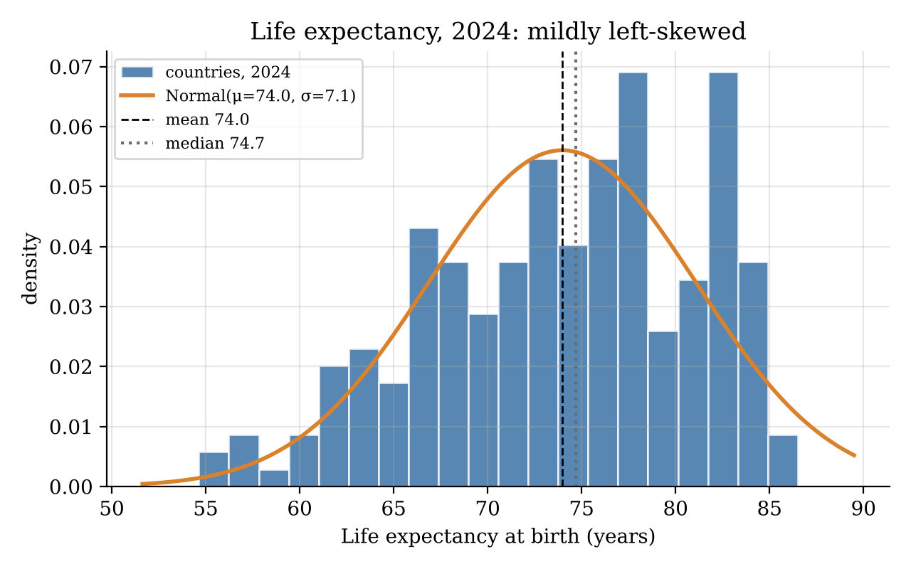
Figure 2. Histogram of life expectancy with fitted normal density, 2024
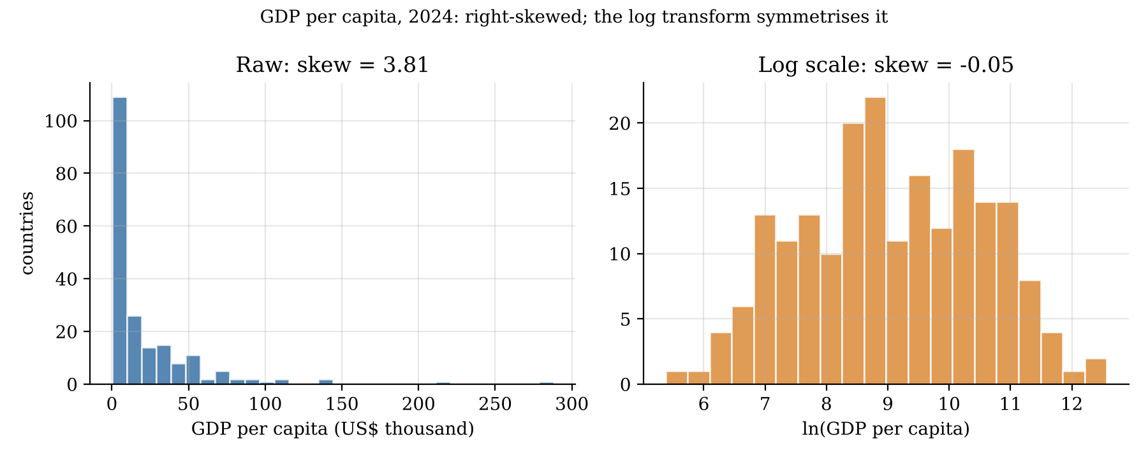
Figure 3. GDP per capita on raw and log scales, 2024
Figure 4 shows an almost linear relationship between life expectancy and ln GDP: LE = 35.9 + 4.18 ln(GDP), with r = 0.86. Doubling income goes with about 4.18 × ln 2 ≈ 2.9 extra years, so in dollar terms the relationship is concave, with diminishing returns, as Preston described [4]. Figure 5 compares the self-defined groups: the higher-income median is 79.0 years (IQR 6.1) against 68.3 years (IQR 7.7) for the lower-income group. The boxes do not overlap, and the lower-income group is more spread out. The 1.5 × IQR rule flags one outlier, Nauru (62.3 years), in the higher-income group.
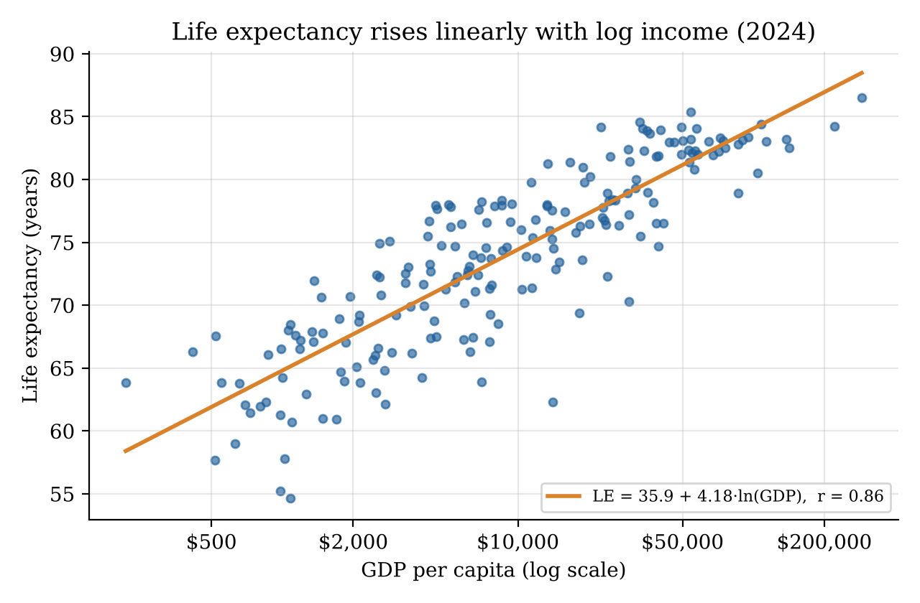
Figure 4. Life expectancy against log GDP per capita, 2024
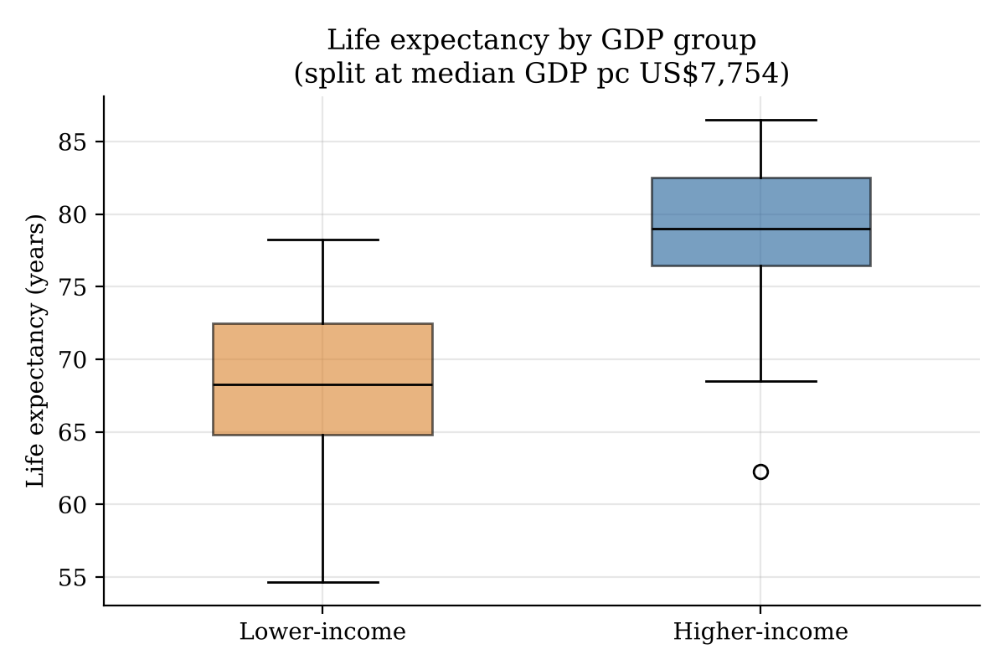
Figure 5. Life expectancy by self-defined income group, 2024
Figure 6 uses the full panel. Mean life expectancy rose from 72.07 years in 2015 to 72.98 in 2019, fell to 71.75 in 2021 during COVID-19, and recovered to 73.97 in 2024, about one year above its pre-pandemic level. This dip and recovery matter for the probability model below.
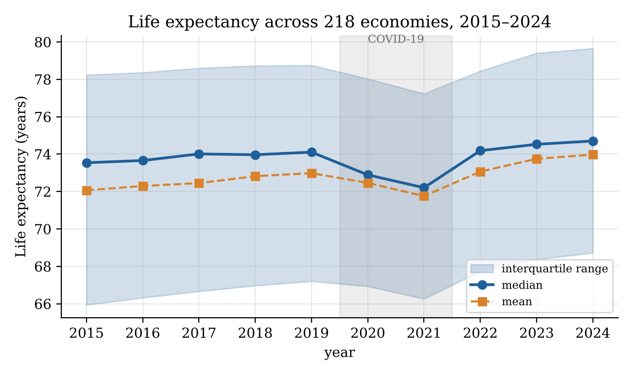
Figure 6. Life expectancy across 218 economies, 2015–2024

2.4 Random Variables and Probability
Discrete variable. K is the number of the nine year-on-year changes (2015–16 to 2023–24) in which a country’s life expectancy rose, so K ∈ {0, …, 9}. Each change is a Bernoulli trial, and pooling 218 × 9 trials gives p̂ = 0.747. If the trials were independent with a constant p, then K ~ Bin(9, p), with P(K = k) = C(9, k)p^{k}(1 − p)^{9−k}, E[K] = 9p and Var K = 9p(1 − p) [12].
The empirical PMF peaks at k = 7 (0.339) and k = 8 (0.239) (Table 6, Figure 7). The model matches E[K] = 6.72 by construction and the variance closely (1.741 observed against 1.700). It also gets P(K ≤ 5) almost exactly (0.170 against 0.171), but it predicts too few countries at the mode (0.299 against 0.339) and too many improving every year (P(K = 9) = p̂⁹ = 0.073 against 0.055). A χ² goodness-of-fit test, pooling cells so that every expected count is at least 5, gives χ² = 5.79 (df = 4, p = 0.22), so the binomial model is not rejected. However, the trials are clearly not identically distributed: between 81% and 95% of countries improved in normal years, but only 30% did in 2020 and 28% in 2021. The model fits the overall distribution even though its assumptions are false.
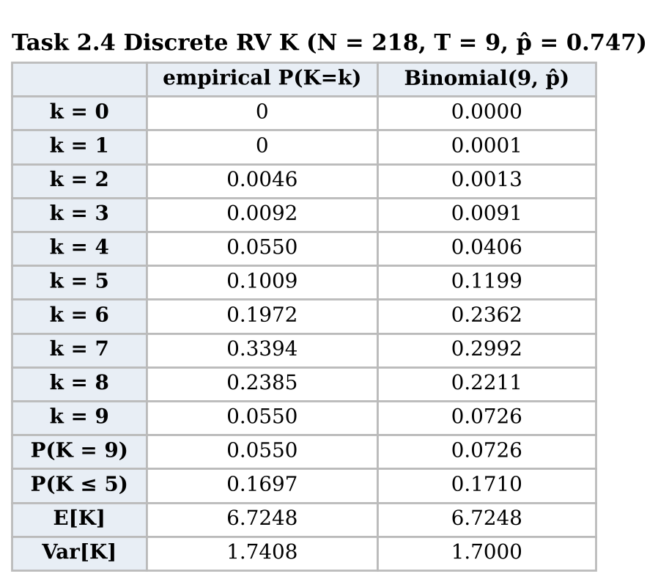
Table 6. Empirical and binomial probabilities for K
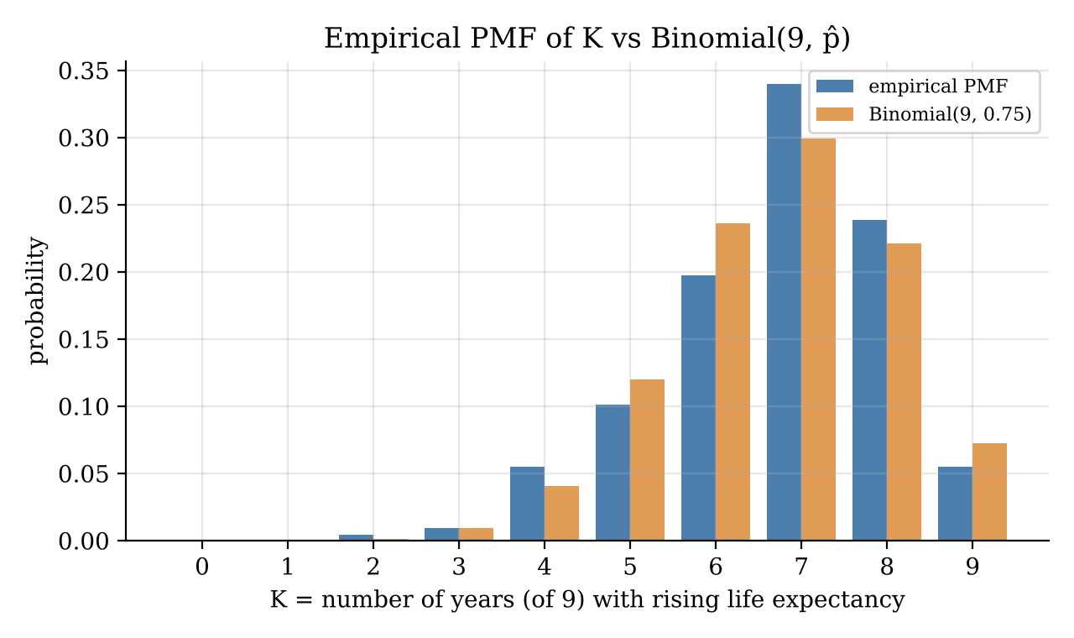
Figure 7. Empirical PMF of K against Binomial(9, 0.747)
Continuous variable. Life expectancy L is modelled as N(μ, σ²) with μ̂ = 73.97 and σ̂ = 7.12. For example, P(L > 80) = 1 − Φ((80 − 73.97)/7.12) = 1 − Φ(0.847) = 0.199, against 0.239 observed (Table 7). The normal model puts too much probability near the centre (P(65 < L < 75) = 0.454 against 0.385; within one σ, 0.683 against 0.615) and too little at the top, because the real distribution is flatter than normal (g₂ = −0.61). The Shapiro–Wilk test [13] rejects normality (p < 0.001), and the Q-Q plot bends at the upper end (Figure 8). GDP per capita is modelled as log-normal, ln G ~ N(9.06, 1.47²). This gives P(G > $20,000) = 0.284 against 0.328 observed, and P(G < $1,500) = 0.117 against 0.154. Normality of ln G is not rejected at the 5% level (p = 0.064, Q-Q r = 0.995), so the log-normal is the better-fitting model of the two.
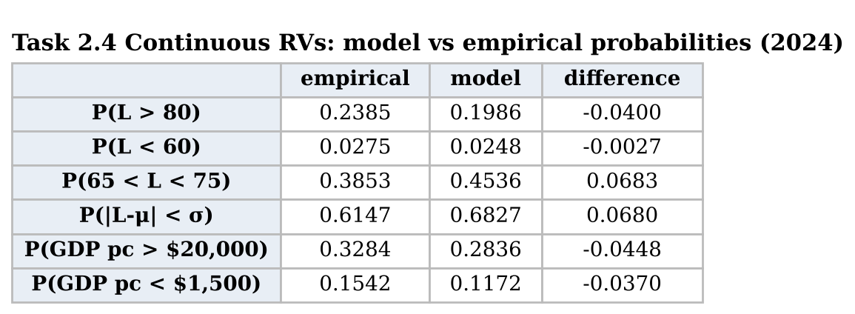
Table 7. Normal and log-normal model probabilities against observed frequencies
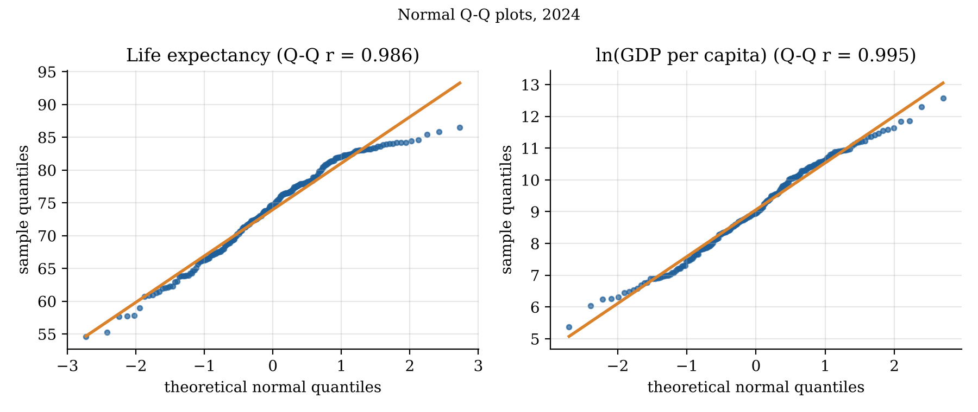
Figure 8. Normal Q-Q plots for life expectancy and ln GDP per capita, 2024

2.5 Interval Estimates
All intervals use 2024 data and a 95% confidence level (Table 8, Figure 9).
- One-sample mean (life expectancy): x̄ ± t_{0.975, 217}·s/√n = 73.97 ± 1.971 × 0.482 = [73.02, 74.92] years. A t interval is used because σ is unknown; with n = 218 the central limit theorem makes it reasonable even though the data are not exactly normal.
- One-sample proportion (internet use ≥ 75%): p̂ = 109/182 = 0.599, SE = √(p̂(1 − p̂)/n) = 0.036, CI = [0.528, 0.670]. The normal approximation is reasonable because np̂ = 109 and n(1 − p̂) = 73 both exceed 10. The Wilson interval [14], which performs better than the simple Wald interval in small samples [15], gives almost the same result: [0.526, 0.667].
- Two-sample mean difference (life expectancy, higher − lower income): 78.98 − 68.59 = 10.39 years, SE = √(s₁²/n₁ + s₂²/n₂) = 0.690, Welch–Satterthwaite ν = 189.8, t = 1.973, CI = [9.03, 11.75] years. Welch’s version [16] is used because the group variances differ (Figure 5); SciPy returns the same interval.
- Two-sample proportion difference (health spending ≥ 6% of GDP): 59/89 = 0.663 against 41/99 = 0.414, difference 0.249, SE = 0.070, CI = [0.111, 0.387].
Neither difference interval contains 0, so at the 5% level higher-income countries live between 9.0 and 11.8 years longer and are more likely to spend at least 6% of GDP on health. The mean interval is narrow (±0.95 years) because n is large, whereas the proportion intervals are wide (±7 to ±14 percentage points) because yes/no data carry less information per observation. “95%” describes the method: across repeated samples, 95% of intervals built this way would contain the true value; it is not a 95% probability for this particular interval [12].
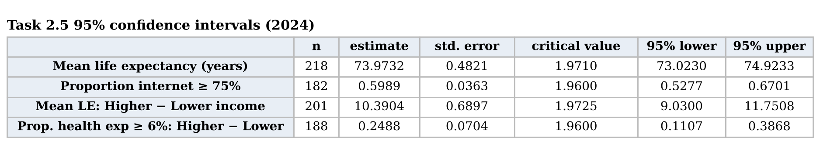
Table 8. 95% confidence intervals, 2024
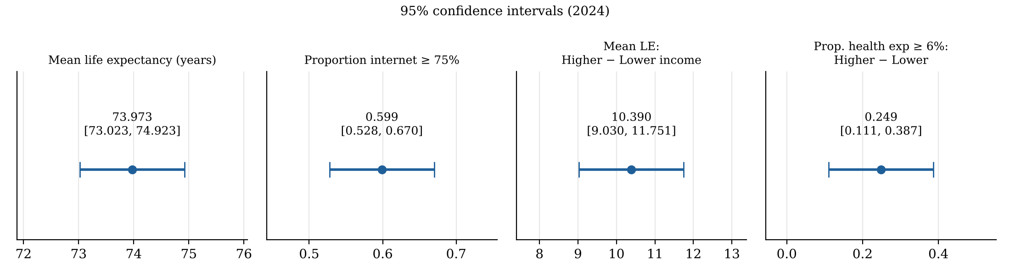
Figure 9. The four 95% confidence intervals

Task 3 – Critical Reflection
Where it worked. Linear algebra suited the data: centred cosines, Z^{T}Z and det R revealed one dominant development dimension, and the log transform made GDP nearly symmetric and linear in life expectancy.
Where it broke down. Randomness: the 218 economies are effectively the whole population (finite-population correction = 0), so the intervals describe a hypothetical super-population, not sampling error. Independence: COVID-19 hit almost every country in 2020–21, yet the binomial still passed its χ² test, so a good fit hid a false model. Normality and year choice: switching from 2022 to 2024 moved kurtosis from 8.58 to −0.61. Countries are also weighted equally (Tuvalu counts as much as India), GDP is in current US dollars rather than purchasing power, and health spending comes from 2023.
Misuse. A raw cosine of 0.9996 could be read as “unchanged”, internet use’s tiny coefficient as “irrelevant”, and a significant interval as proof that income causes longevity. Reporting robust statistics, testing sensitivity to outliers, years and cut-offs, and naming the population an interval refers to would reduce these risks.

References
[1] World Bank, “World Development Indicators,” DataBank, 2026. [Online]. Available: https://databank.worldbank.org/source/world-development-indicators [Accessed: Nov. 2, 2026].
[2] W. McKinney, “Data structures for statistical computing in Python,” in Proc. 9th Python in Science Conf., 2010, pp. 56–61.
[3] J. D. Hunter, “Matplotlib: A 2D graphics environment,” Computing in Science & Engineering, vol. 9, no. 3, pp. 90–95, 2007.
[4] S. H. Preston, “The changing relation between mortality and level of economic development,” Population Studies, vol. 29, no. 2, pp. 231–248, 1975.
[5] World Health Organization, World Health Statistics 2024: Monitoring Health for the SDGs, Sustainable Development Goals. Geneva, Switzerland: WHO, 2024.
[6] G. Strang, Introduction to Linear Algebra, 6th ed. Wellesley, MA, USA: Wellesley-Cambridge Press, 2023.
[7] C. R. Harris et al., “Array programming with NumPy,” Nature, vol. 585, pp. 357–362, 2020.
[8] I. T. Jolliffe and J. Cadima, “Principal component analysis: A review and recent developments,” Phil. Trans. R. Soc. A, vol. 374, no. 2065, Art. no. 20150202, 2016.
[9] D. A. Belsley, E. Kuh, and R. E. Welsch, Regression Diagnostics: Identifying Influential Data and Sources of Collinearity. New York, NY, USA: Wiley, 1980.
[10] D. N. Joanes and C. A. Gill, “Comparing measures of sample skewness and kurtosis,” J. Royal Statist. Soc. D (The Statistician), vol. 47, no. 1, pp. 183–189, 1998.
[11] P. Virtanen et al., “SciPy 1.0: Fundamental algorithms for scientific computing in Python,” Nature Methods, vol. 17, pp. 261–272, 2020.
[12] D. C. Montgomery and G. C. Runger, Applied Statistics and Probability for Engineers, 7th ed. Hoboken, NJ, USA: Wiley, 2018.
[13] S. S. Shapiro and M. B. Wilk, “An analysis of variance test for normality (complete samples),” Biometrika, vol. 52, no. 3/4, pp. 591–611, 1965.
[14] E. B. Wilson, “Probable inference, the law of succession, and statistical inference,” J. Amer. Statist. Assoc., vol. 22, no. 158, pp. 209–212, 1927.
[15] A. Agresti and B. A. Coull, “Approximate is better than ‘exact’ for interval estimation of binomial proportions,” The American Statistician, vol. 52, no. 2, pp. 119–126, 1998.
[16] B. L. Welch, “The generalization of ‘Student’s’ problem when several different population variances are involved,” Biometrika, vol. 34, no. 1/2, pp. 28–35, 1947.
[17] Anthropic, “Claude (Opus 5.5),” Large language model, 2026. [Online]. Available: https://claude.ai [Accessed: Nov. 2, 2026].

Declaration of Generative AI Use
The dataset was independently selected and downloaded from the World Bank Open Data portal. The analysis, interpretation of results, calculations and conclusions presented in this report are my own work. Digital tools were used for limited assistance during the preparation of the Python code and improvement of report wording. All code was independently executed, and the outputs, calculations and figures were reviewed and verified against the notebook results. I take full responsibility for the accuracy, originality and content of this report.

