**NODE JS**

**Installation of Node JS**

Step 1: Open the below Link & download Node JS

<https://nodejs.org/en/download/>

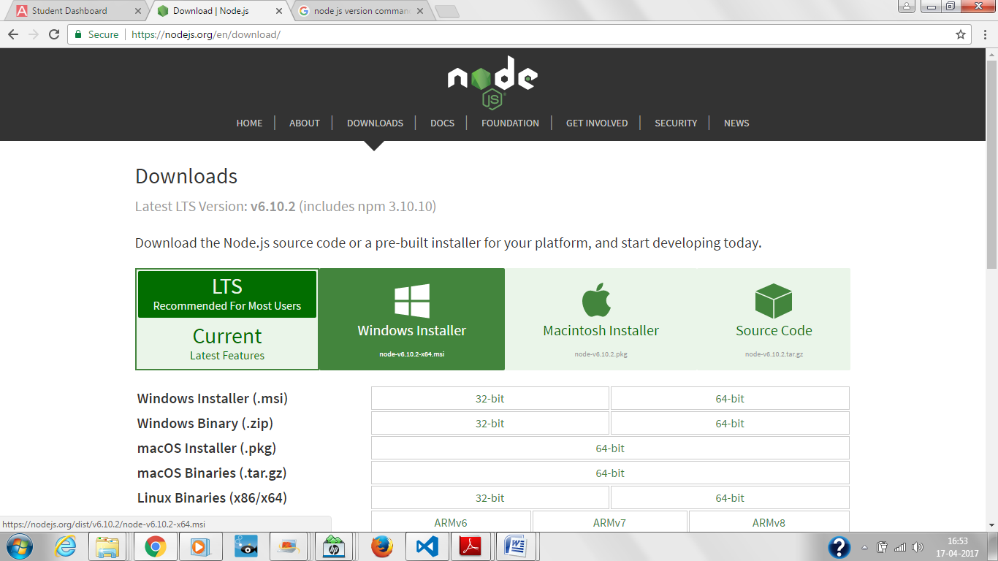

Step 2: Double click on the exe after download is complete

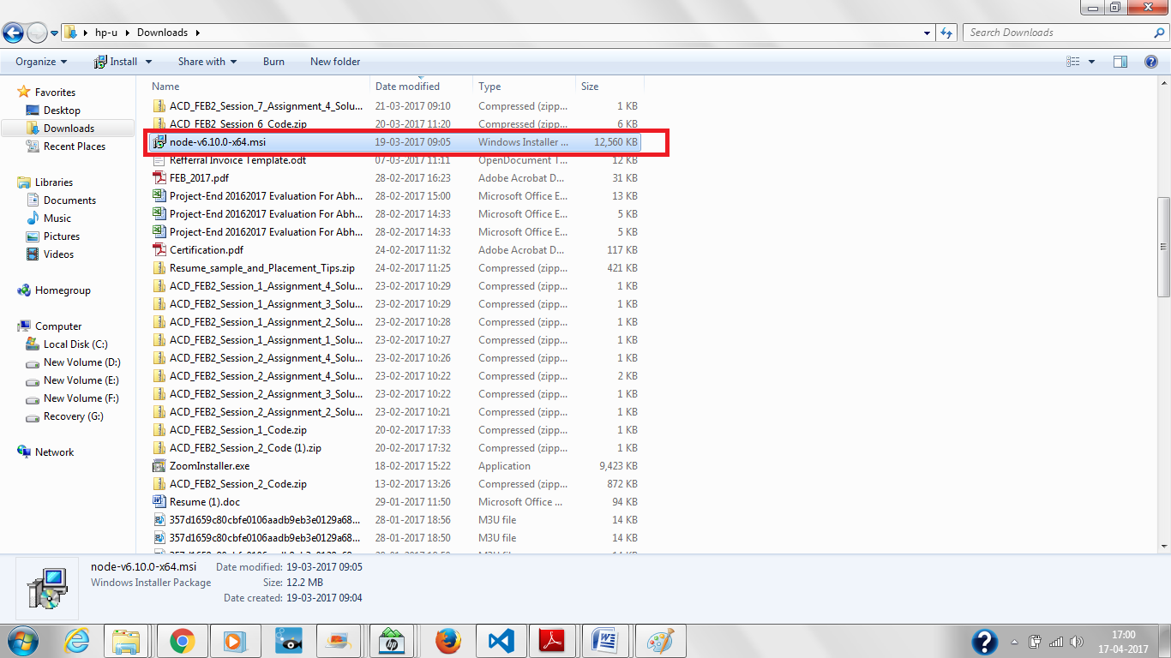

Step 3: Once Installation is done go & check in below path your machine

C:\Users\hp-u\AppData\Roaming\npm

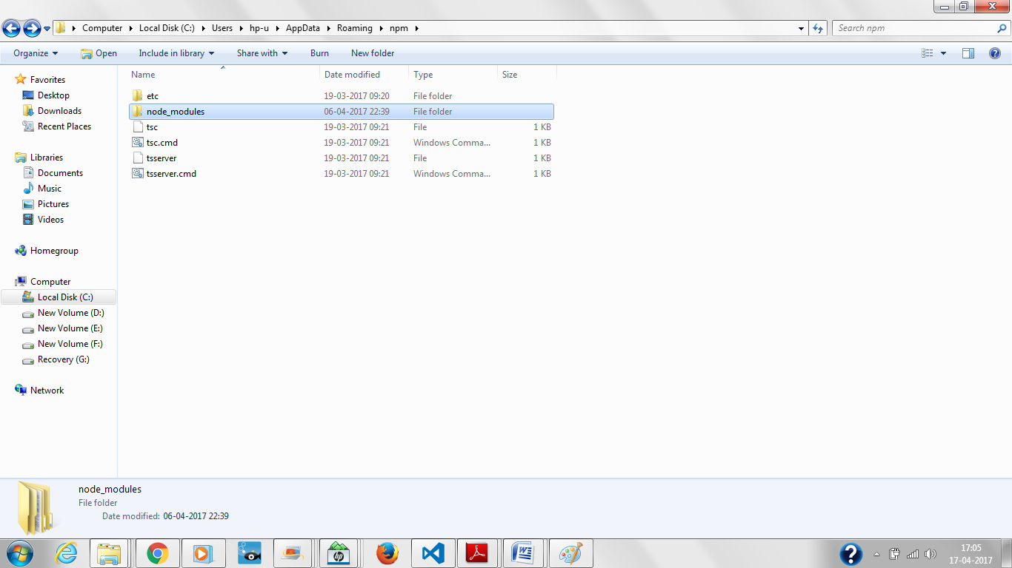

Step 4: Check if node is installed on your machine or not through cmd.

Type the command as shown in screenshot

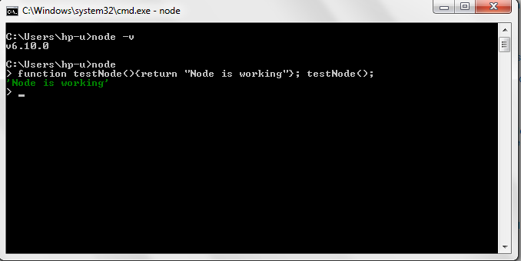

Step 5: Node JS Version & npm Version

