**Angular CLI**

**Installation of Angular CLI**

Step1: Install Angular cli through npm.



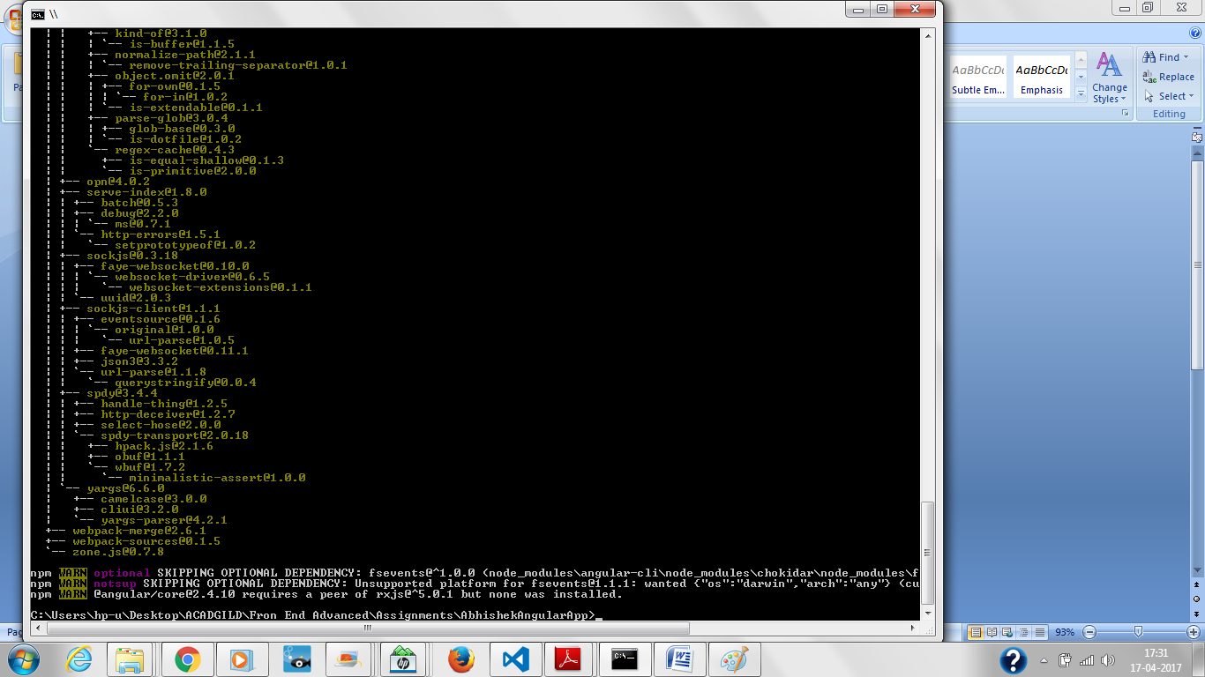

Step2: Check angular cli version

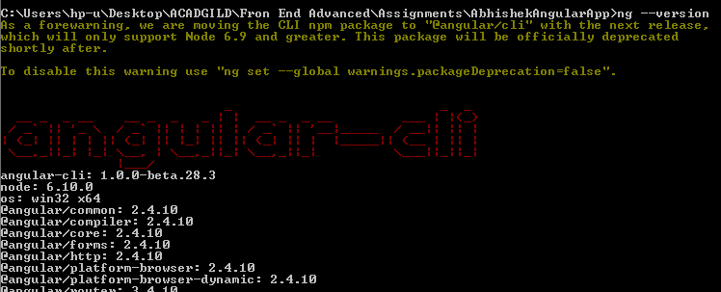

Step3: Create new project with Angular CLI through cmd

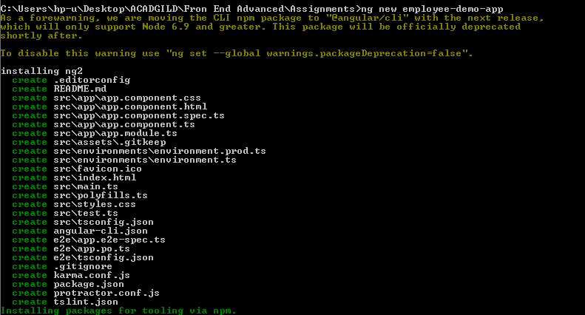

Step4: Run the project and navigate tothe*http://localhost:4200/*

