**Install 3rd Party Library**

•Install 3rdParty libraries (bootstrap).

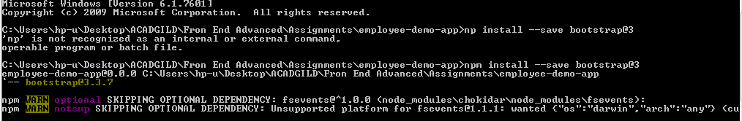

•Check if the Bootstrap is installed properly or not by adding this line of code

<button *type*=*"submit"class*=*"btnbtn-primarybtn-lgbtn-*

*block"*[*disabled*]=*"form.invalid"*>Submit</button>

Please check the code

