**Angular Git-Hub Seed**

Step1: Clone the project from Angular Git hub seed.

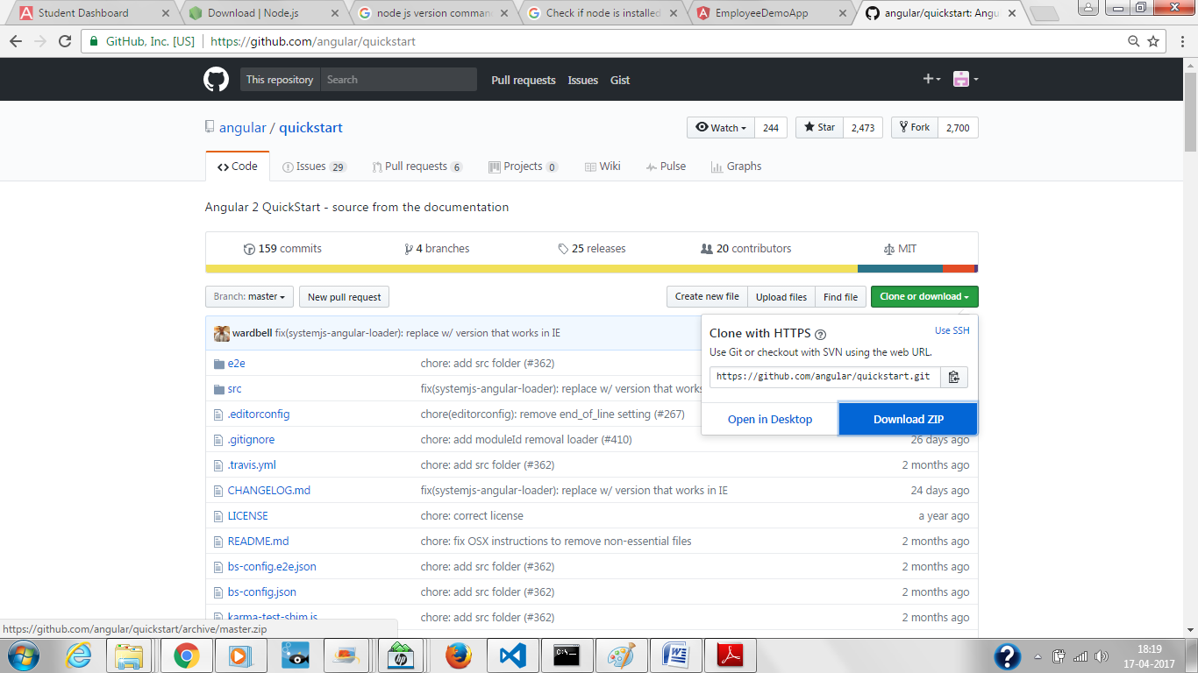

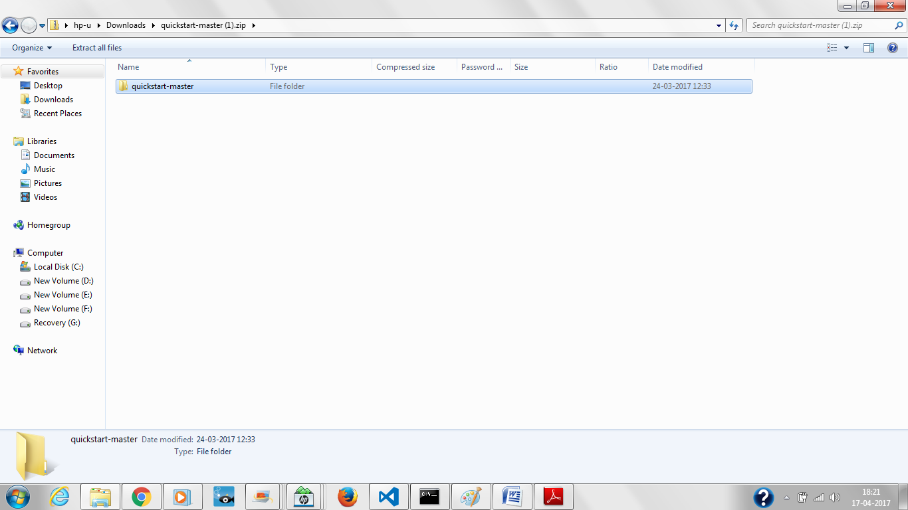

Step 2: Install all the packages in the project by command npm install

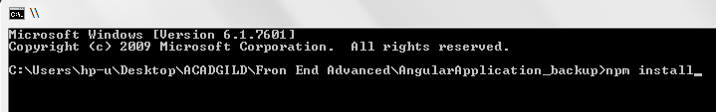

Step3: Check the folder Structure

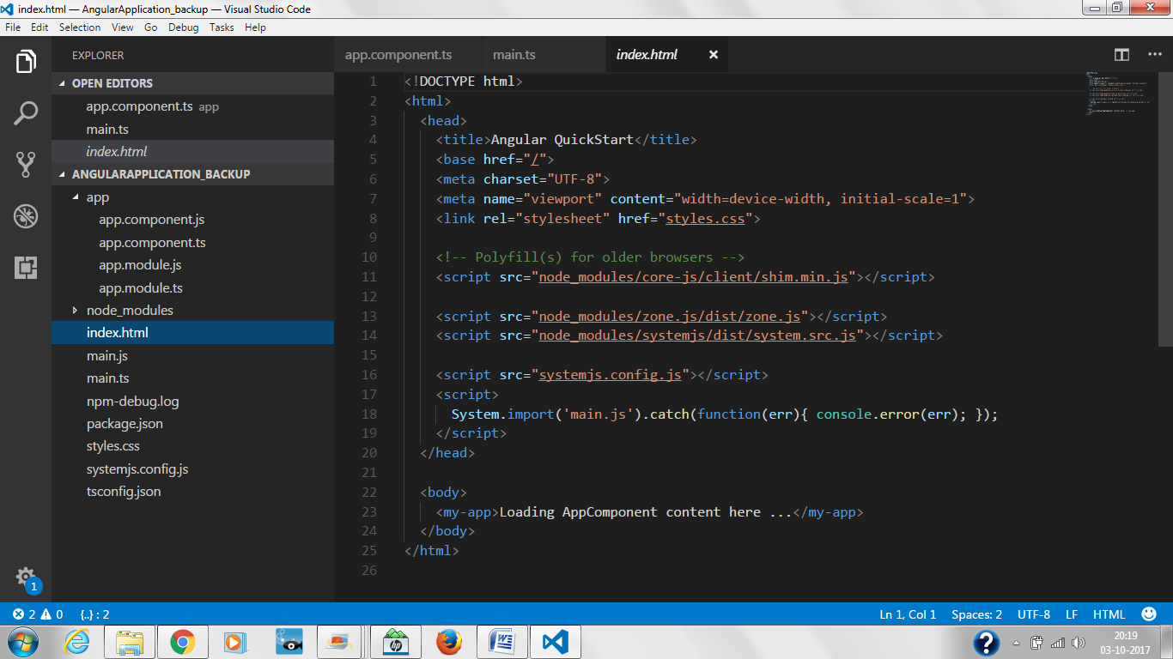

Step 4: Start the project using npm start.

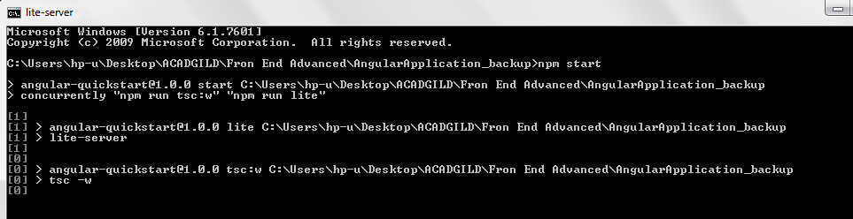

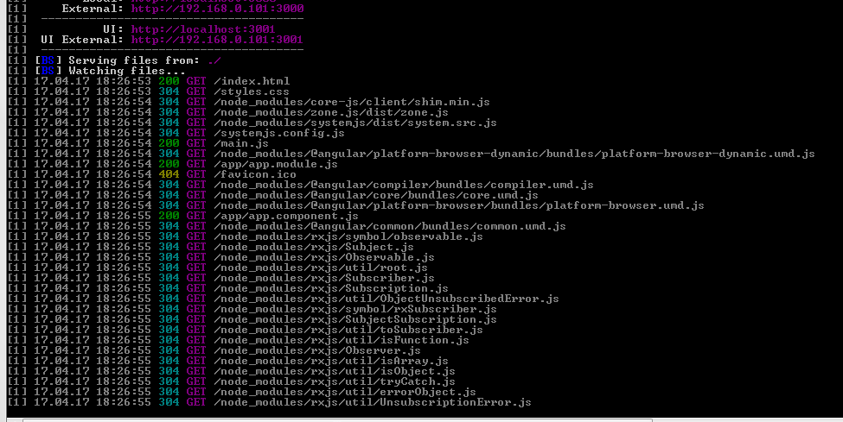

Final Output

