**BOOTSTRAP Installation in Angular Project**

Step-1:

We need to go into our project folder and run the command:

npm install - -save bootstrap as shown below

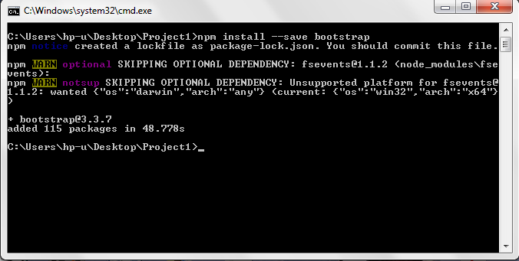

Step-2:

After downloading bootstrap now we need to import it,

Go into .angular-cli.json file and will reference the bootstrap file into styles section as shown below.

