Issue1: send button is not responding.

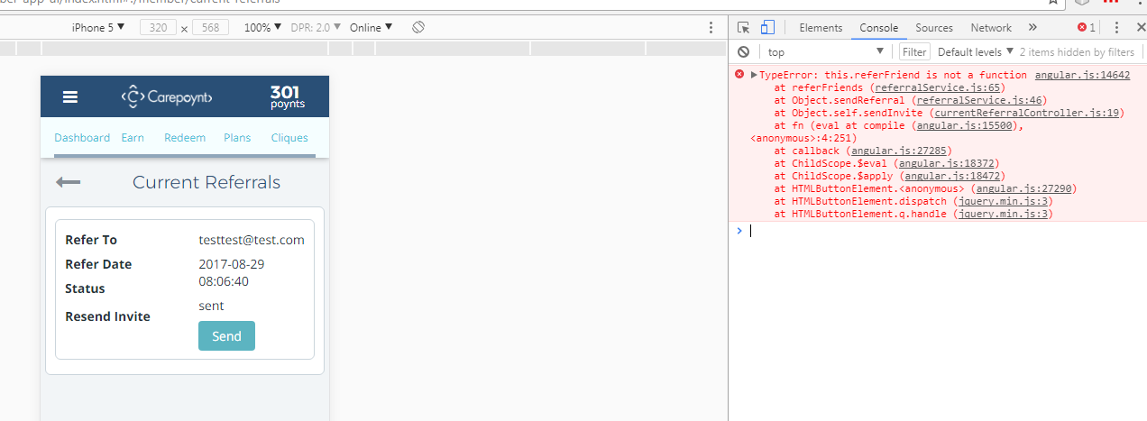

Issue2: Getting the error if user don’t have anything in current referrals.

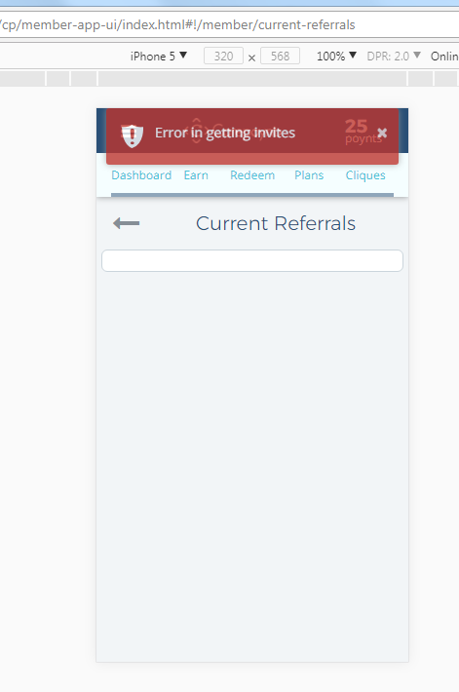

Issue3: UI alignment issue – Unable to view complete email id and in front of status time stamp get display

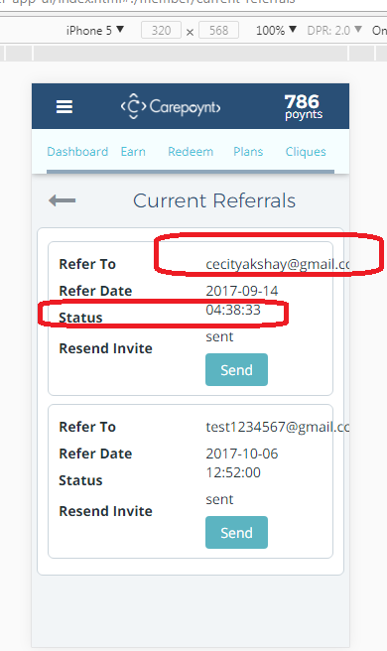

Issue4: Unable to send any invitation

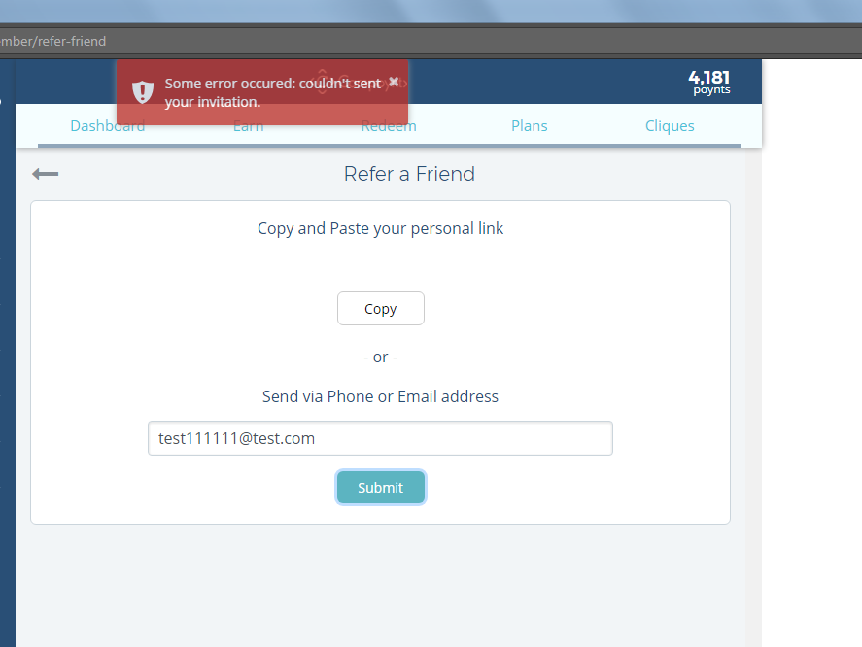

Issue5: if we don’t have email id in “Refer to” this entry should not get display current referrals page.

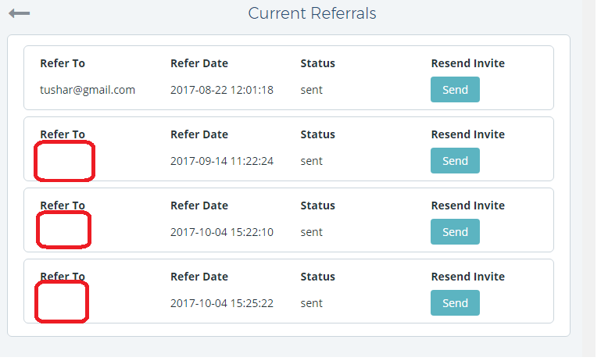

Issue6: email id should not overwrite on refer date.

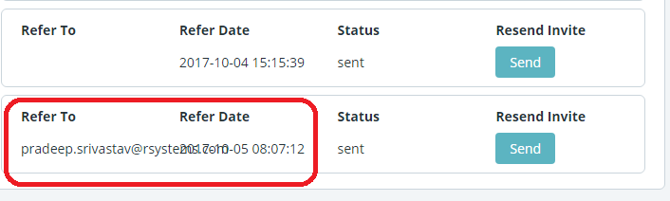

Issue 7: view current referral , left menu icon is missing.