9/25/2017

Abhishek Shrivastava

[senior software engineer]

[Carepoynt]

[UI Best Practice Document]

Contents

**Contents Index**1

**Level 1**

Main Container2

Left Navigation Bar2

Header4

**Level 2**

Top Navigation5

Back arrow with Title Area5

Right Inner Section Area6

Banner Area7

**Level 3**

Border Area8

Inside Container Area8

Thin bottom boarder line9

**Level 4**

Common Custom CSS used for company logo image9

Used custom media query for mobile and tablet view10

Used custom common class for model popup design10

**Level 5**

Used custom common class for social icon section11

Used custom common class for main sub title11

**Level 6**

Used custom common class for getting text-color12

Used custom common class for getting font-size12

Used font-family12

Additional CSS file used in the project Used font-family12

Apart from Bootstrap we have created carepoynt.css this will have custom CSS created by us, also we will use this to over write Bootstrap classes.

**Main Container**

<div id="wrapper"></div>

This is the main container all the sections will come inside it.

Left Navigation Bar

Side / Page Container:

<div id="left-sidebar" class="close-sidebar"></div>

This is the side container, where we use fly-in/out add different page html code link in this container only.

Logo image with profile detail:



<div class="left-container">

<img src="images/CP-login-white-navmenu.png" class="img-fluid" />

<div class="detail-section">

<p>Arun Yahoo</p>

<p>arun1119@yahoo.com</p>

</div>

</div>

Left Navigation also contains Application Logo and User Name and Email ID, and below it has menu items.

Here I am using this “left-container” custom class inside that I am using logo image with profile detail section where for this profile detail section I am using “detail-section”.

Left section menu item:

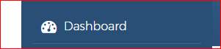

<ul id="accordion">

<li><a href="#"><i class="fa fa-tachometer fa-lg" aria-hidden="true"></i> Dashboard</a></li>

</ul>

Here I use left menu items without contain there sub-menu, with font-awesome icon.

Left section menu items with their sub-menu:

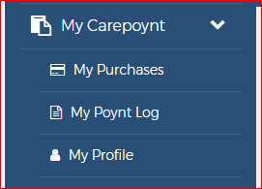

<ul id="accordion">

<li class="card">

<a role="button" data-toggle="collapse" data-parent="#accordion" data-target="#myCarepoynt" aria-expanded="false" aria-controls="collapseOne"

class="collapsed">

<i class="fa fa-clipboard fa-lg" aria-hidden="true"></i> My Carepoynt

<span class="float-right">

<i class="fa fa-chevron-right fa-right-icon"></i>

<i class="fa fa-chevron-down fa-down-icon"></i>

</span>

</a>

<ul id="myCarepoynt" class="sub-menu collapse" role="tabpanel" arialabelledby="headingOne" aria-expanded="false">

<li><a href="#"><i class="fa fa-credit-card" aria-hidden="true"></i> My Purchases</a></li>

<li><a href="#"><i class="fa fa-file-text-o" aria-hidden="true"></i> My Poynt Log</a></li>

<li><a href="#"><i class="fa fa-user" aria-hidden="true"></i> My Profile</a></li>

</ul>

</li>

</ul>

Here we are using left menu items with contain there sub-menu, with font-awesome icon.

Header

D:\NEW PROJECT\CarepointInfo\images\doc image\header.PNG

<div class="row-container left-pannel">

<div class="maincontainer">

<header>

<div class="container">

<div class="row row-padding">

<div class="col-4">

<a href="#" id="main_toggle"><i class="fa fa-bars" aria-hidden="true"></i></a>

</div>

<div class="col-4 text-center">

<img src="images/CP-logo-white-header.png" />

</div>

<div class="col-4 text-right">

<span class="points"> 1,000</span><br /> poynts

</div>

</div>

</div>

Here we separate right section by using custom class, where I put right section in other main container. This header contains small size application logo, icon to open left navigation panel

D:\NEW PROJECT\CarepointInfo\images\doc image\header-mobile.PNG

<a href="#" id="main_toggle"><i class="fa fa-bars" aria-hidden="true"></i></a>

Here we use bar icon for mobile view, where we toggle left menu items fly in/out.

Top Navigation

D:\NEW PROJECT\CarepointInfo\images\doc image\header-nav.PNG

<ul class="nav-menu">

<li class="active"><a href="#">Dashboard</a></li>

<li><a href="Earn.html">Earn</a></li>

<li><a href="#">Redeem</a></li>

<li><a href="#">Plans</a></li>

<li><a href="#">Cliques</a></li>

</ul>

This is the Second level menu, where I use custom css for right main navigation section.

Back arrow with Title Area

Back button sample 1

D:\NEW PROJECT\CarepointInfo\images\doc image\back-arrow.PNG

<div class="container">

<div class="row px-3">

<div class="col-2 col-sm-1 my-auto pl-0"><a class="back-btn"><i class="fa fa-long-arrow-left"></i></a></div>

<div class="col-10 col-sm-11">

<h5 class="text-center py-3">My Careplans</h5>

</div>

</div>

</div>

Back button sample 2



<div class="search_padding m-3 ng-scope">

<div class="container">

<div class="row">

<div class="col-2 col-sm-2 my-auto pl-0 text-left"><a class="back-btn" ><i class="fa fa-long-arrow-left"></i></a></div>

<div class="col-10 col-sm-10 pr-0">

<div class="content_center">

<div class="input-group input-group-sm margin_auto ">

<input type="text" ng-model="ctrl.searchText" class="form-control input-sm" placeholder="Search Enterprises...">

<!--Search text enter functionality can be moved to search Component -->

<span class="add-on input-group-addon">

<button class="btn btn-sm" type="button" data-toggle="modal">

<i class="fa fa-search" aria-hidden="true"></i>

</button>

</span>

</div>

</div>

</div>

</div>

</div>

</div>

Here we use back button with main title of the section and use custom CSS “back-btn” for styling with their cross ponding pages.

Right Inner Section Area

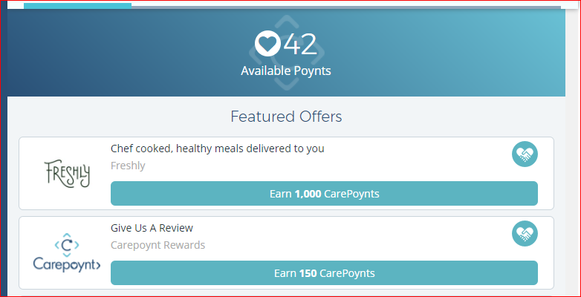

<div id="content_wrapper"></div>

We are using this custom id for render all right section pages inside this id.

Banner Area

Banner area for dashboard



<div class="banner-page py-2">

<div class="col-lg-12 icon-bg">

<div><span class="icon-poynt"><i class="fa fa-heart"></i></span> <span class="total-poynts ng-binding">42</span></div>

<h6>Available Poynts</h6>

</div>

</div>

Banner area image with round image icon

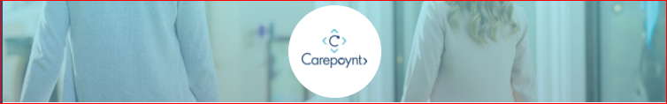

<div class="banner-relate">

<img class="w-100" src="images/company/test/1_profile-photo.png">

<div><span><img src="images/company/test/1_logo-photo.png"></span></div>

</div>

Banner area gradient with round image icon



<div class="banner-page py-0">

<div class="col-sm-12 banner-relate">

<div><span><img src="/cp/img/company/test/1_logo-photo.png"></span></div>

</div>

</div>

Banner area image with no round image icon



<div class="banner-relate banner-img ng-scope">

<img src="/cp/images/family.jpg" class="w-100">

</div>

For image section banner area, I use custom classes “banner-img” for set the property of banner image.

Border Area

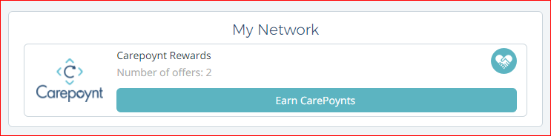

<div class="border-box mb-2"></div>



<div class="content-border-box mb-2"></div>

I use two custom class for border box area one for outer border box (border-box) and another for inner border box (content-border-box).

Inside Container Area

<div class="inside-container">

<form class="form-section">

<p class="text-center my-3">How can we help you ?</p>

<div class="container">

<hr size=2 class="my-2" />

<div class="row">

Here I used “inside-container” custom class for some pages like as contact us, Refer business which have some fixed width inside container.

Thin bottom boarder line

**D:\NEW PROJECT\CarepointInfo\images\doc image\border-bottom.PNG**

<hr size=2 class="my-2" />

This is used for thin line below title or sub title.

Common Custom CSS used for company logo image

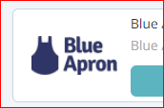

.sm-logo-frame{ width:80px; height:80px; position: relative; }

.sm-logo-frame img {

max-height: 100%;

max-width: 100%;

padding-left: 5px;

padding-right: 5px;

width: auto;

height: auto;

position: absolute;

top: 0;

bottom: 0;

left: 0;

right: 0;

margin: auto;

}

Here we define custom CSS for company logo image where we bound images in certain area.

Used custom media query for mobile and tablet view

@media screen and (max-width: 575px) {

.container { width: 100%; max-width: 100%; }

.nav-menu li a { font-size:12px; }

.nav-menu li a { padding:0; }

.sm-img { padding-left: 5px }

.content-border-box{ padding: 5px 10px; }

}

@media screen and (max-width:320px) {

.text-sm { font-size: 12px;}

.text-md { font-size: 14px;}

.img-frame{ max-width: 75px; max-height: 75px; }

.img-sec { max-width: 62px; max-height: 62px;}

.sm-img { padding-left: 0px }

}

We are using custom media query for handled some part of code in mobile and tablet view.

Used custom common class for model popup design

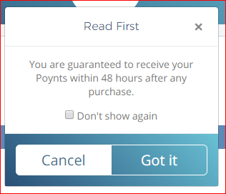

.popup-gradient-blue {

background: #294f76;

background: -moz-linear-gradient(45deg, #294f76 0%, #69c1d5 100%);

background: -webkit-linear-gradient(45deg, #294f76 0%,#69c1d5 100%);

background: linear-gradient(45deg, #294f76 0%,#69c1d5 100%);

}

.btn-group>.btn:last-child:not(:first-child), .btn-group>.dropdown-toggle:not(:first-child) {

border-bottom-left-radius: 0;

border-top-left-radius: 0;

border-bottom-right-radius: 6px;

border-top-right-radius: 6px;

}

We are using customized model popup design using first child and last child concept with proper gradient, where we use “btn:last-child:not(:first-child)” concept for button design.

Used custom common class for social icon section

.social-box { padding:10px; }

.social-box button, .social-box button:hover { display:inline; padding: 5px !important; }

.social-box img { width: 50px; height: 50px; margin-right: 7px; display: inline; }

.social-info{ margin-left:-2px; margin-right:-2px; }

.social-info div[class^="col"]{ padding-left:2px; padding-right:2px; margin-top: 10px; }

Here we use custom class for display social section like Facebook and twitter, where we set image bound to certain

Area and used concept of “[class^="col"]” for performing Facebook and twitter section.

Used custom common class for main sub title

.main-sub-title {

color: #294F76;

font-size: 16px;

text-align: center;

padding-top: 15px;

padding-bottom: 5px; }

Here we used common class for setting main sub title text with color and proper font-size.

Used custom common class for getting text-color

.text-grey { color: #aaa; }

.text-w { color: #fff; }

.text-grey-s { color: #777; }

Used custom common class for getting font-size

.small, small {

font-size: 11px;

}

.medium {

font-size: 12px;

}

.large {

font-size: 16px;

}

.x-large {

font-size: 20px;

}

Used font-family

font-family: 'Montserrat', arial, sans-serif;

font-family: 'Open Sans', sans-serif;

Additional CSS file used in the project

*font-awesome.min.css*

I have also added comments in my page for different sections.

bootstrap.min.js is the script file from Bootstrap framework which automatically handles functionalities like collapsible panels, tabs, navigation behaviors etc.